**"CFD ANALYSIS OF A TWO-STROKE COMBUSTION ENGINE: INSIGHTS INTO PRESSURE DYNAMICS, COMBUSTION EFFICIENCY, AND PERFORMANCE OPTIMIZATION"**

**Prabhat Singh Rathore1, Vineet Kumar Dwivedi2**

1Scholar, School of Mechanical Engineering, Faculty of Engineering and Technology, SAM Global University, Bhopal, M.P, 462046, INDIA

2Head and Prof., School of Mechanical Engineering, Faculty of Engineering and Technology, SAM Global University, Bhopal, M.P, 462046, INDIA

**ABSTRACT**

This study focuses on the Computational Fluid Dynamics (CFD) analysis of a two-stroke combustion engine to investigate the complex dynamics of pressure distribution, combustion progression, and fluid flow behavior. Two-stroke engines, known for their high power-to-weight ratio, are widely utilized in various applications; however, they pose challenges in terms of fuel efficiency, emissions, and scavenging performance. Using ANSYS Fluent, a detailed simulation was conducted to analyze pressure contours, combustion progress variables, and flow patterns within the engine. The results demonstrate critical insights into pressure gradient transitions, indicating effective scavenging and minimal backflow under optimized conditions. Combustion progress variable contours highlight the efficiency of air-fuel mixture burning and identify regions where incomplete combustion occurs. Additionally, flow behavior near ports and exhaust regions was analyzed to assess design efficacy and highlight areas for improvement. This research highlights the capability of CFD tools in optimizing engine performance, enabling significant improvements in fuel economy, power output, and emissions control. By providing a comprehensive understanding of the intricate processes within a two-stroke engine, this study lays the groundwork for further advancements in engine design, including modifications to port geometry, enhanced fuel injection strategies, and the integration of alternative fuels for sustainable and efficient engine operation.

**Keywords:** Two-Stroke Engine, Computational Fluid Dynamics (CFD), Pressure Distribution, Combustion Efficiency, Engine Optimization

1. **INTRODUCTION**

The efficiency and performance of internal combustion engines are critical factors in various applications, from automotive to industrial machinery. Among these engines, the two-stroke engine has gained attention due to its compact design, simplicity, and high-power output. However, despite its advantages, the two-stroke engine faces significant challenges related to fuel consumption, emissions, and overall thermal efficiency. As environmental concerns and stringent emission standards become more prominent, understanding and optimizing the combustion process in these engines is essential. Computational Fluid Dynamics (CFD) has emerged as a powerful tool for analyzing and optimizing combustion processes in engines. It allows for a detailed investigation into fluid flow, heat transfer, and combustion phenomena within the engine cylinder. CFD simulations can predict crucial parameters such as temperature distribution, pressure variations, and species concentrations, providing valuable insights into the engine's performance under different operating conditions. This paper focuses on the CFD analysis of a two-stroke combustion engine, aiming to explore the intricate dynamics of the combustion process. By simulating the engine's behavior under various conditions, the study seeks to enhance the understanding of fuel-air mixing, ignition, combustion, and exhaust processes. The insights gained through CFD simulations can contribute to optimizing engine performance, improving fuel efficiency, reducing emissions, and supporting the development of more environmentally friendly combustion technologies. The paper will explore the setup of CFD models for two-stroke engines, discuss the challenges involved in simulating these engines, and present findings that highlight the potential benefits of CFD in the design and optimization of two-stroke combustion engines. Ultimately, the goal is to provide a foundation for future research and advancements in this area, driving improvements in engine technology for sustainable and efficient power generation.

F. Kawaharazuka et al. [1] examine the simultaneous improvement of thermal efficiency and cooling loss in a wider operating range by applying a thin stainless steel thermal spray coating to the piston top and cavity. The stainless steel (SUS316) has lower thermal diffusivity compared to the original forged steel piston (SCM435), which helps sustain local surface temperatures where the spray flame directly impacts. The fine surface finish reduces convective heat transfer. Experimental results using a single-cylinder engine show significant improvements in both cooling loss and thermal efficiency, especially under high load conditions with a compression ratio of 23.5:1. The analysis suggests that both convective and radiative heat transfer contribute to cooling loss mechanisms D. W. Djamari et al. [2] discuss the ongoing research and development in internal combustion engines (ICEs), highlighting the growing concerns about air pollution, fuel costs, and market competitiveness, which have driven innovations in diesel engine technology. Diesel engines offer advantages over gasoline engines, such as higher efficiency, greater power output, and reliability. The paper reviews the progress in understanding diesel spray atomization, a complex phenomenon due to the high-speed, high-pressure, and high-temperature conditions under which it operates. It also explores advancements in optical technology that have enabled better visualization of spray evolution. Despite significant progress, the paper acknowledges that comprehensive understanding of diesel spray mechanisms, including liquid atomization and two-phase spray flow, remains incomplete, and calls for further investigation into these areas A. A. Yusuf et al. [3] investigate the effects of n-butanol-hydrogen-gasoline blends on the performance, combustion, and emissions of a turbocharged gasoline direct injection (TGDI) engine. The study focuses on different spark timing (ST), brake mean effective pressure (BMEP), and load conditions under stoichiometric operation. The results show that the brake specific fuel consumption (BSFC) decreases by an average of 3.79%, improving combustion rates and reducing ignition delay. Additionally, the brake thermal efficiency (BTE) increases with higher additive energy ratios. Retarded ignition timing lowers NOx emissions, while CO emissions rise slightly. The study concludes that the optimized blends contribute to effective output work and reduced heat loss through the cylinder walls A. A. Yusuf et al. [4] investigate the effects of low CeO2 nanoparticles dosage in biodiesel blends on toxic pollutants and combustion parameters in a six-cylinder turbocharged common-rail diesel engine. Experiments were conducted using four different test fuels under 50% engine load at a constant speed of 1800 rpm. The results show that the B15C15 biodiesel-CeO2 blend significantly improves in-cylinder pressure and heat release rate compared to other test fuels. The biodiesel-CeO2 blend leads to a substantial reduction in CO and HC emissions compared to B0 (pure diesel), with a slight increase in NOx emissions (2.78% to 19.01%). The reduction in unburned hydrocarbons shifts the particle size distribution toward smaller particles, and B15C15 also reduces PAH emissions by 64.7% compared to B0. The study also finds that biodiesel-CeO2 blends reduce organic carbon (OC) and elemental carbon (EC), suggesting these compounds are either less readily formed or more effectively reduced during combustion A. A. Yusuf et al. [5] explore the impact of waste plastic pyrolysis oil, n-butanol, hybrid (Al2O3 and TiO2) nanoparticles, and diesel fuel blends on combustion, emissions, and toxic particulates in a CRDI diesel engine under steady-state conditions. Experiments involved blending different fuel ratios with hybrid nanoparticles at concentrations of 20 ppm, 40 ppm, and 60 ppm, and using an ultra-sonification process to prepare the blends. The most optimal blend was identified using Shannon entropy-weighted TOPSIS and PROMETHEE II, and confirmed with experimental results A.L. Hanato et al. [6] explore the potential of green butanol, a biofuel, for diesel engines, assessing its impact on engine performance and emissions. The study examines several engine parameters, including brake-specific fuel consumption (BSFC), brake thermal efficiency (BTE), and exhaust gas temperature, as well as emissions such as carbon monoxide (CO), hydrocarbons (HC), nitrogen oxides (NOx), and smoke opacity. These factors are influenced by the use of butanol in various biofuel ratios. The study also utilizes advanced machine learning techniques, specifically Elman and Cascade Neural Networks, to predict engine performance and emissions when using butanol. The models are trained with a Conjugate Gradient Learning Function with Polak-Ribière Restarts to simulate the effects of butanol on diesel engines. J.R. Serrano et al. [7] present a new opposed-piston 2-stroke engine architecture designed for hybrid configurations to meet "zero-emissions" urban standards. The engine features innovative rod-less kinematics, offering compactness, vibration-free operation, and competitive power density and fuel consumption. The study includes experimental testing and the development of a 1D gas-dynamics model to analyze gas exchange and combustion. The goal is to improve fuel consumption while maintaining simplicity and cost-effectiveness compared to current market standards.

1. **FLUENT SETUP**

In Figure 1, the 2D model shown is one of the four piston models that were used to do the combustion modelling. Another important detail about the geometry of the combustion chamber is that the chamber is 3 symmetric and will be beneficial when running computational analysis as it can be simulated as an axisymmetric solution and thus cutting down on computational time.

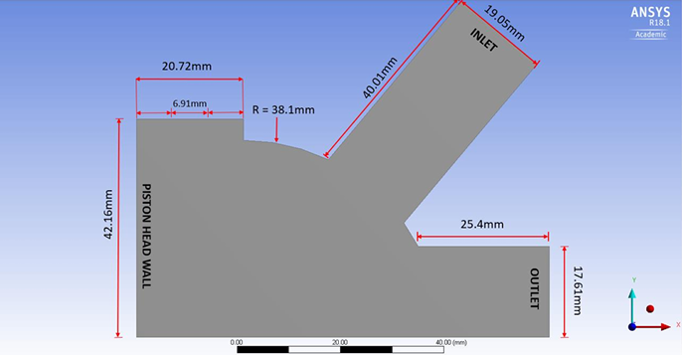

**Figure 1**: Dimension of 2D Model

In combustion modelling, the mesh plays a crucial role in the CFD analysis, as the number of elements, nodes, and their sizes can significantly impact the results. It was important to ensure the mesh was fine enough to accurately capture the combustion process and had sufficient elements along the chamber walls to detail the combustion dynamics. A poorly set-up mesh would prevent the combustion simulation from yielding successful results. After several adjustments, including resizing and modifying inflation layers to assess the effects, the final mesh used for the combustion simulation is shown in Figure 2. This mesh design was applied to the combustion chamber model with the piston wall at BDC, and the same mesh configuration was used for the other three combustion chamber models.

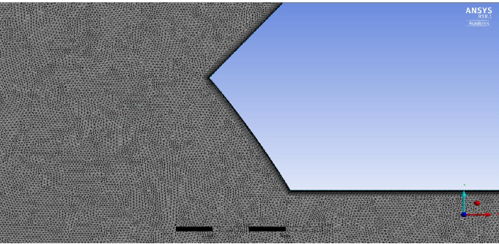

Figure 2: Mesh of the Geometry

As previously mentioned, this simulation employs the premixed combustion model in a 2D rectangular coordinate system. Upon importing the mesh into the Fluent Solver, the program automatically recognizes the model as 2D and adjusts the governing equations accordingly. The Fluent Solver is configured to operate as a parallel solver utilizing eight processors and double precision, ensuring accuracy in the computational analysis. Each piston wall model will be solved as an axisymmetric solution, enabling the simulation of the entire combustion chamber using only half of its geometry. The solver is pressure-based and operates under steady-state conditions, meaning the flow characteristics remain constant over time, and steady-state criteria are achieved. For the 2D model, the continuity equation is expressed as follows:

∂ρ/∂t + ∂(ρu)/∂x + ∂(ρv)/∂y = 0

Definitions of Quantities:

ρ: Fluid density (kg/m³)

t: Time (s)

u: Velocity component in the x-direction (m/s)

v: Velocity component in the y-direction (m/s)

x: Spatial coordinate in the horizontal direction (m)

y: Spatial coordinate in the vertical direction (m)

Another governing equation that Fluent will be solving is the equations for conservation of momentum in the x and y-direction for the 2D model.

Conservation of Momentum in the x-Direction:

∂(ρu)/∂t + ∂(ρu²)/∂x + ∂(ρuv)/∂y = -∂p/∂x + ∂/∂x(μ ∂u/∂x) + ∂/∂y(μ ∂u/∂y)

Conservation of Momentum in the y-Direction:

∂(ρv)/∂t + ∂(ρuv)/∂x + ∂(ρv²)/∂y = -∂p/∂y + ∂/∂x(μ ∂v/∂x) + ∂/∂y(μ ∂v/∂y)

Definitions of Symbols:

ρ: Fluid density

u: Velocity component in the x-direction

v: Velocity component in the y-direction

p: Pressure

μ: Dynamic viscosity

t: Time

x, y: Spatial coordinates

1. **RESULTS AND DISCUSSION**

The results in this report include contour plots, vector plots, velocity streamlines, and bar charts to illustrate the fluid flow characteristics within the combustion chamber. Since the premixed combustion model is adiabatic, it has inherent limitations in the scope of results produced. However, these results provide a foundational understanding of the phenomena occurring in the combustion chamber.

The first set of results, focused on the Methane/Air mixture, is critical as it serves as the baseline to validate the premixed combustion model. These results confirm the model’s capability to represent combustion characteristics such as turbulent kinetic energy, the Damköhler number, and the progress variable accurately. Once the Methane/Air mixture results were established, simulations for the other three Fuel/Air mixtures were conducted. The data collected from all four Fuel/Air mixtures were compared, leading to the creation of four bar charts: Average Temperature vs. Piston Position, Turbulent Flame Speed vs. Piston Position, Progress Variable vs. Piston Position, and Damköhler Number vs. Piston Position.

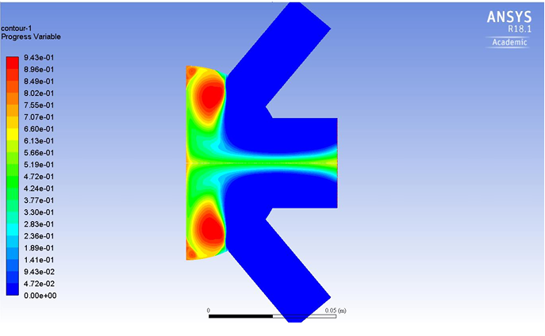

**Figure 3:** Contour of Progress Variable for Methane at Position of TDC

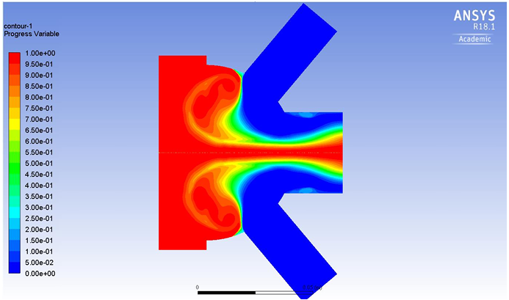This figure 3 represents a simulation performed using ANSYS R18.1 Academic, likely modelling a flow field or a reaction process in a T-junction-like geometry. The color contour indicates the distribution of a parameter labelled as the "Progress Variable," which is a dimensionless scalar ranging from 0.00 (blue) to 0.943 (red). This variable typically represents the extent of a reaction, such as combustion progress, mixing efficiency, or temperature distribution. The geometry appears to consist of two opposing inlets that merge in a central mixing chamber, suggesting a study of flow interaction, mixing, or reaction dynamics.

**Figure 4**: Contour of progress variable for methane/air at BDC

The figure 4 represents a computational fluid dynamics (CFD) simulation performed in ANSYS Fluent (R18.1), showcasing a contour plot of a "progress variable" distributed across a symmetric flow domain resembling a T-junction or Y-junction pipe. This simulation is typically used to study the behavior of fluid flow, mixing, or reaction progress within a bifurcated geometry. The progress variable depicted in the contour plot could represent a physical property such as temperature, species concentration, or the progression of a chemical reaction, depending on the specific problem being analyzed

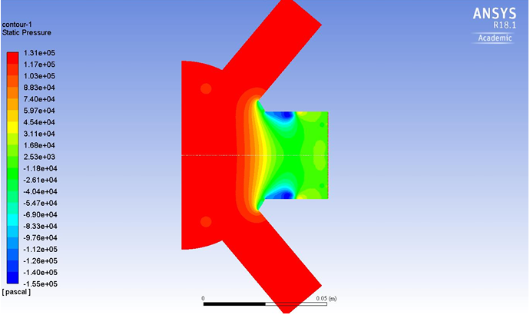

**Figure 5:** Contour of pressure for methane/air at TDC

This figure 5 represents a static pressure contour plot from a Computational Fluid Dynamics (CFD) simulation, as visualized in ANSYS Fluent (version R18.1). The setup appears to involve a cross-sectional view of a two-stroke engine's port geometry, where gas flow dynamics are being analyzed. Static pressure distribution is displayed across the computational domain, with values ranging from high pressure (red) to low pressure (blue), as indicated by the legend on the left.

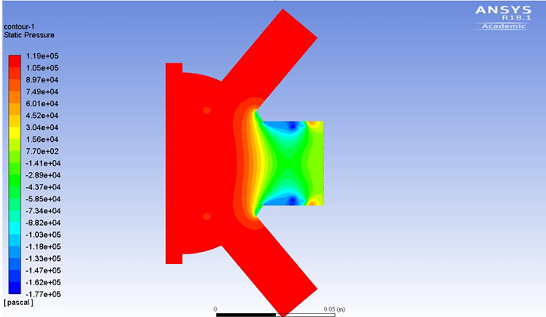

Figure 6: Contour Static

The figure 6 represents a static pressure contour for a CFD simulation of a two-stroke combustion engine's port geometry. This simulation focuses on the pressure distribution within the engine's ports, which are critical for managing the intake of fresh air-fuel mixture and the expulsion of exhaust gases. The static pressure is color-coded, ranging from high pressure (red) to low pressure (blue), as indicated by the legend on the left.

The high-pressure zones are concentrated near the central region of the geometry, likely near the intake or combustion chamber. This area experiences a build-up of static pressure, possibly due to the compression of the air-fuel mixture or the aftermath of the combustion event. The symmetric distribution of the high-pressure regions suggests a well-maintained port design, reducing the likelihood of uneven flow distribution or pressure imbalances. The pressure transitions from red (high) to yellow and green as the flow moves outward from the central chamber to the exhaust or intake ports. This gradient indicates the release of pressure as the gases expand and flow toward the boundaries. This transition is crucial for determining scavenging efficiency, as it signifies the effectiveness of removing exhaust gases and introducing a fresh charge.

1. **CONCLUSION**

The Computational Fluid Dynamics (CFD) analysis of a two-stroke combustion engine provides invaluable insights into the intricate dynamics of combustion, pressure distribution, and fluid flow. Through detailed simulations, this study has identified critical parameters influencing engine performance, including the effects of scavenging, combustion progress, and pressure gradients. The results highlight the importance of optimizing geometric design and operating conditions to achieve efficient scavenging, minimize backflow, and ensure uniform combustion.

The pressure contours demonstrate how high-pressure regions near the combustion chamber transition effectively into low-pressure zones at the exhaust, underscoring the engine's ability to manage pressure gradients for improved performance. Similarly, the analysis of the progress variable reveals the mixing efficiency and combustion progression, offering a deeper understanding of the transition from unburned to fully burned air-fuel mixtures.

This study underscores the role of CFD in evaluating and enhancing engine design without extensive physical prototyping. By identifying areas of inefficiency, such as localized pressure losses or incomplete scavenging, targeted modifications can be implemented to improve fuel efficiency, power output, and emissions control. Future work could explore alternative port geometries, advanced fuel injection strategies, and the integration of renewable fuels to further optimize two-stroke engine performance while addressing environmental challenges.

1. **REFERENCES**
2. F. Kawaharazuka, N. Uchida, Osada H J S I J O A, et al., A novel piston insulation technique to simultaneously improve both heat loss and thermal efficiency for diesel engines [J], SAE Int J Adv & Curr Prac in Mobility 3 (5) (2021) 2173–2181.
3. D.W. Djamari, M. Idris, P.A. Paristiawan, et al., Diesel spray: development of spray in diesel engine [J], Sustainability 14 (2022), 15902.
4. A.A. Yusuf, F.L. Inambao, A.A. Farooq, Impact of n-butanol-gasoline-hydrogen blends on combustion reactivity, performance and tailpipe emissions using TGDI engine parameters variation [J], Sustain. Energy Technol. Assessments 40 (2020), 100773.
5. A.A. Yusuf, H. Dandakouta, I. Yahuza, et al., Effect of low CeO2 nanoparticles dosage in biodiesel-blends on combustion parameters and toxic pollutants from common-rail diesel engine [J], Atmos. Pollut. Res. 13 (2) (2022), 101305.
6. A.A. Yusuf, J. Dankwa Ampah, M.E.M. Soudagar, et al., Effects of hybrid nanoparticle additives in n-butanol/waste plastic oil/diesel blends on combustion, particulate and gaseous emissions from diesel engine evaluated with entropy-weighted PROMETHEE II and TOPSIS: environmental and health risks of plastic waste [J], Energy Convers. Manag. 264 (2022), 115758.
7. A.L. Hananto, A. Fauzi, A. Suhara, et al., Elman and cascade neural networks with conjugate gradient Polak-Ribi`ere restarts to predict diesel engine performance and emissions fueled by butanol as sustainable biofuel [J], Results in Engineering 19 (2023), 101334.
8. J.R. Serrano, F.J. Arnau, P. Bares, et al., Analysis of a novel concept of 2-stroke rod-less opposed pistons engine (2S-ROPE): testing, modelling, and forward potential [J], Appl. Energy 282 (2021), 116135.