**EVALUATION OF ENGINEERING PROPERTIES OF EXPANSIVE SOIL ON ADDITION OF RICE HUSK ASH WITH JEO JUTE FIBER**

Tahir Imam1, Dr. Mumtaz Begam2 , Prof. Deepak Garg3

1 M. Tech Scholar, Department of Civil Engineering, Oriental Bhopal, India

2 Asso. Prof. Department of Civil Engineering, Oriental Bhopal, India

3 Astt. Prof. Department of Civil Engineering, Oriental Bhopal, India

**Abstract.** Geopolymer concrete is often called environmentally friendly "or" green building materials. Since the production process of Geopolymer, concrete does not consume as much energy that is consumed during cement manufacturing. Geopolymers can significantly reduce the emission of carbon dioxide to replace Cement. This research focuses on developing mix proportions for geopolymer concrete with material densities ranging from 1200 kg/m3 to 1400 kg/m3 to attain strength ranges suitable for usage as a structural material. The admixture employed in this research is Aluminium oxide powder, and to densify the geopolymer created, a 12.5 molarity sodium hydroxide solution was used. In this study, concrete mixes are prepared with partial replacement of natural sand at different substitution rates 10%, 20% ,30%, 40%, 50%and 60% with waste materials then different properties of concrete are compared ..., with the control concrete mix containing 100% natural sand. Finally an optimum amount of Sand replacement has been determined & a concrete sample was prepared using this configuration, its strength & workability were estimated.

**Keywords:** Copper Slag, Durability, Fly ash, Flexural strength, Geopolymer Concrete, Strength parameters, Stone dust, Workability.

1. Introduction

Concrete production has a significant impact on our environment. It is the second-largest producer of carbon dioxide, accounting for 8% of the world's carbon footprint, responsible for climate change. The amount of waste generated in many other industries is increasing. In short, our landfills are quickly being filled up, and valuable resources are being lost. Therefore, people are rethinking the role of waste, giving industrial by-products new lives, reducing carbon dioxide emissions, and reducing landfills. World cement consumption rose by 2.8% in 2019, leading to CO2 2.5-3% emission per metric ton. Currently, (OPC) is the most broadly used concrete binder globally. OPC, aggregate, and water form traditional Ordinary Portland cement concrete (OPCC) that Rules the construction materials market. Worldwide OPC production exceeded 3.8 billion tonnes in 2018, as per the United States Geological Survey report (USGS 2020; Cui, Gao, and Zhang 2020) Cement Minerals program. Considering that OPC production causes serious greenhouse gas emissions, the widespread use of OPC is a big problem. Carbon dioxide (CO2) emitted from fossil fuels in cement production is considered the main driver of climate change(Gregg, Andres, and Marland 2008; Cui, Gao, and Zhang 2020). Also, the durability issues caused by OPC (Zhang et al. 2017; Wang et al. 2019) constitute a serious problem that directly impairs structural safety. Besides, cement production is expected to increase. In 2016, the entire construction area in the world was around 235 billion square metres, and this figure is predicted to quadruple by 2025. Over the next 40 years, the amount of construction space in Japan will expand by 40 percent. An average of 15 per planet per year until 2060(Lehne and Preston 2018).

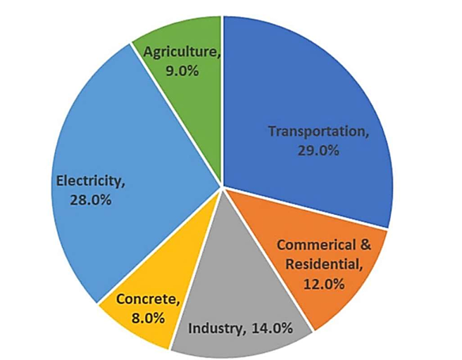

**Fig. 1.** Emission of CO2 from different Sectors (www.google.co.in)

Geopolymer is a rising field of research for utilizing by-products. It has paved the way for finding new alternatives for the replacement of cement in the concrete industry and may be utilized by cement producers to offer a broader range of cementitious products to the market. Geopolymers are members of the family of inorganic alumino-silicate polymer synthesized from alkaline activation of various aluminosilicate materials or other by-product materials like fly ash, metakaoline, blast furnace slag etc. (Davidovits, 2008). The chemical composition of the geopolymer material is similar to natural zeolitic materials, but the microstructure is amorphous. The final products of geopolymerisation are influenced by several factors based on chemical composition of the source materials and alkaline activators (Diaz et al. 2010; Yip et al. 2008). The polymerisation process is generally accelerated at higher temperatures. Fly ash based geopolymer produced in ambient temperature achieve lower strength in early days as compared to heat-cured specimens (Vijai et al. 2010).

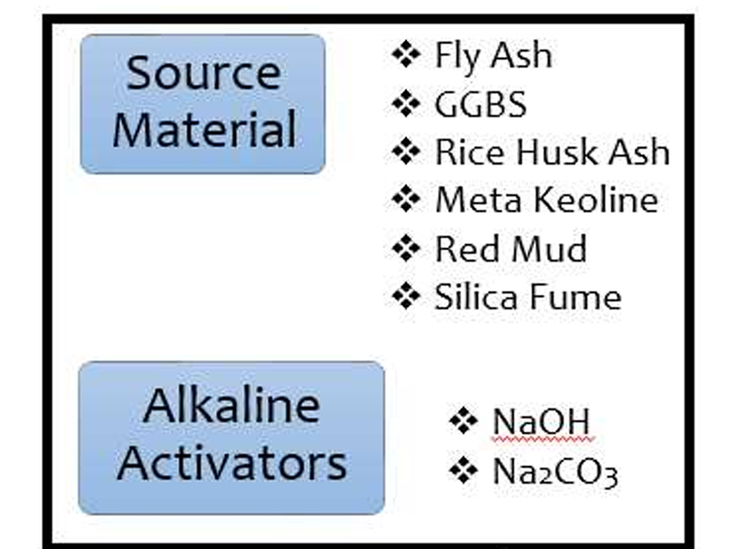

**Fig. 2.** ingredients of GPC

Following are the objectives of this work-

* To assess the physical and engineering properties of Copper slag, steel slag and pond ash collect from nearby sources and compare them with same properties of Zone II fine aggregate (sand) available near Bhopal region.
* To investigate the strength properties of fly ash based GPC with copper slag, pond ash, steel slag, as replacement of sand when subjected to a static load, and compare with the GPC concrete with conventional Zone II fine aggregate (sand) .
* To examine the workability characteristics of geopolymer concrete with alternate materials.

1. Literature Review

* Ganesh et.al. (2024) In this research work, the efect of partial replacement of fyash with GGBS in proportions such as 0, 10, 20, 30 and 40% is investigated. Also Molarity of NaOH are tested from 8 to 14 M and both the parameters are optimized. In this optimized Geopolymer concrete, the utilization of iron slag as a partial substitute for river sand in various proportions such as 10, 15, 20, 25, 30 35, 40 and 45% are investigated. The optimized Geopolymer concrete with iron slag is investigated for its performance as a paver block with incorporation of banana fber in proportions such as 0, 0.5, 1 and 1.5 and is compared with conventional cement concrete paver block. The results show that there is a signifcant enhancement in the properties of Geopolymer concrete with the diferent levels of optimization and the utilization of natural banana fber. The developed sustainable paver block was found to with stand medium trafc conditions as per IS 15658:2006. Further this study employed random forest (RF) algorithm for the prediction of compressive strength of geopolymer concrete specimens for the variable parameters such as molarity of alkaline solution, Flyash/GGBS ratio and partial replacement of river sand with iron slag. The performance evaluation parameters represented high accuracy of developed RF model. This research work unleashes a heft potential of Geopolymer concrete to develop economical eco-friendly sustainable paver blocks to the society through mitigation of environmental strain on the ecosystem.
* Arvind Singh Gaur (2023) This paper reviews past studies on concrete paver blocks constructed using construction and demolition wastes (CDW). The review work focuses on studies using recycled aggregate with partial replacements of natural aggregates. The results from the experimental investigation of workability, density, water absorption, abrasion resistance, compressive strength, flexural strengths, etc of concrete reported earlier were reviewed. The split tensile strength, impact value, crushing value tests, etc that were conducted to evaluate the performance of the paver blocks were analyzed in this study. The critical observations of the past work were summarized at the end of this paper. A few of the important findings are given as Most of the research has suggested a replacement of natural aggregate up to 50% by demolition wastes to reach the desired performance level of paver blocks. The studies have focused primarily on M20, M25, and M35 grades of concrete for making paver blocks. The paver blocks made by using demolition wastes could be used in streets for high volume traffic provided the blocks were overlaid on adequately designed base and subbase layers.
* Mahdi et.al. (2022) This study proposes development of geopolymer paver (GEOPAV) blocks utilizing brick kiln rice husk ash (BKRHA). It presents fresh, mechanical and durability properties of GEOPAV blocks blended with fly ash, BKRHA, natural aggregates, NaOH and Na2SiO3 solution, and cured in both sundry and room temperature conditions. Microstructural analysis using scanning electron microscope (SEM) and X-ray diffraction (XRD) was adopted to study the influence of BKRHA on hardened properties of GEOPAV blocks. The results show that addition of BKRHA reduce the workability of GEOPAV mixes due to micro porous surface with honeycombed structure of BKRHA particles. The addition of BKRHA showed negligible improvement in compressive strength of GEOPAV blocks. However, the major advantage was observed with improved split tensile strength and flexural strength for GEOPAV blocks with BKRHA. Further, the durability properties in terms of resistance to acid and frost attack was significantly improved with the addition of BKRHA in GEOPAV blocks. Such improvements can be attributed to high amounts of amorphous silica in BKRHA which contribute towards dissolution and formation of polymeric gel, and thereby serve as a binder to enhance the geopolymer matrix making it dense. Finally, all the developed GEOPAV blocks satisfy the IS 15658–2021 specification requirements and perform much better when compared to commercially available paver blocks. Replacement of SPFA with BKRHA has reduced the workability of GEOPAV mixes. This can be attributed to microporous and honeycombed structure in the morphology of BKRHA particle.
* Leong Sing Wong (2022) studied that a comprehensive understanding on the durability behavior of geopolymer concrete could be achieved from this review. It can be concluded from this review that geopolymer concrete is durable and resistant to heat, chloride penetration, acid attack, and abrasion. An optimal addition of fibers and ultra-fine silica material such as nano-silica to geopolymer concrete could enhance its residual compressive strength. This could be achieved through the actions of reinforcing fibers and pore blocking of extremely-small-sized silica particles that prevented crack propagation in geopolymer concrete. In that regard, it is interesting for future research to explore the role of thermal insulating raw material such as fiberglass at enhancing the residual compressive strength of geopolymer concrete. A high degree of alkalinity in admixture; tough aggregate; and the optimal utilization of fibers and additives were the identified elements that could minimize the porosity and maximize the binding effect of geopolymer concrete, thereby protecting it from damage due to harsh environmental exposure. The review on the durability aspects of geopolymer concrete showed that it had high compressive strength at an optimal elevated temperature, low to medium chloride ion penetrability, and high resistance to acid attack and abrasion. This makes geopolymer concrete a viable candidate to replace OPC concrete in the construction industry.
* Lelian ElKhatib et.al. (2022) Attempted to review recent articles on the production and properties of geopolymers and alkali activated materials. Different hardened, structural, and durability properties are studied. These include; compressive strength, flexural strength, modulus of elasticity, ultrasonic pulse velocity, shrinkage, expansion, creep, weight loss, carbonation, sulfate, and corrosion. Authors concluded that, substituting cement in traditional concrete with alkali activated ashes to produce geopolymer concrete will become more popular in the future, as this will reduce the environmental pollution due to the extensive use of cement. Also, another advantage is that alkali activated concrete can have improved properties compared with traditional concrete. However, more research and field studies should be conducted to establish the practical use of geopolymer concrete. This will include cost and performance. In addition, other pozzolanic materials from bio-sources should be investigated for the production of alkali activated or geopolymer materials.

1. Material Used

The following materials are used during the research work-

* Cement
* Fine aggregates (Sand)
* Coarse Aggregates(20mm)
* Coarse Aggregates(10 mm) or Jeera aggregate
* Fly Ash (F class)
* Steel Slag
* Copper Slag
* Pond Ash
* Sodium hydroxide
* Sodium silicate
* Water

1. Methodology

Following procedure has been adopted for the work:

**Table 4.** Cases considered for study

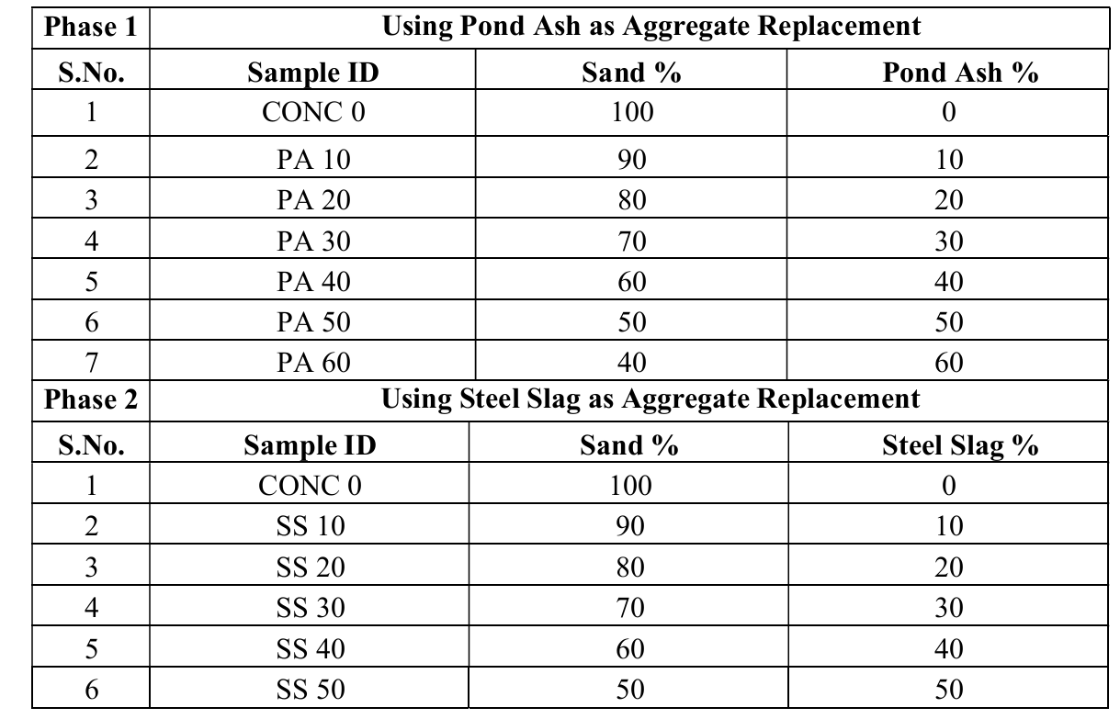

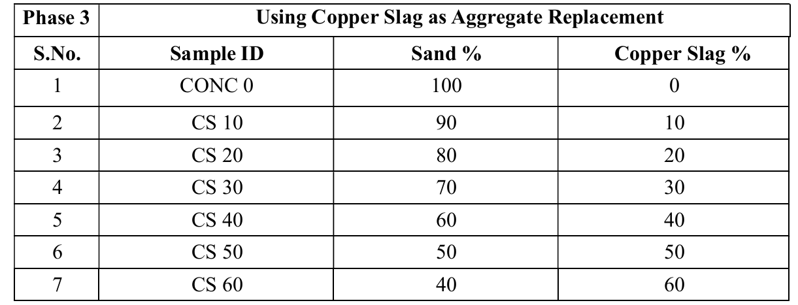

1. Results

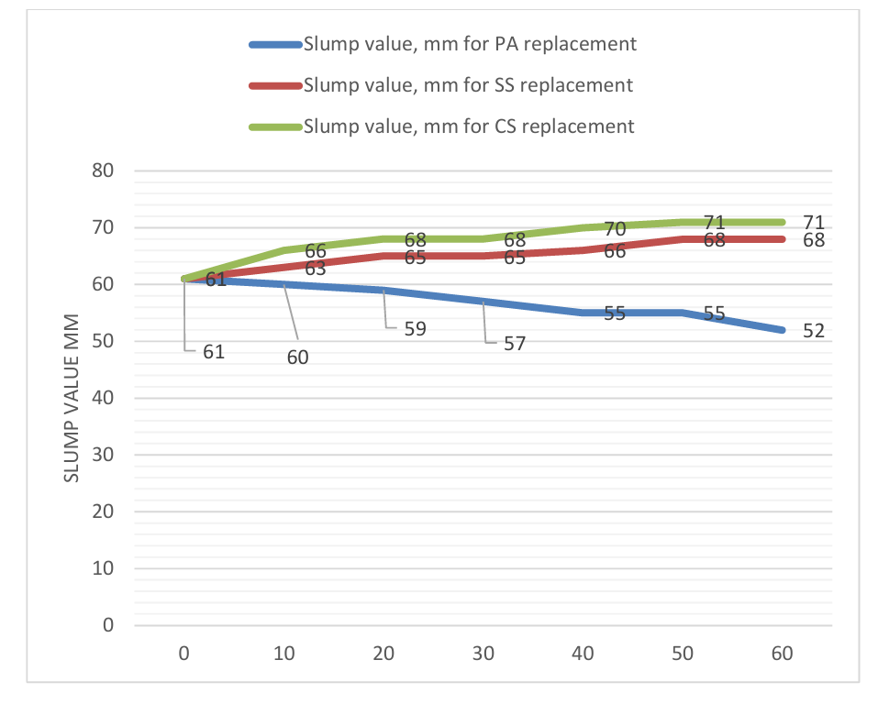

**Fig. 3** Graphical Representation of variation of slump value on varying replacement

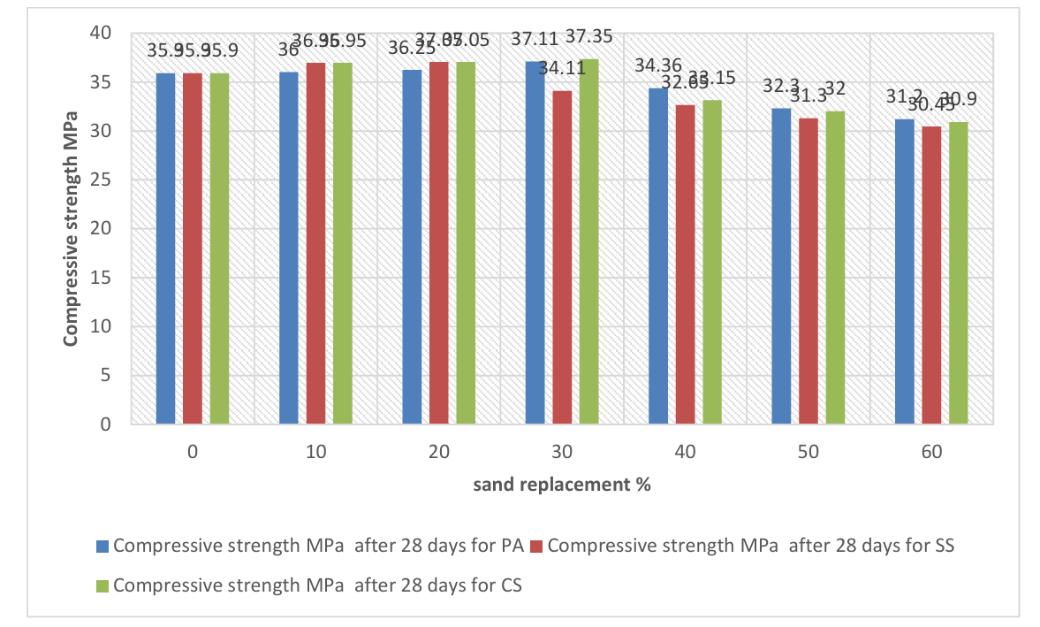

**Fig. 4** Graphical Representation of variation of Compressive Strength value on 28 days

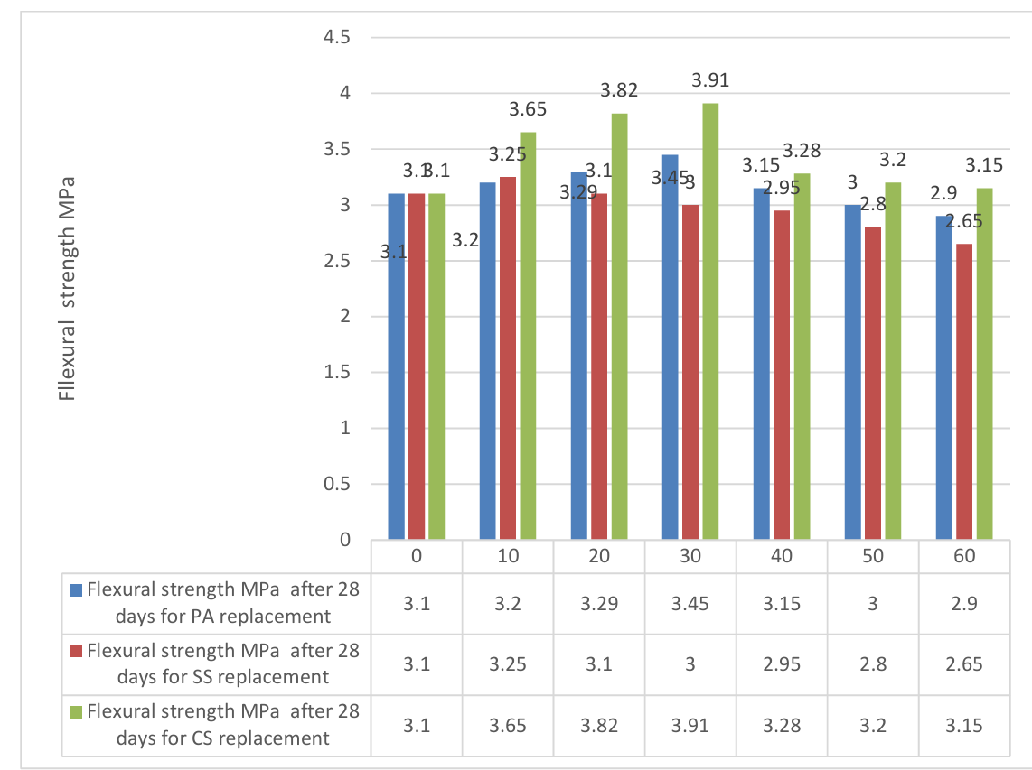

**Fig. 5** Flexural Strength of M30 having replacements

1. Conclusion

From the results we can conclude that

* When the replacement of sand is increased up to 60% by Pond ash in concrete mix, there is decrease in the slump value which shows the workability of the concrete is decreased. However it is satisfactory for construction work.
* Partial replacement of sand with Steel slag and copper slag leads to increment in workability as show in slump value graph.
* In terms of Compressive Strength mix prepared with replacement up to 30% with pond ash and Copper Slag the 7th, 14th and 28th day strength was higher than control mix. All the experimental mixes satisfy the 28th day compressive strength expected from M30 grade of concrete.
* In terms of Compressive Strength mix with replacement up to 20% steel slag the 7th, 14th and 28th day strength was higher than control mix.
* It is observed that the flexural strength for concrete with replacements was increased when the copper slag was added up to level of 30% replacement & the flexural strength of the CS30 mix designation is higher than the control concrete.
* It is observed that the flexural strength for concrete with replacements was increased when the pond ash was added up to level of 30% replacement & the flexural strength of the PA30 mix designation is higher than the control concrete.
* It is observed that the flexural strength for concrete with replacements was increased when the steel slag was added up to level of 20% replacement & the flexural strength of the SS 30 mix designation is higher than the control concrete.
* Therefore, the conclusions of all these tests suggest that the mixture containing 30% copper slag or 20% steel slag or 30% Pond ash may be used as a suitable replacement for natural sand in concrete in moderate environments without compromising the strength.

References

* ChithambarGanesh, R. Mohana , Parthiban Loganathan , Vinod M. Kumar, Mehmet Serkan Kırgız, N. Nagaprasad & Krishnaraj Ramaswamy. Development of alkali activated paver blocks for medium trafc conditions using industrial wastes and prediction of compressive strength using random forest algorithm. Scientifc Reports | (2024) 13:15152. ¬
* Arvind Singh Gaur. A Brief Review of Experimental Studies of Paver Blocks Manufactured with Concrete Demolition Wastes. Engineering and Technology Journal for Research and Innovation (ETJRI) ISSN 2581-8678, Volume V, Issue I, Dec 2023. ¬
* Shaik Numan Mahdi , Dushyanth V Babu R b , Nabil Hossiney , Mohd Mustafa Al Bakri Abdullah. Strength and durability properties of geopolymer paver blocks made with fly ash and brick kiln rice husk ash. Case Studies in Construction Materials 16 (2022) e0080. ¬
* Leong Sing Wong, Durability Performance of Geopolymer Concrete: A Review. Polymers 2022, 14, 868. ¬
* Tahir, M.F.M.; Abdullah, M.M.A.B.; Rahim, S.Z.A.; Mohd Hasan, M.R.; Sandu, A.V.; Vizureanu, P.; Ghazali, C.M.R.; Kadir, A.A. Mechanical and Durability Analysis of Fly Ash Based Geopolymer with Various Compositions for Rigid Pavement Applications. Materials 2022, 15, 3458. https://doi.org/ 10.3390/ma15103458. ¬
* ElKhatib, Lelian; Al Aridi, Fadi; ElKordi, Adel; and Khatib, Jamal (2022) "mechanical and durability properties of geopolymer concrete – a review," BAU Journal - Science and Technology: Vol. 3: Iss. 2, Article 8. DOI: https://www.doi.org/10.54729/SUIQ7034 Available at: https://digitalcommons.bau.edu.lb/stjournal/vol3/iss2/8 ¬
* Lelian W. ElKhatiba et.al. Selected properties of geopolymer concrete , A review. 3rd international turkish world seicnce and engineering congress 22-22 ,2021 turkey (page 387-390). ¬
* Niveditha M and Srikanth Koniki , Effect of Durability properties on Geopolymer concrete – A Review, E3S Web of Conferences 184, 01092 (2020) https://doi.org/10.1051/e3sconf/202018401092 ICMED 2020. ¬
* Dr. Aradhana Mehta and Kuldeep Kumar, strength and durability characteristics of fly ash and slag based geopolymer concrete. International Journal of Civil Engineering and Technology (IJCIET) Volume 7, Issue 5, September-October 2016, pp. 305–314, Article ID: IJCIET_07_05_034 Available online at http://iaeme.com/Home/issue/IJCIET?Volume=7&Issue=5 ISSN Print: 0976-6308 and ISSN Online: 0976-6316.
* Nicola, M, Kyritsis ,K., & Hal,C. (2008). The mineralogy of the CaO–Al2O3–SiO2–H2O (CASH) hydroceramic system from 200 to 350 °C. Cement and Concrete Research doi:10.1016/j.cemconres. ¬
* Olivia, M & Nikraz, H.R. (2012). Properties of fly ash geopolymer concrete designed by Taguchi method, Material and Design, 36, 191-198, retrieved from http:// www.sciencedirect.com ¬
* Olivia, M and Nikraz, H.R. (2011). Corrosion performance of the embedded steel in fly ash geopolymer concrete by impressed voltage method. In Incorporating Sustainable Practice in Mechanics of Structures and Materials – Fragomeni, Venkatesan, Lam and Setunge (eds). Taylor Francis group, London. DOI: 10.1201/b10571-141. ¬
* Palomo A, Grutzeck, M.W. & Blanco, M.T. (1999). Alkali-activated fly ashes: cement for the future. Cement and Concrete Research, 29, 1323–9. ¬
* Papworth, F, and Grace, W. (1985). Designing for concrete durability in Marine Environments . Concrete 85 Conferences, Brisbane, Australia. ¬
* Patil .K.K and Allouche.E. (2011). Effect of alkali silica reaction (ASR) in geopolymer concrete. world of coal ash (WOCA) conference, Denver, CO,USA, May 9-12.
* Poon, C., Azhar. S, Anson,M., Wong.Y. (2003). Performance of metakaolin concrete at elevated temperatures. Cement and Concrete Composites, 25, 83–89. retrieved from http:// [www.sciencedirect.com](http://www.sciencedirect.com)
* Provis J.L. 2009. Introduction to geopolymers. In: Geopolymers, structure, processing, properties and industrial applications. J.L. Provis and J.S.J. van Deventer (Eds.). Woodhead Publishing Limited, Oxford, U.K. ¬
* Zuda, L., Pavlik Z., Rovnanikova, P., Bayer, P., Cerny, R. (2006). Properties of Alkali Activated Aluminosilicate Material after Thermal Load. International Journal of Thermophysics 27, No. 4, pp. 1250-1263.