**BOOK RECOMMENDATION SYSTEM USING AI**

*Guide: Nisha MR*

*D. Harika*

*School of Engineering(AIML)*

*B Tech*

*Malla Reddy University*

*D. Pallavi*

*School of Engineering(AIML)*

*B Tech*

*Malla Reddy University*

*C. Revanth Reddy*

*School of Engineering(AIML)*

*B Tech*

*Malla Reddy University*

*Srushti Dhidse*

*School of Engineering(AIML)*

*B Tech*

*Malla Reddy University*

*C. Lakshmi*

*School of Engineering(AIML)*

*B Tech*

*Malla Reddy University*

---------------------------------------------------------------------***---------------------------------------------------------------------

**Abstract -** The Book Recommendation System is designed to provide personalized book suggestions to users by leveraging advanced machine learning algorithms. In an era of information overload, this system helps readers discover relevant and engaging content based on their individual preferences. By analyzing user input, such as previous reading history, ratings, genres of interest, and real-time feedback, the system predicts and recommends books that align with the user's tastes. The system employs collaborative filtering, content-based filtering, and hybrid models to enhance recommendation accuracy. Additionally, it incorporates natural language processing (NLP) techniques to evaluate book summaries, reviews, and other text-based information, enriching the user experience. The result is an intelligent and adaptive platform that caters to diverse reading interests while promoting lesser-known books, enhancing user satisfaction, and fostering a more engaging reading culture. To address this challenge, we propose an advanced book recommendation system powered by artificial intelligence (AI).

**Keywords:** NLP(Natural language Processing), AI, Machine Learning, Recommended system.

**1. INTRODUCTION**

A book recommendation system is an application of machine learning and data science that suggests books to users based on their preferences, behaviours, and interests. These deep learning and collaborative filtering. The system uses a variety of techniques such as collaborative filtering, content-based filtering, and hybrid approaches to analyze user behavior, book genres, and reviews. By understanding patterns in user data and book features, the system can recommend personalized reading lists, helping users explore new books that they are likely to enjoy. This project will not only enhance the reading experience but also save time by narrowing down choices and introducing users to books they might not have found on their own. The ultimate goal is to create a robust, intelligent recommendation engine that continually improves with user interaction, ensuring a seamless discovery of books for readers of all genres.

## 2. LITERATURE REVIEW

Recommender systems are efficient tools for filtering online information, which is widespread owing to the changing habits of computer users, personalization trends, and emerging access to the internet. Even though the recent recommender systems are eminent in giving precise recommendations, they suffer from various limitations and challenges like scalability, cold-start, sparsity, etc. Due to the existence of various techniques, the selection of techniques becomes a complex work while building application-focused recommender systems. In addition, each technique comes with its own set of features, advantages and disadvantages which raises even more questions, which should be addressed. This paper aims to undergo a systematic review on various recent contributions in the domain of recommender systems, focusing on diverse applications like books, movies, products, etc. Initially, the various applications of each recommender system are analysed.

**3. METHODOLOGY**

**Objective**: Develop an AI-driven book recommendation system to suggest personalized reading materials based on user preferences and behaviors.

**Data Collection**: Gather a diverse dataset of books, including genres, ratings, reviews, and user profiles from platforms like Goodreads or Amazon.

**User Profiling**: Create user profiles based on reading history, ratings, and preferences using collaborative filtering techniques.

**Content-Based Filtering**: Implement content-based algorithms to recommend books similar to those the user has liked in the past.

**Machine Learning Model**: Choose and train a suitable machine learning model (e.g., matrix factorization, neural networks) to enhance recommendation accuracy.

**Evaluation Metrics**: Define metrics like precision, recall, and F1-score to evaluate the system's performance and user satisfaction.

**3.1 Software & Hardware Requirements**

**Frontend:** Developed using Python with additional libraries such as Flask/Django, pandas, numpy, matplotlib, scikit-learn, tensorflow.

**Backend:** Python, Javascript(node.js) handles the backend.

**Database:** MySQL, PostgreSQL, MongoDB, Cassandra.

**Authentication:** Users log in, and the server creates a session that is stored on the server side. A session ID is sent to the client as a cookie.

**Hardware:** The minimum server configuration includes 8GB RAM, 4-core processors, and SSD storage to handle concurrent access by multiple users.

**3.2 System Architecture**

For a book recommendation system, consider using collaborative filtering (user-based or item-based) to leverage user interactions, alongside content-based filtering that analyzes book features. Matrix factorization techniques like SVD can uncover latent patterns, while hybrid models combine strengths from multiple methods. Choose models based on data availability, scalability, and the need to address cold start challenges.

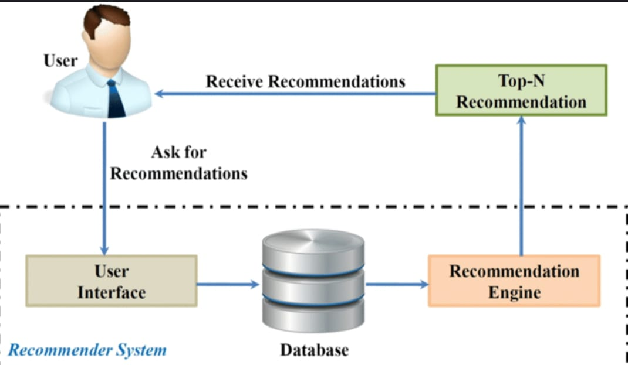

**3.3 Dataflow Diagram**

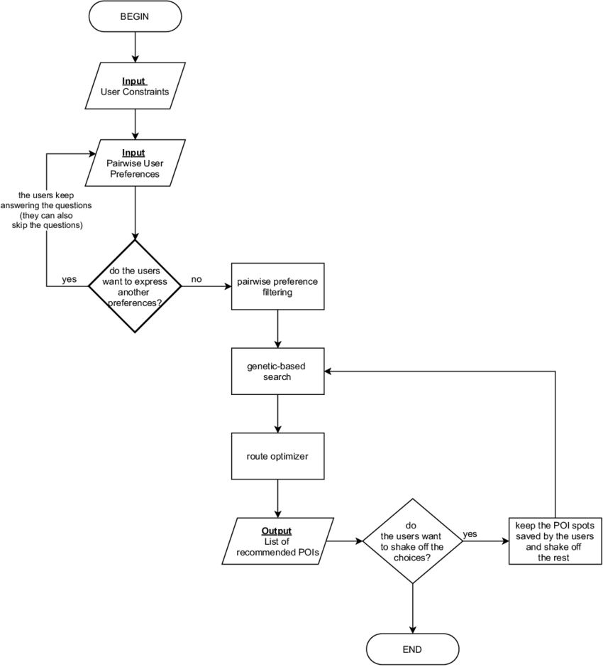

**3.4 Data Set Descriptions**

User Data: This dataset includes information about the users interacting with the recommendation system. User ID: Unique identifier for each user. Demographics: Information such as age, gender, location, and possibly preferences to help personalize recommendations. User Preferences: Data on genres or authors that users have shown interest in, often inferred from their interactions. Activity Logs: Records of user actions (e.g., books viewed, books added to wish lists, time spent on book pages).

Book Metadata: This dataset contains detailed information about **e**ach book in the catalog. Book ID: Unique identifier for each book. Title: The name of the book. Author(s): Names of the authors; multiple authors may be included. Genres: Categories that describe the book (e.g., fiction, non-fiction, mystery, fantasy). Publication Date: Year the book was published, which can help with trends and age-related preferences. ISBN: International Standard Book Number for unique identification. Description: A summary or blurb that provides context about the book’s content. Cover Image: URL or path to the book cover image for visual representation.Ratings and Reviews: User-generated content that provides insights into user opinions and preferences. Rating: Numerical score given by users (e.g., 1 to 5 stars). Review Text: Written feedback from users about their reading experience, which can be analyzed for sentiment. Timestamp: Date and time when the rating or review was submitted.

**4. RESULT**

Model Development and Testing Model Training: Train your recommendation model using historical user data, ensuring to evaluate its performance with appropriate metrics (e.g., precision, recall, F1 score). Validation: Conduct thorough testing using validation datasets to assess how well the model generalizes to unseen data. Use techniques like cross-validation for robust results. 2. Environment Setup Infrastructure: Choose a suitable deployment environment based on the expected load. Options include: Cloud platforms (AWS, Google Cloud, Azure) for scalability and flexibility. On-premises servers for controlled environments. Containerization: Use Docker to containerize your application, which ensures consistency across different environments and simplifies deployment.

**5. CONCLUSIONS**

In conclusion, a book recommendation system powered by AI has the potential to significantly enhance the reading experience for users by delivering personalized and relevant suggestions. By leveraging various approaches such as collaborative filtering, content-based filtering, hybrid methods, and advanced techniques like deep learning and reinforcement learning, these systems can cater to individual preferences, reading history, and emerging trends.knowledge but also fosters a supportive community for collaborative learning.

Personalization: AI-driven recommendation systems tailor book suggestions based on user preferences and behavior, ensuring that each recommendation resonates with the reader’s unique tastes and interests. Diverse Approaches: Combining different recommendation techniques—such as collaborative filtering and content-based methods—can address the limitations of each and provide a more comprehensive recommendation engine. Challenges and Solutions: Issues like the cold start problem and scalability are significant but can be mitigated with effective strategies and technological advancements. Overall, an effective book recommendation system can enrich the reading experience, making it more enjoyable and tailored to individual preferences. As AI technology continues to advance, these systems will likely become even more sophisticated, offering readers increasingly precise and delightful book recommendations.

**REFERENCES**

[1] Mala Dutta, Deepjyothi Roy, “A systematic review and resesearch perspective on recommended system”, 2022

[2] G Van Capellevan, C Amrit, DM Yazan, H Zijm, “The recommender system canvas: A model for developing and documenting recommender system design”, 2019

[3] M Morisio, E Cano, “Hybrid recommender systems”, 2017

[4] CC Agarwal, “Recommender systems”, 2016

[5] J Lu, M Mao, W Wang, G Zhang, “Recommender system application developments”, 2015

[6] J Bobadilla, F Ortega, A Hernando, A Gutierrez, “Recommender systems survey”, 2013

[7]F Ricci, L Rokach, B Shapira, “Introduction to recommender systems handbook”, 2011

[8] G Adomavicius, “Toward the next generation of recommender system: A survey of the state-of-the-art and possible extensions”, 2005

[9] R Burke, “Hybrid recommended systems: Survey and experiments”, 2002

[10] Paul Resnick, Hal R Varian, “Recommender systems”, 1997