A Review of Solar Energy Solutions: Renewable Pathways, Economic Implications, and Coal Conservation Efforts

Shashi Kant Kumar Verma

PG Scholar

JEC Jabalpur

Dr. A.K. Sharma

Prof. Electrical Department

JEC Jabalpur

**Abstract: *This review paper explores the multifaceted benefits and strategic implications of transitioning to solar generation within the broader context of renewable energy adoption. It delves into the current landscape of renewable energy scenarios, highlighting the growing significance of solar power as a sustainable and economically viable alternative to traditional energy sources. A thorough analysis is provided on how increased solar energy deployment contributes to coal conservation, reducing reliance on fossil fuels and mitigating environmental impacts. By preserving coal reserves, the integration of solar power aids in extending the availability of finite resources, which supports both environmental sustainability and resource management. The reduction in coal usage also decreases carbon emissions, contributing significantly to climate change mitigation efforts. The economic benefits associated with solar generation are discussed, emphasizing cost savings, job creation, and long-term energy security. Additionally, the paper evaluates the operational and strategic considerations for power plant switching from coal-based systems to renewable energy-focused plants, showcasing case studies and examples of successful transitions. This comprehensive review aims to underscore the potential of solar energy as a cornerstone of sustainable development and to provide insights into the economic and environmental advantages of accelerating the shift towards renewable energy.***

***Keywords: Solar Generation, Renewable Energy Scenario, Coal Conservation, Economic Benefit, Power Plant Transition***

# Introduction

Load forecasting is a critical process for predicting future energy demand over various time horizons, which aids power utilities in efficient energy generation, distribution, and management. It ensures the stability and reliability of power grids by balancing supply and demand, which is particularly essential with the integration of renewable energy sources. The advent of advanced forecasting techniques, including artificial intelligence and machine learning, has enhanced the accuracy of these predictions, facilitating better pla/nning for grid operators and policy-makers.

# Literature Review

## Load forecasting

In [1], load forecasting in the Indian state of Odisha is presented. The work focusses on creating a dependable load forecasting model that takes into account the particulars of Odisha's electricity consumption patterns and environmental influences. This is driven by the need for precise forecasts to support effective planning and operation of the power system network. A Long Short-Term Memory-based model that can manage non-linear dynamics in time-series data and represent long-term dependencies is suggested as a solution to this issue. The National Aeronautics and Space Administration website provides weather data, while the Odisha State Load Dispatch Centre provides historical load data. The goal of the project is to precisely predict electricity consumption for both short-term (next week) and medium-term (next month) horizons at 15-minute intervals. The suggested strategy performs better in terms of accuracy and dependability when compared to more conventional techniques like artificial neural networks and Gaussian process regression. In order to predict the load demand for January 2023 at 15-minute intervals, one year of the dataset (January through December 2022) is used as training data. During testing, the LSTM model outperforms the current models with an absolute error range of ±10 MW, a mean absolute error of 5.9443 MW, and a mean absolute percentage error of 0.2134%.

In [6], it is mentioned that A comprehensive, thorough, and comparative review of amazing data mining strategies that are helpful in predicting the power load demand of various geographic areas is presented in this work. The main issues with the existing technology and future objectives are also covered, based on the thorough study. This paper also presents the types of forecasting as shown in the figure below

Table 1 Different types of forecasting

|  |  |  |
| --- | --- | --- |
| Forecasting | Period | Purpose |
| Long term load forecasting | 5 to 20 Years | * Planning and growth of the generation capacity * Planning to build new substation and new lines * Decision making whether to add new features in existing sysrems |
| Medium term load forecasting | Few weeks to few months | * Used to meet requirement in the summer and winter season * Used for decision of purchasing fuels and revising tariffs. |
| Short term load forecasting | Few hours to few weeks | * Hourly electric load prediction calculation * Weekly and daily max load of electricity energy generation * Usage : Fuel allocation to generation units; Short term maintenance, generator unit commitment. |
| Very short term load forecasting | From minute to an hour | * Used in energy management system |

## Carbon emission

In [2], it is mentioned that in India, coal is the main fuel used to generate power, and its use is steadily rising to satisfy the nation's energy needs. The emissions of carbon dioxide (CO2), sulphur dioxide (SO2), and nitric oxide (NO) from thermal power plants in India for the nine-year period from 2001–2002 to 2009–2010 are shown in this research. The mass emission factors are theoretically computed utilising the fundamentals of combustion and operating circumstances in a model that serves as the basis for the emission calculations. The estimations for the nine years from 2001–2002 to 2009–2010 are used to create future emission scenarios for the years 2020–21. India's power plants employ a variety of coal types, combustion methods, and operational environments. Consequently, these plants differ in what they are able to efficiency (the amount of coal used for each unit of electricity). The estimates display variations in emissions per unit of power as well as variations in overall emissions by location. Calculated approximations display the total The amount of CO2 released by thermal power plants has gone up from 323474.85 Gg in 2001–02 to The 2009-10 Gg was 498655.78. Between 2001 and 2002, SO2 emissions rose from 2519.93 Gg to 3840.44 Gg. In contrast, NO emissions rose from 1502.07 Gg to 2314.95 Gg in 2009–10. The According to estimates, CO2 emissions per unit of power range from 0.91 to 0.95 kg/kWh, 6.94 to Between 2001-02 and 2009-10, SO2 was 7.20 g/kWh and NO was 4.22 to 4.38 g/kWh. According to the Planning Commission of India's "Business-as Usual (BAU)" and "Best case Scenario (BCS)" projections of coal consumption in Indian thermal power plants, the future emission scenario indicates emissions between 714976 and 914680 Gg CO2, 4734 and 6051 Gg SO2, and 366 and 469 Gg NO in 2020–21. Emissions of greenhouse gases and other pollutants can be considerably decreased by increasing the efficiency of coal utilisation in thermal power plants' electricity output. In an industry where measurable data for emissions components are extremely limited, this technique offers a helpful tool for inventory preparation. Scenario of CO2 emission is shown in the figure below

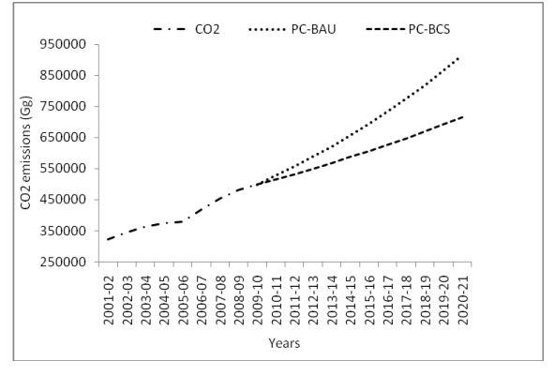

Figure 1 Scenario of CO2 emission

In [3], it is mentioned that building efficient Carbon Emission Prediction Models (CEPMs) to understand and forecast CO2 emission patterns is essential for mitigating climate change in light of the rising worries about the greenhouse effect, particularly its repercussions. Three main roles were identified from a study of 147 Carbon Emission Prediction Model (CEPM) studies: prediction, optimisation, and prediction factor selection. With 75 examples, statistical models were the most common kind of prediction model, followed by neural network models (21.8%). From 2019 to 2022, there was a steady increase in the use of neural network models, especially feedforward designs. With 94.4% using metaheuristic models, the bulk of CEPMs included optimised techniques. The main emphasis was on parameter optimisation, which was followed by structural optimisation. Factors were efficiently filtered using prediction factor selection models that used Principal Component Analysis (PCA) for machine learning models and Grey Relational Analysis (GRA) for statistics models. Examining accuracy, pre-optimized CEPMs performed inconsistently, with Root Mean Square Error (RMSE) values ranging from 0.112 to 1635 Mt. In contrast, post-optimization produced a significant improvement, with the lowest RMSE being 0.0003 Mt and the highest being 95.14 Mt. We concluded by summarising the benefits and drawbacks of current models, categorising and quantifying the variables affecting carbon emissions, elucidating the research goals in CEPM, and evaluating the applicable model assessment techniques as well as the geographical and temporal scales of previous studies.

In research paper [4], it is mentioned that the development trajectory of industrial carbon emissions in Bengbu city, Anhui Province, during the next ten years, and strategies to assist the industry in achieving the carbon peak as quickly as feasible are the main topics of this research. The following are the findings and methodology of the study: (1) Five primary variables influencing industrial carbon emissions are discovered by a study of the literature and the carbon emission index approach. (2) The primary resistance factors to Bengbu City's industrial carbon emission reduction are examined using the resistance model. (3) The grey prediction EGM (1,1) model is used to forecast Bengbu City's industrial carbon emissions from 2021 to 2030 based on the city's current data from 2011 to 2020. The findings indicate that, among the five variables, energy intensity has the least effect on industrial carbon emissions, whereas the pace of urbanisation has the most. Over the next ten years, Bengbu's industrial carbon emissions will rise, albeit at a constant pace. Particular suggestions about Bengbu City's industrial structure, energy structure, and urbanisation growth are made in light of the analysis's conclusions.

According to the general method of IPCC guidelines, this paper calculates the carbon emissions generated when fossil energy is burned, as Eq. ([1](https://www.nature.com/articles/s41598-023-41857-0#Equ1)).

$C_{i}=\sum{B_{j}C_{j}}$………………………………..(1)

Ci is the carbon emissions of industry *I* (ten thousand tons); Bj is the energy consumption after discounting standard coal; cj is the carbon emission factor; j is the type of energy.

This research paper also proposes the method to reduce the carbon emission as shown in the figure below

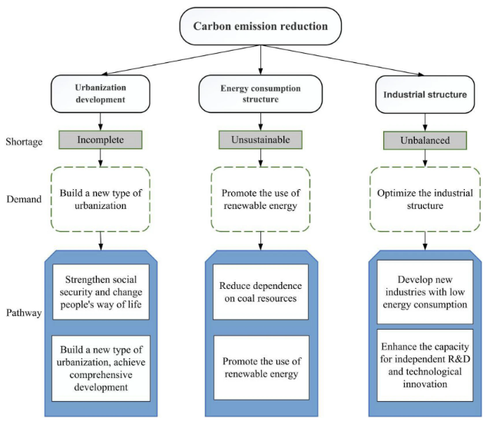

Figure 2 Method to reduce the carbon emission

In research paper [5], it is mentioned that In the twenty-first century, carbon dioxide emissions have become a significant problem. The world's socioeconomic issues are significantly impacted by the growing global average temperature and its effects on climate change. The melting of the polar ice caps, which is a direct result of this rise, leads to a number of other problems, such as the extinction of polar animals, coastal flooding, and exposure to bacteria and ancient microorganisms that are frozen in the snow and could cause many more global pandemics and invisible illnesses. Accurately identifying the danger levels and milestones is the first stage in this procedure. The risk point, point of no return, and other thresholds that represent the most important CO2 levels must be plotted. This paper's primary goal is to solve this problem. The article also attempts to offer various approaches to address the same problem. The following lines outline the experiment's and the paper's flow. The year when the world would reach a specific threshold for the amount of carbon dioxide in the atmosphere was predicted using historical data. This level is crucial in the battle against climate change and must not be exceeded. The amount of emission reduction required to return the CO2 concentrations to a safer range is then determined using data and analysis. The analysis comes to the conclusion that by 2047, the crucial CO2 level of 500 ppm will be reached. This level is regarded as irreversible. To return the emissions to acceptable levels, a 6.37% decrease rate and a 23.38% reversal rate are needed. The study also found that the main socioeconomic variables causing these emissions are the population, greenhouse gas emissions, and combustion industries. In order to create an action plan that is appropriate, the authors advise that more study be done on this issue in order to determine more predictions on the point of no return. The authors further advise that every organisation should make being carbon neutral a top priority and that a rapid transition to renewable energy sources be implemented.

## Solar Demand and Present Scenario

The increasing push for renewable energy solutions has positioned solar power at the forefront due to its availability and decreasing costs. The demand for solar energy has surged globally as countries strive to meet sustainability goals and reduce dependency on fossil fuels. Solar photovoltaic (PV) technology has evolved from niche applications to mainstream power generation, contributing significantly to the global energy mix. Nations such as India, China, and the U.S. have invested heavily in solar infrastructure, with large-scale solar farms and distributed rooftop systems becoming more prevalent. However, the intermittent nature of solar energy poses challenges in grid integration, necessitating accurate solar forecasting and smart grid technologies to optimize its use.

Researh paper [7], focusses on the solar energy for India. Around the world, there is a lot of interest in using renewable energy as a future energy source. As one type of renewable energy source, solar energy—including concentrating solar power (CSP) and solar photovoltaic (PV) power—contributes just 3.6% of the world's electricity output. With about 31% of the installed renewable energy capacity in 2022, it has solidified its place among other renewable energy technologies and is now the second most installed renewable energy source, behind hydropower. As a first step towards developing solar energy in these places, the current review research summarises the global solar energy status and the published solar energy potential assessment articles for 235 nations and territories through a thorough and methodical literature analysis. Taking into account each continent's installed PV and concentrated solar power capacity, a comparison of the solar power situation of the various nations and territories has been offered. The literature review indicates that there are still glaring gaps in the field of solar energy, despite the fact that the installed capacity of solar energy worldwide increased significantly between 2021 and 2022—by around 22%. By building additional solar farms, the solar PV industry can grow to become the second most important generating source in the next three decades, enabling nations to produce around 25% of the world's total power demands by 2050. According to this review, top solar installers are shown below

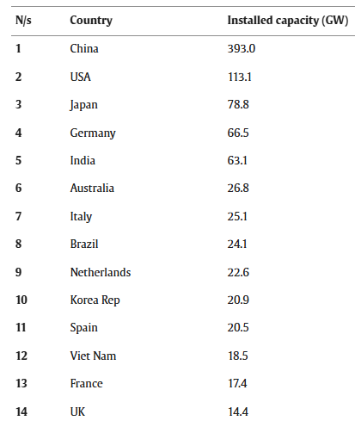

Figure 3 Top solar installers

## Economic Calculations and Benefits

The economic aspect of transitioning to solar power and efficient load forecasting is substantial. Investments in solar energy can yield long-term economic benefits by reducing fuel costs and mitigating price volatility associated with fossil fuels. Properly implemented forecasting reduces the need for expensive peaking power plants, which are often coal-based, and minimizes the reliance on costly energy imports. Additionally, coal conservation contributes to economic savings in terms of reduced mining and transportation costs, as well as lower maintenance and operational expenses for power plants.Economic calculations must take into account not only the initial costs of renewable installations but also the long-term savings and environmental benefits. Governments and industries use metrics such as levelized cost of electricity (LCOE) and return on investment (ROI) to evaluate the feasibility of renewable projects. The reduction in carbon emissions and coal consumption also translates into economic gains through carbon credits and compliance with international environmental regulations.

In [8], it is mentioned that the size of the rise and the duration of the increase determine the costs and advantages of growing solar power output. With the remainder of the electricity system held constant, short-term studies concentrate on the economic viability of small increases in solar capacity. If solar electricity is available during periods of high demand and replaces comparatively carbon-intensive sources, its unpredictability increases value.

The effects of nonincremental variations in solar capacity are taken into account in medium-run assessments. Experience effects may result in lower installation costs, but when solar needs ancillary services and doesn't replace investments in other forms of energy, grid integration costs rise.

## Switching of plants

In research paper [9], it is mentioned that the problem of power outages during the transmission of electricity to the end user is addressed in this article. The need for electricity has increased significantly in the modern world, necessitating the use of both conventional fuels and renewable energy sources to supply the demand. In this context, an automated switch is being developed that enables switching between sources in a way that prioritises the delivery of electricity from wind and solar farms to the main network or to the customer. In addition to resolving unplanned blackouts and power outages, it guarantees that a reliable producing source is providing voltage to the consumer end.

Load forecasting, solar energy integration, and the conservation of coal collectively form a sustainable energy strategy that addresses environmental and economic challenges. By accurately predicting energy demands and leveraging solar power to meet these needs, significant progress can be made in reducing carbon emissions and preserving natural resources, ultimately fostering a more resilient and eco-friendly power system.

# Conclusion and Future Scope

This review paper has highlighted the significant role of solar energy as a key component of renewable energy scenarios and its potential for coal conservation and economic benefits. Through extensive analysis, it is evident that transitioning from conventional coal-based power plants to renewable energy sources, particularly solar, is not only environmentally essential but also economically viable in the long run. The integration of solar generation contributes to sustainable energy solutions, reducing carbon emissions and fostering energy independence. Furthermore, the economic advantages, such as reduced operational costs and long-term financial savings, strengthen the case for accelerated adoption of solar technology. This shift is crucial for achieving global sustainability goals and addressing climate change concerns.

The future scope of this research involves exploring the integration of solar energy with other renewable sources to create hybrid power systems for enhanced reliability and efficiency. Further studies should focus on advanced technologies such as energy storage solutions, smart grid systems, and innovative financial models that support the expansion of solar power. Additionally, policy frameworks and government incentives can be studied to promote large-scale adoption. Research on the application of artificial intelligence and machine learning for predictive maintenance and energy management in solar power plants can also contribute to maximizing output and operational efficiency.

# References

[1] R. Bareth, M. Kochar, A. Yadav and M. Pazoki, "Load forecasting model using LSTM for indian state load dispatch centre," Electrica, Published online August 15, 2024. doi: 10.5152/electrica.2024.23158.

[2] Moti. L. Mittal , “Estimates of Emissions from Coal Fired Thermal Power Plants in ”, Department of Environmental and Occupational Health, University of South Florida, Tampa, Florida, USA.

[3] Yukai Jin, Ayyoob Sharifi, Zhisheng Li, Sirui Chen, Suzhen Zeng, Shanlun Zhao,Carbon emission prediction models: A review,Science of The Total Environment,Volume 927,2024,172319,ISSN 0048-9697,https://doi.org/10.1016/j.scitotenv.2024.172319.

[4] Dai, D., Zhou, B., Zhao, S. et al. Research on industrial carbon emission prediction and resistance analysis based on CEI-EGM-RM method: a case study of Bengbu. Sci Rep 13, 14528 (2023). <https://doi.org/10.1038/s41598-023-41857-0>

[5] Harsh Bhatt, Manan Davawala, Tanmay Joshi, Manan Shah, Ashish Unnarkat, Forecasting and mitigation of global environmental carbon dioxide emission using machine learning techniques, Cleaner Chemical Engineering, Volume 5, 2023, 100095, ISSN 2772-7823, https://doi.org/10.1016/j.clce.2023.100095.

[6] Mandeep Singh,” Various Electricity Load Forecasting Techniques with Pros and Cons”, International Journal of Recent Technology and Engineering (IJRTE) ISSN: 2277-3878 (Online), Volume-8 Issue-6, March 2020

[7] Gautam Raina, Sunanda Sinha, Outlook on the Indian scenario of solar energy strategies: Policies and challenges, Energy Strategy Reviews,Volume 24, 2019, Pages 331-341, ISSN 2211-467X, <https://doi.org/10.1016/j.esr.2019.04.005>.

[8], Erin Baker, Meredith Fowlie, Derek Lemoine, and Stanley S. Reynolds, “The economics of Solar”, The Annual Review of Resource Economics is online at resource.annualreviews.org, 2020

[9] Muneer, A.; Amjad, F.; Jabbar, M.W.; Saleem, U. Development of Automatic Switch for Electric Power Transfer. Eng. Proc. 2021, 12, 72. https://doi.org/10.3390/engproc2021012072