**Bridging the Gap: Strengthening Support Ecosystems for Women Entrepreneurs in India**

**Sheeraz Ahmed**

**Assistant Professor**

**Advanced Centre for Women’s Studies**

**Aligarh Muslim University**

**Abstract**

*Women entrepreneurs in India play a pivotal role in driving socio-economic development. This paper investigates the existing support ecosystems and resources, focusing on financial inclusion, policy frameworks, and mentorship accessibility. Using a mixed-methods approach, the study highlights disparities in urban and rural resource allocation. Although initiatives like "Mudra Yojana" and "Stand-Up India" offer foundational support, their reach is constrained by socio-cultural and procedural barriers. This paper recommends strategic public-private collaborations and rural-specific interventions to empower women entrepreneurs and foster inclusive economic growth.*

***Key Words Women entrepreneurs, financial inclusion, mentorship, policy frameworks, rural-urban divide, socio-economic growth.***

**Introduction**

Entrepreneurship is a key driver of economic innovation, and women entrepreneurs contribute significantly to India's GDP, employment, and social equity. Despite increasing recognition of their contributions, systemic challenges—such as restricted access to finance, inadequate mentorship, and socio-cultural constraints—impede their growth.

The Government of India and private entities have launched initiatives, including "Mudra Yojana," "Stand-Up India," and incubation programs. While these efforts mark progress, they remain largely urban-focused, sidelining rural women entrepreneurs. This study aims to explore these gaps and propose actionable recommendations to foster an equitable entrepreneurial ecosystem.

**Objectives:**

* Assess the accessibility and impact of financial and mentorship programs.
* Identify challenges specific to rural women entrepreneurs.
* Propose strategies for an inclusive entrepreneurial framework.

**Literature Review**

**Challenges for Women Entrepreneurs**

Women entrepreneurs face unique barriers, such as:

1. **Financial Constraints**: Only 30–45% of women entrepreneur’s report access to government schemes (Sharma & Gupta, 2023).
2. **Limited Scalability**: Women-led businesses often remain micro or small-scale enterprises due to lack of market linkages (Rao, 2022).
3. **Socio-Cultural Barriers**: Patriarchal norms restrict women’s mobility and decision-making in rural areas.

**Government and Private Initiatives**

While government schemes like "Stand-Up India" and "Mudra Yojana" aim to improve access to capital, mentorship and capacity-building platforms such as SHEROES remain urban-centric. Moreover, rural entrepreneurs cite procedural complexity as a significant deterrent (Mehta, 2023).

**Significance of Mentorship and Networking**

Mentorship platforms enhance confidence, skill-building, and resource sharing. However, their urban bias limits the inclusion of rural women (Sharma & Gupta, 2023).

**Cited References**:

* Sharma, R., & Gupta, P. (2023). "Assessing the Impact of Networking on Women Entrepreneurs." *Journal of Business Research,* 78(3), 450-460.
* Mehta, S. (2023). Empowering Women Entrepreneurs: Policy Impacts in India. New Delhi: Springer.

**Research Methodology**

To comprehensively assess the support ecosystems for women entrepreneurs in India, this study employs a **mixed-methods approach** that integrates both quantitative and qualitative data. This approach ensures a holistic understanding of the challenges faced by women entrepreneurs and the effectiveness of existing support mechanisms.

**1. Quantitative Analysis**

* **Data Sources**: Secondary data was collected from reliable government and institutional reports, including publications from NITI Aayog, the Reserve Bank of India (RBI), and the Ministry of Micro, Small, and Medium Enterprises (MSME).
* **Data Analysis**: Statistical methods were used to evaluate the reach and impact of financial schemes such as "Mudra Yojana" and "Stand-Up India." Key indicators like the percentage of beneficiaries and geographic distribution were analyzed to identify trends and disparities.

**2. Qualitative Analysis**

* **Interviews**: Twenty semi-structured interviews were conducted with women entrepreneurs, equally divided between urban and rural regions.
  + **Urban Entrepreneurs**: Participants were selected from metropolitan cities like Delhi, Mumbai, and Bengaluru, focusing on those who have benefited from structured support mechanisms.
  + **Rural Entrepreneurs**: Participants were drawn from tier-3 cities and rural regions in states like Uttar Pradesh and Odisha, emphasizing their experiences with accessibility and scalability of support systems.
* **Key Questions**: The interviews explored topics such as:
  + Awareness and utilization of government schemes.
  + Access to mentorship and networking platforms.
  + Challenges in scaling their businesses.
  + Socio-cultural factors impacting their entrepreneurial journey.
* **Thematic Analysis**: Responses were coded and analyzed to identify recurring themes, such as financial barriers, mentorship gaps, and urban-rural divides.

**3. Sampling Methodology**

* A **purposive sampling** method was used to ensure the inclusion of diverse perspectives across industries, geographical locations, and business scales. The sample was stratified to include participants from different sectors (e.g., services, manufacturing, agriculture).

**4. Data Triangulation**

* To improve reliability, data from interviews was cross-validated with secondary data sources. This ensured consistency in findings and highlighted discrepancies between policy frameworks and on-ground realities.

**5. Tools and Techniques**

* **Software**: Statistical software like SPSS was used to analyze numerical data, while NVivo was employed for coding and qualitative analysis of interview transcripts.
* **Visual Representations**: The study used graphs and charts (e.g., bar graphs and pie charts) to visually present data trends and disparities for better comprehension.

**6. Limitations**

* **Sample Size**: Due to resource constraints, the sample size was limited to 20 participants. However, efforts were made to ensure that the sample was representative.
* **Geographical Constraints**: The study primarily focused on selected regions, which may limit the generalizability of findings. Further research with a broader geographic scope is recommended.

This expanded methodology ensures that the study captures the multi-dimensional challenges faced by women entrepreneurs while offering actionable insights for strengthening their support ecosystems.

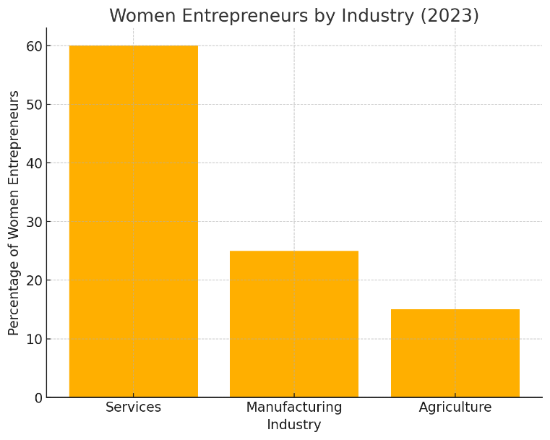

Urban vs. Rural Beneficiaries of Start-Up India (2023)

**Figure 1 Women Entrepreneurs by Industry**: Shows the distribution of women entrepreneurs across services, manufacturing, and agriculture sectors.

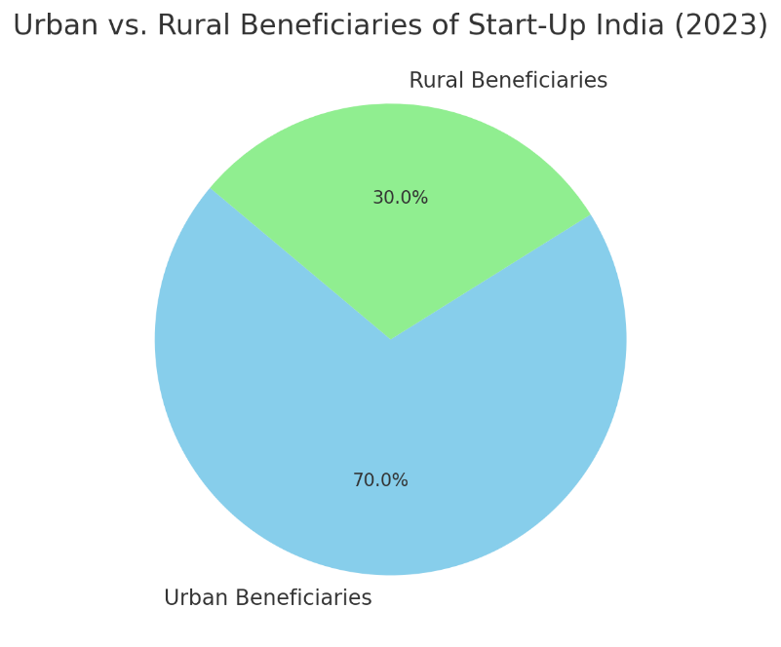

**Figure 2 Urban vs. Rural Beneficiaries**: A pie chart illustrating the disparity in beneficiaries of Start-Up India between urban and rural areas.

Access to Government Financial Schemes

Now interactive! (Beta)

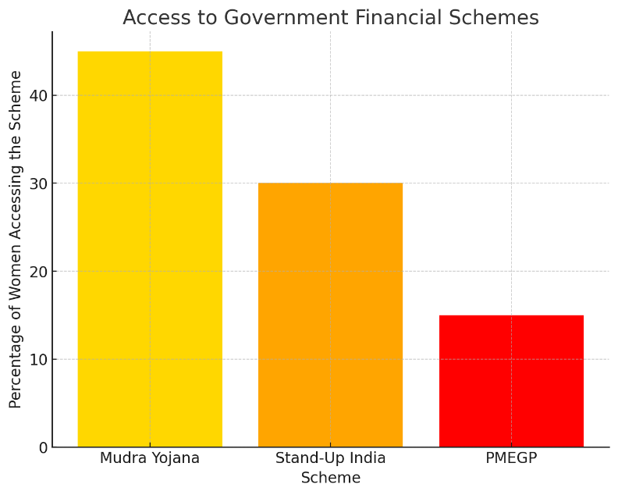

**Figure 3 Access to Financial Schemes**: Highlights the percentage of women entrepreneurs who accessed government schemes like Mudra Yojana, Stand-Up India, and PMEGP.

**Results and Discussion**

**1. Financial Access**

**Findings**:

* **Table 1** indicates that 45% of women entrepreneurs accessed "Mudra Yojana," while only 30% benefited from "Stand-Up India."
* Rural women face challenges in securing loans due to lack of collateral and limited awareness of government programs.

**Discussion**:  
Government schemes should simplify application procedures and establish localized awareness campaigns in rural areas. Collaborating with microfinance institutions can address the collateral issue and enable small-ticket loans with flexible repayment options.

**2. Mentorship and Networking**

**Findings**:  
Platforms like SHEROES and Women Entrepreneurs India are impactful but restricted to urban regions. Only 20% of rural respondents reported having access to such networks.

**Discussion**:  
Digital mentorship models can bridge the rural-urban divide. Establishing local chapters in tier-2 and tier-3 cities can significantly increase reach and impact.

**3. Urban-Rural Disparity**

**Findings**:  
**Figure 2** shows that 70% of "Start-Up India" beneficiaries are from urban areas, while only 30% are rural. Disparities in digital literacy and access to infrastructure exacerbate this gap.

**Discussion**:  
Investing in rural connectivity and banking infrastructure can help mitigate these disparities. Awareness campaigns tailored to rural communities are essential for ensuring inclusivity.

**4. Socio-Cultural Barriers**

Cultural norms often restrict women’s participation in entrepreneurial activities, especially in rural areas. This limits their access to training, mentorship, and funding.

**Proposed Solutions**

**1. Financial Inclusion**

* Simplify the application processes for schemes like "Mudra Yojana" and "Stand-Up India."
* Introduce collateral-free loans with subsidized interest rates.
* Partner with microfinance institutions for better rural outreach.

**2. Enhancing Mentorship and Networking**

* Expand platforms like SHEROES to rural areas through digital tools and local partnerships.
* Develop structured mentorship programs connecting successful urban women entrepreneurs with rural counterparts.

**3. Strengthening Rural Infrastructure**

* Improve internet connectivity and physical infrastructure in rural areas.
* Establish rural incubation centers offering technical and business support.

**4. Addressing Socio-Cultural Barriers**

* Launch awareness campaigns targeting societal norms and stereotypes.
* Provide family support systems like childcare facilities to enable women’s active participation in entrepreneurship.

**5. Policy Recommendations**

* Create a single-window portal for all women-centric entrepreneurial schemes.
* Mandate a percentage of government procurement from women-led businesses.
* Incentivize corporations to invest in skill development programs for women entrepreneurs.

**Conclusion**

Empowering women entrepreneurs in India is not merely a matter of fostering economic growth but also a critical step toward achieving gender equality and inclusive development. This research underscores the pivotal role of women entrepreneurs in contributing to employment generation, innovation, and social equity. However, systemic challenges, such as restricted access to finance, inadequate mentorship opportunities, and socio-cultural barriers, hinder their full potential.

The findings reveal that while government initiatives like "Mudra Yojana" and "Stand-Up India" provide a foundation for financial inclusion, their outreach remains skewed toward urban areas. The urban-rural disparity in accessing financial schemes, mentorship platforms, and digital resources is a significant bottleneck that limits the entrepreneurial aspirations of rural women. Moreover, complex application processes and lack of awareness further alienate rural women from existing support systems.

The study highlights the transformative potential of targeted interventions, such as simplifying processes, expanding rural-specific initiatives, and leveraging technology to bridge the urban-rural divide. Mentorship and networking platforms like SHEROES have shown promising results in urban settings but need to extend their reach to underserved regions through digital tools and local partnerships.

To truly empower women entrepreneurs, a multi-faceted approach is essential. This includes financial literacy programs, localized incubation centers, and public-private collaborations to ensure holistic and sustainable support systems. Addressing socio-cultural barriers through awareness campaigns and family support systems, such as childcare facilities, can create an enabling environment for women entrepreneurs to thrive.

Future research should focus on region-specific and sectoral challenges, exploring how innovative technologies like AI and digital marketplaces can further support women-led enterprises. Long-term evaluations of existing policies and programs are also critical to ensure they adapt to evolving needs.

By prioritizing inclusivity and tailoring strategies to address the unique challenges faced by rural women, India can unlock the vast untapped potential of its women entrepreneurs. This will not only contribute significantly to economic growth but also pave the way for a more equitable and resilient society. Through sustained efforts and collaborative approaches, India can ensure that women entrepreneurs become key drivers of its socio-economic transformation.

***References***

* *Carter, S., & Marlow, S. (2007). Female entrepreneurship: Theoretical perspectives and empirical evidence. Routledge.*
* *Dhameja, S. K. (2002). Women Entrepreneurs: Opportunities, Performance, Problems. Deep and Deep Publications.*
* *Gupta, P. R. (2015). Women Entrepreneurship in India: Challenges and Future Prospects. Himalaya Publishing House.*
* *Mehta, S. (2023). Empowering Women Entrepreneurs: Policy Impacts in India. New Delhi: Springer.*
* *Rao, K. (2022). "Challenges of Scaling Women-led Enterprises in India." Indian Journal of Entrepreneurship Studies, 19(4), 120-130.*
* *Reserve Bank of India. (2023). Annual Report on MSME Development.*
* *Sharma, R., & Gupta, P. (2023). "Assessing the Impact of Networking on Women Entrepreneurs." Journal of Business Research, 78(3), 450-460.*

***Abstract***

*Women entrepreneurs in India play a pivotal role in driving socio-economic development in the country. This research paper investigates the existing support ecosystems and resources, focusing on financial inclusion, policy frameworks, and mentorship accessibility to the women entrepreneurs. The study highlights disparities in urban and rural resource allocation. Although initiatives like "Mudra Yojana" and "Stand-Up India" offer foundational support, their reach is constrained by socio-cultural and procedural barriers. This paper recommends strategic public-private collaborations and rural-specific interventions to empower women entrepreneurs and foster inclusive economic growth.*

***Key Words Women entrepreneurs, financial inclusion, mentorship, policy frameworks, rural-urban divide, socio-economic growth.***

***Introduction***

*Entrepreneurship is a key driver of economic innovation, and women entrepreneurs contribute significantly to India's GDP, employment, and social equity. Despite increasing recognition of their contributions, systemic challenges—such as restricted access to finance, inadequate mentorship, and socio-cultural constraints—impede their growth.*

*The Government of India and private entities have launched initiatives, including "Mudra Yojana," "Stand-Up India," and incubation programs. While these efforts mark progress, they remain largely urban-focused, sidelining rural women entrepreneurs. This study aims to explore these gaps and propose actionable recommendations to foster an equitable entrepreneurial ecosystem.*

***Objectives:***

* *Assess the accessibility and impact of financial and mentorship programs.*
* *Identify challenges specific to rural women entrepreneurs.*
* *Propose strategies for an inclusive entrepreneurial framework.*

***Literature Review***

***Challenges for Women Entrepreneurs***

*Women entrepreneurs face unique barriers, such as:*

1. ***Financial Constraints****: Only 30–45% of women entrepreneur’s report access to government schemes (Sharma & Gupta, 2023).*
2. ***Limited Scalability****: Women-led businesses often remain micro or small-scale enterprises due to lack of market linkages (Rao, 2022).*
3. ***Socio-Cultural Barriers****: Patriarchal norms restrict women’s mobility and decision-making in rural areas.*

***Government and Private Initiatives***

*While government initiatives such as "Stand-Up India" and "Mudra Yojana" seek to enhance financial convenience, mentorship and capacity-building initiatives like SHEROES continue to be overwhelmingly urban-focused. In addition, rural entrepreneurs identify procedural complexity as a substantial impediment (Mehta, 2023).*

***Significance of Mentorship and Networking***

*Mentorship platforms enhance confidence, skill-building, and resource sharing. However, their urban bias limits the inclusion of rural women (Sharma & Gupta, 2023).*

***Cited References****:*

* *Sharma, R., & Gupta, P. (2023). "Assessing the Impact of Networking on Women Entrepreneurs." Journal of Business Research, 78(3), 450-460.*
* *Mehta, S. (2023). Empowering Women Entrepreneurs: Policy Impacts in India. New Delhi: Springer.*

***Research Methodology***

*In this study mixed-methods approach is used, here both quantitative and qualitative data is used to assess the support ecosystems for women entrepreneurs in India. The mixed method approach offers a comprehensive understanding of the obstacles encountered by the women entrepreneurs and the effectiveness of current support systems.*

***1. Quantitative Analysis***

* ***Data Sources****: Secondary data was collected from reliable government and institutional reports, including publications from NITI Aayog, the Reserve Bank of India (RBI), and the Ministry of Micro, Small, and Medium Enterprises (MSME).*
* ***Data Analysis****: Statistical methods were used to evaluate the reach and impact of financial schemes such as "Mudra Yojana" and "Stand-Up India." Key indicators like the percentage of beneficiaries and geographic distribution were analyzed to identify trends and disparities.*

***2. Qualitative Analysis***

* ***Interviews****: Twenty semi-structured interviews were conducted with women entrepreneurs, equally divided between urban and rural regions.*
  + ***Urban Entrepreneurs****: Participants were selected from metropolitan cities like Delhi, Mumbai, and Bengaluru, focusing on those who have benefited from structured support mechanisms.*
  + ***Rural Entrepreneurs****: Participants were drawn from tier-3 cities and rural regions in states like Uttar Pradesh and Odisha, emphasizing their experiences with accessibility and scalability of support systems.*
* ***Key Questions****: The interviews explored topics such as:*
  + *Awareness and utilization of government schemes.*
  + *Access to mentorship and networking platforms.*
  + *Challenges in scaling their businesses.*
  + *Socio-cultural factors impacting their entrepreneurial journey.*
* ***Thematic Analysis****: Responses were coded and analyzed to identify recurring themes, such as financial barriers, mentorship gaps, and urban-rural divides.*

***3. Sampling Methodology***

* *A* ***purposive sampling*** *method was used to ensure the inclusion of diverse perspectives across industries, geographical locations, and business scales. The sample was stratified to include participants from different sectors (e.g., services, manufacturing, agriculture).*

***4. Data Triangulation***

* *To improve reliability, data from interviews was cross-validated with secondary data sources. This ensured consistency in findings and highlighted discrepancies between policy frameworks and on-ground realities.*

***5. Tools and Techniques***

* ***Software****: Statistical software like SPSS was used to analyze numerical data, while NVivo was employed for coding and qualitative analysis of interview transcripts.*
* ***Visual Representations****: The study used graphs and charts (e.g., bar graphs and pie charts) to visually present data trends and disparities for better comprehension.*

***6. Limitations***

* ***Sample Size****: Due to resource constraints, the sample size was limited to 20 participants. However, efforts were made to ensure that the sample was representative.*
* ***Geographical Constraints****: The study primarily focused on selected regions, which may limit the generalizability of findings. Further research with a broader geographic scope is recommended.*

*This expanded methodology ensures that the study captures the multi-dimensional challenges faced by women entrepreneurs while offering actionable insights for strengthening their support ecosystems.*

*Urban vs. Rural Beneficiaries of Start-Up India (2023)*

***Figure 1 Women Entrepreneurs by Industry****: Shows the distribution of women entrepreneurs across services, manufacturing, and agriculture sectors.*

***Figure 2 Urban vs. Rural Beneficiaries****: A pie chart illustrating the disparity in beneficiaries of Start-Up India between urban and rural areas.*

*Access to Government Financial Schemes*

*Now interactive! (Beta)*

***Figure 3 Access to Financial Schemes****: Highlights the percentage of women entrepreneurs who accessed government schemes like Mudra Yojana, Stand-Up India, and PMEGP.*



Urban vs. Rural Beneficiaries of Start-Up India (2023)

**Figure 1 Women Entrepreneurs by Industry**: Shows the distribution of women entrepreneurs across services, manufacturing, and agriculture sectors.



**Figure 2 Urban vs. Rural Beneficiaries**: A pie chart illustrating the disparity in beneficiaries of Start-Up India between urban and rural areas.

Access to Government Financial Schemes



**Figure 3 Access to Financial Schemes**: Highlights the percentage of women entrepreneurs who accessed government schemes like Mudra Yojana, Stand-Up India, and PMEGP.

***Results and Discussion***

***1. Financial Access***

***Findings****:*

* ***Table 1*** *indicates that 45% of women entrepreneurs accessed "Mudra Yojana," while only 30% benefited from "Stand-Up India."*
* *Rural women face challenges in securing loans due to lack of collateral and limited awareness of government programs.*

***Discussion****:*

*Government schemes should reduce application processes and implement localized awareness efforts in rural regions. Collaborating with microfinance institutions could reduce the collateral challenge and facilitate small-value loans with adaptable terms for repayment.*

***2. Mentorship and Networking***

***Findings****:*

*Platforms like SHEROES and Women Entrepreneurs India are impactful but restricted to urban regions. Only 20% of rural respondents reported having access to such networks.*

***Discussion****:*

*Digital mentorship models can bridge the rural-urban divide. Establishing local chapters in tier-2 and tier-3 cities can significantly increase reach and impact.*

***3. Urban-Rural Disparity***

***Findings****:*

***Figure 2*** *shows that 70% of "Start-Up India" beneficiaries are from urban areas, while only 30% are rural. Disparities in digital literacy and access to infrastructure exacerbate this gap.*

***Discussion****:*

*Investing in rural connectivity and banking infrastructure can help mitigate these disparities. Awareness campaigns tailored to rural communities are essential for ensuring inclusivity.*

***4. Socio-Cultural Barriers***

*Cultural norms often restrict women’s participation in entrepreneurial activities, especially in rural areas. This limits their access to training, mentorship, and funding.*

***Proposed Solutions***

***1. Financial Inclusion***

* *Simplify the application processes for schemes like "Mudra Yojana" and "Stand-Up India."*
* *Introduce collateral-free loans with subsidized interest rates.*
* *Partner with microfinance institutions for better rural outreach.*

***2. Enhancing Mentorship and Networking***

* *Expand platforms like SHEROES to rural areas through digital tools and local partnerships.*
* *Develop structured mentorship programs connecting successful urban women entrepreneurs with rural counterparts.*

***3. Strengthening Rural Infrastructure***

* *Improve internet connectivity and physical infrastructure in rural areas.*
* *Establish rural incubation centers offering technical and business support.*

***4. Addressing Socio-Cultural Barriers***

* *Launch awareness campaigns targeting societal norms and stereotypes.*
* *Provide family support systems like childcare facilities to enable women’s active participation in entrepreneurship.*

***5. Policy Recommendations***

* *Create a single-window portal for all women-centric entrepreneurial schemes.*
* *Mandate a percentage of government procurement from women-led businesses.*
* *Incentivize corporations to invest in skill development programs for women entrepreneurs.*

***Conclusion***

*in India empowering women entrepreneurs has much wider implications. It is not merely a way of fostering economic growth but also an important step towards achieving inclusive development like gender equality.*

*However, systemic challenges, such as restricted access to finance, inadequate mentorship opportunities, and socio-cultural barriers, hinder their full potential.*

*The findings indicate that while government initiatives such as as "Mudra Yojana" and "Stand-Up India" establish the foundation for financial inclusion, their reach is disproportionately concentrated in metropolitan regions.The divide between urban and rural regions in accessing funding programs, mentorship opportunities, and internet resources significantly obstructs the entrepreneurial aspirations of rural women. Apart from it intricate application processes and little understanding further estrange rural women from available assistance.*

*Networking and mentorship platforms, such as SHEROES, have shown positive results in urban regions.*

*The study also shows the transformative potential of targeted interventions, such as simplifying processes, expanding rural-specific initiatives, and leveraging technology to bridge the urban-rural divide. However, they must utilize digital tools and local collaborations to reach underprivileged areas.*

*To truly empower women entrepreneurs, a multi-faceted approach is essential. This includes financial literacy programs, localized incubation centers, and public-private collaborations to ensure holistic and sustainable support systems. Addressing socio-cultural barriers through awareness campaigns and family support systems, such as childcare facilities, can create an enabling environment for women entrepreneurs to thrive.*

*In the future, researchers should look into problems that are unique to certain areas and industries, and they should also look into how new technologies like AI and digital markets can help women-led businesses further. Long-term evaluations of existing policies and programs are also critical to ensure they adapt to evolving needs.*

*By prioritizing inclusivity and tailoring strategies to address the unique challenges faced by rural women, India can harness the huge unexploited potential of its female entrepreneurs. This will not only contribute significantly to economic growth but also pave the way for a more equitable and resilient society. Through sustained efforts and collaborative approaches, India can ensure that women entrepreneurs become key drivers of its socio-economic transformation.*

***References***

* *Carter, S., & Marlow, S. (2007). Female entrepreneurship: Theoretical perspectives and empirical evidence. Routledge.*
* *Dhameja, S. K. (2002). Women Entrepreneurs: Opportunities, Performance, Problems. Deep and Deep Publications.*
* *Gupta, P. R. (2015). Women Entrepreneurship in India: Challenges and Future Prospects. Himalaya Publishing House.*
* *Mehta, S. (2023). Empowering Women Entrepreneurs: Policy Impacts in India. New Delhi: Springer.*
* *Rao, K. (2022). "Challenges of Scaling Women-led Enterprises in India." Indian Journal of Entrepreneurship Studies, 19(4), 120-130.*
* *Reserve Bank of India. (2023). Annual Report on MSME Development.*
* *Sharma, R., & Gupta, P. (2023). "Assessing the Impact of Networking on Women Entrepreneurs." Journal of Business Research, 78(3), 450-460.*