An Analytical Study on Growth of Fintech Start-Ups in Mumbai

**Student: Nidhi Nair**

**CPCA Batch V**

**Teacher Mentor’s Name: CA Tanzila Khan**

**Introduction:**

Fintech or Financial Technology can be considered as an interlinkage between financial services and information technology. It is a term used to describe any new technology that aims to improve and automate the use and delivery of financial services. It helps both businesses and consumers better manage their financial processes with the use of specialized software and algorithms used on smartphones and computers.

Even if you are not very familiar with fintech, it’s likely you’re already benefiting from it. Everything from your ability to go online and view your financial transactions to apps that allow you to instantly send and receive money are all part of the financial services evolution.

Fintech allows you to manage all your financial accounts – banking, investments, insurance – entirely online. Whereas these accounts once needed to be managed in-person or through a representative, they can now be easily self-managed online.

Mumbai, being the financial capital of the country is leading the charge with numerous FinTech startups and government policies making it the Fintech hub of the country. This paper studies those factors that differentiate Mumbai from other Indian cities and encourage the growth of FinTech startups. It covers sociological factors like consumers’ expectations and towards new financial products and net banking services. Furthermore. It also studies the economic, technological and political determinants that induce the growth of financial technologies in the next and keep Mumbai in the FinTech race.

**Research Methodology:**

**Hypothesis**

H0:

H1:

**Objective**

To understand the sociological, political and technological ecosystems driving the growth of FinTech startups in Mumbai.

**Data Sampling**

* Population: 1.25 crore
* Sampling Size: 120
* Sampling Method: Probability
* Limitations: Data collection has been primarily done in certain social classes and age groups and might not include information from the lower classes and age groups which make up a large population of Mumbai.

**Literature Review**

* Name of Literature: What is Fintech?
* Name of the Source: builtin.com
* Author: Sam Daley
* Date of publication: 2nd September 2022
* Summary: This article primarily explains what fintech is and how it works. It also discusses the different types of fintech startups and companies in existence and their scope.
* Name of Literature: The Three Ages of FinTech
* Name of the Source: blog.ccgrouppr.com
* Author: Daniel Lowther
* Summary: This article discusses three stages of FinTech viz “First Age of FinTech: Competition”, “Second Age of FinTech: Collaboration”, “Third Age of Fintech: Coopetition”. It explains the history of FinTech and how it has grown, changed hands and meanings of the years of its existence.
* Name of Literature: How FinTech is Affecting Businesses?
* Name of the Source: business.com
* Author: Ryne Landers
* Date of Publication: 20th September 2022
* Summary: This article explains what FinTech is and how the evolving world of financial technology is revolutionizing business and consumer financial resources.
* Name of Literature: India’s FinTech Market: Growth Outlook and Investment Opportunities
* Name of the Source: india-briefing.com
* Author: Yashoda Kapur
* Date of Publication: 26th July 2021
* Summary: This article discusses the current FinTech industry scenario in India, growth trends in the industry and the Indian government’s aim of financial inclusion. It states key statistics supporting strong and rapid growth of the industry in the country.
* Name of Literature: Fintech in India – A Global Growth Story
* Name of the Source: expresscomputer.in
* Author: Seema Prem
* Summary: This article states the milestones achieved by the Indian Fintech Industry and alks about how fintechs are aligning with the Indian financial regulations and the role of the steering committee in Fintech as well.
* Name of Literature: How technology is redefining the future of the fintech industry
* Name of the Source: timesofindia.indiatimes.com
* Author: Nitin Mathur
* Date of Publication: 24th May 2022
* Summary: This article explains how the current technological environment in India is helping the growth of fintech in the country and how the pandemic has accelerated this process. It also explains the challenges of fintech growth in the country along with expectations for its future.
* Name of Literature: What trends are driving the fintech revolution in India?
* Name of the Source: india-briefing.com
* Author: Naina Bhardwaj
* Date of Publication: 9th June 2022
* Summary: This article explains the different fintech segments in India, supply side and demand side factors, what investments are currently being done in the sector, technological advancements as well as the challenges that the sector is facing.
* Name of Literature: fintech will drive Maharashtra to become a trillion-dollar economy: Dy CM Fadnavis
* Name of the Source: businesstoday.in
* Author: Bhavya Kaushal
* Date of Publication: 22nd September 2022
* Summary: This news article states the efforts undertaken by the Maharashtra State Government to support the growth of the Fintech Industry in Maharashtra. It explains the Fintech policy adopted by the Maharashtra Government and the facilities it will provide the state.

**Conceptual Framework**

While fintech seems like a recent series of technological breakthroughs, the basic concept has existed for some time. Early credit cards in the 1950s generally represent the first fintech products available to the public, in that they eliminated the need for consumers to carry physical currency in their day-to-day lives. From there, fintech evolved to include bank mainframes and online stock trading services with the introduction dematerializations of share certifications.

Soon, FinTech then made its way into the corporates with automating many of its financial operations. Accounting operations like accounts reconciliation, updating financial data and preparing financial statements can be completed without human interaction using accounting software. Later, other than computerized accountancy, emerging technologies such as artificial intelligence (AI) and robotic process automation (RPA) have vastly expanded the capability of these systems in recent years. Accounting software may accomplish everything from tracking and recording data by using AI. AI helps you to eliminate repetitive tasks like data entry and calculations so that analysts can focus on more important things. This means no more manual data entry into a computer, manually reconciling bank statements one by one, producing financial reports in a spreadsheet, chasing after documents from your client and so many more repetitive tasks

Today, FinTech serves various audiences with myriad technologies and services. While FinTech benefits a broad spectrum of customers, its tech offerings prioritize two essential elements, i.e., accessibility and speed. It provides fast access to financial tools. FinTech is an equalizer, allowing businesses of all sizes and across all industries to access robust financial tools instantly. Using speedy, always-on internet connections, big data and mobile connectivity, businesses can easily access complex, feature-rich financial software suites and managed services. In the past, such setups would have cost millions of dollars in fees, equipment, license, trained technicians and dedicated IT teams.

However, despite constant technological developments happening in the Finance Industry, the pace of these developments and new innovations particularly technologies that catered to the general public was a distant priority especially during financial crisis as banks were busy dealing with the numerous new rules and facing the heat of regulatory purview as opposed to Big Tech which was comparatively much less regulated. This made Tech giants and startups hesitant to enter the stringent finance space. But there were transformative innovations everywhere, from iPhone and WhatsApp to Amazon and Uber catering to users worldwide causing greater customer expectations. This was accompanied by rapid adoption by the consumers in such rates that for example the percentage of mobile phone users went from 0.41% of the world population to 64.8% in 2010, 92.0% in 2016 and now 98.6% in 2022. Such transformations and swift market penetration proved that the market was ready to witness and adopt innovations for their banking and financial needs which created a gap between consumer expectations and what the banks were offering especially from a user experience and convenience perspective. But that gap was so big that even nontraditional banking firms were ready to jump in and capture this opportunity. That gap is what the FinTech industry is tackling with right now. Thus, Fintech has changed meanings over time, shifting to consumer-oriented services with the emergence of new FinTech start-ups, armed with venture capital cash that instead of going for highly competitive, complex and regulated areas of financial services, targeted low-entry segments with an idea of not becoming a major new competitor to banks but take a small size of the more profitable and easier to disrupt portion of banking.

Today, even platforms like Facebook have entered finance with Facebook having 50 different regulatory licenses in US alone to allow Facebook users to transfer money through their Messenger App. Common category of FinTech companies now include:

Mobile Payments

Most of us use Apple Pay, Google Pay, or other forms of mobile payments on a daily basis. Cash is losing popularity, especially in our post-covid reality, and startups can enter this growing segment with various ideas. A good example to look up to is Paytm. The company offers mobile payment services to consumers and enables merchants to receive payments through its QR code, point of sale and online payment gateway offerings. One can directly pay for bills, do travel, movie and event bookings in partnership with financial institutions, Paytm offers financial services such as microloans and buy now, pay later to its consumers and merchants.

Insurance

Not surprisingly, fintech has influenced this sector too, successfully introducing the Insurtech term to the world. Tech-driven insurance companies take advantage of innovations to provide various services: getting insurance details can be as easy as clicking a button on the phone screen while managing coverage can be easily accomplished via a convenient user-friendly application. Insurtech trends include artificial intelligence, predictive analytics, implementation of chatbots, and even drones to collect and analyze data to make a compensation decision.

Crowdfunding Platforms

History has lots of records of fundraising through the crowd: services like Hotstart or Indiegogo have been giving small startups or even individuals an opportunity to receive basic or additional funding for their projects. As there is no need to go to a bank and ask for a loan anymore, such platforms have been gaining popularity and there is still room for newbies on the market. The crowdfunding market is expected to witness a growth at a CAGR of over 16% during the forecast period 2021-2026.

International Money Transfers

Just a decade ago the speed of international money transfers was really an issue. Besides that, the commission was pretty high (approx. 8%) so both clients and banks were looking for faster ways of sending money. Fintech companies today offer faster and less expensive international money transfers.

For instance, the Ripple company has been able to reduce the time for a transaction from hours to just a few seconds.

Blockchain and Cryptocurrency

Cryptocurrency exchanges are becoming an increasingly popular type of fintech business to invest in: it is a simple and convenient way to buy and sell preferred cryptocurrencies. A good example to look up to is Coinbase, a popular platform that connects users through its website and an app. Now it has over 68 million users across 100+ countries. The service markets itself as a safe way to purchase, store, trade, and sell crypto (Bitcoin, Dogecoin, Litecoin, Ethereum etc.). Here, users (both beginners and experts) can build a portfolio, keep up with the latest crypto news and navigate the market easily.

Another hyped term in the fintech sector is Blockchain as it plays a major role in financial innovations. By storing data across its network, blockchain eliminates the risks of data counterfeiting, which is especially important in the banking sector. There are 80 million blockchain wallet holders globally and their number is increasing; it proves that blockchain’s influence in democratizing finance is already tangible.

Speaking about the most active and successful blockchain projects in the financial sector, we.trade is totally worth mentioning. It is an enterprise-grade blockchain-enabled trade finance platform, developed by IBM alongside major banks including CaixaBank, Deutsche Bank, Erste Group, UniCredit.

Robo-Advising and Stock Trading

Robo-advisors are influencing the asset management industry by giving smart recommendations that decrease costs for clients. Implementing such a solution is more effective than hiring an expert with limited working hours, as the system can analyze data 24/7 with no need for time breaks.

Stock-trading apps are also gaining a lot of attention recently. Machine Learning and Artificial Intelligence help traders to effectively capture and analyze tons of data to make accurate decisions. Money transfer services help to transfer money from stocks and asset trading directly into the trader’s bank accounts; blockchain solutions provide a secure way of conducting international transactions.

Budgeting Apps

The traditional way of getting finance advice was through banks and involved a lot of human interaction, but now people are able to receive personalized budgeting tips right from their smartphones. Apps like Mint or FinancialAdvisor have replaced inconvenient excel sheets and notebooks as they can give you all kinds of resources for managing your money, calculating your monthly payments, and saving smarter.

**Primary Data**

* Age:

1. 18-25 (82)
2. 26-35 (10)
3. 36-45 (3)
4. 46-60 (17)
5. 61 and above (8)

Analysis: More than half of the respondents i.e., 68.3% are below the age of 25.

Interpretation: This is because the survey was primarily conducted on college grounds. This means that the respondents might have more knowledge about new technologies and fintech and thus, might be more likely to clear and strong opinions about it. Their opinions may differ from the average population of the city.

* Family Economy:

1. Lower Middle Class (4)
2. Middle Class (66)
3. Upper Middle Class (46)
4. Upper Class (4)

Analysis: 55% respondents belong to the Middle Class and 38.3%.

Interpretation: This is because the survey was primarily conducted on college peers and parents of acquaintances who majorly belong to these social classes which are more likely to look explore different investment avenues.

* Level of education:

1. Matriculated (0)
2. Intermediate (37)
3. Graduate (47)
4. Post Graduate (30)
5. Other (6)

Analysis: 30.8% respondents have an intermediate level of education, 39.2% of the respondents are graduates while 25% respondents are postgraduates.

Interpretation: This is because the survey was primarily conducted on college peers and parents of acquaintances. Thus, we can interpret that most of the respondents have either graduated or are pursuing their graduation degree and thus, have completed intermediate level of education or belong to an older age group of parents who perhaps are postgraduates.

* Awareness about the functionality of E-Wallets:

1. Fully aware (84)
2. Partially aware (35)
3. Not aware (1)

Analysis: Almost the entire cohort of respondents are either fully or partially aware about the functionality of E-wallets i.e., 70% and 29.2% respectively.

Interpretation: From this, we can derive that fintechs are no more catering to a niche clientele but the information about the usage of fintech and particularly E-Wallets is readily available and accessible to most.

* Sources from where the respondents acquired information about E-Wallets

1. Social Media (39)
2. Friends and Family (55)
3. News/Television (20)
4. All of the above (1)
5. Other (5)

Analysis: 45.8% respondents acquired information about E-Wallets from friends and family while 32.5% and 16.7% respondents acquired their information about E-Wallets from social media and news/television respectively.

Interpretation: To have information about E-Wallets, one does not have to reach out to far away sources as the information about E-wallets is readily available and well talked about resulting in it becoming a household term and having widespread consumer adoption.

* Do the respondents that use E-Wallets for financial transactions

1. Yes (110)
2. No (10)

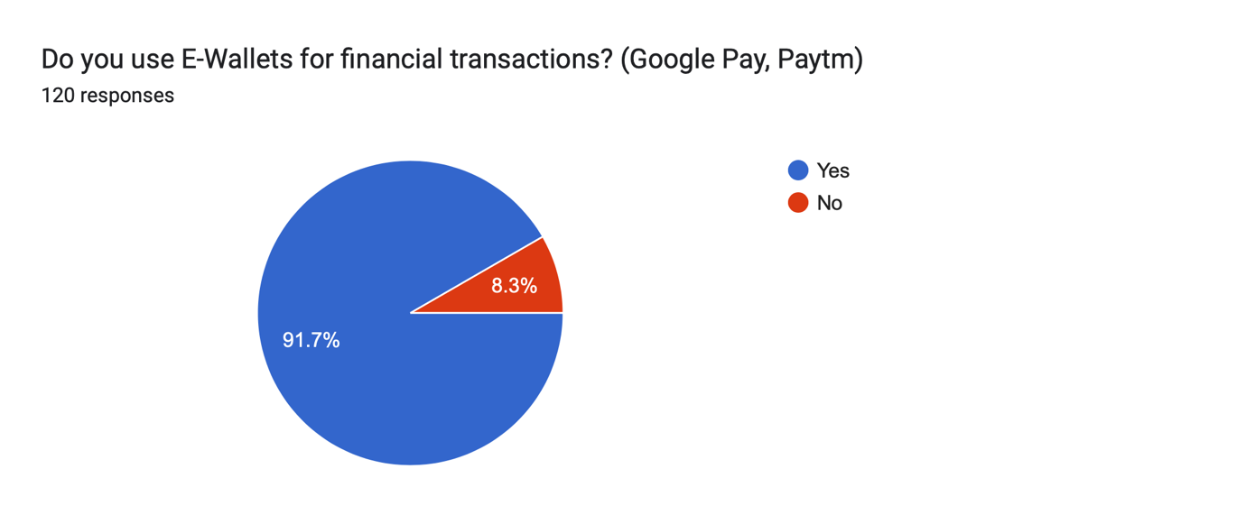

Analysis: 91.7% respondents use E-Wallets for financial transactions whilst 8.3% do not.

Interpretation: It can be interpreted that the consumer adoption of E-Wallets is widespread and rapid with majority of the cohort of respondents trusting and using E-Wallets for financial transactions while a small cohort of respondents not using E-Wallets perhaps because of lack of trust in the new technology and belief in the traditional system.

* Reason why the respondents prefer E-Wallets over other modes of payments

1. Time Saving (15)
2. Security (3)
3. Ease of use (31)
4. All of the above (71)

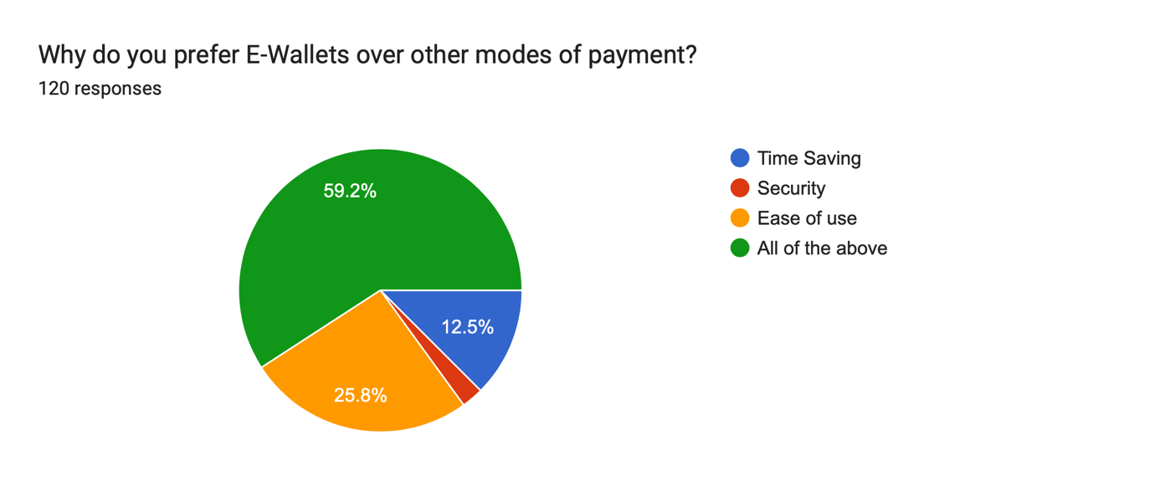

Analysis: 59.2% respondents prefer E-Wallets over other modes of payments because of All of the above reasons whilst for 25.8% of the respondents the main reason is Ease of Use whilst 12.5% respondents prefer E-Wallets because they are Time Saving.

Interpretation: Time, security and ease of use is what is driving consumer adoption of E-Wallets and is thus, involving fintech in the daily lives of consumers with the main reasons being time and ease of use.

* Do the respondents feel more secure while using E-Wallets against other modes of net banking where they have to provide their bank account details for every transaction

1. Yes (81)
2. No (39)

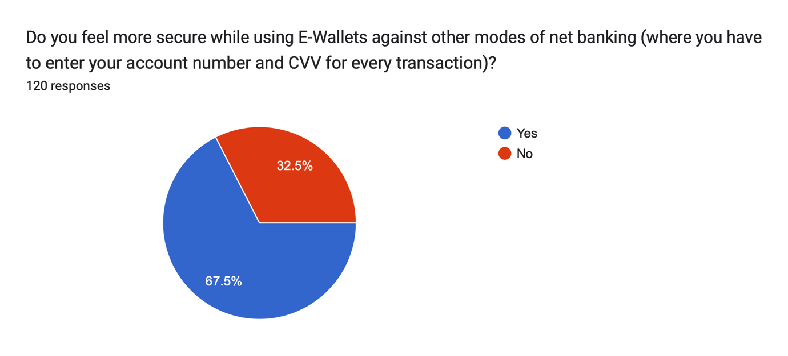

Analysis: 67.5% respondents feel more secure while using E-Wallets as compared to other modes of net banking where they have to provide their bank account details for every transaction whilst 32.5% respondents find no difference in security.

Interpretation: E-Wallets have created more trust amongst users about net banking as they feel more when they do not have to share bank account details for every transaction. Thus, we can conclude that E-Wallets have made net banking and fintech more popular with widespread and deeper penetration making its usage common and not just for a niche segment.

* Do the respondents think that Fintechs are catching up with traditional banks in terms of customer trust

1. Yes (54)
2. No (10)
3. Maybe (56)

Analysis: 45% respondents believe that Fintechs are catching up with traditional banks in terms of trust, 46.7% respondents partially believe so whilst only 8.3% of the respondents think that Fintech are not catching up with traditional banks in terms of trust.

Interpretation: This means that consumers are no longer skeptical about the security provided by fintechs. They are more open and accepting towards such technologies and though, they might not trust fintechs as much as traditional banks in the current stage but believe that fintechs will sooner or later catch up with traditional banks in terms of trust.

* How do the respondents consider net banking against traditional banks

1. Supportive Instrument (72)
2. Substitution (48)

Analysis: 60% respondents think that net banking is a supportive instrument to traditional banking whilst 40% respondents believe that net banking could substitute traditional banking in the future.

Interpretation: More than half of the respondents believe that net banking is not there to compete with traditional banking but there to collaborate and act as a supportive instrument to traditional banks. They cannot function alone and replace banks but are there to assist and make banking services more efficient. However, 40% respondents have enough confidence in net banking replacing traditional banking in the future.

* Do the respondents think that the pandemic played a crucial role in consumers’ acceptance and adoption of fintech payment solutions

1. Yes (104)
2. No (2)
3. Maybe (14)

Analysis: 86.7% respondents think that the pandemic played a crucial role in consumers’ acceptance and adoption of Fintech payment solutions, 11.7% respondents partially believe so whilst only 1.7% respondents do not believe that the pandemic helped.

Interpretation: The pandemic forced and accelerated digital penetration in the country by several years. The respondents believe that the pandemic made them accept and adopt fintech payment solutions when cash was perceived as unsanitary and delivery services become more popular whilst also making them prefer cashless transactions.

* Whether the respondents think that the integration of technology in finance has made the handling of finances more complex for older or lesser educated people

1. Yes (57)
2. No (23)
3. Maybe (40)

Analysis: 47.5% respondents believe that the integration of technology in finance has made the handling of finances more complex for older or lesser educated people, 33.3% partially believe so whilst 19.2% respondents do not believe so.

Interpretation: Though Fintech has been able to improve financial inclusion by reaching the previously untapped segments, many of the respondents fully or partially believe that the integration of technology in finance has made the handling of finances more complex for older or lesser educated people.

* Would the respondents consider investing in a financial product sold by a fintech

1. Yes (34)
2. No (23)
3. Maybe (63)

Analysis: 28.3% respondents would consider investing in a financial product sold by a Fintech startup, 52.5% respondents would possibly do so whilst 28.3% respondents would not invest in a financial product sold by a Fintech startup.

Interpretation: A significant number of respondents would consider investing in a financial product sold by a Fintech company. This shows growing acceptance of fintech products, perhaps their acceptance not being at par with products provided by traditional banks, they have garnered considerable trust from the consumers at this stage of development.

* Have the respondents invested in cryptocurrency yet

1. Yes (25)
2. No (95)

Analysis: 20.8% respondents have already invested in cryptocurrency whilst as many as 79.2% have not yet invested in cryptocurrency.

Interpretation: Though financial technologies like payments and stock trading apps might have gained significant popularity so far with widespread adoption, cryptocurrency on the other hand have not achieved the same kind of popularity and have a long way to go in order to achieve that level of penetration as only a niche segment of the society has involved themselves in cryptocurrency investments.

* Would the respondents be more likely to invest in a cryptocurrency fund provided by a Fintech company (as they do not have to manage it themselves)

1. Yes (24)
2. No (53)
3. Maybe (43)

Analysis: 44.2% respondents would not invest in cryptocurrency even if it is managed by an expert fund manager whilst 35.8% respondents would be more likely to invest in a cryptocurrency fund and 20% would maybe do so.

Interpretation: A considerable number of respondents would consider investing in cryptocurrency if their investments are managed by an expert as the masses have not acquired enough knowledge about cryptocurrency and thus, would be more likely to invest if they receive expert services. Whilst, almost half of the respondents refuse to invest in cryptocurrency even if expert services are provided.

* On a scale of 1-5, how much confidence do the respondents have in the future of cryptocurrency and blockchain in finance

1. 1 (16)
2. 2 (21)
3. 3 (57)
4. 4 (16)
5. 5 (10)

Analysis: On a scale of 1-5, for how much confidence they have in the future of cryptocurrency and use of blockchain in finance, 47.5% respondents have marked 3 while 17.2% respondents marked 2 and 13.3% respondents marked 4.

Interpretation: Even though, the public has gained confidence and adopted digital payment solutions. But they are still either uncertain or underconfident about the future of blockchain technologies and usage of cryptocurrency. They have a long way to go in terms of what stage application of these technologies are and adoption for the masses.

* Do the respondents think that the Indian Government’s promotion of digitalization and net banking help them gain confidence in Fintech

1. Yes (79)
2. No (9)
3. Maybe (32)

Analysis: 65.8% respondents believe that the Indian government’s promotion of digitalization and net banking helped them gain confidence in the Fintech, 26.7% partially believe so whilst 7.5% respondents do not believe that it helped them.

Interpretation: When the Indian Government started to promote “Digital India” and digital payment solutions, it achieved the government’s stamp of approval in the minds of the public, thus, the respondents believe that it created trust and made them try out and gain confidence in Fintech.

**Secondary Data**

India’s fintech market is the world’s fastest growing – 67 percent of the more than 2,100 fintech entities in operation have been set up in the last five years. It has the highest FinTech adoption rate globally at 87%. Currently valued at $31 billion, the India FinTech market is expected to grow to $84 billion by 2025 at a CAGR of 22% and is expected to reach $1 trillion by 2030. Being the country’s technology and financial hubs, Bengaluru and Mumbai are where most fintech companies have their India headquartered.

The Indian fintech market is majorly focused on lending and payments sectors, among other segments such as Wealth Technology, Personal Finance Management, Insurance Technology, and Regulation Technology. Out of a total of 21 unicorns in India, around one-third are FinTech companies, Paytm being the highest valued unicorn.

Existing Fintech companies have gained one-third of new revenue at the cost of traditional banks, as per reports. India along with China accounted for the highest adoption rate of 87 per cent (global adoption rate is 64 per cent) out of all emerging markets in the world. Between 2010 and 2015, India saw 1,216 new FinTech startups founded.

With a major number of FinTechs taking birth in the Financial Capital of the country, Mumbai, the city has become a backbone for FinTech development in the country. There are multiple political, economic, sociological and technological factors that aide the city’s FinTech growth story.

Government support has been key, not only from the regulatory standpoint, but also in providing critical enabling assistance. Be it broadband infrastructure to enhance internet access in rural areas or digital literacy and financial programs, various government programs have accelerated the growth of the Fintech industry in India. These include Startup India, Digital India program, India Stack (an ambitious software plan that will use application programming interface (API) in connecting the government and start-ups under a unique digital infrastructure to achieve paperless and cashless delivery of financial services), E-RUPI, license for payments banks, Jan Dhan Yojana (a government plan to link Jan Dhan accounts with Aadhaar and mobile numbers in order to be able to directly transfer subsidies to needful citizen), recognition of P2P lenders as NBFCs, National Common Mobility Card (NCMC), regulatory sandboxes by RBI, and IRDAI for Fintech. Moreover, a robust public digital infrastructure aided with Aadhar (a biometric identification possessed by persons living and working in India, which can be used as verification during digital payments), UPI, account aggregation etc. and a supportive regulatory environment has eased and augmented the technological transition in India. Regulators (RBI, IRDAI, and SEBI) have undertaken numerous measures to ensure increased accountability and the uninterrupted availability of secure and affordable digital financial systems. As of October 2021, India’s Unified Payments Interface (UPI) has seen participation of 261 banks and has recorded 4.21 billion monthly transactions worth over US$100 billion as of October 2021.

Additionally, Maharashtra is the first state to launch a fintech policy. Under this policy, they have developed the entire ecosystem with smart centers, a fintech registry, a fintech API sandbox, 100 crore fund which resulted in over 500 companies accessing this set-up, and this fund has attracted investments of nearly Rs 1000 crores and indirect investments of over Rs. 9000 crores. The State Government also started an initiative namely “Mumbai Fintech Hub” to promote the fintech ecosystem in the state of Maharashtra with special focus on spearheading the growth of Fintech in Mumbai. The government also held the Global Fintech Festival (GFF) in the city, declaring Mumbai as the Fintech capital of the country, thus, inviting more fintech opportunities to the city.

Technology is another major factor why the Fintech landscape in India has witnessed high speed growth with the help of enablers like extensive internet usage, wide area network coverage, rapid adoption of technology and the pandemic accelerated digital penetration. Covid-19 wreaked havoc globally but acted as a ‘Knight in a shining armor’ for technological growth and digitalization, which accelerated the operations at a remarkable speed, moving ahead by several years with the entire population moving drastically towards online modes of communication and work. The overall financial services market is witnessing a major transition leveraging new and cutting-edge technologies, such as blockchain, AI, ML, and cloud infrastructure. Three key technology factors driving growth of Fintech include a strong talent pool, increasing collaboration between banks and Fintech enterprises, as well as the fast pace of technological innovations on an everyday basis. According to a UNESCO study, India ranks among the top countries producing university graduates, and around 32 percent of all students in India pick Science, Technology, Engineering, and Mathematic (STEM).

Technology is being exploited to bring in efficiency in processes like payments, claims processing, and savings marketplaces through e-KYC, video KYC, IoT, AI, digital signatures, and account aggregation infrastructure. Moreover, these technological advancements are bringing a sense of security among consumers through biometric identity verification techniques, such as voice, face recognition, and iris scanning.

The country’s technological ecosystem is growing not only for payment and lending fintechs but India is now also witnessing a strong digital adoption in insurance as customers are inclined towards digital channels for completing their insurance purchases. Meanwhile, neo banks have witnessed steady growth, with traditional banking players struggling with technology-first operations. They are offering products targeting blue-collar workers and other categories of the customer to ensure a superior and seamless online/digital banking experience. In the case of digital lending, with the easy access to consumer data, they are focusing on more targeted & customized products and lowering default rates.

Along with apt technological ecosystem for the growth of fintech in the country, internet penetration and 4G network have been a great factor helping rapid consumer adoption of fintech with Mumbai topping the list for the most number of internet users in the country. Maharashtra also announced telecommunication infrastructure policy to facilitate 5G rollout. Thus, making financial technologies accessible to every segment of the society in every corner of the city. Additionally, the availability of cheaper smartphones with India estimating to have 1 billion smartphone users by 2026 and extensive smartphone adoption, helping fintech reach anybody who needs it, whenever they need it.

**Conclusion**

Due to emerging technologies, changing cultural trends and a favorable regulatory landscape, the Fintech industry in Mumbai is growing beyond boundaries. At this stage, with the growth of e-commerce and deep digital penetration powered by the pandemic, consumer awareness is at an all-time high paving the way for digital payment modes to become the norm no longer used just by the well-educated and affluent but are also pulling in the backward segments of the society. The primary reason to use traditional banking was trust, but, now with the government’s promotion of Fintech, it was easier for the masses to get information about digital payment modes and adopt and accept them with confidence. However, despite the widespread acceptance of digital payment methods, the public’s confidence in financial technologies like cryptocurrency is still rather low. The acceptance and adoption of cryptocurrency and other blockchain technologies is still in its early-stage catering to only a niche segment of the society.

From providing critical enabling assistance to promoting fintech to the masses, government support is also a key factor as to why Fintech is growing in Mumbai. The government has set up suitable regulations making sure that there is growth in the industry whilst also safeguarding the investors’ capital. The central government has several campaigns and programs supporting the growth of fintech coupled with initiatives introduced by state government that are highly accessible to Mumbai as compared to other tier 1 or tier 2 cities in the country make sure Mumbai’s growth into “Mumbai Fintech Hub”.

Access to technology and the use of new technological advancements in order to create innovative financial technologies are ensuring the growth of Fintech in Mumbai. India also produces a large number of STEM graduates that ensure sufficient man force in technological fields particularly based in metropolitans Deep internet penetration and easy accessibility is helping financial technologies to reach every nook and cranny of the city supported by 4G network and now by 5G in the coming days with Maharashtra announcing telecommunication infrastructure policy to facilitate 5G rollout. In addition to internet penetration, access to cheaper smartphones and swift smartphone adoption too is helping fintech reach anybody who needs it, whenever they need it.

As Mumbai leads the country in fintech adoption rate, riding on the emerging financial technology and innovations, the industry is set to see unprecedented growth in the years to come. This will go a long way extending the reach of banking and financial services to not only people in Mumbai but also mofussil towns and rural swaths of Maharashtra and India as a whole.

**Bibliography**

https://builtin.com/fintech

https://blog.ccgrouppr.com/blog/the-three-ages-of-fintech

https://www.business.com/articles/how-fintech-is-changing-business-and-bank-accounts/

https://www.india-briefing.com/news/indias-fintech-market-growth-outlook-and-investment-opportunities-22764.html/

https://www.expresscomputer.in/guest-blogs/fintech-in-india-a-global-growth-story/90619/

https://timesofindia.indiatimes.com/blogs/voices/how-technology-is-redefining-the-future-of-the-fintech-industry-in-india/

https://www.india-briefing.com/news/what-trends-are-driving-the-fintech-revolution-in-india-23809.html/

https://www.businesstoday.in/latest/story/fintech-will-drive-maharashtra-to-become-a-trillion-dollar-economy-dy-cm-fadnavis-347899-2022-09-22