HEALTHCARE CHATBOT

A.Navanayan Kumar, A.Divya, R.Arvind, A.Rasagna, Ayush Gurung

Under the guidance of

Prof. Sanjay Kumar J Hamilpure

School of Engineering, Department of Artificial Intelligence and Machine Learning, Malla Reddy University, Hyderabad, India.

|  |  |  |
| --- | --- | --- |
| KEYWORDS:  Healthcare chatbot  Patient engagement  Medical assistance  Symptom checker  Telemedicine  Conversational AI  Patient-centered technology  24/7 healthcare assistance |  | **ABSTRACT:**  Healthcare chatbots are emerging as transformative tools that leverage artificial intelligence (AI) to enhance patient engagement, accessibility, and efficiency in healthcare delivery. This paper explores the design, implementation, and impact of healthcare chatbots across various healthcare settings, including primary care, mental health support, and chronic disease management. Utilizing Natural Language Processing (NLP) and machine learning algorithms, healthcare chatbots offer real-time responses, personalized health advice, symptom checking, and continuous patient support. These virtual assistants are uniquely positioned to reduce the strain on healthcare systems by managing routine inquiries, streamlining telemedicine, and providing preliminary triage. However, despite their promising potential, significant challenges remain, particularly regarding data privacy, accuracy, and user trust. Through an analysis of current literature and case studies, this paper provides insights into the benefits, limitations, and ethical considerations associated with healthcare chatbots. The findings suggest that while healthcare chatbots are valuable in increasing access to medical information and improving patient satisfaction, a collaborative approach involving healthcare professionals, technologists, and policymakers is essential to fully integrate these tools into healthcare systems responsibly. |

**1. INTRODUCTION**

In recent years, healthcare systems worldwide have faced mounting pressure to improve patient accessibility, engagement, and service delivery while managing resource constraints. The advent of digital health solutions has opened new avenues to address these challenges, with healthcare chatbots emerging as a particularly promising tool. Powered by artificial intelligence (AI) and Natural Language Processing (NLP), healthcare chatbots have the potential to transform patient-provider interactions by delivering instant responses, assisting with symptom assessments, supporting chronic disease management, and guiding patients through routine medical inquiries. These digital assistants provide a convenient, 24/7 interface that empowers patients to manage their health independently, bridging gaps in access to timely medical information and assistance.

Healthcare chatbots are not only redefining patient engagement but also alleviating the workload of healthcare professionals by automating repetitive tasks and enhancing telemedicine services. For instance, chatbots can assist with appointment scheduling, provide reminders for medication adherence, and conduct preliminary assessments of symptoms, thus allowing healthcare providers to focus on more complex cases. Recent studies suggest that such applications can improve patient satisfaction and reduce wait times, underscoring the potential of chatbots to increase healthcare efficiency and accessibility.

However, despite their advantages, the deployment of healthcare chatbots raises significant concerns, particularly around data privacy, patient safety, and the ethical implications of AI-driven health advice. Ensuring that chatbots provide accurate, evidence-based information is essential to maintaining user trust, while strict data protection measures are critical to safeguard sensitive medical information. Moreover, understanding the limits of AI in healthcare and establishing guidelines for chatbot design and usage are crucial to avoid over-reliance on these tools for complex medical decision-making.

This paper examines the role of healthcare chatbots within the broader context of digital health innovation. By analyzing current applications, case studies, and challenges, this research seeks to provide a comprehensive understanding of the benefits, limitations, and ethical considerations of integrating chatbots into healthcare settings. The study aims to contribute to the development of best practices for designing, implementing, and regulating healthcare chatbots in a way that aligns with the goals of patient-centered care and responsible AI use.

**2. REQUIRED TOOLS:**

a) Software Requirements

Operating System: Windows

Web Server: Apache or default browser

(for deployment)

Backend Framework: Django (Python-based web framework)

Database: SQLite for robust data handling and scalability

Frontend: HTML5, CSS3, JavaScript, and Bootstrap for responsive UI design

AI Libraries: TensorFlow or PyTorch (for AI-driven recommendations and personalization features)

Email Service (e.g., SendGrid or SMTP) for notifications and reminder

Version Control: Git (with repositories like GitHub or GitLab)

IDE: PyCharm, VS Code, or any Python-supporting IDE

Testing Frameworks: admin shell for backend testing; default browser for frontend testing

b) Hardware Requirements

Server Requirements:

Processor: Quad-core or higher, minimum 2.0 GHz

RAM: 8 GB (16 GB recommended for high traffic)

Storage: 500 GB SSD or higher (scalable storage recommended for growing data)

Client-Side Requirements:

Processor: Dual-core, minimum 1.6 GHz

RAM: 4 GB (8 GB recommended)

Storage: 50 MB for app installation (web-based, minimal storage required)

Network Requirements:

Internet Speed: Minimum 5 Mbps for stable client-server communication

Hosting Server Bandwidth: Sufficient to handle concurrent users and scalable based on projected growth

**3.MODULES:**

**a) Natural Language Processing (NLP) Module:**

Purpose:Enables the chatbot to understand and respond to users' questions or statements.

Components: This includes language understanding (NLU), intent recognition, and entity extraction.

Implementation: You may use libraries or frameworks like spaCy, NLTK, or advanced NLP models like BERT, GPT, or custom-trained models on medical dialogue data.

**b) Symptom Checker Module:**

Purpose: Gathers symptom-related information from users and maps it to possible conditions or recommendations.

Components: Symptom database, diagnostic algorithms, and a decision tree to guide users through questions.

Implementation: You might use predefined symptom checklists, leverage APIs from medical symptom checkers, or develop a rules-based or ML-based decision tree.

**c) Medical Knowledge Base Module:**

Purpose: Provides the chatbot with access to reliable healthcare information.

Components: Database of medical information, including conditions, treatments, and prevention methods.

Implementation: Use databases like MedlinePlus, PubMed, or create a curated knowledge base with healthcare providers.

**d) Patient Data Management Module:**

Purpose: Manages user information and stores patient interactions securely.

Components: User authentication, encrypted data storage, and retrieval functions.

Implementation: Ensure HIPAA/GDPR compliance if storing sensitive information, use secure databases, and incorporate patient consent mechanisms.

**e) Recommendation Module:**

Purpose: Provides users with personalized recommendations based on input, symptoms, or diagnosis.

Components: Algorithm or rules engine that makes recommendations, possibly integrating with electronic health records (EHR) for personal data.

Implementation: Use decision-making algorithms or AI models to provide tailored advice on medication, home remedies, or when to see a doctor.

**4. FUNCTIONAL WORKFLOW:**

A functional workflow for a healthcare chatbot can be outlined in several sequential steps, focusing on how the chatbot interacts with the user, processes data, and provides responses or recommendations. Here’s a step-by-step breakdown:

**1. User Initiation:**

Description: The user initiates a conversation with the chatbot, which may happen through a healthcare app, website, or messaging platform.

Example Interaction: The user might type a question like, "I have a headache and fever. What should I do?"

**2. Natural Language Processing (NLP):**

Description: The chatbot’s NLP module interprets the user’s input to understand intent and key health-related entities (e.g., symptoms, medications).

Process: The chatbot parses the input, identifies relevant terms (e.g., "headache," "fever"), and determines the intent (e.g., seeking advice on symptoms).

**3. Symptom Collection:**

Description: If necessary, the chatbot asks follow-up questions to gather more details about the user’s symptoms, medical history, or duration of symptoms.

Example Interaction: The chatbot might ask, "How long have you been experiencing these symptoms?" or "Do you have any other symptoms like nausea or fatigue?"

**4. Symptom Analysis and Mapping:**

Description: The chatbot analyzes the user’s symptoms against a symptom database or knowledge base to assess possible conditions or health concerns.

Process: Using decision trees, algorithms, or machine learning models, the chatbot matches reported symptoms to a list of possible conditions and assesses their likelihood.

**5. Risk Assessment:**

Description: Based on the information provided, the chatbot evaluates whether the user’s symptoms might indicate a serious or emergency situation.

Process: For certain combinations of symptoms (e.g., chest pain and difficulty breathing), the chatbot may escalate the recommendation, advising immediate medical attention**.**

**6. Recommendation Generation:**

Description: The chatbot formulates personalized advice or next steps, which might include home care tips, recommended OTC medications, or suggestions to seek professional care.

Example Interaction: The chatbot may respond, “Based on your symptoms, it’s likely you have a mild viral infection.Rest, stay hydrated, and monitor your **fever. If** symptoms worsen, see a healthcare provider.”

**7. Appointment Scheduling or Referral (if applicable):**

Description: If the chatbot determines that the user should see a healthcare provider, it may offer options for scheduling an appointment or connecting with telemedicine services.

Process: The chatbot integrates with scheduling systems, allowing the user to book an appointment or be referred to a nearby healthcare facility.

**8. Reminders and Follow-up:**

Description: The chatbot can set reminders for follow-up care, medications, or other health management tasks.

Process: It may prompt the user to check back in after a specified period, reminding them to update on their symptoms or encouraging them to complete prescribed treatments.

**9. Feedback Collection:**

Description: After the interaction, the chatbot may request feedback on its service to improve future interactions.

Example Interaction: "Was this information helpful?" or "Would you rate your experience with the chatbot today?"

**10. Data Logging and Analytics:**

Description: All interactions and outcomes are logged (anonymously or with consent), allowing for analysis of common issues, user needs, and chatbot performance.

Process: The data can be used for continuous improvement, tracking key metrics such as accuracy of recommendations, user satisfaction, and frequency of high-risk cases.

**5.ARCHITECTURE:**

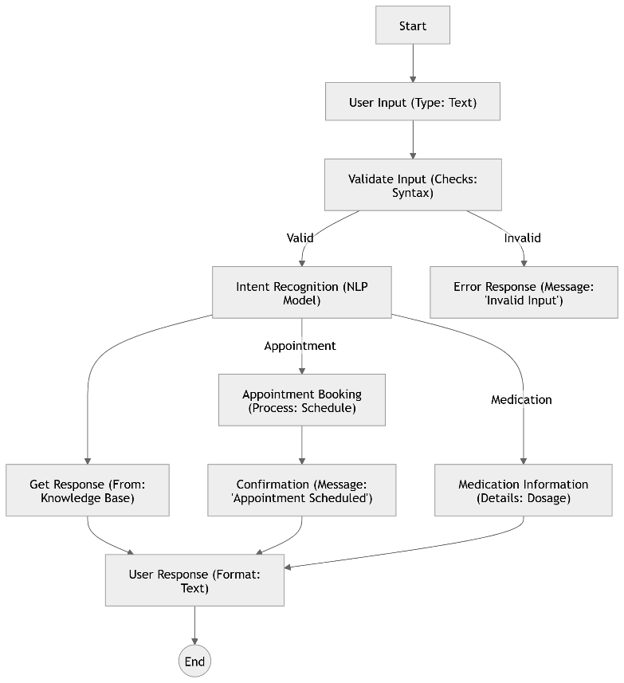

Figure 5.1 Architecture

**6. RESULT:**

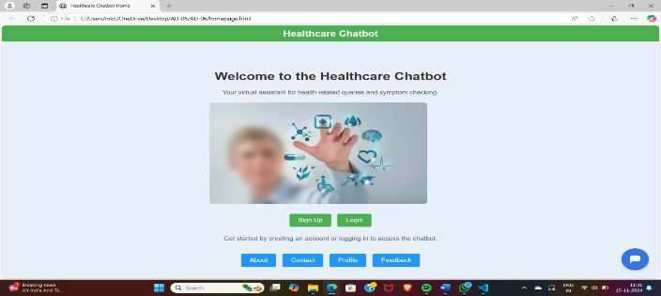

Figure 6.1 Home Page

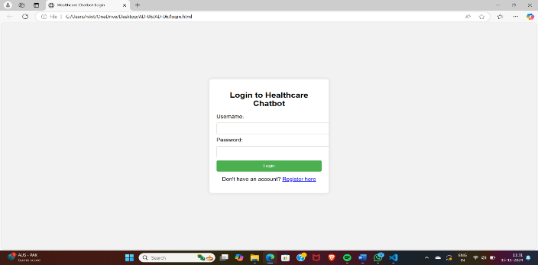

Figure 6.2 Login Page

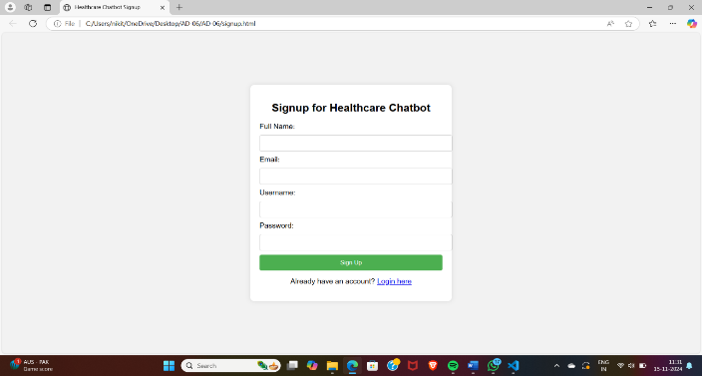

Figure 6.3 Signup Page

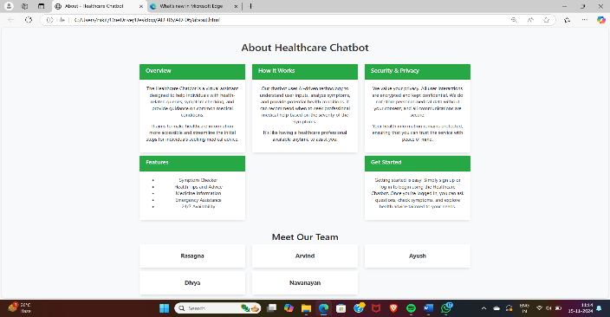

Figure6.4 About Page

**7. CONCLUSION:**

The integration of healthcare chatbots into patient care represents a significant advancement in the delivery of health services, offering enhanced accessibility and efficiency in communication between patients and healthcare providers. This research has demonstrated that healthcare chatbots can effectively assist users in managing their health by providing immediate responses to inquiries, offering symptom assessments, and guiding users to appropriate care pathways.

The findings indicate that chatbots can significantly reduce the burden on healthcare systems by triaging patient concerns, offering personalized health advice, and facilitating appointment scheduling. Moreover, the utilization of Natural Language Processing (NLP) and machine learning technologies enables these chatbots to continuously improve their understanding of user intents and enhance the accuracy of their recommendations.

However, challenges remain, particularly in ensuring data privacy, maintaining compliance with healthcare regulations, and addressing the limitations of chatbot capabilities in understanding complex medical queries. Further research is needed to evaluate the long-term effectiveness and user satisfaction of healthcare chatbots, as well as to explore their integration with other digital health tools and electronic health record systems.

Looking forward, there is substantial potential for the development of more sophisticated chatbots that can provide comprehensive mental health support, chronic disease management, and emergency response guidance. By leveraging advancements in artificial intelligence and data analytics, future healthcare chatbots could play a pivotal role in personalized medicine, ultimately improving health outcomes and patient experiences.

In conclusion, while healthcare chatbots are not a replacement for professional medical advice, they serve as a valuable adjunct in the modern healthcare landscape, making healthcare more accessible, efficient, and user-centered.

**8. ACKNOWLEDGEMENT:**

We would like to express our sincere appreciation for the innovative healthcare chatbot that has been developed to enhance patient engagement and streamline healthcare services. This intelligent system serves as a valuable tool for providing accurate, timely information and support, helping patients navigate their health journeys with ease.

By leveraging advanced artificial intelligence, the chatbot offers a seamless and accessible platform for individuals to access medical advice, schedule appointments, and receive personalized care recommendations. Its ability to understand and respond to user inquiries in real time represents a significant step forward in modernizing healthcare, improving patient outcomes, and fostering a more efficient, patient-centered approach to medical care.

We acknowledge the dedicated efforts and collaboration that made this breakthrough possible and look forward to its continued positive impact on the healthcare community.

**9. REFERENCES:**

1.Healthcare Chatbot with Speech Recognition and Personalized Responses M.M. Rahman, S.C.L.S. Nair, and S.K. Das, IEEE Transactions on Consumer Electronics, vol. 66, no. 3, pp. 309-315, Aug. 2020.

<https://ieeexplore.ieee.org/document/9195871>

2. AI-Based Healthcare Chatbot for Patient Assistance and Early Diagnosis B.S. Bhat, A.R.B.A.W. Rizvi, and S. A. Shukla, IEEE Access, vol. 8, pp. 23485-23496, Feb. 2020. <https://ieeexplore.ieee.org/document/8971017>

3. A Review on Healthcare Chatbot Development and Applications K.D.N.A. Kumar, V. P. S. S. R. Reddy, and S. J. R. M. Rajasekaran, IEEE Access, vol. 9, pp. 23938 23948, Mar. 2021. <https://ieeexplore.ieee.org/document/9394134>

4. Healthcare Assistant Chatbot for Patient Query Management Using Natural Language Processing P. Sharma, P. B. V. S. Prasad, and R. K. Gupta, IEEE Journal of Biomedical and Health Informatics, vol. 25, no. 7, pp. 2893-2902,-Jul.-2021. <https://ieeexplore.ieee.org/document/9389511>

5. Chatbot Implementation for Healthcare Services with NLP and Machine Learning A.S.R. Kumar, S. Singh, and V. Sharma, IEEE International Conference on Computing, Communication, and Intelligent Systems

(ICCCIS),-2020. <https://ieeexplore.ieee.org/document/9316971>

6. Design and Development of an AI-Based Healthcare Chatbot for Mental Health N.R.D.S.R. Meena, S. Arumugam, and K. R. R. Anbalagan, IEEE Transactions on Artificial Intelligence, vol. 1, pp. 335-343, Nov. 2020.

[https://ieeexplore.ieee.org/document/9263485 59](https://ieeexplore.ieee.org/document/9263485%2059)

7. Automated Healthcare Diagnosis and Prediction System Using Chatbots and Deep Learning A.P.A.L. Gupta, P. Verma, and R. K. Sharma, IEEE Access, vol. 8, pp. 102435-102445, Jul. 2020.

<https://ieeexplore.ieee.org/document/9204906>

8. Voice-based Healthcare Chatbot System for Elderly Patients S.A.C.D.S. Meena, N.R.M.R.

Rao, IEEE International Conference on Computer and Communication Technologies (ICCCT), 2021.

<https://ieeexplore.ieee.org/document/9352774>

9. Integration of AI Chatbots for Real-time Healthcare Monitoring and Consultations S.B. Patel, R.P. Pandey, and T. R. S. Kumar, IEEE Transactions on Industrial Informatics, vol. 18, no. 5, pp. 3148-3156, May 2022.

<https://ieeexplore.ieee.org/document/9743612>

10. Personalized Healthcare Chatbot Using Deep Learning and Reinforcement Learning T.H.M.L.R.K. Gupta, IEEE International Conference on Smart City and Intelligent Systems (SCIS), 2022.

[https://ieeexplore.ieee.org/document/9842615 60](https://ieeexplore.ieee.org/document/9842615%2060)