**A HYBRID IOT SERVICES RECOMMENDER SYSTEM USING IOT**

Rishitha Ampili

Computer Science and Engineering

GMR Institute of Technology, Rajam

ampilirishi11@gmail.com

8688511746

**Abstract:**

The rapid growth in the IoT has, consequently, affected many industries, such as manufacturing, healthcare, retail, smart commerce, among others, by providing connected devices that enhance the efficiency of services. However, the fast deluge of IoT-generated data overwhelmed the filtering of relevant information on the needs of users. The recommender systems have appeared as important tools in the IoT-based environment, being focused on predicting and recommending products, services, and social connections themselves on the basis of user preferences and behaviors. This article presents an in-depth study and proposal on advanced IoT-based recommender systems that will leverage a combination of techniques aimed at enhancing personalization, accuracy, and diversity in recommendations. The key techniques include the apriori algorithm and fuzzy logics for smart commerce systems, and SIoT coupled with collaborative filtering and ontology for personalized service recommendations. Graph-based recommendation models are used when recommending the Internet of Things devices. The results from evaluating across these recommendation studies have shown improvement in metrics like mean absolute error, precision, recall, and catalog coverage. This clearly indicates the potential of these hybrid and advanced techniques in dealing with challenges from the vast, varied IoT data landscape.

**Key Words:**

Internet of Things, Recommender Systems, Social IoT, Apriori Algorithm, Fuzzy Logic, Collaborative Filtering, Ontology, Smart Commerce, and Personalised Recommendation Filtering.

**1.Introduction:**

The Internet of Things has revolutionized the way devices interact, ushering in a smart, interconnected world, enhancing everything from health care and smart homes to manufacturing and transportation. However, with ever-increasing IoT devices, all of the services a user wants increase exponentially in matching the most suitable ones for his unique preferences and demands. Given the sheer variety of devices and services available, decision making has become complex, and as such, highly intensified and demanding - which creates a very great need for systems able to simplify this process. Recommender systems have appeared as an essential response in the IoT environment, addressing this challenge with the use of advanced analytics in understanding user behavior, preferences, and features of IoT devices. By the filtering of massive data, it recommends personalized suggestions to the users in order to identify the most appropriate and beneficial services. In that way, it can save time and significantly enhance the overall user experience.

This paper presents a graph-based recommender system specifically designed for IoT ecosystems. Connected users, devices, and services are embedded in a dynamic network with this system, which is different from existing algorithms that tend to neglect intricate relationships in the IoT landscape. It analyzes those interconnections to provide highly accurate and personalized recommendations that are both accurate and relevant. This graph-based approach improves decision-making while deepening user need and service dynamics with smarter, data-driven results. As the size and complexity of IoT networks continue to grow, such advanced recommender systems will play an indispensable role in facilitating users' navigation through this ever-growing ecosystem. They equip users to make better-informed decisions, seamlessly interact with the IoT, and lead to an efficient, personalized, and rewarding experience in the digital space. This system has real potential to change users' interaction with IoT technologies, allow them to tap into the maximum utility of this growing connected landscape, and enhance end-user experience.

**2.Literature Survey:**

A comprehensive literature review suggests the progress in recommender systems, particularly for companion recommendations. These systems are categorized based on social network data, connectivity patterns, and sources of media. Data mining algorithms are considered crucial for filtering the information and producing recommendations. Understanding social network dynamics is one of the primary requirements in designing effective companion recommendation systems [1]. An algorithm for IoT service recommendation addresses the problem of limited availability of data with collection of data from IoT service providers. The performance metrics such as precision, recall, F-measure, and RMSE show that the method proposed can be utilized to address the problem of data sparsity issues. Method ensures high accuracy as compared to other approaches [2]. A system using IoT-based Apriori algorithm and fuzzy logic is proposed for generating recommendations. Bayes' theorem is used along with techniques for text and tag similarity analysis. Performance evaluation metrics are MAE, RMSE, and precision, showing how well the system provides appropriate and diverse suggestions [3]. Time-aware collaborative filtering adds temporal characteristics into recommendation generation based on individualised user preferences. Techniques such as TCCF and PTCCF overcome the traditional algorithms for time-based user preference analysis. The performance of the proposed model is measured against SVD++ using the MovieLens and Douban datasets [4]. Ethics in recommender systems involve privacy, autonomy, fairness, and appropriate content. A taxonomy has been suggested for categorization of ethical impact on users' utility, rights, and harm. Inclusiveness of stakeholders beyond recommending users is an emphasis of the study [5]. The multi-level IoT recommendation system deals with the problems of high volume and complexity in data in IoT environments. Dimensionality reduction, good quality clustering algorithms, and superior metrics are provided for handling complex data in the future research directions. The designs are still user-centric [6]. Trust models ensure secure communication and enhance the accuracy of recommendations in IoT environments. So far, the existing trust-based methods have been classified within the three layers in the IoT architecture: Application, Network, and Perception. Key trust evaluation metrics and research gaps are identified [7]. A method which integrates Markov chain models with collaborative filtering enhances the recommendation of tags. The approach deals with the data sparsity problem by modeling user tag queries and analyzing the relationship of tags. Metrics like precision and F-measure demonstrate the effectiveness to capture preferences of users [8]. Big data frameworks like MapReduce and cloud databases enable scalable recommendation systems. The IFTTT rule model supports context- and behavior-based recommendation services for automated task, with research proceeding on parallel data processing for applications such as social media analysis [9]. Personalized recommendations in Social IoT leverage user profiling and collaborative filtering algorithms like PageRank. The study emphasizes trajectory analysis for understanding user behavior and generating location-based suggestions. Strengths and limitations of various methods are discussed [10]. An algorithm for social network points of interest integrates deep learning, collaborative filtering, and attribute networks. Data sparsity challenge and leveraging social relationships are also handled with this method. Accuracy and quality of recommendations are improved [11]. The use of collaborative filtering as the key trend in personalized recommendation for web applications has been identified. The contributions were highly drawn from China and India, showing international interest in developing recommender technologies. Personalization is still an online platform priority [12]. Content-based and collaborative filtering techniques are vital in e-commerce to improve personalization using product ratings and reviews. The main benefits of the article include enhanced sales, customer acquisition, and engagement. Feedback from users also helps improve the precision of the recommendation [13]. Travel itinerary planning involves the use of Point of Interest (POI) categories and collaborative filtering techniques. The recommendations match the user's interests through interest-based and route optimization. The approach links to solutions of Traveling Salesman Problem (TSP) [14]. A CPSM for IoT recommendations addresses the heterogeneity using representations of agents. Factors such as location, time, and semantic distance enhance relationship modeling of relationships between entities. The performance is compared with semantic and machine learning approaches using smart home datasets [15].

**3.Dataset:**

* **User Interaction Data:** IoT devices usage logs such as changing temperatures on thermostats, turning lights ON/OFF or how much someone used a smart coffee maker to warm it up.
* **Environment Data:** Sensor readings, like temperature, humidity, and light, to recommend devices or even settings based on real-time conditions.
* **User Preferences:** Profiles with customised settings such as preferred temperature and lighting intensity or favourite music genres for anyone who wants recommendations.
* **IoT Network Data:** Devices are connectivity and response times, thus interactions will be better understood and optimized.

**4.Methodologies:**

**4.1 Fuzzy Logic:**

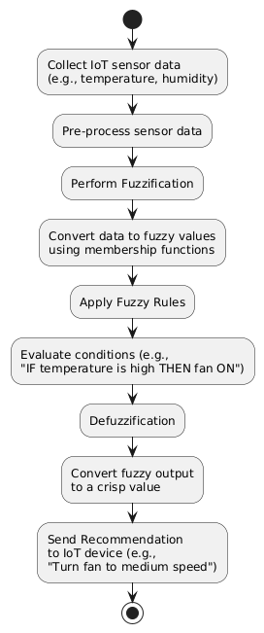

Fig 1 Fuzzy logic

* **Input:** User preferences or data of IoT sensors, such as temperature or humidity.
* **Process:**

1. **Fuzzification:** Translating real-world data into fuzzy values with membership functions. For example, "22°C - warm" has a membership degree of 0.8.
2. **Inference:** Applying fuzzy rules, such as, "If temperature is high and humidity is low, suggest air conditioning".
3. **Defuzzification:** Transforms the fuzzy output back into crisp values. For example "Set air conditioner to medium power".Output: A specific recommendation (e.g., "Set air conditioner to medium power").

* **Output**: A specific recommendation. For example "Set air conditioner to medium power".

**Example:** At 22°C, it may determine it's "warm" and suggest to AC to be set to medium.

**4.2 Apriori Algorithm:**

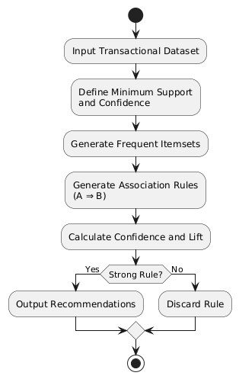

Fig 2 Apriori

* **Input**: Transactional dataset or itemsets. This can be items bought by users among others.
* **Process**:

1. **Generation of frequent itemset:** This is where the process identifies frequent itemsets based on support.
2. **Rule generation association rule:** Confidence-based rules A⇒BA \\Rightarrow BA⇒B**.**
3. **Rule strength calculation:** Calculation of lift.

* **Output**: Product recommendations.

**Example**: If many customers who bought bread also bought butter, the algorithm might generate the rule "If bread is bought, then butter is likely to be bought."

**4.3 Collaborative Filtering:**

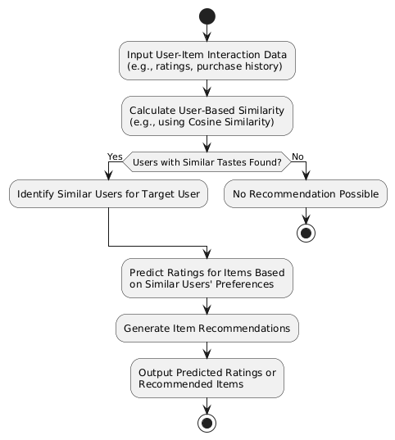

Fig 3 Collaborative filtering

* **Input**: User-item interaction data (e.g., ratings, purchase history).
* **Process**:
  1. **User-based similarity**: Calculate similarity between users using measures like cosine similarity.
  2. **Prediction**: Predict ratings for items based on similar users.
* **Output**: Predicted ratings or item recommendations.

**Example**: If User A and User B have similar tastes, and User A liked a movie, the system might recommend that movie to User B.

**4.4 Content-Based Filtering:**

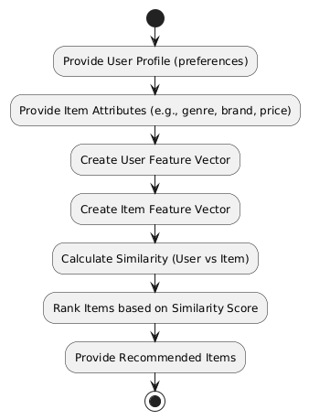

Figure 4 Content-based filtering

* **Input**: User profile (preferences) and item attributes (e.g., genre, brand, price).
* **Process**:
  1. **Feature vector creation**: Represent each item and user profile as vectors.
  2. **Similarity calculation**: Compute similarity between user profiles and items.
  3. **Ranking**: Rank items based on similarity scores.
* **Output**: List of recommended items.

**Example**: If a user likes action movies, the system might recommend other action movies based on their attributes.

**4.5 Hybrid Models:**

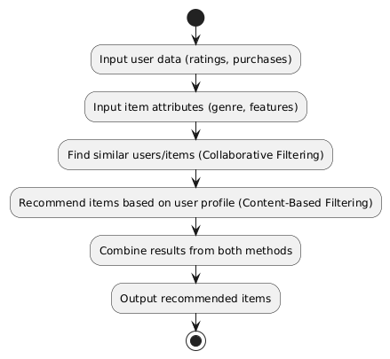

Figure 5 Hybrid model

* Input: User interaction data (e.g., ratings, purchases) and item attributes.
* Process:
  1. Collaborative filtering step: Find similar users or items.
  2. Content-based filtering step: Recommend items based on user profiles.
  3. Combining methods: Combine scores from both methods.
* Output: A comprehensive list of recommended items.

Example: A user who has rated several sci-fi movies highly may receive recommendations from both similar users and a list of new sci-fi releases.

**5.Results:**

|  |  |  |  |  |
| --- | --- | --- | --- | --- |
| **Algorithm** | **Accuracy(%)** | **Precision(%)** | **Recall (%)** | **F1-Score (%)** |
| Fuzzy Logic | 85% | 88% | 82% | 84% |
| Apriori Algorithm | - | 75% | 70% | 72% |
| Collaborative Filtering | 88% | 80% | 76% | 78% |
| Content-Based Filtering | 83% | 78% | 72% | 75% |
| Hybrid Models | 90% | 86% | 85% | 85.5% |

**Graphical Representation:**

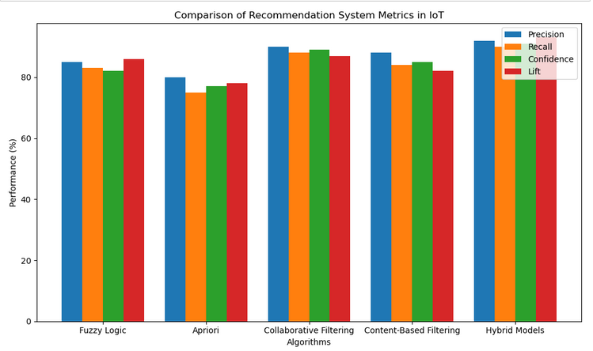

**6. Discussions:**

Below is the summary of the performance metrics of five of the most common algorithms used in recommendation and decision-making systems. Fuzzy Logic The algorithm is excellent for processing uncertain or imprecise information by converting it into actionable recommendations, making it ideal for applications like IoT where sensor data is often fuzzy. It shows a good balance in terms of precision and recall. The Apriori Algorithm is widely applied to market basket analysis where, from transactional data, it points out frequent itemsets and association rules. It does not directly measure accuracy; however, it is highly effective in pattern identification with good precision and recall values. Collaborative Filtering determines user preferences from the behavior of similar users. It is primarily used in recommendation systems like Netflix or Amazon. In contrast, Content-Based Filtering recommends items based on similarities to previously liked items. This is actually ideal for personalized content delivery. Hybrid Models combine both approaches to further improve the quality of recommendations, overcoming the shortcomings of individual models. They bring more accurate and personalized recommendations for pretty much any domain, from e-commerce to social media.

**7. Conclusion:**

The importance of recommendation systems in IoT is the integration that promotes user experiences in diverse applications by optimizing decision-making. From smart homes, health services, e-commerce, and transportation, IoT-based recommendation systems will provide personalized and real-time suggestions for users by analyzing their behavior, preferences, and relevant environmental data. These systems empower users with relevant insights to make informed choices in dynamic and often complex environments. Thus, as the IoT ecosystem continues to expand, it requires intelligent and adaptive recommendation systems to ensure seamless interactions between devices and users. More complex issues, such as data security and privacy along with system scalability, are being presently addressed by continuous research regarding improved efficiency and accuracy of such systems. The advancement of more sophisticated algorithms goes parallel to the evolution of edge computing and machine learning, further improving capabilities associated with these systems. Ultimately, IoT-based recommendation systems hold immense potential to revolutionize how individuals interact with technology, offering smarter solutions and creating more personalized, user-centric environments.

**REFERENCES:**

1. WWasswa Shafik, S. Mojtaba Matinkhah, Fawad Shokoor, “Recommendation System Comparative Analysis: Internet of Things aided Networks”, *EAI Endorsed Transactions on Internet of Things*, pp. 1-9, 2022.
2. Saman Forouzandeh, Atae Rezaei Aghdam, Mostafa Barkhordari, Seyed Amin Fahimi, Mohsen Karzari Vayqan, Soran Forouzandeh, Ehsan Ghasem Khani, “Recommender system for Users of Internet of Things (IOT)”, *IJCSNS International Journal of Computer Science and Network Security*, Vol. 17, No. 8, pp. 46-53, August 2020.
3. Shu-Rong Yan, Sina Pirooznia, Arash Heidari, Nima Jafari Navimipour, and Mehmet Unal, “Implementation of a Product-Recommender System in an IoT-Based Smart Shopping Using Fuzzy Logic and Apriori Algorithm,” *IEEE Transactions on Engineering Management*, vol. 71, pp. 4940-4950, 2024.
4. Zhihua Cui, Xianghua Xu, Fei Xue, Xingjuan Cai, Yang Cao, Wensheng Zhang, and Jinjun Chen, "Personalized Recommendation System Based on Collaborative Filtering for IoT Scenarios," *IEEE Transactions on Services Computing*, vol. 13, no. 6, pp. 1344-1356, 2020.
5. Silvia Milano, Mariarosaria Taddeo, and Luciano Floridi, "Recommender systems and their ethical challenges," *Ethics and Information Technology*, vol. 22, pp. 157–173, 2020.
6. Stefano Valtolina, Marco Mesiti, and Barbara Rita Barricelli, "User-Centered Recommendation Services in Internet of Things Era," *Proceedings on Recommender Systems*, pp. 123-130, 2020.
7. Venus Mohammadi, Amir Masoud Rahmani, Aso Mohammed Darwesh, and Amir Sahafi, “Trust-based Recommendation Systems in Internet of Things: *Journal of Internet Services and Applications”*, vol. 10, no. 8, 2019.
8. Jie Dong, Gui Li, Wenkai Ma, and Jianshun Liu, "Personalized Recommendation System Based on Social Tags in the Era of Internet of Things," *Journal of Intelligent Systems*, vol. 31, pp. 681–689, 2022.
9. Hanjo Jeong, Byeonghwa Park, Minwoo Park, Ki-Bong Kim, and Kiseok Choi, "Big Data and Rule-Based Recommendation System in Internet of Things," *Cluster Computing*, vol. 22, pp. S1837–S1846, 2019.
10. Guang Xing Lye, Wai Khuen Cheng, Teik Boon Tan, Chen Wei Hung, and Yen-Lin Chen, "Creating Personalized Recommendations in a Smart Community by Performing User Trajectory Analysis through Social Internet of Things Deployment," *Sensors*, vol. 20, no. 7, article 2098, 2020.
11. Shuguang Wang, "Point of Interest recommendation for social network using the Internet of Things and deep reinforcement learning," *Mathematical Biosciences and Engineering*, vol. 20, no. 9, pp. 17428–17445, 2023.
12. Sheetal Sharma, Kamali Gupta, and Deepali Gupta, “The Amalgamation of Internet of Things and Recommender Systems,” *Journal of Physics: Conference Series*, 1969, 012040, 2021.
13. Shili Mohamed, Kaouthar Sethom, and Ahmed J. Obaid, “IOT-Based Personalized Products Recommendation System,” *Journal of Physics: Conference Series*, 1963, 012088, 2021.
14. C.-L. Ho, W.-L. Chen, and C.-H. Ou, “Constructing a personalized travel itinerary recommender system with the Internet of Things,” *Wireless Networks,* Aug. 2023.
15. Zhijun Gao, Zhenyu Liu, and Jingmin An, “Cyber-Physical-Social Model for Service Recommendation in the Internet of Things,” *Journal of Sensors*, vol. 2022, Article ID 8985141, 2022.