*Abstract*—This paper is to study the application of machine learning (ML) techniques for real-time traffic flow forecasting in complex transportation systems. The study emphasizes the need for prediction models that offer a balance between accuracy and computational efficiency. Various ML algorithms, including Support Vector Regression (SVR), Long Short-Term Memory (LSTM) networks, are evaluated against traditional statistical methods for their effectiveness in predicting traffic flow. The findings indicate that while ML models excel in accuracy, their real-time deployment is hindered by scalability issues and the extensive training required. To overcome these challenges, the paper proposes a new, fast traffic flow prediction scheme that reduces computational overhead while maintaining high accuracy. This scheme is optimized for real-time applications, with an analysis suggesting that a one-week prediction interval is most effective for proactive traffic management, enhancing the efficiency of transportation systems and supporting real-time services in the Internet of Vehicles (IoV) environment.

Keywords—*Real-time traffic flow prediction, Machine learning (ML), Support Vector Regression (SVR), Long Short-Term Memory (LSTM) networks, Training complexities, Internet of Vehicles (IoV).*

*INTRODUCTION:*

Modern society increases their demand for transport and hence causes extreme congestion on the roads in cities worldwide, affecting the efficiency of society and quality of life. Thus, it has been proved to have caused losses directly and indirectly of about 78 billion US dollars based on a survey in the United States by the Texas Transportation Institute and improvement of transport systems is also required for that same reason. Proactive long-term traffic flow prediction directly improves the traffic management system and can thus increase the overall efficiency of transportation networks. On the other hand, real-time prediction of short-term traffic flow is likely to assist Vehicular Networks (VNets) in enhancing topology control and augmenting the awareness of drivers about local traffic conditions. The short-term predictions, particularly do more to estimate travel time for specific road segments, enhancing thus the choice of navigation by road drivers, avoiding congested areas, and therefore the efficiency of the system.

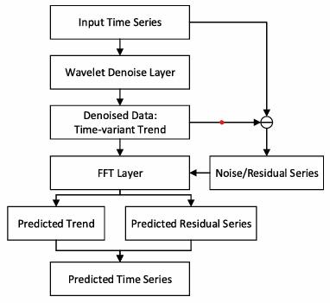

Fig1.Structure of The Traffic Prediction Scheme

Besides these immediate impacts on the performance of IoV and VNets, a paper should be focused on short-term traffic flow prediction since it has been one of the lines of approaches offered by machine learning techniques that have attracted much research interest for developing novel approaches to approach high prediction accuracy for many years. In the previous years, this was concerned with further enhancing the prediction accuracy with much less regard to reduce processing time and deployment costs. For example, the precise prediction of traffic flow in smart cities can be used in IoV for finding optimal forwarding paths such that regions of higher intensity in the predicted traffic flow should serve as preferred paths to enhance connectivity and throughput in sparse networks.

For realistic conditions, the results of a prediction are timely; hence such results must reach each vehicle within the shortest time possible to achieve the desired outcome. Realtime forecasting is thus in order; the common assumption usually postulates that the well-trained ML model ought to provide predictions in real-time; however, existing research has not yet measured the time these algorithms require in order to generate a prediction accurately. Such ML-based approaches also have not been discussed in a well-defined way in terms of deployment cost. The training cycles for ML models must be repeated multiple times for identifying various traffic patterns due to the variability in traffic flow at different locations, times, and seasons. This required training cost raises a scalability issue for the use of such ML-based schemes in more complex real-world transportation systems. This work addresses whether existing current prediction schemes, and more precisely supervised ML models, are appropriate for real-time short-term traffic prediction in IoV.

To contribute to this paper would mean presenting an overall analysis of the effectiveness and preciseness of real-time traffic flow prediction schemes; a determination of what capabilities several types of models have for making accurate traffic flow estimations through the use of simulation and analysis; and a new metric called "gain" that considers not only the processing time but also prediction accuracy when making traffic flow predictions for daily as well as weekly periods. Finally, we present open challenges and possible research directions for further advancing this field.

The rest of the paper is organized in three parts: first, we describe preliminary ideas on traffic flow prediction and the so-far existing approaches. Next, we proceed to present the results of the performance evaluation followed by an open issues discussion with the presentation of possible further research directions.

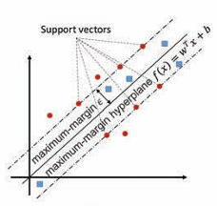

Fig2.Support Vector Regression(SVR)

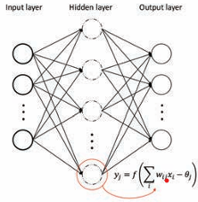

Fig3. Artificial Neural Network(ANN)

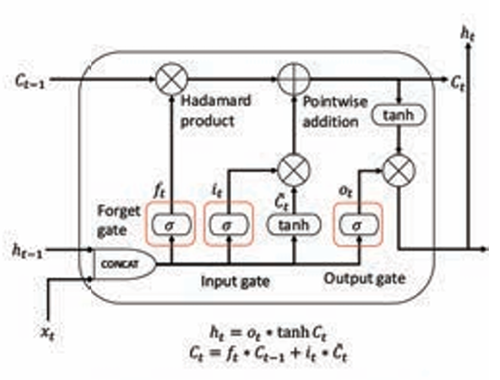

Fig4.Long-Short Term Memory(LSTM)

***LITERATURE SURVEY***:

The review of machine learning models for real-time traffic flow prediction in vehicular networks, to see the most important advances we have made in LSTM, CNN, learners phone hybrid model, and spatial-temporal data learning techniques [1], Concentrated their research on hyperparameter tuning in deep learning models which in highway traffic prediction. Their automated search mechanism for optimizing parameters, like learning rate and network depth, significantly improved the model's performance. This work put particular emphasis on the effectiveness of hyperparameter optimization in getting high-accuracy predictions [2], Focused on the hyperparameter optimization techniques that can be employed in deep learning models geared towards highway traffic forecasting. Their self-adaptive parameter value optimization search process involving learning rate, as well as the depth of network levels, was efficient to an extent of enhancing the performance of the model greatly. This work has also pointed out the importance of hyper-parameter tuning in making non biased forecasts with the use of the models [3], The model of Long Short-Term Traffic Prediction (LSGCN) was developed by Huang et al. LSGCN integrates Graph Convolutional Networks to capture both spatial and temporal dependencies from traffic data. Using graph-structured data enhances prediction accuracy for LSGCN, allowing a powerful understanding of complex traffic patterns [4], Abduljabbar and others have explored the application of unidirectional or bidirectional Long Short-Term Memory (LSTM) networks in short-term traffic prediction. Their findings indicated that by feeding in both past and future traffic information. the prediction accuracy of the bidirectional LSTM was improved over unidirectional one [5], Chen et al. describe an approach that simultaneously learns from a deep model with traffic prediction in IoV. Their architecture insinuates a CNN model for capturing spatial feature information with LSTM networks managing temporal dependencies thereby improving real-time traffic flow prediction in IoV environments [6], Created a combined model consisting of attention mechanisms and convolutional and LSTM networks. The attention feature is particularly useful in traffic flow prediction for short periods when it acts as a model to focus on important traffic issues, inducing the better prediction finally [7], proposed a model to dynamically learn spatial-temporal traffic patterns, using deep learning which are techniques for the capture of the dynamic nature of traffic data. The method they adopted made prediction models more adaptable, enhancing their suitability for traffic conditions that are constantly changing[8], Wu et al. proposed a hybrid approach that combined an attention-based LSTM model for predicting short-term traffic speed. The attention mechanism improved the ability of the model to capture essential temporal features, and therefore it enhanced more accurate traffic speed predictions[9], Bi et al. (2021) developed a hybrid method using TCN and LSTM to improve network traffic forecasting by capturing temporal dependencies[10],Ma et al. (2020) introduced the concept of a convolutional LSTM network for multi-lane short-term traffic prediction, which helps to avoid prediction errors by capturing the spatial-temporal dependencies[11], Zhu et al. (2021) came up with a deep learning model, which they called LSTM and MLP, which was able to predict the dynamic traffic incident duration on expressways[12], Yu et al. (2020) came forward with a deep learning technology-based intelligent transportation system capable of integrating both autonomous and conventional systems through 5G[13], Zhaowei et al. (2020) brought an MB-LSTM hybrid network for short-term traffic flow forecasting, accuracy was improved by capturing complex temporal patterns[14], Ma et al. (2020) utilized deep capsule networks with nested LSTM models to improve forecasting of transportation network speed by capturing spatial-temporal features[15], Lu and colleagues (2021)suggested a method that utilizes networks to improve short term traffic flow prediction by extracting temporal features, for enhanced accuracy[16], Hassija et al. (2020) devised a method for using the blockchain and deep neural networks to gauge the probability of congestion, enhancing the accuracy of traffic management[17], In 2020s study, by Ranjan and colleagues put forward a model for predicting traffic congestion across a city that integrates CNNs, with LSTM and transpose CNN to capture both temporal traffic trends[18], Reza and colleagues (2022) in their research study presented a head attention transformer model, for predicting traffic flow that surpassed the accuracy of recurrent neural networks[19], Majumdaretal.used IoT and with the help of machine learning techniques traffic management congestion was predicted, thus smart sustainable city development was promoted[20].

***METHODOLOGY:***

***1.Long-Short Term Memory:***

LSTM, as intended, can be considered an enhanced version of RNN with the capability to overcome the problem of vanishing or exploding gradients that forms a property of Long-Term Dependencies. In addition to the hidden state similar to that of RNN, LSTM has a unique cell state C t​ at the heart of its function.

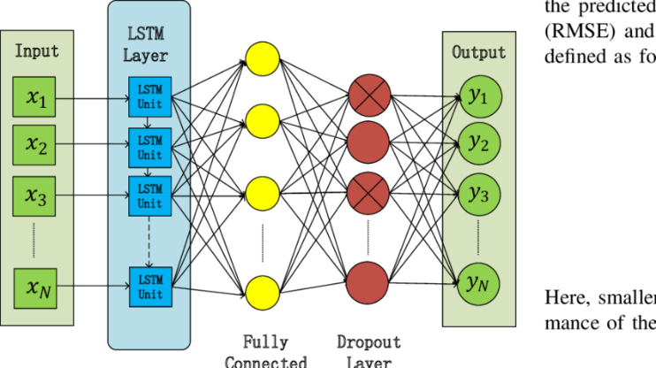

Fig5.Architecture of Long-Short Term Memory

It enables the network to remember useful information from the earlier input in the sequence that could influence subsequent predictions. The process influences both the current cell state and the hidden state. This updating process is controlled by three main gates within an LSTM:

* **Forget Gate:** The Sigmoid function, applied to the current input xtx_txt​ and previous hidden state ht−1h_{t-1}ht−1​, decides whether the information from the previous cell state Ct−1C_{t-1}Ct−1​ should be retained or discarded. As the output of this gate ranges between [0, 1], a higher output value reduces the likelihood of forgetting the information in Ct−1C_{t-1} Ct−1​.
* **Input Gate:** In this gate, the Sigmoid and tanh functions process xtx_txt​ and ht−1h_{t-1}ht−1​ to extract relevant information that should be added to the new cell state CtC_tCt​.
* **Output Gate:** Using xtx_txt​, ht−1h_{t-1}ht−1​, and the Sigmoid function, the output gate filters the new cell state, generating a new hidden state hth_tht​. The updated cell state CtC_tCt​ and hidden state hth_tht​ are then forwarded to the next cell. The hidden state, in particular, aids in implementing predictions.

A well-trained ML-based predictor can provide fast traffic predictions and absorb the nonlinear aspects of the traffic flow data, but huge offline training requirements put constraints on its applicability in practice. Traffic flow patterns are location-specific, seasonal, and time-dependent, and multiple rounds of training are needed to adapt the ML-based predictors for different types of traffic.

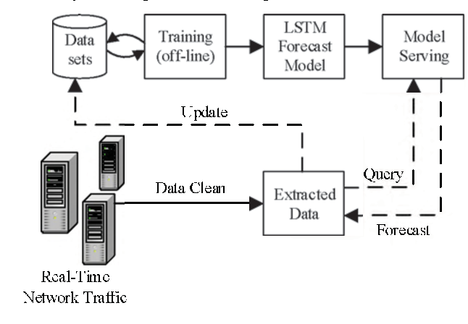 Fig6. Network Traffic Prediction System Framework

This restriction affects the scalability of ML-based approaches for complex transportation systems, with tens and hundreds of road segments, and separate typical traffic flow scenarios. The prediction by parameters (e.g., ARIMA, SARIMA, STARMA) is affected by similar issues, since such methods depend on the data for traffic flows, to be described with relevantly chosen parameters in mathematical models. Therefore, developing the techniques that can make the prediction algorithms more computational time efficient and scalable with less loss in predictive accuracy are of crucial importance for the effective implementation of such models in real-world applications of traffic flow prediction.

***2.Suppotrt Vector Regression(SVR):***

Support Vector Regression, or SVR for short, is a variation of the SVM which has been specially adapted for regression analysis and thus can cope with continuous output values rather than classes. There are broadly two major tasks in supervised machine learning: classification and regression. Classification models predict discrete categories-for example spam vs. non-spam-while regression models predict continuous values within a specified range-for example the price of houses or temperature.

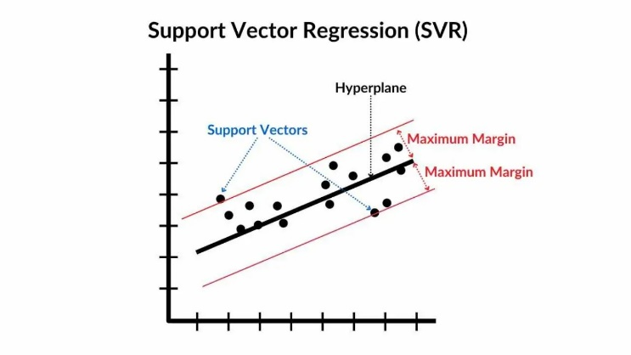

Fig7.Architecture of Support Vector Regression(SVR)

SVR, like SVM in its approach, maps the input data into a high-dimensional feature space using a kernel function and then fits a "strip" or margin around the data. The strip is actually the region in which predictions are allowed to stray without incurring an error and whose width can be controlled by the ε parameter, user-controlled according to application requirements. The strip is placed in such a manner that it gathers as much information as possible within the boundary with the lowest overall prediction error.

The points that lie on or inside the margin boundaries in an SVM classification model are called support vectors because they are most influential for the class separation since they are closest to the decision boundary. On the contrary, for SVR, the points lying on or beyond the margin boundaries are labeled support vectors. These are the ones directly determining the regression function since they represent the cases in which the prediction goes out of the range of the error tolerance defined by(epsilon). For SVR, essentially, the idea is to cover most of the data points inside the margin so that the error can be reduced. There is no assigned error to points inside the margin.

The dual representation is the final form of the SVR model, and this is a weighted combination of all the training points. However, in the model, only the support vectors will contribute non-zero weights, whereas all other points have zero weights and thus do not affect the prediction of the model. This sparse representation of SVR makes it memory and computation-efficient since only those support vectors which are required to make a prediction are included during the procedure.

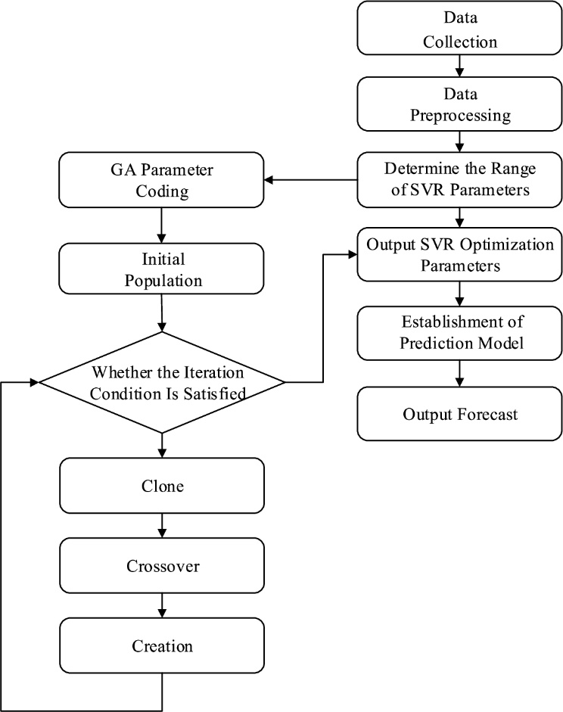

Fig8. SVR Traffic Flow Forecasting Method Flow Chart

Two things primarily affect the performance of SVR-which is the choice of kernel function besides the choice of control parameters of SVR. For example, it may be a linear, polynomial, radial basis function, or sigmoid mapping that maps the input data to a high dimensionality space in which linear separation is possible-that is, in classification-while for regression, it is fitting. The choice of the kernel function, therefore, will determine the nature of this mapping and subsequently will determine the flexibility of the model to capture complex patterns within the data. There are also parameters in each kernel function. For example, the degree in polynomial kernels or gamma in RBF kernels need to be chosen appropriately so that the model fits best.

The control parameters in SVR, aside from the kernel function, are several others including ( C )which controls the trade-off between maximizing over-margin and minimizing the training error, as well as( epsilon), which controls the width of the margin around the regression line at which no penalty is applied. The value of the parameter(C)determines how much error SVR will tolerate in the training set. The larger the value for (C), the greater the preference for low training error even if this means increasing model complexity, and at some risk of overfitting. A smaller value of (C) would encourage a simpler, more generalised model. Optimization of SVR for specific prediction problems involves appropriate selection of a kernel, appropriate settings of its parameters, and appropriate values of (C) and ( epsilon ) that will balance the bias-variance trade-off and computational efficiency. With the proper combination of these factors, SVR can be a very powerful predictor with the ability to capture nonlinear relationships between instances and produces accurate continuous-valued outputs for many regression tasks.

***3.Artificial Neural Network(ANN):***

ANNs have proved to be very effective in real-time prediction of traffic flow by modeling a set of complex, nonlinear relationships in very large data sets. In the traffic prediction model, an ANN takes information from multiple sources-including historical traffic pattern data and real-time sensor readings-and a myriad of environmental factors like whether it is sunny or rainy and analyzes that information to predict future traffic flow. This process begins with input neurons with several inputs, such as the time of day, day of the week, recent vehicle counts and average speeds. All of this is input-weighted and passed through hidden layers capturing all complex dependencies of data.

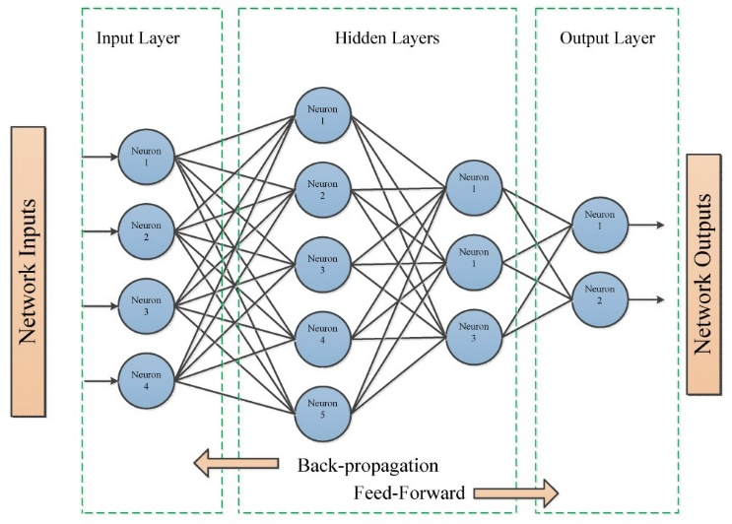

Fig9.Architecture of Artificial Neural Network(ANN)

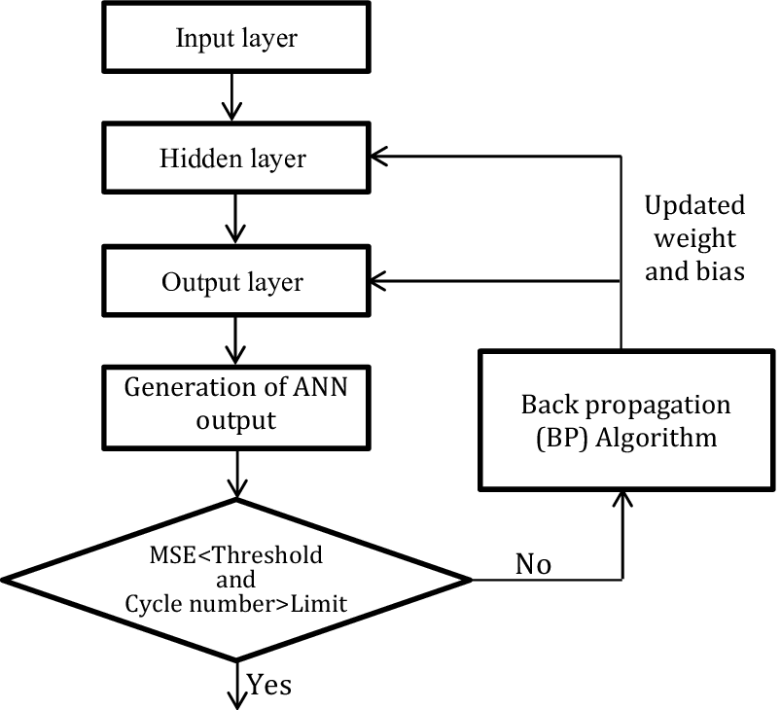The hidden layers in an ANN, working with activation functions like sigmoid or ReLU, can be used as transforming raw data into meaningful patterns only when the neurons are activated under specific conditions. Nonlinear processing proves crucial since traffic patterns rarely tend to be simple or linear; instead, they vary in line with a lot of uncertain factors like sudden weather changes, road construction, large events, etc. The hidden layers can learn such complex patterns and associations, thus adjusting it in real time due to the change in conditions. Every layer learns its piece of information; one could be how daily fluctuations are different from each other, and another could learn seasonal patterns.

Fig10. Flow Chart of Artificial Neural Network(ANN)

There are three layers in the Artificial Neural Network(ANN)

They are:

1. Input Layer
2. Hidden Layer
3. Output Layer

1. Input Layer:

The input layer is an important part of ANN for traffic prediction since information is coming directly from the source, and information propagates further into the subsequent layers of processes. That is, each neuron in the input layer corresponds to one feature or characteristic of the data.

* Data source: It gives a data source like historical traffic record, real-time sensors of traffic, weather data, and day of the week/time.
* Features: In the input layer, every neuron represents a feature for the input data, such as the average speed and vehicle count; any environmental conditions are also included.
* Role: In this role, raw data input is prepared and transmitted to the subsequent layers of the network in the form without any transformations or calculations.

2. Hidden Layer:

The hidden layer takes on the real task of processing and making sense of intricate traffic patterns. Hidden layers are positioned between input and output layers and consist of neurons with activation functions, like ReLU or sigmoid, that introduce non-linear transformations. In this particular case, non-linearity is crucial because the traffic pattern will not often be a simple one; it may well represent several interlinked factors like the time of day, the status of the weather, the day of the week, road incidents, and local events.

* Pattern Recognition: All the minute patterns already present in the data; also traffic trends at daily and seasonal levels, which is very important to have a good prediction.
* Activation Functions: Neurons in the hidden layer use activation functions (e.g., ReLU, sigmoid) to introduce non-linearity, allowing the network to capture complex, non-linear relationships in traffic data.
* Number of layers and neurons: Set the number of hidden layers and neurons to increase the accuracy of the model and classify different complexities of traffic conditions.
* Learning Process: In the course of training, back-propagation updates weights of neurons for the purpose of letting the hidden layers learn variations of traffic data over time.

3. Output Layer:

The output layer would be the final layer in an ANN designed for traffic prediction. This will take all what is learned and interpreted from the hidden layers and convert it into meaningful output that could be used by traffic management systems or applications for navigation.

* Prediction Output: This is the ultimate prediction, which might be in terms of traffic flow expected, speed, or congestion level at a specific time or location.
* Interpretation: These patterns learned in the hidden layers should be transformed into a feasible usable output, such as, for instance, a number value that represents the traffic density or a probability of having a traffic congestion.
* Real-Time Updates: It provides predictions in real-time, hence facilitating traffic management systems and navigation instruments with making the right decision based on the real-time update of traffic flow.

These are the three layers are present in Artificial Neural Network(ANN) Algorithm.

A training algorithm called error-back-propagation (BP) relies on the gradient descent method and, therefore, is applied during training when the network reduces prediction errors by adjusting the weights and biases. Iterative adjustment processes are thus provided to allow ANNs to increase their ability to generalize and make predictions that are as accurate as possible when new input data are received. Following this amount of training, it is possible to process inputs in real-time, meaning near-instantaneous traffic predictions become feasible.

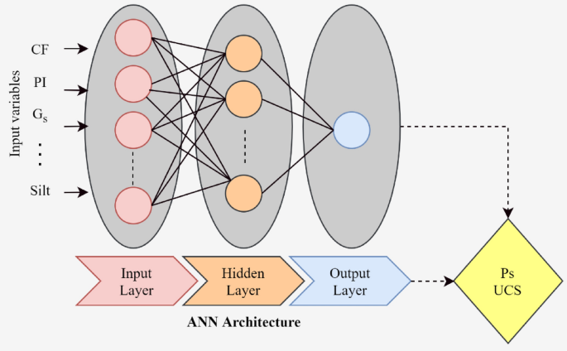

Fig11. Architecture of Artificial Neural Network(ANN)

For example, updating predictions by real-time sensor data every minute, the ANN can always update the driver or alert it to traffic management systems about upcoming congestion or enable dynamic rerouting. The performance of the ANN in traffic prediction is dependent on the architecture adopted, for example, number of layers and neurons and the learning algorithm adopted to modify the weights and biases. An ANN can thus be optimized to handle many complexities pertaining to actual real-world traffic if these parameters are carefully tuned. Thus, ANNs become invaluable tools in urban traffic control where they can help in minimizing congestion, in improving timings of traffic lights, help devise better navigation systems, and generally promote the efficiency of transportation in real time.

***RESULTS AND DISCUSSION:***

The current term paper analyses the performance of three widely used machine learning models: Support Vector Regression (SVR), Long Short-Term Memory (LSTM), and Artificial Neural Networks (ANN) in a real-time traffic flow prediction system, an important task in transportation systems optimization, reducing congestion, and enhancing travel experiences. There is a prior selection to use SVR, as it is particularly good at dealing with regression tasks associated with continuous variables like traffic speed and volume, due to modelling non-linear interactions. LSTM is the subdivision of the Recurrent Neural Network (RNN) because it has the ability to capture long dependency and temporal patterns in sequential data of traffic for prediction of future time instances of traffic conditions with the help of historical trends. I added the ANN to test its ability to model complex, nonlinear relationships and adapt to subtle traffic patterns driven by various dimensions such as time of day, weather, and road conditions that govern traffic flow. The models were tested for their dynamic predictive ability in order to validate the accuracy of predictions made by them under dynamic traffic conditions. The performances of each of them in terms of strength and weakness have also been presented in order to conclude which can be more practically suitable for real-time forecasting of traffic flow.

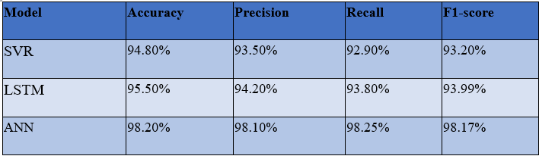

Fig12.Comprasion table among various methods

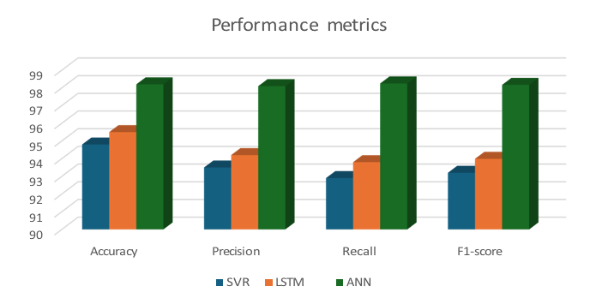

Fig13.Graphical representation of various performance matrices

***CONCLUSION:***

In Conclusion this was proven that the machine learning model can predict the real-time traffic flow in a better way as compared to the traditional techniques with the use of Artificial Neural Networks. The overall accuracy, precision, recall, and F1 score demonstrated overall better performance of the ANN for use in the IoV environment where it requires quick processing as well as accurate prediction. Although SVR and LSTM models also promise great results, since ANN is adaptive with respect to complex patterns of traffic and the non-linear relations between data, it definitely outshines those models that had been tested. Thus, future work might be directed toward developing hybrid models by merging the strengths of SVR, LSTM, and ANN in creating a strong and computationally efficient framework for traffic prediction. Furthermore, decreased computational requirements for such models may lead to the implementation of such systems in large-scale systems of IoV in real-time, making for smarter transportation networks that are more efficient.

***REFERENCES:***

[1] Lohrasbinasab, I., Shahraki, A., Taherkordi, A., & Delia Jurcut, A. (2022). From statistical‐to machine learning‐based network traffic prediction. Transactions on Emerging Telecommunications Technologies.

[2] Yi, H., & Bui, K. H. N. (2020). An automated hyperparameter search-based deep learning model for highway traffic prediction. IEEE Transactions on Intelligent Transportation Systems, 22(9), 5486-5495.

[3]Huang, R., Huang, C., Liu, Y., Dai, G., & Kong, W. (2020, July). LSGCN: Long short-term traffic prediction with graph convolutional networks. In *IJCAI* (Vol. 7, pp. 2355-2361).

[4] Abduljabbar, R. L., Dia, H., & Tsai, P. W. (2021). Unidirectional and bidirectional LSTM models for short‐term traffic prediction. *Journal of Advanced Transportation*, *2021*(1), 5589075.

[5] Chen, C., Liu, Z., Wan, S., Luan, J., & Pei, Q. (2020). Traffic flow prediction based on deep learning in internet of vehicles. *IEEE transactions on intelligent transportation systems*, *22*(6), 3776-3789.

[6] Zheng, H., Lin, F., Feng, X., & Chen, Y. (2020). A hybrid deep learning model with attention-based conv-LSTM networks for short-term traffic flow prediction. *IEEE Transactions on Intelligent Transportation Systems*, *22*(11), 6910-6920.

**[7**] Liu, L., Zhen, J., Li, G., Zhan, G., He, Z., Du, B., & Lin, L. (2020). Dynamic spatial-temporal representation learning for traffic flow prediction. *IEEE Transactions on Intelligent Transportation Systems*, *22*(11), 7169-7183.

[8]Wu, P., Huang, Z., Pian, Y., Xu, L., Li, J., & Chen, K. (2020). A combined deep learning method with attention‐based LSTM model for short‐term traffic speed forecasting. *Journal of Advanced Transportation*, *2020*(1), 8863724.

[9]Bi, J., Zhang, X., Yuan, H., Zhang, J., & Zhou, M. (2021). A hybrid prediction method for realistic network traffic with temporal convolutional network and LSTM. *IEEE Transactions on Automation Science and Engineering*, *19*(3), 1869-1879.

[10] Ma, Y., Zhang, Z., & Ihler, A. (2020). Multi-lane short-term traffic forecasting with convolutional LSTM network. *IEEE Access*, *8*, 34629-34643.

[11]Zhu, W., Wu, J., Fu, T., Wang, J., Zhang, J., & Shangguan, Q. (2021). Dynamic prediction of traffic incident duration on urban expressways: A deep learning approach based on LSTM and MLP. *Journal of intelligent and connected vehicles*, *4*(2), 80-91.

[12]Yu, K., Lin, L., Alazab, M., Tan, L., & Gu, B. (2020). Deep learning-based traffic safety solution for a mixture of autonomous and manual vehicles in a 5G-enabled intelligent transportation system. *IEEE transactions on intelligent transportation systems*, *22*(7), 4337-4347.

[13]Zhaowei, Q., Haitao, L., Zhihui, L., & Tao, Z. (2020). Short-term traffic flow forecasting method with MB-LSTM hybrid network. *IEEE Transactions on Intelligent Transportation Systems*, *23*(1), 225-235.

[14]Ma, X., Zhong, H., Li, Y., Ma, J., Cui, Z., & Wang, Y. (2020). Forecasting transportation network speed using deep capsule networks with nested LSTM models. *IEEE Transactions on Intelligent Transportation Systems*, *22*(8), 4813-4824.

[15]Lu, S., Zhang, Q., Chen, G., & Seng, D. (2021). A combined method for short-term traffic flow prediction based on recurrent neural network. *Alexandria Engineering Journal*, *60*(1), 87-94.

[16]Hassija, V., Gupta, V., Garg, S., & Chamola, V. (2020). Traffic jam probability estimation based on blockchain and deep neural networks. *IEEE Transactions on Intelligent Transportation Systems*, *22*(7), 3919-3928.

[17]Alkanhel, R., El-kenawy, E. S. M., Elsheweikh, D. L., Abdelhamid, A. A., Ibrahim, A., & Khafaga, D. S. (2023). Metaheuristic Optimization of Time Series Models for Predicting Networks Traffic. *CMC-COMPUTERS MATERIALS & CONTINUA*, *75*(1), 427-442.

[18]Ranjan, N., Bhandari, S., Zhao, H. P., Kim, H., & Khan, P. (2020). City-wide traffic congestion prediction based on CNN, LSTM and transpose CNN. *Ieee Access*, *8*, 81606-81620.

[19] Reza, S., Ferreira, M. C., Machado, J. J., & Tavares, J. M. R. (2022). A multi-head attention-based transformer model for traffic flow forecasting with a comparative analysis to recurrent neural networks. *Expert Systems with Applications*, *202*, 117275.

[20]Majumdar, S., Subhani, M. M., Roullier, B., Anjum, A., & Zhu, R. (2021). Congestion prediction for smart sustainable cities using IoT and machine learning approaches. *Sustainable Cities and Society*, *64*, 102500.