**Shantanu Kadam**

**SUBJECT - FINANACIAL PLANNING & WEALTH MANAGEMENT**

**PROJECT TOPIC – FINANCIAL PLANNING OF A SALARIED INDIVIDUAL**

Financial Planning:

Financial planning is the process of setting goals, evaluating current financial resources, and creating strategies to achieve those goals efficiently. It involves assessing one's financial situation, identifying financial objectives, and developing a comprehensive plan to manage income, expenses, savings, investments, and debt effectively. Financial planning is a dynamic and on-going process that requires regular review and adjustments as circumstances change, financial goals evolve, and external factors impact financial stability. It empowers individuals to make informed financial decisions, navigate life transitions, and build a secure financial future for themselves and their families, financial wealth and financial planning are integral components of overall financial well-being, providing individuals with the tools and strategies to achieve their financial goals, build wealth, and attain financial security and independence over time.

Interview:

1. **Income and Expenses Details:**
   * Can you provide details about your monthly income after taxes?
   * What are your essential monthly expenses, including rent/mortgage, utilities, groceries, and transportation?
2. **Financial Goals:**
   * Could you share two financial goals you have for the future?, Buying a home, funding your child's education, or starting a business.
   * What is the estimated cost and the time horizon for each of these goals?
3. **Retirement Planning:**
   * What age do you plan to retire?
   * Could you provide an estimate of your current annual expenses?

Now, let's move on to creating a basic financial plan based on the information gathered.

**Cash Flow Statement:**

| **Income** | **Amount ($)** |
| --- | --- |
| Monthly Income | [Enter amount] |
| Expenses | [Enter amount] |
| Savings/Investments | [Enter amount] |
| Net Cash Flow | [Enter amount] |

**Financial Goals:**

1. **Goal 1: [Enter Goal]**
   * Estimated Cost: $[Enter amount]
   * Time Horizon: [Enter number of years]
   * Future Value Calculation: Future Value = Estimated Cost * (1 + Annual Interest Rate) ^ Number of Years
2. **Goal 2: [Enter Goal]**
   * Estimated Cost: $[Enter amount]
   * Time Horizon: [Enter number of years]
   * Future Value Calculation: Future Value = Estimated Cost * (1 + Annual Interest Rate) ^ Number of Years

**Retirement Planning:**

* Retirement Age: [Enter age]
* Current Annual Expenses: $[Enter amount]

**Retirement Corpus Calculation:**

* + Retirement Corpus = Annual Expenses * (1 + Expected Inflation Rate) ^ (Life Expectancy - Current Age)

**Investment Recommendations:**

Based on your financial goals and retirement plans, here are some investment options to consider:

1. **Emergency Fund:**
   * Keep 3-6 months of living expenses in a high-yield savings account for emergencies.
2. **Short-Term Goals (e.g., Buying a Home):**
   * Consider low-risk options like a Certificate of Deposit (CD) or a conservative mutual fund.
3. **Long-Term Goals (e.g., Child's Education):**
   * Invest in a diversified portfolio of stocks and bonds for potentially higher returns over the long term.
4. **Retirement Planning:**
   * Contribute to employer-sponsored retirement accounts (e.g., 401(k)) for tax advantages.
   * Diversify investments across stocks, bonds, and other retirement vehicles based on risk tolerance and time horizon.

**cash flow statement for a salaried individual**, we need to gather information on their income and expenses. Here's a basic template one can use.

**Income:**

1. **Primary Income:**
   * Monthly salary
   * Bonuses or additional income
2. **Other Income:**
   * Side gig income
   * Rental income
   * Investment income (dividends, interest)

**Expenses:**

1. **Fixed Expenses:**
   * Rent/mortgage
   * Utilities (electricity, water, gas)
   * Property taxes/homeowner's association (if applicable)
   * Insurance (health, life, property)
   * Loan payments (car, student loans)
2. **Variable Expenses:**
   * Groceries
   * Transportation (fuel, public transit)
   * Dining out/entertainment
   * Shopping
   * Subscriptions (Netflix, gym, etc.)
   * Personal care (haircuts, toiletries)
3. **Savings and Investments:**
   * Retirement contributions (401(k), IRA)
   * Emergency fund savings
   * Other investments (stocks, bonds, etc.)
4. **Debt Payments:**
   * Credit card payments
   * Personal loans
5. **Taxes:**
   * Income taxes (estimate based on tax bracket)
   * Property taxes

**Cash Flow Statement:**

Now, let's create a simple cash flow statement by subtracting total expenses from total income:

**Monthly Cash Flow = Total Income - Total Expenses**

This will give you an idea of your monthly surplus or deficit.

**Following is the Income Statement of Mrs Vidya who is a school Teacher**

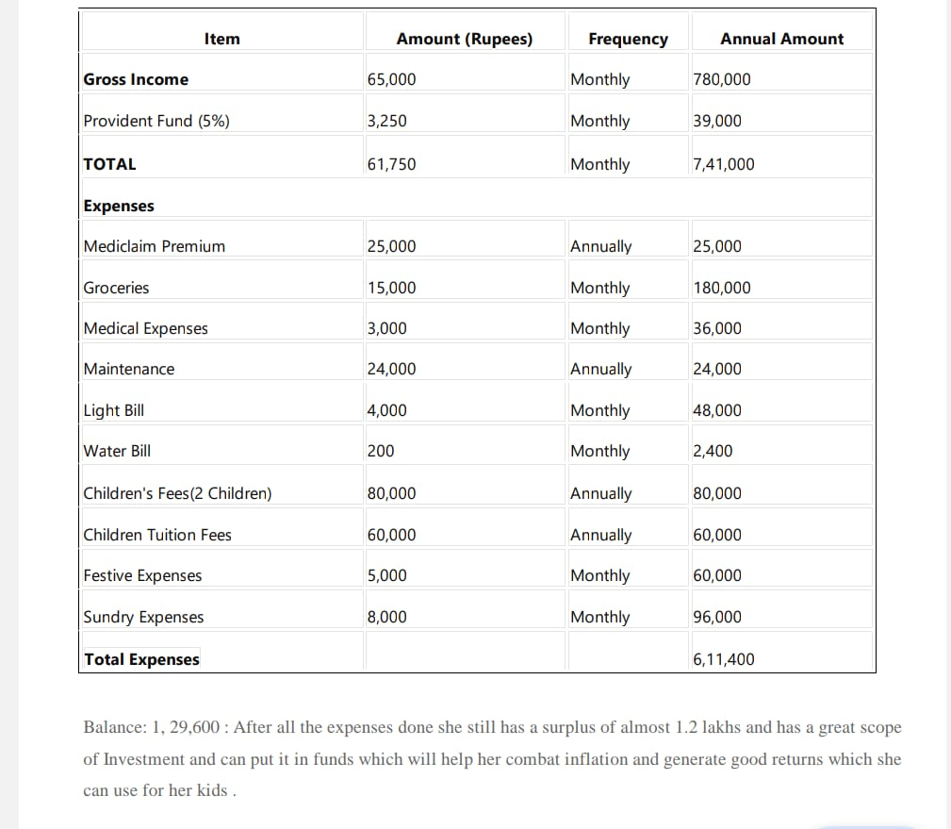

**financial goals and their future value**

**First – children education fund – long term goal**

1. **Children Education Fund:**
   * **Goal: Save ₹2,00,000 for your child's education.**
   * **Time Horizon: 15 years**
   * **Expected Annual Rate of Return: 8%**

**Using the compound interest formula:**

*FV*=*P*×(1+*r*/*n*)*nt*

*FV*=2,00,000×(1+0.08/1)1×15

*FV*=2,00,000×(1.08)15

*FV*≈2,00,000×4.31768

*FV*≈₹8,63,536

**So, the future value of saving ₹2,00,000 for your child's education over 15 years with an 8% annual rate of return would be approximately ₹8,63,536.**

**Second – Buying a car – short term**

1. **Buying a Car in India:**
   * **Goal: Save ₹5,00,000 for buying a car.**
   * **Time Horizon: 5 years**
   * **Expected Annual Rate of Return: 6%**

**Using the compound interest formula:**

***FV*=*P*×(1+*r*/*n*)*nt***

*FV*=5,00,000×(1+0.06/1)1×5

*FV*=5,00,000×(1.06)5

*FV*≈5,00,000×1.34856

*FV*≈₹6,74,280

**So, the future value of saving ₹5,00,000 for buying a car in India over 5 years with a 6% annual rate of return would be approximately ₹6,74,280.**

**Retirement corpus**

**Calculating a retirement corpus involves several assumptions, such as the expected annual expenses in retirement, the expected rate of inflation, the number of years in retirement, and the rate of return on investments. Without specific information on these factors, I'll make some assumptions for a basic estimate.**

**Assumptions:**

1. **Annual expenses: 600,000 rupees**
2. **Retirement age: 60 years**
3. **Life expectancy: 85 years**
4. **Expected rate of inflation: 4%**
5. **Expected rate of return on investments: 6%**

**Now, let's calculate the retirement corpus using the future value of annuity formula:**

***FV*=*P*×(*r*(1+*r*)*n*−1​)**

**Where:**

* **��*FV* is the future value of the annuity (retirement corpus)**
* **�*P* is the annual expenses during retirement**
* **�*r* is the expected rate of return on investments per compounding period**
* **�*n* is the number of compounding periods (number of years in retirement)**

**In this case:**

* *P*=600,000 rupees
* *r*=6% or 0.060.06
* *n*=85−60=25 years (assuming retirement at 60 and life expectancy until 85)

Now, let's calculate:

*FV*=600,000×(0.06(1+0.06)25−1​)

Calculating this gives the estimated retirement corpus. Let's compute it:

*FV*≈600,000×(0.06(1.06)25−1​)

Now, let's compute this value:

*FV*≈600,000×(0.06(1.9837)−1​)

*FV*≈600,000×(0.060.9837​)

*FV*≈600,000×16.395

***FV*≈9,837,000**

**So, based on these assumptions, a rough estimate for the retirement corpus needed at age 40 to sustain annual expenses of 600,000 rupees in retirement until age 85 is approximately 9,837,000 rupees. Keep in mind that this is a simplified calculation and actual needs may vary based on individual circumstances and market conditions.**

Planning for retirement involves a combination of saving and investing to build a sufficient corpus that can sustain you during your retirement years. It's essential to consider a diversified approach to balance risk and return. Here are some Indian investment options you may consider for building your retirement corpus:

1. **Employee Provident Fund (EPF):** If you're employed, contributing to the EPF is a mandatory savings option. Both you and your employer contribute a percentage of your salary, and the interest earned is tax-free.
2. **Public Provident Fund (PPF):** PPF is a long-term savings option with a lock-in period of 15 years. It offers tax benefits, and the interest earned is tax-free. PPF is considered a safe investment with a government guarantee.
3. **National Pension System (NPS):** NPS is a voluntary, long-term retirement savings scheme designed to enable systematic savings. It offers a mix of equity, fixed deposits, corporate bonds, liquid funds, and government funds. It provides tax benefits under Section 80C and 80CCD.
4. **Mutual Funds:** Consider investing in a mix of equity and debt mutual funds based on your risk tolerance and investment horizon. Systematic Investment Plans (SIPs) allow you to invest regularly, helping in rupee cost averaging.
5. **Stock Market Investments:** Investing in blue-chip stocks or diversified equity funds can provide long-term growth potential. However, stocks come with higher risk, and it's important to have a diversified portfolio.
6. **Real Estate:** Owning property can be a good long-term investment. It provides rental income and potential appreciation in property value. However, real estate can be illiquid and may require substantial upfront investment.
7. **Senior Citizens' Saving Scheme (SCSS):** This scheme is specifically designed for individuals above 60 years of age. It has a fixed tenure of 5 years and offers regular interest payouts.
8. **Fixed Deposits (FDs):** FDs are low-risk, fixed-income instruments. While they provide capital protection, returns may be lower compared to other investment options. Consider opting for tax-saving FDs to avail of tax benefits under Section 80C.

**Recommending investment options**

For specific financial goals like an education fund and purchasing a car in India, it's essential to consider investment options that align with your time horizon and risk tolerance. Here are some investment options you may consider:

**Education Fund:**

1. **Public Provident Fund (PPF):**
   * **Features:** Long-term investment with tax benefits and a fixed interest rate.
   * **Suitability:** Suitable for long-term goals, including education.
2. **Equity Mutual Funds:**
   * **Features:** Provides potential for higher returns by investing in a diversified portfolio of stocks.
   * **Suitability:** Long-term investors with a higher risk tolerance.
3. **Sukanya Samriddhi Yojana (SSY):**
   * **Features:** Government-backed savings scheme for the girl child, offering tax benefits.
   * **Suitability:** Specifically designed for education and marriage expenses for the girl child.
4. **ULIPs (Unit Linked Insurance Plans):**
   * **Features:** Combines insurance and investment, offering the potential for market-linked returns.
   * **Suitability:** Consider for long-term goals, but carefully review charges and terms.
5. **Systematic Investment Plans (SIPs):**
   * **Features:** Allows you to invest regularly in mutual funds, reducing the impact of market volatility.
   * **Suitability:** Suitable for systematic, disciplined investing over the long term.

**Car Purchase Fund:**

1. **Recurring Deposit (RD):**
   * **Features:** Allows you to make regular deposits with a fixed interest rate.
   * **Suitability:** Suitable for short-to-medium-term goals like saving for a car.
2. **Short-Term Debt Funds:**
   * **Features:** Invests in short-term debt instruments, providing stability and liquidity.
   * **Suitability:** Suitable for short-term goals with lower risk.
3. **Fixed Maturity Plans (FMPs):**
   * **Features:** Close-ended debt funds with a fixed maturity date, offering tax benefits.
   * **Suitability:** Suitable for medium-term goals with tax efficiency.
4. **Bank Fixed Deposits (FDs):**
   * **Features:** Low-risk investment with a fixed interest rate.
   * **Suitability:** Suitable for short-term goals due to liquidity.
5. **Liquid Funds:**
   * **Features:** Invests in short-term debt instruments, providing liquidity.
   * **Suitability:** Suitable for short-term goals with relatively low risk.

**Conclusion**

In conclusion, financial planning is a crucial and ongoing process that individuals, families, and businesses should prioritize to achieve their financial goals and secure a stable future. By systematically assessing current financial situations, setting realistic objectives, and implementing effective strategies, one can navigate the complexities of managing income, expenses, investments, and debt.

The benefits of financial planning extend beyond mere monetary gains, encompassing peace of mind, reduced stress, and enhanced financial security. Through careful consideration of risk tolerance, diversified investment portfolios, and prudent budgeting, individuals can weather economic uncertainties and unexpected life events.

Moreover, financial planning is not a one-time task but rather a dynamic and adaptive process that should evolve with changing circumstances, such as career shifts, family milestones, and market fluctuations. Regular reviews and adjustments to the financial plan ensure that it remains aligned with one's goals and aspirations.

In essence, embracing financial planning empowers individuals to take control of their financial destiny, fostering a path towards prosperity, resilience, and a more secure future. As we navigate the complexities of an ever-changing financial landscape, a well-crafted financial plan serves as a guiding compass, enabling individuals to make informed decisions and build a foundation for lasting financial success.

Top of Form

**Top of Form**