**A Secure and Resilient Framework for Confidential and Scalable Software Updates -A Review**

**Ratnala Sai Vivek**

**Computer Science and Engineering, GMR Institute of Technology, Rajam**

**saivivekratnala@gmail.com**

**Abstract:**

Software updates play a crucial role in maintaining and enhancing cybersecurity, serving as a primary defense mechanism against the dynamic and ever-growing range of cyber threats. Software updates typically address security vulnerabilities, fixing flaws that could otherwise be exploited by attackers to gain unauthorized access, disrupt services, or steal sensitive data. In addition to mitigating known vulnerabilities, software updates are vital in defending against zero-day exploits, which target vulnerabilities that are not yet publicly known. However, the paper also acknowledges the challenges organizations face in implementing updates, including potential compatibility issues, resource constraints, and ensuring user compliance. These challenges often lead to delays in update deployment, increasing the risk of security breaches. Furthermore, the paper discusses the broader implications of software updates in maintaining regulatory compliance and supporting a security conscious culture within organizations. The research concludes that a proactive and well managed software update strategy is essential for protecting the integrity, confidentiality, and availability of digital assets. By prioritizing updates, organizations can significantly reduce their exposure to cyber threats, safeguarding their operations, reputation, and the trust of their stakeholders in an increasingly interconnected digital world.

**Keywords:** software updates, cybersecurity, patch management, vulnerability mitigation, zero-day exploits, security breaches, information systems, regulatory compliance, digital assets, cyber threats.

**Introduction:**

To upgrade the software in today's digital atmosphere is meant to play a central role in maintaining and enhancing measures of cyber security. With that level of sophistication in threats progressing, adequate and timely upgrades in software come in to cover the vulnerabilities to ensure the system is safeguarded and to ensure regulatory compliance. An upgrade is not only good for patching known security flaws but also at times help in countering zero-day exploits. While most organizations face problems on compatibility issues, resource allocation, and deployment delays, critical mechanisms of handling these problems have been developed. This literature review reviews the body of work pertaining to the security effect via updates in software, focusing on their role in protection systems, enhancement of cybersecurity strategies, and constant responses to emerging threats. Challenges and gaps in current practices would be tackled by looking at the importance of having effective mechanisms for updates.

**Literature Review**

**Software Updates Confidentiality**

It’s pretty basic that update data should be kept safe during both transmission and storage, especially since so many devices are now connecting to distributed systems, where data privacy risks are heightened. Cryptographic and encryption methods are crucial for protecting data, but multi-authority encryption is especially effective because it lets multiple independent authorities control access to update data, sharing responsibility and boosting security among trusted entities. There are privacy-preserving mechanisms that are also really important in large-scale distributed systems where update data is shared across several nodes. These methods ensure that all sensitive info in the software update won’t leak to any bad actors during transmission.

**Scalability of Software Update Systems**

As the need for regular updates grows, scalable strategies for updating have come into the spotlight. Techniques like delta updates, which only transfer changes in software, and over-the-air (OTA) updates help to cut down on the bandwidth and processing power needed for deployment. IoT case studies on update scalability and mixed-criticality systems show how these techniques work in addressing large, resource-limited settings. On the flip side, scalability can make things more complicated by requiring coordination among different levels of criticality within the same system. So, the pros and cons highlighted in real-world examples raise questions about how carefully updates should be designed for various environments.

**Survivability and Resilience of Update Systems**

Along with security, update systems also need mechanisms to handle failures and interruptions. Resilient systems can deal with attacks or issues when updates are supposed to be released. Dynamic software updating combined with systematic testing methods contributes to this resilience by allowing updates to be applied without having to shut down systems. Managing software resilience before launching updates helps prevent downtime and keeps services running smoothly.

**Survivable key compromise in software update systems**

survivable key compromise in software update systems, with the goal of enhancing security and resilience against attacks on cryptographic keys. The paper makes it conceivable for software updates to safely survive even when signing keys are compromised. The authors detail various attack vectors, countermeasures that might be deployed, and validate through simulation. This work, therefore focuses on giving protection related to the integrity of software during updates and it gives solutions that reduce the risks that are associated with key compromise while ensuring low occurrence of system vulnerabilities due to compromised keys**.**

**Evaluating dynamic software update safety using systematic testing**

The safety of dynamic software updates through systematic testing methods and proposes a framework for rating the risks of such updates by extensive testing to assure that it does not bring in new problems and does not compromise the stability of the system under update. The study places high importance on how rigorous protocols of testing guarantee the safety and reliability of software systems under updates.

**Multi-Authority Encryption Framework for Software Updates**

**Overview of the Framework**

The multi-authority encryption framework talked about in this chapter aims to boost the confidentiality, scalability, and resilience of software updates. Different encryption authorities manage access control so that only authorized users can access sensitive update data. The risks tied to this method are lowered because access is spread out among several authorities, each maintaining the encryption standards and user verification. The way the framework operates makes updates confidential, allowing access only based on the authorization rules set by trusted authorities.

**Principles of Multi-Authority Encryption**

Multi-authority encryption is the backbone of the framework; it applies layered access control to secure the data and block unauthorized access to the update data for protecting confidential information. Encryption authorities and users, along with the authentication protocol, boost the overall security of the update process. Public Key and symmetric encryption in the framework also helps ensure data integrity and prevents unauthorized access. The encryption algorithms ensure that only the rightful credential holder can access the update data**.**

**Implement Confidentiality, Scalability and Resilience**

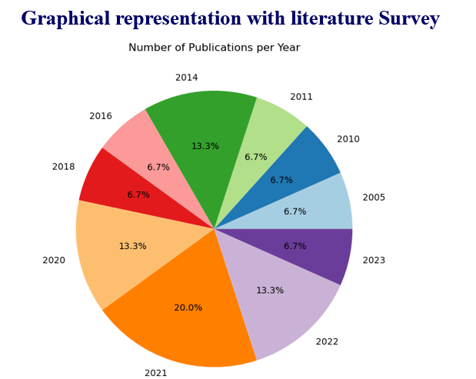Using multi-authority encryption allows for confidentiality by encrypting update data during storage and transport, making unauthorized access virtually impossible. Scalability is achieved through optimized data transmission, cutting down on overhead, and supporting multiple nodes for large networks. Built-in fail-safe features give the system the ability to recover from mishaps and even update services without losing functionality. All these elements come together to create a solid framework that significantly enhances the security and robustness of software updates.

**Comparative Analysis and Methodological Findings**

**Strengths and Weaknesses**

Other confidential measures like multi-authority encryption differ quite a bit because it offers detailed access control that makes for a nearly scalable and resilient approach to software update management. However, like any system, there are trade-offs to consider in resource-limited environments; the multi-authority method might add extra computation that could slow things down on low-power systems, making it important to ensure that security doesn’t sacrifice efficiency, even in environments with limited processing power.

**Methodology Appraisal**

This framework has tested several encryption methods and shows promising results for making software updates more efficient. Findings suggest where encryption enhances security, there are also resources that need to be measured to find the right balance for effectiveness. Data theoretical findings back its usefulness in keeping confidentiality and system robustness in both large and distributed environments.

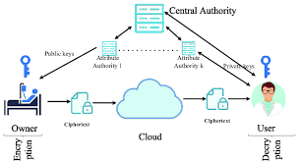

Source:https://www.google.com/imgres?q=Multi-Authority%20Attribute-Based%20Encryption%20(MA-CP-ABE)%20HD%20images&imgurl=https%3A%2F%2Fwww.researchgate.net%2Fpublication%2F334070361%2Ffigure%2Ffig7%2FAS%3A774565777117186%401561682280453%2FCentralized-multi-authority-attribute-based-encryption.png&imgrefurl=https%3A%2F%2Fwww.researchgate.net%2Ffigure%2FCentralized-multi-authority-attribute-based-encryption_fig7_334070361&docid=sCKNZmMO3sOBiM&tbnid=sp3DbBaW18exoM&vet=12ahUKEwir3PTbkeiJAxXXxDgGHQI-OGwQM3oECG8QAA..i&w=648&h=354&hcb=2&ved=2ahUKEwir3PTbkeiJAxXXxDgGHQI-OGwQM3oECG8QAA

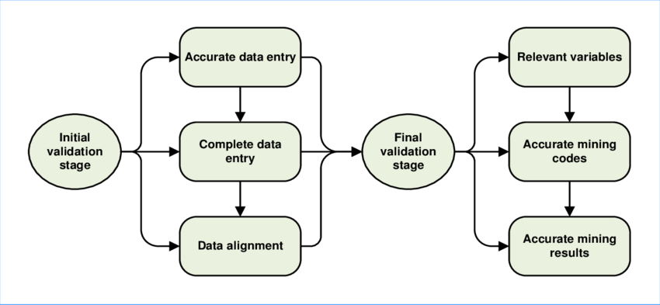

ource:https://www.researchgate.net/figure/Data-validation-process-stages_fig11_323225372

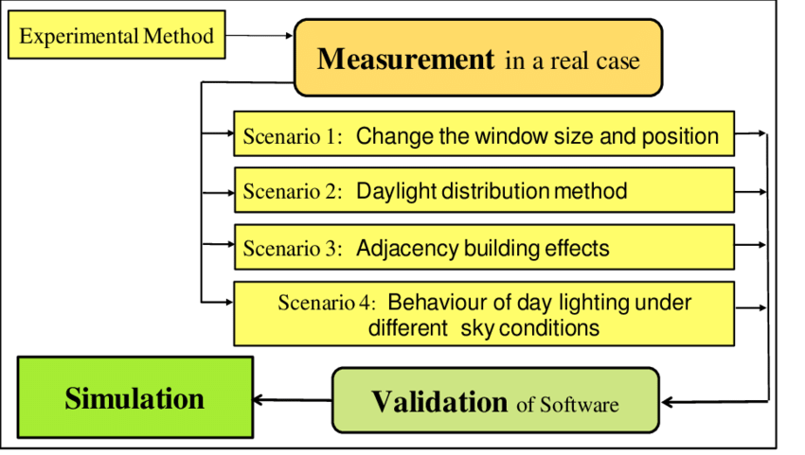

Source:https://www.google.com/imgres?q=updation%20validation%20process%20in%20software%20updates%20hd%20images&imgurl=https%3A%2F%2Fwww.researchgate.net%2Fpublication%2F289534319%2Ffigure%2Ffig2%2FAS%3A667644806037514%401536190334576%2FDiagram-of-software-validation-process.png&imgrefurl=https%3A%2F%2Fwww.researchgate.net%2Ffigure%2FDiagram-of-software-validation-process_fig2_289534319&docid=BHuQK_D8rXTI2M&tbnid=qK9O5O6ObsJnBM&vet=12ahUKEwjqndHclOiJAxWg6jgGHfmDPewQM3oECE0QAA..i&w=850&h=481&hcb=2&ved=2ahUKEwjqndHclOiJAxWg6jgGHfmDPewQM3oECE0QAA

**Research Implications and Future Directions**

While the benefits of update deployments are pretty clear, there's still a lot of open challenges, especially within the constrained environment of IoT and other low-power devices. In this regard, research is likely to focus on lightweight encryption and adaptive security frameworks that can vary based on device or environmental needs.

Some potential solutions for these current issues could include exploring lightweight encryption and automation for managing updates. Adaptive frameworks could be dynamic and integrated into update management systems to respond to emerging threats. The rise of cyber threats means AI and machine learning can help analyse and predict vulnerabilities so update systems could upgrade in real time and deploy updates at the best times.

**Integrating AI for Predictive Update Management**

Bringing AI and ML into the mix can further improve update strategies and spot vulnerability predictions, which helps automate response protocols. This can help systems forecast security issues and perform updates ahead of time, reducing the chances of both known and unknown vulnerabilities being exploited. AI-driven management of updates could be crucial for tightly interconnected and critically important systems, offering a strategic edge in cybersecurity.

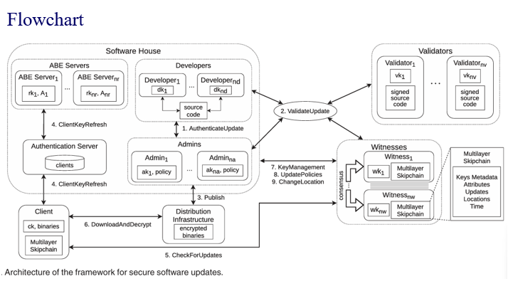

Source: Mugarza, I., Yarza, I., Agirre, I., Lussiana, F., & Botta, S. (2021, November). Safety and security concept for software updates on mixed-criticality systems. In 2021 5th International Conference on System Reliability and Safety (ICSRS) (pp. 171-180). IEEE

The above architecture depicts how the software updates are processed ,received, authenticated and how multi authority attribute based key encryption works.

**Comparison**

|  |  |  |  |
| --- | --- | --- | --- |
| **Aspect** | **MA-CP- ABE)** | **Update Validation Process** | **Data Validation and Security** |
| **Purpose** | Generate and manage encryption keys among multiple authorities to secure updates | Validate authenticity of software updates and ensure they are tamper- free | Confirm authenticity, integrity, and freshness of update data |
| **Functionality** | Each authority creates unique encryption keys; decryption keys are given to clients based on attributes | Validators compile source code to binaries, match them to the source, and collectively sign | Clients verify data integrity using cryptographic proofs to ensure skipchain reliability |
| **Role in Security** | Establishes access control and prevents unauthorized decryption of sensitive updates | Ensures all updates are legitimate and not tampered with by using multiple validators | Provides tamper-evident, secure record of update metadata, ensuring transparency and security |
| **Significance** | Enables distributed, attribute- based access control that limits access to verified users only | Reduces tampering risks, reinforcing the reliability of the update process | Facilitates a transparent, append-only structure for data integrity and recovery |

**Conclusion**

The proposed framework seeks to be an efficient, robust, secure, and not tamper able software update management system based on the combination of Multi-Authority Ciphertext-Policy Attribute-Based Encryption, Update Validation, and Skipchain Data Validation. This combination addresses critical security challenges to account for applying multiple authorities in handling the encryption of messages to ensure update validation. This would, in turn, support strong, distributed access control, considerably minimize single points of failure in the update process, and so on. This solution also provides a reliable, vulnerablility-free, and traceable mechanism for updating-an indispensable feature for maintaining cybersecurity throughout various systems-whether IoT environments or mixed-critical systems.

**References**

1. Mugarza, I., Yarza, I., Agirre, I., Lussiana, F., & Botta, S. (2021, November). Safety and security concept for software updates on mixed-criticality systems. In 2021 5th International Conference on System Reliability and Safety (ICSRS) (pp. 171-180). IEEE.
2. Martinez, S., Gransart, C., Stienne, O., Deniau, V., & Bon, P. (2022). SoREn, How dynamic software update tools can help cybersecurity systems to improve monitoring and actions. Journal of Universal Computer Science, 28(1), pp27-53.
3. Bauwens, J., Ruckebusch, P., Giannoulis, S., Moerman, I., & De Poorter, E. (2020). Over-the-air software updates in the internet of things: An overview of key principles. IEEE Communications Magazine, 58(2), 35-41.
4. Demir, N., Urban, T., Wittek, K., & Pohlmann, N. (2021). Our (in) secure web: understanding update behavior of websites and its impact on security. In Passive and Active Measurement: 22nd International Conference, PAM 2021, Virtual Event, March 29–April 1, 2021, Proceedings 22 (pp. 76-92). Springer International Publishing.
5. Kumar, I. (2023). Emerging threats in cybersecurity: a review article. International Journal of Applied and Natural Sciences, 1(1), 01-08.
6. Mathur, A., Malkin, N., Harbach, M., Peer, E., & Egelman, S. (2018). Quantifying users' beliefs about software updates. arXiv preprint arXiv:1805.04594.
7. Vaniea, K. E., Rader, E., & Wash, R. (2014, April). Betrayed by updates: how negative experiences affect future security. In Proceedings of the SIGCHI conference on human factors in computing systems (pp. 2671-2674).
8. Hayden, C. M., Smith, E. K., Hardisty, E. A., Hicks, M., & Foster, J. S. (2011). Evaluating dynamic software update safety using systematic testing. IEEE Transactions on Software Engineering, 38(6), 1340-1354.
9. Samuel, J., Mathewson, N., Cappos, J., & Dingledine, R. (2010, October). Survivable key compromise in software update systems. In Proceedings of the 17th ACM conference on Computer and communications security (pp. 61-72).
10. Nguyen, V. L., Lin, P. C., Cheng, B. C., Hwang, R. H., & Lin, Y. D. (2021). Security and privacy for 6G: A survey on prospective technologies and challenges. IEEE Communications Surveys & Tutorials, 23(4), 2384-2428.
11. Vaniea, K., & Rashidi, Y. (2016, May). Tales of software updates: The process of updating software. In Proceedings of the 2016 chi conference on human factors in computing systems (pp. 3215-3226).
12. Wash, R., Rader, E., Vaniea, K., & Rizor, M. (2014). Out of the loop: How automated software updates cause unintended security consequences. In 10th Symposium On Usable Privacy and Security (SOUPS 2014) (pp. 89-104).
13. Di Tizio, G., Armellini, M., & Massacci, F. (2022). Software updates strategies: A quantitative evaluation against advanced persistent threats. IEEE Transactions on Software Engineering, 49(3), 1359-1373.
14. Agirre, I., Onaindia, P., Poggi, T., Yarza, I., Cazorla, F. J., Kosmidis, L., ... & Botta, S. (2020, August). UP2DATE: Safe and secure over-the-air software updates on high-performance mixed-criticality systems. In 2020 23rd Euromicro Conference on Digital System Design (DSD) (pp. 344-351). IEEE.
15. Hicks, M., & Nettles, S. (2005). Dynamic software updating. ACM Transactions on Programming Languages and Systems (TOPLAS), 27(6), 1049-1096.