**Applications of Artificial Intelligence, Robotics and Drones in**

**Smart Agriculture-A literature review**

**G. Sasidhar1, K. Yasaswani2, K. Lokesh3, N. Mahesh Babu4, M. Harsha Vardhan5**

1Assistant Professor, Mechanical Dept., GMR Institute of Technology, Rajam, Andhra Pradesh, India

2,3,4,5UG Scholar, Mechanical Dept., GMR Institute of Technology, Rajam, Andhra Pradesh, India

____________________________________________________________________________________

**ABSTRACT**

The integration of robotics and Artificial Intelligence (AI) in agriculture is revolutionizing farming practices by enhancing precision, efficiency, and sustainability. Robotics automates tasks like planting, harvesting, and monitoring, reducing labour costs and increasing productivity, while AI enables real-time data analysis for optimized crop management through predictive modelling. Autonomous machinery such as drones and tractors reduce reliance on manual labour and supports continuous operation, contributing to sustainability by optimizing resource usage and minimizing waste. Drones play a crucial role by offering high-resolution imagery and multispectral data, which enhance crop monitoring, precision irrigation, and pest management. They enable farmers to assess crop health, identify water stress, and detect early signs of pests or diseases, leading to timely and precise interventions. These technologies improve resource efficiency, reduce environmental impact, and lower costs. Despite significant benefits, challenges like high implementation costs, the need for skilled operators, and data privacy concerns hinder widespread adoption. However, advancements in machine learning, blockchain for traceability, and autonomous systems are expected to enhance the adoption and efficacy of these technologies, reshaping agricultural practices and rural economies.

**Keywords:** Artificial Intelligence, Robotics, Autonomous, Monitoring, Precision irrigation, Harvesting

Drones.

1. **INTRODUCTION**

Agriculture is a cornerstone of the global economy and a critical driver of poverty reduction, particularly in countries like India. However, the sector faces growing challenges, including rising food demand driven by population growth, labour shortages, climate change, and resource constraints. Traditional farming methods often fail to meet these demands and contribute to environmental issues like deforestation and pollution. To overcome these challenges, AI and robotics are being integrated into modern agriculture, enabling precision farming, improved resource management, and enhanced productivity. AI-powered tools like machine learning, IoT, and neural networks facilitate real-time crop monitoring, disease detection, and yield prediction. Similarly, robotics automates labour-intensive tasks like harvesting, weeding, and irrigation, addressing labour shortages while boosting efficiency. Together, these technologies promote sustainability by optimizing resource use, reducing waste, and minimizing environmental impacts. Despite their potential, adoption of these technologies remains limited due to high costs, skill requirements, and data accessibility challenges. However, ongoing advancements in AI and robotics are poised to transform agriculture, making it more resilient and efficient while addressing global food security needs. Drones are transforming agriculture by providing efficient solutions for crop monitoring, resource management, and sustainable farming practices. Equipped with advanced imaging and sensing technologies like multispectral, thermal, and LiDAR sensors, drones collect detailed data on crop health, soil conditions, and environmental factors. This enables precision agriculture, where inputs such as water, fertilizers, and pesticides are applied precisely, reducing waste, costs, and environmental impact. Drones assist with tasks like irrigation management, field mapping, spraying chemicals, and even seeding in remote areas. They enhance productivity by identifying issues like pest infestations, nutrient deficiencies, and water stress, allowing timely interventions. Additionally, drones support harvesting decisions through real-time monitoring and yield predictions, improve disaster recovery with rapid damage assessments, and boost overall farm security. Their versatility, cost-efficiency, and adaptability to diverse agricultural environments make them indispensable for modern, sustainable farming practices.

**2**.**LITERATURE REVIEW**

**2.1 Application of Robotics in Agriculture**

Advancements in robotics, artificial intelligence, and machine learning are transforming agriculture by addressing challenges like pest infestations, excessive pesticide use, labour shortages, and resource inefficiency. Machine learning models trained on extensive datasets enable smartphone apps to identify plant diseases and pests through images, providing solutions for prevention. Targeted pesticide spraying using AI-powered drones and robotic rovers minimizes environmental impact as shown in Fig[1]. Automated systems like precision weeding robots, robotic seeders, and irrigation systems enhance efficiency by leveraging computer vision, sensors, and IoT devices. Innovations in robotic harvesting systems streamline the collection of fruits and crops, addressing labour shortages while improving yield and quality. Robotic pollinators mitigate the decline of natural pollinators, and drones offer precise crop monitoring and assessment. Specific technologies like robotic pruners for apple trees and strawberry harvesting robots highlight the use of machine learning and automation for labour-intensive tasks.

**2.2 Robots Used in Agriculture**

**Weed Picking Robot:** Weeds are unwanted plants in agricultural fields that compete with crops for water and nutrients, reducing yield, crop quality, and increasing costs. Weeds also harbour pests and diseases, further affecting crops.

**Harvesting Robot**: Harvesting ripe fruits and crops is labour-intensive and time-consuming, prompting the development of robotic harvesting systems to mitigate labour shortages. These robots use robotic arms and image recognition to identify and pick fruits without damaging them. Key challenges include harvesting from various plants like strawberries and tomatoes.

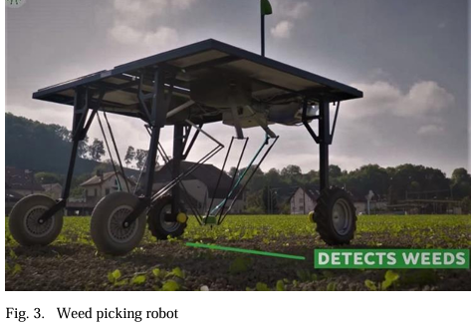 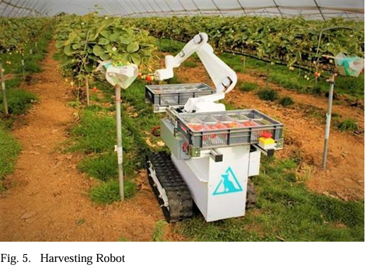 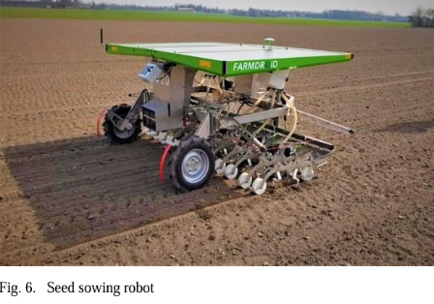

1. (b) (c)

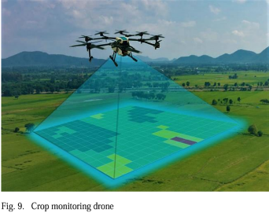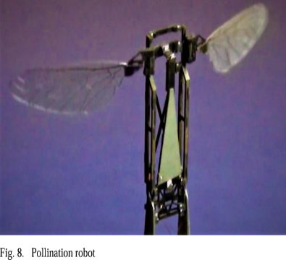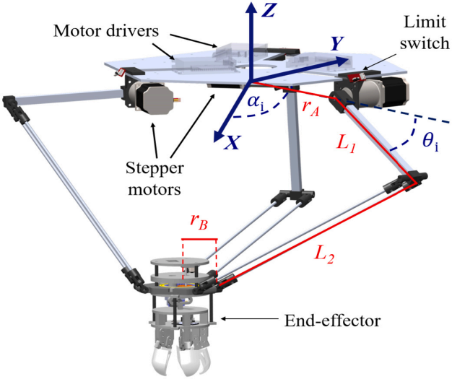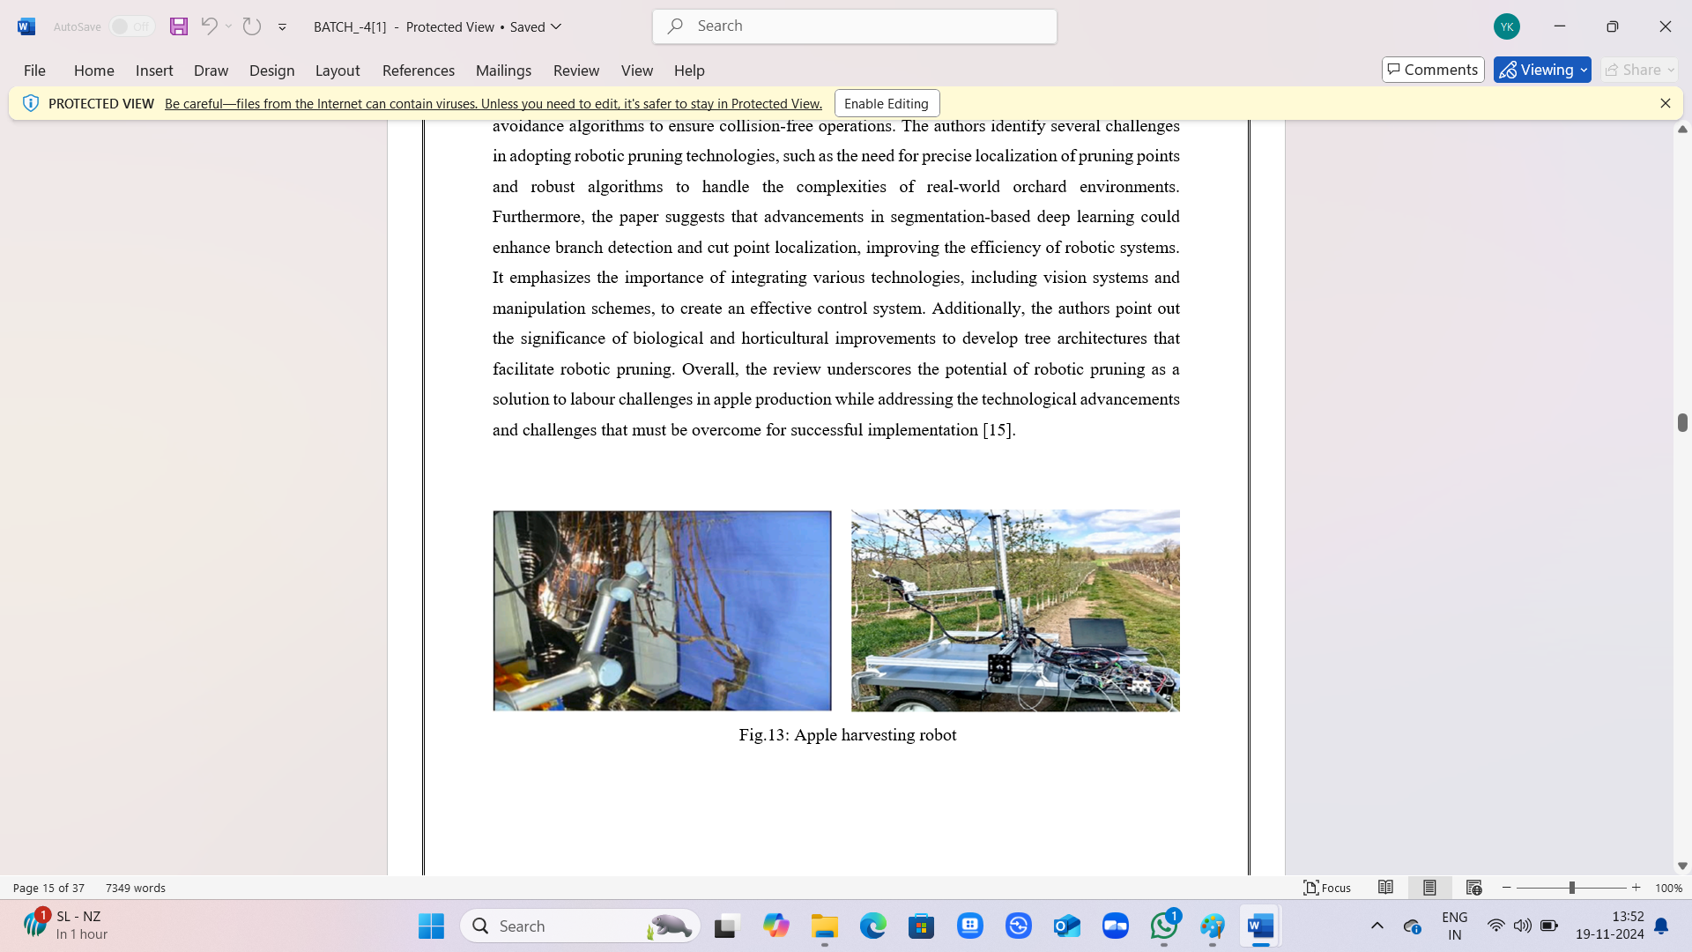

(d) (e) (f) (g)

Fig.1: Different types of robots used in Agriculture (a)Weed Picking Robot, (b)Harvesting Robot, (c) Pollination Robot, (d)Pollination Robot, (e)Crop Monitoring Robot, (f)Strawberry Harvesting Robot, (g)Apple Harvesting Robot

**Seed Sowing Robot:** Traditional hand sowing is labour-intensive and requires skill for even seed distribution. Robotic seeder, however, significantly improve efficiency. One system uses a cell plate to speed up planting by four times, while another uses IR sensors to automate row spacing with minimal human input. This automation is particularly beneficial in greenhouses, where plants are densely planted and frequently replanted.

**Pollination Robot:** Animal pollinators like bees and birds are essential for food production but are declining due to pesticide misuse, impacting ecosystems and food supply. To address this, robotic pollinators are being developed. These micro-air vehicle (MAV) pollinators, controlled by a central system using real-time data, could perform large-scale pollination autonomously, supporting sustainable agriculture.

**Crop Monitoring Robot:** Advanced sensors and imaging technologies, particularly drones equipped with high-definition cameras, have enhanced farmers' ability to monitor crops, improving yield and reducing damage. These drones, or unmanned aerial vehicles (UAVs), can be operated remotely or autonomously, capturing data to help identify crop diseases, pests, and water or nutrient issues.

**Strawberry Harvesting Robot:** A strawberry harvesting robot is an advanced machine designed to autonomously pick ripe strawberries from plants. Equipped with specialized sensors and cameras, it identifies ripe fruit, assesses its quality, and uses robotic arms to carefully harvest them without damaging the plants. These robots aim to address labor shortages in agriculture, increase harvesting efficiency, and reduce the cost of labor while maintaining high-quality fruit production.

**Apple Harvesting Robot:** This review discusses recent technological advancements in the development of robotic pruners for apple trees. It highlights the importance of pruning for tree health and fruit quality, and examines various robotic systems designed to automate this process. The review covers innovations in sensors, machine learning, and robotic manipulation, emphasizing how these technologies enhance precision, efficiency, and scalability in orchards.

**2.3 AI techniques used in agriculture**

Fuzzy Logic (FL), introduced by L. Zadeh, supports decision-making in uncertain environments, with applications in UAV navigation, pest control, and crop monitoring. Its combination with techniques like genetic algorithms (GA) and neural networks (NN) optimizes processes like greenhouse automation and irrigation, promoting sustainable practices. Artificial Neural Networks (ANNs) and deep learning models, inspired by the human brain, address tasks like crop classification, pest detection, and resource management, while convolutional neural networks (CNNs) specialize in image-based tasks such as disease diagnosis and weed segmentation. Optimization algorithms like Genetic Algorithms (GAs) simulate natural selection to enhance robot path planning, crop recognition, and irrigation systems. Similarly, Particle Swarm Optimization (PSO) improves robotic control, disease detection, and irrigation scheduling. Techniques like the Artificial Potential Field (APF) enable real-time path planning for agricultural robots, while Simulated Annealing (SA) optimizes motion planning and route efficiency. The Ant Colony Optimization (ACO) algorithm supports resource management and robot navigation, and the Artificial Bee Colony (ABC) algorithm improves tasks like land partitioning and fruit recognition. The concept of Agriculture 4.0 integrates AI, IoT, remote sensing, and machine learning for smarter, data-driven farming. IoT sensors provide real-time insights into crop and soil health, while cloud platforms address data storage and analysis challenges. Responsible innovation ensures inclusivity and sustainability in adopting these technologies, addressing global challenges like climate change and resource scarcity. Together, these advancements drive agriculture toward greater efficiency, productivity, and environmental stewardship.

**2.4 Artificial Intelligence Robotic in Food Industry:**

Artificial intelligence (AI) and robotics are increasingly transforming the food industry by improving efficiency, quality, and safety in food production and distribution. AI is used in various applications, such as predictive maintenance for machinery, supply chain optimization, and personalized customer experiences. Robotics, on the other hand, enhances tasks like food preparation, packaging, sorting, and even delivery, often with higher precision and speed than human workers as shown in Fig [2]. Robots can handle repetitive tasks like cutting, sorting, and packing, reducing human labor and improving consistency.AI-powered systems can monitor production conditions (temperature, humidity) and detect contaminants, ensuring better hygiene and quality control. The integration of AI and robotics in the food industry is driving.

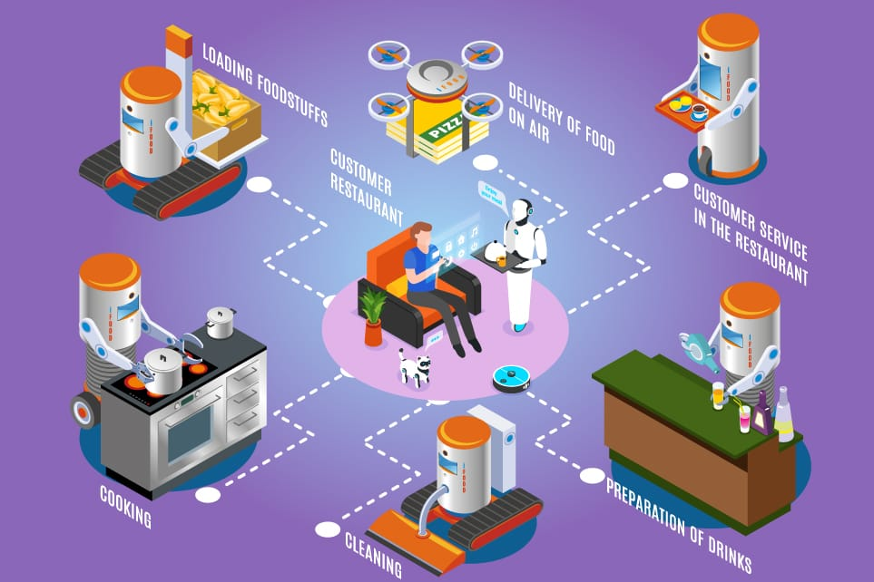

Fig.2: AI technique in Food Industry

innovation, improving sustainability, and enhancing consumer experiences. In the coming future food products and processes must be environmentally friendly, with reuse, remanufacturing, and recycling built in for products nearing the end of their useful lives. Factory automation is a well-known solution to these issues in modern manufacturing [7].

**2.5 Applications of Drones**

Drones play a pivotal role in smart agriculture by integrating advanced technologies like AI, IoT, and real-time data analytics to enhance efficiency and sustainability. They are used for crop monitoring and health assessment, where multispectral and thermal imaging detects diseases, pests, and nutrient deficiencies early, enabling targeted interventions. Precision spraying systems apply fertilizers and pesticides accurately, reducing waste and environmental impact as shown in Fig [3]. Soil and field analysis through drones provides detailed 3D maps, helping optimize planting and irrigation strategies. Drones also detect water stress in plants, ensuring efficient irrigation. In planting and seeding, drones enable precise seed placement, even in challenging terrains, saving time and labour. For livestock farming, drones monitor herds, identify strays, and assess pasture conditions, improving operational efficiency.

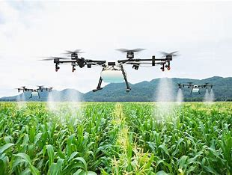 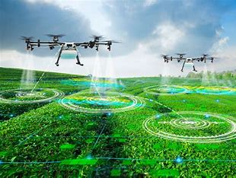

(a) (b)

Fig.3: Different Applications of Drones (a)Pesticides Spraying, (b)Pollination Drones

They aid in harvest estimation by analysing crop maturity and density, supporting better planning and supply chain management. After disasters, drones assess crop damage, expediting insurance claims and recovery efforts. Furthermore, drones collect real-time data, enabling informed decision-making, and support pollination in areas with declining pollinator populations. Their ability to map fields, scout crops, and integrate with IoT devices enhances productivity while promoting sustainability and scalability.

**2.6 Future of Drones in Agriculture**

The future of drones in agriculture is highly promising, driven by advancements in AI, IoT, and machine learning. Autonomous drones are becoming more affordable and capable, enabling tasks like crop monitoring, precision spraying, and field analysis with greater efficiency. AI-driven data analysis and integration with satellite imagery and cloud computing enhance precision and real-time decision-making. Drones support climate-smart agriculture by adapting to weather changes, reducing resource use, and mitigating environmental impacts, contributing to sustainability and food security as shown in Fig [4]. They play a central role in smart farming ecosystems, working alongside sensors, robots, and machinery to optimize operations. The expansion of drone technology also brings opportunities for new business models, training programs, and policies, benefiting farmers of all scales. However, challenges such as data privacy, regulations, and the environmental impact of drone production must be addressed for widespread adoption. In addition to current applications, the future includes expanded use in livestock management, seed planting, and AI-powered predictive analytics. These innovations will drive automated, eco-friendly farming practices, reducing costs, saving time, and improving productivity while supporting sustainable agriculture and climate change mitigation.

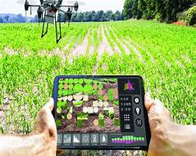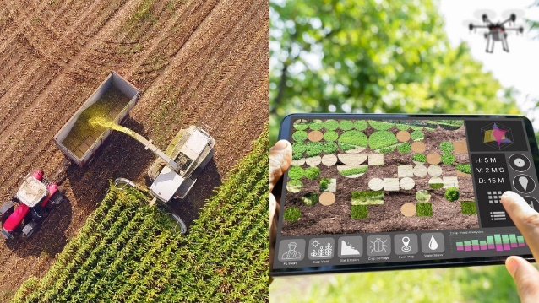

Fig.4: AI technique with Drones

**2.7 Disease detection in plants**

Plant diseases, caused by environmental exposure, can significantly reduce agricultural yield and quality. Early detection and prevention are crucial, and AI technologies, particularly computer vision and deep learning, have proven effective as shown in Fig [5]. Key advancements include:

* **Image Processing**: Automated methods such as K-means clustering, Support Vector Machines (SVM), and Deep Convolutional Neural Networks achieve high accuracy in disease detection by analysing plant features like colour, texture, and shape.
* **Spectroscopic & Imaging Techniques**: Tools like hyperspectral imaging and thermal infrared imaging identify diseases early, often before visible symptoms appear. For example, fluorescence imaging helps in detecting stress signals in crops.
* **Machine Learning Algorithms**: AI methods like Alex Net and VGG16 achieve over 97% accuracy in classifying plant diseases using large datasets, enhancing scalability and efficiency.
* **Integrated Systems**: Startups like Prospera use AI-driven networks of sensors and cameras to monitor crops and alert farmers to disease outbreaks.

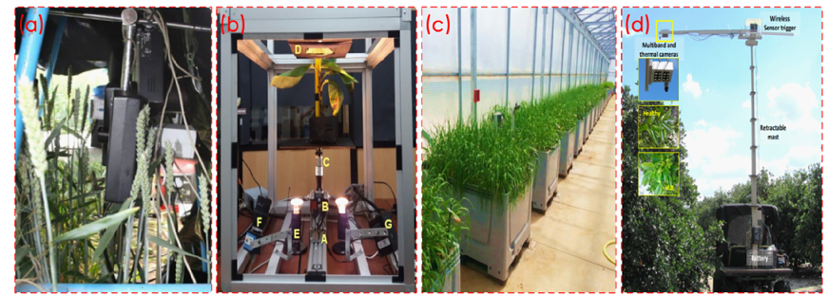 Fig.5: Disease detection in plants (a)Hyperspectral and chlorophyll fluorescence imaging. (b)Hyperspectral imaging system for disease scanning on banana plants. (c) hyperspectral imaging: from the lab to the field (d) Infrared and Thermal imaging for citrus greening detection

**2.8 New Technology to Improve Indian Agriculture**

**Solar-Powered Water Pumps:** Enable irrigation in remote areas using renewable energy, reducing reliance on fossil fuels and lowering costs.

**Drip Irrigation & Smart Sprinklers:** Deliver precise water to plant roots, minimizing waste, particularly in water-scarce regions.

**Farm Management Software:** Tools like CropIn and Agri Digital assist in crop tracking, supply chain management, and data-driven decision-making.

**E-commerce Platforms:** Apps like Ninja cart and Agro Star connect farmers directly to buyers, increasing profits by removing intermediaries.

**Sensors & IoT**: Smart sensors monitor soil and crop health, optimizing water and fertilizer use to improve yields and reduce waste.

**Drones:** Used for crop monitoring, pest management, and precise aerial spraying of inputs.

**Automated Harvesters:** Robots perform harvesting tasks, reducing labour costs and boosting efficiency.

**Weeding Robots:** Mechanically remove weeds, cutting the need for chemical herbicides.

**Artificial Intelligence:** AI analyses weather, soil, and crop data, helping optimize planting, irrigation, and harvesting schedules for improved decision-making.

**3.CONCLUSION**

In conclusion, the integration of robotics, AI, and drones is revolutionizing agriculture by enhancing efficiency, productivity, and sustainability. Robotics automates labour-intensive tasks like planting, harvesting, and monitoring, while AI enables data-driven decision-making through predictive modelling and real-time insights. Drones, as transformative tools, provide high-resolution data on crop health, soil conditions, and pest infestations, empowering precision agriculture to optimize resource use, increase yields, and minimize environmental impacts. Future advancements will see drones integrated with AI, IoT, and big data, enabling autonomous, intelligent systems capable of independent monitoring and interventions. These innovations promise improved resilience against climate change and unpredictable weather. While initial costs and regulatory hurdles pose challenges, advancements and supportive policies are making this technology more accessible to smallholder and large-scale farms. Drones will play a pivotal role in promoting sustainable and resilient agriculture, contributing to global food security, environmental conservation, and sustainable development goals. As they become more affordable and user-friendly, drones will democratize precision farming, supporting a smarter, greener, and more productive agricultural future.

**4.REFERENCES**

1. Wakchaure, M., Patle, B. K., & Mahindrakar, A. K. (2023). Application of AI techniques and robotics in agriculture: A review. Artificial Intelligence in the Life Sciences, 3, 100057.
2. Shet, A. P., & Shekar, P. (2020). Artificial Intelligence and Robotics in The Field of Agriculture.
3. Javaid, M., Haleem, A., Khan, I. H., & Suman, R. (2023). Understanding the potential applications of Artificial Intelligence in Agriculture Sector. Advanced Agrochem, 2(1), 15-30.
4. Yang, Q., Du, X., Wang, Z., Meng, Z., Ma, Z., & Zhang, Q. (2023). A review of core agricultural robot technologies for crop productions. Computers and Electronics in Agriculture, 206, 107701.
5. Albiero, D., Garcia, A. P., Umezu, C. K., & de Paulo, R. L. (2022). Swarm robots in mechanized agricultural operations: A review about challenges for research. Computers and Electronics in Agriculture, 193, 106608.
6. Ahirwar, S., Swarnkar, R., Bhukya, S., & Namwade, G. (2019). Application of drone in agriculture. International Journal of Current Microbiology and Applied Sciences, 8(01), 2500-2505.
7. Aditya S Natu, Kulkarni SC. Adoption and Utilization of Drones for Advanced Precision Farming: A Review. published in International Journal on Recent and Innovation Trends in Computing and Communication, ISSN: 2321-8169. 2016; 4(5):563-565.
8. *Kutyauripo Kumar, R., Yadav, S., Kumar, M., Kumar, J., & Kumar, M. (2020). Artificial intelligence: new technology to improve Indian agriculture. International Journal of Chemical Studies, 8(2), 2999-3005.*
9. *Kumar, R., Yadav, S., Kumar, M., Kumar, J., & Kumar, M. (2020). Artificial intelligence: new technology to improve Indian agriculture. International Journal of Chemical Studies, 8(2), 2999-3005.*
10. *Sachithra, V., & Subhashini, L. D. C. S. (2023). How artificial intelligence uses to achieve the agriculture sustainability: Systematic review. Artificial Intelligence in Agriculture, 8, 46-59.*