A SURVEY ON SCENE TEXT DETECTION USING DEEP LEARNING
K.SUHAN JAYAKAR

ABSTRACT:

Text recognition is critical in various domains, including driving assistance, handwriting recognition. Scene text detection using Deep Learning has more demand for recognising and locating text in natural images. Unlike traditional Optical Character Recognition (OCR) systems have been designed for structured environments, whereas scene text detection deals with unstructured and unorganised text such as street signs, product labels and handwritten notes. Deep Learning methods are used to detect the patterns, shapes, fonts. This study includes Fusion Neural Networks (FNN) which uses Convolutional Neural Networks (CNN) and Recurrent Neural Networks (RNN) which can automatically learns to detect a text or segments from complex backgrounds. The system integrates CNN for feature extraction and RNN for feature classification and prediction.Usage of Bi-directional Grated Recurrent Unit (Bi-GRU) for forward and backward pass in Deep Learning models results in improved accuracy. The integration of Deep Learning models for Scene Text Detection are more accurate than traditional systems in real world scenarios.

KEYWORDS:

Optical Character Recognition, Fusion Neural Networks, Convolutional Neural Networks, Recurrent Neural Networks, Deep Learning Bi-directional Grated Recurrent Unit.

1. INTRODUCTION:

Scene text detection has emerged as a challenging task in computer vision, with direct applications in autonomous driving, document digitisation, and augmented reality. Unlike traditional Optical Character Recognition (OCR) systems in which a well-structured environment, such as the page of a printed book, represents the primary subject of study, scene text detection faces unstructured and complex backgrounds-including street signs, product labels, and handwritten notes. Not only is it challenging, but the problem of scene text detection is very dynamic in nature due to the difficulties- varied fonts, various orientations and lighting conditions.

Recent studies in deep learning have pushed these abilities of detecting and recognising text in natural scenes, and the instances of Convolutional Neural Networks (CNNs) and Recurrent Neural Networks (RNNs) are main examples. CNNs are widely used in the feature extraction area due to its superiority in terms of

the recognition, while RNNs, specific to the Long Short Term Memory (LSTM) network models, perform very well in terms of detecting temporal dependencies and sequence information, which is all integral in recognising text patterns. Together with convolutional recurrent models (CRNNs) that absorb attention mechanisms towards more relevant parts of an image, detection accuracy at challenging moments has also witnessed a revolution in the area. Hybrid models have done wonders in detecting and classifying text from natural scenes compared to traditional methods. This paper explores in-depth the rise in deep learning techniques for scene text detection and recognition, an integration of CNNs and RNNs complemented by attention mechanisms, which have greatly improved the accuracy, robustness, and real-time performance. This would give us the current state-of-the-art methods and their future scope for applications.

2. RELATED WORK:

The performance of Attention Based Model for Scene Text Detection and the effectiveness of combining Convolutional Neural Networks CNN and Recurrent Neural Networks RNN for accurate prediction.The paper is discussed about upscaling and it utilises GRU and CTC loss for labelling, enhancing accurate digit recognition [1].Attention system in CNN improves text correction. Persian dataset is used which consists of 20,000 images to achieve high performance. The usage of 3 stages helped the model in detecting text from the unordered dataset of scene text images. The model performed better when compared to other models like ResNet50. It struggles with irregular and noise text. Overall good for Persian digit recognition.

The importance of Fusion Neural Network [2] which combines different deep learning layers to improve scene text detection. It highlights the previous effect on text recognition using Convolutional Neural Networks and Long Short Term Memory for feature extraction and sequence decoding.It combines CNN and RNN for sequence labelling and prediction.Extraction and sequence labelling is done by the two layers. It handles text sequences of different lengths. The model is evaluated using some datasets like RRC-MCT-2019 which consists of 20,000 text images.

According to advances of deep learning based on text detection in natural scenes compares the DL approaches and the model effectiveness in detecting text in complex and noisy backgrounds.Key based models like CNN and RNN are used for feature extraction and handling sequence of data in complex scenarios. Representative models like CTPN and EAST [3] are used for detecting text while sliding and directly predicting text areas without multiple steps. Seglink models like TextBoxes are used for fast and accurate detection.PESNet model is used for scale expansion to separate close text lines. PAN model is used for segmentation division for irregular text.

FCENet model is used for curve detection for providing high accuracy and shaped text.

The usage of CRNN model which combines both CNN and RNN to detect and classify text from natural scenes. It focuses on sequential data processing improving text accuracy in complex backgrounds. The given image is preprocessed for better enhancement and then CNN is used for extracting features. It uses Bidirectional Long Short Term Memory (BiLSTM) [4] to capture forward and backward dependencies for improving writing styles.CTC layer is used for mapping the predicted sequences to the final outputs.Datasets like LCDAR 2015 and 2017 are used and a PDT 2023 custom dataset is used for analysis. It is trained for data augmentation, scaling and normalisation.

The different Deep learning models for STR which compares performance, strength and weakness of the models. It is divided into 2 ways called top-down and bottom-up methods in which top-down treats text as general objects and the other treats as small parts of the text and link respectively [5]. Regression based predicts bounded boxes around the text, Segmentation based involves pixel wise classification to separate and link together, hybrid based is combination of regression and segmentation to achieve good result.

A scene-text synthesis engine that learns from decomposed real world to generate text data for training models. It is used for boosting and performance of scene text detection. DecompST [6] a high quality dataset is used. The engine is trained for identifying outlier boxes that appear in images.TLPNet is used to find a suitable place for text insertion. TAANet is used to match the text with the background appearance by adjusting the size.

The localisation in STR by improving localisation accuracy and efficiency of detecting texts in different conditions like fronts, sizes. The localisation involves identifying locations of the texts within the image.Different shapes and languages make it difficult and complex [7]. Noisy background effects the detection and localisation. Image quality also makes a difference and for localisation a high quality image is required. Before DL they used MSER called maximally stable external regions which detect both texts and identifying regions in images.EAST is more efficient and accurate for localising and detecting text.

The highlights of weakly supervised learning techniques for STR by Deep Reinforcement Learning [8]. It reduces the need of labelled data while improves detection performance through agent based learning. Usage of CNN and RNN is used in rotation and dimensions and enhancing the ability to detect text in various backgrounds. Reinforcement learning methods aim to detect text by reducing labelling of data. As the weak supervision can detect the shapes like polygonal types and other forms which is used to detect text shapes. Weak supervision can detect text instances although bounding boxes may not fit in box. By combining weak supervised method leads to improved performance. It proves effective for unlabelled dataset of images.

Scene Text Detection and Recognition The Deep Learning Era briefly reviews how the scene text detection and recognition dramatically changed from traditional handcrafted methods to deep learning models like CNNs and RNNs [9] in recent years. The text spans methods on text detection, methods on text recognition, and finally end-to-end systems that integrate both text detection and recognition. Synthetic data generation came out to be highly beneficial in addition to semi-supervised learning that helped achieve better performance along with producing massive datasets. The paper outlines challenges with diverse writing styles, elaborate background, and multilingual text; hence the future work should strengthen the strong and efficient ability to handle real-world tasks. Much is still left to be done; however deep learning significantly progressed in the field.

Scene text recognition model is used by integrating a Convolutional Recurrent Neural Network (CRNN) with DBNet [10] for text detection, a text direction classifier for multi-oriented text, and the Retinex algorithm for image enhancement. This model significantly improves recognition accuracy in complex environments, especially for multi-oriented text. The model was tested on datasets such as ICDAR2015 and Total-Text, achieving 84.8% accuracy for complex scenes, and 82.1% accuracy for multi-oriented text compared to other methods like SegLink and EAST. The model cannot do well with curved text and consumes a lot of computational resources, which need to be addressed in future work.

GWNet: a real-time scene text detection framework that can handle arbitrarily shaped text with high precision. The proposed GWNet [11] consists of two modules - namely the Global Module, designed for improved Differentiable Binary using k and shift sub-modules in order to enhance convergence and accurate detection, and the RCNN Module to fuse global- and word-level features for recognition of text. This approach outperforms previous methods regarding the two aspects of precision and efficiency simultaneously, and achieves state-of-art performance on datasets such as MSRA-TD500 and ICDAR2015, especially in complicated text shape detection in natural scenes

The two techniques Scale-Aware Data Augmentation (SADA) and Shape Similarity Constraint (SSC) [12] is the augmentation of training data diversity through specific-scale image crops and generation of various text parts allows for faster convergence. The Loss function SSC improves the accuracy of text boundaries capturing global shape structures in the text. Together, these innovations result in improved detection accuracy and generalisation, outperforming existing models on datasets like CTW1500 and Total-Text.

3. METHODOLOGY:

3.1 Problem Definition:

The main goal focuses on improvement on scene text detection in real world images. The deep learning approach is used to enhance optimistic, efficiency and accurate decision-making for identifying the text. It is introduced to improve and accelerate the processing of high-quality data inputs and recognise the pattern of a given image.

3.2 Data Pre-processing:

A dataset of Persian digits is created from the images like electricity meter devices and contains 20,000 images gathered from the devices. It contains the problem or challenges like low-quality, tilted, blurry images and various fonts etc. To prepare the dataset for text analysis normalisation is performed. Then Annotation and Grayscale Conversion followed by Cropping and Resizing for the required length is performed.

Normalisation is used for normalising the input by dividing each pixel value by 255. It ensures the pixel values are in the range between 0-255 only. The images are annotated by using bounding and drawing the box around the required text area. Vgg image annotator(VIA) is used to perform the task. After this the image is converted into RGB colour to grayscale. It simplifies the dimensionality of the images. Then in final the images are cropped and resized to 50 × 200 pixels.

3.3 Deep Learning Model:

Convolutional Recurrent Neural Networks (CRNN) is mainly used for better performance.In Input Preprocessing, an image is prepared with Height H, width W and Channels C. Then the pixel values are normalised by dividing each by 255 to bring them into the range [0, 1]. If necessary, convert the image to greyscale. Detect the region of interest (ROI) where the text is located, then crop and resize the image to a fixed dimension (eg. 50 × 200 pixels). Apply two convolutional layers followed by the ReLU activation function and batch normalisation following apply max pooling to reduce the spatial dimensions. In Squeeze and Excitation (SE) Block, global average pooling (1) should be applied for reducing the spatial dimensions of the feature maps and generating channel wise statistics,

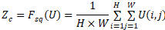

→(1)

Use a gating mechanism with two fully connected layers and ReLU (2) activation to capture channel wise dependencies.Then apply a sigmoid activation.
S = Fex (Z,W) = σ (g(Z,W)
= σ(W2 (δ (W1Z))) →(2)
Recalibrate the squeezed and excited features element-wise by multiplying them with the same input features to focus the attention of that squeezed and excited feature towards the important channels. Pass the concatenated feature through a Bi-GRU network which extracts sequential dependency in both forward and backward directions. Sequence of features is output from the Bi-GRU representing recognised text. The CTC Layer decodes a sequence of features to a sequence of text tables, supports variable-length sequences, and aligns an input image with output labels.This formula (3) is used to determine the probability of the output label sequence:

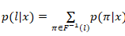
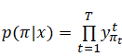 →(3)
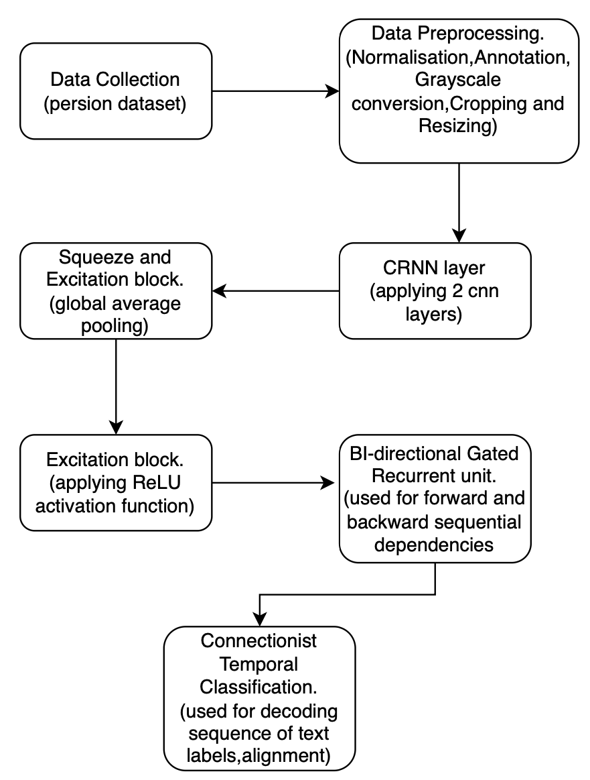
For maximum likelihood decoding, a probability function maps the output from the GRU to its final sequence. The maximum probability decides the label-sequence by the CTC for the output of the predicted text.

Figure 1

4. RESULTS:

As seen in the graph the built-in models like CRNN(Bi-GRU) with accuracy of 89.13%,CRNN(Bi-LSTM) with accuracy of 88.11%, GeoTRNet with an accuracy of 45.3%,CNN-Baseline with an accuracy of 91.71% are not able to achieve almost accuracy and were weak in detecting the the patterns and shapes in text recognition.The proposed model is able to achieve 94.26% of accuracy by predicting and analysing the shapes and patterns of a given dataset.This model achieves higher accuracy when compared with other built-in models and is good for using the text recognition.
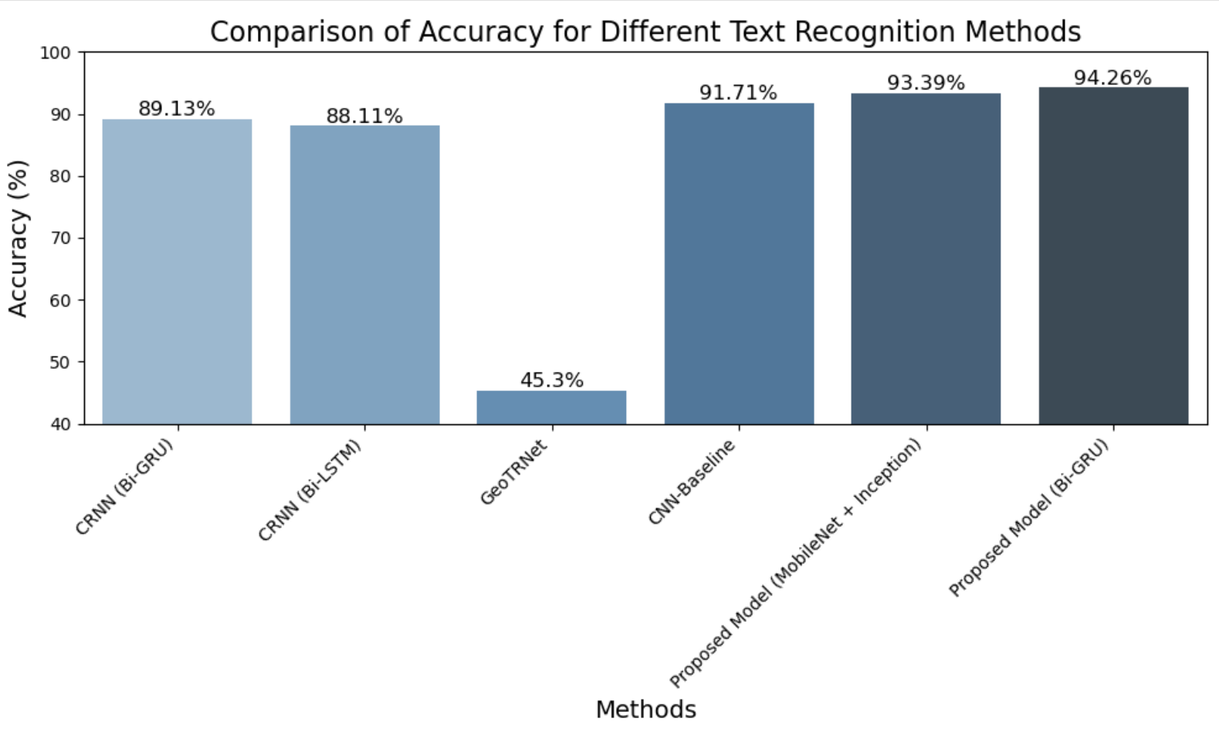

Figure 2

5. CONCLUSION:

The study focuses on how deep learning techniques are playing a key role for scene text recognition. There are many techniques in detecting a text from a given input image.The study is performed on a non-latin dataset and was able to achieve good amount of accuracy compared with pre-trained models. Despite performing well it is not suitable for irregular and noisy text. Furthermore the dataset is limited to 5 digits only. By increasing the size and training the model with noisy and irregular dataset it achieves more accurate results. The combination of CRNN can improve the optimistic performance of the model for time complexity. Additionally the model can be trained and can be used for irregular and nosy text also. The effectiveness of the proposed model has achieved the highest compared to all the pre-defined models.

6. REFERENCES:

[1] Alshawi, A. A. A., Tanha, J., & Balafar, M. A. (2024). An attention-based convolutional recurrent neural networks for scene text recognition.IEEE Access.

[2] S. K., Mehta, S. (2023) .Text detection and recognition through deep learning based fusion neural network.Dasari, IAES International Journal of Artificial Intelligence (IJ-AI).

[3] Zhao, Q. (2022).Researches advanced in Natural Scenes Text Detection Based on Deep Learning., Highlights in Science Engineering and Technology.

[4] P., Hanumanthaiah, S. K. Y., & Mayigowda, S. B. (2024). CRNN model for text detection and classification from natural scenes.Prakash, IAES International Journal of Artificial Intelligence (IJ-AI).

[5] Khan, T., Sarkar, R., & Mollah, A. F. 54.(2022). Deep learning approaches to scene text detection: a comprehensive review. Artificial Intelligence Review,, 3239-3298.

[6] Tang, Z., Miyazaki, T., & Omachi, S.(2023). A Scene-Text Synthesis Engine Achieved Through Learning From Decomposed Real-World Data.IEEE Transactions on Image Processing, 32, 5837-5851.

[7] Sonsare, P., Banode, A., Jain, R., Dave, K., & Runwal, R. (2023). A Novel Study On Localization In Scene Text Detection.International Journal of Next-Generation Computing, 14(1).

[8] Metzenthin, E., Bartz, C., & Meinel, C. (2022). Weakly Supervised Scene Text Detection using Deep Reinforcement Learning.arXiv preprint arXiv:2201.04866.

[9] Long, S., He, X., & Yao, C. (2023). Scene text detection and recognition: The deep learning era. Journal of Computer Vision, 30(4), 567–589.

[10] Liu, Y., Wang, Y., & Shi, H. (2023). A convolutional recurrent neural-network-based machine learning for scene text recognition application.Symmetry, 15(4), 849.

[11] Zhao, F., Yu, J., Xing, E., Song, W., & Xu, X.(2022). Real-time Scene Text Detection Based on Global Level and Word Level Features.arXiv preprint arXiv:2203.05251.

[12] Dai, P., Li, Y., Zhang, H., Li, J., & Cao, X. (2022).Accurate scene text detection via scale-aware data augmentation and shape similarity constraint. IEEE Transactions on Multimedia, 24, 1883-1895.

