

# Department of Computer Science & Engineering

## MALLA REDDY UNIVERSITY, HYDERABAD

**2024-2025**



# TRIP-IT The Way To Travel

**Designed and Developed by**

1. VAJRALA YASHWANTH REDDY 2311CS010669
2. THURPU APOORVA 2311CS010654
3. TENALI MEGHANA 2311CS010644
4. YADLA SANKAR RAO 2311CS010694

**Under the Guidance of**

**Dr. B. JOGESWARA RAO**

**ASSOCIATE PROFESSOR**

# Department of Computer Science & Engineering

## MALLA REDDY UNIVERSITY, HYDERABAD

### 2024-2025



**CERTIFICATE**

This is to certify that this is the Application Development Lab record entitled TRIP – IT ,

submitted by **VAJRALA YASHWANTH REDDY (2311CS010669), THURPU APOORVA (2311CS010654), TENALI MEGHANA (2311CS010644), YEDLA SHANKAR RAO (2311CS010694)** B. Tech II year I semester, Department of CSE during the year 2024-25. The results embodied in this report have not been submitted to any other university or institute for the award of any degree or diploma.

**Internal Guide Dean - CSE**

**Dr.B.Jogeswara Rao Dr. Shaik Meeravali**

#### Associate Professor

**External Examiner**



# DECLARATION

We declare that this project report titled **TRIP - IT submitted** in partial fulfilment of the degree of B.Tech in CSE is a record of original work carried out by me under the supervision of **Dr.B.JOGESWARA RAO**, and has not formed the basis for the award of any other degree or diploma, in this or any other Institution or University. In keeping with the ethical practice in reporting scientific information, due acknowledgements have been made wherever the findings of others have been cited.

## VAJRALA YASHWANTH REDDY 2311CS010669 THURPU APOORVA 2311CS010654 TENALA MEGHANA 2311CS010644

## YEDLA SHANKAR RAO 2311CS010694

**ACKNOWLEDGEMENT**

With great pleasure we want to take this opportunity to express our heartfelt gratitude to all the people who helped in making this mini project work a grand success.

We express our deep sense of gratitude to **Dr.B.JOGESWARA RAO** for his constant guidance throughout our mini project work.

We are grateful to **Mr.M.Rakesh** for his/her valuable suggestions and guidance given by him during the execution of this mini project work.

We would like to thank **Dr. Shaik Meeravali**, **Head of the Department of Computer Science and Engineering,** for providing seamless support and right Suggestions in the development of App.

First of all, we express our sincere thanks to **Chairman** for this continuous care towards our achievements

We are highly indebted to **Vice Chancellor**, for giving us the permission to carry out this mini project.

Last but not the least we would like to thank the **Teaching & Non- Teaching staff** of CSE Department for sharing their knowledge with us.

**VAJRALA YASHWANTH REDDY 2311CS010669 THURPU APOORVA 2311CS010654 TENALI MEGHANA 2311CS010644**

**YEDLA SHANKAR RAO 2311CS010694**

**TABLE OF CONTENT**

|  |  |
| --- | --- |
| **DESCRIPTION** | **PAGE NUMBER** |
| **CERTIFICATE** | iii |
| **DECLARATION** | iv |
| **ACKNOWLEDGEMENT** | v |
| **ABSTRACT** | viii |
| **LIST OF FIGURES** | vii |
| **Chapter 1 Introduction**   * 1. Introduction   2. Problem Statement   3. Objective of Project   4. Goal of Project   5. Literature Survey | 1  1  2  3  4  5 |
| **Chapter 2 Problem Identification**   * 1. Existing System   2.2 Proposed System | 6  6  6 |
| **Chapter 3 Requirements**  3.1Software Requirements  3.2 Hardware Requirements | 7  7  7 |
| **Chapter 4 Design and Implementation**   * 1. Design   4.2 Uml Daigrams  4.3 Implementation | 8  8  10  15 |
| **Chapter 5 Code**  5.1 Source Code  5.2 Screenshot of Application | 16  16  40 |
| **Chapter 6 Results & Conclusion**  6.1 Results  6.2 Conclusion  REFERENCES | 46  46  47  48 |

|  |  |  |
| --- | --- | --- |
| **FIGURE** | **LIST OF FIGURES**  **TITLE** | **PAGE** |
|  |  | **NUMBER** |
| 4.1.1 | Design of Trip It | 8 |
| 4.1.2 | Dataflow of Trip It | 9 |
| 4.2.1 | Use case of Trip It | 11 |
| 4.2.2 | Sequence Diagram of Trip It | 12 |
| 4.2.3  4.2.4  4.2.5 | Class Diagram of Trip It  State Diagram of Trip It  Activity Diagram of Trip It | 13  14  15 |
| 5.2.1 | Home Page | 40 |
| 5.2.2 | Gallery | 40 |
| 5.2.3 | Admin Login | 41 |
| 5.2.4 | User Registration | 41 |
| 5.2.5 | Admin Home Page | 42 |
| 5.2.6 | User Home Page | 42 |
| 5.2.7 | Contact Form | 43 |
| 5.2.8 | Tourist Place | 43 |
| 5.2.9 | All User | 44 |
| 5.2.10 | Admin Tourist Place | 44 |
| 5.2.11 | Feedback | 45 |

## ABSTRACT

The purpose of this is how the travel and tourism industry are changing and development in the world. ​Travel and tourism industry is one of the world's great industrial sectors. ​It drives economic growth, creates jobs, improves social development and promotes peace. Hundreds of millions of people around the world are dependent on the sector for their employment.​In some island economies, travel and tourism industry is not just the biggest employer, it is effectively the only employer. ​The role is to contributing to the creation of sustainable economies. ​Travel and tourism industry is a diverse sector consisting of millions of companies and employers, from the biggest global travel brands to the smallest tour operator or hostel owner. ​Together we form a formidable force with a voice to be heard at the highest levels of society and government.​

Tourism is an important economic activity that can stimulate growth and provide jobs in both rural and urban areas. Tourism can bring a much-needed influx of cash to an area, and can provide a boost to local businesses.  Tourism also encourages a greater appreciation for the area’s culture, heritage, and attractions. It provides a way for people to learn about a new culture and understand its history. Tourists can help preserve an area’s unique attractions, such as its natural environment, architecture, and monuments. Tourism can also help preserve cultural practices and traditions by providing an incentive to keep them alive. Tourism provides a way for people to explore new places and gain a better understanding of the world. Tourism can help build bridges between different cultures, allowing people to learn more about each other. For many destinations, tourism is an important source of revenue and foreign exchange.

# CHAPTER – 1

## INTRODUCTION

# INTRODUCTION

Nowadays, as the people’s lifestyle are changing with development of technology and national economy, people are more and more choosing tourism for spending their holidays and getting distressed from their all workloads. Its business has been expanded a lot since past few years. There can be an actual tourist guide or a virtual tourist guide, people are more preferring the online tourist guide because it gives the accurate result of the query that is being asked. There are many shortcomings of the traditional guide system, for example: Limited number of tour operators, expensive traditional guide service, the explanation by the tour guide may be inaccurate or misleading, tourist guide may cheat tourists and noise pollution etc. which may disappoint the tourists. Previously, the e-traditional guide system mainly designed some equipment with related electronic information. The content was mainly information based on the baseless facts related to the historical and cultural background. They can’t be updated timely and contained some pictures in the form of gallery. The function was analyzed by the operation of tourists or staff members. This traditional system was usually designed for one specific place. It costs much for the particular place. It was not user friendly based on the choices which were taken from the users in the form of tags while registration. From the provided user’s details best results will be shown from the database, with the help of intelligent tree algorithm. On clicking the place and result the system will provide the user with the details and description of locations along with the pictures and those places will be set according to the rating, which will be done by rating compilation using NLP. Users can look to their tour plan; they need to select the dates and all the details will be displayed according to it. User can also give the feedback to the admin related to the working of the system. And admin can check all the feedback provided by the users and improvise the system. The tools and language used in this system is Java, HTML5, NLP, CSS3, Java Script, and MySQL for database, Apache Tomcat as webserver and development environment was Eclipse Web Tools Platform. The goal of this research is to design and implement intelligent platform that will aid tourists to have access to information on tourist spots in India thus help fasten their decision-making process and inconvenient for the tourists to operate the system. With the development of tourism and growth in demands of tourists, the previous traditional systems cannot meet the present demands. As the tourists are important part of tourist guide services, we should take care of the theoretical study, basic concepts, practical knowledge and practical design on the intelligent tourist guide.

## PROBLEM STATEMENT

Travel planning today is often a fragmented and stressful process, with travelers needing to juggle multiple apps and platforms for booking flights, accommodations, transportation, and local experiences. This results in inefficiencies, a lack of personalization, and missed opportunities to optimize trip costs. Additionally, travelers frequently encounter challenges such as limited access to real-time updates, safety information, and local insights, all of which can significantly impact the quality and enjoyment of their trip. Existing solutions fail to deliver a truly seamless and personalized experience, often offering generic recommendations that don't account for individual preferences, budgets, or real-time conditions. To address these issues, there is a need for a comprehensive travel application that consolidates all aspects of trip planning into a single platform, offering personalized recommendations, cost optimization, real-time alerts, and local insights. Such a solution would not only simplify the planning process but also enhance the overall travel experience, providing users with the tools and information they need to travel more efficiently, safely, and enjoyably.

**Fragmented Travel Planning**

Travelers often need to use multiple apps, websites, and services for different aspects of their trip. For example:

* Booking Bus on one platform (e.g., Expedia, Kayak)
* Reserving accommodations on another (e.g., Booking.com)
* Organizing transportation (e.g., Uber, Lyft, or local transit apps)
* Finding activities and local experiences (e.g., Viator, TripAdvisor)
* Keeping track of visas, currency exchange, weather forecasts, or local emergency contacts

This constant switching between platforms not only wastes time but also increases the risk of missing out on deals, mismanaging information, or overlooking important updates. It also creates a disjointed experience where travelers must manually integrate multiple sources of data (buses schedules, weather conditions, activity bookings, etc.) into a coherent plan.

## OBJECTIVES

The main objective of this project is to help those who wish to travel at new places alone or without any prior information about that place.

This Advanced Intelligent Trip It will inform about:

1. **CENTRALIZED TRAVEL MANAGEMENT:** Consolidate all aspects of the travel experience into a single platform for seamless trip planning, booking, and management.
2. **PERSONALIZED RECOMMENDATIONS:** Provide tailored suggestions for buses, accommodations, activities, and experiences based on individual preferences, travel history, and budget.
3. **REAL-TIME ALERTS AND UPDATES:** Deliver timely notifications on buses statuses, weather conditions, transportation delays, and local events to keep travelers informed.
4. **COST OPTIMIZATION AND BUDGETING TOOLS:** Help users manage travel expenses by offering cost comparisons, price alerts, and budgeting tools to optimize trip costs.
5. **LOCAL INSIGHTS AND RECOMMENDATIONS:** Offer users Ayurvedic diet plans tailored to their unique dosha, helping them understand which foods and beverages are beneficial or detrimental to their health. Include recipes, meal suggestions, and tips for sourcing Ayurvedic ingredients.
6. **SAFETY AND EMERGENCY SUPPORT:** Provide access to safety information, emergency contacts, and 24/7 support to ensure travelers' well-being throughout their journey.
7. **COLLABORATIVE TRIP PLANNING:** Facilitate easy access to certified Ayurvedic practitioners for consultations and personalized advice. Offer virtual appointments or chat features to answer users' questions and provide guidance on their health journeys.
8. **SEAMLESS BOOKING INTEGRATION:** Facilitate direct, secure bookings for flights, hotels, and activities with transparent pricing and a smooth payment process.
9. **OFFLINE ACCESS TO TRAVEL INFORMATION:** Allow users to access critical trip details, maps, and safety information even when they have limited or no internet connectivity.
10. **SUSTAINABILITY AND ECO-FRIENDLY TRAVEL:** Promote eco-conscious travel choices by suggesting sustainable accommodations, transportation, and activities to reduce environmental impact.
11. **USER REVIEWS AND COMMUNITY ENGAGEMENT:** Foster a community of travelers sharing insights, recommendations, and experiences to enhance the travel planning process.

## GOAL PROJECT

#### SIMPLIFY TRIP PLANNING:

Streamline the entire travel process, from flight bookings to local activities, into a single platform, reducing the need for multiple apps and websites.

1. **ENHANCE PERSONALIZATION:**

Provide tailored travel recommendations based on individual preferences, travel history, budget, and specific needs, ensuring a more relevant and enjoyable experience for each user.

1. **OPTIMIZE TRAVEL COSTS:**

Enable cost-effective trip planning by offering real-time pricing updates, price comparisons, and budget management tools to help users find the best deals and save money.

1. **PROVIDE REAL-TIME UPDATES**:

Offer timely notifications for flight statuses, weather changes, local events, and safety alerts, allowing travelers to make informed decisions and adjust their plans accordingly.

1. **ENSURE SAFETY AND SUPPORT:**

Equip travelers with up-to-date safety information, emergency contacts, and 24/7 support to help them stay safe and confident during their journey.

1. **FOSTER A COLLABORATIVE TRAVEL EXPERIENCE:**

Enable users to collaborate on trip planning with family, friends, or groups, making it easier to organize shared itineraries and coordinate decisions.

1. **PROMOTE SUSTAINABILITY:**

Encourage eco-friendly travel options and raise awareness of sustainable practices, helping users reduce their environmental impact during their trips.

## LITERATURE SURVEY

**Title** : TRAVEL AND TOURISM MANAGEMENT

**Author** : Md. Abu Barkat Ali

**Description** : Hospitality industry is growing at a rapid pace. The improving cross-country relations have resulted into boom in the Travel and Tourism Industry and its services. This book gives a comprehensive account on tourism industry of India, at large, and the world, in general. From hotel to transportation (airways, railways and roadways), the book delves on services that helps in managing a tour efficiently. It also talks about tourism’s role in revenue generation, and trade forming an integral part of the tourism industry.

**Title**  : Tourism: Principles, Practices, Philosophies

**Author** : [Charles R. Goldner](https://www.wiley.com/en-us/search?filters%5Bauthor%5D=Charles+R.+Goeldner&pq=++), [J. R. Brent Ritchie](https://www.wiley.com/en-us/search?filters%5Bauthor%5D=J.+R.+Brent+Ritchie&pq=++)

**Description** : The *12th Edition of Tourism: Principles, Practices, Philosophies* explores major concepts in tourism, what makes tourism possible, and how tourism can become an important factor in the wealth of any nation. Written in global terms, it provides an overview of the principles, practices, and philosophies that affect the cultural, social, economic, psychological, and marketing aspects of human travel and the tourism industry. Among the topics given expanded coverage in this edition are: B&Bs, time shares, meetings and conventions, sustainable tourism, climate change, social media, and mobile marketing.

# CHAPTER-2 PROBLEM IDENTIFICATION

## EXISTING SYSTEM

* In the present system a customer has to approach various agencies to find details of places and to book tickets.
* This often requires a lot of time and effort.
* A customer may not get the desired information from these offices and often the customer may be misguided.
* It is tedious for a customer to plan a particular journey and have it executed properly.
  1. **PROPOSED SYSTEM**

In this project two main entities are there and only these two entities can access the system. Both the entities have to sign up first, if they are new. As a new user, they have to fill the registration form. They have to fill username, email, password, contact number, full name and the places they want to visit of their choice i.e. tags. Admin can add places, remove places and edit their details. They can add details of places like their name, picture, location, area, city, state, facts, history and description along with the weather report of that place. Admin also can view all the added places. After the registration user can anytime login with their password and user id. After the user has logged in, they will get the recommended places.

* An intelligent tree algorithm will execute to find the best results that will be provided by the database, based on details that are provided by users
* Users can look to their tour plan; they need to select the dates and all the details will be displayed according to it
* User can give feedback to admin regarding the working of the system. Admin can view all feedback messages received from the registered user.
* User can also give the feedback to the admin related to the working of the system. And admin can check all the feedback provided by the users and improvise the system.

## CHAPTER-3 REQUIREMENTS

#### SOFTWARE REQUIREMENTS

1. **Front End:** Bootstrap/ jQuery /Ajax/JavaScript.
2. **Middle Layer (Business Logic):** Java Servlet/JSP.
3. **Database:** MySQL-8.0.
4. **Server:** Apache Tomcat 8.0.
5. **Scripting Language:** JavaScript.
6. **Editor:** Eclipse Neon & Let us version of eclipse.
7. **Operating System:** Windows Family

#### HARDWARE REQUIREMENTS

1. **Processor :** An Intel Core i3 processor or higher will provide sufficient processing power for running the application smoothly.
2. **RAM :** 2GB of RAM is recommended to ensure optimal performance while running the application.
3. **Hard Disk :** A Minimum of 320GB of free storage space is required to install the necessary software and store the files.

## DESIGN

**CHAPTER-4**

**DESIGN AND IMPLEMENTATION**

**Android:** This indicates that the system is primarily designed for Android devices.

**Users:** This represents the end-users who will be interacting with the system..

**App System:** This encompasses the entire application system, including the user interface and backend functionalities.

**Database:** This stores all the relevant data for the system, such as user information, trip details, location data, etc.

**Main Functional Interface:** This refers to the core interface that users will interact with to perform the main functions of the system, like planning trips or searching for places.

**Login/Registration Interface:** This is where users can create new accounts or log in to existing ones.

**Place Interface:** This likely allows users to search for and select places of interest for their trips.

**Maps Location:** This component probably integrates with mapping services to display locations and routes.

**Other Information:** This might include other relevant information like weather updates, travel tips, etc.

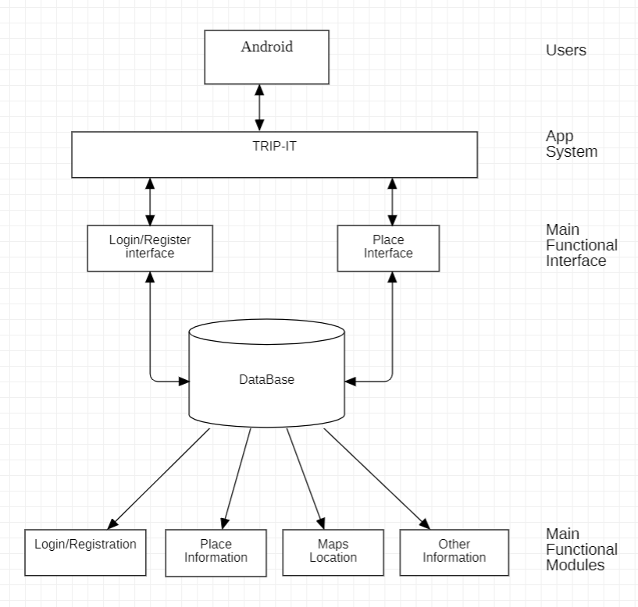

**Fig 4.1.1** Design of Trip It

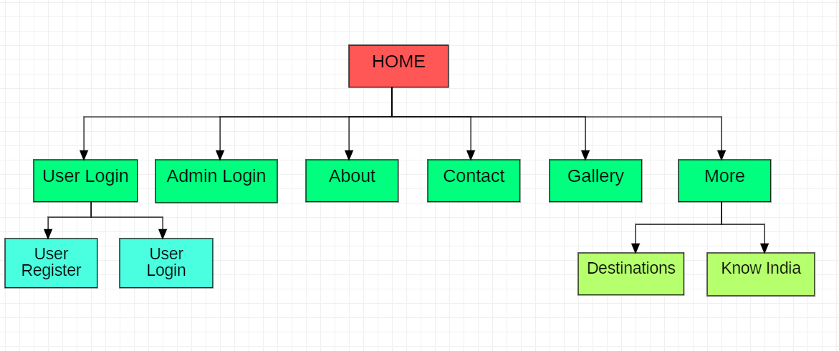This figure illustrates the workflow of a Trip It web application, facilitating connections between users and admin. The process begins with user logging in and filling out an application form, which is then stored in the database. The application provides admin with access to users profiles, allowing them to review and view contact details. Admin can review users applications, assess their suitability, and make informed decisions. Once a suitable user is identified, admin can initiate contact, streamlining the user recruitment process. This web application promotes transparency, efficiency, and effective matching of users with Admin, fostering meaningful collaborations and social impact.

**Fig 4.1.2** Dataflow of Trip It

## UML DIAGRAMS:

**System User:** Represents any user who interacts with the system, whether they are a customer, admin, or staff.

**Authorized Customer:** Represents a customer who has been authenticated and authorized to use the system.

**Administrator:** Represents a user with administrative privileges to manage the system.

Staff: Represents employees who have access to certain system functionalities.

### Use Cases:

**Validate User:** This use case handles the authentication process, ensuring that users are who they claim to be.

**Sign-in-New:** This use case allows new users to create accounts and register with the system.

**Reserve for Tour:** This use case enables authorized customers to book tours.

**Maintain Reservation:** This use case allows authorized customers and staff to manage existing reservations.

**View Details:** This use case allows authorized customers and staff to view details about tours, reservations, and other relevant information.

**Make Payment:** This use case enables authorized customers to make payments for their bookings.

**Maintain Tour Scheme:** This use case allows administrators to manage the tour schemes and packages offered by the system.

**Reserve Ticket:** This use case enables staff to reserve tickets for tours.

**Reserve Hotel:** This use case enables staff to reserve hotels for tour packages.

### Relationships:

**<<extend>>:** This relationship indicates that the "Sign-in-New" use case extends the functionality of the "Validate User" use case. This means that the "Sign-in-New" use case includes all the steps of "Validate User" plus additional steps for creating a new account.

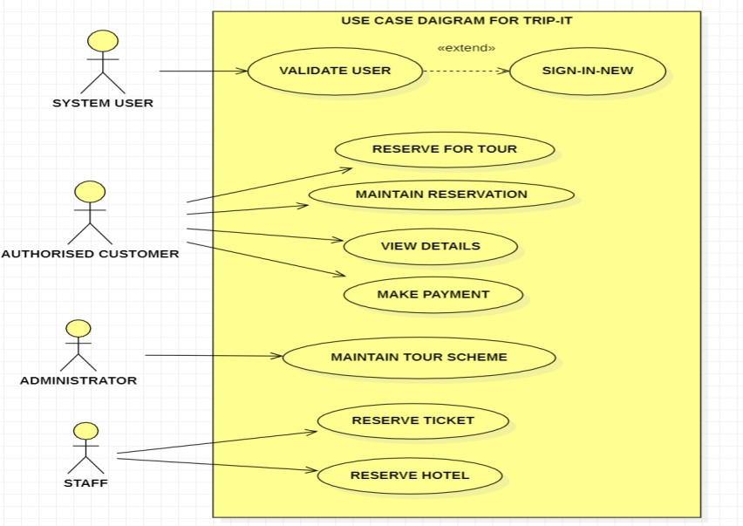**Fig 4.2.1** Use case of Trip It

### This sequence diagram illustrates the interaction flow of a Trip It web application.

### Overall Flow:

This sequence diagram illustrates the interaction between three entities: Agent, Admin, and Database, during a booking process.

### Key Interactions:

**Visit:** The Agent initiates the process by visiting the Admin.

**Admin Response:** The Admin acknowledges the visit and begins processing the request.

**Check Availability:** The Admin queries the Database to check the availability of seats for the requested trip.

**Acknowledgment Availability**: The Database responds to the Admin with the availability status.

**Make Deal:** Based on the availability, the Admin makes a deal with the Agent.

Agent Response: The Agent confirms the deal with the Admin.

**Seats Booked:** The Admin updates the Database to book the seats for the Agent.

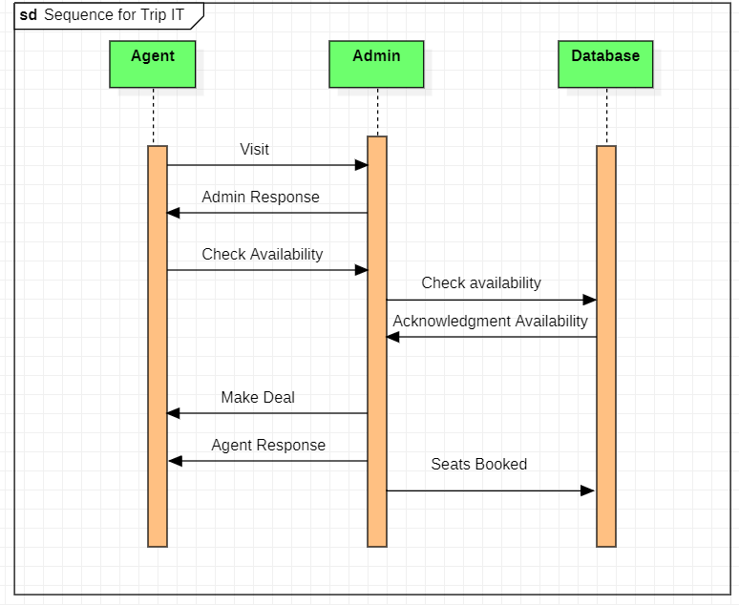

**Fig 4.2.2** Sequence Diagram of Trip It

### Classes:

**User:** Represents users of the system, with attributes like ID, name, email, date of birth, and more.

**Admin:** Represents administrators of the system, with attributes like ID, name, email, and date of birth.

**Profile:** Stores additional information about users, such as preferences, region, avatar, and more.

**Message:** Represents messages exchanged between users, with attributes like content and subject.

**Trip:** Represents trips or tours offered by the system, with attributes like name, description, destination, start and end dates, maximum participants, price, and contact person.

**Agency:** Represents agencies or organizations that offer trips, with attributes like name, city, address, contact email, and code.

### Relationships:

**User - Profile:** A one-to-one relationship, indicating that each user has one profile.

**User - Message:** A one-to-many relationship, indicating that a user can send and receive multiple messages.

**User - Trip:** A many-to-many relationship, indicating that a user can participate in multiple trips, and a trip can have multiple participants.

**Admin - Message:** A one-to-many relationship, indicating that an admin can send and receive multiple messages.

**Admin - Trip:** A one-to-many relationship, indicating that an admin can manage multiple trips.

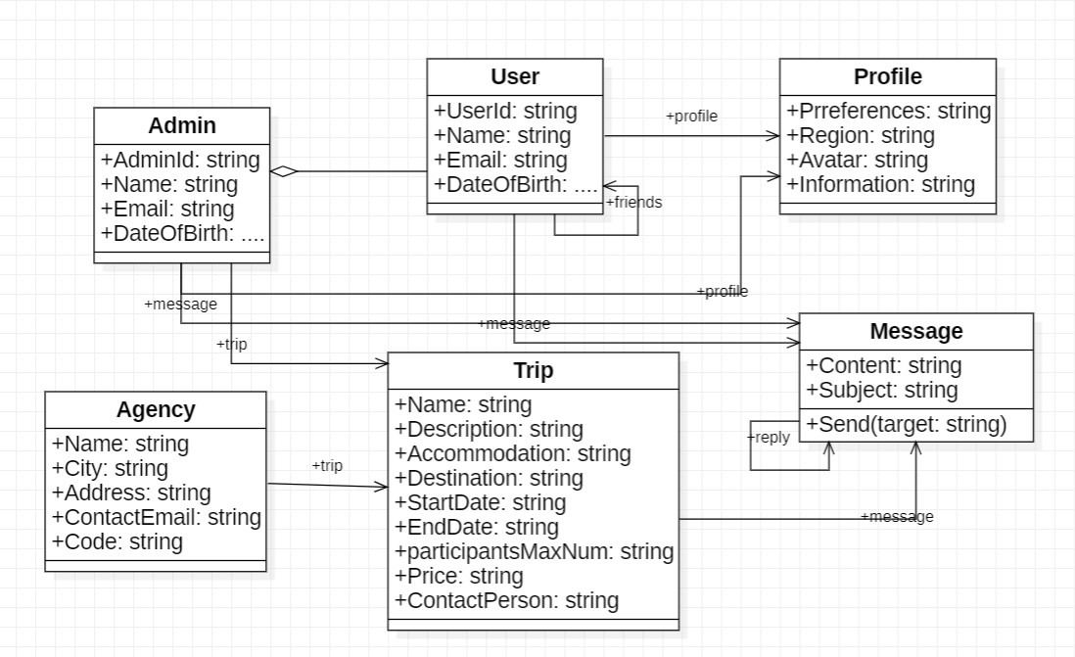**Agency - Trip:** A one-to-many relationship, indicating that an agency can offer multiple trips.

**Fig 4.2.3** Class Diagram of Trip It

### Overall Flow:

The diagram depicts the process of a customer requesting a tour scheme, registering or logging in, selecting a tour package, and finally reserving the tour.

### Key Activities:

**Request Scheme:** This is the starting point where the customer initiates the process by requesting a tour scheme.

**Register Customer:** If the customer is new, they need to register by providing their information. If they are already registered, they can log in.

**Select Tour Package:** After registration or login, the customer selects a desired tour package from the available options.

**Reserve Tour:** Once a package is selected, the customer proceeds to reserve the tour.

### Decision Points:

**New Customer:** A decision point is present after the "Request Scheme" activity to determine if the customer is new or registered.

**More Packages:** Another decision point is present after the "Select Tour Package" activity to allow the customer to explore more packages or proceed to reservation.

### End Point:

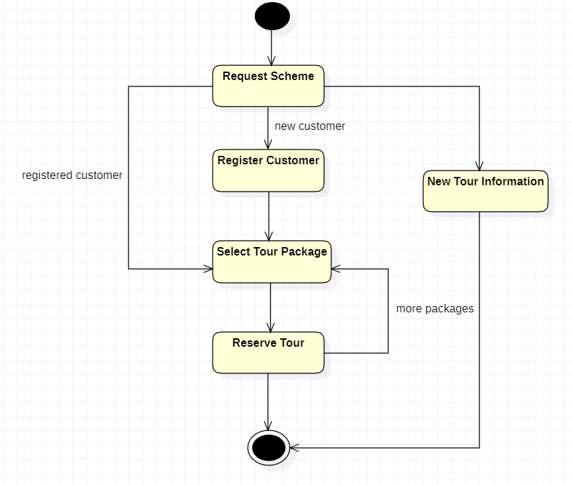The final activity, "Reserve Tour," leads to the end point, indicating the completion of the tour reservation process.

**Fig 4.2.4** State Diagram of Trip It

### Overall Flow:

This activity diagram depicts the various activities and decisions involved in a user's journey within a travel booking system.

### Key Activities:

**Registration:** The initial step where a new user registers their account.

**Login:** Existing users log in to access the system.

**Book Trip (Assisted):** Users can request assistance from a customer service executive to book a trip

**Book Trip (Manual):** Users can manually book a trip themselves.

**Update Travel Preferences**: Users can update their travel preferences.

**Manage User Profile:** Users can manage their profile information.

**Approves New Service:** System admins can approve new services offered by the system.

**Approves Update to Services:** System admins can approve updates to existing services.

**Approves Registration:** System admins can approve new user registrations.

**Add New Features to Application**: System admins can add new features to the application.

**Add New Service:** Data admins and customer service executives can add new services.

**Revoke Existing Service**: Data admins can revoke existing services.

**Update a Service:** Data admins can update existing services.

**Manage Database:** Data admins can manage the system's database.

### Decision Points:

**Registration Approved/Not Accepted:** A decision is made after registration to determine if the registration is approved or not.

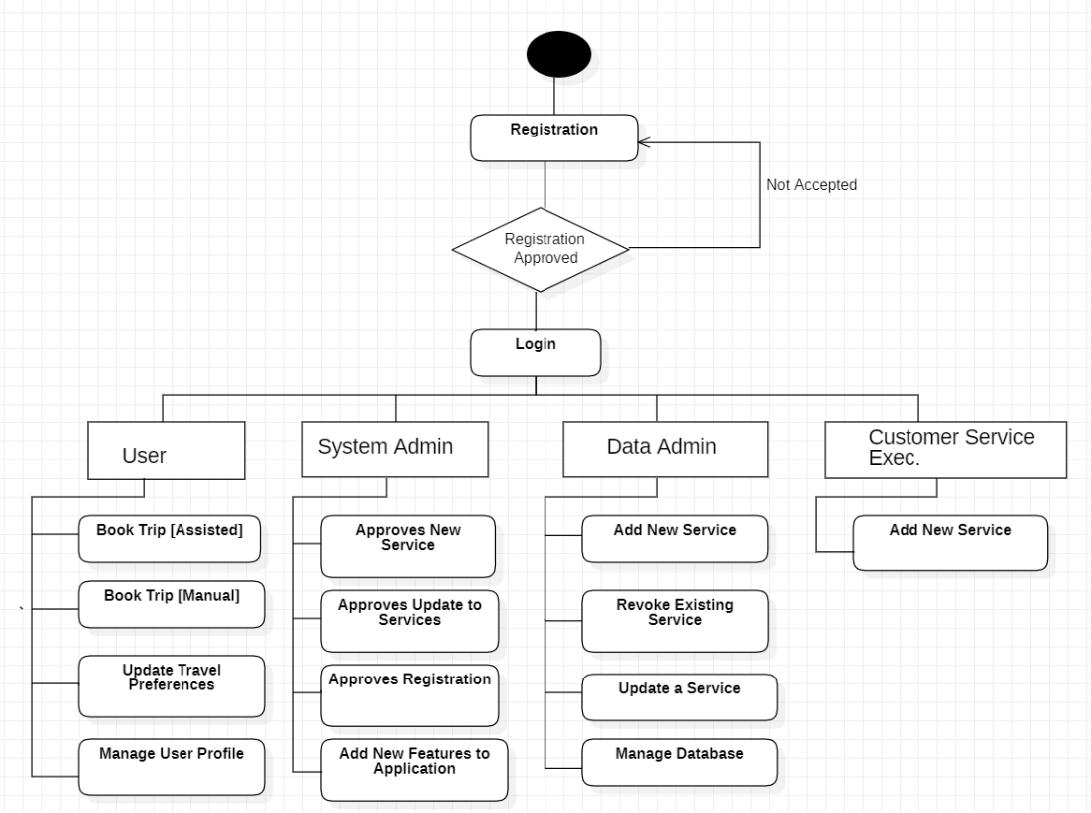

**Fig 4.2.5** Activity Diagram of Trip It

## IMPLEMENTATION

A travel-based application is a mobile or web platform designed to assist users in planning, booking, and managing their travel experiences. It typically integrates various features such as destination discovery, flight and hotel booking, itinerary creation, and local activity recommendations. Users can search for and compare flight prices, check availability for accommodations, and even book tours or activities directly through the app. These applications often include real-time updates like flight delays, weather conditions, and local events. Additionally, travel apps may offer user reviews, maps, currency converters, and language translation tools to enhance the traveler's experience.

By leveraging APIs from airlines, hotels, and activity providers, a travel app can provide a comprehensive service that simplifies the planning process, making it easy for users to organize every aspect of their trip from start to finish. With the growing trend of personalized recommendations and artificial intelligence, many apps also offer tailored suggestions based on user preferences and previous travel history, further enhancing the user experience.

## 5.1 Source Code

## CHAPTER-5 CODING

const <%@ page language="java" contentType="text/html; charset=ISO-8859-1"

pageEncoding="ISO-8859-1"%>

<!DOCTYPE html>

<html lang="en">

<head>

<title>Trip It</title>

<!-- Meta tag Keywords -->

<meta name=*"viewport"* content=*"width=device-width, initial-scale=1"*>

<meta charset=*"utf-8"*>

<meta name=*"keywords"*

content=*"In Travel Responsive web template, Bootstrap Web Templates, Flat Web Templates, Android Compatible web template,*

*Smartphone Compatible web template, free webdesigns for Nokia, Samsung, LG, SonyEricsson, Motorola web design"* />

<script type=*"application/x-javascript"*>

addEventListener("load", **function** () {

setTimeout(hideURLbar, 0);

}, **false**);

**function** hideURLbar() {

window.scrollTo(0, 1);

}

</script>

<!--// Meta tag Keywords -->

<!-- pop up box -->

<link href=*"css/popuo-box.css"* rel=*"stylesheet"* type=*"text/css"*

media=*"all"* />

<!-- //pop up box -->

<link rel=*"stylesheet"* href=*"css/jquery.desoslide.css"*>

<!-- css files -->

<link rel=*"stylesheet"* href=*"css/bootstrap.css"*>

<!-- Bootstrap-Core-CSS -->

<link rel=*"stylesheet"* href=*"css/style.css"* type=*"text/css"* media=*"all"* />

<!-- Style-CSS -->

<link rel=*"stylesheet"* href=*"css/font-awesome.css"*>

<!-- Font-Awesome-Icons-CSS -->

<!-- //css files -->

<link rel=*"stylesheet"* href=*"css/jquery-ui.css"* />

<!-- web-fonts -->

<linkhref=*"http://fonts.googleapis.com/css?family=Raleway:100,100i,200,200i,300,300i,400,400i,500,500i,600,600i,700,700i,800,800i,900,900i&amp;subset=latin-ext"*

rel=*"stylesheet"*>

<!-- //web-fonts -->

</head>

<body>

<scriptsrc=*'../../../../../../../ajax.googleapis.com/ajax/libs/jquery/1.10.2/jquery.min.js'*></scrip>

<scriptsrc=*"../../../../../../../m.servedby-buysellads.com/monetization.js"*type=*"text/javascript"*></script>

<script>

(**function**() {

**if** (**typeof** _bsa !== 'undefined' && _bsa) {

// format, zoneKey, segment:value, options

_bsa.init('flexbar', 'CKYI627U', 'placement:w3layoutscom');

}})();

</script>

<script>

(**function**() {

**if** (**typeof** _bsa !== 'undefined' && _bsa) {

// format, zoneKey, segment:value, options

_bsa.init('fancybar', 'CKYDL2JN', 'placement:demo');}

})();

</script>

<script>

(**function**() {

**if** (**typeof** _bsa !== 'undefined' && _bsa) {

// format, zoneKey, segment:value, options

_bsa.init('stickybox', 'CKYI653J', 'placement:w3layoutscom');

}

})();

</script>

<!—

<script>(function(v,d,o,ai){ai=d.createElement("script");ai.defer=true;ai.async=true;ai.src=v.location.protocol+o;d.head.appendChild(ai);})(window, document, "//a.vdo.ai/core/w3layouts_V2/vdo.ai.js?vdo=34");</script>-->

<div id=*"codefund"*>

<!-- fallback content -->

</div>

<script src=*"https://ethicalads.io/?ref=codefund"* async=*"async"*></script>

<!-- Global site tag (gtag.js) - Google Analytics -->

<script async

src=*'https://www.googletagmanager.com/gtag/js?id=UA-149859901-1'*></script>

<script>

window.dataLayer = window.dataLayer || [];

**function** gtag() {

dataLayer.push(arguments);

}

gtag('js', **new** Date());

gtag('config', 'UA-149859901-1');

</script>

<script>

window.ga = window.ga || **function**() {

(ga.q = ga.q || []).push(arguments)

};

ga.l = +**new** Date;

ga('create', 'UA-149859901-1', 'demo.w3layouts.com');

ga('require', 'eventTracker');

ga('require', 'outboundLinkTracker');

ga('require', 'urlChangeTracker');

ga('send', 'pageview');

</script>

<script async src=*'../../../../../../js/autotrack.js'*></script>

<meta name=*"robots"* content=*"noindex"*>

<body>

<link rel=*"stylesheet"*

href=*"../../../../../../images/demobar_w3_4thDec2019.css"*>

<!--Header-->

<header>

<div class=*"container agile-banner_nav"*>

<div class=*"row header-top"*>

<div class=*"col-md-5 top-left p-0"*>

<p>

<i class=*"fa fa-phone"* aria-hidden=*"true"*></i> Call us :

91-9898989898

</p>

</div>

<div class=*"col-md-7 top-right p-0"*>

<p>

<i class=*"fa fa-map-marker"* aria-hidden=*"true"*></i>Trip It

</p>

</div>

</div>

<nav class=*"navbar navbar-expand-lg navbar-light bg-light"*>

<h3>

<a class=*"navbar-brand"* href=*"index.jsp"*>Trip It</a>

</h3>

<button class=*"navbar-toggler"* type=*"button"* data-toggle=*"collapse"*

data-target=*"#navbarSupportedContent"*

aria-controls=*"navbarSupportedContent"* aria-expanded=*"false"*

aria-label=*"Toggle navigation"*>

<span class=*"navbar-toggler-icon"*></span>

</button><div class=*"collapse navbar-collapse justify-content-center"*

id=*"navbarSupportedContent"*>

<ul class=*"navbar-nav ml-auto"*>

<li class=*"nav-item"*><a class=*"nav-link"*

href=*"user-login.jsp"*>User Login</a></li>

<li class=*"nav-item"*><a class=*"nav-link"*

href=*"admin-login.jsp"*>Admin Login</a></li>

<li class=*"nav-item"*><a class=*"nav-link"* href=*"about.jsp"*>About</a>

</li>

<li class=*"nav-item pr-lg-0"*><a class=*"nav-link pr-lg-0"*

href=*"contact.jsp"*>Contact</a></li>

<li class=*"nav-item"*><a class=*"nav-link"* href=*"gallary.jsp"*>Gallery</a></li>

<li class=*"dropdown nav-item"*><a href=*"#"*

class=*"dropdown-toggle nav-link"* data-toggle=*"dropdown"*>More

<b class=*"caret"*></b>

</a>

<ul class=*"dropdown-menu agile_short_dropdown"*>

<li><a href=*"destinations-places.jsp"*>Destinations</a></li>

<li><a href=*"knowIndia.jsp"*>Know India</a></li>

<li><a href=*""*>Wish List</a></li>

</ul></li>

</ul>

</div>

</nav>

</div> </header>

<!--Header-->

<!-- banner-text -->

<div class=*"slider"*>

<div class=*"callbacks_container"*>

<ul class=*"rslides callbacks callbacks1"* id=*"slider4"*>

<li>

<div class=*"banner-top"*>

<div class=*"layer"*>

<div class=*"container"*>

<div class=*"banner-info_agile_w3ls"*>

<h2>

Travel Things go as <span> per plan</span>.

</h2>

<p>Holiday packages and special deals.</p>

</div>

</div>

</div>

</div>

</li>

<li>

<div class=*"banner-top1"*>

<div class=*"layer"*>

<div class=*"container"*>

<div class=*"banner-info_agile_w3ls"*>

<h3>

Best travel website <span> Inspire</span> You.

</h3>

<p>Holiday packages and special deals.</p>

</div>

</div>

</div>

</div>

</li>

<li>

<div class=*"banner-top2"*>

<div class=*"layer"*>

<div class=*"container"*>

<div class=*"banner-info_agile_w3ls"*>

<h3>

Lets Find Some <span>Beautiful</span> Place.

</h3>

<p>Holiday packages and special deals.</p>

</div>

</div>

</div>

</div>

</li>

<li>

<div class=*"banner-top3"*>

<div class=*"layer"*>

<div class=*"container"*>

<div class=*"banner-info_agile_w3ls"*>

<h3>

Travelling Is like <span>Breathing</span>.

</h3>

<p>Holiday packages and special deals.</p>

</div>

</div>

</div>

</div>

</li>

<li>

<div class=*"banner-top4"*>

<div class=*"layer"*>

<div class=*"container"*>

<div class=*"banner-info_agile_w3ls"*>

<h3>

Travelling Is like <span>Breathing</span>.

</h3><p>Holiday packages and special deals.</p>

</div>

</div>

</div> </div>

</li>

<li><div class=*"banner-top5"*>

<div class=*"layer"*>

<div class=*"container"*>

<div class=*"banner-info_agile_w3ls"*>

<h3>

Travelling Is like <span>Breathing</span>.

</h3>

<p>Holiday packages and special deals.</p>

</div>

</div>

</div>

</div>

</li>

<li>

<div class=*"banner-top6"*>

<div class=*"layer"*>

<div class=*"container"*>

<div class=*"banner-info_agile_w3ls"*<h3>

Travelling Is like <span>Breathing</span>.

</h3>

<p>Holiday packages and special deals.</p>

</div>

</div>

</div>

</div>

<div class=*"banner-top7"*>

<div class=*"layer"*>

<div class=*"container"*>

<div class=*"banner-info_agile_w3ls"*>

<h3>

Travelling Is like <span>Breathing</span>.

</h3>

<p>Holiday packages and special deals.</p>

</div>

</div>

</div>

</div>

</li>

</ul>

</div>

<div class=*"clearfix"*></div>

<!-- Social Icons -->

<div class=*"w3_agileits_social_media"*>

<ul>

<li><a href=*""* class=*"wthree_facebook"* target=*"_blank"*><i

class=*"fa fa-facebook"* aria-hidden=*"true"*></i></a></li>

<li><a href=*""* class=*"wthree_twitter"* target=*"_blank"*><i

class=*"fa fa-twitter"* aria-hidden=*"true"*></i></a></li>

</ul>

</div>

<!-- //Social Icons -->

<p class=*"ab"*>connect with us</p>

</div>

<!--//Slider-->

<!---728x90--->

<!-- welcome -->

<section class=*"welcome py-5"*>

<div class=*"container py-3"*>

<h3 class=*"heading text-center mb-md-5 mb-4"*>About Us</h3>

<div class=*"row welcome-grids"*>

<div class=*"col-lg-6"*>

<h4 class=*"mb-3"*>welcome to the Trip It</h4>

<h3>Remember that happiness is a way of travel, not a

destination.</h3>

<p class=*"my-4"*>Trip It is the movement of people between distant geographical locations. Travel can be done by foot, bicycle, automobile, train, boat, bus, airplane, ship or other means, with or without luggage, and can be one way or round trip. Travel can also include relatively short stays between successive movements, as in the case of tourism.</p>

</div>

<div class=*"col-lg-6 mt-lg-0 mt-5 welcome-grid3"*>

<div class=*"position"*>

<img src=*"images/banner1.jpg"* alt=*""* class=*"img-fluid"* />

</div>

</div>

</div>

</div>

</section>

<!-- //welcome -->

<!--/middle-->

<section class=*"middle-sec-agileinfo-w3ls py-5"*>

<div class=*"container py-3"*>

<h3 class=*"heading text-center mb-5"*>Latest Tour Blog</h3>

<div class=*"row inner-sec"*>

<div class=*"col-lg-4 col-md-6 news-left"*>

<ul id=*"demo1_thumbs"* class=*"list-inline"*>

<li><a href=*"images/banner1.jpg"*> <img

src=*"images/b1.jpg"* alt=*""*

data-desoslide-caption=*"*<h3>*Latest Post 1*</h3>*"*>

<div class=*"mid-text-info"*>

<h4>She has no filter and is such a warm hearted individual.</h4>

<p class=*"font-italic"*>posted 2 days ago</p>

</div>

</a></li>

<li><a href=*"images/banner4.jpg"*> <img

src=*"images/b4.jpg"* alt=*""*

data-desoslide-caption=*"*<h3>*Latest Post 4*</h3>*"*>

<div class=*"mid-text-info"*>

<h4>He's created his own travel show through Snapchat.</h4>

<p class=*"font-italic"*>posted 2 days ago</p>

</div>

</a></li>

<li><a href=*"images/banner2.jpg"*> <img

src=*"images/b2.jpg"* alt=*""*

data-desoslide-caption=*"*<h3>*Latest Post 2*</h3>*"*>

<div class=*"mid-text-info"*>

<h4>His photography has also been published in Beautiful Destination.</h4>

<p class=*"font-italic"*>posted 2 days ago</p>

</div>

</a></li>

</ul>

</div>

<div id=*"demo1_main_image"* class=*"col-lg-8 col-md-6 news-right"*>

<h4 class=*"text-uppercase mb-4"*>Happy Travelling</h4>

<div class=*"clearfix"*></div>

</div>

</div>

</section>

<!--//middle-->

<!-- team -->

<div class=*"team py-5"*>

<div class=*"agile_dot_info two"*>

<div class=*"container"*>

<h3 class=*"heading text-center mb-5"*>Our Team</h3>

<div class=*"row agileits_team_grids"*>

<div class=*"col-lg-3 col-sm-6 agileits_team_grid"*>

<div class=*"agileits_team_grid_figure"*>

</div>

<div class=*"agileits_team_grid_figure_social"*>

<ul class=*"w3ls_social"*>

<li><a href=*"#"* class=*"w3_agile_facebook"*><i

class=*"fa fa-facebook"* aria-hidden=*"true"*></i></a></li>

<li><a href=*"#"* class=*"w3_agile_dribble"*><i

class=*"fa fa-dribbble"* aria-hidden=*"true"*></i></a></li>

</ul>

</div>

<div class=*"clearfix"*></div>

<h4>

Yashwanth Reddy <span>guide</span>

</h4>

<p>Help the client to giving tour place information.</p>

</div>

<div class=*"col-lg-3 col-sm-6 agileits_team_grid"*>

<div class=*"agileits_team_grid_figure"*>

<img src=*"images/guide2.jpg"* alt=*" "* class=*"img-responsive"* />

</div>

<div class=*"agileits_team_grid_figure_social"*>

<ul class=*"w3ls_social"*>

<li><a href=*"#"* class=*"w3_agile_facebook"*><i

class=*"fa fa-facebook"* aria-hidden=*"true"*></i></a></li>

<li><a href=*"#"* class=*"w3_agile_dribble"*><i

class=*"fa fa-dribbble"* aria-hidden=*"true"*></i></a></li>

</ul>

</div>

<div class=*"clearfix"*></div>

<h4>

Kishor Kadam <span>guide</span>

</h4>

<p>Help the client to giving tour place information.</p>

</div>

<div class=*"col-lg-3 col-sm-6 agileits_team_grid"*>

<div class=*"agileits_team_grid_figure"*>

<img src=*"images/guide3.jpg"* alt=*" "* class=*"img-responsive"* />

</div>

<div class=*"agileits_team_grid_figure_social"*>

<ul class=*"w3ls_social"*>

<li><a href=*"#"* class=*"w3_agile_facebook"*><iclass=*"fa fa-facebook"* aria-hidden=*"true"*></i></a></li>

<li><a href=*"#"* class=*"w3_agile_dribble"*><i

class=*"fa fa-dribbble"* aria-hidden=*"true"*></i></a></li>

</ul>

</div>

<div class=*"clearfix"*></div>

<h4>

Yashwanth Reddy <span>guide</span>

</h4>

<p>Help the client to giving tour place information.</p>

</div>

<div class=*"col-lg-3 col-sm-6 agileits_team_grid"*>

<div class=*"agileits_team_grid_figure"*>

<img src=*"images/guide4.jpg"* alt=*" "* class=*"img-responsive"* />

</div>

<div class=*"agileits_team_grid_figure_social"*>

<ul class=*"w3ls_social"*>

<li><a href=*"#"* class=*"w3_agile_facebook"*><i

class=*"fa fa-facebook"* aria-hidden=*"true"*></i></a></li>

<li><a href=*"#"* class=*"w3_agile_dribble"*><i

class=*"fa fa-dribbble"* aria-hidden=*"true"*></i></a></li>

</ul>

</div>

<div class=*"clearfix"*></div>

<h4>

Kishor Kadam <span>guide</span>

</h4>

<p>Help the client to giving tour place information.</p>

</div>

</div>

</div>

</div>

</div>

<!-- //team -->

<!-- footer -->

<footer class=*"py-5"*>

<div class=*"container py-md-3"*>

<div class=*"row footer-grids pb-md-5 pb-3"*>

<div class=*"col-md-6 col-sm-6 col-6"*>

<a href=*"#"*> <i class=*"fa fa-phone"*></i>Call Us

</a>

</div>

<div class=*"col-md-6 col-sm-6 col-6"*>

<a href=*"#"*> <i class=*"fa fa-envelope"*></i>Send Message

</a>

</div>

</div>

<div class=*"subscribe-grid text-center"*>

<p class=*"para three mt-4"*>Travel is the movement of people between distant geographical locations. Travel can be done by foot,bicycle, automobile, train, boat, bus, airplane, ship or other means, with or without luggage, and can be one way or round trip.Travel can also include relatively short stays between successive movements, as in the case of tourism.</p>

<h5>Subscribe for our latest updates</h5>

<p>

Get <span>10%</span> off on booking

</p><form action=*"#"* method=*"post"*>

<input class=*"form-control"* type=*"email"* placeholder=*"Subscribe"*

name=*"Subscribe"* required=*""*>

<button class=*"btn1"*>

<i class=*"fa fa-paper-plane"*></i>

</button>

</form>

</div>

</div>

</footer>

<!-- //footer -->

<!---728x90--->

<!-- copyright -->

<section class=*"copyright py-4 text-center"*>

<div class=*"container"*>

<p>

© 2022 In Trip It. All Rights Reserved | Design by <a

href=*""* target=*"=_blank"*> ABC </a>

</p>

</div>

</section>

<!-- //copyright -->

<!-- //copyright -->

<!-- js-scripts -->

<!-- js -->

<script type=*"text/javascript"* src=*"js/jquery-2.2.3.min.js"*></script>

<script type=*"text/javascript"* src=*"js/bootstrap.js"*></script>

<!-- Necessary-JavaScript-File-For-Bootstrap -->

<!-- //js -->

<!-- desoslide-JavaScript -->

<script src=*"js/jquery.desoslide.js"*></script>

<script>

$('#demo1_thumbs').desoSlide({

main : {

container : '#demo1_main_image',

cssClass : 'img-responsive'

},

effect : 'sideFade',

caption : **true**

});

</script>

<!-- Calendar -->

<script src=*"js/jquery-ui.js"*></script>

<script>

$(**function**() {

$("#datepicker,#datepicker1").datepicker();

});

</script>

<!-- //Calendar -->

<!-- banner slider -->

<script src=*"js/responsiveslides.min.js"*></script>

<script>

$(**function**() {

$("#slider4").responsiveSlides({auto : **true**,pager : **true**,nav : **true**,

speed : 1000,

namespace : "callback

before : **function**() {

$('.events').append("<li>before event fired.</li>");

},

after : **function**() {

$('.events').append("<li>after event fired.</li>");

}

});

});

</script>

<!-- //banner slider -->

<!--pop-up-box -->

<script src=*"js/jquery.magnific-popup.js"*></script>

<script>

$(document).ready(**function**() {

$('.popup-with-zoom-anim').magnificPopup({

type : 'inline',

fixedContentPos : **false**,

fixedBgPos : **true**,

overflowY : 'auto',

closeBtnInside : **true**,

preloader : **false**,

midClick : **true**,

removalDelay : 300,

mainClass : 'my-mfp-zoom-in'

});

});

</script>

<!-- //pop-up-box -->

<!-- start-smoth-scrolling -->

<script src=*"js/SmoothScroll.min.js"*></script>

<script type=*"text/javascript"* src=*"js/move-top.js"*></script>

<script type=*"text/javascript"* src=*"js/easing.js"*></script>

<script type=*"text/javascript"*>

jQuery(document).ready(**function**($) {

$(".scroll").click(**function**(event) {

event.preventDefault();

$('html,body').animate({

scrollTop : $(**this**.hash).offset().top

}, 1000);

});

});

</script>

<!-- here stars scrolling icon -->

<script type=*"text/javascript"*>

$(document).ready(**function**() {

/*

var defaults = {

containerID: 'toTop', // fading element id

containerHoverID: 'toTopHover', // fading element hover id

scrollSpeed: 1200,

easingType: 'linear'

};

*/$().UItoTop({

easingType : 'easeOutQuart'

});

});

</script>

<!-- //here ends scrolling icon -->

<!-- start-smoth-scrolling -->

<!-- //js-scripts -->

</body>

</html>

<%@ page language=*"java"* contentType=*"text/html; charset=ISO-8859-1"*

pageEncoding=*"ISO-8859-1"*%>

<!DOCTYPE html>

<html lang=*"en"*>

<head>

<title>Trip It</title>

<!-- Meta tag Keywords -->

<meta name=*"viewport"* content=*"width=device-width, initial-scale=1"*>

<meta charset=*"utf-8"*>

<meta name=*"keywords"*

content="In Travel Responsive web template, Bootstrap Web Templates, Flat Web Templates, Android Compatible web template,

Smartphone Compatible web template, free webdesigns for Nokia, Samsung, LG, SonyEricsson, Motorola web design" />

<script type="application/x-javascript">

addEventListener("load", **function** () {

setTimeout(hideURLbar, 0);

}, **false**);

**function** hideURLbar() {

window.scrollTo(0, 1);

}

s</script>

<!--// Meta tag Keywords -->

<!-- css files -->

<link rel=*"stylesheet"* href=*"css/bootstrap.css"*>

<!-- Bootstrap-Core-CSS -->

<link rel=*"stylesheet"* href=*"css/style.css"* type=*"text/css"* media=*"all"* />

<!-- Style-CSS -->

<link rel=*"stylesheet"* href=*"css/font-awesome.css"*>

<!-- Font-Awesome-Icons-CSS -->

<!-- //css files -->

<!-- web-fonts -->

<link

href="http://fonts.googleapis.com/css?family=Raleway:100,100i,200,200i,300,300i,400,400i,500,500i,600,600i,700,700i,800,800i,900,900i&amp;subset=latin-ext"

rel=*"stylesheet"*>

<!-- //web-fonts -->

</head>

<body>

<script

src=*'../../../../../../../ajax.googleapis.com/ajax/libs/jquery/1.10.2/jquery.min.js'*></script>

<script

src=*"../../../../../../../m.servedby-buysellads.com/monetization.js"*

type=*"text/javascript"*></script>

<script>

(**function**() {

**if** (**typeof** _bsa !== 'undefined' && _bsa) {

// format, zoneKey, segment:value, options

_bsa.init('flexbar', 'CKYI627U', 'placement:w3layoutscom');

}

})();

</script>

<script>

(**function**() {

**if** (**typeof** _bsa !== 'undefined' && _bsa) {

// format, zoneKey, segment:value, options

_bsa.init('fancybar', 'CKYDL2JN', 'placement:demo');

}

})();

</script>

<script>

(**function**() {

**if** (**typeof** _bsa !== 'undefined' && _bsa) {

// format, zoneKey, segment:value, options

_bsa.init('stickybox', 'CKYI653J', 'placement:w3layoutscom');

}

})();

</script>

<!--<script>(function(v,d,o,ai){ai=d.createElement("script");ai.defer=true;ai.async=true;ai.src=v.

location.protocol+o;d.head.appendChild(ai);})(window,document,"//a.vdo.ai/core/w3layouts_V2/vdo.ai.js?vdo=34");</script>-->

<div id=*"codefund"*>

<!-- fallback content -->

</div>

<script src=*"https://ethicalads.io/?ref=codefund"* async=*"async"*></script>

<!-- Global site tag (gtag.js) - Google Analytics -->

<script async

src=*'https://www.googletagmanager.com/gtag/js?id=UA-149859901-1'*></script>

<script>

window.dataLayer = window.dataLayer || [];

**function** gtag() {

dataLayer.push(arguments);

}

gtag('js', **new** Date());

gtag('config', 'UA-149859901-1');

</script>

<script>

window.ga = window.ga || **function**() {

(ga.q = ga.q || []).push(arguments)

};

ga.l = +**new** Date;

ga('create', 'UA-149859901-1', 'demo.w3layouts.com');

ga('require', 'eventTracker');

ga('require', 'outboundLinkTracker');

ga('require', 'urlChangeTracker');

ga('send', 'pageview');

</script>

<script async src=*'../../../../../../js/autotrack.js'*></script>

<meta name=*"robots"* content=*"noindex"*>

<body>

<link rel=*"stylesheet"*

href=*"../../../../../../images/demobar_w3_4thDec2019.css"*>

<!--Header-->

<header>

<div class=*"container agile-banner_nav"*>

<div class=*"row header-top"*>

<div class=*"col-md-5 top-left p-0"*>

<p>

<i class=*"fa fa-phone"* aria-hidden=*"true"*></i> Call us :91-9898989898

</p>

</div>

<div class=*"col-md-7 top-right p-0"*>

<p>

<i class=*"fa fa-map-marker"* aria-hidden=*"true"*></i> Trip It

</div>

</div>

<nav class=*"navbar navbar-expand-lg navbar-light bg-light"*>

<h3>

<a class=*"navbar-brand"* href=*"index.jsp"*>Trip It</a>

</h3>

<button class=*"navbar-toggler"* type=*"button"* data-toggle=*"collapse"*

data-target=*"#navbarSupportedContent"*

aria-controls=*"navbarSupportedContent"* aria-expanded=*"false"*

aria-label=*"Toggle navigation"*>

<span class=*"navbar-toggler-icon"*></span>

</button>

<div class=*"collapse navbar-collapse justify-content-center"*id=*"navbarSupportedContent"*>

<ul class=*"navbar-nav ml-auto"*>

<li class=*"nav-item"*><a class=*"nav-link"*

href=*"user-login.jsp"*>User Login</a></li>

<li class=*"nav-item"*><a class=*"nav-link"*

href=*"admin-login.jsp"*>Admin Login</a></li>

<li class=*"nav-item"*><a class=*"nav-link"* href=*"about.jsp"*>About</a>

</li>

<li class=*"nav-item pr-lg-0"*><a class=*"nav-link pr-lg-0"*

href=*"contact.jsp"*>Contact</a></li>

<li class=*"nav-item"*><a class=*"nav-link"* href=*"gallary.jsp"*>Gallery</a></li>

<li class=*"dropdown nav-item"*><a href=*"#*class=*"dropdown-toggle nav-link"* data-toggle=*"dropdown"*>More

<b class=*"caret"*></b>

</a>

<ul class=*"dropdown-menu agile_short_dropdown"*>

<li><a href=*"destinations-places.jsp"*>Destinations</a></li>

<li><a href=*"knowIndia.jsp"*>Know India</a></li>

<li><a href=*""*>Wish List</a></li>

</ul></li>

</ul>

</div>

</nav>

</div>

</header>

<!--Header-->

<!-- inner page banner -->

<div class=*"innerpage-banner"*>

<div class=*"layer1"*></div>

</div>

<!-- //inner page banner -->

<!---728x90--->

<!-- contact -->

<section class=*"w3ls-section contact py-5"*>

<div class=*"container py-sm-3"*>

<div class=*"w3ls-title"*>

<h2 class=*"heading text-center mb-sm-5 mb-4"*>Get in touch</h2>

</div>

<div class=*"row contact_wthreerow agileits-w3layouts"*>

<div class=*"col-lg-5 col-md-6 agileits_w3layouts_contact_gridl"*>

<div class=*"agileits_mail_grid_right_grid"*>

<h4>Contact Address</h4>

<ul class=*"contact_info"*>

<li><span class=*"fa fa-map-marker"* aria-hidden=*"true"*></span>Trip It</li>

<li><span class=*"fa fa-envelope"* aria-hidden=*"true"*></span><a

href=*""*>info@tourist.com</a></li>

<li><span class=*"fa fa-phone"* aria-hidden=*"true"*></span>(+91)9898989898</li>

<li><span class=*"fa fa-globe"* aria-hidden=*"true"*></span><a

href=*"#"*>info@tourist.com</a></li>

</ul>

</div>

</div>

<div class=*"col-lg-7 col-md-6 mt-md-0 mt-5 w3l_contact_form"*>

<h4>Contact Form</h4>

<form action=*"AddContact"* method=*"post"*>

<input type=*"text"* name=*"name"* value=*"name"* onfocus="this.value = '';"

onblur="if (this.value == '') {this.value = 'Name';}"> <input type=*"email"* name=*"email"* value=*"Email"* on focus="this.value = '';"

onblur="if (this.value == '') {this.value = 'Email';}"

required=*""*> <input type=*"text"* name=*"phone"*

value=*"Phone"* onfocus="this.value = '';"

onblur="if (this.value == '') {this.value = 'Phone';}" required=*""*>

<textarea name=*"message"* onfocus="this.value = '';"

onblur="if (this.value == '') {this.value = 'Message...';}" required=*""*>Message...</textarea>

<input type=*"submit"* value=*"Submit"*>

</form>

</div>

</div>

</div>

</section>

<!-- //contact -->

<!---728x90--->

<!-- footer -->

<footer class=*"py-5"*>

<div class=*"container py-md-3"*>

<div class=*"row footer-grids pb-md-5 pb-3"*>

<div class=*"col-md-6 col-sm-6 col-6"*>

<a href=*"#"*> <i class=*"fa fa-phone"*></i>Call Us

</a>

</div>

<div class=*"col-md-6 col-sm-6 col-6"*>

<a href=*"#"*> <i class=*"fa fa-envelope"*></i>Send Message

</a>

</div>

</div>

<div class=*"subscribe-grid text-center"*>

<p class=*"para three mt-4"*>Trip It is the movement of people between distant geographical locations. Travel can be done by foot, bicycle, automobile, train, boat, bus, airplane, ship or other means, with or without luggage, and can be one way or round trip. Travel can also include relatively short stays between successive movements, as in the case of tourism.</p>

<h5>Subscribe for our latest updates</h5>

<p>

Get <span>10%</span> off on booking</p>

<form action=*"#"* method=*"post"*>

<input class=*"form-control"* type=*"email"* placeholder=*"Subscribe"*

name=*"Subscribe"* required=*""*>

<button class=*"btn1"*>

<i class=*"fa fa-paper-plane"*></i>

</button>

</form>

</div>

</div>

</footer>

<!-- //footer -->

<!---728x90--->

<!-- copyright -->

<section class=*"copyright py-4 text-center"*>

<div class=*"container"*>

<p>

© 2022 In Trip It. All Rights Reserved | Design by

<a href=*""* target=*"=_blank"*>ABC.</a>

</p>

</div>

</section>

<!-- //copyright -->

<!-- js-scripts -->

<!-- js -->

<script type=*"text/javascript"* src=*"js/jquery-2.2.3.min.js"*></script>

<script type=*"text/javascript"* src=*"js/bootstrap.js"*></script>

<!-- Necessary-JavaScript-File-For-Bootstrap -->

<!-- //js -->

<!-- start-smoth-scrolling -->

<script src=*"js/SmoothScroll.min.js"*></script>

<script type=*"text/javascript"* src=*"js/move-top.js"*></script>

<script type=*"text/javascript"* src=*"js/easing.js"*></script>

<script type=*"text/javascript"*>

jQuery(document).ready(**function**($) {

$(".scroll").click(**function**(event) {

event.preventDefault();

$('html,body').animate({

scrollTop : $(**this**.hash).offset().top

}, 1000);

});

});

</script>

<!-- here stars scrolling icon -->

<script type=*"text/javascript"*>

$(document).ready(**function**() {

/*

var defaults = {

containerID: 'toTop', // fading element id containerHoverID: 'toTopHover', // fading element hover id

scrollSpeed: 1200,

};

*/

$().UItoTop({

easingType : 'easeOutQuart'

});

})

</script>

<!-- //here ends scrolling icon -->

<!-- start-smoth-scrolling -->

<!-- //js-scripts -->

</body>

</html>

# 5.2 SCREENSHOT OF APPLICATION

## HOME PAGE

This is our home page of the application where we proudly display the total Trip it and their applications filled by the Trip It.

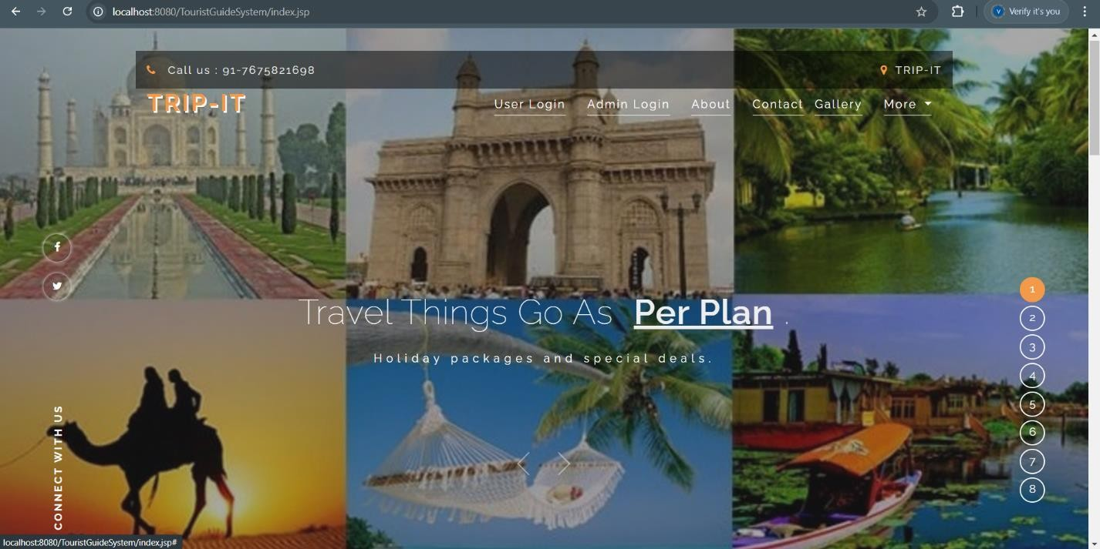

**Fig 5.2.1** Home Page

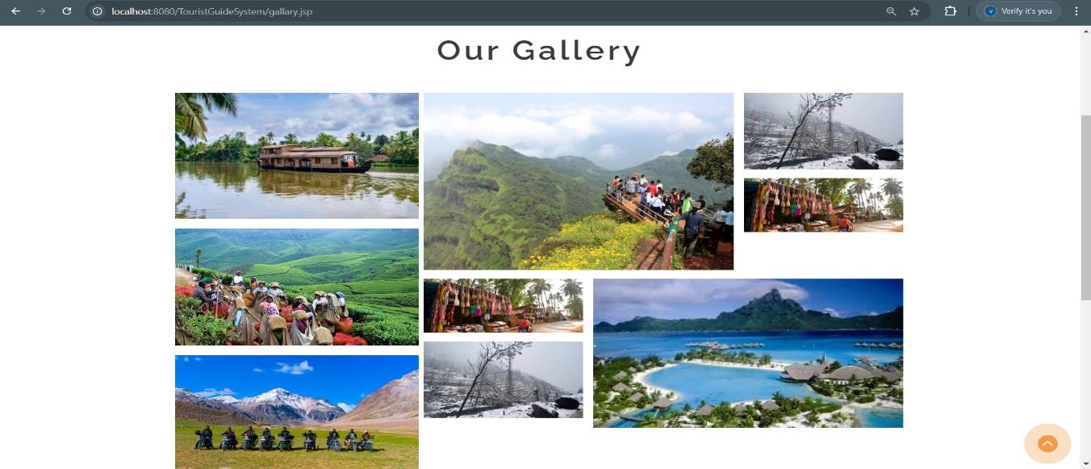

**Fig 5.2.2** Gallery

## ADMIN LOGIN

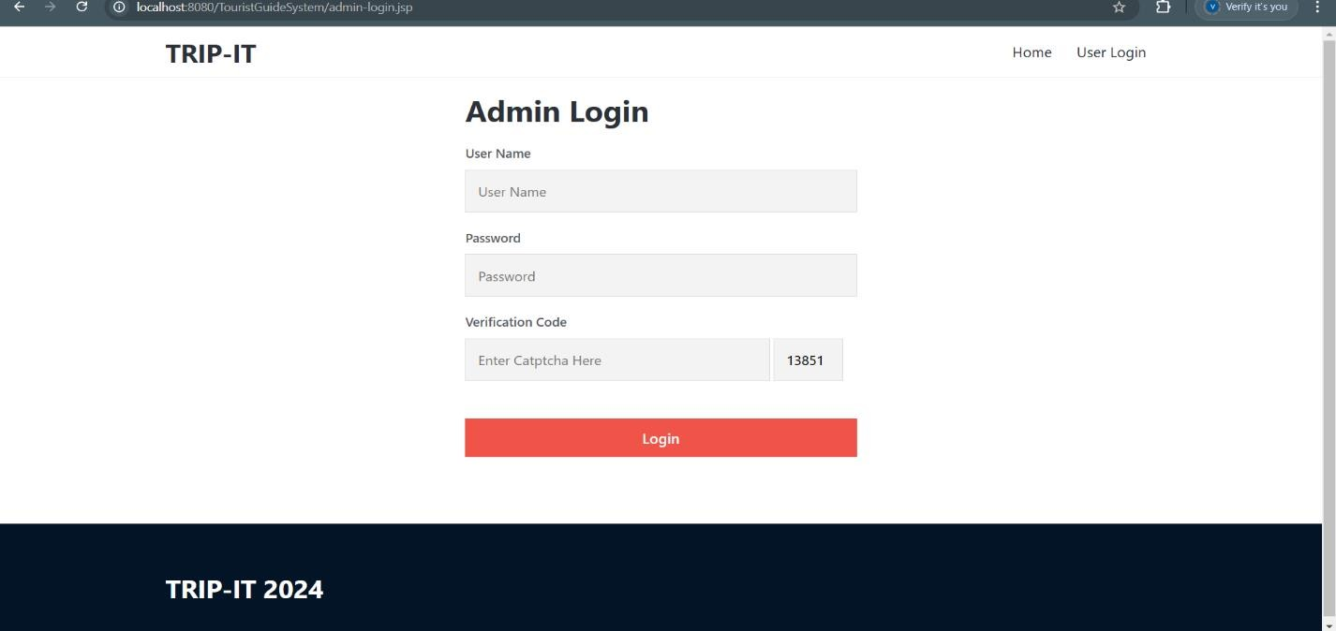The Trip It Login is designed for Admin to login directly, if they have account. If not, they will be directed, where they can create an account if they do not have the account.

**Fig 5.2.3** Admin Login

## USER REGISTRATION

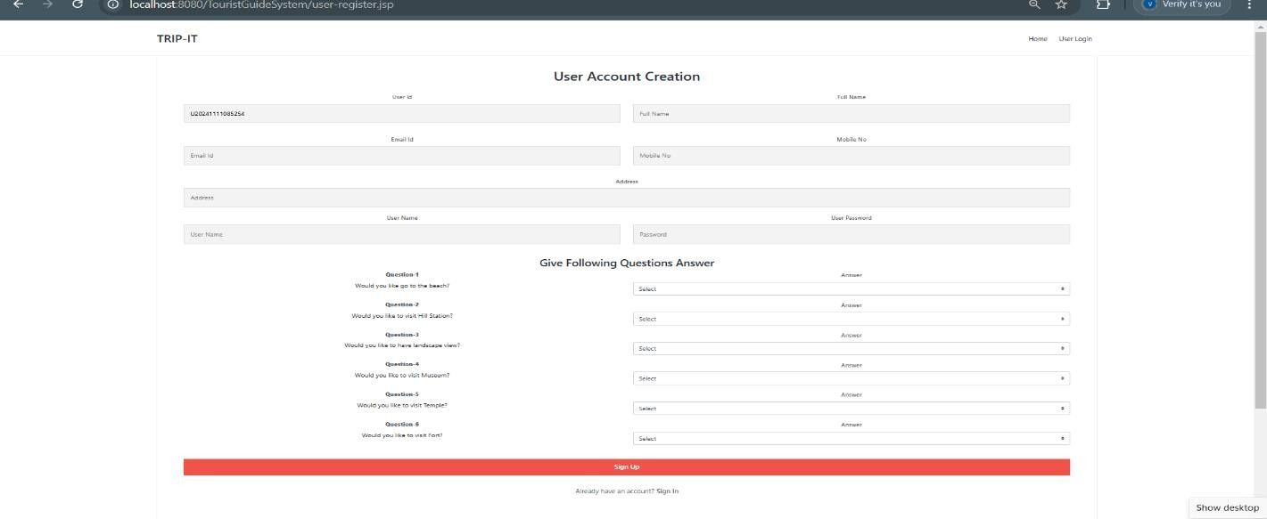TRIP IT can register with their email and other necessary details like name, date of birth, Phone number and gender where they can create a password which will be encrypted.

**Fig 5.2.4** User Registration

## ADMIN HOME PAGE

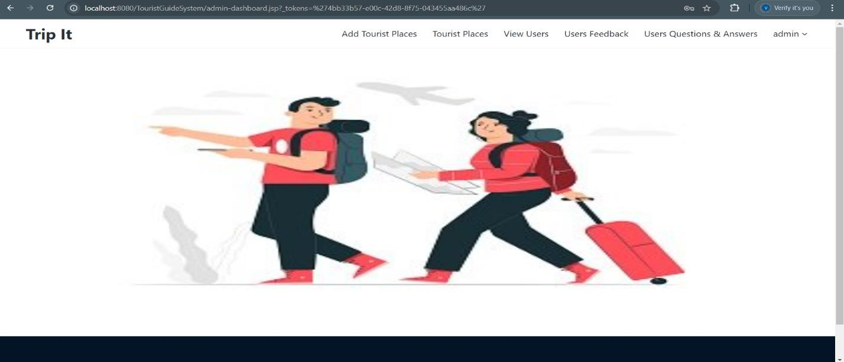 Homepage is designed as per needs of the TRIP IT where he/she can fill their TRIP IT application and view their application, edit or delete their application and can view their profile.

**Fig 5.2.5** Admin Home Page

## USER HOME PAGE

## Homepage is designed as per needs of the TRIP IT where he/she can fill their TRIP IT application and view their application, edit or delete their application and can view their profile.

**Fig 5.2.6** User Home Page

## CONTACT FORM

TRIP IT can fill their application by which users can contact them directly and they can fill numerous applications with their choice of interests.

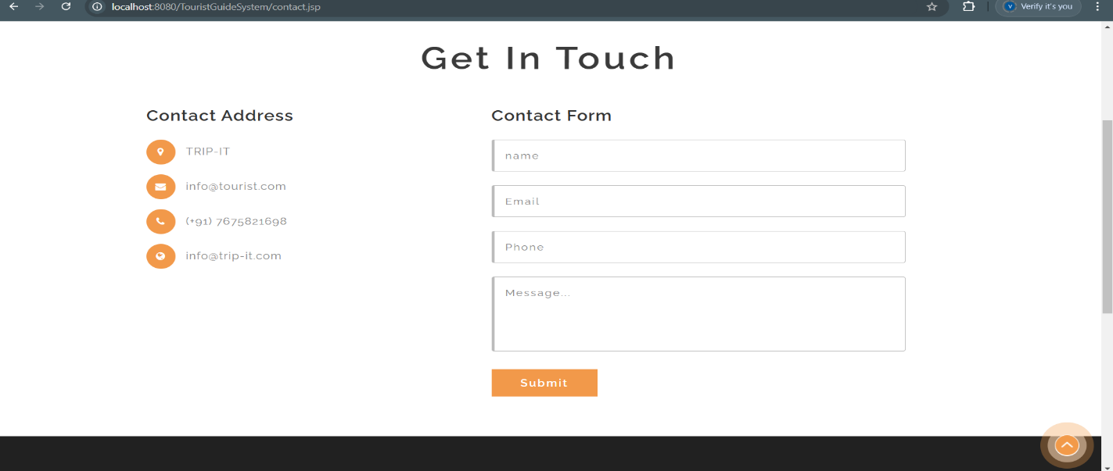

**Fig 5.2.7** Contact Form

## TOURIST PLACE

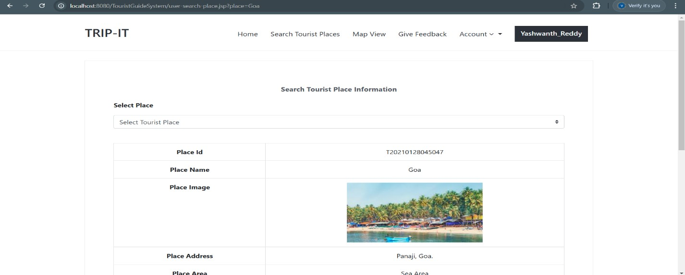TRIP IT can provide view their user can search tourist places.

\

**Fig 5.2.8** Tourist Place

## ALL USERS

This is the TRIP IT profile where the TRIP ITcan view his/her details and can edit their password and can glance their reviews.

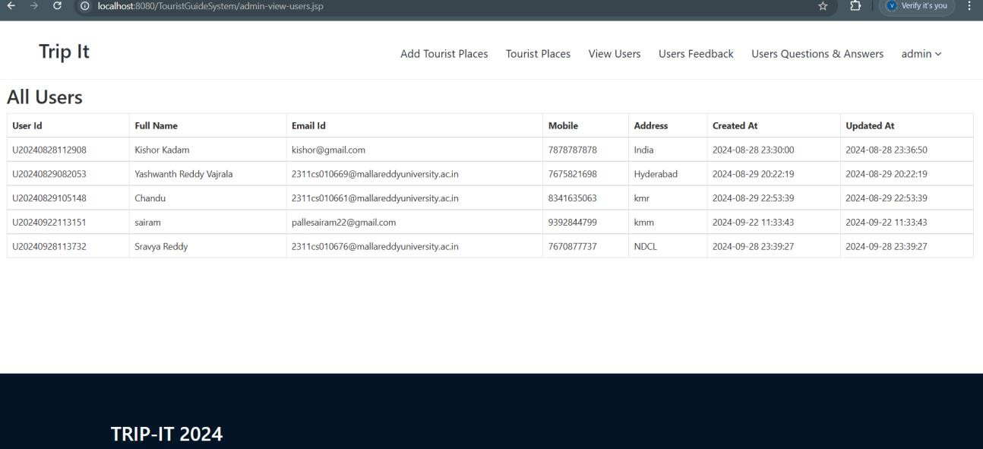

**Fig 5.2.9** All Users

## ADMIN TOURIST PLACE

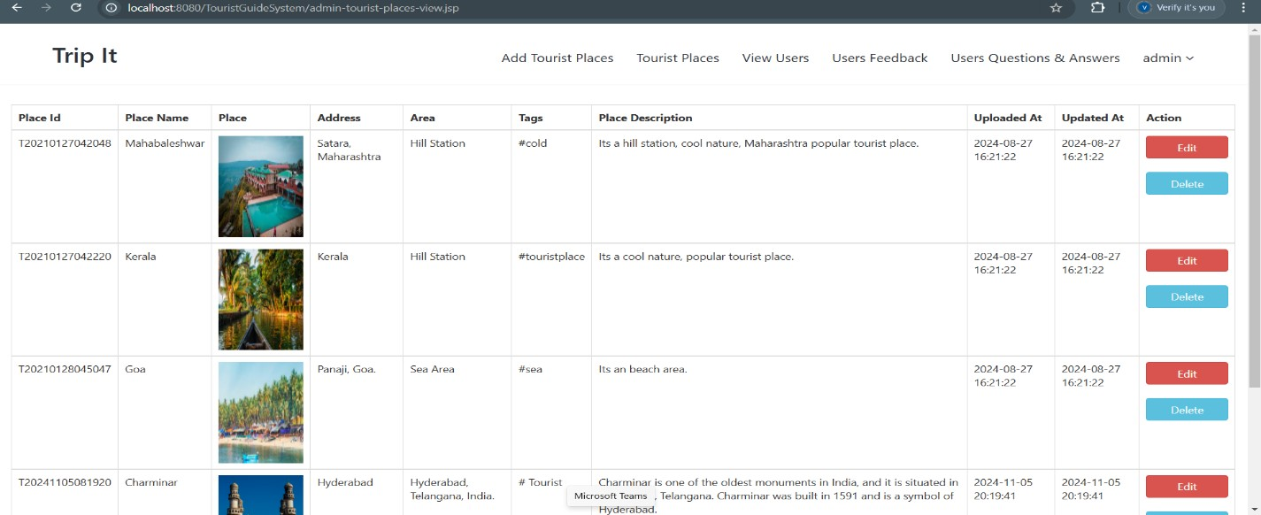The Admin Tourist Place is designed for users to Update places if they have an account or else they can create an account.

**Fig 5.2.10** Tourist Place

## USER FEEDBACK

Users can Login with their email and other details like username and password of their And Give Feed Back.

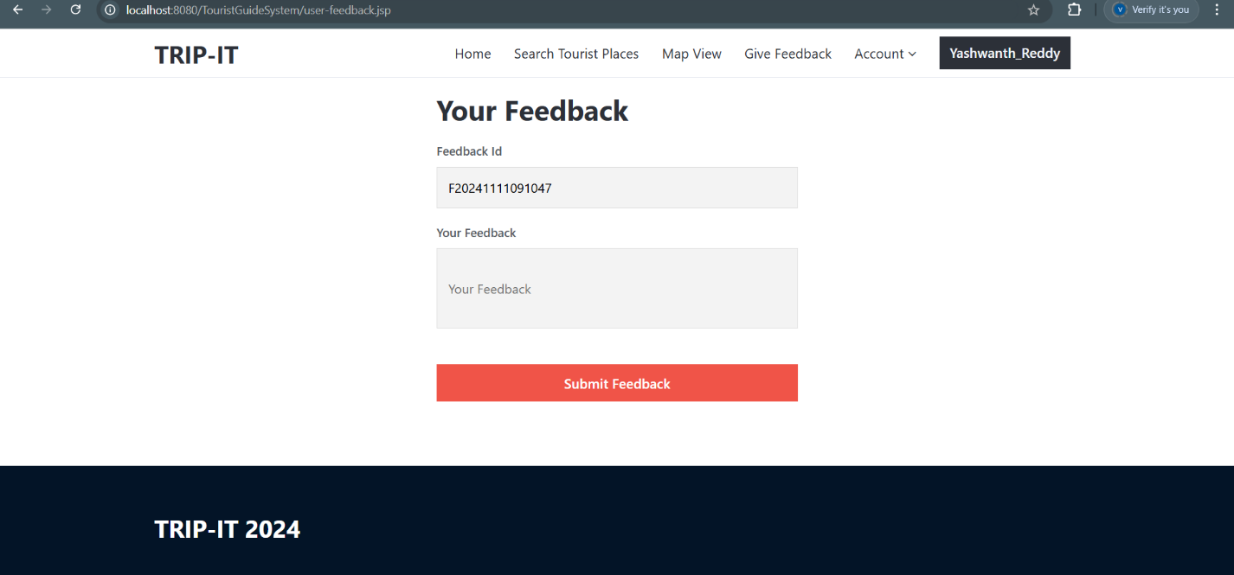

**Fig 5.2.11** Feedback

**CHAPTER – 6**

# RESULT & CONCLUSION

## RESULT

**Key Results:**

The result of implementing a trip it application can manifest in several key outcomes, both for users and the business behind the app:

* + 1. **Enhanced User Experience**: The app streamlines the travel planning process, allowing users to easily research destinations, compare flight and hotel prices, create personalized itineraries, and book activities all in one place. This convenience reduces the stress and time traditionally associated with travel planning.
    2. **Improved Customer Engagement**: With features like real-time notifications, personalized recommendations, and tailored offers, users are more likely to engage with the app frequently. Push notifications about travel deals, flight status updates, or local events can help keep users involved and encourage repeat usage.
    3. **Increased Bookings and Revenue**: By integrating with airlines, hotels, and local service providers, the app can drive bookings and generate revenue through commissions or partnerships. The convenience of booking directly through the app can result in higher conversion rates and increased sales for travel service providers.
    4. **Data Collection and Insights**: Travel apps gather valuable user data, such as preferences, search behavior, and booking patterns, which can be used to improve the app’s functionality, optimize marketing strategies, and offer personalized promotions. This data also helps in predicting travel trends and understanding consumer behavior.
    5. **Community and Social Interaction**: Many travel apps feature social aspects, such as user-generated reviews, ratings, and forums where travelers can share experiences or recommendations. This builds a sense of community among users and can contribute to brand loyalty.
    6. **Cost Savings and Time Efficiency**: Travelers benefit from cost savings through price comparison tools and special offers. The app helps users find the best deals on flights, accommodations, and activities, leading to more efficient spending on travel-related expenses.
    7. **Business Growth and Brand Recognition**: For the company behind the app, the result can be significant business growth. An intuitive, well-designed app with positive user reviews can increase brand recognition and attract new users. A good reputation and strong market presence can position the app as a leading player in the competitive travel.

**6.2 Conclusion:**

In conclusion, tourism is a powerful force that connects people, cultures, and the beauty of our planet. It fosters mutual understanding, appreciation of different cultures, and awareness of our environment. Additionally, tourism serves as an economic engine, creating jobs and supporting local businesses. As we embrace the wonders of tourism, let us remember its positive impact on individuals and societies. By exploring new places, connecting with diverse cultures, and advocating for responsible travel, we not only enrich our lives but also contribute to a more connected and sustainable world. Tourism is not just a journey; it’s a bridge that spans continents and unites hearts in the pursuit of exploration, understanding, and harmony.

## 6.3 FURTHER ENHANCEMENT:

## Provide more facilities like international tourist places suffering. Provide more information like food, facilities, travelling facilities in tourist places. Convert the System more flexible by adding more advanced facility which is remaining because of the time limit.

### 

# REFERENCES

1. [1] Smirnov A, Kashevnik A, Balandin S I, et al. “Intelligent Mobile Tourist Guide,” in Internet of Things, Smart Spaces, and Next Generation Networking. Springer Berlin Heidelberg, 2013.94-106.
2. [2] Schilling A, Giersich M, Aasgaard R. “Introducing 3D GIS for the Mobile Community -

Technical Aspects in the Case of TellMaris,” International Workshop on Mobile Computing (IMC 2003), Fraunhofer IRB Verlag, April 2003.86-92.

1. [3] Owaied H H, Farhan H A, Alhawamdeh N, et al. A model for intelligent tourism guide system [J]. Journal of Applied Sciences, vol. 2011 11(2) 342-347.
2. [4] Zhao Ji, Zhang Xuedong. Design and Implementation of a Handheld Electronic Tour Guide System [J].Journal of University of Science and Technology Liaoning. vol. 2006 29(4) 381-384.
3. [5]J.Honkola, H. Laine, R. Brown, O.Tyrkko, “Smart-M3 Information Sharing Platform,” In proc. IEEE Symp. Computers and Communications, IEEE Comp. Soc., 2010, pp. 1041-1046.
4. [6] A. Smirnov, A. Kashevnik, N. Shilov, N. Teslya, A. Shabaev, “Mobile Application for Guiding Tourist Activities: Tourist Assistant – TAIS,” In proc. of the 16th Conference of Open Innovations Association FRUCT, Oulu, Finland, IEEE, 2014, pp. 94-100.
5. [7] R. Anacleto, L. Figueiredo, F. Almeida, P. Novais, “Mobile application to provide personalized sightseeing tours,” Network and Computer Applications, vol. 41, 2014, pp. 56-64.