DIGI PASS

Mohammed Aly

[2311cs020095@mallareddyuniversity.ac.in](mailto:2311cs020095@mallareddyuniversity.ac.in)

Malla reddy university

B. Vineel Reddy

[2311cs020098@mallareddyuniversity.ac.in](mailto:2311cs020098@mallareddyuniversity.ac.in)

Malla reddy university

B. Sai Thanmai

[2311cs020103@mallareddyuniversity.ac.in](mailto:2311cs020103@mallareddyuniversity.ac.in)

Malla reddy university

B. Tarun Kumar

[2311cs020112@mallareddyuniversity.ac.in](mailto:2311cs020112@mallareddyuniversity.ac.in)

Malla reddy university

B. Sai Geethika

[2311cs020116@mallareddyuniversity.ac.in](mailto:2311cs020116@mallareddyuniversity.ac.in)

Malla reddy university

DIGI-PASS

**Abstract:**

Seeking permissions using letters takes a long process and is a risky process which irritates the user. Digitalization could be a modern and highly efficient way of solving this problem. Creating sessions for a specific interval of time using Face Recognition based Artificial Intelligence can help in reducing the complexity of permissions and long process for out permissions. It can more efficiently store data without Any use of hard copies which are difficult to store, retrieve or access data. There can be a chance of loss of data using hard copies. Face Recognition is a computer application that is capable of detecting, tracking, identifying or verifying human faces from an image or video captured using a digital camera. Although lot of progress has been made in domain of face detection and recognition for security, identification and attendance purpose, but still it is not used to its widespread. Implementation of face recognition with simple modifications in an innovative way can solve this permission seeking mechanism drawbacks. Further development of a system that can identify and classify human emotions from facial expressions in images or video streams. This system can be used in various applications, including user experience enhancement, mental health monitoring, and interactive entertainment.

I. **INTRODUCTION**

"Paper" work and maintenance is really difficult either to access data or to retrieve it. A digital approach is very much needed in view of reducing paper usage and the risk of maintaining it.Face recognition system powered with artificial – intelligence brings a full-fledged and an accurate solution for this problem. Using an application with facial recognition mechanism can help one alternating the complexity nature of letter permissions. The issue of security is foremost in any organization, especially for the students. And when it comes to outings and attendance permissions the students found it more time consuming especially in emergency situations as he/she had to run in search of their allocated wardens who may be a teaching faculty.

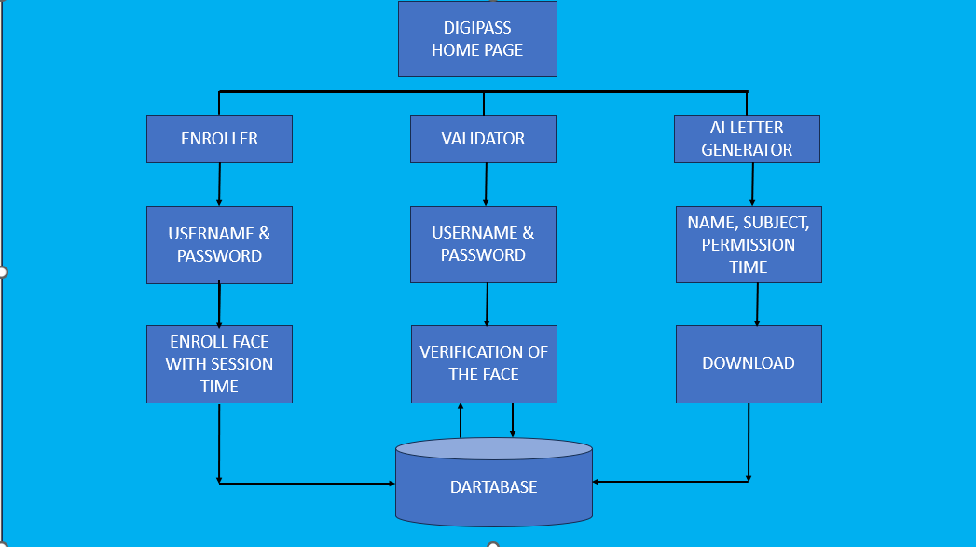

Fig 1: Block diagram of Digi-pass

In these scenarios it is difficult to reach our respective wardens. The above issue pushes us to develop the automated system known as Digipass which can help in easy access and retrieval of the data

# II. LITERATURE SURVEY

Methodology for face recognition based on information theory approach of coding and decoding the face image is discussed in [Sarala A. Dabhade & Mrunal S. Bewoor, 2012 [3]. Proposed methodology is connection of two stages – Face detection using Haar Based Cascade classifier and recognition using Principle Component analysis. Various face detection and recognition methods have been evaluated [Faizan Ahmad et al., 2013] [4] and also solution for image detection and recognition is proposed as an initial step for video surveillance.

Implementation of face recognition using principal component analysis using 4 distance classifiers is proposed in [Hussein Rady, 2011] [5]. A system that uses different distance measures for each image will perform better than a system that only uses one. The experiment show that PCA gave better results with Euclidian distance classifier and the squared Euclidian distance classifier than the City Block distance classifier, which gives better results than the squared Chebyshev distance classifier. A structural face construction and detection system is presented in [Sankarakumar et al., 2013] [6-7].

The HUMAN FACE DETECTION AND RECOGNITION is our first paper referred. This paper represents face recognition algorithm such as PCA (principal component analysis), MPCA (Multi linear Principal Component Analysis) and LDA(Linear Discriminant Analysis) in which we recognize an unknown test image by comparing it with the known training images stored in the database as well as give information regarding the person recognized. These techniques works well under robust conditions like complex background, different face positions. These algorithms give different rates of accuracy under different conditions as experimentally observed. In face detection, we have developed an algorithm that can detect human faces from an image. We have taken skin colour as a tool for detection. This technique works well for Indian faces which have a specific complexion varying under certain range. We have taken real life examples and simulated the algorithms in MATLAB successfully [8] . A literature survey for a facial recognition-based outing management system covers various fields, such as biometrics, computer vision, and security systems, to understand how similar technology has been applied across sectors.

Face Recognition in Educational Institutions: Studies (e.g., Bakken et al., 2020) show applications of face recognition for attendance and security in schools and universities, highlighting benefits in automating entry and enhancing safety. Face recognition has also shown promise in identifying individuals in controlled environments efficiently.

Smart University and Campus Security Systems: Research (Uskov et al., 2016) discusses the use of face recognition within "smart campus" frameworks, focusing on improved security, ease of access, and real-time attendance monitoring, all of which enhance user experience.

Privacy Concerns and Security Policies: Literature such as that by Hoffman (2019) explores the implementation and regulation of facial recognition in educational settings, addressing privacy, security, and ethical concerns.

Gate Management and E-Pass Systems: Implementations of gate pass and visitor management applications show how face recognition simplifies security checks and access control, as seen in recent IEEE studies (e.g., Rambo et al., 2021).

Technological Advancements in Face Recognition: Recent advancements in AI and machine learning have enabled more accurate and reliable facial recognition, as outlined in studies focused on access control systems (Heo et al., 2021). These advancements allow for scalable, real-time recognition with enhanced accuracy, especially beneficial in high-traffic areas like event venues.

Through this survey, it is evident that face recognition technology has matured enough to be applied in outing management systems, bringing benefits in security, convenience, and efficiency. The integration of privacy measures and real-time processing will be crucial to addressing potential ethical concerns and ensuring smooth, user-friendly experiences.

# III. PROPOSED WORK

The Face Recognition based Gate Pass System is a software-based application with the primary goal of replacing the present paper-based gate pass solution with a computerized and time- saving system. It keeps track of students' and teachers' admission and exit data in a database, which administrators can view at any time. All records and major records are stored in the database. Finally, we designed an application for our institution to make the process of requesting and receiving gate passes easier than it was previously, as well as to protect the college from outside visitors. Face matching and pass restriction for illegal users, time based pass creation, out time reporting, are only few of the benefits of the application. The application has been tested with a variety of student profiles and ultimately advises on the proposed system's efficiency and correctness.

STUDENT REGISTRATION :

By providing their roll number, password, email, address, department, and batch, students can register and login to the system. He has the ability to send and receive requests. Students may track the status of their requests, making it simpler and more efficient for them. Students can organize their schedules based on the department's response when they ask for an out pass.

DEPARTMENT :

The department can check for pending pass requests from students and grant or reject them based on the severity of the situation. By entering in with their credentials, faculty can see the pending requests for the current day. They can look up the student's name, branch, and year and accept or deny the request based on that information. They also have the authority to check the students' past data and requests for permits, which can sometimes prove to be useful in the future.

SECURITY :

When the admin receives the updated list of students who have been granted permission to depart the college grounds, face recognition is used. When a student arrives at the admin to leave the premises, his or her face is scanned, the face is checked against the database, and the roll number and status of the request appears. The administrator can double-check this with the approved student list before allowing the student to leave the university.

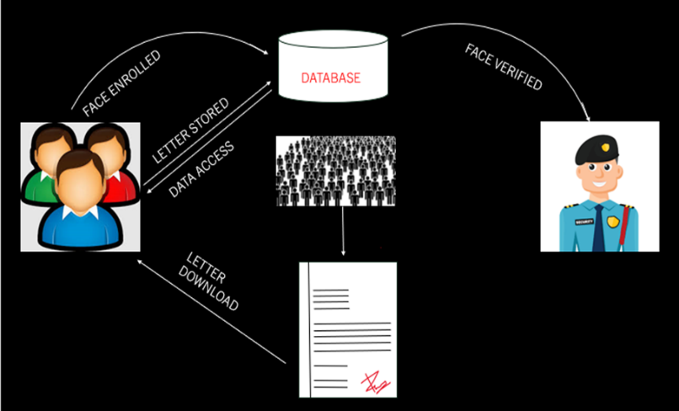

Fig 2: Client-server architecture

# IV. RESULTS& IMPLEMENTATION

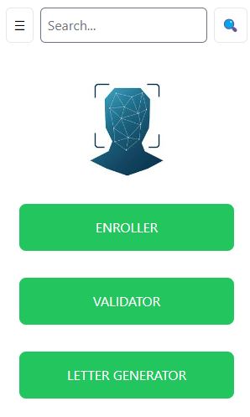

Fig 3: Home-page

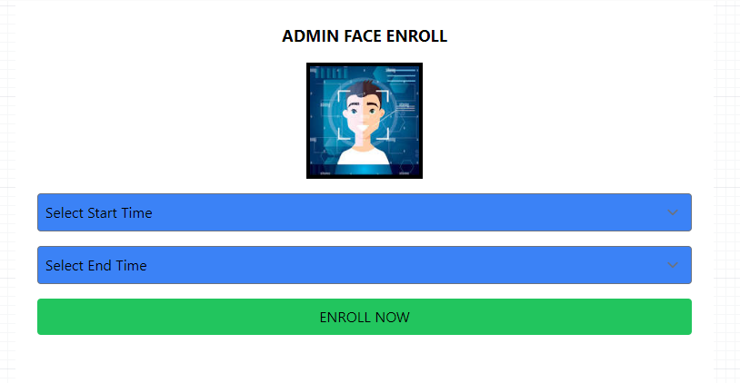

Fig 4: Admin-page

The Digipass outing app represents a significant advancement in managing outing permissions through innovative technology. By integrating AI-driven face recognition, the app effectively streamlines the permission-seeking process, allowing for a more efficient, secure, and user friendly experience.

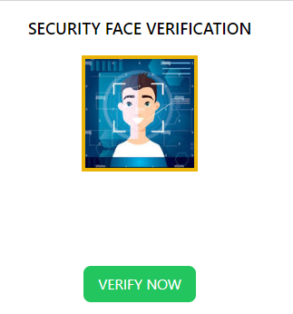

Fig 5: Security-page

Key Outcomes:

Reduction in Paperwork:

The app eliminates the need for physical permission slips and forms, greatly reducing paper usage and associated administrative tasks. This shift not only simplifies the approval process but also contributes to environmental sustainability.

Enhanced Security and Verification:

By utilizing face recognition technology, Digipass ensures accurate identity verification, minimizing the risk of unauthorized access. This enhancement fosters a safer environment for all participants.

Increased Efficiency:

The automated approval workflow allows for instantaneous processing of outing requests, significantly reducing wait times and improving overall efficiency in managing permissions.

User-Centric Design:

With its intuitive interface, the app encourages user engagement and simplifies the process of requesting permissions, catering to the needs of modern users accustomed to digital solutions.

Future Potential:

The successful implementation of Digipass sets the stage for further innovations in digital management solutions, paving the way for additional features such as data analytics, enhanced user feedback, and integration with other digital systems.

# V. CONCLUSION

The Face Recognition based Gate Pass System is a software-based application with the primary goal of replacing the present paper-based gate pass solution with a computerized and time- saving system. It keeps track of students' and teachers' admission and exit data in a database, which administrators can view at any time. All records and major records are stored in the database. Finally, we designed an application for our institution to make the process of requesting and receiving gate passes easier than it was previously, as well as to protect the college from outside visitors. Face matching and pass restriction for illegal users, time based pass creation, out time reporting, are only few of the benefits of the application. The application has been tested with a variety of student profiles and ultimately advises on the proposed system's efficiency and correctness.

# 

# VI. REFERENCES

1. Jeffrey P. Bakken, Nivee Varidireddy & Vladimir L. Uskov "Face Recognition Systems for Smart Universities in proceedings of The Smart Innovation, Systems and Technologies book series (SIST,volume 188),Conference paper First Online: 08 June 2020
2. Uskov, V.L, Bakken, J.P., Pandey, A., Singh, U., Yalamanchili, M., Penumatsu,” A. Smart university taxonomy: features, components, systems” in Uskov, V.L., Howlett, R.J., Jain, L.C. (eds.) Smart Education and e-Learning 2016, pp. 3–14. Springer, June 2016, 643 p. (2016)
3. Burt, C.”Australian schools testing facial recognition for attendance”. Biometric Update.com (2018, August 29).
4. Connor Hoffman "Lockport school officials update security policies related to facial recognition software"Feb 10, 2019
5. Sharma, Y." Facial recognition security measures grow on campuses". University World News (26 July 2018).
6. Rambo Hilary, D. Machuve, S. Mirau “Mobile Application for Gate Pass Management System Enhancement” Computer Science 2021 IEEE AFRICON Published 13 September 2021
7. D. Saravanan, K. Dhivakar, T. Vignesh, V. Visvashwarr, K. P. Kumar, I. Arun “ Outpass Generation with Raspberry Pi Using Arbian Operating System” Published in ICARCSET '15 6 March 2015
8. Chaitanya Lengure, “A Review on E - Gatepass System” Computer Science, Education
9. International Journal for Research in Applied Science and Engineering Technology Published 31 March 2018
10. M. Vasanthi,” GATE PASS MANAGEMENT SYSTEM FOR COLLEGE” Published 2017
11. Ki-Hyeon Kwon, Hyung-Bong Lee “Gate Management System by Face Recognition using Smart Phone” Published 30 November 2011
12. Rida M. Hamza, David W. Meyers “System for Gate Access Control” in proceedings of Honeywell International Inc., Morristown,NJ. Published 22 April,2008
13. Heo Seok Yeol, Kang-Min Kim, Lee wan jik “Design and Implementation of Visitor Access Control System using Deep learning Face Recognition” Published 2021