**E – VOTING SYSTEM**

Mrs .Angel Barakka (Asst. professor andGuide)

Mr. D Prabhu (Asst. professor and co-ordinator)

Arutchelvi Jayaraj (Student)

G L K Niharika (Student)

**ABSTRACT**

Our country, India is the largest democratic country in the world. So it is essential to make sure that the governing body is elected through a fair election. India has only offline voting system which is not effective and up to the mark as it requires large man force and it also requires more time to process and publish the results. Therefore, to be made effective, the system needs a change, which overcomes these disadvantages. The new method does not force the person's physical appearance to vote, which makes the things easier. Our project focuses on a system where the user can vote remotely from anywhere using his/her computer or mobile phone and doesn't require the voter to go to the polling station, through two step authentication and OTP system by using their own aadhar number. Our project outlines the development and implementation of an online voting system that leverages advanced machine learning, blockchain technology, and a user-friendly interface to ensure a secure, transparent, and accessible voting process. Through the implementation of this online voting system, we envisage a future where the electoral process is more accessible, efficient, and trusted by the electorate.

**Keywords: Two step authentication, OTP system, multilevel security, face recognition, Google capcha verification** **I. INTRODUCTION**

1. **Objective**

The primary objective of the Online Voting System is to revolutionize the traditional voting process by leveraging web-based technology to create a secure, efficient, and user-friendly platform for conducting elections, polls, and voting events.

The system is designed to achieve the following key goals:

1. **Enhance Accessibility:** Facilitate widespread access to the voting process by enabling eligible voters to cast their votes conveniently from any location with internet access, thereby eliminating geographical barriers and promoting inclusivity.

2. **Ensure Security and Integrity:** Implement robust security measures to safeguard the integrity of the voting system, prevent unauthorized access, and protect the confidentiality of individual votes, thereby instilling trust in the electoral process.

3. **Simplify Voting Procedures:** Streamline the voting process to make it more intuitive and user-friendly, reducing the likelihood of voting-related errors and enhancing the overall efficiency of the electoral system.

4. **Increase Voter Participation**: Encourage higher voter turnout by providing a convenient and accessible platform for casting votes, engaging a broader demographic, and fostering civic participation in the democratic process.

5. **Ensure Accuracy and Transparency**: Employ advanced technologies to ensure accurate and transparent recording, tallying, and reporting of votes, thereby minimizing errors, enhancing the credibility of election outcomes, and fostering public confidence in the electoral system.

6. **Adaptability and Scalability:** Design the system with scalability in mind to accommodate varying scales of elections and polls, ensuring that the platform remains adaptable to evolving

technological needs and changing demographic landscapes.

7. **Compliance with Legal and Regulatory Standards:** Ensure that the Online Voting System complies with applicable legal and regulatory standards, including data protection and privacy laws, to safeguard the rights and information of voters in accordance with established norms.

**B. Motivation**

Voting procedures around the world have a variety of drawbacks that hinder the democratic process. First-past-the-post voting results in disproportionate representation and encourages strategic voting. Proportional representation, while aiming for fairness, can be difficult and lead to unstable coalition administrations. The complexity of Single Transferable Vote in both understanding and counting votes presents challenges, and Mixed-Member Proportional systems may create the prospect of dual representation. Though intended for more nuanced expression, Ranked Choice Voting can be difficult for voters to understand, and Approval Voting lacks the precision of ranking systems. Participation may be limited in caucus systems, which are marked by exclusivity and time-consuming procedures. Each system involves trade-offs, stressing the significance of carefully considering the unique goals and ideals of an election system in order to achieve success. The relevance of an online voting system project lies in addressing several key issues and offering potential benefits in the context of elections and voting processes.

Here are some of the key aspects highlighting the relevance of such a project:

**Accessibility:** An online voting system can enhance accessibility, allowing a broader range of citizens, including those with disabilities or those residing in remote locations, to participate in the electoral process without the need to physically visit a polling station.

**Convenience:** Online voting provides a convenient alternative to traditional in-person voting methods. Voters can cast their ballots from the comfort of their homes, potentially increasing voter turnout by eliminating barriers related to travel, work schedules, or health concerns.

**Efficiency:** Online voting systems can streamline the voting process, reducing the time and resources required for organizing and conducting elections. The quick and automated counting of votes can lead to faster and more efficient election results.

**Accuracy:** Automated online voting systems can minimize the risk of manual errors in the vote counting process, contributing to more accurate and reliable election outcomes.

**Increased Participation:** By offering a user-friendly and accessible platform, an online voting system may encourage greater participation among tech-savvy and younger demographics, potentially diversifying and expanding the electorate.

**Reduced Costs:** While implementing an online voting system may involve initial investment, it has the potential to reduce costs associated with traditional paper-based voting, including printing and distributing ballots, staffing polling stations, and manual vote counting.

**Security Measures:** A well-designed online voting system with robust security measures can address concerns related to the integrity and confidentiality of the voting process. Encryption, multi-factor authentication, and other cybersecurity measures are crucial to ensure a secure online voting environment.

Adaptation to Technological Advances: In a rapidly evolving technological landscape, implementing online voting systems demonstrates a willingness to adapt to advancements, showcasing a modern approach to democratic processes.

However, it's essential to note that the implementation of online voting systems also comes with challenges, such as ensuring cybersecurity, protecting voter privacy, and maintaining public trust. Rigorous testing, security audits, and ongoing improvements are necessary to address potential risks and vulnerabilities.

**C. Design Methodology**

**1. Registration Phase:** The user has to select an image from their gallery and draw a pattern on the selected image. This will be set as password and stored in the database.

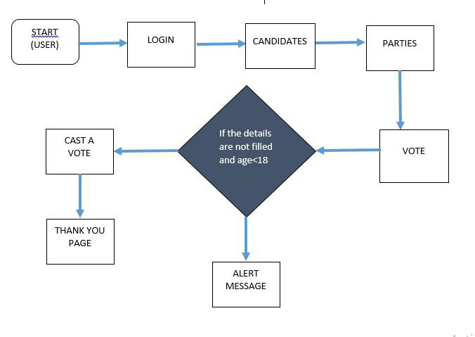

**Figure 1. Design Methodology - Registration**

**2. Login Phase:** When the user tries to login to the system, four images will be displayed that look similar. The user has to select the correct image that they used in the registration phase and draw the corresponding pattern on the image. Only if the password is correct, the user can login to the system.

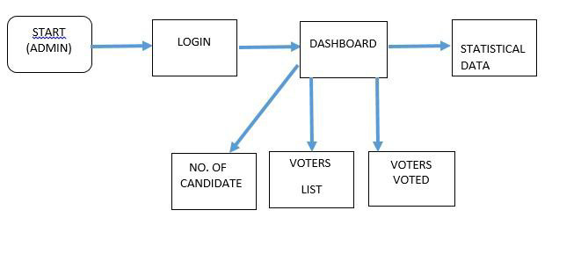

**Figure 2. Design Methodology - Login**

**E. Abridgement**

The relevance of an online voting system project lies in addressing several key issues and offering potential benefits in the context of elections and voting processes. Here are some of the key aspects highlighting the relevance of such a project:

**Accessibility:** An online voting system can enhance accessibility, allowing a broader range of citizens, including those with disabilities or those residing in remote locations, to participate in the electoral process without the need to physically visit a polling station.

**Convenience:** Online voting provides a convenient alternative to traditional in-person voting methods. Voters can cast their ballots from the comfort of their homes, potentially increasing voter turnout by eliminating barriers related to travel, work schedules, or health concerns.

**Efficiency:** Online voting systems can streamline the voting process, reducing the time and resources required for organizing and conducting elections. The quick and automated counting of votes can lead to faster and more efficient election results.

**Accuracy:** Automated online voting systems can minimize the risk of manual errors in the vote counting process, contributing to more accurate and reliable election outcomes.

**Increased Participation:** By offering a user-friendly and accessible platform, an online voting system may encourage greater participation among tech-savvy and younger demographics, potentially diversifying and expanding the electorate.

**Reduced Costs:** While implementing an online voting system may involve initial investment, it has the potential to reduce costs associated with traditional paper-based voting, including printing and distributing ballots, staffing polling stations, and manual vote counting.

**Security Measures:** A well-designed online voting system with robust security measures can address concerns related to the integrity and confidentiality of the voting process. Encryption, multi-factor authentication, and other cybersecurity measures are crucial to ensure a secure online voting environment.

**Adaptation to Technological Advances:** In a rapidly evolving technological landscape, implementing online voting systems demonstrates a willingness to adapt to advancements, showcasing a modern approach to democratic processes.

However, it's essential to note that the implementation of online voting systems also comes with challenges, such as ensuring cybersecurity, protecting voter privacy, and maintaining public trust. Rigorous testing, security audits, and ongoing improvements are necessary to address potential risks and vulnerabilities.

**II. RELATED WORKS**

Vaishali Ravi[1] This proposed system integrates graphical password and video signature. The password consists of a sequence of images in which the user can select one cue point per image. In addition, the user is asked to select a video signature corresponding to interval click point. The password for login is a combination of image and video click point. If the click points do not match then the window closes. This is a two-level password authentication method.

Abhijith S[2] This paper has presented a secure graphical web-based authentication system that protects users from becoming victims of shoulder surfing attacks.The user is required to select a picture displayed. At this point, users need to click any five points in the picture that had been chosen before. After that, registration information will be saved in the database. Bilgi, B.[3] In the proposed method, the user selects a unique user name while registering in the system, then selects 6 pictures from a 5X5 black-and-white hybrid image set and immediately creates a story by thinking about the pictures it chooses. The user is asked to write a story in order to contribute to the better recognition of the selected pictures. The registration process is completed by selecting pictures in the proposed method and creating the story afterwards. Zujevs, N.[4] The method is based on the idea of combining several images in one picture and displaying a few additional pictures with decoy images. In this case, the observer from the side of the person will not be able to understand why this particular picture was chosen from several others, because it shows 95 several symbols and only one of them is the password’s symbol. Albayati, M. R.[5] In this proposed system, the user gets access to the system using graphical password by choosing the real sub-images among the decoy sub-images and organize them in its right place matching the original image that was chosen during the registration phase

**III. EXISTING AND PROPOSED**

The Online Voting System is a web-based application designed to enable secure and convenient voting in elections, polls, and other voting events. It serves as a user-friendly platform where eligible voters can cast their votes electronically, ensuring accuracy, transparency, and accessibility in the voting process. The system aims to simplify voting procedures, reduce voting-related errors, and encourage higher voter participation.

E-Voting System is an automated voting system that provides a secure and trustworthy platform to facilitate the voting process. It is a highly reliable tool used in software development and allows an organization to enable its users to cast their votes electronically.

Designing a secure and reliable online voting system is a complex task that requires careful consideration of various factors, including security, privacy, accessibility, usability, Legal and Regulatory Compliance and continuous improvement

**IV. CONCLUSION**

Developments in technology can lead to improved accessibility features, making online voting more inclusive for individuals with disabilities or those facing mobility challenges. The use of biometric authentication methods, such as facial recognition, two step verification, tab switch limitation could add an extra layer of security to verify the identity The Online voting systems can provide convenience for voters, allowing them to cast their votes from the comfort of their homes using internet-enabled devices. Accessibility may be improved for individuals with mobility issues or those who cannot easily reach physical polling stations. The ability to verify and audit the election results is essential. A well-designed online voting system should allow for transparency, enabling voters to confirm that their votes were counted accurately. The transparency of the system can be drawn based on the availability of verifiable results. Public trust in the online voting system is crucial for its success. If users do not trust the security and fairness of the system, it may face resistance and skepticism. On the bases of public perception and trust in the system. The user experience of the online voting system can impact its adoption. If the system is user-friendly and easy to navigate, it may encourage more people to participate. In conclusion, the

**V. FUTURE ENHANCEMENT**

Developments in technology can lead to improved accessibility features, making online voting more inclusive for individuals with disabilities or those facing mobility challenges. The use of biometric authentication methods, such as facial recognition, two step verification, tab switch limitation could add an extra layer of security to verify the identity The Online voting systems can provide convenience for voters, allowing them to cast their votes from the comfort of their homes using internet-enabled devices. Accessibility may be improved for individuals with mobility issues or those who cannot easily reach physical polling stations. The ability to verify and audit the election results is essential. A well-designed online voting system should allow for transparency, enabling voters to confirm that their votes were counted accurately. The transparency of the system can be drawn based on the availability of verifiable results. Public trust in the online voting system is crucial for its success. If users do not trust the security and fairness of the system, it may face resistance and skepticism. On the bases of public perception and trust in the system. The user experience of the online voting system can impact its adoption. If the system is user-friendly and easy to navigate, it may encourage more people to participate.

**VI. REFERENCE**

[1] Kausar, N., Din, I. U., Khan, M. A., Almogren, A., & Kim, B. S. (2022), “GRA-PIN: A Graphical and PIN-Based Hybrid Authentication Approach for Smart Devices”, Sensors (volume: 22,issue: 4)

[2] T. Kawamura, T. Ebihara, N. Wakatsuki and K. Zempo, “EYEDi: Graphical Authentication Scheme of Estimating Your Encodable Distorted Images to Prevent Screenshot Attacks,” IEEE Access, ( vol. 10), 2022

[3] Alhamed, A., & Bhatia, S. (2021, November), “VowPass: Novel Method to Generate Secure and Memorable Passwords”, IEEE 4th International Conference on Signal Processing and Information Security (ICSP IS-2021)

[4] Vaishali Ravi, Seema Khan P, Usha H Y, “Yashaswini B N, Kanmani B S, 2020, Integration of Image and Video Signature in Graphical Password Authentication System”, International Journal of Engineering Research & Technology (IJERT-2020)

[5] Abhijith S, Soja Sam, Sreelekshmi K U, T T Samjeevan, Sneha Mathew, 2021, “Web based Graphical Password Authentication System”, International Journal of Engineering Research & Technology (IJERT) ICCIDT – 2021 (Volume 09 – Issue 07)

[6] Khan, Z. I., & Shandilya, V. K. (2020, December). Enhanced Recognition Based Image Authentication Scheme to Save System Time & Memory. IEEE Bombay Section Signature Conference (IBSSC-2020)

[7] Zujevs, N. (2019, August),” Authentication by Graphical Passwords Method ‘Hope’, IEEE International Conference on Computing, Electronics & Communications Engineering (iCCECE-2019)

[8] Glory, F. Z., Aftab, A. U., Tremblay-Savard, O., & Mohammed, N. (2019, October). Strong password generation based on user inputs. IEEE 10th Annual Information Technology, Electronics and Mobile Communication Conference (IEMCON-2019)

[9] Calanda , F. B., Sison, A. M., Molato, M. R. D., & Medina, “Simple and Secured Password Hiding Technique for Image-based Authentication using a Least Significant Bit based Embedding Scheme”, IEEE 4th International Conference on Technology, Informatics, Management, Engineering & Environment (TIME-E- 2019)

[10] Liu, Y., Zhang, W., Peng, X., Liu, Y., Zheng, S., Wei, T., & Wang, “Design of password encryption model based on AES algorithm” ,IEEE 1st International Conference on Civil Aviation Safety and Information Technology (ICCASIT-2019)

[11] Bilgi, B., & Tugrul, “A shoulder-surfing resistant graphical authentication method” ,IEEE International Conference on Artificial Intelligence and Data Processing (IDAP-2018,September)

[12] Shahzad, M., Liu, A. X., & Samuel, A. (2016), “Behavior based human authentication on touch screen devices using gestures and signatures”, IEEE Transactions on Mobile Computing, (volume: 16, issue: 10)

[13] Baskaran, P., Anurag, E. G., Kaviyarasu, S., Eniyavan, A. V., & Karthikeyan, "Time slot based data sharing with time slot based password”, IEEE International Conference on Innovations in Information, Embedded and Communication Systems (ICIIECS-2017)

[14] Zheng, W., & Jia, “CombinedPWD: a new password authentication mechanism using separators between keystrokes”, IEEE 13th International Conference on Computational Intelligence and Security (CIS-2017)