**International Journal of Research Publication and Reviews**

Journal homepage:

www.ijrpr.com

ISSN 2582

-

7421



**Tribological study of different composites of Al-5052 using pin on disc equipment—A brief review**

***V Danunjay1, P Devaraju2,V Meghana3,P Karthikeya4, T Manasamitra5***

**1UG Student, Dept. of MECH, GMR Institute of Technology, Rajam**

**2UG Student, Dept. of MECH, GMR Institute of Technology, Rajam**

**3UG Student, Dept. of MECH, GMR Institute of Technology, Rajam**

**4UG Student, Dept. of MECH, GMR Institute of Technology, Rajam**

**5UG Student, Dept. of MECH, GMR Institute of Technology, Rajam**

**KEYWORDS:**

Aluminium Alloy 5052, Metal Matrix Composites (MMCs), Wear Resistance, Coefficient of Friction, Stir Casting, Tribology, Mechanical Properties, Hardness, Lightweight Materials, Marine Applications.

**ABSTRACT:**

Aluminium matrix composites are widely used in engineering applications due to their superior properties, which cannot be achieved by any existing monolithic material. The properties of these composites are highly influenced by the nature of reinforcement, which can be continuous or discontinuous fiber form. The selection of processing techniques for fabrication depends on factors such as matrix and reinforcement type, desired microstructural integrity, and structural, mechanical, electrochemical, and thermal properties. It provides an overview of synthesis routes, mechanical behavior, and applications of aluminium matrix composites, with a special focus on primary processing techniques. The paper also discusses commercialization challenges, industrial aspects, and future research directions. The study found that reinforcements like zinc, magnesium, and carbon powder significatly improved the mechanical and tribological properties of Aluminum Alloy 5052, making it suitable for lightweight applications requiring high wear resistance and durability, expanding its suitability for marine and industrial uses.

I**NTRODUCTION:**

Metal Matrix Composites (MMCs) are popular in industries like automotive, aerospace, and marine due to their superior mechanical and tribological properties. Aluminum Alloy 5052, known for its corrosion resistance and lightweight nature, can be reinforced with carbon powder, magnesium, and zinc to improve its mechanical properties. Zinc enhances corrosion resistance and mechanical properties, while magnesium enhances strength, hardness, and toughness without adding significant. weight. Carbon powder acts as a solid lubricant, reducing friction and improving wear resistance in sliding applications. This study aims to investigate the effects of these reinforcements on Aluminum Alloy 5052's mechanical and tribological properties under different load and speed conditions. The combined effects will be analyzed through experimental testing to identify the optimal composition for improved performance in lightweight engineering applications and marine environments.

**LITERATURE REVIEW:**

A material composite is a substance composed of two or more physically and chemically separate parts, with the matrix and reinforcement being non-metallic components. Metal Matrix Composites (MMCs) are created when the matrix is made of a metal or metal alloy, and the reinforcing component is typically non-metallic. Aluminum is the most widely used matrix for MMCs due to its low density, low coefficient of thermal expansion, superior strength-to-weight ratio, outstanding mechanical qualities, and increased resistance to wear and corrosion. However, aluminum's poor wear resistance restricts its usefulness as a multipurpose material. (1)

Diboride titanium is a highly effective reinforcement due to its high Young's modulus (345-409 GPa) and stability in liquid Fe. It has a high melting point (3225qC), low density, superior Vickers hardness (3400 HV), good thermal conductivity, and high electrical conductivity. TiB2 ceramic is characterized by good corrosion resistance, tribological properties, and considerable chemical stability. Studies have been conducted on the use of TiB2 ceramic as a reinforcing phase in composites with iron, aluminium, copper, cobalt, and their alloys. The studies have focused on the effect of the number of reinforcing phases on the properties and microstructure of the composites. The composites synthesized by this process have high hardness, high temperature stability, and abrasive wear resistance compared to high-chromium white cast iron. The mechanical properties of the 316L austenitic stainless steel reinforced with 15 vol.% TiB2 showed improvements in Young's modulus, tensile strength, and compression strength. The addition of TiB2 particles was effective in improving the wear resistance and ductility of austenitic stainless steel. The influence of temperature and pressure on the properties and microstructure of the composites was also studied. (2)

This research examines the impact of cast-iron disc thickness on the reliability of tribological data from pin-on-disc tests in brake friction materials. Four disc thicknesses were tested, varying in thickness values (10, 15, 20, and 22 mm). The study found that reducing disc thickness reduces kinetic temperature rise and enhances thermal response and tribological brake pad performance, thereby improving tribometer-outcomes.(3)  
This study explores the potential of using a pin-on-disc test to investigate the tribological performance of friction materials while considering the influence of disc thickness. The researchers manufactured discs with four different thicknesses and conducted friction and wear tests under cyclic loading at medium temperatures. They proposed a 3D numerical model to complement their experimental efforts and compared numerical results with experimental data obtained from tests conducted on discs with varying thicknesses. Key performance parameters, including disc temperature evolution, were systematically compared between numerical predictions and experimental outcomes. The integration of experimental results, coupled with numerical disc temperature predictions, provides valuable insights for selecting the most appropriate disc thickness in practical applications. The study highlights the impact of disc thickness while creating a representative environment mirroring a real braking system.(3)

Laser surface texturing (LST) significantly improves frictional characteristics of aluminium 6061 and 7075 alloys using pin-on-disc tribometers. The technique generates micro dimples on the sliding path surface of the pin, acting as a micro-hydrodynamic bearing and a micro-trap for wear debris. The laser textured Al 6061 alloy with the triangular pattern shows the lowest friction coefficient.(4)  
Aluminium and its alloys are versatile and attractive for various engineering and construction applications due to their low density and high thermal conductivity. The demand for aluminium alloys is increasing due to its superior properties such as hardness, tensile strength, high specific modulus, low coefficient of thermal expansion, and good corrosion resistance. Al-6061 and Al-7075 alloys are the most common and popularly used in the automotive industry. Lubrication and retention of lubricating film over sliding surfaces are critical for minimizing friction and wear. Researchers have tried various surface engineering techniques, such as laser surface texturing, hard coatings using physical vapor deposition techniques, and chemical vapor deposition using diamond films. This work investigates the frictional characteristics of Al 6061 and Al-7075 alloys with various laser texturing techniques using a pin on disc tribometer.(4)

This paper investigates the wear depth and contact pressure distribution of an aluminum MMC pin on a disc tribometer. The study uses the finite element software ANSYS-15 to simulate the wear of the pin under various loading conditions. The wear depth and contact pressure are evaluated using Archad's linear wear law and Euler integration formulation. The wear coefficient (k) is obtained from the experimental results, accounting for oxide formation and debris during dry slide wear. The simulation results confirm the experimental results.(5).

Wear can be classified into abrasive, adhesive, corrosion, and surface fatigue modes. Steel can wear out in any of these modes, with adhesive and abrasive wear being common. The wear process is dynamic and nonlinear, with surface-to-surface contact problems. Wear coefficient (k) is important in wear tests, considering material hardness and applied load. Coating adhesion is crucial for coating application, and sprayed coating should be hard, resistant to wear or corrosive environments. Contact modeling, including single asperity contact models, is essential for understanding the forces of contact and their relationship to contacting bodies.(5)

The study focuses on optimizing tool wear parameters in machining AA7075/SiC composites. Thirty experiments were conducted using tungsten carbide inserts, and the Desirability approach was used to find the optimum process parameters. The study found that turning at the optimum GA parameters resulted in minimum flank and crater wear.(6)  
  
AA7075 aluminium alloys are used in aerospace and automobile components due to their high strength, low density, toughness, ductility, and resistance to fatigue. The wear properties of these alloys are affected by the addition of hard ceramic reinforcements like SiC, Al 2 O 3, B 4 C, and TiB 2. Metal Matrix composites (MMCs) are used for advanced aerospace and automobile structures due to their good physical, mechanical, and corrosion resistance properties. The world market for MMCS was 5.9 million kilograms in 2014, and demand is expected to increase to 10 million in 2020. However, machining of AA7075–10 wt.% SiC composites is difficult due to the high hardness of SiC particles and the bonding strength of the AA7075 matrix. This paper investigates the wear of tungsten carbide inserts while turning samples of AA7075/SiC composites using three different approaches.(6)

The study investigates the impact of hard ceramic particles on the tribological behavior of aluminum metal matrix composites, consisting of single (SRP) and dual reinforced particles (DRP). Zircon sand and silicon carbide particles were used as reinforcement in commercial grade LM13 piston alloy. Composites of dual reinforced particles in aluminum matrix (DRP-AMCs) were developed by mixing 15 wt% reinforced particles by two step stir casting technique. The wear behavior of DRP-AMCs and SRP-AMCs was investigated using a pin-on-disc method at high temperatures under dry sliding conditions. The study reveals that the dual reinforcement of particles enhances wear resistance compared to single reinforced particles if mixed in a definite ratio. A combination of 3% zircon sand and 12% silicon carbide particle reinforced composite exhibits better wear resistance at all temperatures for low and high loads.  
  
The study uses zircon sand and silicon carbide as reinforcement in LM13 piston alloy. The alloy was obtained in ingots and melted and stirred to create a vortex. The composites were fabricated with 15 wt% reinforcement in different proportions of zircon sand and silicon carbide. Dry sliding wear tests were performed on the reinforced and unreinforced alloys.(7)

Metal matrix composites (MMCs) are attractive materials for structural, thermal, wear, and electrical applications. Aluminum-based polymer reinforced MMCs are used in aerospace, automobile, chemical, transportation, and mineral processing industries due to their high specific modulus, strength, wear, fatigue, and creep resistances. MMCs can be fabricated using various casting techniques, such as liquid state, semi-solid, and powder metallurgy methods. TiB2 is particularly attractive due to its high Young modulus, low specific gravity, superior hardness, good thermal conductivity, high electrical conductivity, high elastic modulus, high melting point, superior wear resistance, excellent corrosion, and good thermal stability. This study focuses on aluminium 6061 composites, a metal alloy with low density and high thermal conductivity but poor wear resistance. The reinforcement of TiB2 with an aluminum matrix was carried out using stir casting and improved the dry sliding wear behavior of Al6061 alloy reinforced with TiB2. SEM and EDS analyses were used to study the distribution of TiB2 particles in the composite.(8)

The study evaluates the tribological properties of aluminum 5154/SiC/TiB 2 metal matrix composites, which are prepared by reinforcing the aluminum matrix with SiC and TiB 2 in 5% weight fractions. The composites are manufactured using the stir casting method, and the reinforcement in the composite affects properties like wear, corrosion, and hardness. Silicon carbide aluminum 5154 composites show better corrosion and hardness properties than TiB 2 Al554 composites, while titanium diboride silicon carbide Al5154 composites show excellent wear properties. The study suggests Al5154 with SiC composite may be recommended for marine applications with better corrosion and hardness properties.  
  
Stir casting is a flexible and cost-effective method for creating composites for AMCs. Al 5154 is heated and mixed with a matrix metal, then poured into the required shape. The process is repeated for different reinforcement compositions. Composite specimens are machined according to ASTM standards for testing properties. Results show that Al with SiC has the highest hardness, while Al with TiB2 composite has the highest hardness. Wear tests show that aluminum with TiB2 has a better wear rate, while Al with SiC composite has better wear rate.(9)

Recent research emphasizes solid-state powder and surface processing routes for producing 2D-Grnp reinforced aluminum MMCs. However, these methods are expensive and limited to small components. Liquid metallurgy routes offer advantages like improved yield and low cost, but face challenges due to density mismatch.

This research focuses on the development of a graphene-reinforced aluminum alloy (AA 2014) matrix material for lightweight aerospace structural applications. The researchers synthesized a novel reinforcement mixture of graphene with Al 2014 powder using ball milling techniques. The resulting powder was used as a reinforcement to fabricate Al 2014-based MMCs through squeeze casting. The results showed that the Al 2014 mixture with embedded and interlocked 2D-Grnp (2.517 g/cm3) matched the density of the matrix metal (2.771 g/cm3), facilitating homogeneous dispersion of 2D-Grnp and solving dispersion problems during stir casting. The final casted plate after T6 heat treatment with 0.5 wt% 2D-Grnp exhibited an improved tensile strength of 361 MPa (52% higher than the monolithic 2014 aluminium alloy), total elongation of 21%, and improved hardness of 119 HRB (45.5% increase). SEM and TEM results showed that squeeze casting led to enhanced interfacial bonding between the 2D-Grnp and Al 2014. This innovation could be a potential fabrication route for the launch vehicle super lightweight fuel tank (SLWT) structural application.(10)

The sliding tribology of materials is influenced by factors such as normal applied load, sliding speed, sliding distance, temperature, and counter surface hardness. Research has shown that the working range of these variables is crucial for real-time evaluation of tribological performance and component service life. Studies have shown that load is the most significant factor in determining wear rate, with abrasive and adhesive wear being dominant mechanisms. Other factors include boron content, ceramic particulates, fly ash particles, and sliding parameters.(11)

The Taguchi Method, pioneered by Genichi Taguchi, is a robust optimization technique in alloy material development, particularly in automotive, electronics, and manufacturing. It uses the L 27 orthogonal array for efficient experimentation, enhancing resource utilization and reducing experimental runs. Research on the use of solid lubricants and the impact of varying particulates in 6063 aluminum alloy matrix composites is limited.

Dry friction wear tests were conducted on three materials: pure 6063 aluminum alloy, a composite with 4 wt% SiC and 4 wt% WS 2 reinforcement, and another composite with 6 wt% SiC and 4 wt% WS 2 reinforcement. Scanning electron microscope (SEM) images showed that incorporating SiC and WS 2 significantly enhanced the wear resistance of the aluminum alloy. This suggests that incorporating SiC and WS 2 reinforcement has the potential to enhance the wear resistance of aluminum alloys, making them suitable for applications such as piston rings in internal combustion engines.(12)

Organic friction materials used in automotive brake pads are composed of reinforcements, binders, fillers, and friction additives. Various metal sulfides and graphite are commonly used in brake pad formulations for their high thermal conductivity and ability to stabilize the friction coefficient. Graphite is considered a strategic component in the development of copper-free formulations due to its high thermal conductivity, which is close to copper's but less sensitive to temperature. Synthetic graphite has been extensively studied for its influence on friction coefficient and wear rate, while natural graphite has been studied for its properties in friction materials. This research uses a pin-on-disc tribometer to correlate specific test conditions to fundamental tribological mechanisms in Cu-free base formulations, examining the recovery capability of diverse friction materials.(13)

Metal Matrix Composites (MMCs) are increasingly used in industries like automobile, aerospace, and marine due to their superior mechanical, thermal, and electrical properties. MMCs are fabricated with reinforcements of ceramic, carbon, or metallic materials, with alloys like aluminum being preferred due to their enhanced properties. Stir casting is the most extensively employed liquid state processing method for MMC fabrication. Aluminum Alloy 5052 is known for its excellent corrosion resistance, but its wear and friction characteristics can be improved by incorporating ceramic particles. TiB2 has emerged as an excellent reinforcement material due to its superior hardness, high Young's modulus, low specific gravity, high electrical conductivity, and wear resistance. Several studies have examined the mechanical and tribological behavior of MMCs with various reinforcements.(14)

The U.S. automotive industry aims to achieve a corporate average fuel economy rating of 54.5 miles per gallon by 2025, a significant increase from 2016. Lightweight materials like composite materials hold great promise, especially in the aerospace industry. Aluminium metal and its alloys are widely used in automobile and aircraft structures. In recent decades, researchers have focused on developing metal matrix composites (MMCs) due to their high mechanical properties, low weight, adaptability to different requirements, and potential to evade the strength-ductility trade-off. MMCs account for about 69% of mass annually for various industrial uses, including aviation, automobiles, electronic devices, marine industries, and space shuttles. The selection of appropriate materials for aircraft applications depends on the maximum efficiency and minimum cost of manufacturing routes. Recent trends and developments for aluminium 7075 alloy and its MMCs for improving aircraft mechanical properties are summarized.(15)

Hybrid aluminium matrix composites (HAMCs) with reinforcements in the matrix are used in aerospace, marine, automotive, and defense applications. By controlling processing conditions, fabrication process type, and reinforcement particle choice, these composites can improve their mechanical and metallurgical properties. These composites have superior mechanical properties like high hardness, fracture toughness, fatigue resistance, creep resistance, and corrosion and wear resistance. The mechanical properties of aluminium alloy composites reinforced with micro and nano boron carbide particles have been studied, with nano boron carbide having better mechanical properties than micro boron carbide. The elastic modulus of aluminium composites reinforced with B4C particles depends on the reinforcement content and porosity. The non-heat treatable aluminium alloy AA 5052, with high weldability and corrosion resistance, finds applications in marine and offshore environments.(16)

Metal matrix nano-composites have seen significant growth in recent years, particularly in the automotive industry due to their ability to withstand high temperatures and pressures. Conventional manufacturing techniques have limitations, but nano-particle reinforced materials can provide high performance functionality in conjunction with conventional materials. Researchers are exploring the fabrication of nano-particle reinforced metal, ceramic, and polymer matrix composite materials. Stir casting is a promising route for synthesizing AMCs due to its simplicity and scalability. The addition of nano-sized ceramic particles can be beneficial for various applications, including automobile and aerospace. Ultrasonic nonlinear effects have been used to achieve uniform dispersion of nano-sized B4C particles in molten aluminum alloy, improving the mechanical properties of cast MMNCs. Reinforcing aluminum matrix with nano-sized particles is crucial for producing high-performance composites with improved mechanical properties.(17)

The study examines the wear and frictional properties of Al alloy reinforced with graphite and alumina MMCs fabricated using stir casting method. The study found that sliding distance, applied load, sliding speed, and coefficient of friction significantly influence wear rate. Reinforcing graphite enhances wear resistance, while alumina as secondary reinforcement also plays a significant role. Nano-sized Al2O3-Al 2024 matrix composites were studied using conventional stir casting technique combined with ultrasonic treatment. The tensile and yield strength of 1 wt% nano Al2O3-Al 2024 composite were better by 37% and 81% compared to the alloy matrix. The study also found that adding hard ceramic particles in aluminium ductile matrix improves processing difficulties.(18)

The Zn27Al Alloy, one of the four zamak alloys, has superior tensile strength and wear resistance compared to typical cast aluminium alloys. It has been explored for commercial applications and effectively challenges copper, aluminium, and nickel-based alloys. However, it has low creep resistance and resistance to high temperatures. To improve its properties, hard ceramic reinforcements have been added, and the mechanical properties of hybrid composites have been examined and compared at room temperature. This research aims to prepare and study the mechanical characteristics of the as cast Zn-Al-Cu alloy and the influence of hybrid reinforcements.(19)

A study explores the effects of ceramics on the dry sliding wear behavior of Al-Cu-Mg-based metal matrix composites at different temperatures. The research suggests that boron carbide and graphite content can be an appropriate alternative to Al2219 alloy. The study found that contemporary HMMCs show significant increases in wear resistance at 150°C, and the presence of B4C & Gr reinforcement improves the matrix phase strengthening kinetics.  
  
This study investigates the high-temperature dry sliding wear behavior of new heat-resistant aluminum alloy 2219 and strengthened by ceramic particulates Al2O3, B4C, and Gr. The composite was manufactured using a stir casting process, with a melted Al2O3 matrix and a magnesium lump added for further wettability. The composite was then stir-cast to obtain a homogeneous mixture. The composite was then cooled to room temperature and then cooled to 650°C.(20)

Organic friction materials used in automotive brake pads are composed of reinforcements, binders, fillers, and friction additives. Various metal sulfides and graphite are commonly used in brake pad formulations for their high thermal conductivity and ability to stabilize the friction coefficient. Graphite is considered a strategic component in the development of copper-free formulations due to its high thermal conductivity, which is close to copper's but less sensitive to temperature. Synthetic graphite has been extensively studied for its influence on friction coefficient and wear rate, while natural graphite has been studied for its properties in friction materials. This research uses a pin-on-disc tribometer to correlate specific test conditions to fundamental tribological mechanisms in Cu-free base formulations, examining the recovery capability of diverse friction materials.(21)

The study compares the tribological, thermal, vibration, and particle emissions of the two systems, focusing on the sensitivity of the systems to contact pressure and sliding velocity. The results show that both systems reproduce dragging conditions with varying contact pressures, sliding velocity, and maximum disc temperature. The primary differences between the two systems and their influence on tribological and emission behaviors are identified, with particular attention on the role of disc temperature. The study aims to improve general understanding and guide informed decisions regarding tribological testing, aiming to improve the understanding of friction material formulations and reduce testing times.

Pin-on-disc tests show higher vibration values and tangential vibrations than reduced-scale dynamometer tests. The study emphasizes the importance of including transient values in pin-on-disc testing to evaluate tribological and emission behaviors in modern brake systems.(22)

The braking system in motor vehicles is crucial for safety and performance. It is made up of three main components: asbestos, non-asbestos organic (NAO), and semi-metallic. Asbestos-based brake friction is banned due to its health risks. Non-asbestos friction materials use blends of fibers, while semi-metallic materials use steel wools and porous iron powder. Friction materials consist of reinforcement fiber, binder, friction modifier, and fillers. The wear rate of brake friction materials increases linearly until the degradation temperature of 230°C, leading to brake fade phenomena and increased wear rate. This study focuses on the effects of different carbon composition on physical, mechanical, tribological properties, and braking performance.

Three samples were prepared using varying carbon volume percentages and subjected to tests. Results showed that the coefficient of friction (COF) increased in the early braking stage, decreased with increasing speed and temperature, and decreased pad thickness loss and rotor roughness with increasing carbon volume percentage. Sample B was found to be the best formulation based on friction characteristics and pad thickness loss.(23)

A study reveals that a novel ferrous powder metallurgy composite has been synthesized to improve automotive valve guide performance. The composite, made of ferrous lubrication, has been studied under varying loads and sliding speeds under lubricated conditions. The composite shows negative wear rates due to high hardness and capillary action of lubricating oil, and stable friction coefficient values. Morphological analysis of worn samples revealed micro-cutting, ploughing, and delamination as the main wear phenomenon.  
  
Powder metallurgy (PM) is a crucial process in the production of automobile components, such as valve guides. These components are created from a mix of metal powders, ensuring strength and durability. PM allows for the generation of intricate shapes, superior dimensional accuracy, and porosities, which act as oil grooves. PM valve guides are known for their uniformity and consistency, which is crucial for maintaining precise valve clearance and avoiding engine damage. Two composite materials, FeCCr and FeCMo, were synthesized using the powder metallurgy technique. Wear tests were conducted under different loading conditions, showing that the wear coefficient varies depending on the material.(24)

The study of friction mechanics dates back to the sixteenth century and focuses on interfacial conditions such as normal load, geometry, surface motion, sliding velocity, surface roughness, material type, system rigidity, temperature, stick-slip, relative humidity, lubrication, and vibration. The coefficient of friction may not remain constant as a function of load, and may decrease with load. The study investigates the effects of normal load and sliding velocity on friction coefficients of different types of steel materials.  
  
The experimental setup involves a circular test sample on a rotating plate with a long vertical shaft, fixed with a stainless steel plate and base. The motor's speed is controlled by an electronic speed control unit. A 6mm diameter cylindrical pin is fitted with an arm, and sliding speed is varied by changing the rotational speed while maintaining a constant friction radius.(25).

**METHODOLOGY:**

Almost all manufacturers have begun to use aluminum-based composite materials in their manufacturing processes, ranging from very tiny items to large products. Melting the alloy and stirring in heated reinforcements, then casting and solidifying the mixture, is how the composites are made. Mechanical qualities are assessed using hardness test, and wear resistance and friction are evaluated using pin-on-disc wear tests under various pressures and sliding speeds. The best reinforcement composition for enhancing hardness, wear, and frictional performance is determined by data analysis after conducted to investigate wear mechanisms. Similar to other materials, the cost/performance ratio of aluminum-based composites is the most important consideration for industries when deciding whether or not to employ them in their products. After reviewing all of the preceding data, we believe that commercial use of aluminum-based composites on a big scale will

Occur

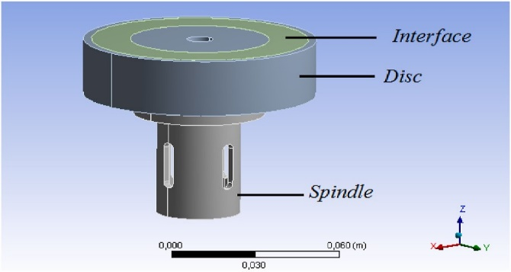 **Fig. 1.** 3D numerical model

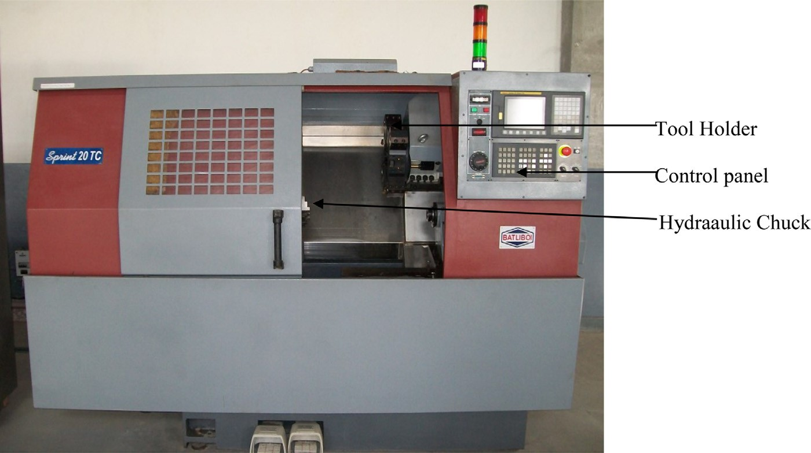

**Fig.** **2.** CNC Machine (Model TC 20).

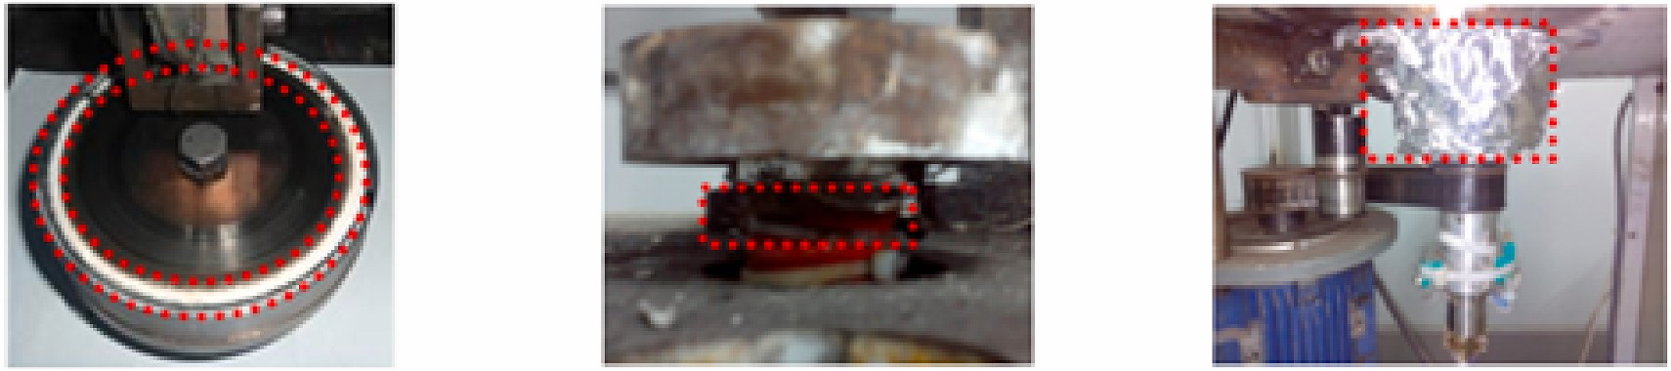 **Fig. 3.** Experimental setup of the wear

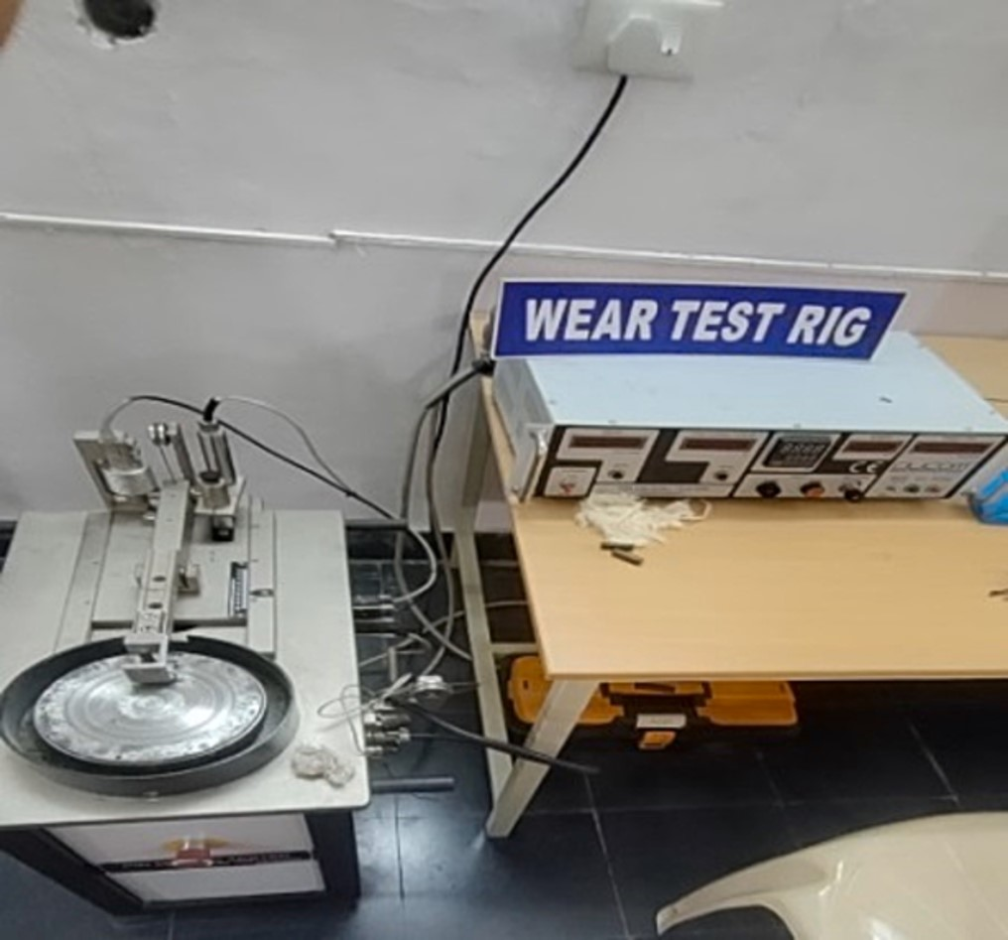

**Fig. 4.** Wear Test Rig.

**CONCLUSION:**

Composites made from Al5052, Al2O3, and Si3N4 showed increased ultimate tensile strength, impact strength, uniform distribution of reinforcing particles, strong interfacial adhesion, low porosity, and best wear resistance. Two steel-TiB2 composites were developed, showing improved mechanical properties of austenitic AISI 316L steel, increased Vickers hardness, Young's modulus, and compression strength, with the highest properties observed in 20 vol. composites. Aluminum 5154 composites are promising for lightweight structures, with SiC reinforcement enhancing corrosion and hardness properties. TiB2 composites show excellent wear, and microstructural studies predict corrosion effects. The mechanical properties of AA 5052 hybrid composites, incorporating tungsten carbide, silicon carbide, and graphite particulates, revealing improved impact strength and mixed ductility. TiB2 reinforced Al6061 metal matrix composites using the stir casting method. It found that TiB2 addition improved wear resistance, increased hardness, and reduced wear rates in wear tests.

**RESULT:**

The outcomes of this experiment show significant improvements in the mechanical and tribological characteristics of aluminum alloy 5052 reinforced with powdered carbon, magnesium, and zinc at weight percentages of 5%, 10%, and 15%. Because of the strengthening effects of magnesium in the aluminum matrix, hardness significantly enhanced, particularly at 15% magnesium, showing a 40% improvement over the standard alloy. Significant improvements in tensile strength were also seen; combinations of magnesium and zinc produced a 35% increase, hence increasing the alloy's load-bearing capability.

Composites with 10% carbon powder showed the greatest improvement in wear resistance, with material loss reduced by up to 35% under high-load circumstances. The solid lubricating action of carbon powder decreased abrasive wear, and the alloy's endurance during sliding operations was increased by the reinforcement of structural stability by zinc and magnesium. Furthermore, the coefficient of friction decreased by 30% in samples with 15% carbon powder, indicating effective friction reduction due to carbon’s lubricating properties.

**REFERENCE:**

1. Parikh, V. K., Patel, V., Pandya, D. P., & Andersson, J. (2023). Current status on manufacturing routes to produce metal matrix composites: State-of-the-art. *Heliyon*, *9*(2).
2. Venkat, P. P., Naidu, P. C., Kumar, L. P., Babu, K. V., Prasad, M. K., & Rao, M. V. (2023). Effect of Al2O3 particles on mechanical, microstructural and tribological characteristics of Al5052 metal matrix composite reinforced with Si3N4 particles. *Materials Today: Proceedings*, *91*, 158-166.
3. Sulima, I., Jaworska, L., Wyżga, P., & Perek-Nowak, M. (2011). The influence of reinforcing particles on mechanical and tribological properties and microstructure of the steel-TiB2 composites. *Journal of Achievements in Materials and manufacturing Engineering*, *48*(1), 52-57.
4. Sellami, A., & Elleuch, R. (2024). Effect of cast-iron disc thickness on the reliability of tribological data from pin-on-disc test: Case study of brake friction materials. *Heliyon*, *10*(3).
5. Kumar, P. K., & Kumar, A. S. (2021). Investigation of frictional characteristics of laser textured aluminium 6061 and aluminium 7071 alloys under dry sliding conformal contact in pin on disc tribometer. *Materials Today: Proceedings*, *45*, 670-676.
6. Suresh, R., Kumar, M. P., Basavarajappa, S., Kiran, T. S., Yeole, M., & Katare, N. (2017). Numerical Simulation & Experimental study of wear depth and Contact pressure distribution Of Aluminum MMC Pin on Disc Tribometer. *Materials Today: Proceedings*, *4*(10), 11218-11228.
7. Bhushan, R. K. (2020). Optimization of tool wear parameters in machining AA7075/SiC composite. *Composites Part C: Open Access*, *2*, 100035.
8. Kumar, S., Panwar, R. S., & Pandey, O. P. (2013). Effect of dual reinforced ceramic particles on high temperature tribological properties of aluminum composites. *Ceramics International*, *39*(6), 6333-6342.
9. Nagercoil, K. D. (2014). Tribological, tensile and hardness behavior of TiB2 reinforced aluminium metal matrix composite. *Journal of the Balkan Tribological Association Vol*, *20*(3), 380-394.
10. Kumar, N. R., & Sree, P. G. S. S. (2023). Evaluation of tribological properties of aluminum 5154/SiC/TiB2 metal matrix composites. *Materials Today: Proceedings*.
11. Pazhani, A., Venkatraman, M., Xavior, M. A., Moganraj, A., Batako, A., Paulsamy, J., ... & Bavan, J. S. (2023). Synthesis and characterisation of graphene-reinforced AA 2014 MMC using squeeze casting method for lightweight aerospace structural applications. *Materials & Design*, *230*, 111990.
12. Bhaskar, S., Kumar, M., & Patnaik, A. (2019). Mechanical and Tribological overview of ceramic particulates reinforced aluminium alloy composites. *Reviews on Advanced Materials Science*, *58*(1), 280-294.
13. Leonardi, M., Alemani, M., Straffelini, G., & Gialanella, S. (2020). A pin-on-disc study on the dry sliding behavior of a Cu-free friction material containing different types of natural graphite. *Wear*, *442*, 203157.
14. Prabakaran, V., Palani, R., & Praveen, M. (2024). Study of tribological performance and corrosion resistance of aluminum alloy 6063 composites enhanced with a combination of silicon carbide and tungsten disulfide particles. *Results in Surfaces and Interfaces*, *15*, 100233.
15. Farooq, S. A., Mukhtar, S. H., Raina, A., Haq, M. I. U., Siddiqui, M. I. H., Naveed, N., & Dobrota, D. (2024). Effect of TiB2 on the mechanical and tribological properties of marine grade Aluminum Alloy 5052: An experimental investigation. *Journal of Materials Research and Technology*, *29*, 3749-3758.
16. Dhas, D. E. J., Velmurugan, C., Wins, K. L. D., & BoopathiRaja, K. P. (2019). Effect of tungsten carbide, silicon carbide and graphite particulates on the mechanical and microstructural characteristics of AA 5052 hybrid composites. *Ceramics International*, *45*(1), 614-621.
17. Ramachandra, M., Abhishek, A., Siddeshwar, P., & Bharathi, V. (2015). Hardness and wear resistance of ZrO2 nano particle reinforced Al nanocomposites produced by powder metallurgy. *Procedia Materials Science*, *10*, 212-219.
18. Garg, P., Jamwal, A., Kumar, D., Sadasivuni, K. K., Hussain, C. M., & Gupta, P. (2019). Advance research progresses in aluminium matrix composites: manufacturing & applications. *Journal of materials research and technology*, *8*(5), 4924-4939.
19. Chandra, D., Chauhan, N. R., & Rajesha, S. (2020). Hardness and toughness evaluation of developed Al metal matrix composite using stir casting method. *Materials Today: Proceedings*, *25*, 872-876.
20. Chebolu, R., Nallu, R., & Chanamala, R. (2022). Experimental investigation on mechanical behavior of as cast Zn-Al-Cu/SiC/TiB2 hybrid metal matrix composite by ultrasonic assisted stir casting technique. *Engineering Research Express*, *4*(2), 025040.
21. Sharath, B. N., Venkatesh, C. V., Afzal, A., Baig, M. A. A., & Kumar, A. P. (2021). Study on effect of ceramics on dry sliding wear behaviour of Al-Cu-Mg based metal matrix composite at different temperature. *Materials Today: Proceedings*, *46*, 8723-8733.
22. Leonardi, M., Alemani, M., Straffelini, G., & Gialanella, S. (2020). A pin-on-disc study on the dry sliding behavior of a Cu-free friction material containing different types of natural graphite. *Wear*, *442*, 203157.
23. Rita, D. A., Candeo, S., Jayashree, P., Nogueira, A. P. G., Rustighi, E., & Straffelini, G. (2024). Comparative analysis of pin-on-disc and inertia-dynamometer sliding tests on a friction material. *Wear*, *558*, 205552.
24. Farooq, S. A., Mukhtar, S. H., Raina, A., Haq, M. I. U., Siddiqui, M. I. H., Naveed, N., & Dobrota, D. (2024). Effect of TiB2 on the mechanical and tribological properties of marine grade Aluminum Alloy 5052: An experimental investigation. *Journal of Materials Research and Technology*, *29*, 3749-3758.
25. Singh, B., Grewal, J. S., Kumar, R., Sharma, S., Kumar, R., Singh, H., ... & Lozanovic, J. (2024). Tribomechanical, and Microstructural Morphological analysis of Nitride Ferrous Powder Metallurgy Composites for Enhanced Automotive Valve Guide Performance. *Journal of Materials Research and Technology*.