**ADDITIVE MANUFACTURING OF METALS AND PLASTICS FOR BIOMEDICAL APPLICATIONS-A LITERATURE REVIEW**

***Mr.G.Sasidhar1, S.sai2, R.satish Kumar3, Sumith Rowlo4, U.Madhava4, R.Krishna6***

**1Assistant professor, Mechanical engineering, GMRIT, Rajam, Andhra Pradesh**

**2,3,4,5,6UG Scholar, Mechanical engineering, GMRIT, Rajam, Andhra Pradesh**

**ABSTRACT**

Additive manufacturing (AM), commonly known as 3D printing, has revolutionized the biomedical industry by enabling the creation of customized and patient-specific medical solutions. AM’s ability to fabricate geometrically complex structures has been instrumental in producing a wide range of medical applications, including implants, medical devices, and pharmaceuticals. The technology’s flexibility extends to producing both hard and soft tissue implants, offering substantial improvements in tissue engineering and biomanufacturing. Despite its advantages, the adoption of AM across different processes and materials remains uneven. Techniques like powder bed fusion, material extrusion, and VAT photopolymerization are widely used, while others like directed energy deposition and sheet lamination are less common. The continuous evolution in AM processes, particularly in binder jetting and biomaterials, holds promise for expanded future applications. However, standardization in AM terminology and further advancements in biomaterials are necessary to fully realize its potential. Overall, AM presents a transformative approach in the medical field, offering innovative solutions and addressing the need for personalized healthcare, though further development and research are crucial for its broader application and success.

Keywords: Powder bed fusion, Material Extrusion, VAT photopolymerization, Binder Jetting, Medical implants, Pharmaceuticals, Biomanufacturing, Sheet Lamination.

**1.INTRODUCTION**

Additive manufacturing (AM), or, in a non-technical context, 3D printing, is a process where physical parts are manufactured using computer-aided design and objects are built on a layer-by-layer basis. Usually, these procedures are called toolless processes. There are other processes, such as incremental sheet forming or laser forming, that build objects on a layer-by-layer basis as well but do so by adding the form, not the material [6]. These processes are not counted as an additive manufacturing process even though they have been similarly used in making, for example, customized medical products. Currently, additive manufacturing is utilized and being investigated for use in areas such as the medical, automotive, aerospace and marine industries, as well as industrial spare parts [1]. Additive manufacturing is referred to as a manufacturing method where complexity or customization is free. However, this requires marking and tracing of the different parts compared to mass production of the same kind of parts. Nevertheless, when comparing AM against conventional manufacturing, it has a much higher potential for customization and complex geometries [2]. However, when comparing cost, additive manufacturing is usually not cheaper if the geometry is designed for mass production and only the manufacturing cost is calculated. It would suffice to reiterate the whole product design and look at the economics over the entire product life cycle [4].

* 1. ***Basic Principle of Additive Manufacturing***

The basic principle of additive manufacturing (AM), also known as 3D printing, is to create objects layer by layer from digital models, rather than by traditional subtractive methods like machining [2]. In additive manufacturing, a 3D design is sliced into thin cross-sectional layers, which are successively built up to form the final object [5].

Digital Design Creation: A 3D model is created using computer-aided design (CAD) software. This model serves as the blueprint for the object. [3]

Slicing and Layering: The digital model is "sliced" into thin layers. Each layer is essentially a 2D cross-section of the object, which will be built sequentially from the bottom up [4].

Layer-by-Layer Fabrication: Using various AM technologies (e.g., Fused Deposition Modeling, Selective Laser Sintering, or Stereolithography), the printer deposits or solidifies material in each layer according to the digital design, gradually creating the full 3D object.

Material Deposition or Solidification: Depending on the method, material can be deposited as a melted filament, resin, powder, or metal that then solidifies to form each layer [6].

Object Completion: The object is built up one layer at a time until it is complete. Once the printing process is done, some post-processing may be required for finishing, such as removing supports or polishing surfaces [7].

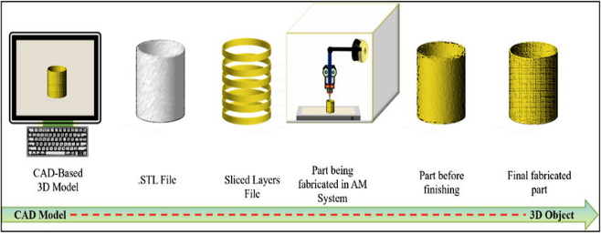

**Fig.1- Principle of Additive Manufacturing. [1]**

* 1. ***Additive Manufacturing Processes***

Additive Manufacturing encompasses seven main technologies, each utilizing different processes and materials to build objects. These technologies are classified based on how they create layers and the materials they use.

Seven main additive manufacturing technologies are as follows:

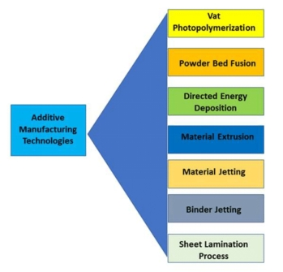

**Fig.2- Different AM Processes. [16]**

**Vat Photopolymerization**: This process uses Photopolymerization, in which radiation-curable resins or photopolymers are used to create three-dimensional objects by selectively exposing them to ultraviolet light [4]. When exposed, these materials undergo a chemical reaction and become solid. Only plastics can be printed using these technologies. This process is known for producing high-resolution parts and is commonly used in industries like dentistry and jewellery [5].

Subtypes: Three main types under this category are [Stereolithography, Digital Light Processing and Continuous Digital Light Processing](https://engineeringproductdesign.com/knowledge-base/vat-photopolymerization/).

**Binder Jetting:** As the name implies, [Binder Jetting](https://engineeringproductdesign.com/knowledge-base/binder-jetting/) selectively deposits the bonding agent, a binding liquid, to join the powder material to form a 3D part. This process differs from any other AM technology as it does not employ heat during the process like others to fuse the material, making it suitable for a wide range of materials, including metals and ceramics. The print head and a powder spreader deposit alternating layers of bonding agent and build material to form a 3d object [7].

Directed energy deposition: [Directed energy deposition technology](https://engineeringproductdesign.com/knowledge-base/direct-energy-deposition/) uses focused thermal energy such as a laser, electron beam, or plasma arc to melt and fuse the material as they are deposited to create a 3D object. These are very similar to the welding process but very finely detailed. The geometric information in a Computer-Aided Design (CAD) solid model is used by LENS 3D printers to autonomously direct the DED process as it builds up a part layer by layer [9]. The two main types of Directed energy deposition technologies are LENS and EBAM. EBAM uses an electron beam, and LENS uses a focused laser to melt the material [10].

**Material extrusion:** Material Extrusion is an additive manufacturing technique that uses a continuous thermoplastic or composite material filament to construct 3D parts. [Material extrusion](https://engineeringproductdesign.com/knowledge-base/material-extrusion/) was initially developed and patented by [S. Scott Crump](https://en.wikipedia.org/wiki/S._Scott_Crump) under Fused Deposition Modelling (FDM) in the 1980s.In this additive manufacturing technique, the continuous filament of thermoplastic is fed through a heated nozzle before being deposited layer by layer onto the build platform to create the object [3].

**Material jetting**: In [material jetting](https://engineeringproductdesign.com/knowledge-base/material-jetting/), build material droplets are selectively deposited layer by layer into the build platform to form a 3D part. This additive manufacturing technique is very similar to standard inkjet printers, where the material droplets are deposited layer by layer selectively to create a three-dimensional object [5]. Once a layer is complete, it is cured by ultraviolet light. Powder material jetting includes the following commonly used printing technologies: UV-cured Material Jetting, Drop-on-Demand (DOD), and nano-particle jetting (NPJ) [4].

**Powder bed fusion:** [Powder bed fusion](https://engineeringproductdesign.com/knowledge-base/powder-bed-fusion/) is an Additive Manufacturing technique that uses a laser or electron beam to melt and fuse the material to form a 3D geometry part. Powder Bed Fusion includes the following commonly used printing technologies: Multi-Jet Fusion (MJF), Direct metal laser sintering (DMLS), Electron beam melting (EBM), Selective heat sintering (SHS), Selective laser melting (SLM), and Selective laser sintering (SLS). Powder bed fusion processes, especially selective laser sintering, are early industrial additive manufacturing techniques. This method uses a laser or electron beam to melt the powdered material and fuse it to create a solid object [3].

**Sheet lamination:** [Sheet lamination technologies](https://engineeringproductdesign.com/knowledge-base/sheet-lamination/) use sheets of material to create 3D objects by stacking them and laminating them using either adhesive or ultrasonic welding. Once the object is built, the unwanted areas of the sections are removed layer by layer. Sheet lamination technology is an umbrella term for Ultrasonic Additive Manufacturing (UAM, Selective Deposition Lamination (SDL, and Laminated Object Manufacturing (LOM) [5].

**2.BIBLIOGRAPHIC SURVEY**

**2.1 Additive manufacturing of PEEK for biomedical applications**

Polyetheretherketone (PEEK) is an efficient semi-crystalline thermoplastic alternative to implantable metal materials as it has excellent biocompatibility and combines good strength and stiffness. Elastic modulus of PEEK is similar to cortical bone, which reduced stress shielding after implantation. It is also radiolucent which permits radiographic assessment. The combination of these properties has made PEEK of great potential for orthopaedic application. Medical grade PEEK-OPTIMA has been developed by Invibio to meet with Food and Drug Administration (FDA) requirements and has been used in multiple clinical applications such as spinal cage fusion, total join replacement, and craniomaxillofacial reconstruction [1].

***2.1.1 Experimental set-up***

Two different high-temperature extrusion-based AM systems with different extrusion head configurations were set up and tested: syringe-based (Figure 3(a)) and filament-based extrusion head designs (Figure (3b)). In both techniques, one nozzle was used for deposition of both part and support materials. As for the syringe-based method, the pre-set device suitable for low-temperature printing of bio ceramic scaffolds was modified in order to reach nozzle temperature up to 450°C for PEEK extrusion. The extrusion syringe was made from two different metal tubes coupled together: a brass tube with an internal diameter of 17 mm with good thermal conductivity attached to a 500 µm nozzle and a stainless-steel tube with high strength and lower thermal conductivity. Using the brass tube, PEEK can absorb sufficient energy to get fully melted and easy to extrude through a nozzle [1].

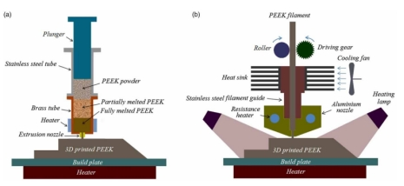

**Fig.3- Schematic of (a) the syringe-based and (b) the filament-based device set-up for PEEK 3D printing. [1]**

In the other region (within stainless steel tube), PEEK has lower temperature since there is less thermal conductivity, and thus less chance to get overheated and degraded. A self-adhesive etched foil silicone heater was also used to get the substrate heated (up to 170°C) in order to transfer heat to the printed PEEK parts continuously to minimise thermal stress. As for filament-based system, a driving gear feeding system was used to extrude PEEK through a 0.4 mm nozzle and deposited layer by layer to build up complex 3D structures. For this end, a UP 3D printer was modified so that nozzle temperature up to 460°C and heated build plate of 130°C could be achieved. In addition, heating lamps surrounding the build area were used to control ambient temperature (approx. 80°C) to avoid severe part warpage and delamination [3].

***2.1.2 Mechanical Tests***

The 3D printed porous samples were cut using a diamond cutter (Mecatome T210, Presi, France) for microstructural analysis. The morphologies of the 3D printed parts and porous scaffolds were examined using optical microscopy (Olympus BH2-UMA, Japan) and scanning electron microscopy (SEM) (JEOL JSM6500F, Oxford Instruments, UK). In addition, the printed PEEK scaffolds were characterised in terms of porosity and mechanical properties. Porosity was measured by correlating PEEK scaffolds’ geometrical dimensions and material density as per ASTM F 2450-04 [4]:

**2.2 polymer-based additive manufacturing**

This section discusses in-depth the various polymer-based AM processes and several variables that should be considered while selecting a preferable manufacturing method.

***2.2.1 From Digital Model/CAD to a 3D Printable Mesh***

Mesh is a digital blueprint of the 3D CAD model which encompasses the geometric data for that part. Most of the 3D modelling software has an option to export a mesh file in the latest updates because of the growing acceptance of 3D printing for rapid prototyping in every manufacturing industry. Some used mesh formats include.stl, .obj, amf, and .3mf. All these file formats have gained respectable support across the 3D printing toolchain, but all of these vary in terms of the type of data they store and what information goes to the 3D printer. The choice of the file format is also tightly coupled with the tool being used for 3D printing.

***2.2.2 Standard Tessellation/Triangulation Language (STL)***

The most commonly used file format, standard tessellation/triangulation language (.stl), essentially divides a 3D model surface into smaller triangular meshed surfaces. The triangles can be made arbitrarily small to approximate the curved regions, but increasing mesh density increases the file size. In Figure 4, the perfect spherical surface on the left is approximated by tessellations. Figure 4c uses big triangles, resulting in a coarse model with a small file size, whereas Figure 4b uses smaller triangles and achieves a smoother approximation at the cost of a much larger file size

|  |
| --- |
|  |
|  |  |

**(a) (b) (c)**

**Fig.4- (a) CAD, (b) high-resolution mesh, (c) low-resolution mesh.**

The .stl format will soon become obsolete as it is the most bloated file format for storing mesh data. It stores the normal vectors to the triangles even though this is redundant information. Additionally, there is no information about the inter-connectivity of the triangles, and therefore a watertight manifold of the mesh cannot be assured; it hence requires mesh repairs. The .stl format also lacks the capability of storing units, material, and texture of the design.

***2.2.3 OBJ***

The .obj format is the preferred mesh format for multicolour 3D printing applications as it can store colour and material for the part. Its open-source nature and the ease of use have made it the second most used format. However, as with stl, there is a balance required between the file size and the mesh accuracy as it also depends on the polygon tessellation of the surface. The texture and colour of every 3D surface are mapped on a 2D contour and stored in a companion file called Material Template Library (.mtl) format. Advanced schemes exist to store curves or free form surfaces without losing any precision, which makes it a little more complicated to repair or debug if the file has errors.

***2.2.4 AMF***

This format was introduced by the American Society of Testing and Materials (ASTM) as a replacement for the bloated and error-prone stl format. It being a .xml based format, natively supports geometry, scale, colour, materials, lattices, duplicates, and orientation. Similar to the stl format, amf also stores tessellated triangles, but with better accuracy. Additionally, it can also allow for curved triangles, which reduces the number of facets. As an encoding-based framework, it can allow for the repetition of similar geometry without bulking up file size. However, this format has not been widely adopted in the 3D printing industry.

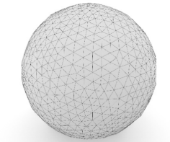  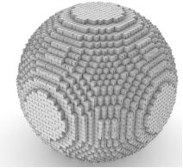

**(a) (b) (c)**

**Fig.5- (a) Triangulated mesh, (b) 3D-sliced, (c) 3D voxels.**

|  |
| --- |
|  |

These slices are then used to generate a toolpath, which is interpreted by a 3D printer to begin the manufacturing process. A novel alternative to the slicing is the voxel (3D pixel) generation in which instead of dividing the model into thin layers, it is broken down into small volumetric pixels (Figure 5c), which are then used to generate the toolpath. Amongst many other parameters, the thickness of the layers and the size of the voxels also decide the quality of the final product. Homogeneity of the material in the printed parts becomes an essential factor for robotics and it can be observed that voxels provide the highest quality and control of material properties in all directions. Although slicing is well accepted in most applications, it is also successful as compensation is undertaken either by selecting better/stronger materials or by decreasing the layer resolution for improved fusion. Several other 3D printing parameters which are key to the slicing process are discussed in detail in the next section.

**2.3 Iron-based alloys containing silver for biomedical applications**

Fe-Mn-Ag alloys fabricated using additive manufacturing (AM) in general, and selective laser melting (SLM) in particular, will be promising materials for biomedical applications as they can avoid the major limitations of traditional manufacturing procedures, namely, the immiscibility of the iron and silver elements. In the alloy, the presence of silver can induce a corrosion rate with localized cathodic sites, which will be useful for the controlled biodegradation which is an important feature of implants. Analyses through the mechanical, microscopic, and electrochemical methods all assert and confirm uniform dispersion of silver particles, retaining the mechanical strength of the alloy while providing better dissolution rates. These alloys balance properties, which make them extremely suitable for patient-specific implants requiring gradual degradation and reliable mechanical performance. TWIP steel, characterized by high strength and ductility, is an excellent base material for AM since the material displays enhanced formability, energy absorption, and wear resistance. Due to these properties, TWIP steels are considered to be one of the best alloys for various applications, for example, in aircraft and automobile parts, as well as for advanced medical devices. Thus, it is possible to design immiscible metal alloys using the favourable properties of AM techniques to manufacture parts suitable for sophisticated, customer-specific parts in high-demand industries [2].

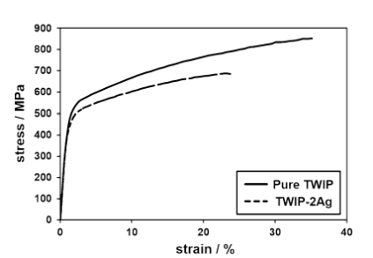

**Fig.6- Monotonic stress–strain response of pure TWIP steel and TWIP-2Ag processed by selective laser melting. [2]**

**2.4 3D printing of biodegradable polymers**

Additive manufacturing, or 3D printing, is actually now revolutionizing the biomedical field by allowing production of very highly complex customized devices using the biodegradable polymers polyhydroxyalkanoates (PHAs). These are biopolymers produced by bacteria under conditions of limiting nutrients. Being bio-based and biodegradable, they provide more favorable mechanical and physical properties that make them ideal candidates for applications in drug delivery, tissue engineering, and patient-specific medical implants [3].

Traditional manufacturing techniques for PHA-based devices, such as the use of solvent casting and electrospinning, face many drawbacks. These include the nature of poor 3D structures and heavy reliance on toxic solvents, with minimal control over pore architecture. AM does not suffer from these drawbacks in its layer-by-layer approach to manufacturing, which gives better geometry, porosity, and a fit to the patient's specific requirement [6]. Direct ink writing creates intricate microstructures, whereas fused deposition modeling excludes the use of solvents and provides strong scaffolds. Although SLS uses the resource of laser to create very precise structures, it does not allow for multi-scale porosity that will help cellular interaction like CAWS [3].

AM is able to design PHA scaffolds specifically for the application: porosity would thus be optimized for bone and cartilage tissue engineering, while controlled degradation rates would be important for sustained drug delivery. Biomedicine is at a promising node for personalized medicine but to date has faced challenges regarding the difficulty in accessing material that is expensive and may have issues related to regulatory matters [4].

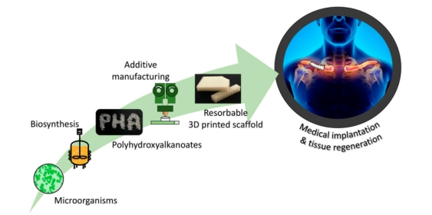

**Fig.7- Schematic representation of the production, technological transformation, and biomedical applications of polyhydroxyalkanoate (PHA)-based devices. [3]**

***2.4.1 Conventional manufacturing techniques for bio-medical implants using PHA***

Advances in the biomedical field are not limited to their final applications or the materials used, but they may also concern advancements in the processing techniques of the final implants and devices. Considering the thermoplastic behaviour and the solubility in organic solvents of PHA, different approaches have been followed for transforming PHA raw material into architectures with various potential biomedical applications [3]. The first PHA biomedical devices were simple systems with no control on the structure development, and they were obtained by traditional methods, such as (a) solvent casting, (b) salt leaching, (c) thermally induced phase separation (TIPS), (d) non-solvent-induced phase separation (NIPS), (e) emulsification, and (f) electrospinning. Here, the main features of these techniques are reported and summarized [6].

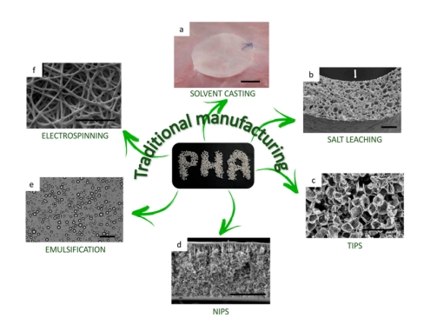

**Fig.8- Morphology of PHA scaffolds produced with conventional techniques. [3]**

***2.4.2 Additive manufacturing techniques to produce biomedical implants using PHA***

Many different techniques of 3D printing have been invented according to the characteristics of the material processed. For PHA 3D printing, the most applied approach is the one of extrusion-based techniques, in which the biopolymer is either melted or dissolved in a solvent and then extruded through a nozzle and deposited on a printing bed, layer-by-layer. Hereafter, the essential extrusion-based AM techniques used in the production of PHA biomedical applications are discussed and compared to the traditional ones: (a) Direct Ink Writing (DIW), (b) Fused Deposition Modelling (FDM), (c) Selective Laser Sintering (SLS), and (d) Computer Aided Wet-Spinning (CAWS) [3].

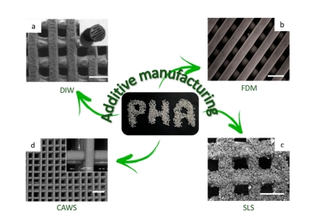

**Fig.9- SEM images of PHA scaffolds 3D printed with different AM techniques. [3]**

**3. CONCLUSION**

Critical analysis of the potential of AM in biomedical applications reveals that it is capable of creating highly customized and complex solutions for medical applications. It offers direct geometry, porosity, and material properties as such in implant, scaffold, and tissue engineering due to layer-by-layer building processes. The most common methods are powder bed fusion, material extrusion, and VAT photopolymerization. However, promising applications of binder jetting and directed energy deposition are very encouraging for further use. Discussed in the discussion is efficiency of AM for processing advanced materials such as PEEK, biocompatible, radiolucent, orthopedic, and biodegradable polymers that can offer a means of environmentally friendly solutions for tissue engineering and drug delivery. Porosity at multi-scale has also been achieved but with conventional manufacturing being the limitation of needing toxic solvents. This has many positive points, but it is weak in areas like uneven adoption among various stakeholders, high costs of mass production, and regulatory hurdles. So its major phase of increasing adoption includes standardization of terms, new development of biomaterials, and cost efficiency. Innovation, precision, and adaptability govern the state of merge of AM with precision medicine. One would certainly change the paradigm and meet requirements in the medical field and requirements from the environment; however, research is needed for stable development.

**4. REFERENCES**

1. Mohammad Vaezi & Shoufeng Yang (2015): Extrusion-based additive manufacturing of PEEK for biomedical applications, Virtual and Physical Prototyping, DOI: 10.1080/17452759.2015.1097053
2. Niendorf, T., Brenne, F., Hoyer, P., Schwarze, D., Schaper, M., Grothe, R. & Maier, H. J. (2015). Processing of new materials by additive manufacturing: iron-based alloys containing silver for biomedical applications. Metallurgical and Materials Transactions A, 46, 2829-2833.
3. Giubilini, A., Bondioli, F., Messori, M., Nyström, G., & Siqueira, G. (2024). Advantages of additive manufacturing for biomedical applications of polyhydroxyalkanoates. Bioengineering, 8(2), 29.
4. Shuai, C., Li, D., Yao, X., Li, X., & Gao, C. (2023). Additive manufacturing of promising heterostructure for biomedical applications. International Journal of Extreme Manufacturing, 5(3), 032012.
5. Ahangar, P., Cooke, M. E., Weber, M. H., & Rosenzweig, D. H. (2019). Current biomedical applications of 3D printing and additive manufacturing. Applied sciences, 9(8), 1713
6. Venkatesh, C., Fuenmayor, E., Doran, P., Major, I., Lyons, J. G., & Devine, D. M. (2019). Additive manufacturing of PLA/HNT nanocomposites for biomedical applications. Procedia Manufacturing, 38, 17-24.
7. Harun, W. S. W., Kamariah, M. S. I. N., Muhamad, N., Ghani, S. A. C., Ahmad, F., & Mohamed, Z. (2018). A review of powder additive manufacturing processes for metallic biomaterials. Powder Technology, 327, 128-151.
8. Murr, L.E., 2018. Additive manufacturing of biomedical devices: an overview. *Materials technology*, *33*(1), pp.57-70.
9. Mercado Rivera, F.J. and Rojas Arciniegas, A.J., 2020. Additive manufacturing methods: techniques, materials, and closed-loop control applications. *The International Journal of Advanced Manufacturing Technology*, *109*, pp.17-31.
10. Das, A., Chatham, C. A., Fallon, J. J., Zawaski, C. E., Gilmer, E. L., Williams, C. B., & Bortner, M. J. (2020). Current understanding and challenges in high temperature additive manufacturing of engineering thermoplastic polymers.
11. Pakkanen, J. (2018). Designing for Additive Manufacturing - Product and Process Driven Design for Metals and Polymers.
12. Shanmugam, V., Das, O., Neisiany, R. E., Babu, K., Singh, S., Hedenqvist, M. S., Berto, F., & Ramakrishna, S. (2020). Polymer Recycling in Additive Manufacturing: an Opportunity for the Circular Economy. Materials Circular Economy, 2(1). https://doi.org/10.1007/s42824-020-00012-
13. Gopal, M., Lemu, H. G., & Gutema, E. M. (2023). Sustainable Additive Manufacturing and Environmental Implications: Literature Review. In Sustainability (Vol. 15, p. 504). https://doi.org/10.3390/su15010504
14. Anwajler, B., Zdybel, E., & Tomaszewska-Ciosk, E. (2023). Innovative Polymer Composites with Natural Fillers Produced by Additive Manufacturing (3D Printing)—A Literature Review. Polymers, 15(17), 3534. https://doi.org/10.3390/polym15173534
15. Fernandez, E., Edeleva, M., Fiorio, R., Cardon, L., & D’hooge, D. R. (2022). Increasing the Sustainability of the Hybrid Mold Technique through Combined Insert Polymeric Material and Additive Manufacturing Method Design. Sustainability, 14(2), 877. <https://doi.org/10.3390/su14020877>
16. https://www.researchgate.net/figure/The-major-seven-AM-processes_fig1_361937982