**TRIBOLOGICAL PERFORMANCE ANALYSIS OF PIN-ON-DISK:**

**IMPACT OF WEAR, LUBRICATION, FRICTION COEFFICIENT**

**AND SURFACE ROUGHNESS**

**Y. Shireesha1, M. Sai prasanna2, K. Sirisha3, K. Prem sai4, N. Raghu5**

1Assistant Professor, Mechanical Dept., GMR Institute of Technology, Rajam, Andhra Pradesh, India

2,3,4,5UG Scholar, Mechanical Dept., GMR Institute of Technology, Rajam, Andhra Pradesh, India

____________________________________________________________________________________

**ABSTRACT**

Pin-on-disk test is a fundamental experimental method used to investigate the tribological properties of materials, focusing on friction, wear, and lubrication under controlled sliding contact conditions. This study evaluates the tribological behavior of different material combinations through pin on-disk experiments, analyzing the effects of varying parameters such as friction coefficient, wear rate, lubrication, contact pressure, and surface roughness. The results demonstrate the influence of these factors on the interaction between the pin and the disk, providing insights into frictional forces, material degradation, and the effectiveness of lubricants. By examining the wear mechanisms and performance characteristics of different materials and lubricants, this research contributes to optimizing material selection and enhancing the design of tribological systems in engineering applications. The findings offer valuable guidelines for improving the durability and efficiency of components subjected to sliding contact, with implications for a wide range of industrial applications.

**Keywords:** Impact of Wear, Lubrication, Friction Coefficient, and Surface Roughness

.

1. **INTRODUCTION**

Tribological performance is crucial in understanding and optimizing the wear, friction, and lubrication behaviors of materials in mechanical systems. One of the most common and effective methods for evaluating tribological properties is the "pin-on-disc" test, a laboratory setup where a stationary pin, usually made of a specific material, is pressed against a rotating disc under controlled conditions. This simple yet effective setup allows researchers to study the wear and frictional behavior of materials in various applications, such as automotive, aerospace, and industrial machinery. The test evaluates parameters like friction coefficient, wear rate, and temperature changes at the contact surfaces, providing insights into the material's durability and suitability for specific applications. By altering variables such as the applied load, sliding speed, surface roughness, and environmental conditions (e.g., humidity or lubrication), researchers can simulate different working environments and analyze how these factors influence the wear and frictional characteristics of the materials. The pin-on-disc test involves a stationary pin, often cylindrical or spherical, pressed against a rotating disc. The contact between the pin and disc simulates real-life conditions of sliding motion, making it suitable for evaluating material properties such as friction coefficient, wear rate, and surface damage mechanisms. The test parameters, including normal load, sliding speed, environmental conditions (e.g., dry or lubricated), and material pairing, are carefully controlled to mimic specific application scenarios. Understanding tribological performance through pin-on-disc testing is vital for material selection and surface engineering, as it allows engineers to predict how materials will perform under specific conditions, potentially leading to improvements in product reliability, energy efficiency, and maintenance costs. Tribological performance is assessed by measuring the frictional forces during sliding and analyzing the wear patterns on the surfaces. The test provides valuable insights into the suitability of materials for applications ranging from automotive components to biomedical implants. Additionally, it helps in optimizing surface treatments, coatings, and lubricants to improve durability and efficiency. Tribological performance is assessed by measuring the frictional forces during sliding and analyzing the wear patterns on the surfaces. The test provides valuable insights into the suitability of materials for applications ranging from automotive components to biomedical implants. Additionally, it helps in optimizing surface treatments, coatings, and lubricants to improve durability and efficiency.

**2**.**LITERATURE REVIEW**

**2.1 Main Components in Pin-On-Disk**

**Pin:** Function: The pin, typically made of a specific material being tested, is pressed against the rotating disc. It can have various shapes, such as cylindrical or spherical, which affects the contact area and wear mechanisms.

Material Selection: Pins are made of materials relevant to the application, like metals, ceramics, or composites, to simulate real-world contact conditions.

**Disc:** Function: The disc rotates beneath the pin at a controlled speed, simulating relative motion between two surfaces. The disc is often the counter-material against which the pin’s wear and friction characteristics are tested.

Material Selection: The disc material can vary, depending on the application and desired contact pairing, and can be metal, ceramic, or coated surfaces.

**Loading Mechanism:**

Function: This component applies a consistent load or force to press the pin against the disc, allowing the simulation of different contact pressures.

Configuration: The loading mechanism is typically adjustable to apply various loads, which helps simulate real-life stresses the materials would encounter in applications.

**Rotational Drive System:**

Function: The drive system rotates the disc at a controlled speed, allowing adjustments to simulate different sliding speeds.

Control: The speed can be varied to observe how different sliding velocities affect friction and wear behavior, such as thermal effects at higher speeds.

**Wear Measurement System:**

Function: This can include direct methods, such as measuring the weight or volume loss of the pin and disc, or indirect methods like 3D imaging and surface profilometry to observe wear patterns.

Purpose: Accurate wear measurement helps determine the wear rate and wear mechanisms, which are essential for assessing material durability.

**2.2 Factors that influencing its accuracy**

the tribological properties of materials, focusing on friction, wear, and lubrication under controlled sliding contact conditions. Ensuring consistent testing conditions helps maintain reliability in measuring the friction coefficient.

**Friction:** Friction plays a key role in improving the accuracy and reliability of the test results. These experimental set up typically involves a pin (often a small cylindrical sample) being pressed against a rotating disk and friction between the pin and the disk can influence various aspects of the test.

**Wear simulation**: The frictional forces acting between the pin and the disk create a more realistic simulation of wear and tear in real world applications. By increasing the friction the system can more closely mimic the operating conditions of machinery where friction is a significant factor (like bearings, gears or other contact surfaces). As the friction increases the wear mechanism becomes more stable and predictable, allowing for better monitoring of wear patterns and providing more reliable data on material performance.

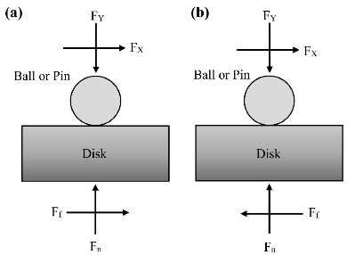 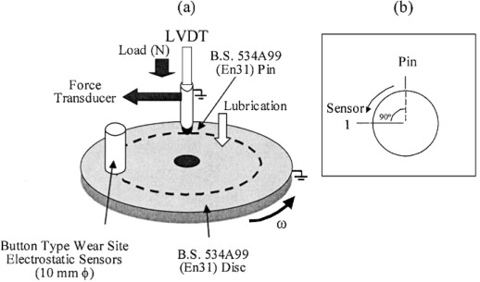 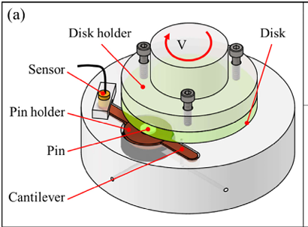

1. (b) (c)

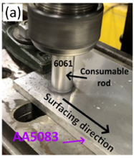 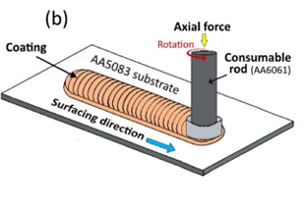 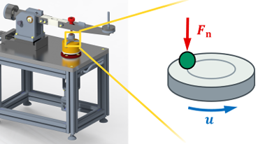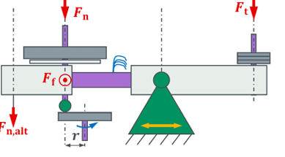

(d) (e) (f) (g)

Fig.1: Pin-on-disk Tribometers (a)multi directional pin-on-disk testing machine, (b)pin on disk wear test, (c) schematic representation of the pin-on-disk tribometer, (d)Original friction surfacing setup, (e)Schematic friction surface setup, (f)Typical configuration of a pin-on-disk tribometer with contact situation, (g)simplified concept of the friction measurement

**Lubrication Effect:**

Boundary lubrication: occurs when lubricant film is too thin to completely separate the surfaces. High friction and wear are typically observed.

Hydrodynamic lubrication: A thicker lubricant layer forms, leading to reduce the friction and wear

Full film lubricant: Occurs at higher speeds or with thicker lubricants, where the surfaces are completely separated by the lubricant, resulting in minimal wear

**Pin-on-disk Tribometer**

The tests were performed in a pin-on-disc tribometer with a horizontal rotating disc, using a deadweight to provide a desired nominal contact pressure on the pin. The tribometer is a conventional tribometer that was redesigned for particulate emission testing. It can run with constant applied normal forces of up to 100Nand rotational speedsofupto3000rpm. In the tribometer the coefficient of friction was indirectlymeasuredusinganHBM®Z6FC3/20kgload cell that gives the tangential force. The disc bulk temperature was registered using a K-type thermocouple 3mmbelow the contact surface. The mass loss of the test specimens was measured by weighing the test samples before and after the test to the nearest 0.1mgusinga Sartorius®ME614Sbalance.

The pin-on-disk test is widely used because it's relatively simple and can simulate various types of contact, such as dry, lubricated, and even biological implants

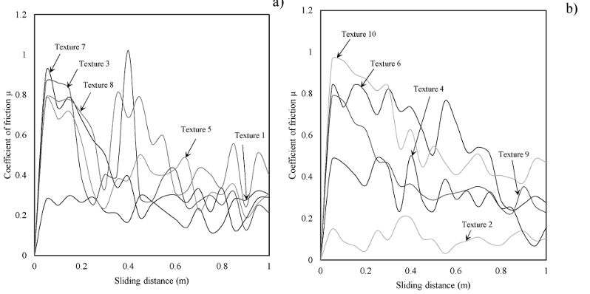

The graph showing the coefficient of friction versus sliding distance typically illustrates how friction changes as two surfaces slide against each other over time. Here's a simplified explanation:

1. Initial High Friction: At the beginning of the sliding process, the coefficient of friction is usually high. This is because the surfaces are rough and have many asperities (tiny peaks and valleys) that interlock, causing more resistance.

2. Running-In Period: As sliding continues, these asperities start to wear down, and the surfaces become smoother. This period is known as the "running-in" phase. During this phase, the coefficient of friction gradually decreases as the surfaces conform to each other.

3. Steady-State Friction: After the running-in period, the surfaces reach a more stable condition where the coefficient of friction levels off. This steady-state friction is typically lower than the initial friction and remains relatively constant over time.

4. Wear and Tear: Over a long period, wear and tear can cause changes in the friction coefficient. If the surfaces become too smooth, lubrication might be less effective, or if new asperities form, the friction might increase again.

The graph usually starts with a high coefficient of friction, decreases during the running-in period, and then stabilizes at a lower value during steady-state sliding. This pattern helps in understanding the wear behavior and the effectiveness of lubrication in reducing friction over time.

**2.4 Set up and experimental conditions:**

First, before each test, ensure that the load cell and the test weights used in the tribometer test have been properly calibrated. The axial runout of the specimen adapter must also be adjusted, aiming for a maximum deviation of 0.02 mm following ISO 18535:2016 [6]. The desired pin track radius is then set and checked via the diameter of the wear track on a setting disc. The contact point is adjusted via the cantilever so that the direction of friction is tangential to the pin track circle and in the direction of measurement. The cantilever is then brought into balance. The remaining test conditions are written directly to the main controller via USB before the tests and can be adapted as required within the technically possible limits of the hardware used. Conceivable are e.g., continuous sliding, oscillating tests with different swing angles as well as defined speed ramps. After switching on, all modules are initialized, and the force sensor is zeroed. Then the test force is applied, and the test starts automatically with the stored test parameters. The test stops when either the maximum sliding distance or alternatively the test time or number of revolutions is reached or when limit values for the COF have been exceeded to a defined extent. In the event of an overload, which can also be defined, the test is also aborted. The tribometer is then switched off and the data can be imported from the SD card for further evaluation. If several tests are performed in succession, the result file is simply continued with a new header. In standard configuration the friction forces are recorded with a sample rate of 10 Hz. As with Round Robin tests, the test conditions were selected so that all parameters except the test rig used were identical. n = 5 repeat tests were performed in each case. For comparison, the tests were also carried out on the MT1 tribometer. This has the identical control system and data recording.

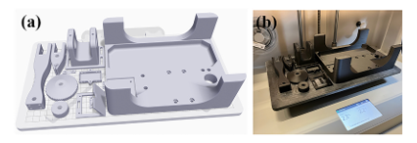

(a)arrangement of all components in the print bed (b)printed components

**3.CONCLUSION**

The tribological performance analysis of the pin-on-disk experiment provided valuable insights into the wear and friction behaviour of the tested material pairs. The findings indicate that the coefficient of friction and wear rate are significantly influenced by factors such as applied load, sliding speed, and the material properties of the pin and disk. Materials with higher hardness and favorable microstructures showed reduced wear rates, which suggests better durability and resistance to abrasion.

Furthermore, the study highlights the role of surface treatments and lubricants in improving wear resistance and lowering friction, pointing to practical applications in reducing material degradation in real-world engineering components. This analysis is essential for optimizing material selection and improving the lifespan and reliability of mechanical systems that operate under sliding contact conditions. Future studies could explore a wider range of environmental conditions, contact pressures, and material pairings to deepen the understanding of tribological mechanisms at play.

**4.REFERENCES**

1. Wang, Y., Paidar, M., Eslami-Farsani, R., Ahmadi-Danesh-Ashtiani, H., Salman, S., Mehrez, S., & Zhang, H. (2024). Friction surfacing of AA6061 on AA5083 aluminum alloy with adding 316 stainless steel powders: effect of volume fraction of reinforcements. *Journal of Materials Research and Technology*, *30*, 1800-1805.
2. . Orgeldinger, C., Rosnitschek, T., & Tremmel, S. Unveiling an Innovative Additively Manufactured Open Hardware Pin-on-Disc Tribometer Considering its High Reproducibility. *Available at SSRN 4777567*.
3. Orgeldinger, C., Rosnitschek, T., & Tremmel, S. (2024). Unveiling an additively manufactured open hardware pin-on-disc tribometer considering its high reproducibility. *Wear*, 205437.
4. Yue, H., Schneider, J., Frohnapfel, B., & Gumbsch, P. (2024). The influence of pin inclination on frictional behavior in pin-on-disc sliding and its implications for test reliability. *Tribology International*, 110083.
5. Vásquez-Chacón, I. A., Sanchez-Tizapantzi, P., Gómez-Guarneros, M. A., Enciso-Aguilar, M. A., & Gallardo-Hernández, E. A. (2023). Running-in evaluation after a rail grinding process using a pin-on-disk tribometer. *Wear*, *522*, 204686.
6. Pabandi, H. K., Jashnani, H. R., & Paidar, M. (2018). Effect of precipitation hardening heat treatment on mechanical and microstructure features of dissimilar friction stir welded AA2024-T6 and AA6061-T6 alloys. *Journal of Manufacturing Processes*, *31*, 214-220.
7. K. Holmberg, A. Erdemir, Influence of tribology on global energy consumption, costs and emissions, Friction 5 (2017) 263–284, [https://doi.org/10.1007/s40544- 017-0183-5](https://doi.org/10.1007/s40544-%20017-0183-5).
8. Mang, T., Bobzin, K., & Bartels, T. (2011). *Industrial tribology: Tribosystems, friction, wear and surface engineering, lubrication*. John Wiley & Sons.
9. Varriale, F., Carlevaris, D., Wahlström, J., Malmborg, V., & Lyu, Y. (2023). On the impact of pad material ingredients on particulate wear emissions from disc brakes. *Results in Engineering*, *19*, 101397.
10. Yue, H., Schneider, J., Frohnapfel, B., & Gumbsch, P. (2024). The influence of pin inclination on frictional behavior in pin-on-disc sliding and its implications for test reliability. *Tribology International*, 110083.
11. Sivaprakasam, P., Hailu, T., & Elias, G. (2023). Experimental investigation on wear behavior of titanium alloy (Grade 23) by pin on disc tribometer. *Results in Materials*, *19*, 100422.
12. Rita, D. A., Candeo, S., Jayashree, P., Nogueira, A. P. G., Rustighi, E., & Straffelini, G. (2024). Comparative analysis of pin-on-disc and inertia-dynamometer sliding tests on a friction material. *Wear*, *558*, 205552.