**Energy-Efficient IoT Device Management Using ESP and Firebase for Smart Agriculture**

Dr. Ashok Verma

Department of CSE

GGITS Jabalpur

Devendra Kumar

Department of CSE

GGITS Jabalpur

Abstract:

***The concept of smart agriculture leverages IoT technology to improve the efficiency of agricultural processes. This research explores the development and implementation of an energy-efficient IoT-based system using the ESP microcontroller and Firebase real-time database for remote monitoring and control of an agricultural water pump. The system utilizes energy-efficient communication protocols and enables farmers to manage irrigation systems remotely, optimizing water usage and reducing energy consumption. The system features a web interface hosted on Firebase for user interaction, ensuring real-time data monitoring and control.***

Keywords: Smart Agriculture, IoT, ESP , Firebase, Energy Efficiency, Remote Monitoring, Water Pump, Web Interface

# Introduction

The agricultural sector has undergone a significant transformation with the advent of Internet of Things (IoT) technology. The integration of IoT in agriculture helps to monitor and control various agricultural processes, thus improving overall efficiency. Among these processes, irrigation plays a crucial role in ensuring optimal water usage. However, traditional irrigation systems often waste water and energy. This research presents an energy-efficient IoT system for managing an agricultural water pump using the ESP- microcontroller and Firebase, which allows for remote monitoring and control via a web interface.

With the increasing demand for sustainability, the system aims to provide farmers with the tools to reduce their carbon footprint by minimizing energy usage and maximizing water conservation through smart automation and real-time data access.

# Problem Statement:

Traditional irrigation methods are inefficient and energy-consuming. There is a need for a more energy-efficient and easily manageable system for farmers to monitor and control water pumps remotely to conserve water and energy.

# Objective:

This research aims to design and implement an energy-efficient IoT-based water pump management system using the ESP-32 microcontroller and Firebase. The system should provide a real-time database for monitoring, and users should be able to remotely control the water pump via a web interface.

# Literature Review

A variety of IoT-based agricultural systems have been developed to automate irrigation systems. Many of these systems utilize low-power microcontrollers such as the ESP-32 and cloud databases like Firebase to improve scalability and reduce operational costs.

## IoT in Agriculture:

Several research works have demonstrated the utility of IoT in monitoring environmental factors like soil moisture, temperature, and humidity. IoT-based irrigation systems, such as the ones developed by researchers like Yassir et al. (2021), focus on automating water pump operations based on soil moisture readings. These systems help reduce water wastage and increase crop yield.

## Firebase in IoT:

Firebase has become a popular cloud-based solution for real-time data storage and synchronization, especially in IoT applications. Using Firebase for IoT device management allows for seamless communication between devices and databases in real-time. Firebase offers a scalable and efficient solution for managing large datasets generated by IoT devices, making it ideal for agricultural systems. Firebase project creation is shown below

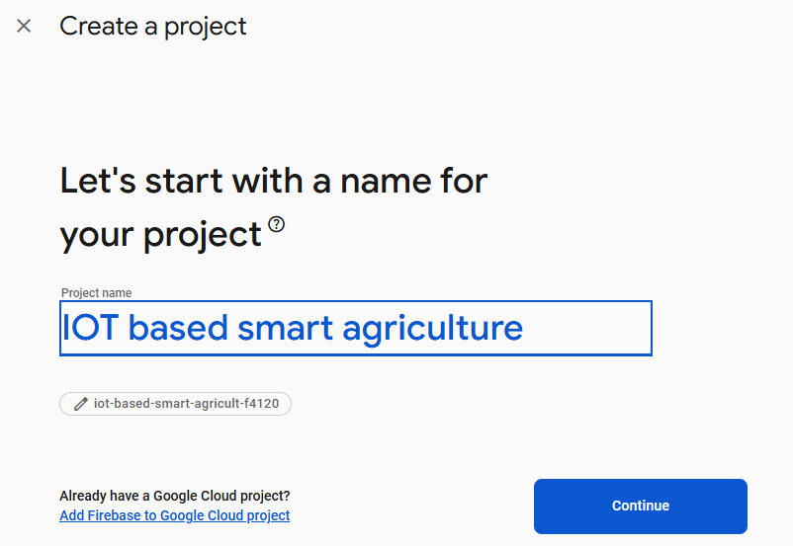

Figure 1 Firebase project creation page

## Energy-Efficient IoT Systems:

Energy efficiency is a crucial factor in IoT devices for agriculture. Systems like those proposed by Kumar et al. (2020) discuss various energy-saving strategies for IoT devices, including power-efficient microcontrollers, low-power communication protocols, and data aggregation techniques to minimize energy consumption.

# Methodology

The design of the energy-efficient IoT device management system involves several key components: Methodology is shown below. As shown the hardware sends data to the firebase real time database and the an Website fetch the data base and show it on the home page of the website.

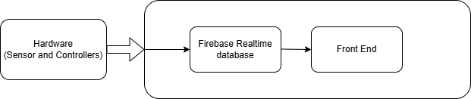

Figure 2 Block diagram of Methodology

**3.1 System Architecture**

The system architecture consists of the following main components: Block diagram of the circuit used is shown below

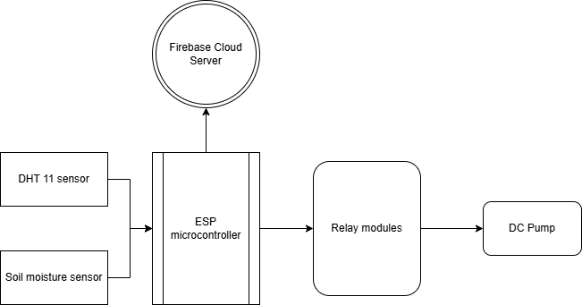

Figure 3 Block diagram of circuit

* **ESP Microcontroller**: The ESP is a low-power, dual-core microcontroller with integrated Wi-Fi and Bluetooth capabilities. It serves as the brain of the system, collecting data from sensors and controlling the water pump.ESP microcontroller is shown the figure below

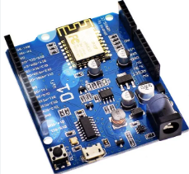

Figure 4 ESP microc-controller

* **Sensors**: Soil moisture sensors are used to detect the moisture levels in the soil. Based on these readings, the system decides whether the water pump should be activated. For tempearature and humidity monitoring DHT 11 sensor is used which is shown in figure below

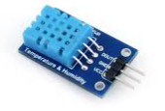

Figure 5 DHT 11 sensor for temperature and humidity sensing

* **Firebase Database**: Firebase is used for real-time data storage and synchronization. It stores sensor data and provides a platform for the web interface to interact with the system. Realtime database of firebase is used,
* **Water Pump**: A 12V DC water pump is controlled remotely via a relay connected to the ESP
* 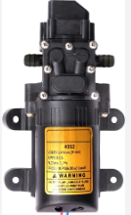

Figure 6 12 V water pump used for the agriculture

**3.2 Energy-Efficient Communication Protocol**

To ensure the system operates efficiently, an energy-efficient communication protocol is used. The ESP-32 uses Wi-Fi for communication with Firebase, which is considered an energy-efficient option for short-range communication. Additionally, the system incorporates sleep modes to minimize power consumption when the system is idle.

### Algorithm used for the ESP controller

This code is for an ESP8266 microcontroller that connects to a Wi-Fi network and sends data to a Firebase real-time database. It begins by including necessary libraries for Wi-Fi, Firebase, and time functions. The Wi-Fi credentials and Firebase project details, such as the database URL and authentication key, are defined. In the `setup()` function, the ESP8266 connects to the Wi-Fi and initializes Firebase, printing a confirmation message once connected. It also sets up time synchronization using an NTP server to add a timestamp to the data. The `loop()` function runs continuously and simulates temperature and humidity readings. These readings, along with a moisture value and a timestamp, are formatted into a JSON object. The data is then sent to Firebase at the path `/sensorData/`. If successful, a message is printed to the serial monitor; otherwise, an error message shows why it failed. The `loop()` pauses for 5 seconds before repeating, allowing data to be sent at regular intervals. This code is useful for smart agriculture applications, where real-time monitoring and remote data management are essential.

**3.3 Web Interface Development**

A web interface is developed to allow users to monitor and control the water pump remotely. The interface is hosted on Firebase, enabling real-time updates. It provides the user with the current moisture levels, water pump status, and control buttons for turning the pump on or off.

**3.4 Database Design**

The Firebase real-time database is structured to store:

* **Sensor Data**: Soil moisture readings and other environmental parameters.
* **Pump Status**: The status (on/off) of the water pump.

**4. Implementation**

**4.1 Hardware Setup**

* **ESP**: The ESP is connected to the soil moisture sensor and DHT 11 sensor and a relay module. The relay controls the water pump, and the sensor measures the soil moisture levels.
* **Water Pump**: A 12V DC water pump is used to irrigate the soil when activated by the relay. The pump is connected to the relay, which is controlled by the ESP-32.
* **Power Supply**: A 12V DC power supply is used to power the water pump and the ESP-32.

**4.2 Software Development**

The software is written in Arduino IDE for the ESP-32, and it includes:

* **Sensor Data Collection**: The soil moisture data is collected periodically and sent to Firebase.
* **Pump Control**: Based on the moisture levels, the system determines if the water pump should be turned on or off. The pump can also be manually controlled via the web interface.
* **Web Interface**: The web interface is developed using HTML, CSS, and JavaScript. It is hosted on Firebase Hosting and provides a user-friendly interface for real-time monitoring and control.

**5. Results and Discussion**

**5.1 System Functionality**

The system was successfully implemented with the ESP-32 microcontroller, Firebase, and the water pump. The system performs as expected, with the following features:

* **Real-Time Monitoring**: The web interface provides live updates of the soil moisture levels and pump status.
* **Remote Control**: Users can turn the water pump on and off remotely via the web interface.
* **Energy Efficiency**: The system minimizes power consumption by utilizing the ESP-32’s low-power features, such as sleep modes.

**Webpage is shown in the figure below**

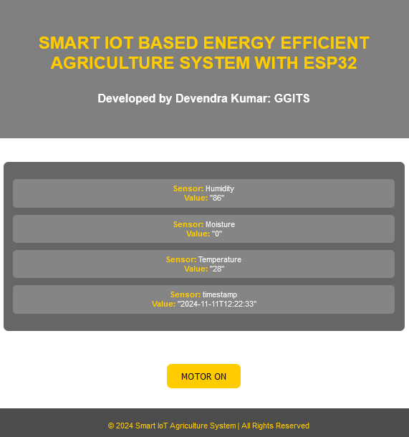

Figure 7 Front end of the proposed model

Live data update and webpage running on a domain is shown below.

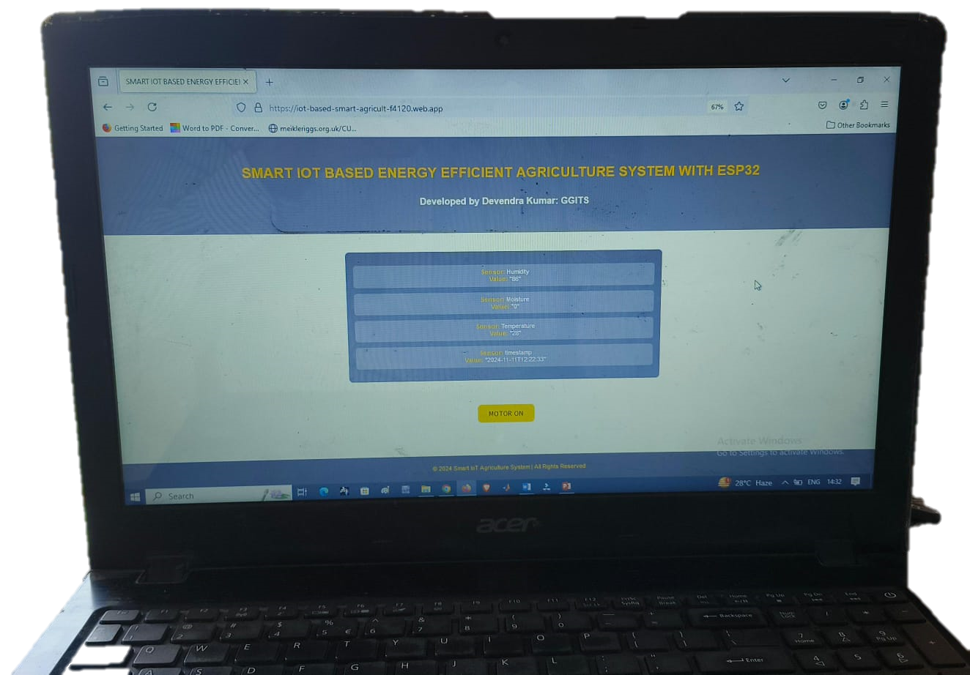

Figure 8 PC running proposed model

## Backend of the proposed model

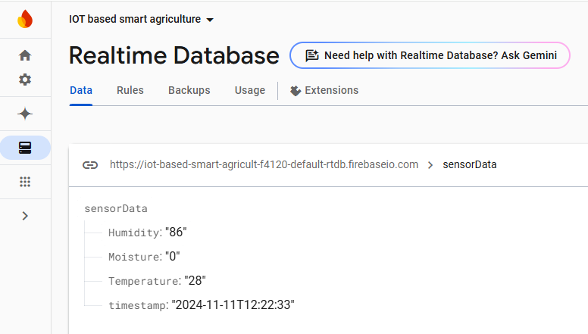

**5.2 Performance Evaluation**

The system was tested under various environmental conditions, and the following performance metrics were evaluated:

* **Accuracy of Sensor Readings**: The soil moisture sensor provided accurate readings, with minimal deviation from expected values.
* **Pump Control Response**: The water pump responded promptly to the control commands sent via the web interface.
* **Energy Consumption**: The energy consumption of the system was significantly reduced compared to traditional systems, thanks to the use of low-power communication protocols and sleep modes in the.

**5.3 Challenges**

Some challenges faced during implementation included ensuring stable Wi-Fi connectivity for real-time data transmission and managing the power consumption of the ESP-32 during long periods of idle time.

**6. Conclusion**

This research demonstrated the feasibility of using the ESP-32 microcontroller and Firebase to create an energy-efficient IoT system for managing agricultural water pumps. The system successfully provides remote monitoring and control via a web interface, helping farmers manage irrigation more efficiently. The energy-efficient design helps reduce the environmental impact of irrigation systems, contributing to the sustainability of agriculture. Future work could explore integrating additional sensors, such as temperature and humidity sensors, to further optimize irrigation and expand the system’s capabilities for precision agriculture.

# References

1. F Schierhorn, M. Elferink, Global Demand for Food Is Rising. Harv Bus Rev, 2016, 7 (2017). https://hbr.org/2016/04/global-demand-forfood-is-rising-can-we-meet-it

2. Singh, G. Machine Learning Models in Stock Market Prediction. International Journal of Innovative Technology and Exploring Engineering, 2022, vol. 11, no. 3, pp. 18-28. <https://doi.org/10.35940/ijitee.C9733.0111322>

3. WK Mok, YX Tan, WN. Chen, Technology innovations for food security in Singapore: A case study of future food systems for an increasingly natural resource-scarce world, Trends Food Sci Technol, 2020, vol. 102, pp. 155–168,

<https://doi.org/10.1016/j.tifs.2020.06.013>

4. Nagar, P., & Issar, G. S. Detection of outliers in stock market using regression analysis. International Journal of Emerging Technologies in Computational and Applied Science, 2013. https://doi.org/10.5281/zenodo.6047417

5. R Abbasi, P Martinez, R. Ahmad, An ontology model to represent aquaponics 4.0 system’s knowledge, Inf Process Agric, 2021. <https://doi.org/10.1016/J>. INPA.2021.12.001

6. R Abbasi, P Martinez, R. Ahmad, An ontology model to support the automated design of aquaponic grow beds, Procedia CIRP, 2021, vol. 100, pp. 55–60,

<https://doi.org/10.1016/j.procir.2021.05.009>

7. G Aceto, V Persico, A. Pescapé, A Survey on Information and Communication Tech- nologies for Industry 4.0: State-of-the-Art, Taxonomies, Perspectives, and Challenges, IEEE Commun Surv Tutorials, 2019. <https://doi.org/10.1109/COMST.2019.2938259>

8. B. Ozdogan, A. Gacar, H. Aktas. Digital agriculture practices in the context of agriculture 4.0. Journal of Economics, Finance and Accounting (JEFA), 2017, vol. 4, iss. 2, pp. 184-191. <https://doi.org/10.17261/pressacademia.2017.448>

9. Y Liu, X Ma, L Shu, GP Hancke, AM. Abu-Mahfouz, From Industry 4.0 to Agriculture 4.0: Current Status, Enabling Technologies, and Research Challenges, IEEE Trans Ind Informatics, 2021, vol. 17, no. 6, pp. 4322-4334. <https://doi>. org/10.1109/TII.2020.3003910

10. F da Silveira, FH Lermen, FG. Amaral, An overview of agriculture 4.0 development: Systematic review of descriptions, technologies, barriers, advantages, and disadvantages, Comput Electron Agric 189 (2021) 106405, <https://doi.org/10.1016/J.COMPAG.2021.106405>

11. . G Idoje, T Dagiuklas, M. Iqbal, Survey for smart farming technologies: Challenges and issues, Comput Electr Eng, 2021, vol. 92, 107104. <https://doi.org/10.1016/J.COMPELECENG.2021.107104>

12. J Miranda, P Ponce, A Molina, P. Wright, Sensing, smart and sustain- able technologies for Agri-Food 4.0, Comput Ind, 2019, vol. 108, pp. 21–36. <https://doi.org/10.1016/J.COMPIND.2019.02.002>

13. M Lezoche, H Panetto, J Kacprzyk, JE Hernandez, Alemany Díaz MME.Agri-food 4.0: A survey of the supply chains and technologies for the future agriculture, Comput Ind, 2020, vol. 117, 103187. <https://doi.org/10.1016/J.COMPIND.2020.103187>

14. Bhakta I, Phadikar S, Majumder K. State-of-the-art technologies in precision agriculture: a systematic review. Journal of the Science of Food and Agriculture,2019, vol. 99, no. 11. pp. 4878-4888. <https://doi.org/10.1002/jsfa.9693>

15. SO Araújo, RS Peres, J Barata, F Lidon, JC. Ramalho, Characterising the Agriculture 4.0 Landscape — Emerging Trends, Challenges and Opportunities, Agron, 2021, vol. 11, no. 4, 667. <https://doi.org/10.3390/AGRONOMY11040667>

16. M Bacco, P Barsocchi, E Ferro, A Gotta, M. Ruggeri, The Digitisation of Agriculture: a Survey of Research Activities on Smart Farming, Array, 2019, 3–4,100009. <https://doi.org/10.1016/j.array.2019.100009>