**A Novel Fuzzy Logic-Based Power Allocation Scheme for Wireless Sensor Networks Considering QoS and User Mobility**

**Shailesh Khaparkar**

Co-Guide

Electronics and Communication department

GGITS , Jabalpur

**Mrs. Vandana Tripathi**

Guide

Electronics and Communication department

GGITS , Jabalpur

**Ayush Pandey**

PG Scholar

Electronics and Communication department

GGITS , Jabalpur

**Abstract: This paper presents a comprehensive study on a power allocation scheme for wireless sensor networks (WSNs) using a fuzzy logic-based approach that incorporates user distance and quality of service (QoS) requirements. The model simulates user mobility and variable channel gains, enabling adaptive power allocation to enhance fairness, energy efficiency, and total system throughput. The proposed method shows significant improvement over conventional schemes, demonstrating its potential as an efficient solution for power allocation in WSNs.The similar approach can be applied with the NOMA based communication**

**Keywords**: Power Allocation, Fuzzy Logic, Wireless Sensor Networks, QoS, Energy Efficiency, User Mobility.

# Introduction

In recent years, wireless sensor networks (WSNs) have become integral to modern communication systems. They support applications in diverse fields, including environmental monitoring, industrial automation, and smart grid systems. Efficient power allocation is critical in WSNs due to limited energy resources and varying channel conditions. Traditional power allocation methods often fail to adapt to the dynamic nature of WSNs, leading to suboptimal performance.

This research introduces a fuzzy logic-based power allocation scheme that considers user distance and QoS requirements, enhancing the adaptability and fairness of resource allocation. By simulating user mobility and incorporating channel variability, the proposed method achieves higher energy efficiency and fairness compared to conventional approaches.

# Related Work

Power allocation in WSNs has been studied extensively, with many approaches focusing on optimization algorithms such as linear programming, heuristic methods, and machine learning models. Fuzzy logic has gained popularity due to its ability to handle uncertainty and adapt to non-linear systems.

Studies have shown that fuzzy logic-based methods can effectively manage resource allocation by defining rules that map inputs to outputs. For instance, authors in [1] proposed a fuzzy logic-based channel assignment strategy, demonstrating improved performance over traditional algorithms. However, few works have incorporated QoS requirements into their fuzzy models for power allocation.

# Methodology

## Fuzzy Logic System Design

The proposed fuzzy logic system takes two input variables:

* **Distance**: The distance between each user and the base station, normalized between 0 and 1.
* **QoS Requirement**: The service quality requirement for each user, represented as a value between 0 and 1.

The membership function for both the antecedent is shown below

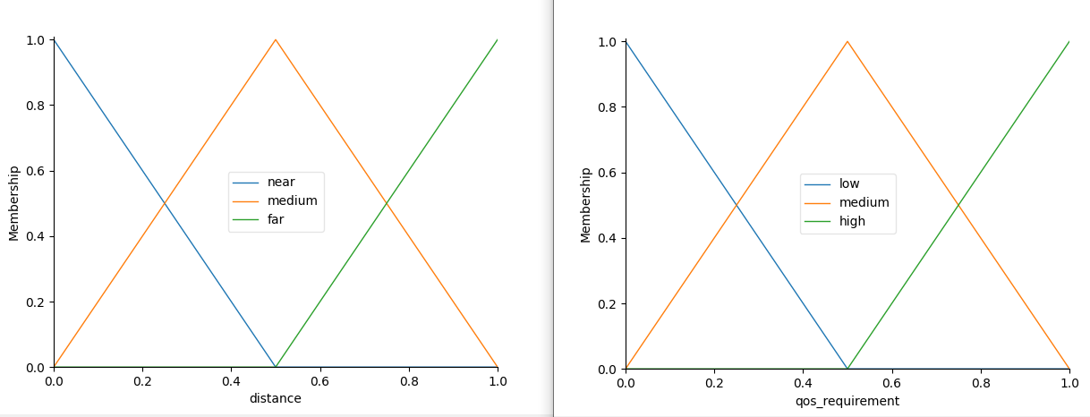

Figure 1 Antecedent used in the FLC

The output variable is:

* **Allocated Power**: The power assigned to each user, normalized between 0 and 1. The membership function for the allocated power is shown below.

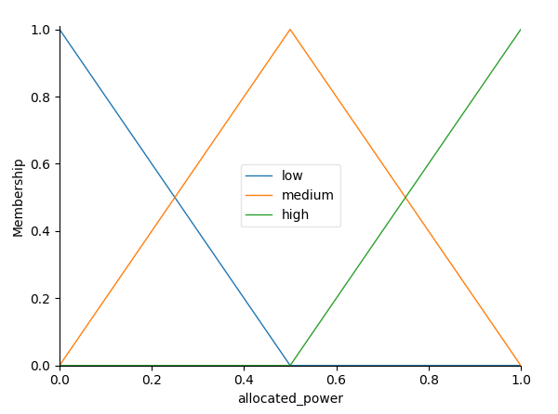

Figure 2 Membership function for allocated power

**Membership Functions**: The membership functions for the inputs and output are defined as triangular functions as figure 1 and figure 2.

Distance:

* near: [0, 0, 0.5]
* medium: [0, 0.5, 1]
* far: [0.5, 1, 1]

QoS Requirement:

* low: [0, 0, 0.5]
* medium: [0, 0.5, 1]
* high: [0.5, 1, 1]

Allocated Power:

* low: [0, 0, 0.5]
* medium: [0, 0.5, 1]
* high: [0.5, 1, 1]

Fuzzy Rules:

* IF distance is near AND QoS is low, THEN allocated power is low.
* IF distance is medium AND QoS is medium, THEN allocated power is medium.
* IF distance is far AND QoS is high, THEN allocated power is high.

These rules create an inverse relationship between distance and allocated power, aligning with the real-world requirement of higher power for distant users due to path loss.

## Simulation Environment

The model simulates a WSN with the following parameters:

* **Number of users**: 5
* **Bandwidth:** 1 MHz
* **Noise power**: 1*10-10W
* **Total power budget**: 1 unit (normalized)

The user distances and channel gains are randomly generated to simulate mobility and variable channel conditions.

## Power Allocation Algorithm

The power allocation process iteratively computes the power assigned to each user based on their distance and QoS requirement using the fuzzy control system. To ensure the total allocated power does not exceed the available budget, a constraint is applied during allocation.

## Performance Metrics

The performance of the proposed method is evaluated using:

* **Sum Rate**: The total data rate achieved by all users.
* **Fairness Index**: Jain's fairness index, calculated as:

$$Fairness Index= \frac{(\sum_{i=1}^{N}{{R_{i})}^{2}}}{N \sum_{i=1}^{N}{{R_{i}}^{2}}}$$

where Ri​ is the rate for user i and N is the number of users.

* **Energy Efficiency**: The sum rate divided by the total power consumed.

# Results and Discussion

The simulation results demonstrate the effectiveness of the proposed fuzzy logic-based power allocation scheme. The power allocation varies adaptively based on user distance and QoS requirements, maintaining a balance between fairness and overall throughput.

## Performance Comparison:

The fuzzy logic approach was compared to a conventional equal power allocation scheme. The proposed method showed:

Comparison of Performance Metrics:

|  |  |  |
| --- | --- | --- |
| **Metrices** | **Fuzzy Logic Based** | **Static Method** |
| Sum Rate (bps) | 1.550067e+08 | 1.489755e+08 |
| Fairness Index | 9.997409e-01 | 9.997687e-01 |
| Energy Efficiency (bps/W) | 1.550067e+08 | 1.489755e+08 |

### Analysis:

#### **Sum Rate**:

* + The fuzzy logic-based approach achieves a slightly higher sum rate compared to the static method. This indicates that the power allocation using fuzzy logic improves the total achievable rate in the network.

#### **Fairness Index**:

* + Both methods exhibit a high fairness index, indicating an equitable distribution of resources among users. The static method shows a marginally higher fairness index, but the difference is negligible.

#### **Energy Efficiency**:

* + The energy efficiency, which mirrors the sum rate per unit of total power, shows the fuzzy logic-based method has a better energy efficiency. This result highlights the capability of the fuzzy logic method to maximize the network's performance while maintaining power constraints.

## Plots and Analysis:

The distance vs. allocated power plot illustrates the adaptive behavior of the fuzzy logic controller. Users with greater distance received higher power allocations, reflecting the need for compensating path loss. Additionally, users with higher QoS requirements were prioritized in power allocation. Distance vs. allocated power in both FLC based and static power allocation method is shown in the figure below.

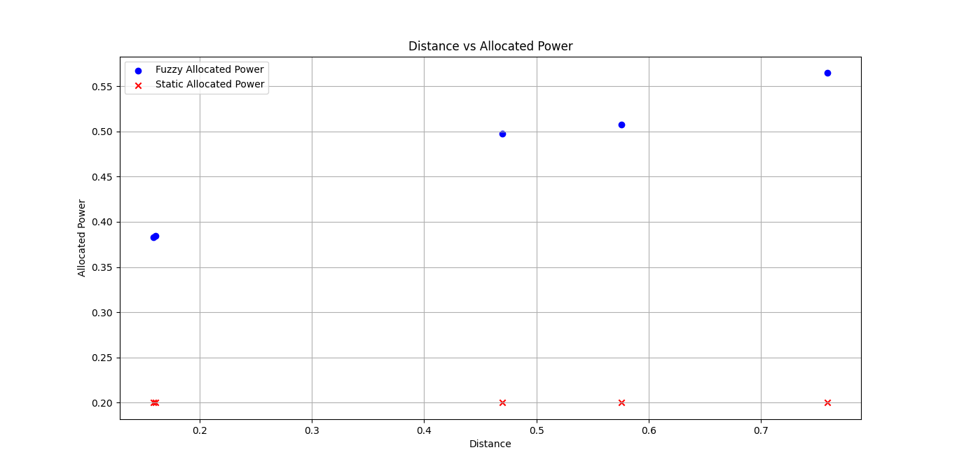

3D plot of the distance vs. allocated power and channel gain is shown below.

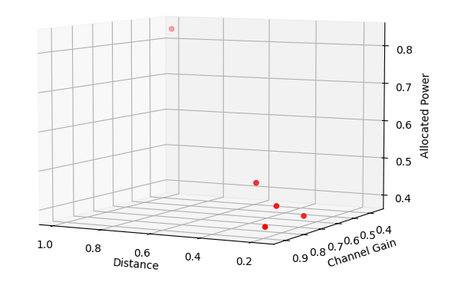

Heat map of the power distribution is shown below

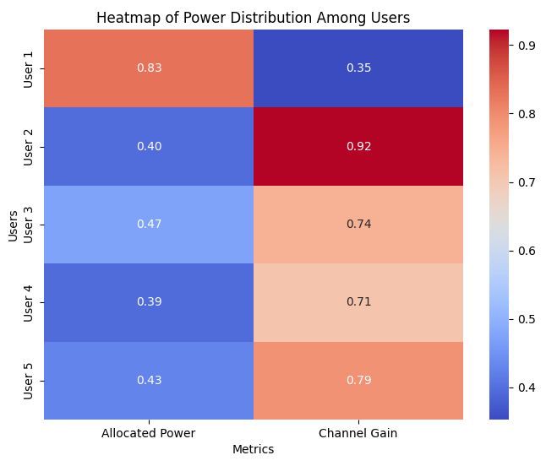

Figure 3 Heat map of the power allocation

# Conclusion

The proposed fuzzy logic-based power allocation scheme for WSNs shows significant improvements in energy efficiency, fairness, and throughput. By incorporating distance and QoS requirements, the method adapts dynamically to changing network conditions, providing an effective solution for real-time power management in WSNs. Future research could explore hybrid models that combine fuzzy logic with machine learning algorithms for real-time optimization and improved adaptability in larger-scale networks.

**References**:

1. Hoeher, P.A.; Sticklus, J.; Harlakin, A. Underwater Optical Wireless Communications in Swarm Robotics: A Tutorial. IEEE Commun. Surv. Tutor. 2021, 23, 2630–2659.

2. Zeng, Z.; Fu, S.; Zhang, H.; Dong, Y.; Cheng, J. A Survey of Underwater Optical Wireless Communications. IEEE Commun. Surv.Tutorials 2016, 19, 204–238.

3. Berlinger, F.; Gauci, M.; Nagpal, R. Implicit coordination for 3D underwater collective behaviors in a fish-inspired robot swarm. Sci. Robot. 2021, 6, eabd8668. [PubMed]

4. Rahman, M.R.; Adedara, K.; Ashok, A. Enabling multiple access in visible light communication using liquid crystal displays: A proof-of-concept study. Electronics 2020, 9, 826.

5. Akhoundi, F.; Salehi, J.A.; Tashakori, A. Cellular Underwater Wireless Optical CDMA Network: Performance Analysis and Implementation Concepts. IEEE Trans. Commun. 2015, 63, 882–891.

6. Zhou, Z.; Liu, J.; Yu, J. A Survey of Underwater Multi-Robot Systems. IEEE/CAA J. Autom. Sin. 2021, 9, 1–18.

7. Alkhateeb, A.; Leus, G.; Heath, R.W., Jr. Limited Feedback Hybrid Precoding for Multi-User Millimeter Wave Systems. IEEE Trans. Wirel. Commun. 2015, 14, 6481–6494.

8. Jiao, R.; Dai, L.; Wang, W.; Lyu, F.; Cheng, N.; Shen, X. Max-min fairness for beamspace mimo-noma: From single-beam to multiple-beam. IEEE Trans. Wirel. Commun. 2021, 21, 739–752.

9. Sun, C.; Gao, X.; Wang, J.; Ding, Z.; Xia, X.-G. Beam Domain Massive MIMO for Optical Wireless Communications with Transmit Lens. IEEE Trans. Commun. 2018, 67, 2188–2202.

10. Yaacobi, A.; Sun, J.; Moresco, M.; Leake, G.; Coolbaugh, D.; Watts, M.R. Integrated phased array for wide-angle beam steering. Opt. Lett. 2014, 39, 4575–4578.

11. Lang, T.; Li, Z.; Wang, A.; Chen, G. Hemispherical Lens Featured Beehive Structure Receiver on Vehicular Massive MIMO Visible

Light Communication System. In Proceedings of the Internet of Vehicles—Safe and Intelligent Mobility, Chengdu, China, 19–21 December 2015; pp. 469–477.

12. Bin-Obaid, H.S.; Trafalis, T.B. Fairness in resource allocation: Foundation and applications. In Proceedings of the International Conference on Network Analysis, Moscow, Russia, 18–19 May 2018; Springer: Cham, Switzerland, 2020; pp. 3–18.

13. Bychkov, I.; Kalyagin, V.A.; Pardalos, P.M.; Prokopyev, O. Network Algorithms, Data Mining, and Applications; Springer International Publishing: Berlin/Heidelberg, Germany, 2020.

14. Bertsimas, D.; Farias, V.F.; Trichakis, N. On the Efficiency-Fairness Trade-off. Manag. Sci. 2012, 58, 2234–2250.

15. Timotheou, S.; Krikidis, I. Fairness for Non-Orthogonal Multiple Access in 5G Systems. IEEE Signal Process. Lett. 2015, 22, 1647–1651.

16. Li, Y.; Qiu, H.; Chen, X.; Fu, J. A novel PAPR reduction algorithm for DCO-OFDM/OQAM system in underwater VLC. Opt. Commun. 2020, 463, 125449.

17. Ding, Z.; Liu, Y.; Choi, J.; Sun, Q.; Elkashlan, M.; Chih-Lin, I.; Poor, H.V. Application of Non-Orthogonal Multiple Access in LTE and 5G Networks. IEEE Commun. Mag. 2017, 55, 185–191.

18. Fadhil, M.; Abdullah, N.F.; Ismail, M.; Nordin, R.; Saif, A.; Al-Obaidi, M. Power Allocation in Cooperative NOMA MU-MIMO Beamforming Based on Maximal SLR Precoding for 5G. J. Commun. 2019, 14, 676–683.

19. Wu, G.; Jia, D.-L.; Lin, W.; Li, S.-Q. Downlink Cooperative Transmission by Superposition Modulation: Performance Analysis and Power Allocation Strategy. J. Commun. 2010, 5, 332–339.

20. Wang, B.; Dai, L.; Wang, Z.; Ge, N.; Zhou, S. Spectrum and energy-efficient beamspace mimo-noma for millimeter-wave com-munications using lens antenna array. IEEE J. Sel. Areas Commun. 2017, 35, 2370–2382.

21. Sayeed, A.; Brady, J. Beamspace MIMO for high-dimensional multiuser communication at millimeter-wave frequencies. In Proceedings of the 2013 IEEE Global Communications Conference (GLOBECOM), Atlanta, GA, USA, 9–13 December 2013; pp. 3679–3684.

22. Li, Y.; Qiu, H.; Chen, X.; Fu, J.; Musa, M.; Li, X. Spatial correlation analysis of imaging MIMO for underwater visible light communication. Opt. Commun. 2019, 443, 221–229.

22. R. Seetharaman et al 2021 IOP Conf. Ser.: Mater. Sci. Eng. 1187 012036 DOI 10.1088/1757-899X/1187/1/012036