Enhancing Cybersecurity in Industry 4.0: A Machine Learning-Based Approach for Robust Threat Detection and prevention

T. Chandrasekhar, Mr. Ch. Viswanathasarma

**Abstract:**

As Industry 4.0 transforms manufacturing with interconnected CPPS, a growing need to integrate more advanced machine-learning techniques into existing cybersecurity frameworks has been realized. In this respect, the growing reliance upon real-time data transfer and networked devices of industrial environments intrinsically presents severe vulnerabilities to cyber-attacks that traditional security measures are not designed too effectively counter. The paper focuses on the exploitation of different machine learning algorithms such as Decision Trees, Random Forests, SVMs, and Naive Bayes in detection and prevention against cyber threats within Industry 4.0 ecosystems. This detection gets enhanced with sophisticated attack detection capabilities through traffic pattern analysis and anomaly detection. Experimental tests within an industrial network prove these machine learning models make threat detection much more accurate and faster, hence drastically reducing unauthorized access and unwanted disturbance. The results tell clearly of the potential of machine learning to secure not just better security measures but also enable secure and scalable adoption of Industry 4.0 technologies.

**Keywords:** *Industry 4.0, Cybersecurity, Machine Learning, Cyber-Physical Production Systems (CPPS), Supervisory Control and Data Acquisition (SCADA), Threat Detection, Random Forest, Support Vector Machines, Naive Bayes, Industrial Control Systems.*

**1.Introduction:**

In the age of Industry 4.0, industrial operations are being transformed by the combination of Cyber Physical Systems (CPS), Industrial Internet of Things (IoT), and real-time data processing. This network provides the boost to efficiency and automation but also presents significant cybersecurity challenges. The concentration of interconnected devices in Industry 4.0 ecosystems and the reliance on real-time communication fraught with risk. These attacks pose a major threat to critical infrastructure, as conventional security measures struggle to cope with the complex evolution of cyber threats. What is urgently needed is a set of cybersecurity frameworks that can meet these challenges and keep industrial networks protected.

This article solves these problems by coming up with an elected machine learning-based approach to the question of threat detection and prevention in Industry 4.0: machine learning deployment including Decision Trees, Random Forests, Support Vector Machines (SVMs), and Naive Bayes. The proposed framework makes up for its lack of historical effectiveness in real-time pattern analysis on traffic data streams by using these algorithms to increase cyber-attack detection and realize of anomalies. Both scalability and pinpoint threat detection are characteristics that these models are able to fulfil in the complex environment of data-intensive Industry 4.0.

For example, the adaptability of these machine-learning models means that they are continuously learning from new data translating into a robust and nimble solution for evolving cyber threats. building on research of previous years, this paper is the first to study a machine-learning-based approach to cybersecurity in the industry 4.0 Scenario. With this new framework, we can not only detect threats more accurately but ensure that our capabilities keep pace with the growth of industrial systems. Having undergone experimentation in industrial environments, the new model is considered capable of significantly increasing the proportion of threats that can be detected accurately. This is a path to make the achievable, it navigates Industry 4.0 technologies through periods of secure growth.

**2.Pervious Works:**

This approach would integrate a multilayered cybersecurity framework with existing SCADA systems in the CPPS environment. This would include network segmentation, machine learning-based anomaly detection, and secure communication protocols. In this proposed resiliency deployment strategy, real-time cyber threat detection is deployed for CPPS toward mitigation of the risks associated with failure of systems.[1].

This work thus explored the integration of machine learning into a novel network-based cyber-attack detection approach under Industry 4.0 and exploits weaknesses in traditional security methods. Several algorithms, such as Decision Trees, Random Forests, KNN, and SVM, were considered and compared with each other based on their accuracy, precision, recall, and F1 score values. This indicates the potential of using machine learning to enhance the cybersecurity of industrial systems and suggests its recommendation to use in advanced industrial threat detection systems of Industry 4.0 environments [2].

It talked about the role of machine learning in cyber security, particularly in malware detection, with deep learning, SVMs, and Bayesian classification approaches. Several key datasets that have been used to evaluate some models include Bot-IoT and UNSW-NB15. In order to address the fact that threats evolve over time and would demand more sophisticated reactions, it should be underlined that the approach should lie on adaptive models with even improved datasets. From its discussion, it also went beyond cryptography and how it impacts processes like machine learning in ensuring cyber security, advocating for continued innovation to make resilience better in cybersecurity [3].

Application of machine learning algorithms for the detection of cybersecurity threats is applied against the IoT environment. The approach followed would include large datasets preprocessing, feature extraction, and training SVM and neural network models to classify potential security threats; the performance evaluation goes through accuracy, precision, recall, and F1-score [4].

A paper develops a complementary cyber human systems framework by integrating machine learning with improvement to the horizon for added security in industrial systems. Sensor data analysis and human-in-the-loop decision-making through continuous threat monitoring in the form of a feedback loop provide for prompt action against cyber-attacks [5].

The methodology was based on the qualitative analysis toward building a base to place early detection and response strategies within Industry 4.0-based manufacturing systems as being machine learning-based with predictive analytics and situational awareness approaches on proactive mitigation of threats [6].

Give the list of cybersecurity threats in CI for Industry 4.0, focusing on the effectiveness of machine learning technique data mining and anomaly detection to detect threats. Discuss Behavioural analysis based on Bayesian models and SVMs for malware detection. The gap the paper has briefed about is the accounting for the motive of attackers in the survey, and it shows how motivational factors need to be integrated into technical methods of detection. It also speaks about the challenges by Industry 4.0 and calls for proactive strategies to uplift CI cybersecurity resilience [7].

This study tests a few cybersecurity datasets with various machine and deep learning models, namely SVM and CNN, to analyse the different effects in identifying different types of cyber-attacks. The method relies on feature extraction and model training of labelled and unlabelled data; therefore, the evaluation is based on accuracy and time detected [8].

This gives a multi-layered security framework, designed specifically for SCADA of Industry 4.0 environments with security-on and system-level defences by firewalls as well as encryption and machine learning analysis of industrial networks are examined to find occurrences of abnormal traffic patterns [9].

The work on investigating vulnerabilities brought about by CPPS to cyber-physical and industrial threats in SCADA systems in Industry 4.0 is taken forward. There is much higher intensity in IT-OT integration, which opens up attack paths into legacy SCADA environments at a time when more of them are not maintaining even the most basic of security measures. This call is proposed to be addressed by a proactive multi-layered defence approach at granular access controls, micro-segmentation, anomaly detection, and encryption. The work demonstrates definite and substantial security improvements, emphasizing the need for robust frameworks to protect SCADA systems in Industry 4.0 environments [10].

This study integrates AI-based models of machine learning into smart industry applications related to cybersecurity. Real-time data streams are bridged with decision trees and deep learning methods in order to make predictive and preventive measures for cybersecurity breaches. The approach is tested on an IoT-enabled smart factory environment [11].

ML in manufacturing: Key reviews that synthesize the advances and frameworks of ML apps focusing improvements for modern manufacturing, relevant theoretical models such as the interpretive model of manufacturing, and application as predictive maintenance and process optimization-demonstrate that ML bound to take efficiency to the next notch. Critical research directions pertaining to integrating ML into manufacturing are identified [12].

 AI and ML to mitigate the cyber risks resulting from Industry 4.0. Important points include the digital advancement of these technologies toward advanced data management and threats detection. The paper has also touched the cyber risks like malware and ransomware along with some practical applications of ML, such as power sector attacks countering. Underlining the importance of data sharing for the accomplishment of effective AI solutions, the paper outlines future opportunities for the expansion of ML in different industries, such as healthcare and automation [13].

Generally speaking, ICSs used to work behind isolated walls, while the tremendous expansion of IoT and internet protocols opens ICSs to cyber-attacks in the first place. Limitations on traditional IDS include its signature-based methodologies that fail against new attacks. These approaches-by recent reinforcement learning and deep learning approaches, for instance, LSTMs-are able to address these limitations; however, imbalanced datasets and system-specific models create gaps that affect detection. The proposed deep learning model provides improved generalization across diverse ICS environments with minimal integration effort toward attack detection [14].

The study outlines a methodology that examines current machine learning applications in cybersecurity, evaluates framework architectures, and identifies gaps in data security management within industrial networks [15].

**3.Methodology:**

**3.1 Frame work:**

The proposed framework uses Decision Tree, Multilayer Perceptron, and Autoencoder in the intrusion detection of Industry 4.0 WSN's. All these models were given specific roles to deter any type of attack. The proposed methodology uses AI detection in the classification of intrusion detection from diverse types that have been identified to include Blackhole, Gray hole, Flooding, and Scheduling attacks. The proposed models can be able to classify tasks in both multidimensional and binary types.

**3.2 Data collection and preprocessing:**

The dataset used in the research is WSN-DS Dataset where it simulates the various Denial-of-service (DoS) attacks on WSN’s using LEACH protocol. The dataset also explains about Blackhole attack, gray hole attack, Flooding attack, Scheduling attacks

1. Data Sources: These include sensor networks and network traffic records. The nature of traffic records is such that both alive and historical information is implicated. The kinds of dataset involved in this record are text, numerical measurement data, and categorical variables.
2. Preprocessing: it encompasses data preprocessing so that the integrity of data is preserved since it has to do with cleaning up, normalization, and outlier treatment. Data preprocessing, in turn, involves feature engineering based on missing values, low dimensionality of the data, and better efficiency of the model.

The model training uses labelled data in building its ability to find the patterns of cyber-security intrusion detection through a supervised learning method.

**3.3 Model Implementation:**

1. **Decision Tree:** It is a model of an approach that uses the majority of intrusion categories within WSNs. It produces decisions based on the conditions in a data set.
2. **Multilayer Perceptron (MLP):** That is an advanced approach of neural networks capable of modelling the complex patterns inside structured and unstructured data which might help in the discovery of multiple attack cases.
3. **Autoencoder (AE):** One type of unsupervised model, particularly useful for the task of binary classification and anomaly detection that do not behave as they should according to the model.

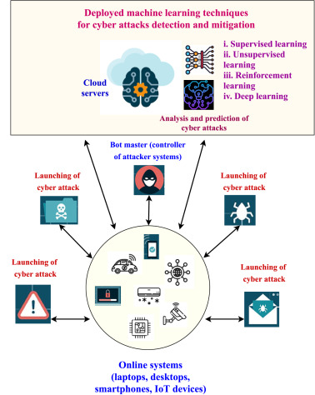

Fig 1: ML Techniques for Cyber Attack Detection & Mitigation

**3.4 Category of Attacks and detection:**

The models are supposed to indicate four major categories of attacks.

1. **Blackhole Attacks:** The malicious nodes in the network drop packets, thereby causing data loss.
2. **Gray Hole Attacks:** Gray hole attack is the selective packet dropping, which prevents data flow through a network.
3. **Flooding Attacks:** Flooding attacks send enormous volumes of traffic that flood the network, thus stopping networks from performing according.
4. **Scheduled Attacks:** They include timing and scheduling in WSNs, which results in the failure of a network.

**3.5 Training and Testing of Model:**

Training and Validation: The entire data is divided into 80% for training and remaining 20% for testing purposes. Here, Autoencoder is an unsupervised model; therefore, an independent validation approach had been followed. However, while this was implemented with the cases of supervised models like the Decision Tree and MLP, cross-validation had been followed.

The key metrics used in measuring the performance of these models are Accuracy, Precision, Recall, F1score.

1. Accuracy: Ratio of correctly classified samples of all samples.

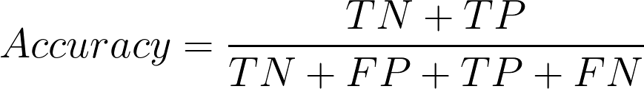

1. 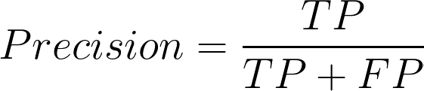Precision: the percentage of correct positive predictions out of the actual number of predicted positives, describes how the model can suppress false positives.
2. Recall: the percentage of positive predictions of the total to be actual positive, illustrating how good a model is at locating the positive samples.



1. 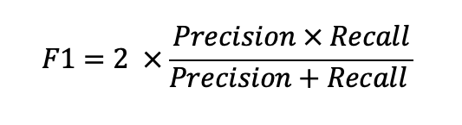F1-Score: it describes the harmonic mean of both precision and recall. Even if class imbalance occurs, the F1 score is balanced.

**3.6 Keen Prioritization and Prevention:**

The system ranks threats by their respective risks; and greater risky intrusions should have a high priority in the industry 4.0 settings for mitigation.

This is the point at which the system carries out customized responses with the type of attack; for instance, path verifications in the case of Blackhole attacks or repair concerning time synchronizations due to Scheduling attacks.

**3.7 Test and Output:**

Compare how close these models of random forests and logistic regression algorithms are towards the ones already mentioned. The model was compared with benchmarking algorithms checking how close these models of random forests are to the already mentioned ones. The MLP came up with accuracy at 99.52%. Decision Tree obtained 99.48%. Autoencoder stood at 91%.

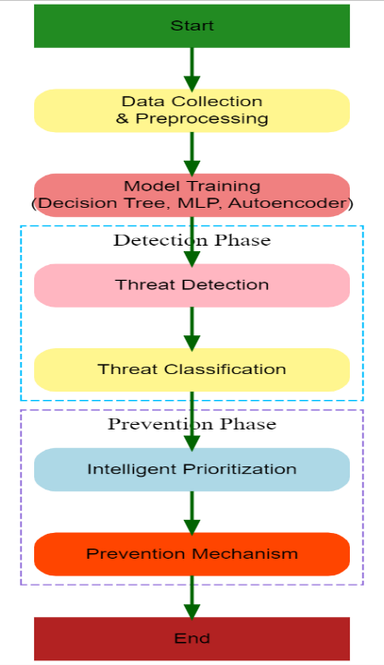

Fig.2: flow chart

**Benchmark Models:**

Implements Random Forest & Logistic Regression as benchmark models to compare the performance against the proposed models. The comparison helps in validating the effectiveness of DT, MLP, Autoencoder, in detecting the cyber security intrusions.

**Results:**

Decision Tree Model: Achieved an accuracy of 99.48%, with precision and recall rates also around 99.49%.

MLP Model: Slightly outperformed the Decision Tree with an accuracy of 99.52%, maintaining high precision and recall.

Autoencoder Model: Provided a lower accuracy of 91% but balanced precision and recall effectively for binary classification.

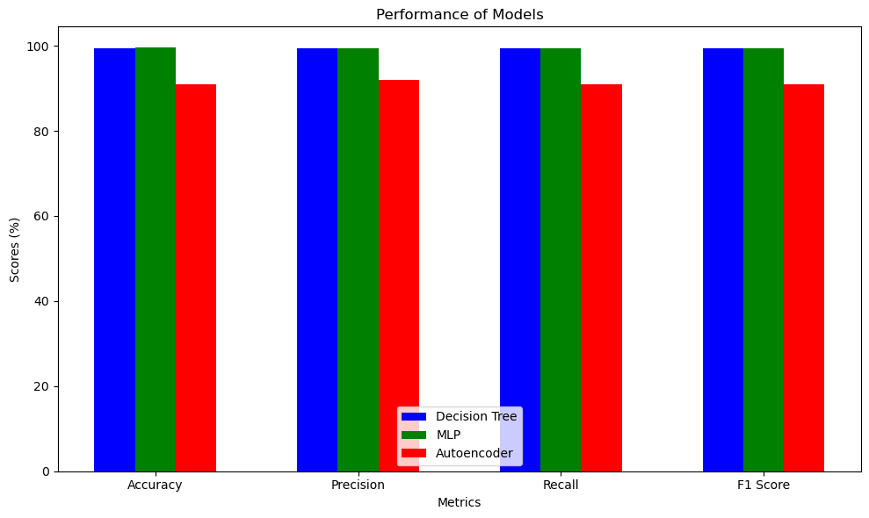

Fig.3: Model Performance Comparison

**Comparison with Benchmark Models:** The proposed models significantly outperformed the benchmark models, indicating the effectiveness of the multi-criteria approach in enhancing cybersecurity in Industry 4.0.

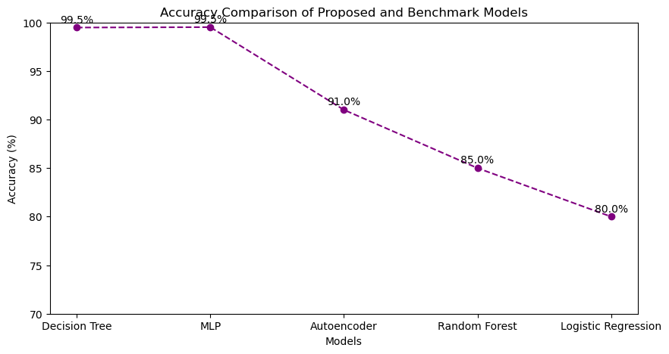

Fig.4: Accuracy Comparison of proposed and Benchmark Models

**Comparision and Discussion:**

|  |  |  |  |  |
| --- | --- | --- | --- | --- |
| **Ref No** | **Objectives** | **Limitations** | **Advantages** | **Gaps** |
| **[1]** | Suggest a multi-layered SCADA system cybersecurity framework for CPPS within the Industry 4.0 with a focus on resilience | Limited focus on real-time implementation in  various Industry 4.0. | Comprehensive framework with layered security which heightens protection of   SCADA systems is designed. | It has limited scalability across the diverse architectures of CPPS. |
| **[2]** | Comparative cybersecurity approaches comparison; identification of effective ML models; evaluation of ML in cyber-attack scenarios has limited real-time detection | It only tests a few   attack types and lacks evaluation in various industrial environments. No focus   on scalability. | Comparison of multiple ML approaches; Relevant for Industry 4.0 cybersecurity | It lacks real-time deployment. It requires a lot more diversified  testing and datasets |
| **[3]** | Discuss the threat of cybersecurity and mitigation approaches available through machine learning in Industry 4.0. | Primarily theoretical, with no implemented example or field test cases. | It provides a general perspective toward ML application in threat mitigation. | There is limted  guidance to help   integrate ML into  existing setups for cyber security. |
| **[7]** | Develop a proactive model of threat  predictions in Industry 4.0 by  analyzing the attacker's motivations. | Limited to theoretical models, lacking real-world application testing. | Useful in threats prediction by examining motive and behavior of attackers. | It is not clear if applicability exists in dynamic, continually evolving threat landscapes. |
| **[11]** | AI integration with cybersecurity for smart Industry 4.0 applications:   Smart threat detection and mitigation. | These approaches lack cross-vector evaluation  of cyber attacks | highly adaptable in smart industries to bring proactive  responses through AI. | little evidence is found regarding AI's effectiveness in  complex  and diverse threats. |

|  |  |  |  |  |  |
| --- | --- | --- | --- | --- | --- |
| **Ref.No** | **Model** | **Accuracy** | **Precision** | **Recall** | **F1 Score** |
| [1] | LSTM | Not specified | Not specified | Not specified | Not specified |
| RNN | - | - | - | - |
| DL | - | - | - | - |
| [2] | Random Forest | 100% | 100% | 100% | 100% |
| Decision Tree | 100% | 100% | 100% | 100% |
| KNN | 99.99% | 99% | 99% | 99% |
| Naïve Bayes | 99% | 99% | 99% | 99% |
| SVM | 92% | 100% | 90% | 95% |
| Logistic Regression | 92% | 99% | 90% | 94% |
| [7] | Linear Discriminant | 59.5% | 70.7% | 94.8% | 80.99 |
| Qudratic SVM | 64.8% | 57.0% | 91.0% | 70.09% |
| Fine Gaussian SVM | 64.2% | 72.8% | 95.7% | 82.69% |
| Fine tree | 57.2% | 51.4% | 77.0% | 61.64% |
| [3] | Navie Bayes | 97% | - | - | - |
| SVM | 95% | - | - | - |
| Decision Tree | 94.7% | - | - | - |
| Random Forest | 99% | - | - | - |
| [10] | Proposed CNN and LSTM | 95% | 92% | 97% | 94% |
| CNN | 92% | 89% | 94% | 91% |
| LSTM | 93% | 87% | 96% | 91% |

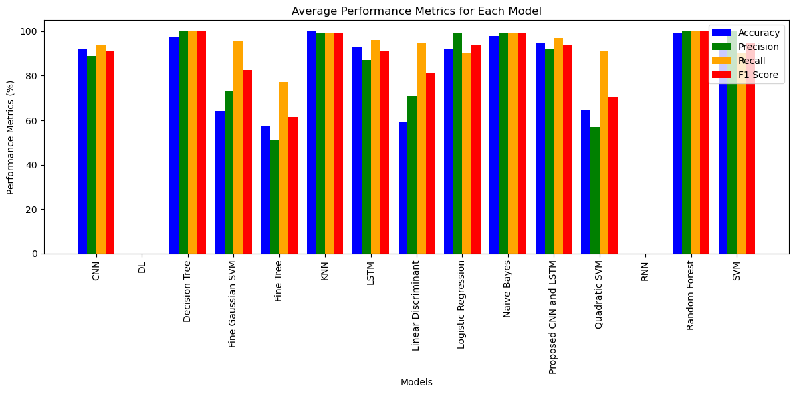

**Fig.5:** Average Performance Metrics for Each Model

**Conclusion:**

Advanced cyber solutions aligned with the needs of Industry 4.0 are declared as a necessity, as natural security can no longer stop the sophisticated kind of modern cyber threats. The key emphasis of the study indicates that high connectivity in industrial settings poses a tremendous amount of vulnerability that needs some innovative solutions.

One of the most interesting findings from this research is that machine learning algorithms significantly improve the efficacy of threat detection and prevention abilities. The study shows that Decision Trees, Random Forests, Support Vector Machines (SVMs), and Naive Bayes could reach high accuracies. Also, the Multilayer Perceptron model posted an impressive accuracy of 99.52% in its cyber threat detection. This implies that through machine learning, the speed and accuracy involved in threat detection will be significantly reduced, hence limited instances of unauthorized access and possible disruptions in the industrial systems.

The paper proposes a proactive defence strategy with real-time data analysis and anomaly detection. Such a multi-layered structure, including granular access controls and micro-segmentation, can be designed to protect critical infrastructure, especially in systems like SCADA-where the integration of IT and OT increased vulnerability to cyber-attacks.

This includes recommendations for further investigation on the incorporation of human factors into cybersecurity frameworks, since insights from attacker motives can complement technical detection methods. The study demonstrates the role that machine learning might play in not only strengthening security measures but also supporting Industry 4.0 technologies' scalable adoption; this will lead to more resilient industrial environments against cyber threats.

**References:**

1. Wai, E., & Lee, C. K. M. (2023). Seamless Industry 4.0 Integration: a multilayered Cyber-Security framework for resilient SCADA deployments in CPPS. *Applied Sciences*, *13*(21), 12008. https://doi.org/10.3390/app132112008
2. F. S. Cebeloglu and M. Karakose, "Comparative Analysis of Cyber Security Approaches Using Machine Learning in Industry 4.0," (2020)IEEE International Symposium on Systems Engineering (ISSE), Vienna, Austria, 2020, pp. 1-5, doi: 10.1109/ISSE49799.2020.9272237.
3. Ahsan, M., Nygard, K. E., Gomes, R., Chowdhury, M. M., Rifat, N., & Connolly, J. F. (2022). Cybersecurity threats and their mitigation approaches using Machine Learning—A Review. Journal of Cybersecurity and Privacy, 2(3), 527-555.
4. Shah, V. (2021). Machine Learning Algorithms for Cybersecurity: Detecting and Preventing Threats. Revista Espanola de Documentacion Cientifica, 15(4), 42-66.
5. Krugh, M., & Mears, L. (2018). A complementary cyber-human systems framework for industry 4.0 cyber-physical systems. Manufacturing letters, 15, 89-92.
6. Alqudhaibi, Adel, Majed Albarrak, Sandeep Jagtap, Nikki Williams, and Konstantinos Salonitis. "Securing industry 4.0: Assessing cybersecurity challenges and proposing strategies for manufacturing management." Cyber Security and Applications 3 (2025): 100067.
7. Alqudhaibi, A., Albarrak, M., Aloseel, A., Jagtap, S., & Salonitis, K. (2023). Predicting cybersecurity threats in critical infrastructure for industry 4.0: a proactive approach based on attacker motivations. Sensors, 23(9), 4539.
8. Apruzzese, G., Colajanni, M., Ferretti, L., Guido, A., & Marchetti, M. (2018, May). On the effectiveness of machine and deep learning for cyber security. In 2018 10th international conference on cyber Conflict (CyCon) (pp. 371-390). IEEE.
9. Wai, E., & Lee, C. K. M. (2024). Depth in Defense: A Multi-layered Approach to Cybersecurity for SCADA Systems in Industry 4.0.
10. Saghezchi, F. B., Mantas, G., Violas, M. A., de Oliveira Duarte, A. M., & Rodriguez, J. (2022). Machine learning for DDoS attack detection in industry 4.0 CPPSs. Electronics, 11(4), 602.
11. Goyal, S. B., Rajawat, A. S., Solanki, R. K., Zaaba, M. A. M., & Long, Z. A. (2023, April). Integrating AI with cyber security for smart industry 4.0 application. In 2023 International Conference on Inventive Computation Technologies (ICICT) (pp. 1223-1232). IEEE.
12. Rai, R., Tiwari, M. K., Ivanov, D., & Dolgui, A. (2021). Machine learning in manufacturing and industry 4.0 applications. International Journal of Production Research, 59(16), 4773-4778.
13. Vishavnath, S. K., Anwar, A., & Ahmed, M. (2021). Machine learning based cybersecurity defense at the age of Industry 4.0. In Machine Intelligence and Data Analytics for Sustainable Future Smart Cities (pp. 355-368). Cham: Springer International Publishing.
14. Al-Abassi, A., Karimipour, H., Dehghantanha, A., & Parizi, R. M. (2020). An ensemble deep learning-based cyber-attack detection in industrial control system. Ieee Access, 8, 83965-83973.
15. Toussaint, M., Krima, S., & Panetto, H. (2024). Industry 4.0 data security: A cybersecurity frameworks review. Journal of Industrial Information Integration, 100604.