**HYDROGEN ENERGY WITH DIESEL ENGINE**

**K. Siva prasad1, M. Madhuri2, P. Vamsi3, K. Sai4**

1Assistant Professor, Mechanical Dept., GMR Institute of Technology, Rajam, Andhra Pradesh, India

2,3,4UG Scholar, Mechanical Dept., GMR Institute of Technology, Rajam, Andhra Pradesh, India

____________________________________________________________________________________

**ABSTRACT**

Fossil fuels are not renewable energy sources. Fossil fuels pollute the environment. In the case of irresponsible use, they can be dangerous. If biofuel were grown on every available piece of farm land, it would still only replace 20% of the energy we currently use from crude oil. The internal combustion engine industry is facing huge challenges, and it is imperative to find new clean energy. Hydrogen energy is expected to replace traditional fossil fuels as an excellent fuel for internal combustion engines because of its clean, continuous regeneration and good combustion performance. Hydrogen supplementation in diesel engines has the potential to significantly improve performance while reducing greenhouse gas emissions and smoke. As a promising renewable alternative to conventional fuels, hydrogen offers a number of advantages, including high heating value, flame speed, diffusion rate, and rapid oxidation characteristics. Renewable energy has been thrust into the spotlight in recent years due to rising global awareness of the environmental impacts of fossil fuel combustion in conjunction with growing energy demands. Continued research is essential for advancing hydrogen-diesel technology and achieving cleaner engine performance.

**Key words:** Hydrogen direct injection Diesel pilot injection Dual direct injection Dual-fuel engine.

___________________________________________________________________________________

**1.INTRODUCTION**

Hydrogen energy, when combined with diesel engines, offers an innovative approach to reducing emissions and improving fuel efficiency. In a hydrogen-diesel dual-fuel setup, hydrogen gas is introduced into the engine along with a reduced amount of diesel fuel. This blend allows for cleaner combustion, as hydrogen burns without producing CO₂, and results in fewer harmful emissions like carbon monoxide and particulates, which are typical of conventional diesel engines. Hydrogen-diesel engines leverage hydrogen’s high energy content to improve efficiency. Since hydrogen combusts at a faster rate than diesel, it helps increase the thermal efficiency of the engine and reduces fuel consumption. Additionally, hydrogen can extend the range of diesel engines, especially useful in sectors like transportation, heavy machinery, and shipping. However, challenges exist, such as hydrogen storage, safety concerns, and the need to modify diesel engines to handle hydrogen. Still, with advancing technologies, hydrogen-diesel engines represent a promising step toward cleaner and more sustainable energy in diesel-reliant industries.

Hydrogen energy is emerging as a powerful solution to our growing energy and environmental challenges. Known for being clean and sustainable, hydrogen has the potential to transform how we power vehicles and machinery. It’s abundant, produces only water when burned, and delivers high energy efficiency, making it an exciting alternative to traditional fossil fuels. Diesel engines, on the other hand, are celebrated for their efficiency and reliability but have long been criticized for their high emissions of pollutants like nitrogen oxides (NOx) and particulate matter (PM). This is where hydrogen steps in as a game-changer. By combining hydrogen with diesel in a dual-fuel system, we can create a cleaner, greener engine without compromising performance. In this setup, hydrogen is mixed with air and introduced into the engine. The mixture, called the "primary fuel," is ignited with a small amount of diesel, which acts as a "pilot fuel" to kickstart the combustion process. This clever integration allows us to reduce the reliance on diesel, cut harmful emissions, and improve overall engine efficiency. Using hydrogen in diesel engines is a practical and promising step toward cleaner energy. It blends the strengths of both technologies, offering a way to make diesel engines more eco-friendly while paving the path for a sustainable future in transportation and industry.

**2**.**LITERATURE REVIEW**

**2.1 Hydrogen Energy: Challenges and Opportunities**

In figure. 1 Hydrogen is a clean energy source for vehicles. Its potential is vast, but challenges remain. Production, transportation, storage, and usage must improve. Researchers explore two hydrogen vehicle options: Hydrogen Fuel Cells (HFCs) and Hydrogen-Powered Internal Combustion Engines (ICEs). HFC’s generate electricity through chemical reactions, powering vehicles with minimal emissions. However, expensive production costs and the need for high-purity hydrogen hinder adoption. In contrast, hydrogen-powered ICEs modify existing engine technology, offering a less expensive alternative with slightly higher emissions. HFC’s offer numerous benefits, including near-zero emissions, energy efficiency, and reduced greenhouse gases. Nevertheless, high production costs, limited hydrogen infrastructure, and storage and transportation challenges persist. Researchers aim to enhance HFC efficiency, reduce production costs, and develop supporting infrastructure. A cleaner transportation future relies on overcoming these challenges. Hydrogen's potential as a clean energy carrier remains vast. Its adoption could significantly mitigate climate change. The automotive industry is investing heavily in hydrogen technology. Governments are implementing policies to support its development [1].

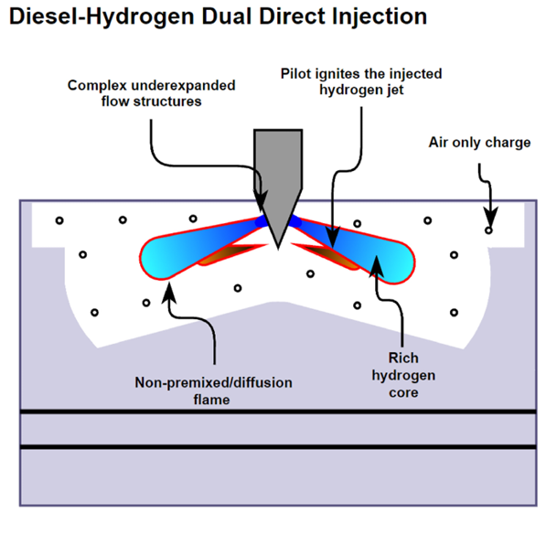

Figure.1 Diesel Hydrogen dual direct injection

**2.2 Hydrogen Production: Methods, Properties, and Future Directions**

Hydrogen can be made from fossil fuels and renewable sources. Two main methods from fossil fuels are hydrocarbon reforming and pyrolysis. Steam Methane Reforming (SMR) is the most common method. It produces hydrogen and carbon monoxide, then carbon dioxide as shown in Fig [2]. Hydrogen Biomass conversion methods include thermochemical and biological pathways. Water electrolysis splits water into hydrogen and oxygen using electricity [2].

**Properties of Hydrogen:** Hydrogen is odorless, colorless, and non-toxic. It's highly flammable and has low density. Hydrogen is the lightest and most abundant element. Its high reactivity makes it versatile. Hydrogen is clean-burning, producing only water vapor.

**Storage Challenges:** Hydrogen requires high pressure or cryogenic temperature for storage.

**Future of Hydrogen:** Hydrogen production will likely combine different technologies. SMR and electrolysis will play key roles. Renewable sources will become increasingly important.

**Electrolysis:** Splits water into hydrogen and oxygen using electricity. if powered by renewable energy, it produces "green hydrogen," which is entirely carbon-free.

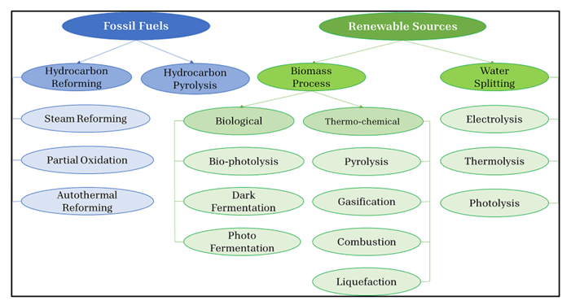

Figure.2 Hydrogen production methods

**2.3 Use of hydrogen in diesel engines powered by diesel**

Hydrogen is being used in diesel engines to reduce emissions. Adding hydrogen to diesel fuel can improve engine efficiency and performance. Hydrogen's high flame temperature and faster flame velocity enable complete combustion, increasing brake thermal efficiency (BTE). However, excessive hydrogen can lead to incomplete combustion and decreased BTE. Biodiesel blends with hydrogen also show improved combustion efficiency due to hydrogen's high energy value and biodiesel's oxygen content. Nano additives and oxygenated additives can further enhance combustion quality, reducing fuel consumption. Overall, hydrogen addition has potential benefits for diesel engine performance and emissions reduction. Some researchers have shown that oxygenated additives could decrease the fuel consumption rate of hydrogen-fueled diesel engines by providing fuel-bound oxygen content The lower flash point, higher cetane number, higher volatility, and lower viscosity of some oxygenated additives than diesel fuel could improve the combustion process. It has been confirmed in various studies that adding oxygenated additives could reduce the BSEC of hydrogen-fueled diesel engines [3].

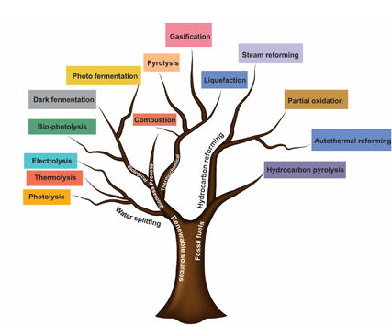

Figure.3 Hydrogen production routes

Figure.3 Hydrogen production routes

The global market for diesel-powered engines is expected to grow significantly, rising from 8.1 billion in 2018 to 2026. While diesel engines offer several benefits, they also face challenges, particularly due to their high emissions of nitrogen oxides (NOx), particulate matter (PM), and smoke. To address these issues and improve energy sustainability, researchers are actively exploring alternative fuels for diesel engines. A lot of focus has been placed on gaseous fuels as cleaner and more efficient options. These include liquefied petroleum gas (LPG), natural gas (NG), liquefied natural gas (LNG), compressed natural gas (CNG), biogas, and syngas. Gaseous fuels are well-suited for diesel engines because of their excellent knock resistance, which allows them to perform better under the high compression conditions typical of diesel engines. Properly managed mixing and combustion of gaseous fuels can improve fuel economy and significantly reduce harmful emissions.

One promising approach is using gaseous fuels in diesel engines through a dual-fuel mode. This method is both economically viable and environmentally friendly. In dual-fuel diesel engines, often referred to as "gas diesel engines," a combination of diesel and gaseous fuel is used. Here’s how it works: gaseous fuel is mixed with intake air, forming what’s known as the "primary fuel." This mixture is compressed within the engine cylinder, just below its auto-ignition temperature. A small amount of diesel fuel, called the "pilot fuel," is then injected to ignite the mixture. This is possible because diesel has a lower auto-ignition temperature than the air-gas mixture. The result is a cleaner and more efficient combustion process. The widespread availability of gaseous fuels has made dual-fuel engines increasingly popular worldwide as they strike a balance between reducing emissions and maintaining performance.

**2.4 Hydrogen-Enriched Nano Fuel for Cleaner Diesel Engines**

Fossil fuels are running out, and prices are rising. Pollution is a major concern, prompting experts to seek alternative energy sources. Biodiesel from Africana seeds is a promising option. Adding TiO2 nanoparticles improves engine performance, while hydrogen enrichment reduces emissions. Researchers produced biodiesel via transesterification and synthesized TiO2 nanoparticles using the sol-gel method. They mixed nanoparticles with biodiesel, sonicated, and added hydrogen to the air inlet at 3-4 LPM. Testing revealed improved brake thermal efficiency and decreased emissions: CO by 50%, HC by 77%, and NOx by 75%. This biodiesel meets ASTM and EN standards, providing a sustainable source. TiO2 nanoparticles enhance combustion, hydrogen enrichment reduces pollution, and this blend offers a cleaner alternative. Engine performance improves, emissions decrease, and fossil fuel dependence lessens, leading to better air quality. This research contributes to sustainable energy, highlighting biodiesel's potential, nanotechnology's efficiency boost, and hydrogen enrichment's benefits TiO2 nanoparticles reduce NOx emissions due to lower heat of vaporization and density. Nano biofuel emissions are 10% lower than diesel fuel. Hydrogen addition further reduces NOx emissions [4].

Fig.4 presents the variations in brake thermal efficiency with engine load for all the tested fuels at 100 % load condition. As the BTE increased, the engine load also increased. The highest BTE (39.5 %) was recorded for the BN@25 ppm + H2 (3 LPM) fuel, while that of biodiesel and diesel fuels gave 21 and 29 %, respectively. This result corroborates the findings of Refs. One major factor responsible for poor/lower BTEs is poor atomization and spray characteristics of a fuel. The high performance of the hydrogen enriched fuels (BN@25ppm +H2 (3 LPM) and BN@25 ppm + H2 (4 LPM) is as a result of better heating value and lower fuel consumption. The low BTE of the neat bio diesel is as a result of the high premixing potential of the fuel. The hydrogen enrichment with nano fuel increased the BTE as a result of the synergistic effect of the constituents of the blends induced by an increase in the engine load. The introduced fraction of H2 in the diesel engine increased the hydrogen/carbon ratio of the fuel which in turn increased the fuel’s BTE. Furthermore, hydrogen addition increased the cetane number of the BN@25 ppm + H2 (3 LPM) and BN@25 ppm + H2 (4 LPM), thus increasing the performance and efficiency of the test-fuel. Cetane number is account able for ignition delay and fuel ignition. As illustrated in Fig. 18, at 5 kW, a positive effect was observed as the load increased. Due to the reduced viscosity and specific fuel usage, the above is possible. The BTE can be enhanced at higher speeds by reducing the mass of fuel flowing into the chamber [4].

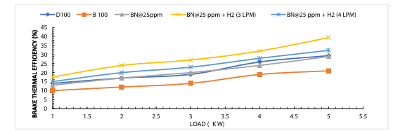

Figure.4 Variation of BTE with engine loads

**3. CONCLUSION**

In conclusion, using hydrogen in conjunction with diesel engines offers a balanced approach to cleaner energy for heavy-duty applications. One significant benefit is the reduction in nitrogen oxide (NOx) emissions, as hydrogen’s high flame speed promotes more complete combustion, which lowers hotspots in the engine where NOx formation typically occurs. Hydrogen’s flexibility as a supplementary fuel also allows for adaptable fuel ratios, enabling engines to run on higher hydrogen levels to further reduce diesel use or switch to lower hydrogen ratios when storage or supply is limited. Moreover, the improved combustion efficiency from hydrogen’s wide flammability range and lower ignition energy leads to more complete burning, which reduces emissions of unburned fuel that contribute to pollution.

Despite its benefits, adopting hydrogen-diesel technology faces challenges, such as the high initial costs associated with hydrogen infrastructure for production, storage, and transport. However, as green hydrogen from renewable sources becomes more cost-effective, the economic feasibility of hydrogen-diesel engines is expected to improve. Retrofitting existing diesel engines to run on hydrogen presents a practical, cost-effective transition strategy, particularly valuable in transportation and heavy industry where full replacement may not be feasible.

Hydrogen-diesel hybrid engines thus represent a promising transitional technology, offering an immediate reduction in emissions and positioning industries to meet intermediate environmental targets while fully renewable energy solutions, like fuel cells and electric engines, continue to advance. This approach not only helps in reducing environmental impact but also supports a gradual shift toward the zero-emission goals essential for a sustainable future.

**4.REFERENCES**

[1] Ramsay, C. J., & Dinesh, K. R. (2024). Numerical modelling of a heavy-duty diesel-hydrogen dual-fuel engine with late high pressure hydrogen direct injection and diesel pilot. *International Journal of Hydrogen Energy*, *49*, 674-696.

[2] Algayyim S. J. M., Saleh, K., Wandel, A. P., Fattah, I. M. R., Yusaf, T., & Alrazen, H. A. (2024). Influence of natural gas and hydrogen properties on internal combustion engine performance, combustion, and emissions: A review. *Fuel*, *362*, 130844.

[3] Hosseini, S. H., Tsolakis, A., Alagumalai, A., Mahian, O., Lam, S. S., Pan, J., ... & Aghbashlo, M. (2023). Use of hydrogen in dual-fuel diesel engines. *Progress in Energy and Combustion Science*, *98*, 101100.

[4] Adebisi, A., Abd-Rasheed, A., Olusegun, T., Sanni, S. E., Oguntade, T., & Oni, B. A. (2023). Effects of hydrogen enrichment on diesel engine fueled with Afzelia Africana biodiesel–TiO2 blends. *Egyptian Journal of Petroleum*, *32*(1), 81-86

.