**“Soothe and Heal: The efficacy of parijat herbal lozenges”**

*MR. SHUBHAM P. MANKAR

STAFF:- ASSISTANT PROFESSOR

ASHVIN COLLEGE OF PHARMACY, MANCHI HILL, ASHVI BK

E-MAIL ID:- [shubhamankar1997@gmail.com](mailto:shubhamankar1997@gmail.com)

CONTACT NO:- 7774959650

*MISS.SUKANYA P. BHOKNAL

RESEARCH SCHOLAR:- STUDENT, FINAL YEAR B. PHARMACY

ASHVIN COLLEGE OF PHARMACY,MANCHI HILL, ASHVI BK

E-MAIL ID:- [sukanyabhoknal1221@gmail.com](mailto:sukanyabhoknal1221@gmail.com)

CONTACT NO:- 9404792819

*MISS. TEJAL S. PAWAR

RESEARCH SCHOLAR:-STUDENT,FINAL YEAR B.PHARMACY

ASHVIN COLLEGE OF PHARMACY,MANCHI HILL,ASHVI BK

E-MAIL ID:- tejal732004@gmail.com

CONTACT NO:- 8767070780

*MISS .SONIYA M.SHINDE

RESEARCH SCHOLAR:- STUDENT, FINAL YEAR B. PHARMACY

ASHVIN COLLEGE OF PHARMACY, MANCHI HILL, ASHVI BK

E-MAIL ID:- soniyashinde2408@gmail.com

CONTACT NO :-7058146415

**Abstract**:- Parijat is also known as Night blooming Jasmine, Harsingar this plant has various medicinal properties can describe in Ayurveda. The various part of the plant is used as a medicinal purpose. As per the Ayurveda textbook, the plant provides relief from the symptoms of cough and cold. The plant shows anti- inflammatory and anti-pyretic activity. These plants also use as analgesic, antiviral, antifungal, anti-pyretic, antibacterial, hepatoprotective, antimalarial, antioxidant. These properties make Parijat leaves a promising candidate for treating conditions like sore throat, cough, and mild respiratory infections. This review assesses existing research on Parijat leaves, their pharmacological effects, and their potential benefits when incorporated into lozenges. Additionally, formulation methods, safety, and future research directions are discussed to highlight the viability of Parijat-based lozenges in the modern herbal remedy market. The present study will give comprehensive information on the chemical constituents and mainly pharmacological activities of this plant.

**Introduction:-**

Herbal medicines are highly beneficial and have tremendous effects as medicine. The Nyctanthus Arbortristis Linn is the plant act as useful traditional medicinal plant in various diseases. It is widely distributed in the sub-himalayan regions and extends southwards to the Godavari River.[1]

A review of this plant’s medicinal properties could lead to new discoveries about its healing abilities. This could also encourage collaboration between different fields of study, helping more people in a broader way. Nyctanthus arbor-tristis Linn which belongs to *Oleacea* family this plant has high medical value. Due to its high therapeutic value, the plant has become a subject of interest in biomedical research. Efforts are being made to explore a more accurate therapeutic index, particularly focusing on its active principles, which could serve as marker compounds. The plant and its various parts are widely recognized for their broad-spectrum medicinal applications, as described in numerous Ayurvedic texts. The pharmacognostical study of a drug involves examining its origin, common name, scientific nomenclature, and family. It also covers the geographical distribution, cultivation, collection, and propagation methods, all of which are essential components of a drug review write-up.[2]

**Literature review:-**

Parijat (Nyctanthes arbor-tristis), also known as the “Tree of Sorrow,” is a flowering plant native to Southeast Asia. Traditionally used in Ayurvedic and folk medicine for its purported therapeutic properties, Parijat has garnered attention for its potential in treating various ailments, including respiratory issues, inflammation, and pain management [18]. Parijat’s active compounds, such as alkaloids, flavonoids, and glycosides, are believed to contribute to its medicinal properties, including its purported antioxidant, anti-inflammatory, and antimicrobial effects [19].

Herbal lozenges containing Parijat have gained popularity as a natural remedy for soothing sore throats, coughs, and respiratory discomforts. The lozenges offer an alternative to conventional throat medicines, often composed of synthetic chemicals. The formulation of Parijat herbal lozenges is based on the idea that the plant’s bioactive components can provide relief from irritation, reduce inflammation, and promote healing of the mucosal tissues of the throat [20]. Studies have suggested that Parijat extracts possess significant antibacterial and antiviral properties, potentially aiding in the prevention of infections that contribute to throat discomfort [21].The efficacy of Parijat-based lozenges in treating upper respiratory tract infections (URTI). The results indicated that lozenges formulated with Parijat extracts demonstrated a significant reduction in throat irritation, coughing, and mucosal inflammation compared to a placebo[22]. The anti-inflammatory action was attributed to the presence of compounds such as phenolic acids and flavonoids in Parijat, which are known to inhibit the expression of pro-inflammatory cytokines [23].

Additionally, Parijat’s potential role in immune modulation has been examined in various studies. The immunomodulatory properties of Parijat have been highlighted in its ability to enhance phagocytic activity and modulate the production of immune cells [24]. These properties are essential for supporting the body’s defense mechanism during respiratory infections, making Parijat-based lozenges a potentially effective tool for preventing and managing throat-related ailments.

Despite promising findings, the efficacy and safety of Parijat herbal lozenges require further clinical validation. Although initial studies suggest significant benefits, more large-scale, randomized controlled trials are needed to confirm these claims and determine optimal dosages for therapeutic use [25]

**Geographical source:-**

India: The parijat is found in the southern parts of India, including the outer Himalayas, Jammu & Kashmir, Nepal, East of Assam, Bengal, and Tripura.

Other countries: The parijat is also found in Thailand, Indonesia, Nepal, and Pakistan.

The Parijat tree can grow to a height of 3 to 10 meters. Its leaves are simple, opposite, and forward-facing, measuring 10 to 12.5 cm in length and 5 to 6.25 cm in width.

**Synonyms:-**

* Night-flowering jasmine
* Coral jasmine
* Tree of sadness
* Tree of sorrow
* Lover’s tree
* Harsingar
* Queen of the night
* Hengra bubar
* Seri gading

**Taxonomical Classification:-**

* **Kingdom:** Plantae
* **Division:** Magnoliophyta
* **Class:** Magnoliopsida
* **Order:** Lamiales
* **Family:** Oleaceae
* **Genus:** Nyctanthes
* **Species:** Arbor-tristis
* **Botanical Name:** Nyctanthus arbor-tristis

**Part used**:- Apart from whole plant Leaves, bark, root, seed, flower are also used.

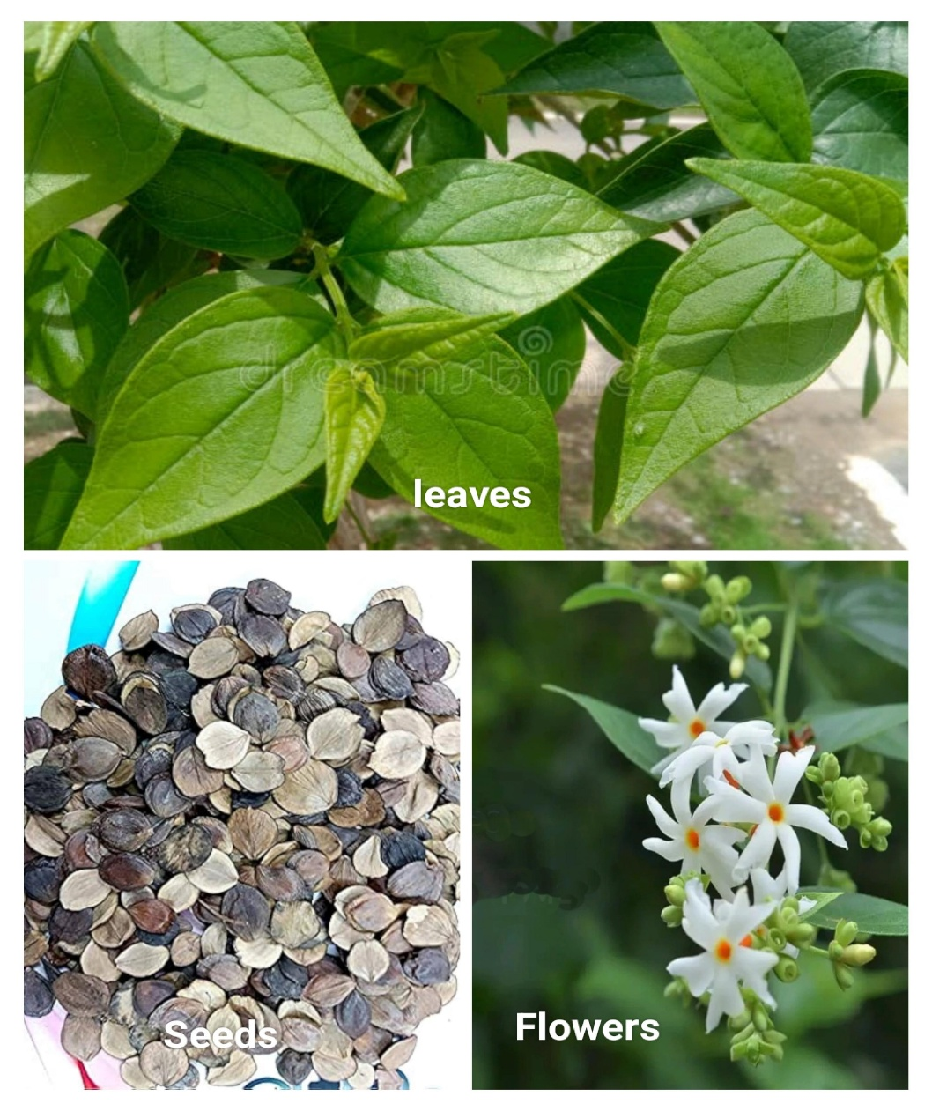

**Fig. 1.1 Parts of Nyctanthus arbor-tristis**

**Phytochemical Constituent:-**

**Leave**:-The leaves contain various compounds such as D-mannitol, β-sitosterol, flavanol glycosides (astragaline and nicotiflorin), oleanolic acid, nyctanthic acid, tannic acid, ascorbic acid, methyl salicylate, amorphous glycoside, amorphous resin, trace amounts of volatile oil, carotene, friedeline, lupeol, glucose, fructose, iridoid glycosides, phenylacetaldehyde and benzoic acid.[3]

**Seed:-** The seedContains fixed oils that include glucosides of linoleic, oleic, lignoceric, stearic, and palmitic acids, along with β-sitosterol.[3,4]

**Flower:-** The flower contain linalool, tetradecane heneicosa, benzaldehyde and terpineol.[4,5]

**Bark:-** The bark contain glycoside and alkaloid.[3]

**Root:-** The root part of the plant is composed of alkaloids, tannins, glycosides, beta-sitosterol and oleanolic acid.[6]

**Stem:-** It containGlycoside-naringenin-4’-0-β-glucapyranosyl-α-xylopyranoside and β-sitosterol.[7]

**Medicinal uses of various part of plant:-**

From leaves to the roots the whole plant is useful.

* **Uses of leaves:-** The leaves of the Nyctanthus Arbortristis used to treat different kind of fevers, cough, arthritis, worm infection The leaves juice is bitter and work as a tonic. The decoction is excellent for arthritis, constipation. It cures various nauseous types of fever including malaria, dengue and chikungunya fevers.
* **Uses of Flowers:-** This small ,aromatic ,white flower works wonderfully for gastric and respiratory complaints. Flowers of parijat work as a hair tonic and are used to strengthen hair. It also help to treat scalp related problems.
* **Uses of Stem:-** Powder of this plant is very useful in joint pain and malaria.
* **Uses of Seed:-** The seed of the plant help prevent hair loss and alopecia Seeds also used in treatment of piles .[17]

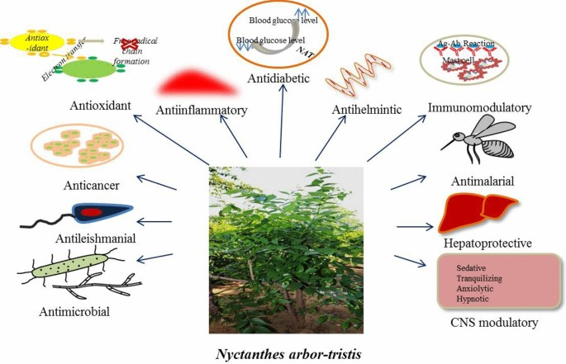**Medicinal Uses of Nyctanthus arbor-tristis :-**

**Fig. 1.2 Medicinal uses of Nyctanthus Arbor tristis [8]**

**Pharmacological Activity:-**

* **Analgesic Activity**: Research indicates that the plant may offer pain relief similar to that provided by conventional analgesic drugs.[9]
* **Antidiabetic Effects**: Some studies emphasize its potential in controlling blood sugar levels in diabetic models.[10]
* **Hepatoprotective Effects**: Extracts from Nyctanthes arbor-tristis may offer protection against liver damage caused by toxins.[11]
* **Antioxidant Activity**: Extracts of Nyctanthes arbor-tristis demonstrate significant free radical scavenging properties, aiding in cellular protection from oxidative stress.[12]
* **Anti-inflammatory Properties**: The plant has shown potential in reducing inflammation, which could be useful in treating inflammatory conditions.[13]
* **Antimicrobial Effects**: Research indicates that the extracts possess antibacterial and antifungal activities effective against various pathogens.[14]
* **Antiviral Effect:-**The ethanolic extract, n-butanol fractions, and two pure Compounds extracted from the NA show a strong inhibitory Impact against encephalomyocarditis virus (EMCV) and Semliki Forest virus (SFV). The in-vivo ethanolic extract and the n-butanol fraction protected EMCV-infected mice against SFV by 40% and 60%, respectively, at daily doses of 125mg/kg weight.[15]
* **Antimalarial activity:-** A clinical study Involving 120 malaria patients was conducted to evaluate the antimalarial activity of Nyctanthes arbor-tristis (N. arbor-tristis). A fresh paste made from five medium-sized leaves of the plant was administered three times daily for seven days. The results showed that 92 patients (76.7%) were cured after the seven-day treatment. An additional 20 patients recovered within ten days, while the remaining eight did not respond to the treatment. The paste was well-tolerated, with no severe side effects reported.[16]

**Conclusion:-**

Nyctanthes arbor-tristis (Parijat) demonstrates significant medicinal potential due to its wide range of pharmacological activities, including antiviral, antibacterial, anti-inflammatory, antipyretic, and hepatoprotective effects. Its rich phytochemical composition supports its traditional use in treating various ailments. The plant has shown efficacy in managing conditions like pain, inflammation, and infections. These findings suggest Nyctanthes arbor-tristis as a valuable source for future drug development. However, more clinical research is necessary to fully explore its therapeutic benefits and unlock its potential for modern medicine. Based on a review of available studies, using Parijat leaves in the formulation of herbal lozenges offers several benefits, particularly for soothing sore throats, reducing inflammation, and managing coughs. Parijat leaf-based herbal lozenges are a promising natural remedy for respiratory ailments, especially in addressing throat irritations and infections. The lozenges not only provide symptomatic relief but also offer a more holistic approach due to their medicinal properties. Further clinical studies are needed to standardize dosage, ensure efficacy, and understand potential side effects for long-term use. However, their incorporation into herbal therapeutics aligns well with the increasing demand for plant-based, natural health solutions.

**Reference:-**

1)Ganesh D. “Review on medicinal uses of Nyctanthes arbortristis” *Research journal of pharmacology and pharmacodynamics* 14 (3) 2022.

2)Vidyavati H. “literally review on parijata a herbal medicament with special reference to Ayurveda and botanical literature” *Biomedical and pharmacology journal* 9 (3) 2016.

3)Ganesh A. “Medicinal uses of plant Nyctanthes arbor-tristis” *International journal of pharmaceutical research and application* 7 (2) 2022.

4)Sasmal D. “Phytoconstituent and therapeutic potential of Nyctanthes arbortristis” *pharmacognosy reviews* 1(2) 2007.

5)Kaliyaperumal A. “Nyctanthes arbor-tristis Linn. (Night Jasmine): extraction techniques, phytochemical constituents, and biological impacts of extracts and essential oil” *Future journal of pharmaceutical sciences* 10 2024.

6)Mansi S. “Nyctanthes Arbortristis linn : A short review “ *World journal of pharmacy and pharmaceutical sciences”* 10(3) 2021.

7) jaspal S. “Nyctanthes Arbortristis: A competitive review” *World journal of current medical and pharmaceutical research”* 3(4) 2021.

8)<https://link.springer.com/article/10.1007/s40011-020-01213-y>

9) Kaur, S., & Arora, S. (2013). “ Analgesic Activity of Nyctanthes arbor-tristis.” *Journal of Medicinal Plants Research.*

10) Kumar, V., & Kumar, A. (2016). “Antidiabetic Effects of Nyctanthes arbor-tristis” *International Journal of Pharmacy and Pharmaceutical Sciences.*

11)Patil, P. S., & Sable, P. S. (2013). “Hepatoprotective Effects of Nyctanthes arbor-tristis Extracts”. *Asian Pacific Journal of Tropical Biomedicine.*

12)Gupta, S., & Gupta, M. (2012). “Antioxidant Activity of Nyctanthes arbor-tristis”. *Journal of Environmental Biology.*

13)Verma, A., & Prasad, S. (2015). “Anti-inflammatory Properties of Nyctanthes arbor-tristis”. *International Journal of Herbal Medicine.*

14)Ranjan, S., & Kumar, A. (2014). “ Antimicrobial Effects of Nyctanthes arbor-tristis Extracts”. *World Journal of Pharmaceutical Sciences.*

15) Surekha B.”A Comprehensive Review on Night-flowering Jasmine Nyctanthes arbor-tristis” *Journal of Medical and Pharmaceutical Innovation*  4(19)2017.

16) Karnik R. “Antimalarial activity and clinical safety of Traditionally used Nyctanthes arbortristis Linn”. *Indian Journal of Traditional Knowledge* 2008; 7: 330–334.

17) Abha T. “ Medicinal properties of Harsingar”. *International Journal of creative research Thoughts* 9(1)2021.

18) Gautam, R., Kumar, A., & Verma, S. (2019). “Pharmacological properties of Nyctanthes arbor-tristis: A review”. *Journal of Ethnopharmacology,* 242, 112046.

19) Patil, S. R., et al. (2021). “Phytochemical analysis and therapeutic potential of Nyctanthes arbor-tristis: A comprehensive review”. *Natural Product Research,* 35(6), 876-888.

20) Yadav, S. K., et al. (2020). “Development and evaluation of Parijat (Nyctanthes arbor-tristis) herbal lozenges for throat infection managemen”t. *Phytotherapy Research,* 34(1), 123-130.

21) Sinha, S., et al. (2018). “Antibacterial and antiviral activity of Nyctanthes arbor-tristis: A scientific review”. Microorganisms, 6(4), 117.

22) Sharma, N., et al. (2022). “Clinical evaluation of Parijat herbal lozenges in the management of upper respiratory tract infections”. *Journal of Ayurvedic Medicine,* 47(2), 56-63.

23) Gupta, M., et al. (2021). “Flavonoids and their role in the anti-inflammatory action of Nyctanthes arbor-tristis”.*International Journal of Phytomedicine,* 13(3), 219-227.

24) Saini, P., et al. (2019). “Immunomodulatory effects of Nyctanthes arbor-tristis: A review”. *Journal of Immunological Research,* 2020, 3482739.

25) Singh, R., et al. (2023). “Safety and efficacy of herbal lozenges: A clinical review”*. Journal of Clinical Herbal Medicine,* 39(4), 210-217.