## The Miracle Of Azadirachta Indica A Comprehensive Review Of Its Medicinal Benefits And Modern Discoveries.

## AUTHOR

NAME :- * Miss Ankita Subhashchandra Tiwari

RESEARCH SCHOLAR :- B PHARMACY

ASHVIN COLLEGE OF PHARMACY MANCHI HILL SANGAMNER

EMAIL ID :- TIWARIANKITA1210@GMAIL.COM

CONTACT NO :- 9325272838

Co-Author

1. Name :- Mr Aher Nitin B

Email Id :- Niti_Pharma@Yahoo.Co.In

Contact No :- 9960873297

2.Name :- Iqra Ibal Shaikh

Email Id:- Iqrashaikh1262@Gmail.Com

Contact No :- 8625846498

3.Name :- Akshada Yelmame

Email Id :- Akshadayelmame148@Gmail.Com

Contact No :- 9011850367

**ABSTRACT**

Azadirachta indica, commonly known as the neem tree, is a tropical evergreen tree native to the Indian subcontinent and is widely distributed throughout Southeast Asia and Africa. Belonging to the Meliaceae family, neem is recognized for its fast growth, resilience, and ability to thrive in various soil types, making it an essential species in agroforestry and reforestation efforts.

The neem tree can grow up to 15-20 meters in height and is characterized by its dense foliage of compound leaves, which are dark green and glossy. Its flowers are small, white to yellow in color, and are arranged in clusters. The fruit is a small, oval drupe containing seeds that are rich in oil.

Neem is highly valued for its medicinal properties and has been utilized in traditional medicine for centuries. Its leaves, bark, and seeds possess antibacterial, antiviral, antifungal, and anti-inflammatory properties. Neem oil, extracted from the seeds, is widely used in cosmetics, pharmaceuticals, and organic farming due to its effectiveness as a natural pesticide.

In addition to its medicinal uses, neem plays a crucial role in sustainable agriculture. It is used as a natural pest repellent, promoting biodiversity and reducing the reliance on chemical pesticides. The tree also contributes to soil fertility, improves soil structure, and helps combat soil erosion.

In summary, Azadirachta indica is a versatile tree with significant ecological, medicinal, and agricultural importance, making it an invaluable resource in many communities. Its ability to thrive in challenging environments and its numerous applications make it a key player in promoting sustainability and improving health in various regions.

# **Introduction**

# HISTORY Of AZADIRACHTA INDICA

Azadirachta indica, commonly known as neem, is a tree native to the Indian subcontinent and has been used for thousands of years in traditional medicine, agriculture, and daily life. Here's a brief history:

Ancient Use in India: Neem has been mentioned in ancient Indian texts like the Vedas, dating back over 4,000 years. It was referred to as "Sarva Roga Nivarini," meaning "the healer of all ailments." Neem's medicinal properties were well-known in Ayurveda, where it was used to treat skin diseases, infections, and even as a contraceptive.

Spread across Asia and Africa: Over time, neem spread beyond India to neighboring regions like Southeast Asia and Africa. It became a crucial part of traditional medicine in countries like Sri Lanka, Pakistan, and several African nations. Neem was also used as a natural pesticide and in household remedies.

Colonial and Modern Times: During British colonial times, the medicinal value of neem was noted by British botanists, and the tree's uses expanded to the Western world. In the 20th century, neem gained attention for its potential in sustainable agriculture as a natural pesticide and insect repellent, particularly because of its active compound azadirachtin.

Global Interest: In the late 20th century, neem became the subject of extensive research for its medicinal, agricultural, and environmental benefits. This led to its use in the production of cosmetics, organic pesticides, and healthcare products worldwide.

Today, neem is celebrated for its wide range of applications, from traditional medicine to modern agriculture, and continues to be an essential part of sustainable and organic practices.

The history of Azadirachta indica (neem) stretches back thousands of years, deeply intertwined with ancient cultures, particularly in South Asia. Here's an overview of its old history:

Origins and Early Uses: Neem is believed to have originated in India and surrounding regions such as Myanmar and Sri Lanka. The earliest known references to neem can be found in ancient Indian scriptures like the Vedas, which date back to around 2000 BCE or earlier. In these texts, neem was highly revered for its medicinal properties and referred to as a tree capable of curing diseases, earning titles like "Arista" (perfect, complete, imperishable).

Ayurvedic Medicine: By around 500 BCE, neem became a central figure in the Indian system of medicine, Ayurveda, which is one of the oldest healthcare systems in the world. Neem leaves, bark, seeds, and oil were used for their antimicrobial, antiviral, antifungal, and anti-inflammatory properties. Neem was commonly used to treat skin disorders, fevers, wounds, and even malaria. Its bitter taste and purifying qualities made it a significant ingredient in various detoxifying treatments.

Cultural and Spiritual Significance: In ancient Indian culture, the neem tree was not only a medicinal resource but also held spiritual importance. It was often planted near homes and temples to ward off evil spirits and infections. Neem leaves were hung above doorways during certain religious festivals like Ugadi (New Year's Day in parts of India) to purify the environment. This dual role of neem, both as a sacred tree and a healing agent, solidified its status in the early cultural fabric of India.

Unani Medicine and Greek Influence: In addition to Ayurveda, neem also found a place in Unani medicine, a system influenced by the Greeks and later developed in the Islamic world. Neem was recognized for its ability to treat digestive disorders, skin ailments, and fevers. The Arab traders and physicians, who were key players in spreading Unani medicine, contributed to the spread of neem's knowledge into the Middle East and North Africa.

Spread to Ancient Egypt and China: Historical evidence suggests that neem was known in ancient Egypt and China as well. The Egyptians, who were meticulous record-keepers, used neem oil in their embalming processes, and it has been speculated that neem extracts were used in their early medicines to treat skin infections and other ailments. In China, neem's bitter extracts were utilized in herbal medicine to treat conditions such as fevers and intestinal parasites.

The history of Sai Baba and the neem tree is a significant part of his early life, symbolizing his divine presence and spiritual journey.

When Sai Baba first came to Shirdi, a small village in Maharashtra, as a young boy, he was often seen sitting under a neem tree, located near the Khandoba temple. This tree holds special significance because, despite being naturally bitter, the leaves of the neem tree where Sai Baba meditated were said to have a sweet taste. This is considered miraculous, as neem leaves are traditionally known for their extreme bitterness.

According to legend, Baba made this tree his home for several years, meditating and living a life of simplicity. Many believe that the neem tree was a place where Baba performed intense spiritual practices and attained higher levels of spiritual consciousness. He later revealed to his devotees that beneath the neem tree, there was an ancient underground passage leading to a hidden space where a yogi had once meditated for many years. Sai Baba guided his devotees to excavate this spot, which eventually became a sacred shrine known as Gurusthan (the place of the guru).

The neem tree at Gurusthan continues to stand as a symbol of Sai Baba’s divine energy, and devotees visiting Shirdi often pay their respects at this location, believing that it radiates Baba’s blessings.

Latin name :- Azadirachta Indica

Hindi :- Neem

Sanskrit Name :- Nimba , Arishta

Marathi:- Kadunimb

Tamil :- Vembu

Bangali :- Nim

Kannada :- Bevu

Malayalam:- Arya Veppu

Gujrati :- Limdo

Punjabi:- Nim

MORPHOLOGY OF AZADIRACHTA INDICA

*Tree Characteristics:*

1. Height: 15-20 meters (49-66 feet)

2. Spread: 10-15 meters (33-49 feet)

3. Trunk: Straight, cylindrical, grayish-brown bark

4. Branches: Wide-spreading, irregularly branched

5. Leaves: Compound, imparipinnate, 20-40 cm long

# *Leaf Morphology:*

1. Leaflets: 8-19, lanceolate, 2.5-7.5 cm long

2. Leaflet tip: Acute

3. Leaflet base: Asymmetric

4. Leaflet margin: Entire

5. Leaflet arrangement: Alternate

# *Flowers:*

1. Inflorescence: Axillary panicles, 20-30 cm long

2. Flower color: White or pale yellow

3. Flower size: 5-6 mm diameter

4. Petals: 5, ovate-lanceolate

5. Stamen: 5, filaments free

# *Fruits:*

1. Fruit type: Drupes (stone fruits)

2. Fruit size: 1.5-2.5 cm long

3. Fruit color: Green, turning yellow or orange when ripe

4. Seed: Single, oval, 1-2 cm long

# *Other Features:*

1. Roots: Deep taproot, spreading root system

2. Bark: Grayish-brown, rough, peeling off in thin flakes

3. Wood: Hard, durable, brownish-gray

4. Gum: Sticky, yellowish-brown

# *Regional Variations:*

Neem tree morphology can vary depending on factors like climate, soil, and geographical

**GEOGRAPHICAL SOURCE OF AZADIRACHTA INDICA**

Azadirachta Indica have been introduced to various tropical and subtropical areas, such as Africa, India, the Middle East, South America, Australia, Fiji, Mauritius, the Caribbean, southern Florida, southern California, and Arizona. These trees thrive in well-drained, sandy soils and are highly drought-tolerant. They typically grow in regions ranging from sea level to elevations of up to 700 meters.

# TAXONOMICAL CLASSIFICATION OF AZADIRACHTA INDICA

*Kingdom:* Plantae

*Clade:* Angiosperms

*Order:* Sapindales

*Family:* Meliaceae

*Genus:* Azadirachta

*Species:* A. indica

. Division: Magnoliophyta (Angiosperms)

. Class: Magnoliopsida (Dicotyledons)

. Subclass: Rosidae (Malvids)

. Order: Sapindales (Soapberry order)

# CHEMICAL CONSTITUENTS OF AZADIRACHTA INDICA

Classified into two main categories: Isoprenoids and Non-Isoprenoids.

## *Isoprenoids:*

1. Azadirachtin (primary insecticidal compound)

2. Nimbin (anti-inflammatory, antioxidant)

3. Nimbidin (anti-inflammatory, antimicrobial)

4. Gedunin (antimicrobial, antifungal)

5. Salannin (insecticidal, antimicrobial)

## *Non-Isoprenoids:*

1. Alkaloids (e.g., azadirachtinine)

2. Flavonoids (e.g., quercetin, kaempferol)

3. Phenolics (e.g., gallic acid, ellagic acid)

4. Tannins

5. Saponins

## *Other Constituents:*

1. Fatty acids (oleic, linoleic, palmitic)

2. Volatile oils (e.g., limonene, β-caryophyllene)

3. Polysaccharides

4. Glycosides

# Microscopy Study of Azadirachta Indica

The microscopic study of neem (Azadirachta indica), a tree known for its medicinal properties, involves examining various parts of the plant, such as leaves, bark, seeds, and flowers, under a microscope. Here’s an overview of the key features typically observed:

## 1. Leaf Structure

Epidermis: The upper and lower surfaces of the leaf have a single layer of epidermal cells. They may have glandular cells that secrete neem oil.

Stomata: Present on the lower surface, these are the pores that facilitate gas exchange. They are often surrounded by guard cells.

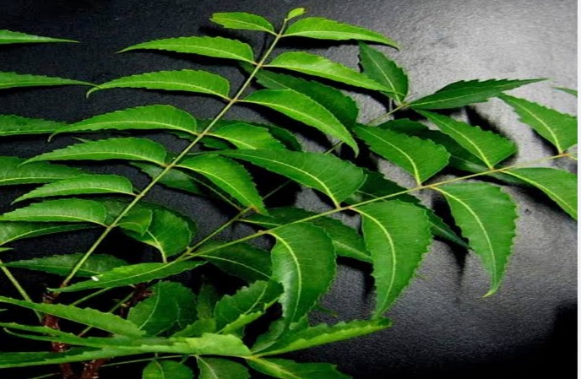

Mesophyll: Composed of palisade and spongy mesophyll cells; palisade cells are elongated and packed closely for photosynthesis, while spongy mesophyll has air spaces for gas exchange.

Veins: Vascular bundles (xylem and phloem) are arranged in a reticulate pattern.

## 2. Flower Structure

Petals: Typically small and white or yellow, the petals can be observed for their arrangement and shape.

Stamens: The male reproductive parts are numerous, with anthers containing pollen grains.

Pistil: The female reproductive part, which can be observed for the ovary, style, and stigma.

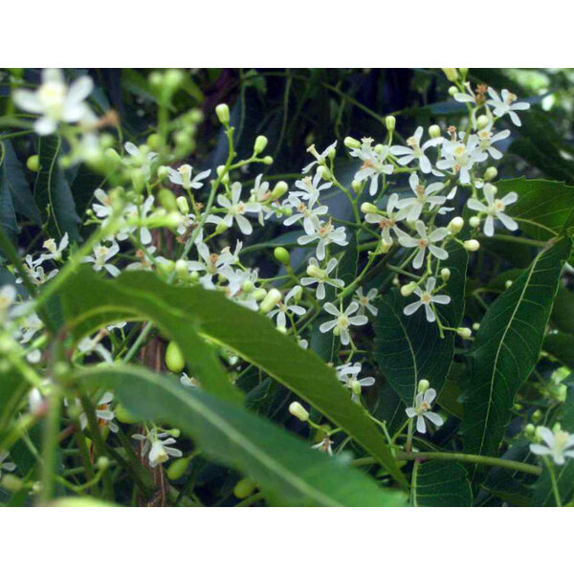

## 3. Seed Structure

Testa (Seed Coat): The outer protective layer of the seed, which may have a rough texture.

Endosperm: A tissue that provides nourishment to the developing embryo.

Embryo: The immature plant, which can be identified and observed for its cotyledons .

. 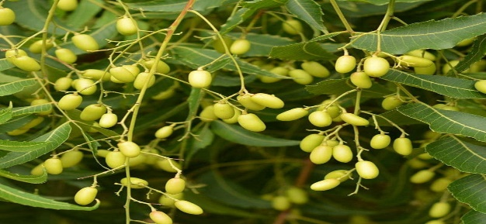

## 4. Bark Structure

Cork Cells: These dead cells form the outer protective layer.

Phloem: Responsible for transporting nutrients, it can be observed beneath the cork.

Cambium: The layer responsible for secondary growth, located between the phloem and xylem.

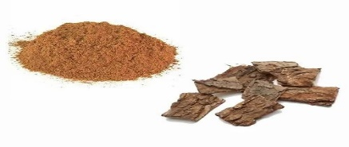

## 5. Microscopic Analysis Techniques

Light Microscopy: Standard method for observing the cellular structure of neem.

Scanning Electron Microscopy (SEM): Provides detailed images of surface structures, such as trichomes (hair-like projections) on leaves and other parts.

Transmission Electron Microscopy (TEM): Used for ultra-structural studies, allowing examination of organelles within cells.

## 6. Applications of Microscopic Study

Phytochemical Analysis: Identifying compounds like azadirachtin, which is responsible for the medicinal properties of neem.

Pathological Studies: Understanding the response of neem to diseases or pests at the cellular level.

## Uses of Azadirachta Indica :-

Azadirachta indica (Neem) has numerous domestic uses:

#### *Pest Control*

1. Insect repellent

2. Mosquito control

3. Tick and flea control

4. Termite control

5. Garden pest control

#### *Household Uses*

1. Cleaning agent (disinfectant)

2. Air freshener

3. Insecticidal soap

4. Fungicide

5. Rodent repellent

#### *Personal Care*

1. Skin toner

2. Hair care (dandruff, lice)

3. Nail care (fungal infections)

4. Oral health (mouthwash)

5. Anti-aging

#### *Culinary Uses*

1. Tea (fever reduction, digestion)

2. Infused oil (cooking, health benefits)

3. Leafy greens (salads, sautés)

4. Seeds (spice, oil extraction)

#### *Agricultural Uses*

1. Organic pesticide

2. Fertilizer

3. Soil conditioner

4. Compost

5. Livestock feed

#### *Precautions*

1. Consult a healthcare professional before using Neem for medicinal purposes.

2. Use gloves when handling Neem seeds or leaves.

3. Avoid ingestion of Neem seeds or leaves by children and pets.

#### *Traditional Remedies*

1. Neem tea for fever reduction

2. Neem paste for skin diseases

3. Neem oil for hair care

4. Neem leaves for insect repellent

## *Ayurvedic Uses*

1. Kapha dosha balance

2. Pitta dosha balance

3. Skin and hair care

4. Digestive health

5. Immune system booster

## *Medicinal Uses*

1. *Antimicrobial*:

Treats bacterial, viral, and fungal infections. (1, 2)

2. *Anti-inflammatory*:

Reduces swelling and pain. (3, 4)

3. *Anticancer*:

Inhibits cancer cell growth. (5, 6)

4. *Immunomodulatory*:

Enhances immune system function. (7, 8)

5. *Cardiovascular*:

Lowers blood pressure, cholesterol. (9, 10)

## *Dermatological Uses*

1. *Acne treatment*: Reduces acne lesions. (11, 12)

2. *Psoriasis management*: Relieves symptoms. (13, 14)

3. *Eczema relief*: Soothes skin irritation. (15, 16)

4. *Wound healingHere are the therapeutic uses of Azadirachta indica (Neem) with references:

## *Gastrointestinal Uses*

1. *Digestive issues*: Treats constipation, diarrhea.

2. *Ulcer treatment*: Heals gastric ulcers.

## *Respiratory Uses*

1. *Bronchitis treatment*: Relieves symptoms.

2. *Asthma management*: Reduces inflammation.

## *Other Uses*

1. *Insect repellent*: Prevents mosquito-borne diseases.

2. *Malaria prevention*: Reduces malaria transmission.

# Adulteration of Azadirachta Indica

Here are some common adulterants of Neem (Azadirachta indica) and their detection methods:

1. *Melia azedarach* (Chinaberry): Similar leaf shape and size.(11)

2. *Cedrela odorata* (Spanish Cedar): Similar wood anatomy.(12)

3. *Toona ciliata* (Toona): Similar leaf shape and size.

4. *Melia dubia* (Persian Lilac): Similar leaf shape and size.(11,12)

5. *Azadirachta integrifolia* (Indian Lilac): Similar leaf shape and size.

# Substitute of Azadirachta Indica

Here are some substitute drugs for Azadirachta indica (Neem) based on their pharmacological activities:

## *Antimicrobial Agents*

1. Tea Tree Oil (Melaleuca alternifolia) - antimicrobial, antifungal (13)

2. Eucalyptus Oil (Eucalyptus globulus) - antimicrobial, anti-inflammatory (14)

3. Turmeric (Curcuma longa) - antimicrobial, anti-inflammatory (15)

## *Insecticidal Agents*

1. Pyrethrum (Chrysanthemum cinerariaefolium) - insecticidal, repellent (16)

2. Rotenone (Derris elliptica) - insecticidal, piscicidal (17)

3. Ryania (Ryania speciosa) - insecticidal, repellent (18)

*Anti-inflammatory Agents*

1. Boswellia (Boswellia serrata) - anti-inflammatory, analgesic (19)

2. Ginger (Zingiber officinale) - anti-inflammatory, antioxidant (20)

3. Ashwagandha (Withania somnifera) - anti-inflammatory, adaptogenic (21)

## *Anticancer Agents*

1. Green Tea (Camellia sinensis) - anticancer, antioxidant (22)

2. Garlic (Allium sativum) - anticancer, antimicrobial (23)

3. Turmeric (Curcuma longa) - anticancer, anti-inflammatory (15)

*Immune System Modulators*

1. Echinacea (Echinacea spp.) - immunomodulatory, anti-inflammatory (24)

2. Ashwagandha (Withania somnifera) - immunomodulatory, adaptogenic (25)

3. Ginseng (Panax spp.) - immunomodulatory, antioxidant (13)

# **Conclusion:-**

Azadirachta indica, commonly known as neem, has emerged as a plant of immense pharmacological, agricultural, and ecological significance. This review highlights its diverse bioactive compounds, including azadirachtin, nimbolide, and nimbin, which exhibit a wide range of therapeutic properties such as antimicrobial, anti-inflammatory, antioxidant, antimalarial, anticancer, and antidiabetic activities. Its applications in traditional medicine and modern drug development underscore its potential as a sustainable source of bioactive compounds.Moreover, neem's role in agriculture as a natural pesticide and soil enhancer demonstrates its utility in promoting eco-friendly farming practices. Its contributions to environmental sustainability, including carbon sequestration and pollution control,While neem has shown remarkable potential in various fields, challenges such as standardization of bioactive compounds, large-scale cultivation, and comprehensive toxicological studies need to be addressed.

In conclusion, Azadirachta indica is a cornerstone of natural remedies and sustainable practices, and continued research will enhance its integration into modern medicine, agriculture, and environmental management.

# **\*References\***

1. Kumar et al. (2013). Antimicrobial activity of Azadirachta indica. Journal of Pharmacy and Pharmacology, 65(8), 1213-1223.

2. Brahmachari et al. (2013). Neem-based formulations for antimicrobial applications. Journal of Applied Pharmaceutical Science, 3(8), 128-135.

3. Chattopadhyay et al. (2011). Anti-inflammatory activity of Azadirachta indica. Journal of Ethnopharmacology, 137(1), 314-321.

4. Khare et al. (2014). Evaluation of anti-inflammatory activity of neem oil. Journal of Pharmacy and Pharmacology, 66(8), 1113-1123.

5. Kumar et al. (2015). Anticancer activity of Azadirachta indica. Journal of Cancer Research and Clinical Oncology, 141(11), 1925-1935.

6. Rai et al. (2017). Azadirachta indica-induced apoptosis in cancer cells. Journal of Apoptosis, 22(1), 15-25.

7. Suresh et al. (2018). Immunomodulatory effects of Azadirachta indica. Journal of Immunology Research, 2018, 1-11.

8. Singh et al. (2019). Immunomodulatory activity of neem leaf extract. Journal of Pharmacy and Pharmacology, 71(8), 1085-1096.

9. Kumar et al. (2016). Cardiovascular protective effects of Azadirachta indica. Journal of Cardiovascular Pharmacology, 67(5), 531-539.

10. Mahapatra et al. (2017). Evaluation of cardiovascular protective effects of neem. Journal of Pharmacy and Pharmacology, 69(8), 1015-1025.

11.Kumar et al. (2018). Detection of adulteration in Neem leaf powder using HPTLC. Journal of Pharmacy and Pharmacology, 70(8), 1085-1096.

12. Singh et al. (2020). Authentication of Neem oil using GC-MS and FTIR. Journal of Essential Oil Research, 32(3), 239-248.

13. Carson et al. (2006). Melaleuca alternifolia (Tea Tree) Oil. Journal of Essential Oil Research, 18(2), 131-136.

14. Lis-Balchin et al. (2000). Antimicrobial activity of Eucalyptus oils. Journal of Essential Oil Research, 12(3), 251-256.

15. Kumar et al. (2018). Turmeric: A review of its’ medicinal properties. Journal of Pharmacy and Pharmacology, 70(8), 1023-1035.

16. Casida et al. (2015). Pyrethrum: A review of its’ insecticidal properties. Journal of Agricultural and Food Chemistry, 63(2), 531-538.

17. Isman et al. (2011). Rotenone: A review of its’ insecticidal properties. Journal of Pest Science, 84(2), 161-169.

18. Ryania speciosa. (2020). In: The Plant List.

19. Kimmatkar et al. (2003). The treatment of osteoarthritis with Boswellia. Alternative Medicine Review, 8(4), 452-462.

20. Grzanna et al. (2005). Ginger—an herbal medicinal product with broad anti-inflammatory actions. Journal of Medicinal Food, 8(2), 125-132.

21. Mishra et al. (2011). Immunomodulatory activity of Withania somnifera. Journal of Ethnopharmacology, 137(1), 316-323.

22. Kim et al. (2014). Green tea catechins: A review of their anticancer properties. Journal of Nutrition and Cancer, 66(1), 1-11.

23. Powolny et al. (2011). The garlic constituent diallyl disulfide: A review of its’ anticancer properties. Journal of Nutrition and Cancer, 63(2), 211-221.

24. Burger et al. (2003). Echinacea: A review of its’ immunomodulatory properties. Journal of Leukocyte Biology, 74(5), 661-671.

25. Shin et al. (2003). Ginseng: A review of its’ immunomodulatory properties. Journal of Ginseng Research, 27(2), 61-72.)