**"OPTIMIZING INVENTORY MANAGEMENT: A DATA-DRIVEN APPROACH TO REDUCING STOCKOUTS AND OVERSTOCKING"**

**Amit Sawarkar**

Research Scholar

Indira School of Business Studies PGDM, Pune

[amit.sawarkar@indiraisbs.ac.in](mailto:amit.sawarkar@indiraisbs.ac.in)

**Mrunal Sahastrabuddhe**

Research Scholar

Indira School of Business Studies PGDM, Pune

[mrunal.sahastrabuddhe@indiraisbs.ac.in](mailto:mrunal.sahastrabuddhe@indiraisbs.ac.in)

**ABSTRACT**

Inventory management is a critical component of efficient business operations, particularly in manufacturing and production. It involves the strategic planning, organizing, and controlling of inventory levels to meet demand while minimizing costs. Inventory, defined as a usable but idle resource, includes raw materials, work-in-progress (WIP), finished products, and spare parts. Effective inventory management ensures a balanced supply chain, preventing production stoppages and loss of sales due to stockouts. Over time, inventory management practices have evolved from manual record-keeping to sophisticated software systems that track inventory in real-time. The introduction of methods such as Economic Order Quantity (EOQ), Just-In-Time (JIT), and ABC analysis has significantly improved inventory control by optimizing order quantities and timing. This paper explores the importance of inventory management, the historical evolution of inventory control techniques, and the benefits of implementing efficient inventory practices, such as improved customer satisfaction, reduced production interruptions, and optimal use of working capital. Through the lens of the ABC analysis technique, the paper also highlights how inventory can be categorized and managed based on its value and usage frequency, emphasizing the need for scientific approaches to maintain the delicate balance between supply and demand.

**INTRODUCTION:**

A tangible, physical resource that can be used, like materials, is referred to as inventory. Our inventory is, in this sense, our stock, though even in that case, the term inventory refers to something broader. Despite being a resource that can be used, inventory is also idle unless it is properly and efficiently managed. Keeping an adequate supply of something to meet the expected demand pattern, while taking budgetary considerations into account, is the essence of inventory management. Indirect materials such as spare parts, finished goods, work-in-progress (WIP), and raw materials can all be included in inventory. Inventory management plays a major role in how well the materials and production functions work.

Since there is never a time when inventories can be instantly available, they must be acquired, stored, and carried for a production system.

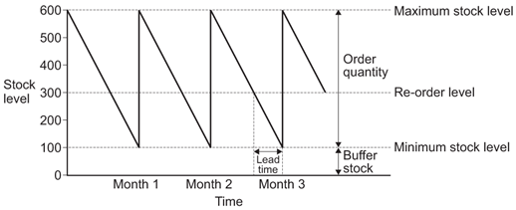

Figure 1: Inventory Control Chart

**LITERATURE REVIEW**

Essentially, merchants had to list every item they sold on a daily basis prior to the Industrial Revolution. Then, relying on their instincts and handwritten notes, they had to place additional product orders. Doing business in this manner was terribly inaccurate and inefficient.

Shopkeepers were forced to perform laborious physical counts on a regular basis in order to truly account for stolen goods. Also, because of their shoddy recordkeeping, they had problems ensuring they received the correct quantity of products when orders were placed. All they could do, though, was that.

The first machine-readable punch card was created in 1889 by a man by the name of Herman Hollerith. Using paper sheets with tiny holes in particular locations, people could record intricate

A group of retailers (grocery stores mostly at first) got together in the 1960s and developed the modern barcode as a new way to track inventory. Before barcodes were standardized with the Universal Product Code (UPC) in 1974, there were a number of competing types. Even now, in the United States, it remains the most commonly used barcode.

UPCs became more and more common as computers became more affordable and efficient. Businesses began experimenting with inventory management software in the mid-1990s, which recorded information as products were scanned into and out of warehouses. By the early 2000s, the technology had developed into a complete inventory management solution. (Lockard, Roth, 2012)

Using inventory management software is becoming a useful tool for businesses trying to operate more effectively.

The ongoing process of planning, arranging, and regulating inventory with the goal of minimizing the investment in inventory while maintaining supply and demand equilibrium is known as inventory management. (West, 2009).

**METHODOLOGY**

According to Kotler (2002), inventory management encompasses all the tasks associated with creating and maintaining the quantities of raw materials, work-in-progress materials, and finished goods in stock to ensure sufficient supply and minimize expenses associated with excess or understocking. A crucial component of project or business management is material and inventory management, which is the process of supplying the appropriate material in the appropriate quantity at the appropriate location at the appropriate time to reduce costs. The planning, identification, procurement, storage, receiving, and distribution of materials are all included in material management (Ashwini & Smita, 2013). The materials that are kept in stock are referred to as inventory. It is often referred to as an enterprise's idle resource.

Inventories represent those items which are either stocked for sale or they are in the process of manufacturing or they are in the form of materials, which are yet to be utilised. The interval between receiving the purchased parts and transforming them into final products varies from industries to industries depending upon the cycle time of manufacture. It is, therefore, necessary to hold inventories of various kinds to act as a buffer between supply and demand for efficient operation of the system. Thus, an effective control on inventory is a must for smooth and efficient running of the production cycle with least interruptions.

Items that are kept in stock for sale, in production, or in the form of raw materials that have not yet been used are referred to as inventories. Depending on the manufacturing cycle time, the time it takes to turn purchased parts into finished goods varies from industry to industry. For the system to operate efficiently, several types of stocks must be kept on hand to serve as a buffer between supply and demand. Thus, for the production cycle to function smoothly and efficiently with the fewest disruptions possible, proper inventory control is essential.

Reasons of keeping the inventory:

1. To stabilize production: A variety of factors, such as seasonality and manufacturing schedule, can cause fluctuations in an item's demand. In order to prevent stock outs and production halts due to material shortages, stocks (raw materials and components) should be made available to the production in accordance with demand. In order to ensure smooth manufacturing, inventory is kept to handle this fluctuation.

2. To benefit from price breaks: Manufacturers typically give discounts for large purchases, so even though the materials aren't needed right away, people buy them in bulk to take advantage of this pricing advantage. As a result, inventory is kept in order to maximize purchasing efficiency.

3. To satisfy demand during the replenishment period: The lead time for material procurement is dependent on a number of variables, including the source's location and the state of the demand and supply. Therefore, during the procurement (replenishment) period, inventory is kept in order to meet demand.

4. To avoid losing orders or sales: In this competitive environment, one must adhere to 100% service level delivery schedules; therefore, they cannot afford to miss any deliveries, which could lead to a loss of sales. Organizations must keep inventory in order to prevent out of stock situations.

5. To stay up with shifting market conditions: Businesses must foresee shifting consumer attitudes and store up on supplies in case those supplies become unavailable or prices spike unexpectedly.

6. Miscellaneous: Organizations occasionally need to stock materials because of various factors, such as minimum quantity requirements from suppliers, seasonal material availability, or unexpected price increases.

What is inventory control?

The deliberate process of choosing what to order, when to order it, how much to order, and how much stock to keep in order to minimize purchasing and storage expenses without compromising sales and production is known as inventory control. Two main issues are addressed by inventory control: (i) When should an order be placed? (Level of order), and (ii) What quantity has to be ordered? (Amount of order). Inventory models provide the answers to these queries. The scientific inventory control system balances the expense of maintaining an item's stock with the loss incurred by its unavailability. The goal of scientific inventory control is to keep the company's items in stock at the optimal level while incurring the least amount of expense.

Objectives of inventory control:

1. To guarantee a sufficient supply of goods to customers and, to the greatest extent feasible, prevent shortages.

2. To guarantee that the least amount of money is invested in inventories (i.e., to see that the working capital is blocked to the shortest extent possible).

3. Purchasing, storing, using, and accounting for goods efficiently is a key goal.

4. To keep accurate records of all item inventories and to keep stock levels within predetermined ranges.

5. To guarantee prompt replenishment action.

6. To maintain a reserve stock in case the wait time for material delivery varies.

7. To offer a scientific foundation for material planning that is both short- and long-term.

Benefits of inventory control:

1. A better rapport with customers as a result of prompt delivery of goods and services.

2. Efficient and continuous production, resulting in no stock outs.

3. The effective use of operating capital. reduces loss brought on by degradation, damage from obsolescence, and theft.

4. Cost-effectiveness in purchases.

5. Gets rid of the chance of ordering twice.

Methods of inventory control:

Keeping inventory varies based on the sort of business in every given organization. The management must exercise appropriate control over the ordering, procurement, maintenance, and consumption of inventory when there are a lot of products in it and a significant financial investment is required to build it. Both order frequency and order quality may be under control. The many inventory control methods are:

(1) ABC analysis

(2) HML analysis

(3) VED analysis

(4) FSN analysis

(5) SDE analysis

(6) GOLF analysis.

ABC Analysis:

Based on the annual worth of the items and their annual consumption, the current inventory is categorized in this study. In order to calculate the yearly consumption cost, we first determine the quantity of inventory items utilized throughout the year and multiply it by the unit cost. After that, the products are stacked in decreasing order of such annual consumption cost. Using a graph based on the total number of products and total consumption cost, the analysis is performed. The 80/20 rule serves as its foundation, classifying "trivial many" as "C" class goods and "Vital few" as "A" class items.

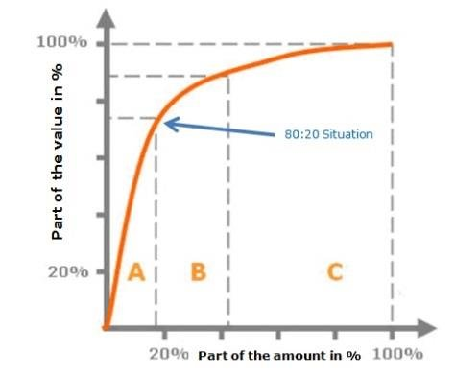

Figure 2: ABC analysis based on Pareto's 80/20 principle

Example:

|  |  |  |  |  |  |  |
| --- | --- | --- | --- | --- | --- | --- |
| **Item** | **Annual Consumption (Units)** | **Price per unit (Rupees)** | **Annual consumption Price** | **Cumulative usage** | **Cumulative usage percentage** | **Category** |
| Benzyl penicillin | 5000 | 10 | 50000 | 50000 | 31.12 | A |
| Gentamycin | 6500 | 6 | 39000 | 89000 | 55.39 | A |
| Mannitol | 1800 | 18 | 32400 | 121400 | 75.56 | A |
| Tetracycline | 2500 | 5 | 12500 | 133900 | 83.34 | B |
| Dexamethasone | 650 | 10 | 6500 | 140400 | 87.38 | B |
| Chloroxylenol | 4200 | 1 | 4200 | 144600 | 90.00 | B |
| Trifluoperazine | 4200 | 1 | 4200 | 148800 | 92.61 | C |
| Streptopenmicillin | 100 | 35 | 3500 | 152300 | 94.79 | C |
| Vitamin C | 750 | 4 | 3000 | 155300 | 96.66 | C |
| Aluminium Hydroxide | 300 | 7 | 2100 | 157400 | 97.96 | C |
| Diazepam | 100 | 7 | 700 | 158100 | 98.40 | C |
| Imipramine | 50 | 10 | 500 | 158600 | 98.71 | C |
| Phenobarbitone | 2000 | 0.25 | 500 | 159100 | 99.02 | C |
| Ampicillin | 60 | 8 | 480 | 159580 | 99.32 | C |
| Oxytetracycline | 50 | 8 | 400 | 159980 | 99.57 | C |
| Analgen | 20 | 10 | 200 | 160180 | 99.69 | C |
| Aspirin | 20 | 10 | 200 | 160380 | 99.82 | C |
| Prednisolone | 30 | 6 | 180 | 160560 | 99.93 | C |
| Sulphone | 200 | 0.5 | 100 | 160660 | 99.99 | C |
| A.P.C | 80 | 0.15 | 12 | 160672 | 100.00 | C |

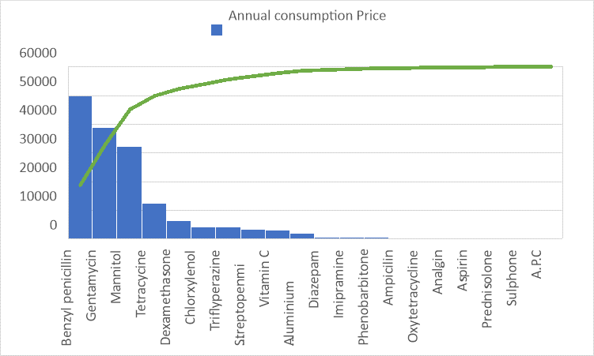

Figure 3: Pareto chart

From above example, we can distribute the items in A, B and C category by considering the cumulative annual usage percentage. Benzyl penicillin, gentamycin and mannitol is having the the share of 75% in total inventory and they are crucial. Hence, they will be in “A” category. Tetracycline, dexamethasone and chloroxylenol is having 15% share in overall inventory hence, they are in “B” category and rest all items have the share of 10% and hence they are in “C” category.

**CONCLUSION**

Successful inventory management is essential for any organization, but it's especially important for manufacturing and production companies. It guarantees that businesses can fulfill orders from clients, prevent delays in manufacturing, and cut down on the expenses related to stockouts or overstocking. Businesses may now more efficiently monitor their inventory levels because to the advancement of inventory management, which started with manual record-keeping and progressed to complex software systems.

In inventory control, methods like ABC analysis, Just-In-Time (JIT), and Economic Order Quantity (EOQ) have become indispensable. Businesses can allocate resources to high-impact goods by classifying inventory. based on how valuable and frequently consumed it is, as the ABC analysis in particular shows. Businesses can guarantee that their most important stock is always available by concentrating on "A" category items, which make up the majority of the inventory value. This lowers the chance of stockouts, which could result in missed sales and disgruntled customers.

Making well-informed judgments about inventory management that optimize costs while balancing supply and demand is made easier by incorporating a data-driven approach. As the ABC analysis example shows, businesses may increase efficiency, cut down on waste, and streamline processes by identifying and classifying inventory according to its relevance. This strategy improves customer happiness, stabilizes production, and fortifies the company's overall financial performance.

Overall, a well-implemented inventory management strategy is key to achieving operational excellence and sustaining competitive advantage in today's dynamic market environment.

**REFERENCES**

https://www.researchgate.net/publication/362344346_inventory_management_concepts_and_implementations_a_systematic_review

https://www.aqa.org.uk/resources/business/as-and-a-level/business-7131-7132/teach/teaching-guide-inventory-control-chart

https://www.slideshare.net/slideshow/literature-review-r/50958370

https://www.ascdegreecollege.ac.in/wp-content/uploads/2020/12/production-and-operation.pdf

https://www.researchgate.net/figure/illustration-of-abc-analysis-classification-80-20-rule-1_fig1_303020679

Chunawalla S.A, Patel D.R (2010), *Production and Operations Management,* (8th Edition), Himalaya Publishing House.