**LORA BASED TRANSCEIVER FOR LOAD MONITERING AND CONTROL IN POWER SYSTEM**

1**Mr. A. Vinothkumar,** 2**Karthikeyan M,** 3**Kiruthik S,** 4**Abibulla S,** 5**Karthik V**

1Assistant Professor, Department of Electrical and Electronics Engineering, P. A. College of Engineering and Technology, Pollachi, Tamilnadu, India

2,3,4UG Student, Department of Electrical and Electronics Engineering, P. A. College of Engineering and Technology, Pollachi, Tamilnadu, India

**ABSTRACT**

Various renewable energy plants have been globally developed from conventional fossil fuel based power generation plants. The renewable energy sources are difficult to operate in a planned schedule and have unstable output due to unpredictable environmental conditions such as the weather. It is possible to manage the power generation system more stably by collecting, analyzing, responding to the information of continuous power generation status, the accumulated data provides an advantage of predicting future power generation and optimal maintenance. This improved stability is also contributed to the grid reliability and flexibility. To implementation this method for effectively construct energy monitoring system which is based on open IoT hardware and software platforms for economic system construction. LoRa supporting low power long distance network is applied through low cost solution without base station of Telco’s. The monitoring system proposed in this paper can be applied to the future energy LoRa system because of the case of implementation, reduced development cost and variety of applications.

1. **INTRODUCTION**

The increasing demand for reliable and efficient power distribution has driven the adoption of innovative technologies in the power sector. One such technology is LoRa (Long Range), a wireless communication solution enabling real time monitoring and control of power systems. LoRa based power monitoring, controlling offers a cost effective, scalable, secure solution for optimizing power distribution, reducing energy losses and enhancing grid reliability.

1. **METHODOLOGY**

A LoRa-based load monitoring and control system enhances power system efficiency and reliability. It utilizes LoRa transceivers, microcontrollers, sensors to monitor voltage, current and power factor in real time.

1. 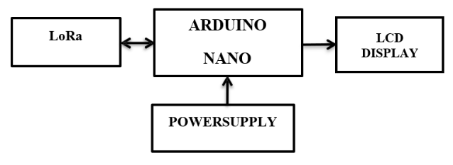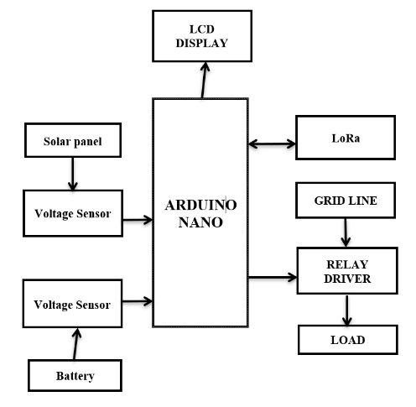**MODELING AND ANALYSIS**

**Figure 1:** Block diagram (n1) **Figure 2:** Block diagram (hub)

1. **RESULTS AND DISCUSSION**

Thus the use of LoRa transceivers for power monitoring and control in power systems offers significant advantages in terms of long range communication and low power consumption. These devices enable real time data transmission from remote sensors, allowing for efficient monitoring of electrical parameters such as voltage and energy consumption. LoRa technology facilitates the integration of devices into power systems, enhancing predictive maintenance, reducing operational costs and improving overall grid.

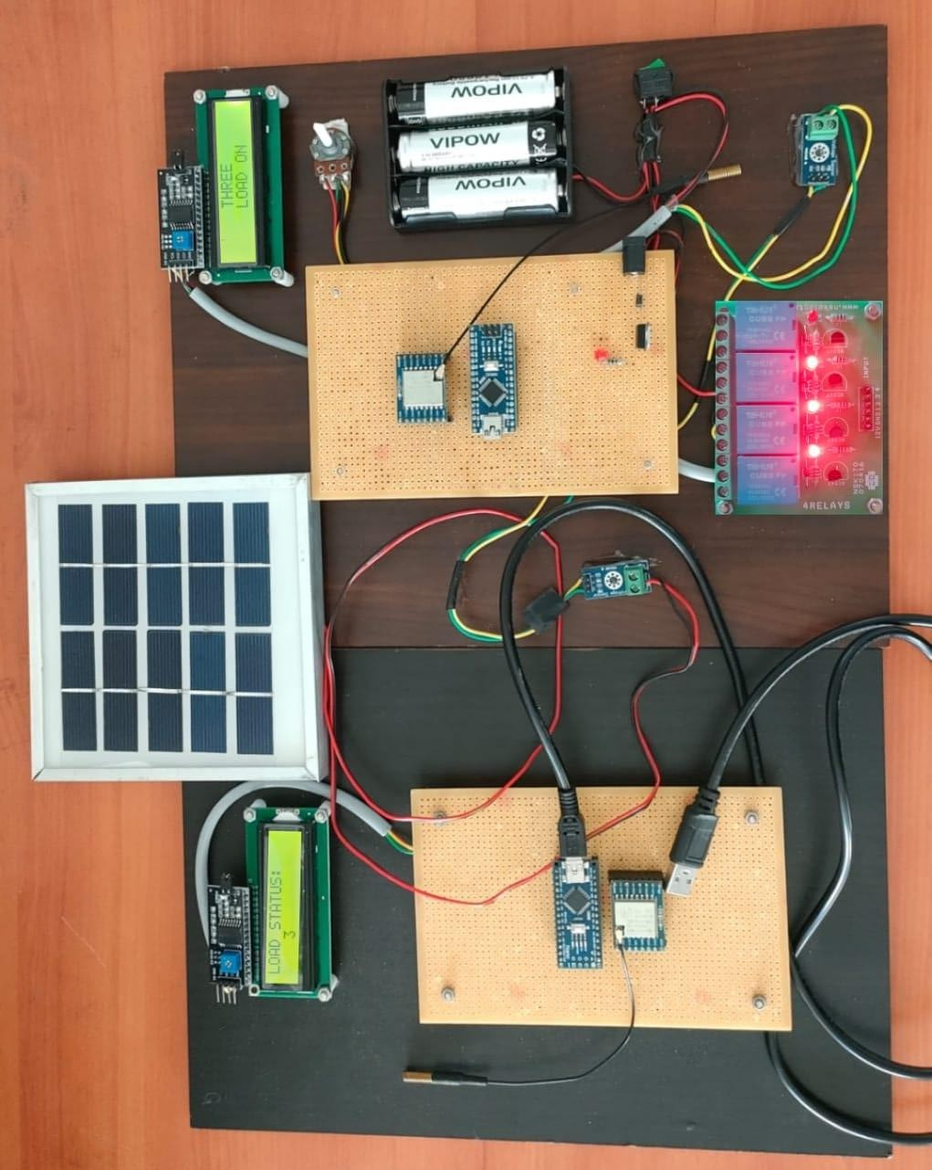

**Figure5.1 Hardware model of Lora based load monitoring and controlling power system**

1. **CONCLUSION**

The thesis demonstrates the effectiveness of LoRa transceivers for load monitoring, control in power systems, achieving accurate monitoring, reliable communication and efficient control. The LoRa based system offers advantages over traditional solutions, including long range communication, low power consumption and low cost. The research contributes to the development of smart grid technologies, enabling efficient monitoring and control of power distribution. The findings suggest utilities, grid operators consider adopting LoRa based solutions, future research should focus on integrating LoRa with emerging technologies and developing advanced control algorithms. Overall, the thesis showcases LoRa's potential to enhance power system efficiency, reliability and sustainability.

.

1. **REFERENCES**
2. Afgan, N. H., & Carvalho, M. G. (2008) “Sustainability assessment of a hybrid energy system”, Energy Policy, 36(8), 2903-2910.
3. Caspary, G. (2009) “Gauging the future competitiveness of renewable energy in Colombia”, Energy Economics, 31(3), 443-449.
4. García Vera, Y. E., Dufo-López, R., & Bernal-Agustín, J. L. (2019) “Energy management in microgrids with renewable energy sources”, A literature review, Applied Sciences, 9(18), 3854.
5. Hatziargyriou, N., Asano, H., Iravani, R., & Marnay, C. (2007) “An overview of ongoing research, development, and demonstration projects”, IEEE power & Energy magazine, 5(4), 79-94.
6. Lasseter, R. H. (2002) “Microgrids”, IEEE power engineering society winter meeting, Conference proceedings (Cat. No. 02CH37309) (Vol. 1, pp. 305-308). IEEE.
7. Meng, L., Sanseverino, E. R., Luna, A., Dragicevic, T., Vasquez, J. C., & Guerrero, J. M. (2016) “Microgrid supervisory controllers and energy management systems”, A literature review ,Renewable and Sustainable Energy Reviews, 60, 1263-1273.
8. Olatomiwa, L., Mekhilef, S., Ismail, M. S., & Moghavvemi, M. (2016) “Energy management strategies in hybrid renewable energy systems”, A review, Renewable and Sustainable Energy Reviews, 62, 821-835.
9. Parhizi, S., Lotfi, H., Khodaei, A., & Bahramirad, S. (2015) “State of the art in research on microgrids” , A review IEEE access, 3, 890-925.
10. Parhizi, S., Lotfi, H., Khodaei, A., & Bahramirad, S. (2015) “State of the art in research on microgrids”, A review. IEEE access, 3, 890-925.
11. Robert, F. C., Sisodia, G. S., & Gopalan, S. (2018) “A critical review on the utilization of storage and demand response for the implementation of renewable energy microgrids”, Sustainable cities and society, 40, 735-745.
12. Sivachandran, P., & Muthukumar, R. (2014) “An overview of microgrid system”, International Journal of Applied Engineering Research, 9(22), 12353-12376.
13. Thirugnanam, K., Kerk, S. K., Yuen, C., Liu, N., & Zhang, M. (2018) “Energy management for renewable microgrid in reducing diesel generators usage with multiple types of battery”, IEEE Transactions on Industrial Electronics, 65(8), 6772-6786.
14. Wu, J., Yan, J., Jia, H., Hatziargyriou, N., Djilali, N., & Sun, H. (2016) “Integrated energy systems”, Applied Energy, 167, 155-157.