**THE REVIEW ON ZIKA VIRUS**

**Ms.Snehal Koli(1),Dr.Rajmani Shabadi(2),Dr.Sable V.U(3),Dr.Rani Mhetre(4)**

**Author(1),Guide(2), Principal(3), Vice Principal(4)**

**Department of Pharmacy**

**Lokmangal College Of Pharmacy, Wadala Solapur, Maharashtra**

# ABSTRACT

Zika virus is a mosquito-borne flavivirus that is the cause of a current epidemic and public health emergency. Zika virus previously occurred only sporadically in Asia and Africa, but has spread rapidly throughout the Americas following the first outbreak in Brazil in 2015. Although most Zika virus infections result in subclinical or influenza- like illness, severe Guillain- Barre syndrome has been reported in adults, and microephaly has beed reported in inflants born to infected mothers.

Since there is currently no vaccine or effective treatment for Zika virus, public health interventions have focused primarily on preventing pregnancy in women. Although our understanding of this disease is increasing, concerns about its pathophysiology, genetic diversity, vectors, and reservoirs remain unresolved. It is associated with neurological diseases.

Vector control appears to be the most effective strategy currently available to prevent the spread of ZIK.

**KEYWORDS:** ZIKA VIRUS, Arbovirus, Flavirus, mosquitoes, Aedes, Viruses, Anomalies in the craniofacial region

# 1.INTRODUCTION

Zika virus is a flavivirus that was first discovered in Uganda in 1947. It was found in Aedes mosquitoes in Africa and was later found in fever rhesus monkeys (1). The first three cases were reported in Nigeria in 1954 (2). Observational studies in humans suggest that Zika virus is present in Oceania, Asia, and Africa (Technical Appendix Table 1). These studies were conducted in light of the overlap between Zika virus and similar flaviviruses such as dengue virus (DENV) and West Nile virus (WNV). Sporadic cases have spread throughout Asia and Africa since the 1960s [1,7,8,9,10]. Aedes Two years later, Africa (Aedes aegypti) and Malaysia

(Aedes aegypti) became the source of many ZIKV isolates, suggesting that these species may be endemic. Many human isolates of ZIKV were also obtained from East and West Africa in the

1960s and 1970s. Additional serologic studies in the 1950s and 1960s identified human cases of ZIKV in Egypt, Nigeria, Uganda, India, Malaysia, Indonesia, Pakistan, Thailand, Northern Vietnam, and the Philippines. Based on available data, it is thought that ZIKV may have moved west and north of the Wallace Line from Africa to Southeast Asia [10] , [11] .

According to the description, ZIKV is anarthropod-borne virus in the Flaviviridae family, which also includes the Hepativirus and Flavivirus genera. Hepatitis viruses include hepatitis C, while the former group includes Zika virus, yellow fever virus, West Nile virus, and dengue virus.

Co-infection of Zika virus with dengue virus (DENV) and chikungunya virus (CHIKV) has been reported in Polynesia and Brazil but is likely to occur elsewhere. It is now clear that ZIKV has spread to all countries where Aedes aegypti and Aedes albopictus are found via the same routes as DENV and CHIKV .We are currently conducting a review of all that is known about this

novel virus. , encephalitis B virus, and chikungunya virus (CHIKV) are endemic in tropical Asia.

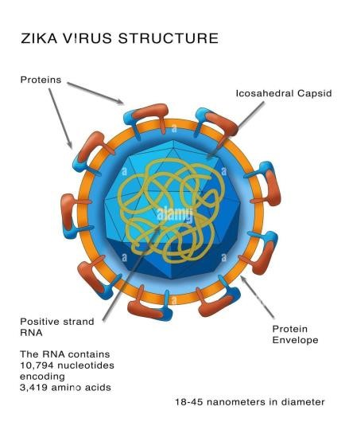

Figure 1. Zika virus structure

Compared with dengue fever, Zika virus has not been studied sufficiently in Asia because the virus is considered a public health problem and was long thought to be a negative disease before a problem with the nervous system was identified. 28 Most of the findings published in the literature 20 date back to the 1950s. Although the sensitivity of these serologic tests is problematic, these studies provide important information about ZIKV infection in Asia. As of September 1, 2016, imported or domestic Zika virus has been reported in all Asian countries

except Brunei, Hong Kong, Myanmar, and Nepal. Map of Asian countries reporting Zika virus outbreaks as of September 1, 2016 [ 15;16]

Figure . Map of Asian countries in which Zika virus circulation has been reported up to September 1, 2016

Year. people. Number of cases Diagnosis

Methods

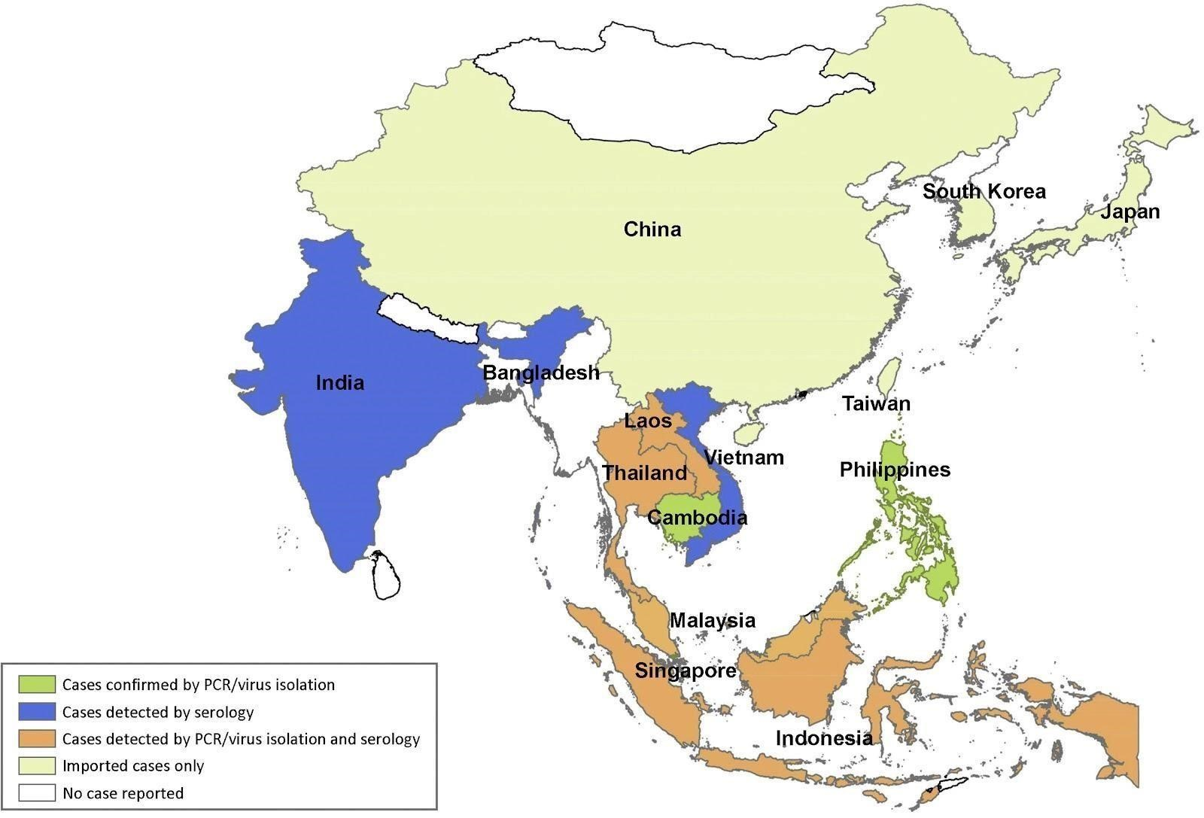

**INDIGENOUS TRANSMISSION**

1. India 33/196 (16.8) NT
2. Philippines 19/153 (12.4). NT$

1953. Malezya. 75/100 (75). NT

1953 Malezya 15/79 (19) NT

1. Borneo. 9/50 (18) NT
2. Tayland 8/50 (16) NT

1954 Vietnam 2/50 (4) NT

1977 Endonezya. 7/219(3.2). HI

1983 Indonesia 9/71 (12.7) HI

1983 Pakistan 1/43 (2.3) CF

2015 Indonesia 1 PCR 1969

2012 Thailand 2/21 (9.5) Western blot

2016 Thailand 97 Unknown

**2.HOW TO ZIKA VIRUS SPREAD?**

Most mosquitoes are Aedes mosquitoes, which can come from several families, including Aedes aegypti, Aedes albopictus, Aedes polynesia, Aedes vita and Aedes mosquitoes. unilineatus and A. hensilli are among many other subtypes previously recorded [9]. There have also been reports of vertical transmission from infected mothers to their fetuses via the placenta. Zika virus can also be transmitted through blood transfusion and through anal, genital or oral contact with an infected person. Mosquito-borne diseases, including Zika, are more common in areas with poor sanitation and infrastructure. The perfect combination of overcrowding, lack of water, stagnant water, household sewage, streets full of garbage, and mosquitoes around garbage dumps has increased Zika virus in poor communities. The recent Zika outbreak in Brazil has clearly benefited the poor region.

To date, Brazil has recorded approximately 1.5 million cases of Zika infection, mainly in the northeastern states of Pernambuco, Bahia, and Paraiba .On February 1, 2016, the World Health Organization recognized mosquito-borne Zika virus and vertebrates as a public health problem [1]. The virus was first isolated from Aedes mosquitoes in the Zika forest in 1948 [10]. The main

role of Ae. aegypti mosquitoes has been found to feed on the blood of sick people and to spread the disease to healthy people. Other species of Aedes mosquitoes have also been prepared; Aedes albopictus is a serious pest that poses a threat to both urban and rural areas and plays a role in the spread of the disease [11], [12]. As the spread of the Aedes mosquito continues to spread worldwide, the potential for arbovirus transmission is also increasing. aegypti and Aedes albopictus [13]. Molecular analysis was performed on 37 viruses isolated in 2014. According to a retrospective report published in December 2015, the virus was found in the semen of a 44-year-old man who was diagnosed with Zika virus two weeks ago [16 ]. Although the mechanism of transmission has not yet been determined, the Centers for Disease Control (CDC) announced in February 2016 that it could be transmitted sexually to 14 people [17]. It is known that Zika virus can be transmitted through sexual contact by infected bacteria (18). Although ZIKV RNA can persist in semen for up to 62 days, infection usually occurs before 19 days after sexual intercourse, and only one case has been recorded. Pregnant women have been infected with Zika virus during pregnancy and mother-to-child transmission has been detected. In addition, two cases in French Polynesia have reported perinatal transmission associated with

## 3.BLOOD TRANSFUSION

Infection in infants. Musso et al. reported the possibility of transmission through blood donation from infected individuals during the ZIKV outbreak in French Polynesia [22]. 4. Clinical presentation.

## 4.PATHOGENESIS

Zika is usually spread by walking in the woods. It is classified as an arbovirus that spreads from one person to another through mosquito bites. Virions have three distinct stages: immature (non-infectious), mature (infectious), and fused (attached to the host membrane). Humans are an unlikely host for virions throughout their life cycle. Sheep, elephants and goats carry antibodies to Zika virus, suggesting that monkeys and apes may also be hosts for the virus.[20] Although the pathophysiology of Zika virus is unclear, it is thought that most arboviruses replicate in cutaneous dendrites at the initial injection site, then migrate to nearby lymph nodes and eventually enter the blood vessels [8]. This virus is said to infect the human host during an incubation period of four to five days. It is then infected with a different virus during a blood meal

that lasts eight to twelve days, before being transmitted to a second host by the vector's saliva, as shown here.[21]

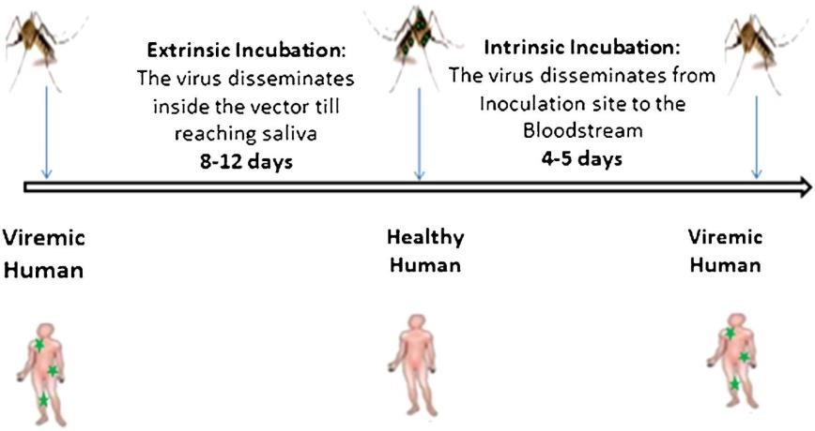

**5.SYMPTOMS**

Fever

Headache

Joint pain

Rash

Muscle pain

Abdominal pain

Sore throat

Vomiting

Diarrhea

Similar to dengue fever and chikungunya. Zika fever occurs after three to twelve days of incubation [16]. Common symptoms include fever, headache, red eyes, joint pain and a maculopapular rash. No one is known to die from the initial stage of infection, and symptoms usually appear in less than a week. Pregnant women infected with Zika virus may develop microcephaly and other brain abnormalities [18-19]. Guillain-Barré Syndrome (GBS) has also been associated with infection in previously healthy individuals.

**6.DIAGNOSIS**

Patients with symptoms of viremia during the regular period of the Aedes mosquito should be suspected of having Zika virus if they have had recent Zika virus infection or unprotected sexual

intercourse. Serum reverse transcription polymerase chain reaction (RT-PCR) for detection of ZIKV RNA or ZIKV serology (IgM antibodies) is used to diagnose ZIKV. Serum RT-PCR is positive if performed during the acute phase of the disease (i.e., within the first 3 to 7 days after the onset of the disease). Specific antibodies (IgM antibodies) to ZIKV can be found in the blood as early as four days after the onset of symptoms. [22,23]

Studies in the clinical literature suggest that it takes longer to detect ZIKV RNA in patient saliva and urie than in blood using RT-PCR. Fetal ultrasound can detect abnormalities as early as 18-20 weeks of pregnancy, depending on the operator, and is used for fetal assessment in pregnant women suspected of having ZIKV infection (who have also been exposed to ZIKV). Microcephaly (head circumference more than two standard deviations below the mean for gestational age), intracranial calcifications (cerebellum, intraocular, cerebral), anencephaly, ventriculomegaly, cerebral atrophy, hypohydramnios, hydrops fetalis, and enlargement of the disease throughout th

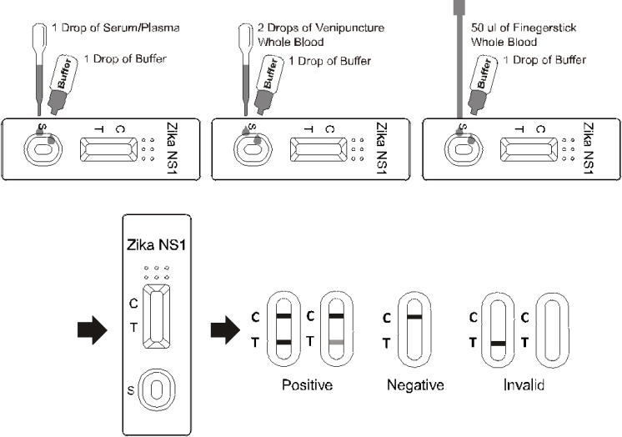

**7.PREVENTION**

Many species of Aedes mosquitoes are important vectors for the transmission and spread of dengue fever, chikungunya, and Zika virus. Therefore, strategies to prevent mosquitoes are the first step in prevention. These strategies include cleaning dog kennels, using insecticides, and using insect repellents such as picaridin or N,N-diethyltoluamide (DEET). Plan well to eliminate mosquito breeding sites in homes and high-risk areas such as construction sites, dumps, dirty traffic areas, and storage areas. High-traffic areas such as schools, churches, health care facilities, and transportation should have at least 400 m of mosquito-free space. In areas where Zika virus has been detected, insecticides should be investigated for mosquito control. When outdoors, visitors and locals in affected areas should use insect repellent or limit their time outdoors. Long pants, long shirts, and clothing treated with permethrin, if possible, should be worn . It is recommended that blood donors undergo a universal nucleic acid test. Universal primers that can detect multiple arboviruses simultaneously should be considered. Another important precaution is to temporarily suspend blood donations in the event of an outbreak. In disease-free areas, blood donors should complete a questionnaire regarding their recent travel history to identify potential donors. Similarly, organs, especially kidneys, donated by individuals with recent travel history to affected areas should be tested for ZIKV because the virus can persist in the genitourinary tract for an indefinite period . Safe sex practices are also recommended to prevent sexual transmission of Zika virus.[24;25]

**8.** **TREATMENT**

Currently there is no treatment for zika virus

A person with symptoms should –

* Rest
* Increase fluid intake to prevent dehydration
* Take over the counter pain killer to relive pain and fever
* Mosquito avoidance
* Supportive care
* Pregnancy monitoring
* Alternative therapies

The CDC advice against using aspirin or other non- steroidal anti- inflammatory drugs until a diagnosis of dengue has been ruled out in those at risk due to the risk of hemorrhage.

## 9.VACCINATION

There are currently no vaccines in development. However, ZIKV vaccines are expected to present similar challenges to arbovirus vaccines because outbreaks can occur rapidly and are rare. Therefore, they may not be effective in protecting large populations during an outbreak [14],As of March 2016, several ZIKV vaccines are being developed by 18 universities and pharmaceutical companies, including inactivated vaccines, live vaccines, DNA vaccines, and anti-inflammatory drugs. Each of these vaccines has advantages and disadvantages. For example, live vaccines can produce long-lasting antibodies, but safety concerns have been raised, especially among pregnant women and children.[26]

## 10.CONCLUSION

According to the review, monkeys and tree-dwelling mosquitoes such as Aedes africanus are the main carriers of ZIKV. It rarely causes serious disease in humans, even in areas where it is highly endemicity. There is currently no effective drug to treat Zika virus. However, this virus has some unique therapeutic targets that could lead to the development of customized ZIKV vaccines. especially the quality of life of children and pregnant women. This situation can be easily prevented if proper precautions and health management are taken. As epidemics occur every year around the world, all healthcare organizations need to make appropriate plans ahead of the busy season.

**REFERENCE**

1.Anna R Plourde, Evan M Bloch

Emerging infectious disease 22(7), 1185, 2016

2. Vivian C Agumadu , Kamleshun Ramphul

Cureus 10 (7), 2018

3 Abdelrahman Ibrahim Abushouk, Ahmed Negida, Hussien Ahmed

Journal of clinical virology 84, 53-58, 2016

4, Saeed Reza Jamali Moghadam, Samaneh Bayrami, Sepideh Jamali Moghadam,

Fatemeh Golsoorat Pahlaviani

Asian Pacific Journal Of Tropical Biomedicine 6 (12), 988-994, 2016

5, Didier Musso, Duane J Gubler

Clinical microbiology reviews 29 (3), 487-524, 2016

6, John S Murray PhD, MSGH, RH, CPNP

Journal for specialists in Pediatric Nursing 22 (1), e12164, 2017

7, Rawal Gautam, Yadav Sankalp, Kumar Raj

Journal of family medicine and primary care 5(3); P 523-527, Jul- Sep 2016

1. M.R. Duffy, T.-H.H. Chen, W.T. Hancock, A.M. Powers, J.L. Kool, R.S. Lanciotti, et al.

Zika virus outbreak on Yap Island, federated states of Micronesia New Engl. J. Med., 360 (24) (2009), pp. 2536-2543 2009/06/12 ed., Mass Med. Soc.

9 . J.C. Kwong, J.D. Druce, K. Leder

Zika virus infection acquired during brief travel to Indonesia

Am. J. Trop. Med. Hyg., 89 (3) (2013), pp. 516-517

2013/07/24 ed., ASTMHA

10. R.S. Lanciotti, O.L. Kosoy, J.J. Laven, J.O. Velez, A.J. Lambert, A.J. Johnson, et al.

Genetic and serologic properties of Zika virus associated with an epidemic, Yap State ,

Micronesia, 2007Emerg. Infect. Dis., 14 (8) (2008), pp. 1232-12392008/08/06

ed.Viepublisher Crossref

11 .E. Oehler, L. Watrin, P. Larre, I. Leparc-Goffart, S. Lastere, F. Valour, et al.

Zika virus infection complicated by Guillain-Barre syndrome-case report, French Polynesia, December 2013

Euro Surveill., 19 (9) (2014) 2014/03/15

1. .A.H. Fagbami

Zika virus infections in Nigeria: virological and seroepidemiological investigations in Oyo State

J. Hyg.: Lond., 83 (02) (1979), pp. 213-219

1979/10/01 ed., Cambridge Univ. Press

1. E.B. Hayes

Zika virus outside Africa Emerg. Infect. Dis., 15 (9) (2009), pp. 1347-1350 2009/10/01 ed.

14.A.J. Haddow, M.C. Williams, J.P. Woodall, D.I.H. Simpson, L.K.H. Goma

Twelve isolations of zika virus from aedes (stegomyia) africanus (theobald) taken in and above a uganda forest

Bull. World Health Organ., 31 (1) (1964), p. 57

1964/01/01 ed., World Health Organization

15.O. Dyer

Trials of Zika vaccine are set to begin in North America

Br. Med. J., 3588 (353) (2016)

British Medical Journal Publishing Group

16. A.P. Durbin

Vaccine development for Zika virus—timelines and strategies

Seminars in Reproductive Medicine, Thieme Medical Publishers (2016)

17. M. Lipsitch, B. J. Cowling

Zika vaccine trials

Science, 353 2016

18.WHO

Zika Virus Fact Sheet [Internet] World Health Organization (2016) Available from: <http://www.who.int/mediacentre/factsheets/zika/en/>

19.A. Gulland

Genetically modified mosquitos may be used in fight against Zika

BMJ, 352 (Feburary) (2016), p. i1086

20. E.E. Petersen, J.E.Staples, D.Meaney-Delman, M.Fischer,S.R.Ellington,W.M.Callaghan et

Interim guidelines for pregnant women during a zika virus outbreak—United States

MMWR Morb. Mortal. Wkly. Rep., 65 (2) (2016), pp. 30-33 2016/01/23 ed

21. T. Oduyebo

Update interim guidelines for health care providers caring for pregnant women and women

reproductive age with possible Zika virus exposure—United States

MMWR Morb. Mortal. Wkly. Rep., 65 (2016) (2016)

22. A.M. Oster

Interim guidelines for prevention of sexual transmission of Zika virus—United States

MMWR Morb. Mortal. Wkly. Rep., 65 (2016) (2016)

23.Wikan N, Smith DR. First published report of Zika virus infection in people: Simpson, not

McNamara Lanacet Infect Dis 2017;17 15-

First published report of Zika virus infection in people: Simpson, not McNamara.Crossref |

24. Basu R, Tumban E. Zika virus on a spreading spree: what we now know that was unknown in in the 1950s. Virol J 2016; 13 165–73.

| Zika virus on a spreading spree: what we now know that was unknown in the 19 50s. C r o s s 1950s Crossref

25. World Health Organization (WHO). WHO statement on the first meeting of the Internatonal

Health Regulations (2005) (IHR 2005) Emergency Committee on Zika virus and observed

Increase in neurological disorders and neonatal malformations. WHO statement world health

organization

http://www.who.int/mediacentre/news/statements/2016/1st-emergency-committee-zika/en/

26. World Health Organization (WHO). Zika virus, microcephaly, Guillain–Barre syndrome.

Situation Report: World Health Organisation (WHO); 2017. Available online at:

<http://www.who.int/emergencies/zika-virus/situation-report/10-march-2017/en/>

27. Duffy MR, Chen T-H, Hancock WT, Powers AM, Kool JL, Lanciotti RS, Pretrick . Duffy Ch Chen T-H, Hancock WT, Powers AM, Kool JL, Lanciotti RS, Pretrick . Duffy MR,

Hancock WT, Powers AM, Kool JL, Lanciotti RS, Pretrick .

Zika virus outbreak on Yap Island,