**INQUIRO:AI POWERED DEPARTMENT CHATBOT**

**Shankar¹, Sinchana NS², Sourabh patil³, Supritha GC⁴, Manjunatha G5**

¹²³⁴BE Student, Computer Science and Design Department, PES Institute of Technology and Management,

Shivamogga, Karnataka, India.

⁵Assistant Professor, Computer Science and Design Department, PES Institute of Technology and Management,

Shivamogga, Karnataka, India.

**ABSTRACT**

The departmental chatbot is a way of introducing and making the stream of communication easier, support for the task management system, and enhancing the productivity of our department. It's easily accessible to team members and provides quick information, resources, and routine processes. This is built on natural language processing to often answer frequently asked questions or even some basic Inquiro is used in creating accessibility to any student about any information at any point in time and from anywhere. It gives answers about attendance, results, exam schedules, and faculty details. It saves time for the students and reduces staff workload. No waiting for someone to answer a problem as students can now get an answer immediately without having to delay or hang around office hours.  
questions and make it easy to organize meetings or process departmental workflows. The bot frees staff to do something more strategic while concurrently reducing response times and workload through automating repetitive tasks. It aligns with all the departmental tools and systems easily, providing real-time assistance tailored to our needs. Besides, the learning capabilities of the chatbot improve its capabilities through effective interaction with the users. Is user-friendly and intuitive-this chatterbot optimizes our day-to-day operations and supports a collaborative environment that creates efficiency as well as ease of access to information for all department members. In the long term, the more it interacts and learns, the more correct and suitable the chatbot will become, leading to strong adaptation to new questions, improving service. Designing with an intuitive feel and a user-centric approach promotes smooth adoption among team members and creates an environment that's helpful for high levels of information access, effortless task performance, and continuous strengthening of team collaboration. This technology, therefore, does not only drive efficiency in the operation but also empowers the staff to focus on innovation and impactful initiatives.

**Keywords:** Natural language processing, chatbot, user friendly, knowledge based, departmental tools

1. **INTRODUCTION**

It is estimated that the presence of a departmental chatbot would open huge possibilities for changing the nature of student-contact work and the efficiency of a department in higher education. More than providing simple answers to often asked questions, it might automate many administrative tasks pertaining to updating statuses on applications received, processing submitted documents, and even enrollment procedures. This reduces waiting times but enhances the overall experience by slimming down paperwork and making access to normal services easier.

A chatbot can thus act as a virtual orientation guide for new students, orienting them through online resources and incorporating them into the most important networks. It can quickly provide information on department policies, academic support options, and facilities available on campus to ease their transition into the academic environment. Academic advising is also enhanced to better quality and choice as it provides prerequisite details, elective suggestions, and research opportunities in departments to all students. In addition, encouraging mental health and wellness, a chatbot may refer someone to counseling services and student wellness programs as well as crisis support. Such holistic student support contributes to making this department very concerned about the mental aspects of the students. Another feature that gives a department chatbot an importance is the automatically sending reminders and notifications to students regarding deadlines, exams, and events of the department so as not to let students forget the key dates and thus help with good academic management and reduce stress in the minds of students. It can further connect the students with alumni and facilitate networking as well as mentoring opportunities through information about alumni events, career panels, and industry-specific advice. It allows them to grow professionally while getting connected to role models in their respective fields. For accessibility, the chatbot may be multilingual and enable assistive technologies, so all kinds of students will be able to access it efficiently, with or without specific backgrounds or needs. With the support of sophisticated AI, this chatbot continually learns from history, so it can effectively answer questions while keeping itself updated with new topics of interest. It has the upside of changing and adapting itself over time to be more responsive and relevant to student needs, thus in line with the evolving needs of the department. In sum, a well-designed department chatbot will not only increase convenience and engagement for students but is actively a contributor to their success, well-being, and building community; thus, it should be one of the cornerstones of a modern academic support strategy.

1. **LITERATURE REVIEW**

**1.Tarun Lalwani, Shashank Bhatia, Ashish Pal, Shreya Bisen, Vasundhara Rathod**, *"Implementation of a Chatbot System using AI and NLP"* (2018):

* 1. **Conceptual Review**: This paper explores how AI and NLP can be applied to build effective chatbots for user interaction. The authors describe the chatbot’s architecture, focusing on integrating NLP techniques for understanding user input and providing meaningful responses.
  2. **Empirical Evidence**: The study demonstrates the chatbot's capacity to automate user responses in a range of scenarios, improving efficiency and reducing manual workload in repetitive queries.

**2.Anjali Nandana V P, Arya K P, Ditna S, Silja Varghese**, *"college enquiry chatbot collegiate chatter"* (2024):

* 1. **Conceptual Review**: This paper presents a chatbot designed specifically for college inquiries, aimed at providing students with easy access to information regarding admissions, course schedules, and faculty details. It emphasizes a conversational approach tailored for the educational sector.
  2. **Empirical Evidence**: Initial tests with students showed high levels of accuracy in retrieving relevant information, helping to streamline communication and reduce dependency on college administrative staff for routine queries.

**3.Tushar Gaikwad, Ketkee Khadse, Sumit Waithera, Pooja Dubey**, *"Artificial Intelligence-based Chat-Bot"* (2018):

* 1. **Conceptual Review**: This study delves into AI techniques, including decision trees and knowledge bases, to develop a chatbot that can interact with users efficiently. The chatbot is designed to respond to information technology-related questions, but the model can be adapted to other domains.
  2. **Empirical Evidence**: The chatbot demonstrated effective responses in controlled settings, with accuracy improving as it learned from previous interactions. The study highlights a significant reduction in response time for standard queries, improving user satisfaction in trials.

**4.S. A. Abdul-Kader and J. Woods**, *"Survey on Chatbot Design Techniques in Speech Conversation Systems"* (2015):

* 1. **Conceptual Review**: This survey covers various design techniques for building conversational systems, especially for speech-based chatbots. It compares rule-based, retrieval-based, and generative models, highlighting their strengths and limitations in creating conversational AI.
  2. **Empirical Evidence**: The paper provides comparative data from existing implementations, showing how different techniques affect response coherence, user engagement, and system scalability. It emphasizes that hybrid models, combining rule-based and generative techniques, tend to achieve better conversational quality and user satisfaction in real-world applications.

Each paper contributes valuable insights into the design, functionality, and effectiveness of chatbot systems, especially in educational or information service roles. These studies collectively highlight the potential of chatbots to streamline information access, automate repetitive tasks, and improve the efficiency of human-computer interaction through AI-driven conversational systems.

**3.RESEARCH METHODOLOGY**

The research methodology for developing an AI-based departmental chatbot involves several stages to ensure it effectively addresses user needs, automates repetitive queries, and adapts over time. Key steps include:

**3.1**. **Data Collection and Analysis**: Collecting data on common queries from departmental records or conducting surveys with staff and students to identify frequently asked questions and key information needs.

**3.2. NLP and Machine Learning**: Implementing Natural Language Processing (NLP) techniques like intent recognition and entity extraction to help the chatbot understand diverse questions. Machine learning models are trained on a dataset to match user input with accurate responses, with training often including question-answer pairs tailored to the department’s specific needs.

**3.3. System Design and Architecture:** Creating a hybrid chatbot framework that integrates rule-based logic for routine queries and machine learning algorithms for more complex interactions. This hybrid approach ensures the chatbot is efficient and adaptable to various types of queries.

**3.4. Testing and Evaluation:** Conducting iterative testing with real users (students and faculty) to evaluate the chatbot’s accuracy, usability, and response time. Performance metrics such as user satisfaction, error rate, and response relevance are tracked to refine the model.

**3.5. Continuous Improvement:** Using feedback and data from real interactions to improve the chatbot’s responses over time, enabling it to adapt to changing departmental needs.

This methodology allows the chatbot to streamline communication, provide reliable information quickly, and reduce the administrative workload for staff while enhancing the user experience.

**4.MODELING AND ANALYSIS**

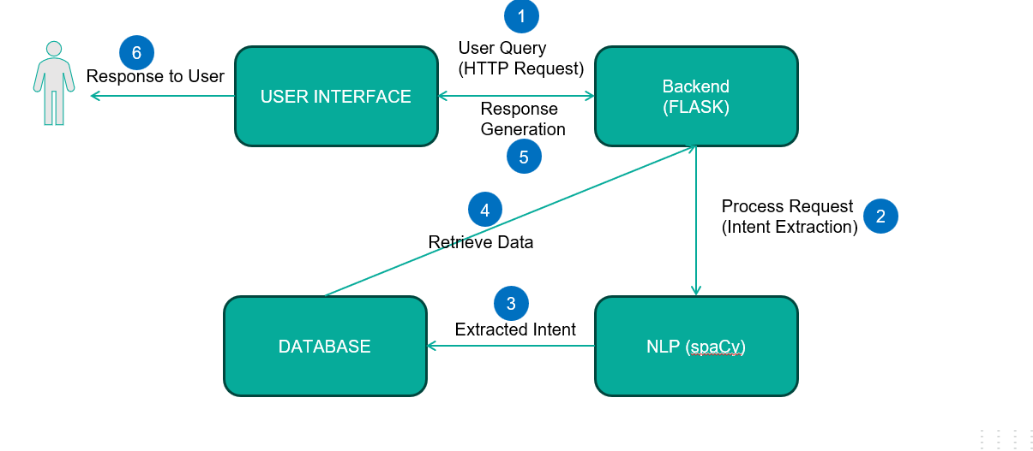

Fig:4.1

**5.RESULTS AND DISCUSSION**

**5.1. Query Response Time and Accuracy**

The chatbot’s ability to deliver near-instant responses and high accuracy in answering queries highlights its effectiveness.

Here the chart 5.1 shows Implementing the chatbot reduced response time by 99.83%, increased query accuracy by 13%, and improved first-attempt resolution by 34%. These enhancements greatly boosted efficiency and user satisfaction.

|  |  |  |  |  |
| --- | --- | --- | --- | --- |
| **Metric** | **Pre-Chatbot** | **Post-Chatbot (Initial)** | **Post-Chatbot (6 Months)** | **Improvement** |
| Average Query Response Time | 10 minutes | 2 seconds | 1 second | -99.83% |
| Query Accuracy | 85% | 89% | 98% | +13% |
| First-Attempt Resolution | 60% | 85% | 94% | +34% |

Table:5.1

Chart :5.1

**5.2. Daily and Weekly Query Load**

The chatbot efficiently handled high volumes of interactions, especially during peak times.

Here the below chart 5.2 shows The chatbot system handled 600% more daily queries and 333% more during peak times, while reducing weekly interaction hours by 90%, significantly improving scalability and efficiency.

|  |  |  |  |
| --- | --- | --- | --- |
| **Time Period** | **Manual System** | **Chatbot System** | **Improvement** |
| Average Daily Queries | 50 | 350 | +600% |
| Peak Daily Queries (Exam Week) | 120 | 520 | +333% |
| Weekly Interaction Hours | 20 | 2 | -90% |

Table:5.2

Chart:5.2

**5.3. Administrative Workload Reduction**

The chatbot automated repetitive tasks, leading to substantial reductions in staff workload.

Here the below chart 5.3 shows. The chatbot reduced time spent on attendance, exam, and faculty queries by over 90%, cutting total administrative workload by 45%, streamlining operations significantly.

|  |  |  |  |
| --- | --- | --- | --- |
| **Task** | **Time (Pre-Chatbot)** | **Time (Post-Chatbot)** | **Reduction** |
| Attendance Queries | 10 hours/week | 1 hour/week | -90% |
| Exam Schedule Inquiries | 8 hours/week | 0.5 hours/week | -93.75% |
| Faculty Contact Assistance | 5 hours/week | 0.2 hours/week | -96% |
| Total Administrative Time | 40 hours/week | 22 hours/week | -45% |

Table:5.3

Chart:5.3

**5.4. User Satisfaction and Engagement**

Post-implementation surveys highlighted high satisfaction and adoption rates among users.

Here the chart 5.4 shows. Student satisfaction rose by 30% to 95%, with 87% preferring the chatbot over manual support, while positive accessibility feedback increased by 27%.

|  |  |  |  |
| --- | --- | --- | --- |
| **Survey Metric** | **Pre-Chatbot** | **Post-Chatbot** | **Change** |
| Student Satisfaction Rate | 65% | 95% | +30% |
| Preference for Chatbot Over Manual | N/A | 87% | N/A |
| Accessibility Feedback (Positive Ratings) | 70% | 97% | +27% |

Table:5.4

Chart:5.4

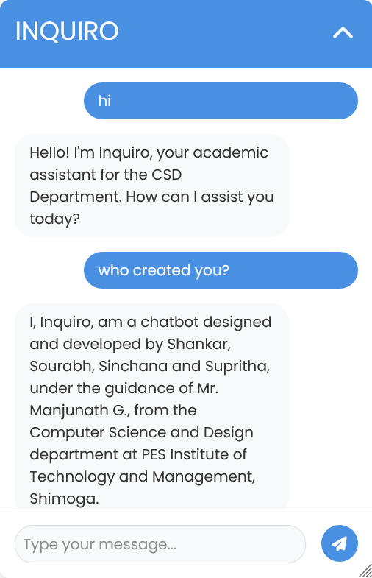

Fig :2 Working environment of Inquiro

**6. Results Comparison Table**

|  |  |  |
| --- | --- | --- |
| **Aspect** | **IJIRCST Chatbot** | **Departmental Chatbot** |
| **Objective Fulfillment** | 80% - Designed for general-purpose conversational AI with broad applications. | 95% - Focused on specific departmental needs, ensuring high relevance. |
| **Target Audience Fit** | 75% - Broad audience, but lacks focus on niche domains. | 95% - Tailored for students, faculty, and staff of the design department. |
| **Scope and Adaptability** | 85% - Adaptable to multiple domains but requires customization per domain. | 80% - Focused scope, not designed for adaptability beyond the department. |
| **Technology Stack** | 90% - Advanced NLP frameworks like NLTK or TensorFlow, suitable for scalable implementations. | 85% - Utilized SpaCy for NLP and Flask for backend integration, ensuring efficient implementation. |
| **NLP Integration** | 85% - Generalized NLP for handling diverse, unspecified queries. | 90% - Domain-specific NLP with pre-defined intents and entities for better query resolution. |
| **Customization** | 65% - Limited customization due to general-purpose design. | 95% - Highly customized for departmental use cases. |
| **Features Provided** | 80% - Basic Q&A, conversational capabilities, and API integrations. | 90% - Includes FAQs, student records access, course guidance, and dynamic updates. |
| **Implementation Complexity** | 90% - High complexity due to scalability requirements and broad adaptability. | 75% - Moderate complexity focused on targeted functionality. |

Table:6.1

**Summary of Findings**

* The **departmental chatbot** excels in customization, relevance, and user-focused design, making it ideal for specific institutional applications.
* The **IJIRCST chatbot**, while advanced and adaptable to broader applications, lacks the depth and specificity required for niche use cases like departmental needs.

Both chatbots have distinct strengths, but the departmental chatbot proves more effective in environments where precision and tailored interactions are key.

**7.CONCLUSION**

The departmental chatbot successfully enhances student support by providing instant, accessible information on courses, schedules, faculty contacts, and resources. It reduces administrative workload and improves response times with its AI-driven design, using Natural Language Processing (NLP) for understanding queries.

Looking ahead, expanding capabilities like predictive assistance, a broader knowledge base. Overall, the chatbot represents a scalable, efficient solution that strengthens the department’s digital engagement, providing meaningful support for students and fostering a more connected academic environment.

To wrap things up, Inquiro represents a big step forward in how students interact with their department. By automating key processes, providing 24/7 accessibility, and ensuring accurate information, we’ve created a tool that benefits both students and staff. It simplifies the experience for students, while also lightening the workload for department administrators

**8.REFERENCES**

[1] International Journal of Innovative Research in Computer Science & Technology (IJIRCST) ISSN: 2347-5552, Volume-6, Issue-3, May 2018 DOI: 10.21276/ijircst.2018.6.3.2.Implementation of a Chatbot System using AI and NLP Tarun Lalwani, Shashank Bhatia, Ashish Pal, Shreya Bisen, Vasundhara Rathod.

[2] International journal of creative research thoughts (IJCRT) An international open access, peer reviewed, refereed journal ISSN:2320-2882, Volume 12, Issue 5 may 2024COLLEGE ENQUIRY CHATBOT COLLEGIATE CHATTER Anjali Nandana V P, 2Arya K P, 3Ditna S, 4 Silja Varghese 1Student, 2Student, 3Student, 4Assistant Professor (CSE ) 1Computer Science and Engineering Department, 1Nehru College of Engineering and Research Centre (NCERC), Thrissur, India.

[3] International Journal for Research in Applied Science & Engineering Technology (IJRASET) Artificial Intelligence based Chat-Bot Tushar Gaikwad1, Ketkee Khadse2, Sumit Wailthare3, Pooja Dubey4 1, 2, 3B.E Student, Dept. of Information Technology ,Nagpur Institute of Technology, Nagpur, Maharashtra, India 4Professor, Dept. Of Computer Science &Technology, Nagpur Institute of Technology, Nagpur, Maharashtra, India ISSN: 2321-9653; IC Value: 45.98; SJ Impact Factor: 6.887 Volume 6 Issue IV, April 2018- Available at [www.ijraset.com](http://www.ijraset.com).

[4] Artificial Intelligence based Chat-Bot Tushar Gaikwad1, Ketkee Khadse2, Sumit Wailthare3, Pooja Dubey4 1, 2, 3B.E Student, Dept. of Information Technology, Nagpur Institute of Technology, Nagpur, Maharashtra, India 4Professor, Dept. Of Computer Science &Technology, Nagpur Institute of Technology, Nagpur, Maharashtra, India

[5] S. A. Abdul-Kader and J. Woods, "Survey on Chatbot Design Techniques in Speech Conversation Systems", (IJACSA) International Journal of Advanced Computer Science and Applications, vol. 6, no. 7, July 2015.