# PETSKART - A WEBSITE FOR BUYING , SELLING AND ADOPTION OF ANIMALS AND PETS

**Dr.Mahendra Makesar1,Yash Jogi2,Khushi Gupta3, Khushi Gupta4, Kamakshi Samarth5**

1Associate proff, IT, Nagpur Institute of Technology, Nagpur, Maharashtra, India

2UG Student, IT, Nagpur Institute of Technology, Nagpur, Maharashtra, India

3UG Student, IT, Nagpur Institute of Technology, Nagpur, Maharashtra, India

3UG Student, IT, Nagpur Institute of Technology, Nagpur, Maharashtra, India

4UG Student, IT, Nagpur Institute of Technology, Nagpur, Maharashtra, India

**ABSTRACT**

The digital transformation of pet ownership and pet care has led to an increased demand for online platforms that facilitate the purchase, adoption, and sale of animals and livestock. This article explores the development and impact of general websites designed to meet these needs. In addition to business support, the platform offers pet owners a variety of solutions that support member responsibility and enhance animal welfare. The platform provides a digital store where pet owners can bypass traditional sales, such as shows and staff, to offer their animals directly to buyers, resulting in better returns and faster sales times. Buyers benefit from a streamlined process, access to proven livestock, and comprehensive training programs designed to improve animal health and productivity. Given the significant role of livestock in the Indian economy (accounting for 4.11% of the country’s GDP and supporting the livelihoods of 20.5 million people), the platform addresses the challenges of the economy where animal footprints are uncoordinated and inconsistent. The ecosystem concept ‘Petskart’ aims to increase value for all partners and improve the economics of livestock farming and the broader economy for rural communities by introducing new business models and technologies.

**Keywords**: Digital transformation,Pet ownership,Pet care,Online platforms,Purchase,Adoption,Animal welfare,Livestock,Digital store,Buyers,Petskart,Animal health,Productivity,Streamlined process

1. **INTRODUCTION**

In today’s digital age, the way we treat and care for animals has changed a lot. The increasing demand for a simple and reliable platform to buy, adopt and sell animals and pets has led to the creation of specialized websites. This report explores the development and impact of a comprehensive website designed to promote the purchase, adoption and sale of animals and pets. The platform offers a variety of solutions that meet the needs of pet owners as well as commerce, increase pet owner responsibility and improve pets’ clean drinking wellbeing. Our goal through this website is to promote the health and happiness of pets and their owners by connecting pet lovers with the resources they need to make heartbreaking decisions. Show people their pets to a variety of buyers. This platform helps them achieve better results without having to participate in animal auctions with employees or sell at low prices, thus reducing the waiting time for sales. Users of the interactive system also have access to a wide range of information, research and knowledge on animal husbandry to help ensure animal health and production. Approximately 20.5 million people, or about twothirds of India’s rural population, depend on animal husbandry for their livelihood, and the industry employs 8.8% of the population. The livestock sector contributes 4.11% to India’s GDP and 25.6% to its agricultural GDP. Cattle are particularly important, providing essential inputs such as fertiliser and traction, supporting agriculture and providing a stable income for many rural families. Livestock also creates many jobs and opportunities for small businesses. Purchases are usually made through traditional methods such as the market, word of mouth or employees, which leads to different and inconsistent information about the quality of the products. Therefore, the profits of animal owners vary. Access to quality and affordable animal husbandry services is often hampered by factors such as the absence of quality service providers, physical distance, price differences and barriers to healthy consumption. and animals are talented. By taking advantage of the number of internet users and advanced technology, it benefits all parties involved. The ecosystem aims to increase the contribution of animal husbandry to the lives of people, businesses and the country as a whole.

1. **LITERATURE SURVEY**

* Zilla: An Animal Based Social Media Platform, [Rakshitha Kasun](https://ieeexplore.ieee.org/author/37088412074); [L.G. Harsha Mahesh](https://ieeexplore.ieee.org/author/37088411609); [Y.A.D.I. Yapa](https://ieeexplore.ieee.org/author/37088412267); [S.M.S.D. Suwendra](https://ieeexplore.ieee.org/author/37088411728); [Nuwan Kodagoda](https://ieeexplore.ieee.org/author/38188449900); [Kushnara Suriyawansa](https://ieeexplore.ieee.org/author/37086847795),

The study utilized the descriptive developmental type of research and administered two sets of the survey questionnaire. The respondents were the animal shelters, pet owners, and adopters in Cebu City, Philippines.

* Digital pet product & service platforms, [Yixuan Feng](https://www.researchgate.net/scientific-contributions/Yixuan-Feng-2230225688?_tp=eyJjb250ZXh0Ijp7ImZpcnN0UGFnZSI6InB1YmxpY2F0aW9uIiwicGFnZSI6InB1YmxpY2F0aW9uIn19),

The empirical analysis of the industry, the fundamental components and growth drivers, and the business models that have potentials in China are presented and discussed with relevant case studies.

* Pet Adoption App to free animal shelters, Bell S. Campanilla , Jonathan O. Etcuban , Angelbert P. Maghanoy , Pet Andrew P. Nacua , Narcisan S. Galamiton

The study utilized the descriptive developmental type of research and administered two sets of the survey questionnaire. The respondents were the animal shelters, pet owners, and adopters in Cebu City, Philippines.

* The study of two competitive firms in the online pet industry and a business proposal solving stray pet issue in china, [Hua Zong](https://dl.acm.org/doi/abs/10.1145/3450148.3450196#artseq-00001)

There are already firms, solving the problem using an online platform.The writer has studied Yourpet and smell me, two pet apps that ranks in the front when searching the word ‘pet’ in several app stores, and has then proposed a business model based on the findings, aiming to solve the problem of stray pets by. It was discovered that given a limited budget, an app should provide as much services as possible, while prioritizing some highly demanded ones.

* Pet care business opportunity in urban Thailand, Mr. Thawatchai maythayaskul

This study will focus on understanding the pet care market in Thai urban cities (with key focus on Bangkok) under the following study objectives. 1. To understand pet care industry within Thailand urban cities. 2. To seek out unmet needs to realize new business opportunities in the pet care industry that serve urban pet owners.

# Developing an animal rescue and adoption website , Nguyen

# The goal of this thesis was to develop a website for animal shelter organizations. This platform allows individuals to apply for pet adoption through an application form. Additionally, the website enables the organization to receive donations, either as one time contributions or monthly

1. **PROBLEM STATEMENT**

Bridging the gap in the unorganized Indian livestock market

The Indian livestock market, despite its economic benefits, is still largely unorganized and has similar trading patterns. This confusion has led to several challenges, including:

* Information Asymmetry: Lack of transparency and access to reliable information protects buyers and sellers from making decisions. , often involving middlemen, and can lead to price fluctuations and quality issues.
* Market Differences: Market differences result in different values and incomes of animal owners.
* Efficiency: Ensuring direct interaction between buyers and sellers, reducing the role of middlemen and ensuring fair prices. Connect pet owners to a network of qualified service providers.
* Promote sustainable practices: Promote sustainable agriculture and health. Roads, prices and best practices. Network connections to appropriate service providers such as personnel. Contribute to the growth and development of India’s livestock industry,enhance farmers welfare and promote animal welfare.

1. **PROPOSED SYSTEM**

**User Profiles:**

* Create profiles for both pet owners and livestock owners.
* Allow users to upload profile pictures, provide contact information, and specify their preferences or needs.

**Pet Listings:**

* Enable users to create detailed listings for pets and livestock, including:
* Species, breed, age, gender, and health status
* Photos and videos
* Description of the animal's personality, habits, and training
* Pricing information

**Search and Filtering:**

* Implement a robust search function to allow users to find pets or livestock based on various criteria, such as location, breed, age, and price.
* Provide filtering options to narrow down search results and help users find the perfect match.

**Adoption and Purchase Processes:**

* Facilitate the adoption process for pets, including:
* Application forms, Background checks ,Adoption fees
* Streamline the purchase process for livestock, including:
* Negotiation, Payment options ,Delivery arrangements by the buyer and seller .

**Community Features:**

* Create forums and discussion boards for users to connect, share experiences, and seek advice and Organize online events and meetups to foster a sense of community.

**Additional Future scope Features**

**Veterinary Services:**

* Partner with local veterinarians to offer online consultations and discounted services.
* Provide information on pet health, care, and nutrition.

**Pet Training Resources:**

* Offer online training resources, such as articles, videos, and courses.
* Connect users with professional dog trainers and behaviorists.

**Pet Insurance:**

* Partner with insurance providers to offer affordable pet insurance options.

**Pet Products and Supplies:**

* Provide a marketplace for pet products and supplies, including food, toys, accessories, and grooming products.

**Livestock Resources:**

* Offer information on livestock care, breeding, and management.
* Connect livestock owners with experts and service providers.

1. **RESULT**

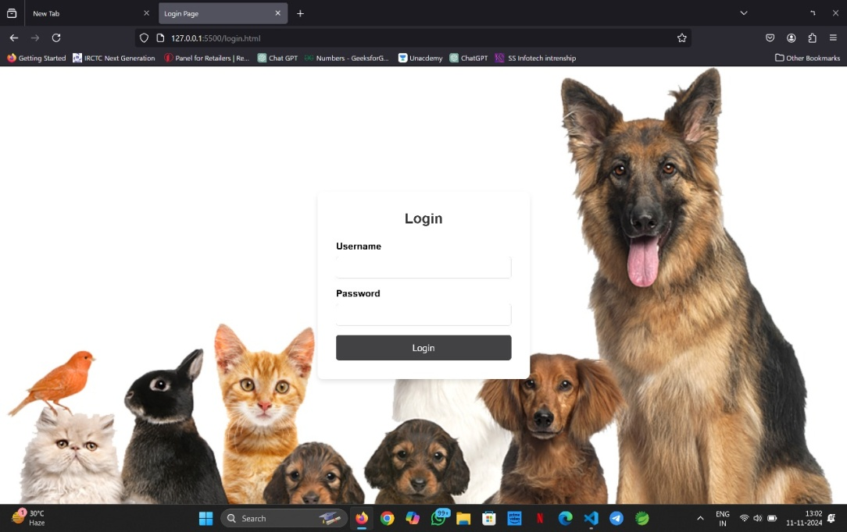

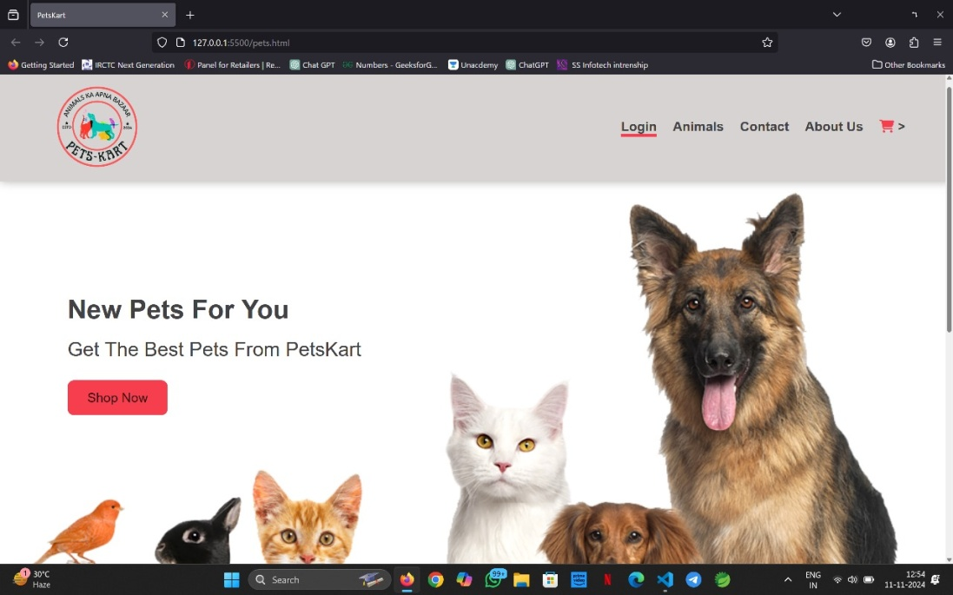

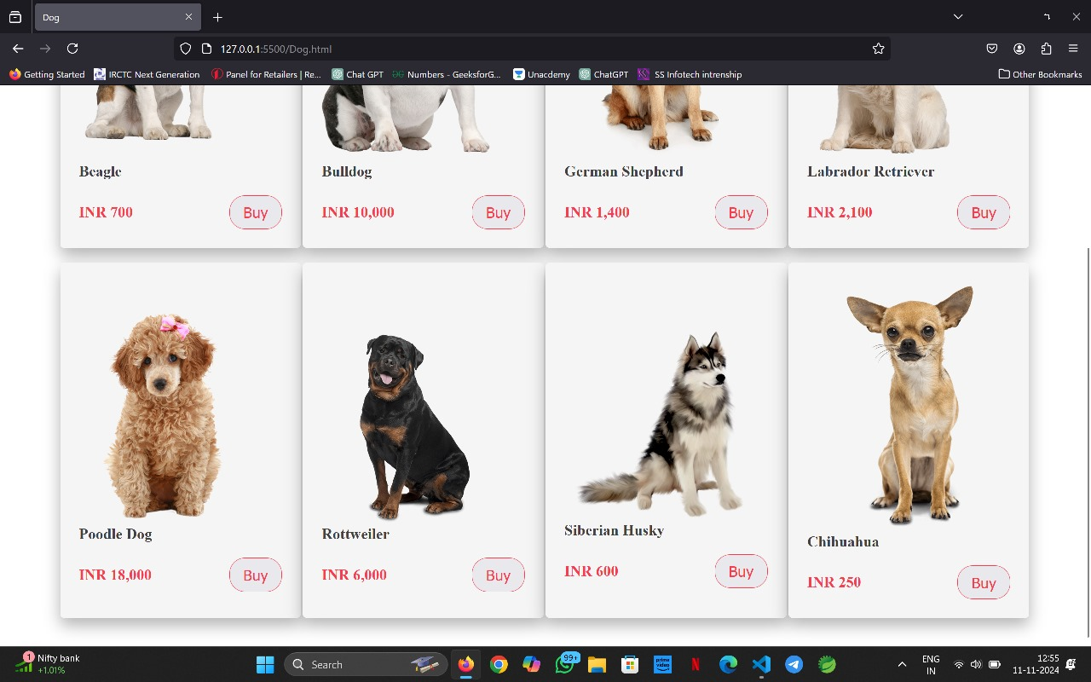

1. **METHODOLOGY**
2. **Needs Assessment:**
   * Conduct in-depth interviews with potential users (livestock owners, buyers, and service providers) to understand their specific needs and pain points.
   * Analyze existing livestock market trends, regulations, and best practices.
3. **Design and Wireframing:**
   * Create a user-friendly interface that is visually appealing and easy to navigate.
   * Develop wireframes to outline the layout and structure of the website's pages.
4. **Development and Coding:**
   * Use a suitable web development framework (e.g., React, Angular, Vue) to build the website's frontend and backend.
   * Ensure the website is mobile-responsive and compatible with different browsers.
5. **Content Creation:**
   * Develop high-quality content, including articles, guides, and resources, on topics related to livestock care, breeding, and market trends.
   * Create a blog or knowledge base to share valuable information with users.
6. **Database Design:**
   * Design a robust database to store user data, livestock listings, service provider profiles, and other relevant information.
7. **Testing and Quality Assurance:**
   * Thoroughly test the website to identify and fix any bugs or errors.
   * Conduct user testing to gather feedback and ensure the website meets user expectations.
8. **CONCLUSION**

In Conclusion , the digital platform Petskart revolutionizes the buying, selling, and care of pets and livestock by providing a streamlined, accessible solution for owners and buyers. It enhances transparency, reduces dependency on traditional intermediaries, and offers valuable resources to support responsible animal care. Given the significant economic role of livestock in India, Petskart's tech-driven approach helps organize the fragmented market, boost productivity, and create new opportunities for rural communities, contributing to the overall growth of the agricultural sector.

1. **ACKNOWLEDGEMENT**

Dr.M.S.Makesar deserves our heartfelt gratitude for his insightful feedback and guidance in shaping our project. Dr.M.S.Makesar, Head of the Department Information Technology, is also acknowledged for his unwavering support. We appreciate the resources provided by our Principal, Dr. Amol Deshmukh, and the Information Technology department's dedicated teaching and support staff. We would like to express our gratitude to the library staff and all contributors to this project, as well as our parents, for their unwavering support.

1. **REFERENCES**

### [1] Glenn Polyn. (2016) Reflect on the Past 45 Years of the Pet Industry. <https://www.petage.com/45-yearsand-counting/>

### [2] Jianhao Liu. (2020) Research Report on the Innovation and Development of Chinas Pet Economy

### .<https://www.iyiou.com/research/20201013753>

### [3] Reilly Roberts. (2021) Pet Industry Trends, Growth & Statistics in 2021 and Beyond: Unleashing Your Ecommerce Pet Marketing Strategies. <https://commonthreadco.com/blogs/coachscorner/pet-industry-trends-growth-ecommercemarketing>

### [4] Cascadia Capital. (2019) Pet Industry Overview. <http://www.cascadiacapital.com/wpcontent/uploads/2019/10/Cascadia-Capital-PetIndustry-Report-Spring-2019-vF.pdf>

### [5] Josh Howarth.(2021) 7 Pet Industry Trends To Know (2021-2025). <https://explodingtopics.com/blog/pet-industrytrends>

### [6] American Pet Products Association.(2021) Pet Industry Market Size, trends & Ownership Statistics.https://www.americanpetproducts.org/pre ss_industrytrends.asp

### [7] Molly Schleicher, Seam B Cash, Lisa M Freeman. (2019) Determinants of pet food purchasing decisions<https://pubmed.ncbi.nlm.nih.gov/31156266/>

### [8] Rover. (2021) Rover Investor Call Presentation. https://www.rover.com/blog/wpcontent/uploads/2021/02/Rover_Investor_Call_Pre sentation.pdf

### [9]BarkBox.(2020)BarkManagementPresentation. [https://static1.squarespace.com/static/5fc915303436806905d7150e/t/5fdae20279e44d2bcf557f77/160 8180228067/BARK-Overview-12162020.pdf](https://static1.squarespace.com/static/5fc915303436806905d7150e/t/5fdae20279e44d2bcf557f77/160%208180228067/BARK-Overview-12162020.pdf)

### [10] Viktor. (2021) The Chewy Business Model – How Does Chewy Make Money?. <https://productmint.com/chewy-business-modelhow-does-chewy-make-money/>