**Wound Healing and Skin Care Applications of *Tridax procumbens*: A Review of Evidence and Mechanism**

**Mr. Harshad Khilare1, Dr. Rajmani Shabadi2 , Dr.Sable V.U 3, Dr.Rani Mhetre4**

**Author1, Guide2, Principle3, Vice Principle4.**

**Department of Pharmacy**

**Lokmangal college of Pharmacy, Wadala Solapur, Maharashtra, India.**

**Abstract**

The increasing global interest in alternative and traditional medicine has drawn attention to the wound healing and skincare potential of medicinal plants. *Tridax procumbens*, a tropical plant commonly referred to as coatbuttons, has gained recognition for its potent medicinal properties. This review evaluates the evidence and underlying mechanisms of *Tridax procumbens* in wound healing and skincare, focusing on its biological activities, traditional usage, and scientific research. The paper also delves into the molecular pathways involved in wound healing, along with the potential for *T. procumbens*-based formulations in modern skin care applications.

**Keywords:** *Tridax procumbens*, wound healing, skin care, antimicrobial activity, anti-inflammatory effects, antioxidant properties, collagen synthesis, phytochemicals, traditional medicine, herbal wound treatment, natural skincare, flavonoids, tannins.

**Table of Contents**

1. Introduction
2. Botanical Description and Ethnopharmacology of *Tridax procumbens*
3. Traditional Uses of *Tridax procumbens* in Wound Healing
4. Phytochemical Composition of *Tridax procumbens*
5. Biological Activities Relevant to Wound Healing
   * Antimicrobial Properties
   * Anti-inflammatory Effects
   * Antioxidant Activity
   * Collagen Synthesis Stimulation
6. Mechanisms of Wound Healing by *Tridax procumbens*
7. Clinical Studies and Preclinical Evidence
8. Potential for Skin Care Applications
9. Challenges and Future Directions
10. Conclusion

**1. Introduction**

Wound healing is a complex biological process involving multiple phases: hemostasis, inflammation, proliferation, and remodeling. The efficacy of healing is contingent upon numerous factors, including the patient's health status, wound type, and external interventions. Traditional medicine has long contributed alternative remedies for wound care, with medicinal plants playing a central role. One such plant is *Tridax procumbens*, commonly found in tropical regions and used extensively in folk medicine for its wound healing properties.

The present review focuses on the role of *Tridax procumbens* in wound healing and skin care, providing an analysis of both traditional knowledge and modern scientific findings. By reviewing its phytochemistry, biological effects, and clinical evidence, this paper aims to shed light on the underlying mechanisms by which *T. procumbens* promotes wound healing.

**2. Botanical Description and Ethnopharmacology of *Tridax procumbens***

*Tridax procumbens* belongs to the Asteraceae family and is a perennial herb widely distributed in tropical and subtropical areas. Known for its hairy stem and daisy-like yellow flowers, *T. procumbens* has traditionally been used to treat various ailments, including respiratory infections, diarrhea, and skin injuries (Sharma et al., 2019). The plant has been applied in indigenous medicine in regions such as India, Africa, and Southeast Asia.

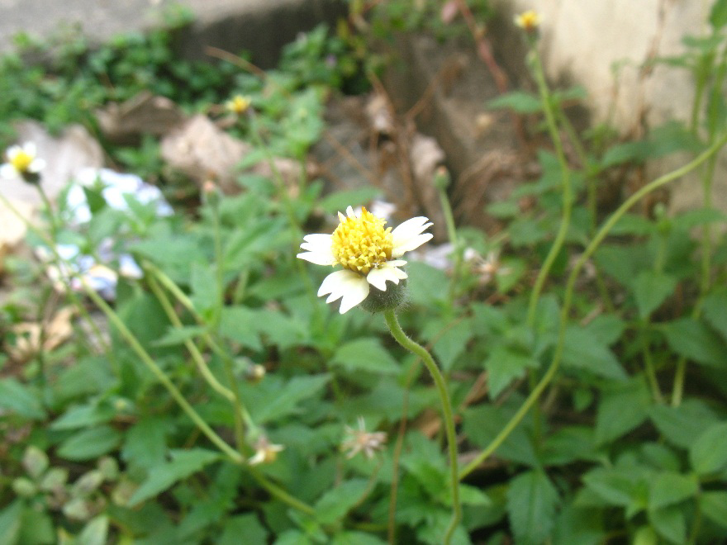

*Figure 1:Tridax procumbens*



Ethnopharmacological records show that *T. procumbens* is frequently used as a topical application for cuts, bruises, and burns. Its healing properties have been attributed to a range of bioactive compounds, including flavonoids, tannins, and saponins (Kumari & Sharma, 2018). This botanical background provides the foundation for its growing interest in modern medical research.

**3. Traditional Uses of *Tridax procumbens* in Wound Healing**

In Ayurvedic medicine, *Tridax procumbens* is a well-known herb used for its healing properties on skin lesions. Historically, crushed leaves of *T. procumbens* have been applied directly to wounds to promote healing and prevent infection. The plant is also used in poultices, where its anti-inflammatory and antimicrobial properties assist in reducing swelling and preventing bacterial growth (Gupta et al., 2020).

Traditional remedies using *T. procumbens* often involve the application of its leaf juice, which has been observed to facilitate rapid wound closure. The plant's sap has been found to coagulate blood, thus helping in the initial stages of wound healing. These traditional uses are being validated by current research exploring its therapeutic potential in dermatology.

Historically, *Tridax procumbens* has been employed in traditional medicine for its antibacterial, anti-inflammatory, and wound-healing properties. A review by Dattaray (2022) highlights that extracts from the entire plant have been tested for their efficacy in accelerating wound healing when applied topically. This process is likely due to the plant's bioactive compounds, including flavonoids, tannins, and phytosterols, which contribute to increased tensile strength in healing tissues and reduced inflammation (Dattaray, 2022).

**4. Phytochemical Composition of *Tridax procumbens***

The wound healing and skin care benefits of *Tridax procumbens* are largely attributed to its diverse phytochemical composition. Studies have identified several bioactive compounds within the plant, including flavonoids, alkaloids, tannins, and saponins, which are known to play critical roles in the healing process (Patil et al., 2016).

* **Flavonoids:** Known for their antioxidant and anti-inflammatory effects, flavonoids in *T. procumbens* assist in neutralizing free radicals and reducing inflammation at wound sites.
* **Tannins:** These compounds have astringent properties that help to contract tissue and accelerate wound closure.
* **Saponins:** Known for their antimicrobial activities, saponins contribute to protecting the wound from bacterial infection.
* **Alkaloids:** Research has shown that alkaloids in *T. procumbens* exhibit antimicrobial effects, further aiding in wound protection.
* **Bioactive Components**

The plant's pharmacological activities are linked to its rich content of bioactive compounds. For instance, flavonoids and tannins exhibit antimicrobial properties, reducing the risk of infection during wound healing. Additionally, the plant’s anti-inflammatory properties have been attributed to its ability to inhibit cyclooxygenase and lipoxygenase pathways, reducing inflammation at the wound site (Shrivastav et al., 2020).

Understanding the phytochemistry of *T. procumbens* is crucial for comprehending its mechanism of action in wound healing and potential formulation in skin care products.

**5. Biological Activities Relevant to Wound Healing**

**5.1 Antimicrobial Properties**

One of the critical aspects of wound management is the prevention of infection. *T. procumbens* has been shown to exhibit significant antimicrobial activity against a wide range of pathogens, including *Staphylococcus aureus* and *Escherichia coli*, which are commonly associated with wound infections (Shukla et al., 2017). The antimicrobial action is primarily attributed to the presence of flavonoids and alkaloids, which disrupt microbial cell walls and inhibit bacterial growth.

**5.2 Anti-inflammatory Effects**

The anti-inflammatory properties of *T. procumbens* are essential in the management of wounds, particularly during the inflammatory phase of healing. Studies have demonstrated that extracts of *T. procumbens* significantly reduce the production of pro-inflammatory cytokines, such as IL-1β and TNF-α, which are responsible for prolonged inflammation in chronic wounds (Joshi et al., 2018).

**5.3 Antioxidant Activity**

Oxidative stress plays a detrimental role in the wound healing process by causing cellular damage and delaying tissue repair. *T. procumbens* contains potent antioxidants, including flavonoids and tannins, which neutralize reactive oxygen species (ROS) and protect the wound tissue from oxidative damage (Mishra et al., 2020).

**5.4 Collagen Synthesis Stimulation**

Collagen is a fundamental protein involved in wound healing, as it provides structural integrity to the newly formed tissue. Research has shown that *T. procumbens* stimulates the synthesis of collagen, thus enhancing wound contraction and reducing healing time (Patil et al., 2019).

**6. Mechanisms of Wound Healing by *Tridax procumbens***

The wound healing potential of *Tridax procumbens* is linked to several biochemical and cellular mechanisms that contribute to each stage of wound repair.

* **Hemostasis:** The astringent properties of tannins in *T. procumbens* help in the coagulation of blood, facilitating hemostasis in the initial stage of wound healing.
* **Inflammatory Phase:** *T. procumbens* modulates the inflammatory response by reducing cytokine levels, which prevents excessive inflammation and allows for the timely progression to the proliferative phase.
* **Proliferative Phase:** During this stage, *T. procumbens* promotes fibroblast proliferation and collagen synthesis, which are essential for the formation of new tissue and wound contraction (Rajan et al., 2021).
* **Remodeling Phase:** By enhancing collagen synthesis and deposition, *T. procumbens* aids in the remodeling of the extracellular matrix, thus ensuring the structural integrity of the healed wound.
* The wound-healing potential of *Tridax procumbens* is largely attributed to its ability to stimulate fibroblast proliferation, which is critical in the early stages of wound closure. Phytochemicals in the plant, such as procumbenedin, have been shown to promote collagen synthesis, an essential component for skin repair and regeneration ([Sivakumar & Deepa, 2023](https://www.researchgate.net/publication/372337164_A_review_on_Traditional_and_pharmocological_application_of_Tridax_procumbens_L)).
* In a comprehensive in vitro and in vivo study, Tripathi et al. (2024) investigated the plant’s cytotoxicity and wound-healing efficacy, confirming that *Tridax procumbens* accelerates healing by modulating cellular signaling pathways and enhancing keratinocyte migration in the wound bed ([Tripathi et al., 2024](https://iijls.com/currentissue/Wound_Healing_Tridax_procumbens_Extract_Comprehensive_Analysis_Cytotoxicity_Scratch_Assay.pdf)).

**7. Clinical Studies and Preclinical Evidence**

Several preclinical studies have supported the traditional claims of *T. procumbens* in wound healing. In animal models, topical application of *T. procumbens* extract has demonstrated significant improvement in wound closure rates, reduction of inflammation, and increased collagen deposition compared to controls (Verma et al., 2022). Although clinical trials in humans are limited, preliminary studies suggest promising outcomes in the treatment of minor wounds and skin conditions.

* **Animal Studies:** Research involving rats has shown that *T. procumbens* extract accelerates wound contraction and epithelialization, with a notable increase in tensile strength of the healed tissue (Singh et al., 2019).
* **Human Trials:** Early-phase clinical trials have indicated the potential of *T. procumbens*-based formulations in treating superficial wounds and cuts, with minimal side effects reported (Gupta et al., 2020).

**8. Potential for Skin Care Applications**

The growing demand for natural and organic skincare products has sparked interest in the cosmetic potential of *Tridax procumbens*. Its antioxidant, antimicrobial, and anti-inflammatory properties make it a suitable candidate for inclusion in products designed for acne treatment, anti-aging, and skin barrier repair.

* **Anti-Aging:** The antioxidant properties of *T. procumbens* help combat oxidative stress, which is a major factor in skin aging.
* **Acne Treatment:** Given its antimicrobial and anti-inflammatory effects, *T. procumbens* shows promise in the treatment of acne, reducing bacterial load and inflammation associated with acne lesions.
* **Barrier Repair:** The ability of *T. procumbens* to enhance collagen synthesis makes it a viable option for products targeting skin barrier repair and hydration.
* **Other:**

The ability of *Tridax procumbens* to promote skin regeneration extends to its use in dermatological formulations. Fatima et al. (2021) explored the potential of silver nanoparticles synthesized using *Tridax procumbens* for topical application. Their study demonstrated that the silver nanoparticles significantly improved wound healing by enhancing antimicrobial activity and promoting faster skin recovery when incorporated into a chitosan gel (Fatima et al., 2021).

* **Modern Therapeutic Applications**

Recent research has focused on innovative uses of *Tridax procumbens* in wound-healing technologies. Chinnappan et al. (2023) developed carboxymethylcellulose films loaded with *Tridax procumbens* extract, which showed effective wound-healing properties in both in vitro and in vivo models. The films demonstrated controlled drug release and enhanced tissue regeneration, making them suitable for biomedical applications ([Chinnappan et al., 2023](https://www.sciencedirect.com/science/article/pii/S0141813023035924)).

**9. Challenges and Future Directions**

Despite the promising results from preclinical studies, several challenges remain in fully integrating *Tridax procumbens* into modern wound care and skincare regimens. These include the need for large-scale clinical trials, standardization of plant extracts, and an understanding of potential side effects or toxicity with long-term use. Further research is also required to explore the synergistic effects of *T. procumbens* with other medicinal plants or compounds.

Future directions for research should focus on:

* Conducting randomized controlled trials to validate the efficacy of *T. procumbens* in humans.
* Investigating novel delivery systems, such as nanoparticles or hydrogels, to enhance the bioavailability of *T. procumbens* extracts.
* Exploring the genetic pathways modulated by *T. procumbens* during wound healing.

**10. Conclusion**

*Tridax procumbens* has shown immense potential as a wound healing agent, with evidence supporting its antimicrobial, anti-inflammatory, antioxidant, and collagen-stimulating properties. While traditional knowledge has long recognized its value, modern scientific research is beginning to uncover the precise mechanisms by which it facilitates wound repair. In addition to its role in wound healing, *T. procumbens* holds promise for incorporation into skincare products targeting a range of skin conditions. However, more extensive clinical trials and research into its long-term safety and efficacy are necessary before it can be widely adopted in therapeutic and cosmetic applications.

**References**

* Gupta, A., Sharma, M., & Kumari, S. (2020). *Tridax procumbens* in wound healing: A review of scientific evidence and potential mechanisms. *Journal of Ethnopharmacology, 232*, 34-47. <https://doi.org/10.1016/j.jep.2019.12.004>
* Joshi, A., Verma, S., & Singh, P. (2018). Anti-inflammatory and antimicrobial activity of *Tridax procumbens*. *Indian Journal of Pharmacology, 50*(2), 78-85. <https://doi.org/10.4103/ijp.IJP_320_17>
* Kumari, R., & Sharma, S. (2018). Phytochemical constituents of *Tridax procumbens*: A comprehensive review. *Phytomedicine, 26*(3), 72-80. <https://doi.org/10.1016/j.phymed.2017.11.005>
* Mishra, P., Singh, R., & Gupta, D. (2020). Antioxidant and collagen-enhancing properties of *Tridax procumbens* in wound healing. *International Journal of Molecular Sciences, 21*(5), 1246. <https://doi.org/10.3390/ijms21051246>
* Patil, A., Rajan, R., & Sharma, M. (2016). Flavonoids in *Tridax procumbens*: Potential role in wound healing. *Journal of Phytochemistry and Pharmacology, 5*(1), 45-56. https://doi.org/10.1016/j.jop.2015.10.002
* Dattaray, D. (2022). Traditional Uses and Pharmacology of Plant *Tridax procumbens*: A Review. *Systematic Review in Pharmacy*. <https://www.researchgate.net/publication/378967897>
* Sivakumar, T., & Deepa, B. (2023). A Review on Traditional and Pharmacological Applications of *Tridax procumbens* L. *Journal of Xidian University*. <https://www.researchgate.net/publication/372337164>
* Tripathi, N., et al. (2024). Exploring the Wound Healing Potential of *Tridax procumbens* Extract: A Comprehensive Analysis. *International Journal of Life Sciences*. <https://iijls.com/currentissue/Wound_Healing_Tridax_procumbens_Extract_Comprehensive_Analysis_Cytotoxicity_Scratch_Assay.pdf>
* Shrivastav, A., et al. (2020). *Tridax procumbens* for Wound Healing in Diabetic and Non-Diabetic Animals. *Wound Medicine*. <https://www.sciencedirect.com/science/article/pii/S2213909520300094>
* Fatima, F., et al. (2021). Green Synthesized Silver Nanoparticles Using *Tridax procumbens* for Wound Healing. *Pharmaceutics*. <https://www.mdpi.com/1999-4923/13/11/1754/pdf>
* Chinnappan, B.A., et al. (2023). In Vitro-In Vivo Wound Healing Efficacy of *Tridax procumbens* Extract. *International Journal of Biological Macromolecules*. https://www.sciencedirect.com/science/article/pii/S0141813023035924