## AUTONOMOUS VEHICLE CONTROL, PART VIII: SURFACE VESSEL YAW ANGLE CONTROL USING I-FIRST ORDER, I-SECOND ORDER COMPENSATORS AND PD-PI, 2DOF-3 CONTROLLERS COMPARED WITH PID CONTROLLER

**Galal Ali Hassaan**

Emeritus Professor, Department of Mechanical Design and Production, Faculty of Engineering, Cairo University, Cairo, Egypt

**ABSTRACT**

This research paper investigates the control of an autonomous surface vessel yaw angle using two compensators and two controllers from the second generation of compensators and controllers presented by the author since 2014. The proposed compensators and controllers are tuned for the best possible performance of the control system incorporating them and the time-based characteristics of the control system are outlined. The step time response of the control system using the proposed compensators/controllers is compared with that of a PID controller tuned by the author. A graphical and quantitative comparison of the step time response and the time-based characteristics is performed to assess the selection of the best compensator/controller suitable for the control of surface vessel yaw angle. The yaw rate of the vessel is also presented following the use of the proposed compensators/controllers with proposed maximum limit for its value for future work.

**Keywords:** Autonomous surface vessel yaw angle control, vessel yaw rate, I-first order compensator, I-second order compensator, PD-PI controller, 2DOF-3 controller, PID controller.

1. **INTRODUCTION**

## Yaw angle is one of the fundamental motions of autonomous surface vessels when turning or tracking a curved path. Controlling this motion yields accurate maneuvering for purpose of achieving vessel tasks with high degree of safety. The paper proposes four of the control compensators and controllers among a large set introduced by the author to the designers of control systems since 2014. Before of all we have a look into some of research efforts in this important field:

## Tzeng and Chen (1999) presented fundamental properties for the Nomoto models. They stated that the zero found in the transfer function is responsible for the overshoot behavior. They presented the Bode plots for the Nomoto models to select appropriate model structure according to desired frequency range of application. The presented also step time responses for ½ Nomoto model with different zero time constant [1]. Matos and Cruz (2008) focused on the positioning control of an autonomous surface vessel. They designed feedback control laws to make sure that the underactuated vessel keeps its position even in the presence of water current and wind. They checked the performance of the control system experimentally [2]. Pedone, Zizzari and Indiveri (2010) presented a novel path-following solution for the dynamic model of an underactuated marine vessel without closed-loop control of the surge speed. They applied feedback linearization of the dynamic model of the surface vessel model and computed the yaw moment command to steer the vessel velocity relative to the desired value. They provided numerical simulation to validate the proposed approach [3]. Baker, Qian and Nowak (2013) investigated the speed and yaw control of an underactuated surface vessel. They proposed a surge speed controller using distance and heading error feedback control to control the vessel speed and the heading subsystem will be stabilized by a finite-time controller. They compared with conventional yaw rate techniques and investigated the effectiveness of their proposed control system using simulation results [4].

## Hajivand and Mousavizadegan (2015) obtained hydrodynamic coefficients numerically for a model ship by visual simulation of captive model tests in computational fluid mechanics (CFM) environment. They used the obtained coefficients to predict the turning circle and zigzag maneuvers of the model ship. They compared the simulated results with experimental data showing good agreement [5]. Fang, Zhang, Wang and Jiang (2016) proposed an adaptive course control method based on back-propagation neural network, PID algorithm and stochastic optimization. They used model reference adaptive theory and PID algorithm to minimize the course error [6]. Jain, Prasad, Dahal and Sudi (2017) proposed wase disturbance models and control algorithms for unmanned water vehicle. They implemented PD controller for trajectory control considering standard models of sea disturbances. They used ½ and ¾ Nomoto models with assigned parameters and plotted the time response of the control system using the proposed PD controller [7]. Liu, Zou, Zou and Guo (2018) used computational fluid dynamics (CFD) to offer a numerical tool for accurate maneuvering prediction. They conducted visual captive model tests for a model scale container ship using unsteady Reynolds-Navier-Stokes computation to obtain a full set of linear and nonlinear hydraulic derivatives in the third-order Abtocoitz model. They compared with available captive model test data and the standard turning and zigzag maneuvers were predicted and compared with available experimental data and proved the effectiveness of their methodology [8].

## Guan, Cao, Sun and Su (2019) used a closed-loop shaping filter to improve the smart autonomous surface vessel steering gain robust scheme. They proposed a model for the vessel and obtained its parameters. They designed a CSF-L2 gain nonlinear robust controller design for the vessel steering autopilot proving its stability and robustness using Lyapunov synthesis and applied practical experiments to demonstrate robustness and good control performance [9]. Saputra, Lukmana and Suranto (2020) designed an autonomous pitching system for autonomous surface vessels using numerical simulation. They developed P, PI and PID controllers to minimize the oscillatory pitching behavior of the vessel. They concluded that the PI was the best for short period dynamics and the PID was the best for long period dynamics [10]. McCullough (2021) in his Ph. D. thesis addressed the problem of controlling an autonomous surface vessel in an optimal manner while maintaining headway towards a desired path in any sea. He designed a two degree of freedom controller considering a tracking planner for optimal heading and velocity reference and a feedback regulator for optimal throttle and rudder commands [11].

## Mounet et al. (2022) presented a wave spectrum estimation when multiple ships operate in the same area forming a network of wave records. They proposed a methodology to improve the accuracy of the wave spectrum estimates and demonstrated it through two case studies and showed that their procedure provided good wave spectrum estimates leading to reduced uncertainty in vessel transfer functions [12]. Degorre, Delaleau and Chocron (2023) presented a review of the most common methods for surface autonomous vehicles and focused on model-based nonlinear control methods and guidance principles with details and examples of model-based linearizing controllers, applications, sliding mode controllers and other control methods. They compared fully-actuated and underactuated cases [13]. Xiros, Actosun and Loghis (2024) investigated the guidance and control of an autonomous swarm of surface watercraft with focus on distributed control laws with and without boat dynamics. They explained the behavior of boats under varying conditions (trajectories, velocities, yaw rates and angles). They introduced noise in simulations enhancing realism and robustness [14].

1. **CONTROLLED SURFACE VESSEL YAW ANGLE**

Jain, Prasad, Dahal and Sudi used a PD controller in a control system for unmanned ship navigation depending on one of the Nomoto models [7]. They used a ½ transfer function model for the transfer function of the ship yaw angle in response to the steering angle. The yaw angle as a process has a transfer function, Gp(s) given by them by [7]:

Gp(s) = (40s+1) / (200s2+30s+1) (1)

The yaw angle dynamics of the ship will be investigated through the plotting of its time response to a unit step input using the MATLAB command ‘*step*’ [15] which is given in Fig.1 for yaw angle (in rad), yaw rate (in rad/s) and yaw rate limit of 0.6 rad/s. The author paid a lot of efforts to trace research work, standards or practical reports about the limit of yaw rate in vessel or ship turning without success. In a work by Liu, Zou, Zou and Guo, they performed research work about ship maneuverability and performed dynamic analysis using maximum yaw rates from 0.2 to 0.6 rad/s [8]. Because of this I used the value 0.6 rad/s as an approximate (not accurate) threshold or limit for the surface vessel yaw rate used with all the compensators/controllers proposed in this work.

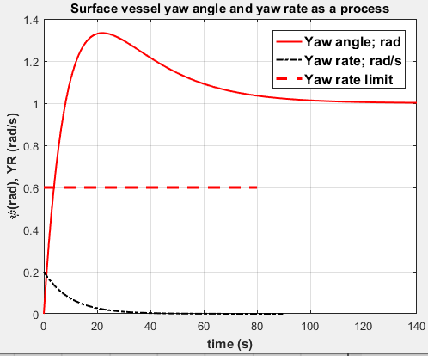

**Figure 1:** Unit step time response of autonomous ship yaw angle.

COMMENTS:

The surface vessel yaw angle as a process to be controlled has the transient and steady-state characteristics:

* Maximum overshoot: 33.33 %.
* Settling time: 91.8 s for ± 2 % tolerance.
* Steady-state error: zero.
* Maximum yaw rate: 0.2 rad/s (less than the proposed maximum limit).
* Bad process dynamics with high maximum overshoot and large settling time represent a real challenge for any proposed compensator/controller.

1. **CONTROLLING THE VESSEL YAW ANGLE USING AN I-FIRST ORDER COMPENSATOR**

The I-first order compensator was introduced by the author as one of the second generation control compensators presented by him since 2014. He used this compensator as one of the proposed compensators to control the longitudinal velocity of an autonomous car [16] and car passenger head rolling angle [17]. The block diagram of the control system comprising an I-first order compensator to control the car sideslip angle is shown in Fig.2 [16]. It has an integral control mode of transfer function Gc1(s) in cascade with a first-order control mode of transfer function Gc2(s) in the feedforward path of the single-loop block diagram of the control system. Both elements have the transfer functions:

Gc1(s) = Ki/s , Gc2(s) = (s+z)/(s+p) (2)

Where Ki , z and p are the integral gain, zero and pole of the compensator.

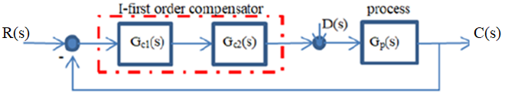

**Figure 2:** I-first order compensator controlling sideslip angle [16].

The I-first order compensator is tuned as follows:

* The process transfer function in Eq.1 has the following zero and simple poles:

Zero: s+0.025

Simple pole 1: s+0.1

Simple pole 2: s+0.05

* The zero/pole cancellation technique [18] is used to tune the compensator as follows:
* The compensator zero is set equal to the process pole s+0.05.
* The compensator pole is set equal to the process zero s+0.025.
* With few trials, the integral gain is set equal to 300 without any optimization.
* The tuned compensator parameters are:

Ki = 300 ; z = 0.05 ; p = 0.025 (3)

The unit step time response of the control system for the surface vessel yaw angle and the corresponding yaw rate time response using the I-first order compensator is shown in Fig.3 as generated by the MATLAB ‘step’ command [16].

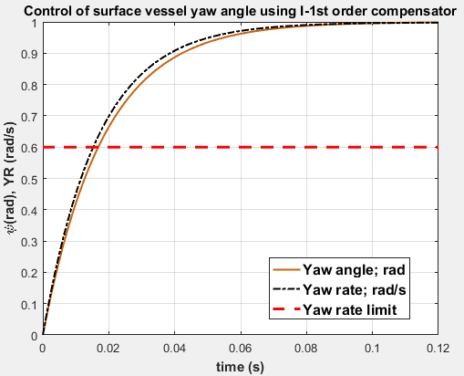

**Figure 3:** Unit step time response of vessel yaw angle and yaw rate using a I-first order compensator.

COMMENTS:

The vessel yaw angle controlled by an I-first order compensator has the following transient and steady-state characteristics:

* Maximum overshoot: zero
* Settling time: 0.07173 s
* Steady-state error: zero
* Maximum yaw rate: 0.9976 rad/s

1. **CONTROLLING THE VESSEL YAW ANGLE USING AN I-SECOND ORDER COMPENSATOR**

The I-second order compensator was introduced by the author as one of the second generation control compensators presented by him since 2014. He used this compensator as one of the proposed compensators to control the car passenger head rolling angle [17]. The block diagram of the control system comprising an I-second order compensator to control the surface vessel yaw angle is is the same like that shown in Fig.2. It has an integral control mode of transfer function Gc1(s) in cascade with a second-order control mode of transfer function Gc2(s) in the feedforward path of the single-loop block diagram of the control system consisting of quadratic zero and two simple poles. Both elements have the transfer functions:

Gc1(s) = Ki/s , Gc2(s) = (s2+2ζzωnzs+ωnz2)/[(s+p21)(s+p22) (3)

Where Ki is the integral gain, ζz  and ωnz are the quadratic zero damping ratio and natural frequency and p21 and p22 are the two simple poles of the compensator.

* The zero/pole cancellation technique [18] is used to tune the compensator as follows:
* The compensator quadratic zero is set equal to the process quadratic pole s2+0.15s+0.005.
* The compensator first simple pole s+p12 is set equal to the process zero s+0.025.
* With few trials, the integral gain is set equal to 300 and the pole p22 is set equal to 0.1without any optimization.
* The tuned compensator parameters are:

Ki = 300 ; ζz = 1.0608 ; ωnz = 0.0707 ; p21 = 0.025 ; p22 = 0.1 (3)

The unit step time response of the control system for the surface vessel yaw angle and the corresponding yaw rate time response using the I-second order compensator is shown in Fig.4 as generated by the MATLAB ‘step’ command [16]. Fig.4 depicts also the yaw rate (dψ/dt) and its proposed limit.

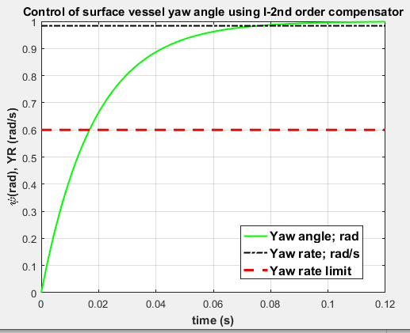

**Figure 4:** Unit step time response of vessel yaw angle and yaw rate using a I-first order compensator.

COMMENTS:

The vessel yaw angle controlled by an I-first order compensator has the following transient and steady-state characteristics:

* Maximum overshoot: zero
* Settling time: 0.0717 s
* Steady-state error: zero
* Maximum yaw rate: 0.9836 rad/s

1. **CONTROLLING THE SIDESLIP ANGLE USING A PD-PI CONTROLLER**

The author introduced the PD-PI controller within a series of controllers proposed for the second generation of PID controllers and used to effectively control difficult processes since 2014. He applied the PD-PI controller to control various processes and compared their effectiveness with that of controllers from the first generation of PID controllers [21] to [46]. The PD-PI controller is composed of a PD control mode cascaded with a PI control mode in the feedforward path of a single-loop block diagram of the control system just after the error detector. The PD-PI controller has the transfer functions GPD(s) and GPI(s) given by:

GPD(s) = Kpc1+Kds and GPI(s) = Kpc2+(Ki/s) (4)

Where Kpc1, Kd, Kpc2 and Ki are the four gain parameters of the PD-PI controller.

* The four gain parameters of the PD-PI controller are tuned by minimizing an ITAE performance index [47] using the MATLAB optimization toolbox [48]. The tuning results are as follows:

Kpc1 = 0.0255935 ; Kd = 0.2559350 ; Kpc2 = 518336.48 ; Ki = 25916.82 (5)

* The unit step time response of the control system for the sideslip angle using the proposed PD-PI controller using its gain parameters in Eq.5 is shown in Fig.5.

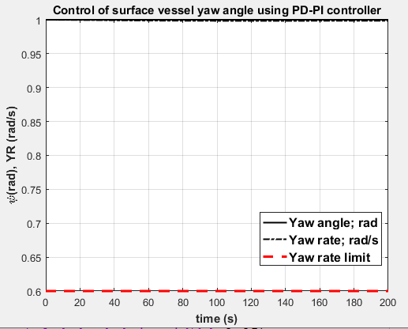

**Figure 5:** Unit step time response of vessel yaw angle and yaw rate using a PD-PI controller.

COMMENTS:

The vessel yaw angle controlled by a PD-PI controller has the following transient and steady-state characteristics:

* Maximum overshoot: zero
* Settling time: zero
* Steady-state error: zero
* Maximum yaw rate: 1 rad/s
* It has a step-wise characteristics for both yaw angle and yaw rate.
* It is ideal, but its problem is in the violation of the yaw rate to the proposed limit of 0.6 rad/s.

1. **CONTROLLING THE SIDESLIP ANGLE USING A 2DOF-3 CONTROLLER**

The author applied 2DOF controller structures to various processes having bad dynamics within the second generation of PID controllers he introduced since 2014 [16], [20], [26], [30], [32]-[46] and [49]. The 2DOF controller structure proposed here is composed of a feedforward PD control mode of Gff(s) transfer function and a feedback PD control mode of Gc(s) transfer function located as shown in Fig.6 [44].

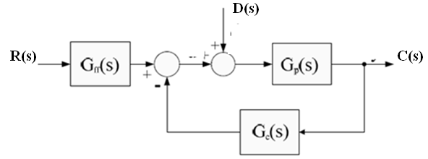

**Figure 6:** 2DOF-2 controller controlling sideslip angle [44].

The 2DOF-3 controller has the transfer functions:

Gff(s) = Kpc1 + Kd1s = Kd1[s + (Kpc1/Kd1)

Gc(s) = Kpc2 + Kd2s = Kd2[s + (Kpc2/Kd2) (6)

Where Kpc1, Kd1, Kpc2 and Kd2 are the four gain parameters of the 2DOF-3 controller.

* The 2DOF-3 is tuned as follows:
* The zero/pole cancellation technique [18] is used in the tuning procedure of the controller.
* The second controller zero in Eq.6 is set equal to the process pole s+0.05. This step resulted in a mathematical relationship between the controller gain Kpc2 and the gain Kd2.
* A constraint is set on the closed-loop transfer function of the control system according to the block diagram in Fig.6 to satisfy zero steady-state error revealing a mathematical relationship between the controller gain Kpc1 and the derivative gain Kd2.
* Now, an optimization technique is used to optimize the two gain parameters Kd1 and Kd2 of the controller using an ITAE performance index [47] and the optimization toolbox of MATLAB [48].
* The tuned controller parameters used the above hybrid procedure are:

Kpc1 = 6.214329 ; Kd1 = 0.947176 ; Kpc2 = 5.214329 ; Kd2 = 104.286599 (7)

* The unit step time response of the car sideslip angle for reference input tracking is shown in Fig.7 as generated by the ‘step’ command of MATLAB using the transfer function of the control system and the 2DOF-3 gain parameters in Eq.7 and the corresponding yaw rate of the surface vessel and the proposed yaw rate limit..

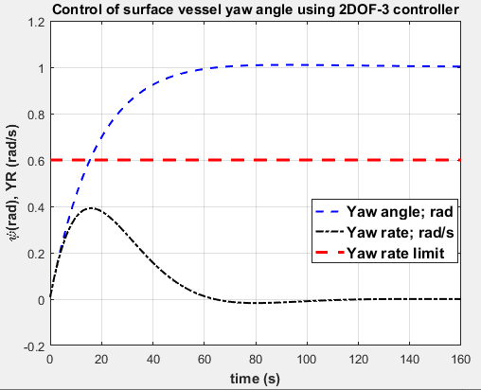

**Figure 7:** Unit step time response of vessel yaw angle and yaw rate using a 2DOF-3 controller.

COMMENTS:

The vessel yaw angle controlled by a PD-PI controller has the following transient and steady-state characteristics:

* Maximum overshoot: 1.001 %
* Settling time: 54 s
* Steady-state error: zero
* Maximum yaw rate: 0.4 rad/s

1. **CONTROLLING THE VESSEL YAW ANGLE USING A PID CONTROLLER**

* The PID controller is used here for sake of comparison purposes between compensators/controllers from the second generation of PID controllers and the PID from the first generation.
* I tuned the PID controller to control the surface vessel having the transfer function in Eq.1 by minimizing an ITAE performance index [47] and the MATLAB optimization toolbox [48]. The tuning results are as follows:

Kpc = 4.5522203 , Ki = 1.1810766 , Kd = 0.000911 (8)

* The unit step time response of the controlled surface vessel yaw angle for reference input tracking using the control system transfer function using PID controller and the controller parameters in Eq.8 is generated using the ‘step’ command of MATLAB and given in Fig.8 showing also the yaw rate of the vessel and its proposed limit.

COMMENTS:

The vessel yaw angle controlled by a PD-PI controller has the following transient and steady-state characteristics:

* Maximum overshoot: 5.79 %
* Settling time: 8.855 s
* Steady-state error: zero
* Maximum yaw rate: 0.85 rad/s

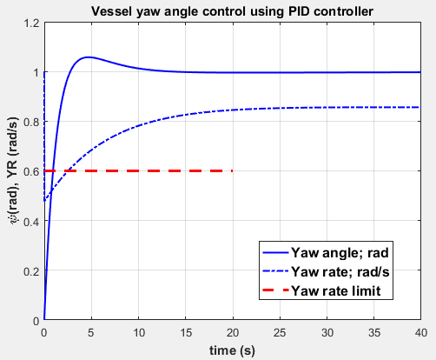

**Figure 8:** Unit step time response of vessel yaw angle and yaw rate using a PID controller.

1. **COMPARISON OF PROPOSED COMPENSATORS/CONTROLLERS WITH A PID CONTROLLER**

The time response of the control system using I-first order, I-second order compensators and PD-PI, 2DOF, PID controllers is compared graphically in Fig.9 for unit reference input tracking while the yaw rate of the vessel using the proposed compensators/controllers is compared in Fig.10.

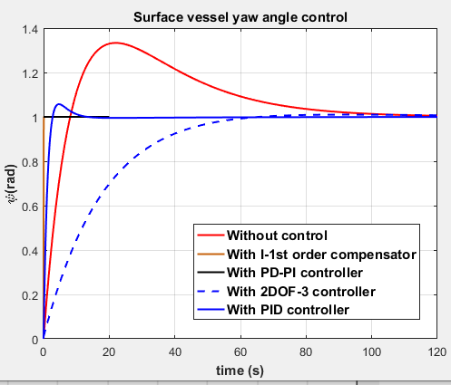

**Figure 9:** Comparison of the step time response of the surface vessel yaw angle.

A quantitative comparison for the time-based characteristics of the step time response of the control systems proposed for the control of the surface vessel angle is presented in Table 1.

**Table 1.** Quantitative characteristics comparison for surface vessel yaw angle control.

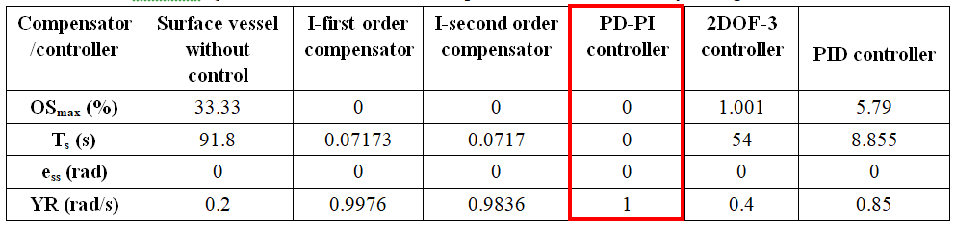

OSmax: Maximum percentage overshoot.

Ts: Settling time to ± 2 % tolerance.

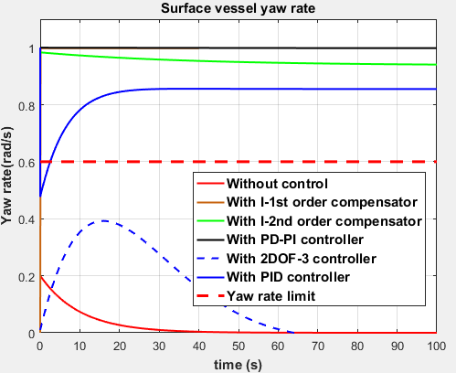ess: steady-state error.

YR: Yaw rate.

**Figure 10:** Comparison of the step time response of the surface vessel yaw rate.

1. **CONCLUSION**

* The paper investigated the control of the surface vessel yaw angle using some compensators and controllers from the second generation of compensators and PID controllers.
* Two tuning techniques for compensator/controller tuning were applied: achieving specific performance measures and using the MATLAB optimization toolbox.
* The performance of the proposed compensators/controllers was compared with that of using a PID controller from the first generation of PID controllers tuned by the author.
* The yaw angle of the surface vessel as a process had bad characteristics in terms of high overshoot (33.33 %) and large settling time (91.8 s). Its steady-state error and maximum yaw rate were accepted.
* The I-first order compensator succeeded to control the vessel yaw angle providing zero maximum overshoot compared with 5.79 % for the PID controller and a settling time of 0.07173 s compared with 8.855 s for the PID controller. It had good performance characteristics except the maximum yaw rate which violated the yaw rate proposed limit of 0.6 rad/s.
* The I-second order compensator succeeded to control the vessel yaw angle performance characteristics very similar to that associated with the I-first order compensator.
* The PD-PI controller succeeded to control the vessel yaw angle providing zero maximum overshoot compared with 4.501 % for the PID controller and a settling of almost zero seconds compared with 5.79 s for the PID controller in a step shape characteristics. The main problem with the PD-PI controller was its maximum yaw rate of 0.9836 rad violating the proposed maximum limit.
* The 2DOF-3 controller succeeded to control the vessel yaw angle providing 1.001 % maximum overshoot compared with 5.79 % for the PID controller and a settling time of 54 s compared with 8.855 s for the PID controller. It provided a maximum yaw rate of 0.4 rad/s compared with 0.85 rad/s for the PID controller within the range of the proposed maximum vessel yaw rate.
* Based on the above comparison of the time based characteristics of the proposed compensators/controllers, the PD-PI controller was chosen as the best compensator/controller to control the surface vessel yaw angle without concern to the resulting yaw rate until further investigations assign better applied value for its limit.

1. **REFERENCES**
2. C. Tzeng and J. Chen, “Fundamental properties of linear ship steering dynamic models,” Journal of Marine Science and Technology, Vol.7, Issue 2, 1999, pp. 79-88.
3. A. Matos and N. Cruz, “Positioning control of an underactuated surface vessel,” DOI: 10.1109/OCEANS.2008,5152091, October 2008, 5 pages.
4. P. Pedone, A. Zizzari and G. Indiveri, “Path-following for the dynamic model of a marine surface vessel without closed-loop control of the surge speed,” 8th IFAC Conference on Control Applications in Marine Systems, Germany, September 15-17, 2010, pp.243-248.
5. B. Baker, C. Qian and B. Nowak, “A combined speed and finite-time yaw controller for an underactuated unmanned surface vessel using way-point navigation,” Proceedings of the International Conference on Mechatronic and Embedded Systems and Applications, Portland, USA, August 4-7, 2013, 11 pages.
6. A. Hajivand and S. Mousavizadegan, “Virtual simulation of maneuvering captive tests for a surface vessel”, International Journal of Navigation Architecture Ocean Engineering, Vol. 7, 2015, pp.848-872.
7. Y. Fang, H. Zhang, B. Wang and C. Jiang, “Adaptive course control system of an unmanned surface vehicle based on back-propagation neural network,” 4th International Conference on Mechanical Materials and Manufacturing Engineering, 2016, pp. 882-885..
8. A. Jain, S. Prasad, S. Dahal and R. Sudi, “PD controller based unmanned ship navigation,” Recent Advances in Communication, Electronics and Electrical Engineering, Vol.5, Issue 4, 2017, pp. 147-154.
9. Y. Liu, L. Zou, Z. Zou and H. Guo, “Predictions of ship maneuverability based on virtual captive model tests,” Engineering Applications of Computational Fluid Mechanics, Vol.21, Issue 1, 2018, pp. 334-353.
10. W. Guan, W. Cao, J. Sun and Z. Su, “Steering controller design for smart autonomous surface vessel based on CSF L2 gain robust strategy,” IEEE Access, Vol. 7, 2019, pp. 109982-109989.
11. N. Saputia, M. Lukmana and R. Suranto, “Development of an automatic anti-pitching system autonomous surface vessel for fish mapping,” Journal of Physics, Conference Series, Vol. 1569, 2020, 7 pages.
12. D. R. McCullough, “Nonlinear model predictive control of autonomous surface vehicle in rough seas,” Ph. D. Thesis, Department of Automatic Control and Systems Engineering, University of Sheffield, December 2021.
13. R. E. Mounet et al. “Simultaneous state estimation and transfer function tuning using a network of dynamically positioned ships,”, Applied Ocean Research, Vol. 129, 2022, 19 pages.
14. L. Degorre, E. Delaleau and O. Chocron, “A survey on model based control and guidance principles for autonomous marine vehicles,” Journal of Marine Science and Engineering, Vol. 11, Issue 430, 2023, 36 pages.
15. N. Xiros, E. Actosun and E. Loghis, “Distributed control of autonomous watercraft dynamics using physicomimeties and robust synthesis for disturbance rejection.” Franklin Open, Vol.7, 2024, 14 pages.
16. Mathworks, “Step response of dynamic system”, https://www.mathworks.com/help/control/ref/dynamicsystem.step.html , 2024.
17. G. A. Hassaan, “Autonomous vehicle control, Part V: Car sideslip angle control using P-D, I-first order compensators and PD-PI, 2DOF-2 controllers compared with a PID controller,” International Journal of Progressive Research in Engineering Management and Science, Vol.4, Issue 10, 2024, pp. 424-432.
18. G. A. Hassaan, ““Autonomous vehicle control, Part VIII: Car passenger head roll angle control using I-first order, I-second order compensators and PD-PI controller compared with a PID controller,” International Journal of Computer Techniques, Vol.11, Issue 6, 2024, pp. 14-22.
19. G. A. Hassaan, ““Autonomous vehicle control, Part I: Car longitudinal velocity control using P-D, I-first order, 2/2 second order and notch compensators compared with a PID controller,” International Journal of Research Publication and Reviews, Vol.5, Issue 9, 2024, pp. 334-344.
20. M. C. Compi, “The problem of pole-zero cancellation in transfer function identification and application to adaptive stabilization,” Automatica, Vol.32, Issue 6, 1996, pp. 849-857.
21. G. A. Hassaan, “Autonomous vehicle control, part IV: Car yaw rate control using P-D, I-second order and PD-PI, 2DOF-2 controllers compared with a PID controller”, International Journal of Engineering Research and Techniques, Vol.10, Issue 11, 2024, pp. 1-20.
22. G. A. Hassaan, “Tuning of PD-PI controller used with first-order delayed process”, International Journal of Engineering Research and Technology, vol.3, issue 4, pp.51-55, 2014.
23. G. A. Hassaan, “Tuning of PD-PI controller used with a highly oscillating second-order process”, International Journal of Science and Technology Research, vol.3, issue 7, 2014, pp.145-147.
24. G. A. Hassaan, “Tuning of PD-PI controller used with an integrating plus time delay process”, International Journal of Scientific & Technical Research, vol. 3, issue 9, 2014, pp. 309-313.
25. G. A. Hassaan, “Controller tuning for disturbance rejection associated with delayed double integrator process, Part I: PD-PI controller”, International Journal of Computer Techniques, vol.2, issue 3, 2015, pp.110-115.
26. G. A. Hassaan, “Tuning of PD-PI controller used with a third-order process”, International Journal of Application or Innovation in Engineering Management, vol.9, issue 8, 2020, pp.6-12.
27. G. A. Hassaan, “Control of a boost-glide rocket engine using PD-PI, PI-PD and 2DOF controllers”, International Journal of Research Publication and Reviews, vol.4, issue 11, 2023, pp.913-923.
28. G. A. Hassaan, “Control of rocket pitch angle using PD-PI controller, feedback first-order compensator and I-PD compensator”, International Journal of Computer Techniques, vol.11, issue 1, 2024, 8 pages.
29. G. A. Hassaan, “Liquefied natural gas tank pressure control using PID, PD-PI, PI-PD and 2DOF controllers”, World Journal of Engineering Science and Technology, Vol.10, Issue 2, 2024, pp.18-33.
30. G. A. Hassaan, “Control of boiler temperature using PID, PD-PI and 2DOF controllers”, International Journal of Research Publication and Reviews, Vol.5, Issue 1, 2024, pp.5054-5064.
31. G. A. Hassaan, “Control of Boiler-drum water level using PID, PD-PI, PI-PD and 2DOF controllers”, International Journal of Engineering and Techniques, Vol.10, Issue 1, 2024, 10 pages.
32. G. A. Hassaan, “Tuning of PD-PI and PI-PD controllers to control the internal humidity of a greenhouse”, International Journal of Engineering and Techniques, Vol.9, Issue 4, 2023, 9 pages.
33. G. A. Hassaan, “Tuning of controllers for reference input tracking of coupled-dual liquid tanks”, World Journal of Engineering Science and Technology, vol.8, issue 2, 2022, pp.86-101.
34. G. A. Hassaan, “Tuning of controllers for reference input tracking of a BLDC motor”, International Journal of Progressive Research in Engineering, Management and Science, Vol.2, Issue 4, 2022, pp.5-14.
35. G. A. Hassaan, “Furnace control using I-PD, PD-PI and 2DOF controllers compared with fuzzy-neural controller”, International Journal of Computer Techniques, Vol.11, Issue 2, 2024, 10 pages.
36. G. A. Hassaan, “Control of an electro-hydraulic drive using PD-PI, PI-PD and 2DOF-2 controllers compared with a PID controller”, International Journal of Engineering and Techniques, Vol.10, Issue 2, 2024, 10 pages.
37. G. A. Hassaan, “Thermoplastics injection molding machine control, Part II: Barrel temperature control using PD-PI, PI-PD and 2DOF-2 controllers compared with ANN-PI controller”, International Journal of Engineering and Techniques, Vol.10, Issue 3, 2024, pp.6-15.
38. G. A. Hassaan, “Thermoplastics injection molding machine control, Part IV: Mold packing pressure control using I-PD, PD-PI, PI-PD and 2DOF-2 controllers compared with an adaptive IMC controller”, World Journal of Engineering Research and Technology, Vol.10, Issue 6, 2024, pp.94-114.
39. G. A. Hassaan, “Thermoplastics injection molding machine control, part V:Ram velocity control using I-PD, PD-PI, PI-PD and 2DOF-3 controllers compared with improved PID controller”, International Journal of Computer Techniques, vol.11, issue 3, 2024, pp.42-52.
40. G. A. Hassaan, “Thermoplastics injection molding machine control, part VI: Full-electric injection molding machine control using PD-PI, PI-PD and 2DOF-4 controllers compared with a PI controller”, International Journal of Engineering and Techniques, vol.10, issue 3, 2024, pp.157-166.
41. G. A. Hassaan, “Power turbines control, part I: Al-Jazari turbine control using I-PD, PD-PI, 2DOF-3 and PI-PD controllers compared with a PI controller”, International Journal of Research Publication and Reviews, Vol.5, Issue 7, 2024, pp.175-186.
42. G. A. Hassaan, “Power turbines control, part II: Banu Musa axial turbine power control using PD-PI, PI-PD and 2DOF-3 controllers compared with a PI controller”, International Journal of Engineering and Techniques, vol.10, issue 4, 2024, pp.86-97.
43. G. A. Hassaan, “Power turbines control, part III: Wind turbine speed control using PD-PI, PI-PD and 2DOF-3 controllers compared with a PI controller”, International Journal of Computer Techniques, vol.11, issue 4, 2024, pp.11-21.
44. G. A. Hassaan, “Power turbines control, part IV: Steam turbine speed control using 2/2 second-order, I-PD compensators and PD-PI, 2DOF-3 controllers compared with a PI controller”, World Journal of Engineering Research and Technology, Vol.10, Issue 9, 2024, pp.112-132.
45. G. A. Hassaan, “Autonomous vehicle control, part II: Car steering angle control using PD-PI, PI-PD and 2DOF-3 controllers compared with a PID controller”, International Journal of Engineering and Techniques, Vol.10, Issue 5, 2024, 12 pages.
46. G. A. Hassaan, “Autonomous vehicle control, part III: Train velocity control with passenger comfort index using PD-PI, PI-PD and 2DOF-2 controllers compared with a PID controller”, International Journal of Computer Techniques, Vol.11, Issue 5, 2024, pp. 1-12.
47. G. A. Hassaan, “Autonomous vehicle control, part VI: Car lateral acceleration control using I-PD, PD-PI and 2DOF-2 controllers compared with a PID controller”, International Journal of Engineering and Techniques, Vol.10, Issue 6, 2024, pp. 28-37.
48. A. Shuaib and M. Ahmed, “Robust PID control system design using ITAE performance index (DC motor model),” International Journal of Innovative Research in Science, Engineering and Technology, Vol.3, Issue 8, 2014, pp. 15060-15067.
49. C. P. Lopez, “MATLAB optimization techniques,” Apress, 2014.
50. G. A. Hassaan, “Tuning of a 2DOF PI-PID controller for use with second-order-like process”, International Journal of Computer Techniques, Vol.5, Issue 5, 2018, pp.67-73.

**BIOGRAPHY**

***GALAL ALI HASSAAN***

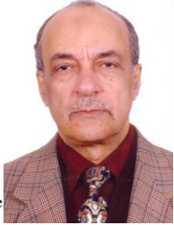

* Emeritus Professor of System Dynamics and Automatic Control.
* Has got his B.Sc. and M.Sc. from Cairo University in 1970 and 1974.
* Has got his Ph.D. in 1979 from Bradford University, UK under the supervision of Late Prof. John Parnaby.
* Now with the Faculty of Engineering, Cairo University, EGYPT.
* Research on Automatic Control, Mechanical Vibrations, Mechanism Synthesis and History of Mechanical Engineering.
* Published more than 340 research papers in international journals and conferences.
* Author of books on Experimental Systems Control, Experimental Vibrations and Evolution of Mechanical Engineering.
* Member of the Editorial Board of some engineering and computer technology international journals.
* Reviewer in some international journals.
* Scholars interested in the authors publications can visit:

**http://scholar.cu.edu.eg/galal**