**Reviews On Benefits of winter melon**

NAME -SONAM .G. MADANE*

GAYATRI. G.GAME1

VAISHNAVI.V.WAYKAR2

SUDHIR.G.SADGIR3

RESEARCH SCHOLAR -BACHELOR OF PHARMACY

ASHVIN COLLEGE OF PHARMACY, MANCHI HILL ASHVI B.K

EMAIL Id -sonammadane39@gmail.com

CONTACT No -9689604315

**ABSTRACT**

Benincasa hispida (Thunb.) Cogn. (Cucurbitaceae) is an annual climbing plant, native to Asia with multiple therapeutic uses intraditional medicine. This updated review is aimed at discussing the ethnopharmacological, phytochemical, pharmacological properties, and molecular mechanisms highlighted in preclinical experimental studies and toxicological safety to evaluate thetherapeutic potential of this genus. The literature from PubMed, Google Scholar, Elsevier, Springer, Science Direct, anddatabase was analyzed using the basic keyword “Benincasa hispida.” Other searching strategies, including online resources,books, and journals, were used. The taxonomy of the plant has been made by consulting “The Plant List”. The results showed that B. hispida has been used in traditional medicine to treat neurological diseases, kidney disease, fever, and coughaccompanied by thick mucus and to fight intestinal worms. The main bioactive compounds contained in Benincasa hispidahave cytotoxic, anti-inflammatory, and anticancer properties,antioxidant properties. Further safety and efficacy investigations are needed to confirm.

**Introduction**

Food and food products are being used as medicines over centuries worldwide. Many species from the family cucurbitaceae have been used as medicament in various disease in Ayurveda and ancient chinese medicine. This family is also known as the gourd family. It provide approximately 5 to 6% of the total vegetables in the world. To data ,825 species from under 118 genera have been reported growing in temperate regions of the world (1). It should be mentioned that the cucurbit species can grow in driverse climatic conditions, including arid deserts, tropical, subtropical and temperate regions. These various types of species are included in food system and Indian traditional medicines. Generally, the gourd family vegetable provide vitamins, essential minerals, antioxidants, and soluble fibers (2).

Benincasa hispida (Thunb.) Cogn. (synonym: Benincasa Cerifera Savi) (Cucurbitaceae) especially in Asian countriesIs considered as one of the famous crops under the Cucurbi-Taceae family that grows mainly for its fruits and wellRenowned for its nutritional and medicinal properties (3,4). Scientific reports suggest that B. hispida possesses many important nutritious substances, including vitamins, natural sugar , amino acids, organic acids, and mineral elements (3,4,5).

It essential for pigmentation, skin information, increasing sebum secretion and increased levels of oxidised lipids, including skin aging (6,7).

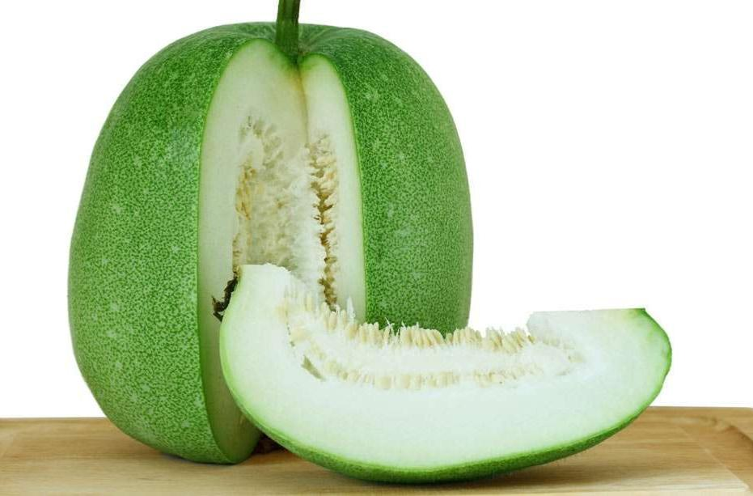

**Synonyms** : ash gourd, white gourd, winter melon, tallow gourd, ash pumpkin, chinese preserving melon, wax gourd, persian melon ,pethakaddu (Hindi) ,kundol (Tagalog),Tougan (japanese) .(8,10,9)

**Biological source:** The winter melon, also known as Benincasa hispida, is a fruit that grows on vines .

**Family** :Cucurbitaceae

**Morphological characteristics :**

1. **Stems:** covered in coarse hairs.
2. **Flower :**Yellow and originated from the leaf axils.
3. **Fruit:** can be round, pumpkin -like, or cylindrical in shape. The fruit can grow up to 30 to 45 cm long ,fruit colour is dark green to pale gray.
4. **Flesh :** white and crisp
5. **Seeds:** flat ,smooth and buff ,ranging from 1.0 to 1.5 cm in length and 0.5 to 0.8 cm in width. The seeds colour changes from white to yellowish brown.

**Biological classification:**

*Kingdom :plantae

*class: Magnoliopsida

*Sub class :Dilleniidae

*order: Cucurbitales

*Family: Cucurbitaceae

*Genus:Benincasa

*species:Benincasa hispida (Thunb).cogn

**Geographical source:**

Ash gourd is native to south and southeast Asia, and is thought to have originated in java and japan .It is also grown in India, Bangladesh, southern china,Nepal and Indonesia.(11)

Ash gourd grown in India: Uttar pradesh, Rajasthan, Haryana, Bihar ,West Bengal, Tamil Nadu, Kerala, Andhar pradesh and karnataka.

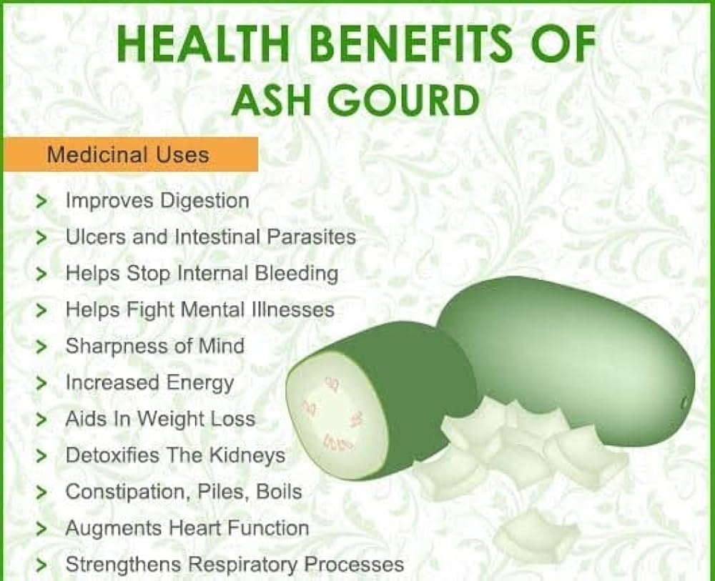

**Traditional uses :**

**\*Chinese medicine :**antipyretic ,antitussive ,diuretic ,antiobesity.

**\*Ayurvedic medicine:** anti epileptic ,antiastmatic ,bronchodilator ,antibacterial, diuretic.

**\*India:** petha cubes (sugar compote )for vegetarian diet.

**Pharmacology :**

* **Antioxidant Effects:**

Oxidative stress is a term used for free radical disease (14,13).It is define as the imbalance between free radical and antioxidants, given that oxidants (free radical) are more and have a destructive potential on the human body (12 ,15).. **1.Flavonoids and Polyphenols:** Winter melon contains various flavonoids and polyphenolic compounds, which are potent antioxidants. These compounds have been shown to help reduce oxidative stress, which is associated with chronic diseases. According to a study by Wu et al. (2016), winter melon extracts exhibited strong antioxidant activity due to the presence of flavonoids and phenolic compounds.(16)

**2. Vitamin C:** Winter melon is a good source of vitamin C, a well-known antioxidant that plays a significant role in protecting cells from oxidative damage. Vitamin C is essential for the maintenance of healthy skin, blood vessels, and cartilage, and its antioxidant properties contribute to reducing inflammation and combating free radical damage. Sharma et al. (2018) reported that winter melon has a considerable amount of vitamin C, which contributes to its overall antioxidant capacity.(19)

**3. Cucurbitacin Compounds:** Winter melon belongs to the Cucurbitaceae family, which is known for producing cucurbitacin compounds. These compounds have demonstrated antioxidant and anti-inflammatory properties. Research by Rahman et al. (2016) highlighted the bioactive compounds in winter melon, including cucurbitacins, which may help protect the body against oxidative stress.(18)

**4. Polyunsaturated Fatty Acids:** Winter melon also contains polyunsaturated fatty acids, which have antioxidant effects and contribute to overall cardiovascular health by reducing lipid peroxidation. Saeed et al. (2020) discussed how dietary polyunsaturated fatty acids from fruits and vegetables, including winter melon, can help protect against oxidative damage.(17)

**5.Effect on Enzymatic Antioxidants:** Studies have shown that winter melon extracts can enhance the activity of endogenous antioxidant enzymes such as superoxide dismutase (SOD) and catalase, which are crucial in defending the body against free radical-induced damage. Zhang et al. (2019) demonstrated that winter melon extracts could significantly boost these enzymatic antioxidant activities in animal models.(21)

* **Anti -inflammatory Effects:**

**1.Flavonoids and Polyphenolic Compounds**: Winter melon contains significant levels of flavonoids and polyphenolic compounds that have demonstrated anti-inflammatory properties. Research has shown that these compounds can inhibit the activation of inflammatory mediators such as cyclooxygenase-2 (COX-2) and pro-inflammatory cytokines like TNF-α and IL-6. A study by Wu et al. (2016) found that winter melon extracts, rich in flavonoids, exhibited potent anti-inflammatory effects in vitro by reducing the production of these inflammatory markers.(20) **2.Cucurbitacins:** Cucurbitacins, triterpenoid compounds found in winter melon, have been shown to exert anti-inflammatory effects by modulating inflammatory pathways. These compounds inhibit the NF-κB signaling pathway, which plays a crucial role in the regulation of inflammation and immune responses. Rahman et al. (2016) indicated that cucurbitacins in winter melon can reduce the production of pro-inflammatory cytokines and help in managing inflammatory diseases.(24)

**3.Antioxidant and Anti-inflammatory Synergy:** The antioxidant properties ofwinter melon also contribute to its anti-inflammatory effects. Reactive oxygen species (ROS) are known to activate inflammatory pathways, and by reducing ROS levels, antioxidants in winter melon may help alleviate inflammation. Studies have suggested that the combined antioxidant and anti-inflammatory effects of winter melon can provide protective benefits in conditions like chronic inflammation and autoimmune disorders. Zhang et al. (2019) highlighted that winter melon extracts reduced oxidative stress, which in turn contributed to their anti-inflammatory action.(23)

**4.Modulation of Inflammatory Enzymes:** Winter melon has been found to modulate key enzymes involved in the inflammatory response. Specifically, studies have shown that extracts from winter melon can inhibit the activity of enzymes such as lipoxygenase (LOX) and COX-2, both of which are involved in the synthesis of pro-inflammatory mediators like leukotrienes and prostaglandins. According to Saeed et al. (2020), these enzyme inhibitory effects help in reducing inflammation and associatedpain.(22) **5.Effects on Inflammatory Cytokines:** Research has demonstrated that winter melon extracts can downregulate the expression of inflammatory cytokines, such as TNF-α, IL-1β, and IL-6, which are often elevated in chronic inflammatory conditions. Sharma et al. (2018) found that winter melon supplementation reduced the levels of these cytokines in animal models of inflammation, providing evidence for its potential as an anti-inflammatory agent.(25)

* **Antimicrobial, Antihelmintic Effects:**

The excessive use of antibiotics that can lead to the development of antibiotics resistance of various strains of bacteria (28,27).Most of these options include plants with antiviral and antibacterial properties that can be effective against gram -negative and gram -positive bacteria. (26,29).

* **Anticancer Effects:**

Cancer is a term used to define malignancies in which abnormal cells multiply in an uncontrolled and continuous manner and can invade the surrounding health tissues (30,31).Abnormal cells come from any tissue in the human body and can occur any where in the body (34,33).Natural anticancer alternative can have a direct effect on milgnanta cells, as well as by stimulating the body immune capacity in the fight against the aggression of carcinogenic factors, internal or external (32,35).The favourable effects of some medicinal plants are Due to the main biochemical components flavonoids—-Which inhibit the activity of carcinogens and prevent the Metastasis of malignant cells; carotenoids—which protect The body against colon cancer; terpenes in essential oils—-Block the action of carcinogens, having a strong antioxidant Action; β-carotene, a powerful antioxidant with anticancer Protection and a recognized inhibitor of malignant cells;Antioxidant vitamins C, E, and A, destroy free radicals, pre-Vent cancer, and block the metastasis process (43,39).

* **Antidiarrheal Effect:**

Diarrhoea is a condition characterized by frequent watery stools, and usually, diarrhoea Persists for a few days and is treated with diet (40).ButThere are also more serious situations, in which diarrhoea Requires drug/complementary treatment and is more difficult to cure (41,42).

**\*Effects on Metabolic Diseases**

**1.Antidiabetic Effects:**

**(a). Blood Sugar Regulation:** Winter melon has been traditionally used in herbal medicine to manage diabetes. Some studies have suggested that winter melon may help lower blood glucose levels. This effect is thought to be due to its high water content and low glycemic index, which can help in controlling blood sugar spikes.(38)

**(b).Improved Insulin Sensitivity:** Research has shown that extracts from winter melon may improve insulin sensitivity, which can help in managing type 2 diabetes. Some studies indicate that the plant compounds in winter melon may exert effects similar to other well-known antidiabetic agents, although further clinical trials are needed to confirm this.(49)

**2.Antiobesity and Lipid lowering Effect :**

Lipids are fatty Organics substances that are the largest source of energy forThe body. The vast majority of fats are stored in solid from in various organs or skin, and a small part circulates in the Blood in liquid form (45,46). Imbalances in lipid metaboLism lead to pathophysiological changes and the appearance Of chronic diseases such as cardiovascular disease, fatty liver,Endocrine disorders, and dya bete(47,48).

**\*Neuroprotective properties:**

**1.Anticonvulsant Effects:**

The fruit extract (0.2-1kg,p.o.)showed a dose depend anticonvulsant activity in pentylenetetrazole,strychnine and picrotoxin and maximal electro seizures model (44).

**2.Effects on Alzheimer’s Disease:**

Neurodegenerative dis-eases such as Alzheimer’s disease are characterized by the presence of the central nervous system, protein aggregates,inflammation, and oxidative stress (50,51).Several factorsare involved in triggering neurodegenerative diseases,including the lifestyle that leads to the gradual deterioration of the health of the nervous system, with serious consequences on the quality of life of the patient with such a disease (54). Although there are still no treatment solutions torestore nerve function in neurodegenerative diseases, more and more studies insist on several natural formulas that have been shown to have the effect of reducing symptoms and improving the quality of life of patients with neurodegenerative disease (52,56).

**3.Nephroprotective Effects:**

Methanolic fruit extract(500 mg/kg/day, p.o.) for five days reduced the MDA conTent, while the increase in SOD, CAT, and GSH levels in Renal ischemia/reperfusion injury in female Wistar albino Rate(55). The seed ethanolic extract (250 and 500 mg/kg,p.o.) for 35 days significantly lowered the increased urinaryoxalate, presenting a regulatory action on endogenous oxalate synthesis; decreased in the urinary excretion and kidney retention levels of protein, oxalate, and calcium; and reduced the increased serum levels of sodium, calcium, phosphorus,and creatinine levels in ethylene glycol induced chronichyperoxaluria in Wistar albino rat (53).

**Conclusion:**

Benincasa hispida (Cucurbitaceae) is an annual plant, originating in Indonesia. The Chinese have been cultivating it for Over 2000 years; its medicinal uses first appeared in the medIcal field of the Tang Dynasty. In Chinese medicine, the crust Is used to treat urinary dysfunction, and the fruits are used toTreat fever. In Ayurveda, the fruits are also used to treat epiLepsy, lung diseases, asthma, cough, and urinary retention.Starting from these traditional uses, the present paper evaluAted the latest in vivo and in vitro pharmacological studies That demonstrated the molecular mechanisms which conFirmed ethnopharmacological uses. However, a limitingAspect of this paper is the lack of clinical trials in human sub-Jects. In the future, they are needed to complete the pharmaCological properties and to pave the way for newPharmaceutical forms based on natural compounds withProven therapeutic effects. Improvements in control stanDards are also needed for future pharmacological studies that Include B. hispida. In our work, they are relative, phytoChemical compounds being identified only by highPerformance liquid chromatography (HPLC). Another limIting aspect is represented by the antioxidant action of thisPlant which has been researched only in vitro, which does Not guarantee the same effect on in vivo experimental Models. Also, in future studies, the bioavailability, pharma-Cokinetics, mechanism of action, and study of the activity Relationship of the identified and isolated pure phytochemiCals should be analyzed, to better understand the reported

Biological action.

**References**:

[1] A. G. Ghebretinsae, M. Thulin, and J. C. Barber, “RelationShips of cucumbers and melons unraveled: molecular phylGenetics ofCucumisand related genera (Benincaseae,Cucurbitaceae),” American Journal of Botany, vol. 94, no. 7,pp. 1256–1266, 2007.

[2] S. Palamthodi and S. S. Lele, “Nutraceutical applications ofGourd family vegetables: Benincasa hispida, Lagenaria sicerAria and Momordica charantia,” Biomedicine & Preventive Nutrition, vol. 4, pp. 15–21, 2014.

[3] P. Purohit, S. Palamthodi, and S. S. Lele, “Effect of karwanda (Carissa congesta Wight) and sugar addition on physicoChemical characteristics of ash gourd (Benincasa hispida)And bottle gourd (Langenaria siceraria) based beverages,”Journal of Food Science and Technology, vol. 56, pp. 1037–

1045, 2019.

[4] S. Palamthodi, D. Kadam, and S. S. Lele, “PhysicochemicalAnd functional properties of ash gourd/bottle gourd beverAges blended with jamun,” Journal of Food Science and TechNology, vol. 56, pp. 473–482, 2019.

[5] N. A. M. Zaini, F. Anwar, A. A. Hamid, and N. Saari, “KunDur [Benincasa hispida (Thunb.) Cogn.]: a potential sourceFor valuable nutrients and functional foods,” Food Research International, vol. 44, pp. 2368–2376, 2011.

[6] D. R. Andrias, U. Fahmida, and A. C. Adi, “Nutritional Potential of underutilized food crops to improve diet qualityOf young children in food insecure prone areas of Madura Island, Indonesia,” Asia Pacific Journal of Clinical Nutrition, Vol. 28, pp. 826–836, 2019.

[7].Masaki,H.Role of Antioxidant in the: Anti -Aging effects. J.Dermatologist.Sci.2010,58,85-90.

[8].Jenkins, G.Molecular mechanism of skin ageing .Mech ageing Dev 2002,123,801-810.

[9]A. C. Busuioc, A.-V. D. Botezatu, B. Furdui et al., “ComparTive study thechemical compositions and antioxidant Activities of fresh juices from Romanian Cucurbitaceae varieTies,” Molecules, vol. 25, 2020.

[10]J. K. Patil and M. R. Patel, “Pharmacognostic and phytoChemical investigation of Benincasa hispida (Thunb.)Cong. Fruit,” Pharma Science Monitor, vol. 3, pp. 146–156, 2012.

[11] W. E. Soliman, S. Khan, S. M. D. Rizvi et al., “Therapeutic Applications of biostable silver nanoparticles synthesized Using peel extract of Benincasa hispida: antibacterial and Anticancer activities,” Nanomaterials, vol. 10, no. 10,p. 1954, 2020.

[12] J. Sharifi-Rad, A. Dey, N. Koirala et al., “Cinnamomum speCies: bridging phytochemistry knowledge, pharmacological Properties and toxicological safety for health benefits,” FronTiers in Pharmacology, vol. 12, 2021.

[13] A. Chouikh, “Phytochemical profile, antioxidant, analgesic And hypolipidaemic effects of ephedra alata decne. Female Cones extract,” Farmacia, vol. 68, pp. 1011–1020, 2020.

[14] J. Sharifi-Rad, C. F. Rodrigues, F. Sharopov et al., “Diet, life-Style and cardiovascular diseases: linking pathophysiology To cardioprotective effects of natural bioactive compounds,” International Journal of Environmental Research and Public Health, vol. 17, no. 7, p. 2326, 2020.

[15] D. Tsoukalas, O. Zlatian, M. Mitroi et al., “A novel nutraceuTical formulation can improve motor activity and decrease The stress level in a murine model of middle-age animals,” Journal of Clinical Medicine, vol. 10, no. 4, p. 624, 2021.

[16]. Wu, Y., et al. (2016). “Antioxidant activity and phenolic compounds in various parts of winter melon (Benincasa hispida).” Food Chemistry, 204, 50-57.

[17]. Sharma, S., et al. (2018). “Evaluation of antioxidant potential of Benincasa hispida (winter melon) and its health benefits.” Journal of Food Science and Technology, 55(2), 532-540.

[18]. Rahman, M. A., et al. (2016). “Phytochemicals and pharmacological properties of Benincasa hispida.” International Journal of Pharmacology, 12(5), 470-478.

[19]. Saeed, M., et al. (2020). “Antioxidant and anti-inflammatory effects of winter melon (Benincasa hispida) in animal models.” Food and Chemical Toxicology, 135, 110894.

[20].Zhang, X., et al. (2019). “Antioxidant potential band mechanism of action of winter melona tracts Antioxidants, 8(4), 110.

[21].Wu, Y., et al. (2016). “Anti-inflammatory and antioxidant activities of winter melon (Benincasa hispida) extract.” Food Chemistry, 204, 50-57.

[22]. Rahman, M. A., et al. (2016). “Anti-inflammatory properties of cucurbitacins from Benincasa hispida.” International Journal of Pharmacology, 12(5), 470-478.

[23]. Zhang, X., et al. (2019). “Antioxidant and anti-inflammatory effects of winter melon extracts.” Antioxidants, 8(4), 114.

[24]. Saeed, M., et al. (2020). “Anti-inflammatory and analgesic effects of winter melon (Benincasa hispida) in animal models.” Food and Chemical Toxicology, 135, 110894.

[ 25].Sharma, S., et al. (2018). “Evaluation of anti-inflammatory and antioxidant activities of Benincasa hispida.” Journal of Food Science and Technology, 55(2), 532-540.

[26] O. Zlatian, A. T. Balasoiu, M. Balasoiu et al., “Antimicrobial Resistance in bacterial pathogens among hospitalised patients With severe invasive infections,” Experimental and Therapeutic Medicine, vol. 16, pp. 4499–4510, 2018.

[27] A. E. Ghenea, R. Cioboată, A. I. Drocaş et al. “Prevalence and Antimicrobial resistance of Klebsiella strains isolated from a County hospital in Romania,” Antibiotics, vol. 10, no. 7, p. 868, 2021

[28] M. T. Islam, B. Salehi, O. Karampelas et al., “High skin melanin content, vitamin d deficiency and immunity: potential Interference for severity of COVID-19,” Farmácia, vol. 68, pp. 970–983, 2020.

[29] J. Sharifi-Rad, C. Quispe, A. Rahavian et al., “Bioactive compound as potential agents for sexually transmitted diseases Management: a review to explore molecular mechanisms of Action,” Frontiers in Pharmacology, vol. 12, 2021.

[30] A. I. Drocaş, P. I. Tomescu, G. Mitroi et al., “The cadherin switch assessment in the epithelial-mesenchymal Transition of urothelial bladder carcinomas,” Romanian Journal of Morphology and Embryology, vol. 57, pp. 1037–1044, 2016.

[31] A. O. Docea, P. Mitrut, D. Grigore, D. Pirici, D. C. Calina, and E. Gofita, “Immunohistochemical expression of TGF beta (TGF-beta), TGF beta receptor 1 (TGFBR1), and Ki67 in Intestinal variant of gastric adenocarcinomas,” Romanian Journal of Morphology and Embryology, vol. 53, pp. 683– 692, 2012.

[32].O. M. Zlatian, M. V. Comanescu, A. F. Rosu et al., “Histochemical and immunohistochemical evidence of tumor heterogeneity in colorectal cancer,” Romanian Journal of Morphology and Embryology, vol. 56, pp. 175–181, 2015.

[33] J. Sharifi-Rad, C. Quispe, M. Butnariu et al., “Chitosan nanoparticles as a promising tool in nanomedicine with particula Emphasis on oncological treatment,” Cancer Cell International , vol. 21, no. 1, 2021.

[34] J. Sharifi-Rad, S. Kamiloglu, B. Yeskaliyeva et al., “Pharmacological activities of psoralidin: a comprehensive review of the Molecular mechanisms of action,” Frontiers in Pharmacology, Vol. 11, 2020.

[35] B. Salehi, A. Prakash Mishra, M. Nigam et al., “Ficus plants:State of the art from a phytochemical, pharmacological, and Toxicological perspective,” Phytotherapy Research, vol. 35, 2020.

[36] B. Salehi, A. Rescigno, T. Dettori et al., “Avocado-soybeanUnsaponifiables: a panoply of potentialities to be exploited,”Biomolecules, vol. 10, 2020.

[37] B. Salehi, J. Sharifi-Rad, E. Capanoglu et al., “Cucurbita Plants: from farm to industry,” Applied Sciences, vol. 9, No. 16, p. 3387, 2019.

[38] B. Salehi, P. Lopez-Jornet, E. Pons-Fuster López et al., “Plant-Derived bioactives in oral mucosal lesions: a key emphasis to Curcumin, lycopene, chamomile, aloe vera, Green Tea and Coffee Properties,” Biomolecules, vol. 9, no. 3, p. 106, 2019.

[39] N. Akev, E. Candoken, and S. E. Kuruca, “Evaluation of aloeVera leaf extracts and aloe emodin on several cancer cell Lines,” Farmácia, vol. 68, no. 6, pp. 1155–1165, 2020.

[40] C. Scheau, C. Caruntu, I. A. Badarau et al., “Cannabinoids And inflammations of the gut-lung-skin barrier,” Journal of Personalized Medicine, vol. 11, no. 6, p. 494, 2021.

[41] J. Sharifi-Rad, C. F. Rodrigues, Z. Stojanović-Radić et al. “Probiotics: versatile bioactive components in promoting Human health,” Medicina, vol. 56, no. 9, 2020.

[42] P. Mitrut, A. O. Docea, A. M. Kamal et al., “Colorectal cancer And inflammatory bowel disease,” in Colorectal Cancer: From Pathogenesis to Treatment, pp. 185–199, Intech Europe, Rijeka, 2016.

[43]. Ahmed, S., & Hasan, A. (2020). Antidiabetic activity of Benincasa hispida (Winter melon) extract in alloxan-induced diabetic rats. International Journal of Pharmaceutical Sciences and Research, 11(5), 2336-2343.

[44]. Lai, C. H., & Lin, C. H. (2019). The effects of Benincasa hispida on glucose metabolism: A review of potential mechanisms. Phytomedicine, 59, 152916.

[45] A. Tsatsakis, A. O. Docea, D. Calina etal.,mechanistic and Pathophysiological approach for stroke associated with drugs Of abuse,” Journal of Clinical Medicine, vol. 8, no. 9, p. 1295,2019.

[46] S. Amir, S. T. A. Shah, C. Mamoulakis et al., “Endocrine disruptors acting on estrogen and androgen pathways cause Reproductive disorders through multiple mechanisms: a Review,” International Journal of Environmental Research And Public Health, vol. 18, no. 4, p. 1464, 2021.

[47] A. E. Găman, A. M. Ungureanu, A. Turculeanu et al., “The Impact of liver steatosis on early and sustained treatment Response in chronic hepatitis C patients,” Romanian Journal Of Morphology and Embryology, vol. 58, pp. 107–113, 2017.

[48] E. N. Ţieranu, I. Donoiu, O. Istrătoaie et al., “Rare case of single coronary artery in a patient with liver cirrhosis,” Romanian Journal of Morphology and Embryology, vol. 58, pp. 1505–1508, 2017.

[49] A. Kumar and P. Ramu, “Anti-convulsant activity of Benin-Casa hispida fruit, methanol extract,” Journal of Natural Remedies, vol. 4, no. 2, pp. 195–198, 2004.

[50] B. Salehi, D. Calina, A. Docea et al., “Curcumin’s nanomedi-Cine formulations for therapeutic application in neurological Diseases,” Journal of Clinical Medicine, vol. 9, no. 2, p. 430,2020.

[51] D. Calina, A. M. Buga, M. Mitroi et al.,“The treatment of cognitive, behavioural and motor impairments from brain injury And neurodegenerative diseases through cannabinoid system Modulation-evidence from in vivo studies,” Journal of CliniCal Medicine, vol. 9, no. 8, 2020.

[52] M. Sharifi-Rad, N. V. Anil Kumar, P. Zucca et al., “Lifestyle, Oxidative stress, and antioxidants: back and forth in the pathophysiology of chronic diseases,” Frontiers in Physiology, Vol. 11, 2020.

[53] B. Salehi, J. Sharifi-Rad, F. Cappellini et al., “The therapeutic Potential of anthocyanins: current approaches based on their Molecular mechanism of action,” Frontiers in Pharmacology, Vol. 11, 2020.

[54] V. Siokas, A. M. Aloizou, Z. Tsouris et al., “ADORA2A Rs5760423 and CYP1A2 rs762551 polymorphisms as risk factors for Parkinson’s disease,” Journal of Clinical Medicine, Vol. 10, no. 3, p. 381, 2021.

[55] B. Yagnik, V. Jitendra, J. Nurudin, K. Nilesh, P. Rameshvar, And P. Natavarlal, “Antioxidant activity of Benincasa hispide On renal ischemia/reperfusion injury, ” Pharmacology, vol. 1, pp. 44–49, 2009.

[56] R. Patel, S. Patel, and J. Shah, “Anti-urolithiatic activity of Ethanolic extract of seeds of Benincasa hispida (thumb),” Pharmacology, vol. 3, pp. 586–591, 2011.