**IOT BASED SMART INGREDIENTS QUANTITY INDICATOR**

1**Mr. A. Kuppuswamy,** 2**Ranjani S,** 3**Mahalakshmi P,** 4**Aruna K,** 5**Subashini B**

1Assistent Professor, Department of Electrical and Electronics Engineering, P. A. College of Engineering and Technology, Pollachi, Tamilnadu, India

2,3,4,5UG Student, Department of Electrical and Electronics Engineering, P. A. College of Engineering and Technology, Pollachi, Tamilnadu, India

**ABSTRACT**

The IoT-Based Smart Ingredients Quantity Indicator is a project aimed at transforming traditional kitchen management into a more efficient and intelligent system by leveraging Internet of Things (IoT) technology. This innovative solution is designed to monitor the quantity of various ingredients in real time, ensuring optimal inventory management and reducing waste. The system utilizes sensors to measure the quantity of ingredients stored in containers, sending the data wirelessly to a central IoT platform. This information is then processed and displayed on a user-friendly interface, accessible via smartphones or other digital devices. By providing timely alerts and notifications about low ingredient levels, the system helps users restock ingredients promptly, plan meals effectively, and avoid running out of essential items. The project not only enhances the convenience and efficiency of kitchen operations but also promotes sustainable practices by minimizing food waste. The integration of IoT with everyday kitchen management represents a significant step towards creating smart, connected homes and optimizing resource usage.

**Keywords:** Quantity Measure, Level Indicator, IoT Platform.

1. **INTRODUCTION**

In today's fast paced world, kitchen management can often be a challenging task, especially when it comes to keeping track of ingredient levels and ensuring timely replenishment. Running out of essential ingredients at crucial moments can lead to unnecessary delays, wasted time, and even spoiled meals. " The IoT-Based Smart Ingredients Quantity Indicator " project aims to revolutionize the way we manage kitchen inventories by utilizing the power of the Internet of Things (IoT). By integrating IoT technology with kitchen containers, the primary goal of this project is to create a smart kitchen environment where ingredient quantities are continuously tracked and updated, ensuring that users are always aware of their stock levels. These sensors communicate wirelessly with a central IoT platform, which processes the data and displays it on a user-friendly interface. Additionally, the system can send notifications or alerts when ingredient levels fall below a predefined threshold, prompting timely restocking. By maintaining optimal ingredient levels, users can plan meals more effectively, avoid unnecessary trips to the grocery store,and reduce the chances of throwing away expired food.

1. **LITERATURE SURVEY**

Metho Hagleitner, C.; Lange, D.; Hierlemann, A.; Brand, O.; Baltes, H.; CMOS single-chip gas detection system comprising capacitive, calorimetric and mass-sensitive microsensors. IEEE J. Solid State Circuit 2022, 37, 1867-1878.

The most important problem faced by restaurant, family circle and some other food chain is controlling and tracking the food record. The home automation system based on Internet of Things is designed and employed in kitchen wardrobe. The grocery products in a kitchen need to be monitored manually and decisions have to be taken by the user. Thus a Smart Kitchen Wardrobe to manage the grocery products in the kitchen wardrobe using Internet of Things is proposed. It has done with the aid of wireless networks, smart phones and internet. The new Live Video Analysis technique is used with Arduino in this project to monitor the products in the kitchen. Also an android application which provides the user-friendly interface to the user.

Marjan Ralevski; Biljana Risteska Stojkoska. IoT based system for detection of gas leakage and house fire in smart kitchen environments. November 2019. .8971021.

The future holds a broader range of available technologies that will offer more innovative ways for solving everyday issues. By combining small processing units with artificial intelligence and machine learning, one can expand the horizon of new concepts and ideas to increase everyday safety. In this paper we have designed a cheap Internet of Things based system which enables the early detection of house fire and gas leaks. We are simulating a scenario where we detect the rising possibility of house fire in a kitchen environment, by measuring temperature and the gases concentration. To optimize the communication process and reduce the number of sent packets from the measuring node to the system gateway, we applied time series forecasting approach based on moving average prediction scheme.

1. **MODELING AND ANALYSIS**

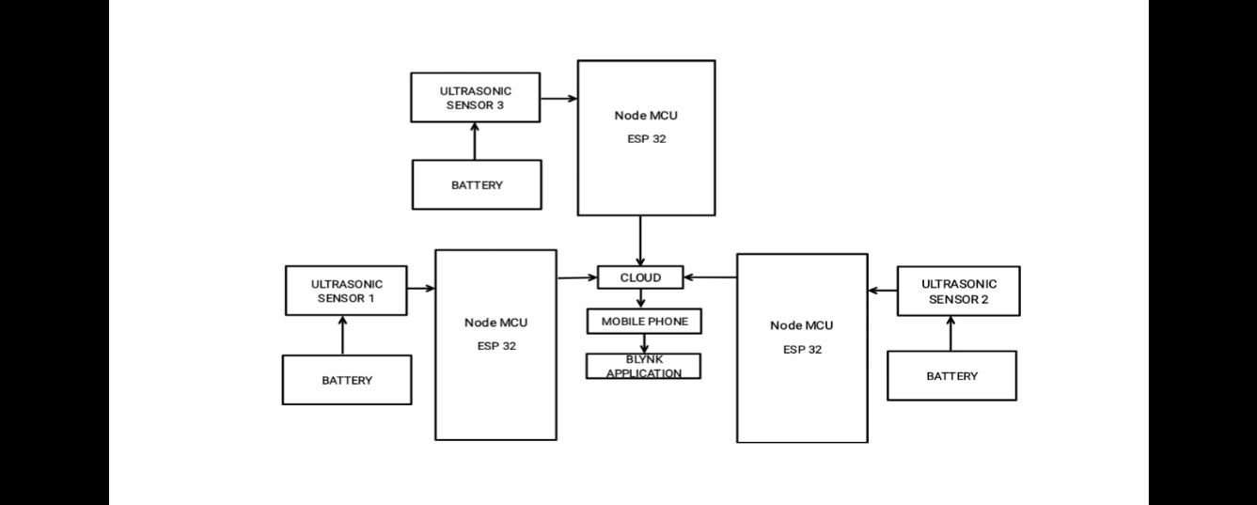

**Figure 1:** Block Diagram

1. **HARDWARE DESCRIPTION**

First of all need the voltage (DC 5v) to give the supply an micro controller and sensor parameters in this project. So, take the voltage regulator consists of (IC 7805), 7805 is used for the give a (5 v) output from the DC Voltage, here used the 5v is used for the give the accurate and flexibility of this voltage. The NODE MCU acts as the core controller or "brain" of the system, processing data from various sensors and managing communication with the cloud via its built in WiFi module. It enables real time monitoring and control of the system. The system can be powered through a 5V power supply for the sensors, or via a battery setup for portability in ensuring continuous operation.NODE MCU has 10 pins, 1 analog and 9 digital pins are connected on this controller. The Ultrasonic sensor is connected to the digital input & output pin D2 & D3 of the NODEMCU. It measures the distance, by measuring the echo pulse width, the distance to target can easily be calculated. Features non-contact measurement with blinding from 0.1cm. When any of the sensor readings (such as distance) exceed their defined thresholds, the system marks these as abnormalities and sends alerts via the IoT platform. The system also triggers the buzzer to notify the ingredients level is low in BOX. sensor data is monitored in real time, and any deviations are displayed on the IoT dashboard for remote access, enabling quick responses to any detected low level.

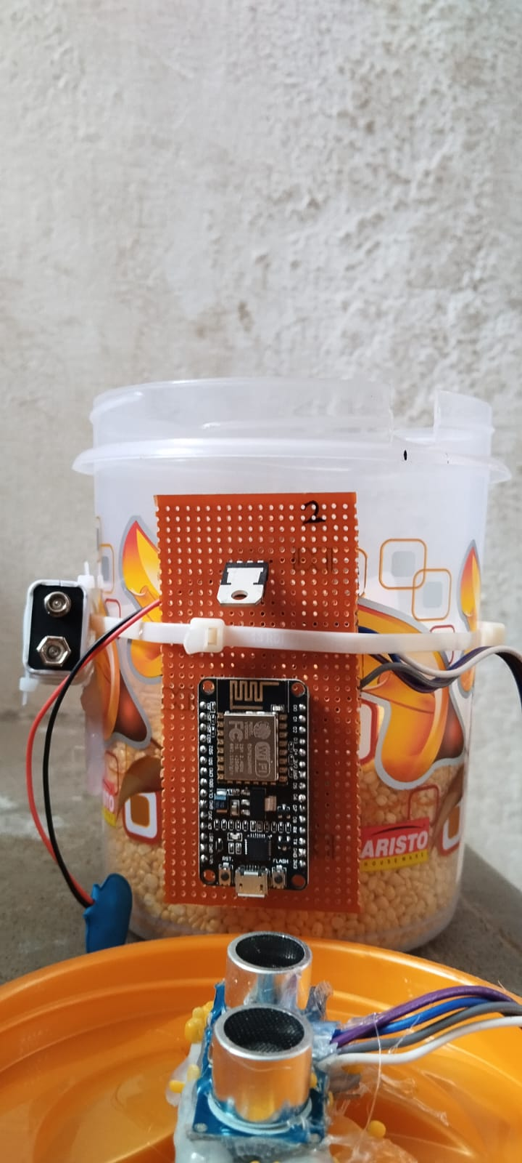

**Figure 2:** Hard ware

1. **RESULTS AND DISCUSSION**

The system will also provide real time monitoring and alerts for low ingredient levels, automated reporting, and analytics for inventory optimization. Qualitatively, we expect 90% positive feedback from users,100% secure data handling, and scalability to accommodate 50% more users without system degradation. In this method, proposed a model which helps us to keep a track of kitchens pantry. Sensors can sense the weight of kitchen storage containers and calculate the quantities of available components in pantry.

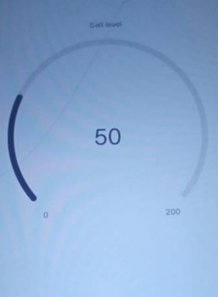



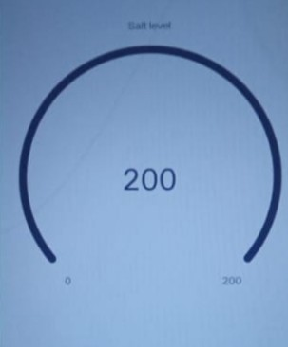**HIGH LEVEL**

**LOW LEVEL**

**Figure 3:** Output of the HardWare

1. **CONCLUSION**

The "IoT Based Smart Ingredients Quantity Indicator" project represents a significant step forward in the evolution of smart kitchen management. By leveraging the power of the Internet of Things, this innovative solution provides a convenient, efficient, and reliable way to monitor and manage kitchen inventory in real time. This not only enhances the cooking experience but also contributes to cost savings and environmental sustainability by reducing food waste and optimizing resource usage. As the IoT ecosystem continues to expand, the smart ingredients quantity indicator can be adapted and scaled to meet the needs of various kitchen environments, from small households to large commercial kitchens.

1. **REFERENCES**
2. Shirsath Shraddha, Somvanshi Snehal, Chavan Ameya, Tambe Rahul. (2016) ‘SMART KITCHEN USING IOT’, International Journal of Advanced Research in Computer Engineering & Technology (IJARCET) Volume 5.
3. J. Tsado, O. Imoru, S.O. Olayemi. (2014) ‘Design and construction of a GSM based gas leak Alert system’, IEEE Transaction, IRJ EEE Vol. 1(1), pp. 002-006.
4. Luay Fraiwan, Khaldon Lweesy, Aya Bani Salma, Nour Mani. (2011) ‘A wireless home safety gas leakage detection system’, IEEE Transaction.
5. Mr. Gaurav V Tawale-Patil, Miss. Kalyani H Kulkarni, Miss. Pooja U Kuwad, Miss.Pooja R Pawar. (2016) ‘Smart Kitchen Using IoT’,International Journal of Research in Advent Technology (E-ISSN: 2321-9637) Special Issue National Conference “NCPCI-2016”.
6. Amita Thakare1, Pooja R. Gandhe2. (2017) ‘A REVIEW PAPER ON KITCHEN MONITORING SYSTEM USING EMBEDDED WEB SERVER’.
7. D.Surie, O. Laguionie, T. Pederson. (2008) ‘Wireless sensor networking of everyday objects in a smart home environment’, Proceedings of the International Conference on Intelligent Sensors, Sensor Networks and Information Processing- ISSNIP, pp. 189 – 194.
8. Liang Zhang, Zhihui Zhou, Yunjie Xu, Xun Guan, Yan Zhang. (2021) ‘Design and Test of Oil Fume Monitoring System for Central Kitchen’, Sensors 21(13):4449.
9. Kavya Achary, Priyanka Auti, Pooja Khyadgi, Sneha Korade. (2017) ‘A Smart Kitchen Device using Ultrasonic Sensor for storage of food ingredient in mega kitchens’.