**Thermal Properties of Short Sisal Fibre Reinforced Polymer Composites**

Azhar Iqbal, Alok Agrawal

Department of Mechanical Engineering, Sagar Institute of Research and Technology, Bhopal-462041

Abstract – In the present investigation, composites are prepared with natural fibre i.e. sisal fibre and polymer i.e. polyester resin. The samples are prepared with a simple hand lay-up method. The content of fibre varies from 0 wt. % to 8 wt. %. The properties evaluated are different thermal properties. The properties under investigation are thermal conductivity, glass transition temperature and coefficient of thermal expansion. From the experimental results, it is found that the inclusion of short sisal fibre in the polyester resin improves the different thermal properties of the composites. Properties like thermal conductivity and coefficient of thermal expansion decrease as a function of fibre loading, whereas the glass transition temperature of the composite material increases with fibre loading.

**Keywords:** Polymer matrix composites, polyester, sisal fibre, thermal properties.

1. **INTRODUCTION**

Natural fibre-polymer composites (NPCs) are gaining popularity across diverse applications due to their environmental and cost benefits compared to traditional petroleum-based materials. Organic waste and residues from industrial and agricultural activities are often underutilized, typically managed through methods like landfilling, composting, or anaerobic digestion. Using these organic by-products in NPCs offers an environmentally friendly alternative with greater value. Natural plant fibres are increasingly seen as a sustainable option for composite fillers. The mechanical and physical attributes of natural fibre composites (NFCs) vary widely and include factors such as dimensional stability and mechanical strength. These properties are influenced by fibre characteristics, the bonding between fibre and matrix, the type of matrix used, production techniques, and any added materials. Additionally, the performance of NFCs can be affected by the conditions under which they are used. Recent interest in natural fibres has surged due to their advantages over traditional reinforcement materials. Natural fibres are cost-effective, lightweight, biodegradable, and non-abrasive, making them a compelling choice for composite applications. This shift aligns with a broader trend towards sustainable materials and practices, offering an eco-friendly alternative while maintaining or enhancing performance characteristics. Among the long list of natural fibres, sisal fibre is of interest to the scientific community because of its multiple advantages.

Sisal fibre has been established as a potential reinforcement material in combination with different thermoset and thermoplastic polymers. Mechanical properties of sisal fibre-reinforced polymer composites depend on various factors which include fibre loading, length of fibre and orientation of fibre. Maurya et al. [1] worked on epoxy reinforced with short sisal fibre and evaluated the mechanical properties of the composites as a function of fibre length. They used four different lengths of fibre ranging from 5 mm to 20 mm with an increment of 5 mm and kept the fibre loading constant at 30 wt. %. Rao et al. [2] fabricated sisal fibre-reinforced polyester composites by varying the content of fibre from 10 volume % to 40 volume %. They used the hand lay-up method for composite fabrication and evaluated the tensile and flexural strength of the composites. In their analysis, they found that tensile and flexural strength both the properties increase linearly with an increase in the content of fibre. Mahato et al. [3] used sisal fibre with vinyl ester polymer and fabricated the samples using the hand lay-up method. They used sisal fibre of length 50 mm in their investigation. NaOH is used by them for modifying the surface of sisal fibre. They fixed the concentration of NaOH used at 2 % and varied the time of treatment. They fabricated the samples with treatment sisal fibre for different durations and also with different weight fractions.

Contrary to that, Huang et al [4] found that the mechanical properties show increasing decreasing trends with an increase in fibre content. They fabricated sisal fibre-reinforced composites with polyester up to 15 volume % fibre content. They used close mould techniques for composite fabrication. In their analysis, they found that tensile strength, flexural strength and impact strength increase with filler content up to 10 volume percentage and with further increase in fibre content, the values start to show decreasing trends. When sisal fibres were incorporated into polypropylene polymer, Hasmi et al. [5] observed continuous increasing trends in all the mechanical properties under investigation. Also, they reported to achieve significant improvement in the mechanical properties. In their work, tensile strength increases from 31.26 MPa to 48.99 MPa and flexural strength increases from 48.03 MPa to 64.51 MPa when fibre weight fraction increases from 0 wt. % (pure PP) to 30 wt. %. Rohit et al. [6] incorporated sisal fibre in low-density polyethene and fabricated composites by the melt mixing method and varied the fibre content from 5 wt. % to 20 wt. %. They observed that tensile strength increases with fibre content up to 15 wt. % and then starts showing a decreasing trend with a further increase in fibre content. On the other hand, impact strength continues to increase with fibre content and maximum impact strength achieved at maximum fibre content. Uppal et al. [7] studied mechanical properties like tensile strength, flexural strength and impact strength of the chopped sisal fibre-reinforced polyester composites. From their thorough investigation, they found that the inclusion of chopped sisal fibre in the polyester resin improves the various mechanical properties of the composites under investigation and makes the composite suitable for building construction products and automotive applications. Sahu et al. [8] fabricated composites by manual method with a constant content and length of fibres as 16 wt. % and 15 mm, respectively. Mechanical tests on the prepared samples were performed in terms of tensile, flexural, impact and hardness.

In the last five years, the study on sisal fibre as reinforcement has grown interest again and is explored with various polymers for their different properties. In that context, the prime work conducted in the last four years is discussed in detail. Sahu and Gupta [9] investigated the effects of eco-friendly treatments and coatings on the mechanical and physical properties of sisal fibre composites. Their study aimed to enhance the performance of these composites while maintaining sustainability. The research revealed that treatment significantly improved the tensile strength of sisal composites by 24%, providing enhanced structural stability. Flexural strength increased by 20%, demonstrating greater resistance to bending forces, which is crucial for load-bearing applications. Bhagat and Ghosh [10] investigated the performance properties of polypropylene (PP) and sisal fibre composites, focusing on composites with near-critical fibre lengths. Their study aimed to understand how fibre length influences the mechanical properties of these composites and to predict their performance. Ayalew and Wodag [11] conducted a study on chemically treated sisal fibre/polyester composites, focusing on how chemical treatments affect the mechanical and physical properties of these composites. The study found that chemical treatment significantly enhanced the tensile strength of the sisal fibre composites, with an improvement of 22% compared to untreated fibres. Olhan et al. [12] investigated the mechanical, thermal, and viscoelastic properties of sisal fibre-based structural composites, with a focus on their suitability for automotive applications. The study combined experimental methods with finite element modelling (FEM) to analyze the performance of these composites. Sanfilippo et al. [13] examined the impact of sodium bicarbonate treatment on sisal fibres and their subsequent effect on geopolymer composites. The study aimed to enhance the performance of sisal fibres when used in geopolymer matrices. Naik et al. [14] explored the use of microwave-assisted alkali treatment to enhance sisal fibres for use in composite materials intended for non-structural building applications. The study focused on improving the mechanical properties and overall performance of the sisal fibres and their composites. The results showed that the microwave-assisted alkali treatment increased the tensile strength of the treated sisal fibres by 28%, and flexural strength improved by 22%. The uniqueness of the present work is to develop a green composite at a low cost for light-duty structural applications using polyester as the base matrix and sisal fibre in short form as reinforcing material. Based on the literature survey, the sisal fibre was first modified using a moles concentration NaOH solution before reinforcing it into the polyester. The effect of the sisal fibre loading on different mechanical properties has been investigated.

1. **MATERIALS AND METHODS**

Unsaturated isophthalic polyester supplied by Carbon black composites, Mumbai India, is the matrix material in the present investigation. Polyester resin is used with its corresponding accelerator i.e. cobalt accelerator and catalyst i.e. MEKP catalyst. The advantage of polyester resin composites is that they can be cured in a variety of ways without altering the physical properties of the finished part. Their advantages include low viscosity, low cost, and fast cure time. The sisal fibre used in the present work was obtained from the local market as it is used in rural areas for making cord, met etc. The fibre was extracted from the leaf of the plant Agave-Sisalana which is available in plenty in the Southern part of India. Among the various natural fibres, sisal fibre is the most promising to be used as reinforcement in polymer composites as it is relatively inexpensive and commercially available. In the present investigation, sisal fibre is used in its short form. An approx. 4 mm length of sisal fibre is used for composite fabrication. The use of short fibres as reinforcement in composites is getting commercial importance, particularly in low-load secondary structure applications. Short fibre reinforced composites offer better stiffness, heat distortion temperature and strength in comparison to the base polymer. Sisal fibres were treated with aqueous solution of NaOH before being used as a reinforcement material. The thermal conductivity of the fabricated composites is measured by [Unitherm Model 2022](http://www.azom.com/ads/abmc.aspx?b=5018). The tests are by ASTM E-1530 Standard. Glass transition temperature and Coefficient of thermal expansion of the composites are measured with a Perkin Elmer DSC-7 Thermal Mechanical Analyzer. During the measurement, the specimen is heated from 30 to 150°C at a heating rate of 5°C/min.

1. **RESULTS AND DISCUSSION**

The effective thermal conductivity of polyester reinforced with short sisal fibre modified with an aqueous solution of NaOH is presented in Figure 1. The figure shows the variation in the thermal conductivity as a function of fibre loading. From the figure, it is observed that the inclusion of short sisal fibre improves the thermal insulation capability of the polyester resin by decreasing the thermal conductivity of the composites. The thermal conductivity of neat polyester is 0.347 W/m-K which is a low value. This further reduces to 0.254 W/m-K when 8 wt. % of sisal fibres were added to it. This shows that the thermal conductivity reduces by 26.8 % which is an appreciable decrement in the thermal conductivity value for a low fibre loading of 8 wt. %.

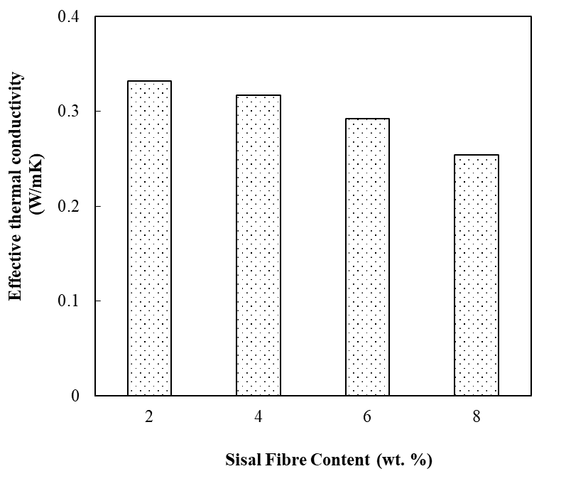

**Figure 1** Effective thermal conductivity of polyester/sisal fibre composites

The glass transition temperature of the fabricated composite samples is measured with a Perkin Elmer DSC-7 thermal mechanical analyzer (TMA). Glass transition temperature is a very important thermal property which decides the maximum working temperature of any material. Figure 2 presents the variation of the glass transition temperature of polyester resin with the inclusion of sisal fibre. It is observed that the glass transition temperature of neat polyester is about 71.2 °C and it gradually increases to 83.1 ºC for a fibre loading of only 8 wt. %. A maximum increase of about 16.71 % in glass transition temperature is obtained.

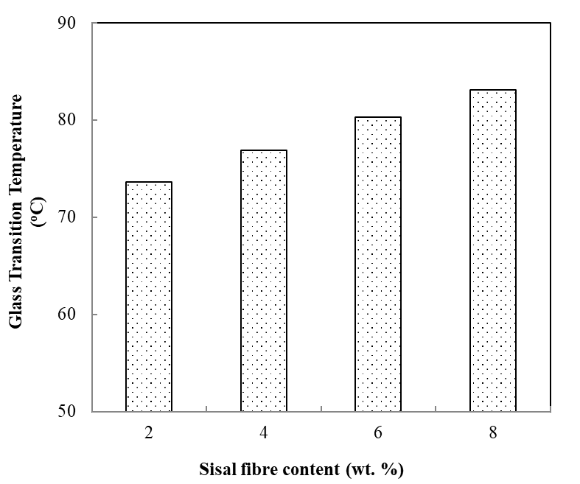

**Figure 2** Glass transition temperature of polyester/sisal fibre composites

The intrinsic coefficient of thermal expansion values of polyester is quite high i.e. 73.8 × 10-6/°C. Hence, on heating, the polymer matrix will expand more. Against that, the same property of sisal fibre is very low as a negligible change in its dimension with temperature change is registered and these changes took place at a higher temperature. However, if the inter-phases are capable of transmitting stress, the expansion of the matrix will reduce giving rise to a reduced value of the coefficient of thermal expansion for the composite as a whole.

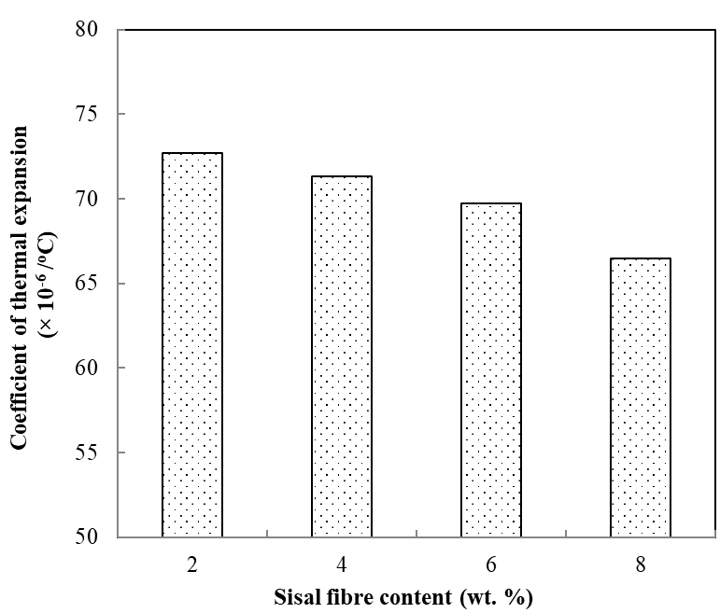

**Figure 3** Coefficient of thermal expansion of polyester/sisal fibre composites

Figure 3 shows the coefficient of thermal expansion of the composite specimen under investigation. It is clear from the graph that the coefficient of thermal expansion of the composite decreases with an increase in the content of sisal fibre. The coefficient of thermal expansion of neat polyester was measured to be 73.8 × 10-6/°C. This value of the coefficient of thermal expansion reduces to 66.5 × 10-6/°C when 8 wt. % of sisal fibre is added to the polyester. A maximum decrease of about 10.09 % in the coefficient of thermal expansion is obtained.

1. **CONCLUSIONS**

This experimental investigation has led to the following specific conclusions:

1. The addition of sisal fibre in the polyester matrix increases the insulative nature of the polymer. The thermal conductivity of neat polyester is 0.347 W/mK and the same reduces to 0.254 W/mK when 8 wt. % sisal fibres were added to it.
2. The glass transition temperature of the polyester gainfully improves with the addition of the sisal fibre. For a fibre loading of 8 wt. %, the glass transition temperature increases from 71.2 oC to 83.1 oC.
3. The coefficient of thermal expansion of the polyester resin reduces with sisal fibre loading. An appreciable decrement of 10.09 % is achieved when the content of sisal fibre was increased to 8 wt. %.

**REFERENCES**

1. H.O. Maurya, M. Gupta, R. Srivastava, H. Singh, Study on the mechanical properties of epoxy composite using short sisal fibre, Mater. Today: Proc. 2 (2015) 1347–1355.
2. Rao, K. M. M., Rao, K. M., & Prasad, A. R. (2010). Fabrication and testing of natural fibre composites: Vakka, sisal, bamboo and banana. Materials & Design, 31(1), 508-513.
3. Mahato, K., Goswami, S., & Ambarkar, A. (2014). Morphology and mechanical properties of sisal fibre/vinyl ester composites. Fibres and Polymers, 15(6), 1310-1320.
4. Huang, Z., Ge, H., Yin, J., & Liu, F. (2017). Effects of fibre loading and chemical treatments on properties of sisal fibre-reinforced sheet molding compounds. Journal of Composite Materials, 51(22), 3175-3185.
5. Hashmi, S. A. R., Rajput, R. S., Naik, A., Chand, N., & Singh, R. K. (2015). Investigations on weld joining of sisal CSM‐thermoplastic composites. Polymer Composites, 36(2), 214-220.
6. Rohit, K., & Dixit, S. (2017). Tensile and Impact Behaviour of Thermoplastic BOPP/Milk Pouches Blends Reinforced With Sisal Fibres. Progress in Rubber Plastics and Recycling Technology, 33(3), 139-152.
7. Uppal, N., Pappu, A., Patidar, R., & Gowri, V. S. (2019). Synthesis and characterization of short sisal fibre polyester composites. Bulletin of Materials Science, 42, 1-8.
8. Sahu, P., & Gupta, M. K. (2021). Eco-friendly treatment and coating for improving the performance of sisal composites. Polymer Testing, 93, 106923.
9. Sahu, P., & Gupta, M. K. (2021). Eco-friendly treatment and coating for improving the performance of sisal composites. Polymer Testing, 93, 106923.
10. Bhagat, A. B., & Ghosh, A. K. (2022). Performance Properties of PP/Sisal Fibre Composites Having Near Critical Fibre Length and Prediction of Their Properties. Fibers and Polymers, 23(7), 1983-1994.
11. Adugna Ayalew, A., & Fenta Wodag, A. (2022). Characterization of chemically treated sisal fiber/polyester composites. Journal of Engineering, 2022(1), 8583213.
12. Olhan, S., Antil, B., Khatkar, V., & Behera, B. K. (2023). Mechanical, thermal, and viscoelastic behavior of sisal fibre-based structural composites for automotive applications: Experimental and FEM analysis. Composite Structures, 322, 117427.
13. Sanfilippo, C., Fiore, V., Calabrese, L., Megna, B., & Valenza, A. (2024). Effect of sodium bicarbonate treatment on the properties of sisal fibers and their geopolymer composites. Case Studies in Construction Materials, 21, e03536.
14. Naik, T. P., Gairola, S., Singh, I., & Sharma, A. K. (2024). Microwave-assisted alkali treatment of sisal fiber for fabricating composite as non-structural building materials. Construction and Building Materials, 411, 134651.