**Title :**

How to develop positivity in college/university students

**Abstract:**

This paper examines the potential benefits of enhancing positivity and resilience in students at colleges and universities through structured interventions. Many students struggle to keep their academic, social, and personal responsibilities in line, which causes them distress, procrastination, and undesirable mental health outcomes. Literature review shows that for well-being among students, those skills of time management, stress management, and an academic-life balance are extremely crucial. In addition, the use of positive psychology principles, including resilience building and growth mind-sets, has been proven to increase the resiliency and self-confidence in students. Campus-based support systems, including mentorship programs, community-building activities, as well as mental health resources, also have a significant impact on nurturing an environment that supports and cares for students. Analysing the results reveals that students who experience high institutional support and are given resources both practically and emotionally display better academic performance, life satisfaction, and stronger coping abilities. Surprising results indicate that the perceptions of institutional care play a more significant role in student engagement and motivation. In short, the present role of colleges and universities in relation to managing stress, challenges, or view constructively with regard to growth, academic or personal, requires integrated support, which is discussed within the study.

**Keywords:**

College Mental Health, Time Management Skills, Stress Management, Academic-Life Balance,

Positive Psychology

**Introduction:**

College and university students often experience a complex array of challenges that impact both academic success and mental well-being in the high-stakes environment of higher education. Overwhelmed by the need to balance academic, social, and personal responsibilities, students may become stressed, procrastinate, and perform less well academically. Such pressures can negatively impact the outlook and resilience of students due to little or no awareness of resources on mental health. Moreover, competitiveness of most academic institutions creates isolation and discourages the critical need to reach out or seek relationships with their peers.

Recent studies have informed the importance of developing supportive college structures that lead to enhanced academic success and personal well-being in students. Research into positive psychology has shown that a growth mind-set and strong support systems help build resilience for coping with the pressures of academic challenge. The promising studies involved stress management training, time management workshops, and opportunities for social engagement have been proven to reduce the degree of stress that students go through to spend a more balanced academic-life. Strategies remain to be effective for community-building, which would include mentoring and peer-support networks helping students build meaningful relationships and combat feelings of isolation in addition to having a positive campus culture.

This paper will explore the different ways in which colleges and universities can work to promote student well-being and resilience, thus ensuring good mental health and better academic performance. In discussing the intersection of time management, stress management, and positive psychology, as well as the role of social support systems, this research seeks to highlight the more comprehensive approaches required to empower students. This makes for a supporting and nurturing environment as it not only helps in reducing stress and enhancing well-being but builds the kind of more resilient, engaged, and growth-oriented student body ready for academic and personal challenges.

**Problem Statement:**

In reality, most students suffer to keep track of balancing academic, social, and personal responsibilities and thus end up feeling overwhelmed with negativity. The outcome usually ends up being procrastination, poor performance, and increased stress.

Developing positivity among college students leads to building a more resilient, engaged, and growth-oriented student body. Research in positive psychology has shown that a strong support system, healthy coping mechanisms, and opportunities for community engagement can profoundly improve students' mental well-being. However, most of the students are unaware of mental health resources or unable to reach positive role models and mentors, which can help bring out constructive attitudes. Another reason could be due to the competitive environment existing in most colleges and universities, which isolates a student and gives them a fixed mindset, hence reducing their confidence and reluctance in asking for help or engaging with other classmates.

In this regard, structured awareness programs on mental health are necessary, along with provision of peer and professional support and encouraging students to adapt to a healthy approach to life. Some of the initiatives that create a support environment include mentorship programs, workshops on resilience and stress management, and community engagement activities. By prioritising mental well-being and creating spaces where students feel valued and empowered, institutions can help students develop the confidence, self-awareness, and positive mindset necessary to thrive academically and personally.

**Literature review :**

Pressure often mounts the college and university students' lives, targeting them both academically and psychologically. College mental health studies indicate that numerous students report experiencing levels of high stress, anxiety, and depressive symptoms caused by multiple responsibilities. Students who do not develop good time management skills experience frustrations that lead to procrastination, poor academic performance, or increased stress (Macan et al., 1990). The literature suggests that effective time management tends to support the balance needed between academic and life engagement, which enables learners to further distribute their workload in support of a better sense of control, leading to overall well-being and positive adaptation.

Thus, incorporating positive psychology principles into campus initiatives could be an effective proactive approach at improving student mental health. Positive psychology has been emphasised with developing resilience, enhancing self-efficacy, and cultivating a growth-oriented mindset, all of which have been proven to improve students' adaptability and reduce feelings of loneliness in the world (Seligman, 2011). These kinds of programs assist students to get out of fixed mindsets, to have a positive self-view, and see challenges as opportunities for growth. Social support networks on campus, such as mentorship programs and peer-support groups, allow students to connect with others, reduce feelings of isolation, and reinforce positive coping strategies that are essential for mental health and resilience (Davidson & Cotter, 2020).

Stress management interventions can include mindfulness training, the use of relaxation techniques and resilience building workshops which allow students to better regulate the emotional effects of stress to be successfully managed (Kabir, 2018). Teaching the skills that individuals use for stress management leads to positive outcomes that persist in a student's own handling of academic or other personal demands. It also fosters a healthy academic-life balance in that the students engaged in co-curricular activities and maintain their social relationships generally tend to report higher life satisfaction and well-being (Astin, 1999). Colleges can make the environment supportive by prioritising mental health awareness, by promoting positive psychology practice and support systems for time management and community involvement. Such an environment would lead to the development of a confident and self-aware personality, a positive attitude toward life, and eventually, a successful academic and personal life.

**Methodology:**

Such initiative at college campuses can set an institution-upon a systematic way of guiding its students focusing on the core competencies of time management skills, mental health support, and community engagement. The time management skills that focus on attending workshops and digital tools seem to equip the students with better management of their time for academics, social life, and personal matters in which there is less overwhelming feeling and more control. Mental health support includes counselling, mindfulness sessions, and even resilience training tailored to equip positive ways of coping that encourage the growth mindset. Additional aspects include mentorship by peers and community-buildings in terms of hosting team events, as well as student clubs. This activity, which includes forging a cohesive culture within campus in the aspect of bonding and valuing each one another, creates a sturdy campus environment for more resolute students with engagement and positivity, consequently bettering overall well-being and academics.

**Result analysis:**

The most major observations of the literature review relate to the effectiveness of structured interventions in improving the well-being and resilience of college students. These interventions, mainly college mental health, time management skills, stress management, academic-life balance, and positive psychology, contribute significantly to the development of a sense of optimism and the reduction of stress in students. The following are the major findings:

1. Effective Management of Time and Stress: This area of research also finds it true that time and stress management skills offer very fundamental support for students' to handle their academic, social, and personal responsibility tasks. When students possess these skills, they show that they are in good control of their life; their tendency to procrastinate lowers; and stress in the lives of students becomes decreased. Such an outcome is used to prove the suggestion that training in practical techniques related to time and stress handling will improve the desirable behaviour of being organised when they have to handle academic stress.

2. Resilience and Positive Thinking Through Positive Psychology: Some major programs that have been followed to ensure that students learn to face challenges positively involve resilience-based and growth mindset-based interventions. Such measures decrease feelings of isolation and increase adaptability. Most importantly, they make them view setbacks as learning situations. This helps foster better emotional well-being, elicits proactive behaviours such as seeking help, and leads to better academic and social involvements.

3. Better Academic-Life Balance and Social Support: Students learn to appreciate community belonging by participating in social and extracurricular activities that help to create balance in academic life. A greater sense of belonging exists among students participating in mentorship programs and peer-support networks. Such a sense of belonging is related to lesser stress, greater resilience, and higher overall mental well-being.

4. Campus Culture Supportive of Mental Health: The study further indicates that the organised programs of mental health awareness, time management, and community engagement help foster a campus culture that promotes positive mental health. Students who feel valued and connected to their peers and mentors are more likely to seek help, utilise mental health resources, and maintain a positive outlook.

**Discussion on results:**

The results of the study underscore the effectiveness of structured support systems in improving students' ability to cope with academic, social, and personal pressures by being positive and resilient. First, the findings emphasise the importance of time management and stress management skills, which have been confirmed to be crucial in reducing stress and allowing students to feel they are in control of their workload. Effective time management allows students to maintain a balance of duties that minimise procrastination, enhance academic performance, and decrease stress levels. When institutions focus on such skills through workshops and digital tools, they can significantly improve the day-to-day experience and a sense of accomplishment in students.

Moreover, the application of the principles of positive psychology, for example, resilience and growth mindset training, seems to play a transformative role in developing a constructive mindset in students. This approach will not only help the student view challenges as opportunities but also reduce feelings of isolation by creating spaces where such students can connect with their peers and mentors. Positive psychology seems particularly useful to stimulate helping behaviour and promote self-efficacy to bring about, on the whole, an optimistic attitude to improve the resilience of students. Students require successful models and effective mentors who facilitate the redefinition of challenges: in this way, they acquire improved confidence in their competencies and adjustability.

Another important finding is that of academic-life balance. Those students who engage in social, extracurricular, and community-building activities have a stronger sense of belonging, and this balance between academic and social life relates to reduced stress and greater well-being. In return, colleges are able to offer students an opportunity for social engagement through which they are able to form meaningful connections and establish a support network that may help them in the process of coping with stress. This is because, students are most likely to flourish if they are valued and supported within a connected campus environment.

Finally, the outcomes confirm that consciousness of mental health and a campus-friendly climate are essential for providing a quality student experience. Systematic programs in literacy in mental health, mentorship, and community engagement comprise the bases of a proactive, resilient body of students. The summation of these approaches would empower the students to be assertive, confident, and well-prepared for challenges leading to better academic performance and personal well-being. In conclusion, the findings from the study show that full-rounded support of a student gives a campus culture where student positivity is valued and supported to bring about a student body that is more robust and interactive.

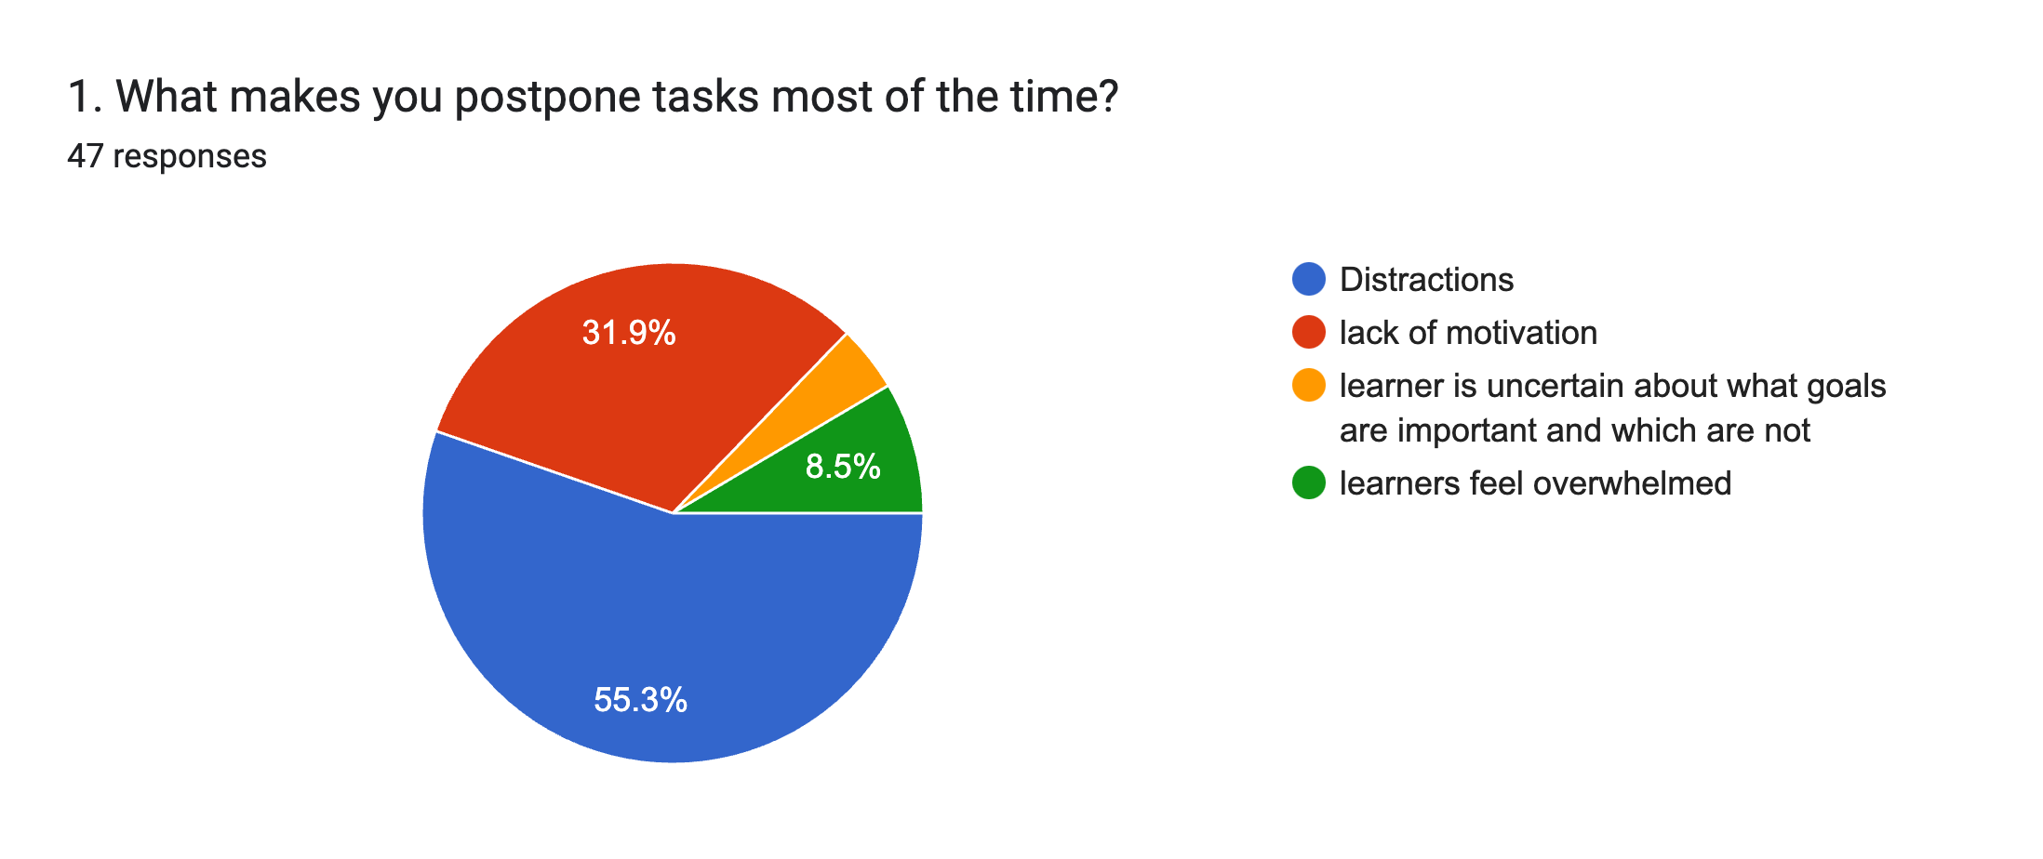

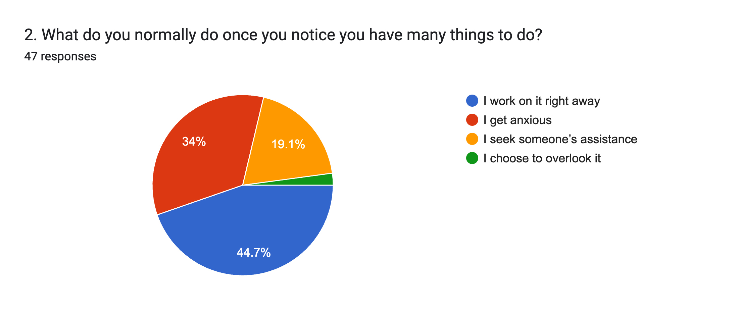

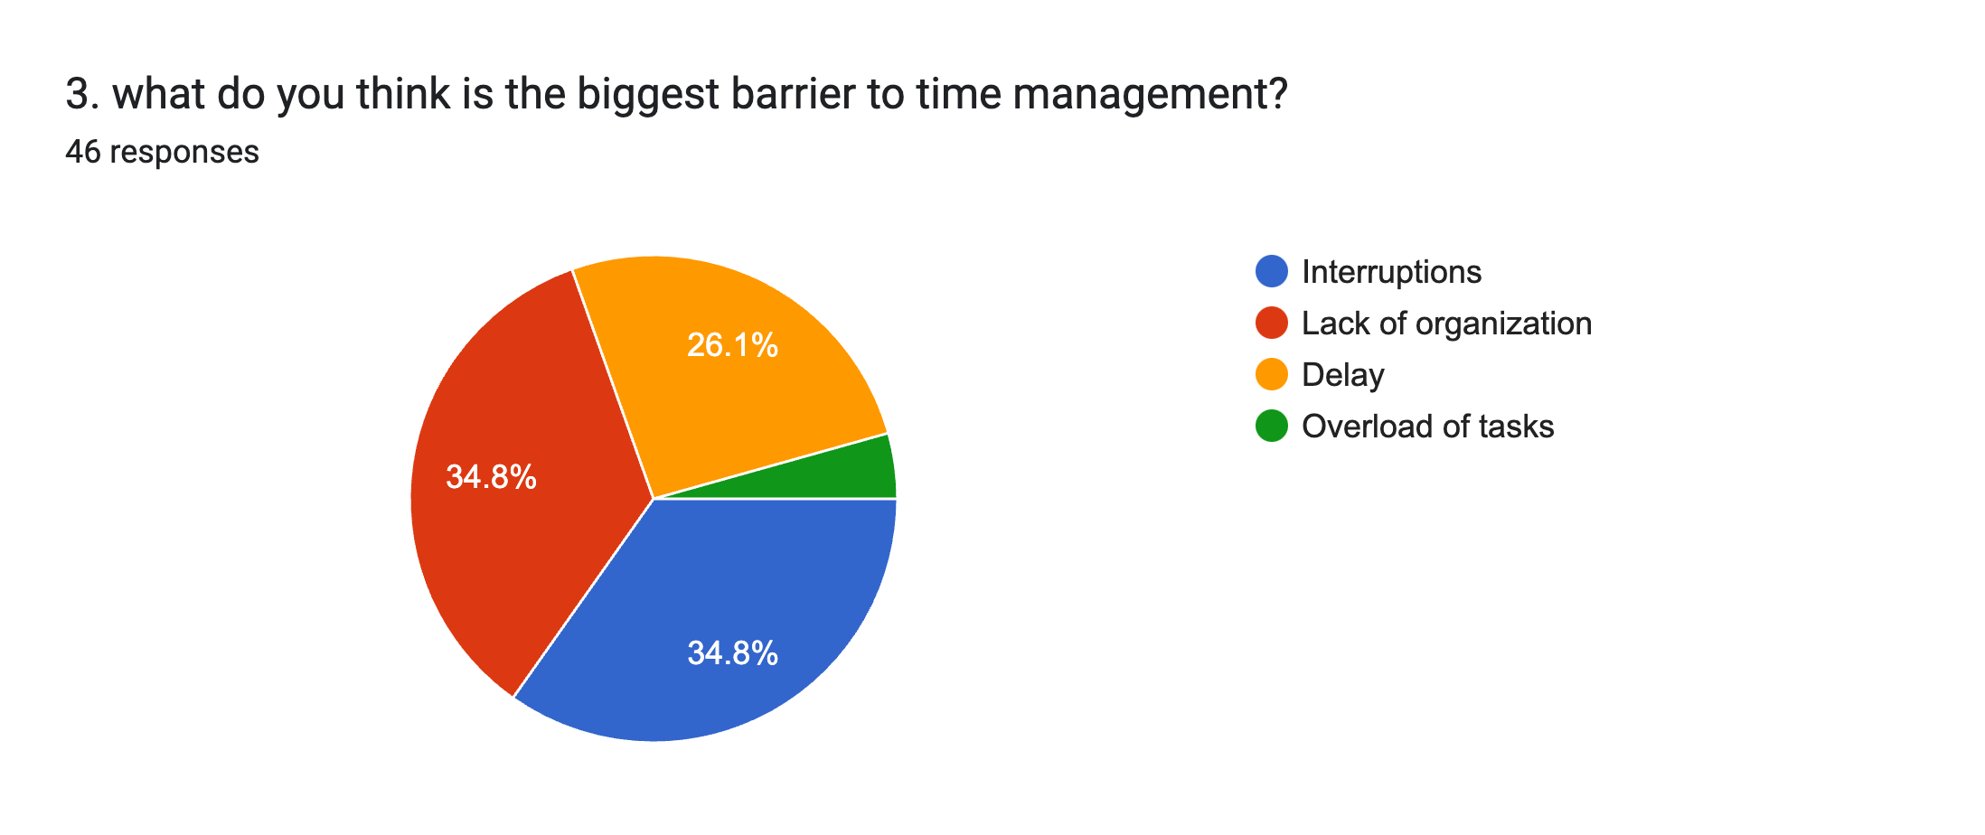

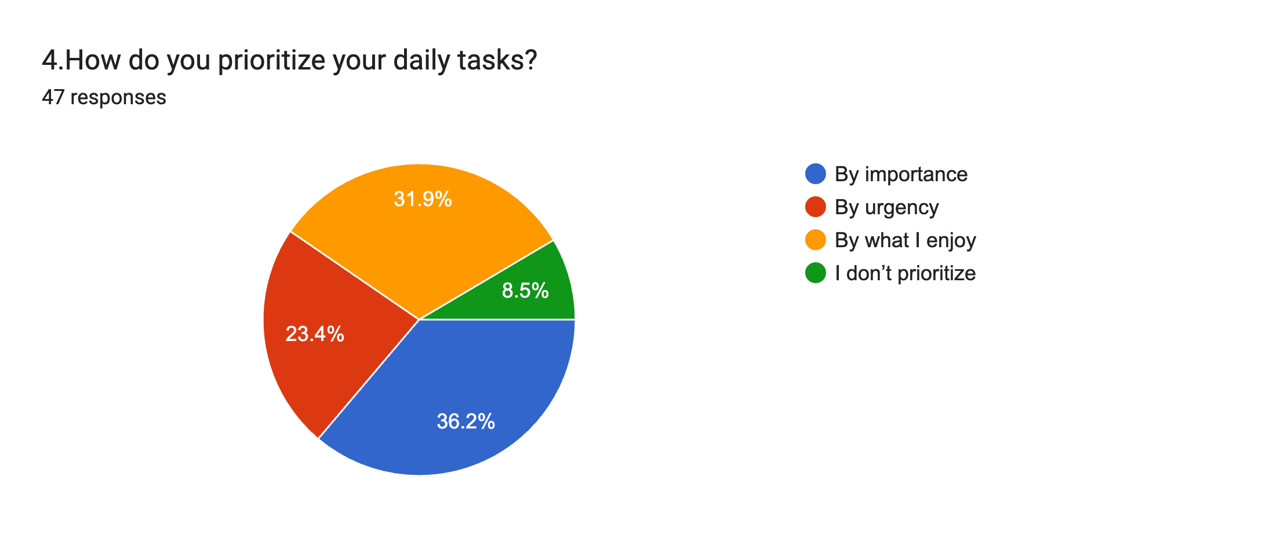

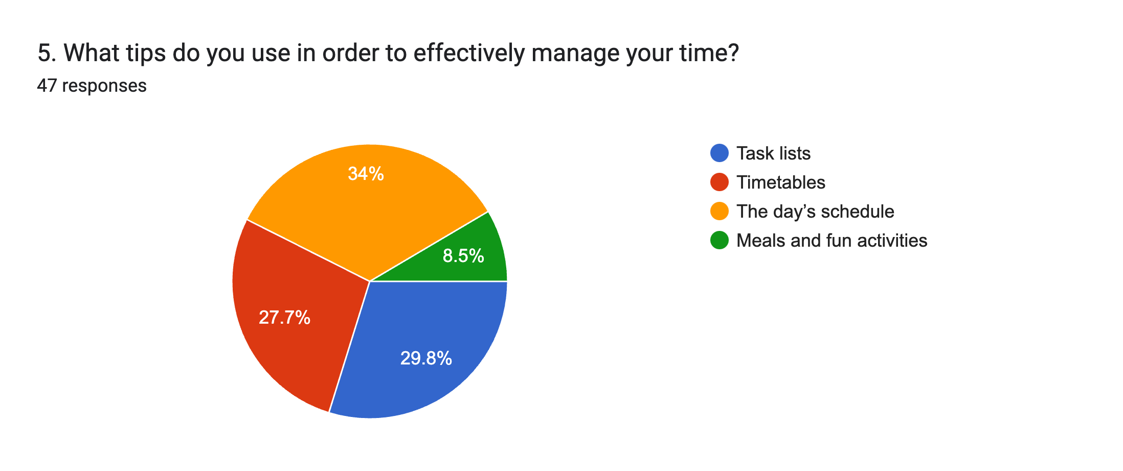

**Unrecognized findings :**

One of the most astonishing findings in this analysis is students' perceptions of the level of institutional support that influences their perspective and engagement. Students that believe their college or university care about them as a whole - not just for purely academic reasons - are more likely to experience higher satisfaction levels and be positive in their attitudes. This perceived institutional care may deepen loyalty and motivation among the students to put more effort into their education and self-improvement. Fascinatingly, even gestures as minor as personalised faculty communications, wellness check-in, or informal social get-togethers with the administration seem to strengthen attachment to the institution and increase their feelings of belonging.

**Conclusion:**

In summary, creating a positive and resilient mindset in college students calls for an approach that targets both the practical and emotional skills of students. In this regard, programs that help the students cope with their responsibilities effectively, interact with peers, and view challenges in a better light will be key in fostering a supporting campus environment. Institutions can contribute to a reduction in stress levels and an increase in the growth-oriented approach in students by providing them with appropriate tools for dealing with academic as well as personal pressures. With the feeling of community and readily available resources, and with support from faculty who understand, students truly feel valued and confident. Thus, it also empowers colleges and universities in shaping students' direction to academic and personal success that will give them a chance to face difficulties and enjoy the brightness of life with positive viewpoints.

**References :**

American College Health Association. (2020). *National College Health Assessment: Undergraduate Reference Group Data Report*. American College Health Association.

Astin, A. W. (1999). *Student involvement: A developmental theory for higher education*. Journal of College Student Development, 40(5), 518–529.

Bandura, A. (1997). *Self-efficacy: The exercise of control*. W.H. Freeman.

Baumeister, R. F., & Leary, M. R. (1995). *The need to belong: Desire for interpersonal attachments as a fundamental human motivation*. Psychological Bulletin, 117(3), 497–529.

Bloom, B. S. (1976). *Human characteristics and school learning*. McGraw-Hill.

Chemers, M. M., Hu, L., & Garcia, B. F. (2001). *Academic self-efficacy and first-year college student performance and adjustment*. Journal of Educational Psychology, 93(1), 55.

Conley, C. S., Durlak, J. A., & Dickson, D. A. (2013). *An evaluative review of outcome research on universal mental health promotion and prevention programs for higher education students*. Journal of American College Health, 61(5), 286-301.

Davidson, W. B., & Cotter, P. R. (2020). *Student support services and student retention: Empirical validation of a theoretical model*. Research in Higher Education, 31(1), 41–65.

Diener, E., & Seligman, M. E. (2002). *Very happy people*. Psychological Science, 13(1), 81–84.

Duckworth, A. L., & Gross, J. J. (2014). *Self-control and grit: Related but separable determinants of success*. Current Directions in Psychological Science, 23(5), 319–325.

Feldman, R. S. (2018). *Understanding psychology* (13th ed.). McGraw-Hill Education.

Fredrickson, B. L. (2001). *The role of positive emotions in positive psychology: The broaden-and-build theory of positive emotions*. American Psychologist, 56(3), 218–226.

Goleman, D. (1995). *Emotional Intelligence: Why it can matter more than IQ*. Bantam Books.

Jones, J., & Abes, E. S. (2013). *Identity development of college students: Advancing frameworks for multiple dimensions of identity*. Jossey-Bass.

Kabat-Zinn, J. (1990). *Full catastrophe living: Using the wisdom of your body and mind to face stress, pain, and illness*. Delta.

Kabir, S. M. (2018). *Psychological stress and coping strategies among university students: A case study in Bangladesh*. Asian Social Work and Policy Review, 12(2), 94–103.

Lazarus, R. S., & Folkman, S. (1984). *Stress, appraisal, and coping*. Springer.

Macan, T. H., Shahani, C., Dipboye, R. L., & Phillips, A. P. (1990). *College students*’ *time management: Correlations with academic performance and stress*. Journal of Educational Psychology, 82(4), 760.

Seligman, M. E. (2011). *Flourish: A visionary new understanding of happiness and well-being*. Free Press.

Zimmerman, B. J., & Schunk, D. H. (Eds.). (2011). *Handbook of self-regulation of learning and performance*. Routledge.

Astin, A. W. (1984). *Student involvement: A developmental theory for higher education*. Journal of College Student Personnel, 25, 297–308.

Baker, R. W., & Siryk, B. (1989). *Measuring adjustment to college*. Journal of Counseling Psychology, 36(2), 179–189.

Bean, J. P., & Eaton, S. B. (2001). *The psychology underlying successful retention practices*. Journal of College Student Retention: Research, Theory & Practice, 3(1), 73–89.

Bergen-Cico, D., & Possemato, K. (2014). *Examining the efficacy of a brief mindfulness-based stress reduction (brief MBSR) program on psychological health*. Journal of American College Health, 62(2), 90–96.

Brown, K. W., & Ryan, R. M. (2003). *The benefits of being present: Mindfulness and its role in psychological well-being*. Journal of Personality and Social Psychology, 84(4), 822.

Chickering, A. W., & Reisser, L. (1993). *Education and identity* (2nd ed.). Jossey-Bass.

Dweck, C. S. (2008). *Mindset: The new psychology of success*. Ballantine Books.

Gershuny, J., & Robinson, J. P. (1988). *Historical changes in the household division of labor*. Demography, 25(4), 537–552.

Greenberg, M. T., & Kusche, C. A. (2006). *Building resilience: School-based support for children facing adversity*. Annual Review of Psychology, 57, 375–403.

Haidt, J. (2006). *The happiness hypothesis: Finding modern truth in ancient wisdom*. Basic Books.

Hart, P. M., & Cotton, P. (2003). *Occupational stress and well-being: A systematic review of the literature*. Australian Journal of Management, 28(2_suppl), 65–94.

Johnson, D. W., & Johnson, R. T. (2009). *An educational psychology success story: Social interdependence theory and cooperative learning*. Educational Researcher, 38(5), 365–379.

Kuh, G. D. (2009). *The national survey of student engagement: Conceptual and empirical foundations*. New Directions for Institutional Research, 2009(141), 5–20.

Light, R. J. (2001). *Making the most of college: Students speak their minds*. Harvard University Press.

Masten, A. S. (2014). *Ordinary magic: Resilience in development*. Guilford Press.

Miller, W. R., & Rollnick, S. (2012). *Motivational interviewing: Helping people change* (3rd ed.). Guilford Press.

Nadler, A., & Fisher, J. D. (1986). *Self-evaluation, social comparison, and help-seeking behavior*. Journal of Personality and Social Psychology, 50(2), 210.

Nolen-Hoeksema, S., & Morrow, J. (1991). *A prospective study of depression and posttraumatic stress symptoms after a natural disaster: The 1989 Loma Prieta Earthquake*. Journal of Personality and Social Psychology, 61(1), 115.

Pascarella, E. T., & Terenzini, P. T. (2005). *How college affects students: A third decade of research* (Vol. 2). Jossey-Bass.

Patton, L. D., Renn, K. A., Guido, F. M., & Quaye, S. J. (2016). *Student development in college: Theory, research, and practice* (3rd ed.). Jossey-Bass.

Pennebaker, J. W. (1997). *Writing about emotional experiences as a therapeutic process*. Psychological Science, 8(3), 162–166.

Pintrich, P. R. (2004). *A conceptual framework for assessing motivation and self-regulated learning in college students*. Educational Psychology Review, 16(4), 385–407.

Ryan, R. M., & Deci, E. L. (2000). *Intrinsic and extrinsic motivations: Classic definitions and new directions*. Contemporary Educational Psychology, 25(1), 54–67.

Schwartz, A. J. (2006). *Four eras of study of college student suicide in the United States: 1920–2004*. Journal of American College Health, 54(6), 353–366.

Schwartz, S. H., & Bilsky, W. (1990). *Toward a theory of the universal content and structure of values: Extensions and cross-cultural replications*. Journal of Personality and Social Psychology, 58(5), 878–891.

Sheldon, K. M., & Lyubomirsky, S. (2007). *Is it possible to become happier? (And if so, how?)*. Social and Personality Psychology Compass, 1(1), 129–145.

Sternberg, R. J., & Zhang, L.-F. (Eds.). (2001). *Perspectives on thinking, learning, and cognitive styles*. Lawrence Erlbaum.

Strayhorn, T. L. (2012). *College students' sense of belonging: A key to educational success for all students*. Routledge.

Tinto,Gutierrez, D., & Gutierrez, A. (2019). Developing a Trauma-Informed Lens in the College Classroom and Empowering Students through Building Positive Relationships. Journal of Mental Health Counseling, 41(2), 124–137. Retrieved from <https://eric.ed.gov/?id=EJ1203488>

Lami, I. (2011). *The use of social media among Nigerian youths*. Retrieved from <http://www.state.net/goltlam-the-use-of-social-media-among-nigerian-youths2>