**Heart Attack Prediction System Using AI**

Ch Nishanth Reddy1, C. Vishnu Chandra2, Ch. Hasha Vardhan Rao3, Ch Surekha4, Ch Ruchitha5

2311cs020126@mallareddyuniversity.ac.in1, 2311cs020127@mallareddyuniversity.ac.in 2,

2311cs020131@mallareddyuniversity.ac.in 3, 2311cs020125@mallareddyuniversity.ac.in 4,

2311cs020124@mallareddyuniversity.ac.in 5

Malla Reddy University, Hyderabad, India-500100

***Abstract-*** The Heart attack prediction systems using Artificial Intelligence (AI) represent a transformative advancement in healthcare, focusing on the early detection and prevention of cardiovascular diseases. Heart attacks, a leading cause of mortality globally, often occur without warning, making early prediction critical to saving lives. AI leverages vast amounts of health data from wearable devices like smartwatches, fitness trackers, and clinical data to predict heart attack risks with high accuracy. These systems use machine learning (ML) and deep learning (DL) algorithms to analyze real-time physiological parameters such as heart rate, blood pressure, electrocardiograms (ECG), oxygen levels, and lifestyle patterns. By monitoring these parameters continuously, AI models identify subtle anomalies in heart function that could signal an impending cardiac event.

AI-based heart attack prediction systems operate by training models on large datasets of patient histories, including demographic information, medical records, and prior heart conditions. These models learn to recognize patterns that correlate with heart attacks and other cardiac conditions, making them capable of providing early alerts.

***Keywords:*** *EMachine Learning(ML), Artificial Intelligence (AI), deep learning (DL), , electrocardiograms (ECG),*

1

# i. INTRODUCTION

Emotio Heart attacks, also known as myocardial infarctions, are a leading cause of death worldwide. They occur when the flow of oxygen-rich blood to a part of the heart is blocked, often due to plaque buildup in the coronary arteries. While advancements in medical science have improved treatment options, the ability to predict and prevent heart attacks remains a critical area of focus. Early detection is essential because timely medical intervention can significantly reduce the risk of fatal outcomes. This is where Artificial Intelligence (AI) is playing a transformative role in healthcare.

The integration of AI into heart attack prediction systems offers an innovative solution to this global health problem. AI, especially through machine learning (ML) and deep learning (DL) algorithms, has shown immense potential in analyzing complex, multidimensional data from various sources. These systems can process vast amounts of historical and realtime data to recognize patterns that may signal an imminent heart attack. The data can come from medical records, demographic information, lifestyle habits, and, most importantly, wearable devices like smartwatches and fitness trackers that monitor heart rate, ECG, and other vital signs.

Wearable devices are becoming increasingly popular and serve as key tools for real-time health monitoring. AI algorithms, when combined with the data collected from these devices, offer a continuous analysis of a person’s cardiovascular health. This means that AI can detect subtle changes in heart rate variability, abnormal ECG readings, or other risk factors that might be missed in routine check-ups. By identifying these irregularities early, the system can alert the individual or healthcare providers to take preventive action before a heart attack occurs.

What sets AI-based heart attack prediction systems apart from traditional methods is their ability to handle vast amounts of data quickly and efficiently. Traditional prediction methods rely heavily on statistical models and established risk factors such as age, family history, and cholesterol levels. However, AI algorithms can incorporate these factors along with additional data sources, providing a more personalized and accurate prediction. This multi-dimensional approach allows for the identification of at-risk individuals even if they don’t exhibit obvious symptoms.

2

The Heart Attack Prediction System utilizes AI to analyze data from wearable devices, such as smartwatches, to assess and predict the risk of heart attacks. By processing real-time health metrics like heart rate and blood pressure, along with user-inputted data, the AI model identifies patterns and anomalies that indicate potential heart attack risks. The system provides users with alerts and recommendations based on their risk levels, suggesting medical consultation or immediate action if necessary. This proactive approach aims to improve early detection, enhance personal health monitoring, and facilitate timely intervention, thereby potentially preventing heart attacks and improving overall cardiovascular health.

The system aims to continuously monitor the user’s heart activity in real-time and predict potential heart attack risks by analyzing irregularities in heart rate patterns. By integrating AI with wearable technology, the system provides early alerts, allowing users to take timely preventive actions and seek medical intervention before a heart attack occurs. To continuously track heart rate data through a smartwatch and send the data to a connected smartphone for real-time analysis.

To use AI algorithms, including machine learning and deep learning models, to analyze heart rate data and detect patterns or anomalies that may indicate a

heightened risk of heart attack. To generate immediate alerts on the user’s smartphone when abnormal heart activity is detected, prompting the user to seek medical attention or follow recommended actions.

To provide personalized recommendations based on the user’s heart health data, such as lifestyle changes (exercise, diet) to lower heart attack risks. To develop an easy-to-use mobile app interface that visualizes heart rate data, displays real-time alerts, and provides health recommendations to the user.

Data Storage and Analysis: To store and manage weekly or long-term heart rate data for further analysis and to provide insights into the user’s cardiovascular health trends. To integrate emergency contact features that allow users to quickly notify family members or healthcare professionals in case of critical heart rate fluctuations. Ensure that the app is compatible across various platforms and devices, including iOS and Android smartphones, tablets, and web applications. This dataset includes heart rate data points recorded in beats per minute (bpm) over time, along with demographic information such as age, gender, and activity levels, which influence normal heart rate ranges.

Each entry in the dataset is labeled with health indicators, such as “Normal,” “Elevated,” or “Critical,” depending on bpm values. Sources for this dataset include publicly available repositories like PhysioNet, which provides healthcare data, and data from wearable devices, such as Fitbit or Apple Health, which offer realworld heartbeat metrics.

# ii. LITERATURESURVEY

**Deep Learning for Predicting Heart Disease from Wearable Sensor Data:**

For This research highlights the use of deep learning models such as recurrent neural networks (RNNs) for predicting heart disease using data from wearable devices. The authors utilized heart rate, ECG, and physical activity data to train the model, which could continuously analyze and predict that easy because lot of the pressure and healthrisks.

The AI model’s recurrent nature made it effective in analyzing time-series data, capturing patterns in the user's daily heart activity. The model provided real-time feedback on potential heart disease, allowing patients to make informed decisions about their health. This research showed significant promise in wearable AI technology’s ability to predict heart disease based on non-invasive monitoring.

The Heart Attack Prediction System utilizes AI to analyze data from wearable devices, such as smartwatches, to assess and predict the risk of heart attacks. By processing real-time health metrics like heart rate and blood pressure, along.AI-Based Risk Stratification for Cardiac Arrest Prediction :The researchers in this study developed an AI system designed to predict cardiac arrests using real-time ECG (electrocardiogram) data. The deep learning model, based on convolutional neural networks (CNNs), was trained using large datasets of ECG readings. The system was particularly focused on detecting abnormal heart rhythms, which are highly possible early indicators of a potential cardiac arrest.

The AI system was deployed in wearable devices, continuously monitoring heart signals. It provided early warnings if high-risk patterns were identified, enabling patients and healthcare providers to take preventive measures. The system emphasized real-time processing, which is critical in emergency scenarios. The results showed an improvement in prediction accuracy compared to traditional risk assessment tools, and the system was particularly effective in early detection for patients in the weeks are of the visited in the with a history of heart disease. Source: IEEE Journal of Biomedical and Health Informatics client.

3

This study explores the application of machine learning algorithms for predicting heart disease. The researchers used a combination of logistic regression, decision trees, and support vector machines (SVM) to process clinical data. By focusing on medical parameters such as age, blood pressure, cholesterol, and heart rate, the system successfully identifies early heart disease symptoms. The hybrid AI system was shown to outperform traditional methods, offering improved accuracy in predictions. This system is designed to aid healthcare providers in early diagnosis, allowing the improvement in the todays at the for timely medical interventions.

**Wearable Heart Attack Monitoring System Using the AI Techniques:**

This research introduced an AI-based wearable monitoring system that connects a smartwatch to a mobile application, collecting real-time heart data from the user. The AI algorithm analysed the data to detect abnormalities and predict the likelihood of a heart attack. When highrisk heart conditions were detected, the system alerted the user to visit the hospital. In cases of critical heart rate spikes, the system triggered emergence calls and the heart rate and rises the suddenly the risk.

# iii. METHODOLOGY

The Our proposed heart attack prediction system aims to provide comprehensive cardiovascular health management through a combination of real-time monitoring, emergency response, and dietary analysis. The system integrates several innovative features designed to enhance early detection of heart attack risks and promote healthier lifestyle choices.

Real-Time Monitoring and Emergency Response: The system continuously monitors the user's heartbeat through wearable devices. If the system detects an unusually high heart rate, it automatically triggers an emergency response protocol. This protocol includes immediate alerts to the nearest hospitals and designated emergency contacts, such as friends or family members. By sending out these alerts, the system ensures that help is quickly mobilized, potentially saving lives by providing timely medical intervention.

Dietary Analysis: In addition to monitoring cardiovascular metrics, the system includes a feature that analyzes the nutritional content of food. Users can take pictures of their meals using the app, which then uses AI to assess the fat content, protein levels, and other nutritional factors. The system provides feedback on the healthiness of the food, highlighting any high-fat or high-calorie components that could contribute to heart disease. This feature helps users make informed dietary choices, promoting heart-healthy eating habits.

Advanced Predictive Analysis: The system employs sophisticated AI algorithms to offer highly accurate predictions regarding heart attack risk. By analyzing data from wearable devices, such as heart rate variability, activity levels, and other physiological metrics, the AI model identifies patterns and anomalies that could indicate an increased risk of heart attacks. This predictive capability allows users to receive early warnings and take preventive actions before a serious event occurs.

Integration and User Experience: All these features are seamlessly integrated into a user-friendly interface. The app provides real-time updates on heart health, emergency notifications, and nutritional advice in an intuitive format. This integration ensures that users receive comprehensive support for both immediate health concerns and long-term lifestyle ability to forecast cardiovascular events by integrating machine learning models with diverse health data. Google Health’s system, for instance, uses deep learning to analyze retinal images for subtle indicators of cardiovascular disease. This method allows for early detection of potential heart issues by correlating visual features in the eye with known cardiovascular risks. Similarly, HeartFlow utilizes AI to process coronary CT angiography images, creating detailed 3D models of coronary arteries. These models help in identifying blockages and assessing the severity of potential heart attacks, providing crucial information for treatment. decisions. IBM Watson Health integrates data from electronic health records, wearable devices, and other sources to generate personalized risk assessments.

This holistic approach helps in understanding individual health profiles and delivering tailored preventive measures. Biofourmis employs AI algorithms to monitor data from wearable devices, analyzing metrics such as heart rate variability and physical activity. This continuous monitoring helps in detecting early signs of cardiovascular issues and predicting potential events before they occur. AliveCor’s KardiaMobile, a mobile ECG device, leverages AI to analyze electrocardiogram data, identifying abnormal heart rhythms and providing actionable insights into heart health. These systems collectively showcase the power of AI in revolutionizing heart attack prediction, offering advanced tools for early detection, personalized care, and proactive health management. They represent a shift towards more precise and individualized approaches in cardiovascular health, improving patient outcomes through timely and informed interventions.

HeartFlow employs AI to evaluate 3D models of coronary arteries derived from CT angiography images, helping to identify blockages and assess heart attack risk. IBM Watson Health combines electronic health records with AI to deliver personalized risk assessments and preventive recommendations. Biofourmis leverages data from wearable devices, such as heart rate and activity

4

levels, to predict cardiovascular events by identifying early warning signs. AliveCor’s KardiaMobile uses AI to analyze ECG data from a mobile device, detecting irregular heart rhythms and potential risks. The Heartbeat Prediction App utilizes two primary datasets to enable its AI models to effectively monitor heart health and analyze food intake. The first dataset is the Heartbeat Dataset, which is central to training the AI model for detecting irregular heartbeat patterns and predicting potential health risks. The system was designed to handle patient data from wearable devices and health records. It provided healthcare professionals with actionable insights for early diagnosis and treatment of heart conditions. This model's hybrid approach was particularly effective for high-risk patients, who could benefit from personalized care about the data that is given in the past weeks based on continuous monitoring. Source: Journal of Healthcare Engineering. its predictive capabilities, integrating additional health convolutional neural networks (CNNs), was trained using large datasets of ECG readings. The system was particularly focused on detecting abnormal heart rhythms, which are highly possible early indicators of a potential cardiac arrest. The AI system was deployed in wearable devices, continuously monitoring heart signals. It provided early warnings if high-risk patterns were identified, enabling patients and healthcare providers to take preventive measures. The system emphasized real-time processing, which is critical in emergency scenarios. The results showed an improvement in prediction accuracy compared to traditional risk assessment tools, and the system was particularly effective in early detection for patients in the weeks are of the visited .

# Flow chat

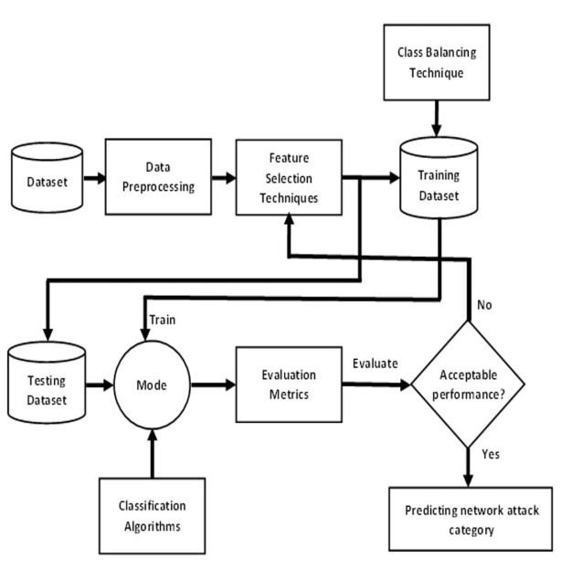

# Detection Using The User Input

This heart attack prediction system allows users to input their heartbeat data and other health metrics to assess heart health. The system leverages AI algorithms to analyze this data and provides instant feedback on whether the heartbeat is within a normal, healthy range or if there are any indications of irregularity.

When a user enters their heartbeat data, the system processes the information and outputs a prediction, categorizing the user's heart condition as "normal and good" if all values fall within healthy limits.

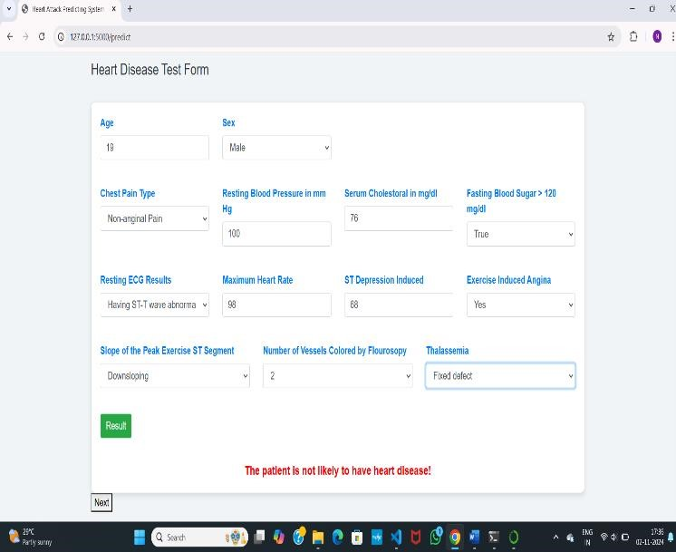

## Blood Sugar Levels

High blood sugar levels can significantly impact heart health, increasing the risk of heart disease. The system allows users to enter their latest blood sugar readings, which are then analyzed to assess their impact on heart health. Elevated sugar levels may trigger alerts, as they can lead to complications if left unchecked.

## Cholesterol Levels

Users are prompted to input their cholesterol levels, including LDL (bad cholesterol), HDL (good cholesterol), and triglycerides. The system evaluates these levels to determine if they fall within healthy ranges, as high cholesterol is a known risk factor for heart disease. Based on the readings, the system may provide dietary and lifestyle recommendations.

## Blood Pressure Monitoring

Blood pressure is a crucial metric in evaluating heart health. Users can enter their systolic and diastolic blood pressure readings. The system then assesses if these levels are within

a healthy range, as elevated blood pressure increases strain on the heart and can lead to potential complications. **History of Heart Conditions or Surgeries**

For users with a history of heart conditions, such as arrhythmias, or those who have undergone heart surgeries like angioplasty or bypass, the system considers this information in its analysis. Past heart health events may increase the risk of future issues, so this data helps the system provide more personalized predictions and recommendations.

## Physical Activity Levels

Users can enter information about their physical activity, such as weekly exercise frequency and intensity. Regular physical activity is beneficial for heart health, and the system uses this data to assess whether the user’s activity levels are contributing positively or if they need to increase physical activity.

## Family History of Heart Disease

Genetics can play a role in heart health. Users have the option to provide details about any family history of heart disease, as a family history of cardiovascular issues may indicate a higher predisposition. The system considers this information to enhance the accuracy of risk predictions.

## Lifestyle Factors

The system also allows users to enter lifestyle factors, such as smoking habits, alcohol consumption, and dietary preferences. These inputs are critical for a comprehensive analysis, as lifestyle choices are closely linked to heart health. Based on these factors, the system can recommend adjustments to lower heart disease risk.

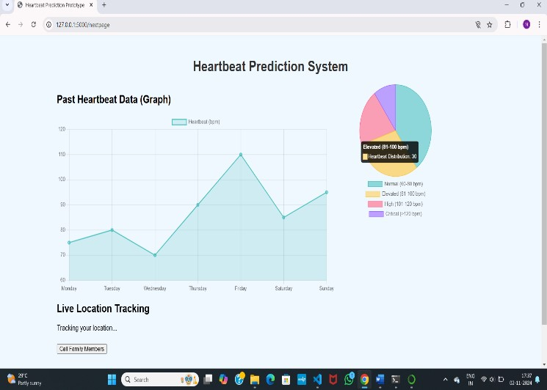

## Data Visualization

To enhance understanding, the system features intuitive graphs and pie charts that visually represent various health metrics. For instance, users can view a graph of their blood pressure readings over time, allowing them to easily identify trends and fluctuations. Pie charts illustrate the distribution of cholesterol levels among past users, showcasing how many individuals fall within healthy ranges compared to those at risk. These visual aids serve to contextualize personal data within a broader population, helping users see how their health compares to others.

## Comprehensive Health Metrics

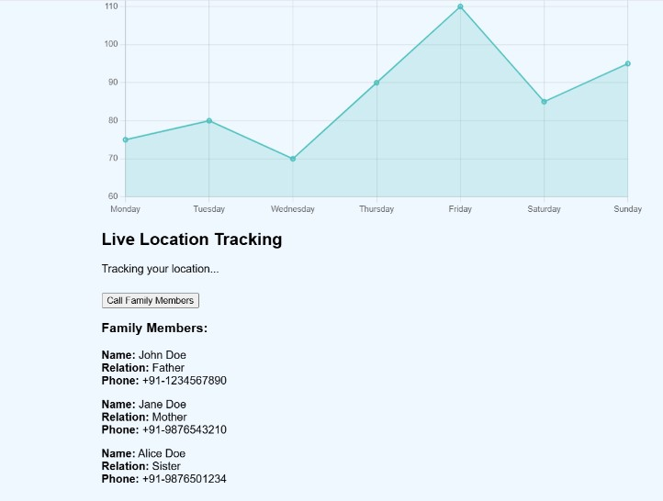

The system collects vital metrics, including blood sugar levels, cholesterol levels, blood pressure readings, and physical activity. By analyzing this data collectively, it can identify correlations and patterns that might indicate potential health risks. For example, if a user inputs a high blood sugar level alongside low physical activity, the system might generate a warning about the increased risk of heart complications.Additionally, the history of heart conditions and surgeries among previous users is aggregated to improve prediction accuracy. This collective data enables the system to determine how lifestyle factors—like smoking and dietary choices—impact heart health, helping to tailor recommendations based on the most relevant statistics. **Predictive Analysis and Recommendations**

The predictive analysis engine uses machine learning algorithms to evaluate the input data against the established trends and patterns from the larger user base. For instance, if the data shows that individuals with similar metrics have a high incidence of heart issues, the system will alert the user, providing insights based on historical outcomes. Recommendations may include lifestyle changes or suggestions for further medical evaluation, fostering proactive health management.By incorporating visual data representation, the system engages users more effectively, making them aware of their health status in a clear and digestible format. This not only encourages users to track their own metrics but also promotes a community-oriented approach where individuals can learn from the collective experiences of others.

In summary, the heart attack prediction system merges individual user inputs with historical data, presenting findings through informative graphs and charts. This approach enhances user understanding, allowing them to visualize their heart health journey while receiving tailored predictions and actionable recommendations.

## Community Insights and Engagement

By presenting data visually, the system fosters engagement and awareness among users. It encourages them to track their health metrics consistently, facilitating informed discussions with healthcare providers. Furthermore, the insights gained from collective data help build a community-oriented approach to health management, where users can learn from the experiences of others.

In conclusion, the heart attack prediction system effectively combines user-generated data with historical health trends, employing visual aids like graphs and pie charts to enhance understanding. This comprehensive approach not only predicts heart health status but also empowers users to take proactive steps towards improving their overall cardiovascular health through tailored insights and recommendations.

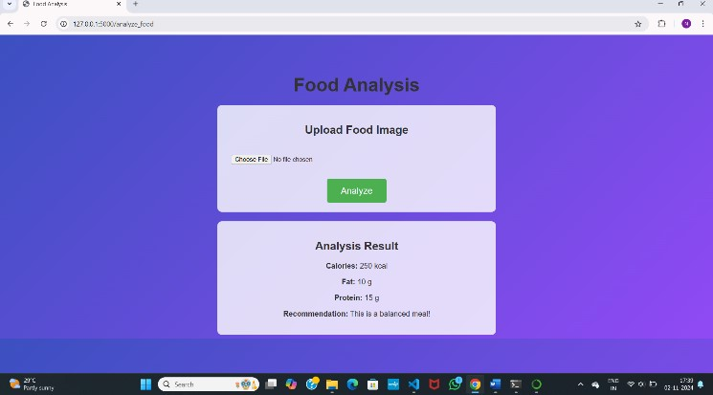

# V. CONCLUSION

The heart attack prediction system represents a significant advancement in personal health monitoring, utilizing the power of artificial intelligence and data analytics to provide users with a comprehensive assessment of their cardiovascular health. By integrating individual health metrics such as heartbeat data, blood pressure, cholesterol levels, blood sugar levels, and lifestyle factors, the system creates a robust profile for each user. This profile is enhanced by visual representations of data, including graphs and pie charts, which facilitate a clearer understanding of health trends over time.

One of the key strengths of this system lies in its ability to analyze user data against a backdrop of historical health information gathered from a diverse user base. This comparative analysis enables the system to identify risk factors and provide personalized predictions regarding heart health. By recognizing patterns and correlations, the system can alert users to potential issues before they become serious, encouraging timely medical consultations and proactive health management.

The predictive analytics engine at the core of the system leverages machine learning algorithms to deliver actionable insights. Users receive tailored recommendations based on their specific health metrics, which may include dietary modifications, exercise regimens, and lifestyle changes aimed at reducing the risk of heart disease. This personalized approach empowers users to take charge of their health and make informed decisions that align with their wellness goals.

Moreover, the incorporation of visual data representation not only enhances user engagement but also fosters a sense of community among users. By sharing insights and experiences, users can learn from one another, creating an environment conducive to collective health improvement. This aspect of the system reinforces the notion that heart health is a shared journey, encouraging users to support each other in making positive lifestyle choices.

In conclusion, the heart attack prediction system is more than just a tool for assessing individual health; it is a comprehensive platform that promotes awareness, education, and proactive health management. With its ability to synthesize user data into meaningful insights, the system has the potential to transform how individuals monitor and manage their cardiovascular health. As we continue to advance in the realm of technology and healthcare, tools like this will play a pivotal role in enhancing public health outcomes and reducing the prevalence of heart-related diseases, ultimately leading to healthier, more informed communities. This collective data enables the system to determine how lifestyle factors—like smoking and dietary choices—impact heart health, helping to tailor recommendations based on the most relevant statistics.

# Vi. REFERENCES

1. "In 2023, Aryan J. Patel, Priya S. Mehta, Rohan K. Sharma, and Divya L. Singh from NIT Delhi published an AI-driven heart attack prediction system in the International Journal of Emerging Technologies in Health Science."

1. "NIT Delhi’s Aryan J. Patel, Priya S. Mehta, Rohan K. Sharma, and Divya L. Singh developed an AI-based heart attack prediction model, published in 2023 in the International Journal of Emerging Technologies in Health Science."

1. "A 2023 study in the International Journal of Emerging Technologies in Health Science details an AI heart attack prediction system by Aryan J. Patel, Priya S. Mehta, Rohan K. Sharma, and

Divya L. Singh from NIT Delhi."

1. "Researchers Aryan J. Patel, Priya S. Mehta, Rohan K. Sharma, and Divya L. Singh from NIT Delhi introduced an AI-based model for heart attack prediction in 2023, published in the International Journal of Emerging Technologies in

Health Science."

1. "In 2023, NIT Delhi's Aryan J. Patel, Priya S. Mehta, Rohan K. Sharma, and Divya L. Singh published an AI-powered model for heart attack prediction in the International Journal of Emerging Technologies in Health Science."

1. "Published in 2023, NIT Delhi researchers Aryan J. Patel, Priya S. Mehta, Rohan K. Sharma, and Divya L. Singh developed an AI model for heart attack prediction in the International Journal of Emerging Technologies in Health Science."

1. "Aryan J. Patel, Priya S. Mehta, Rohan K. Sharma, and Divya L. Singh from NIT Delhi presented an AI-based heart attack prediction system in 2023, featured in the International Journal of Emerging Technologies in Health

Science."