**Automatic Medicine Dispensing Machines in Hospitals and Pharmacies**

**Amatulla Moiz Jarwala**

**Email: amatullajarwala19@gmail.com**

**Kishinchand Chellaram College, Churchgate, Mumbai**

**Abstract:**

The situation today, in India, is such that the sick and their families are greatly troubled by heavy traffic in hospitals and pharmacies, due to which they must stand in queues for hours to successfully get the required medicines. This makes an already difficult time more mentally exhausting for the sick.

The idea of this research is to propose Automatic Medicine Dispensers that would dispense the required medicines to people with help of digital prescriptions without needing human staff. This, I believe, would be efficient, quick and would also reduce the load on the staff operating the pharmacies.

This idea is also meant to be used in local areas/pharmacies for Over the Counter (OTC) drugs that do not require prescriptions and can be bought locally at any time.[1]

In the following paper. The idea of digital barcodes is used wherein barcode generator in python is connected to a UI/UX interface to make it easier for doctors to generate barcodes that hold the medicines’ information. This barcode is then scanned in the dispensing machine that will be controlled with Arduino MEGA and appropriate IC. DC motors will be connected to the controller for medicine dispensing.

**Keywords:** Automatic medicine dispenser, Arduino, digital prescriptions, medicines, integrated circuit (IC), DC motors.

**Introduction:**

In overcrowded hospitals, the sick and their families are greatly troubled by heavy traffic, due to which they must stand in queues for hours to successfully get the required medicines. This makes an already difficult time more mentally exhausting for the sick.

The idea of this research is to propose Automatic Medicine Dispensers that would dispense the required medicines to people with the help of digital prescriptions without needing human staff.

Instead of the entire hospital traffic going to one pharmacy, this idea would facilitate machines in every ward (e.g. oncology, psychiatric, general medicine etc.) containing medicines specific to that ward.

In appointments at hospitals, the doctor would be providing a digital prescription of one-time scan QR code / barcode that would be the input to the machines. The machine would get the information about the medicines required through the code, after which payment would have to be done digitally (card or UPI) on the machine itself. On payment, the machine would give out the medicines.

The best use of these machines can happen when they are placed locally, for example, at railway stations, pharmacies, malls, police stations, fire stations and educational institutions.

For these kiosks, no digital scanner will be required as there will not be a prescription. In these machines, list will be provided in the LCD display of all basic everyday medicines with prices for each being tagged to them beforehand.

On payment, the machine would dispense the drugs.

**Approach:**

**Barcode Scanner:**

A group of photo-electric cells in the scanner scan the black and white barcode in such a manner that when the laser light falls onto the stripes, light is reflected from the white stripes much more than light reflected from the black ones. The reflected light pulses are converted to electrical pulses with the help of photo-electric cells. Hence, pulse will be generated when enough light falls onto it i.e. from the white strip, and this will be converted to binary data as 1. On contrary, light reflected from black stripes will not generate pulse and will be converted to 0.

The binary data is then converted to real information of medicines stored in the code.

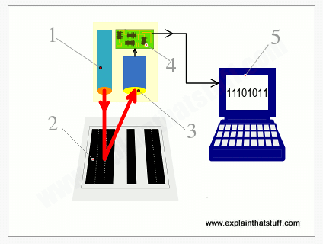

Now, Code 128 is deemed to be the best barcode to encompass all characters like letters, numbers, signs and symbols. Python could be easily used to generate a code 128. The code for which is below and the output code 128 barcode as generated.

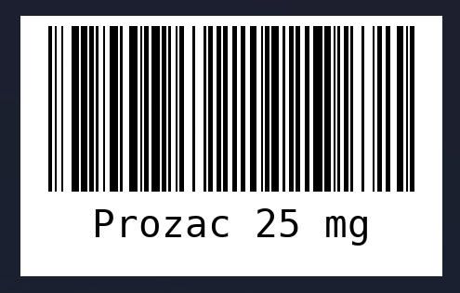

This code and barcode generation can be linked to UI/UX software to make it easier for doctors to use. All they will need to do is use the software, specify the medicines and immediately a barcode will be generated and printed.

This barcode then gets scanned in the machines. The programming in the Arduino micro controller will be such that the names of the medicines will be tagged with the required pins connected to the motors. When the name of the medicine is obtained from the given barcode, the required motors will be activated to dispense the tablets.

**Control Unit:**

A core microcontroller must be used for the functioning of the machine. Normally ATMs use the 8-bit at89s52 microcontroller that can be programmed using C language according to the need of the user. However, for the medicine dispenser, most sources suggest the Arduino microcontroller, programmed by C++ programming language. Most Arduinos are 8-bit; however, 32-bit ones do exist which make the functioning and memory better. [2][3][4][5]

The microcontroller will manage all commands in the machine right from the user input to the medicine dispensing with help of DC motors that will be connected to pins in the controller. . Arduino has 54 digital I/O pins out of which 16 are input ports and 14 are output pins.[3]

Arduino processes the inputs received from the input sensors and will give output according to the programs embedded. Inputs are received from devices like temperature and light sensors (barcode scanner) and the output goes to devices like motor driver, LEDs, IC, etc.

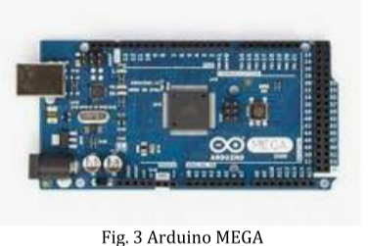

Arduino is a 5V microcontroller. The machine is connected to the local 230V outlet. An adapter and voltage regulator are then used to drop the voltage to 5V to provide for the 5V pin of Arduino. This becomes the power supply the microcontroller.[4]

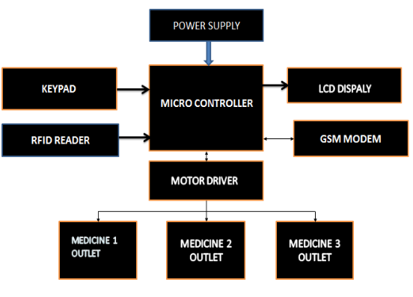

In the block diagram shown above, the microcontroller (Arduino) is connected to a motor driver, which in turn is connected to different motors made for different medicines’ slots. According to the programmed instructions, the required motor will be activated to dispense the correct medicine.[3]

This motor driver is basically an Integrated Circuit (IC). One such example is the L293D IC which can run up to two motors at a time.[4]

**Medicine Dispenser:**

Storage boxes can be constructed in the machines such that medicines must be stacked vertically in each of the boxes. DC motors will then be used to push the medicines out of the storage boxes and into the collection boxes.[4]

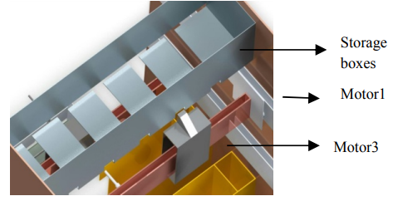

**Dispensers placed Locally:**

In the machines that are intended to be constructed in public places, possibly even rural and tribal areas, the working remains the same as above. The difference would be that the machine would beforehand display the list of non-prescription OTC drugs available in the machine and the user would just have to select the required medicine and pay for it before obtaining the dispensed drug. This could be programmed in the Arduino.

**Conclusion and Future Scope:**

This idea could prove to be very beneficial when it comes to bridging the gap between medicine and technology and could make lives easier and efficient for all patients. It could be a step taken in the direction of development of rural and tribal areas by making medical care available to them using the local dispensers.

Further development can be brought by making the dispensers be able to accept cash instead of just online payments (mainly for rural areas).

The machines can be made so technologically advanced that they could be operated using mobile phones too.

Furthermore, the machines can be made to measure vitals like blood pressure, heartbeat, temperature, etc.[6]

**Acknowledgements:**

I would like to acknowledge Kishinchand Chellaram College to instill the drive of research that inspired this project. I would like to thank Dr. Rakhi Gupta, HOD, MSc IT, KC College, Colaba campus and Ms. Nashrah Gowalker, Assistant Professor, MSc IT, KC College, Colaba campus for supporting and facilitating this research project.

**References:**

[1] M. V. N. Hema, K. M. Student, N. Sonisha, and M. Student, “An IOT Based Intelligent Medicine Box Using Vending Machine-Medical ATM,” 2019. [Online]. Available: https://ssrn.com/abstract=3510968

[2] *RTEICT 2017 : proceedings : 2nd IEEE International Conference on Recent Trends in Electronics, Information & Communication Technology : 19-20 May 2017*. IEEE, 2018.

[3] “Anytime Medicine Vending Machine G Adithya Varaprasad Reddy #1 , A Suman Kumar Reddy #2,” *International Research Journal of Engineering and Technology*, 2020, [Online]. Available: www.irjet.net

[4] *2017 Conference on Emerging Devices and Smart Systems (ICEDSS) : 3-4 March 2017*. IEEE, 2017.

[5] H. K. M. Kanthimathi, A. Professor, and S. Sai, “THINK INDIA (Quarterly Journal) Automatic Medicine Vending System”.

[6] Sofia R, “Automatic Medicine Dispatcher Using Tele-Monitoring System.”