**FORMULATION AND DEVELOPMENT OF FAMCICLOVIR SUSTAINED RELEASE TABLETS USING VARIOUS RETARDING POLYMERS**

Malloju Bharath1*, K. Jyothi2, A. Yasodha3

1Department of Pharmaceutics, Dhanvanthri College of Pharmaceutical Sciences, Thirumala Hills, Centre City, Appannapally, Mahabubnagar, Telangana 509001

2Associate Professor, Department of Pharmaceutics, Dhanvanthri College of Pharmaceutical Sciences, Thirumala Hills, Centre City, Appannapally, Mahabubnagar, Telangana 509001

3Professor & Principal, Department of Pharmaceutical Chemistry, Dhanvanthri College of Pharmaceutical Sciences, Thirumala Hills, Centre City, Appannapally, Mahabubnagar, Telangana 509001

**Corresponding Author:**

**Name:** Malloju Bharath

**Department:** Department of Pharmaceutics

**Phone:** 9052797462

**Mail id:** mallojubharath7@gmail.com

**ABSTRACT**

Sustained release tablets of Famciclovir were formulated by using HPMC K15M and Ethyl cellulose. The tablets were evaluated for Preformulation studies like angle of repose, bulk density, compressibility index and physical characteristics like hardness, weight variation, friability and drug content. In-vitro release of drug was performed in 0.1 N HCL and phosphate buffer pH 6.8 for twelve hours. All the physical characters of the fabricated tablet were within acceptable limits. The tablet with Ethyl cellulose (F5) shows a better sustained drug release (99.23%) was obtained with the matrix tablet. It is cleared through the dissolution profile of Famciclovir from matrix tablets prepared using different polymers were indicated a low in the polymer ratio retarded the drug release to a greater extent.

**Key words:** Famciclovir, HPMC K15M, Ethyl cellulose, Wet granulation and sustained release tablets.

**INTRODUCTION**

A drug delivery system (DDS) is defined as a formulation or a device that enables the introduction of a therapeutic substance in the body and improves its efficacy and safety by controlling the rate, time, and place of release of drugs in the body1. This process includes the administration of the therapeutic product, the release of the active ingredients by the product, and the subsequent transport of the active ingredients across the biological membranes to the site of action2. The term therapeutic substance also applies to an agent such as gene therapy that will induce in vivo production of the active therapeutic agent. Sustained release tablets are commonly taken only once or twice daily, compared with counterpart conventional forms that may have to take three or four times daily to achieve the same therapeutic effect3. The advantage of administering a single dose of a drug that is released over an extended period of time to maintain a near-constant or uniform blood level of a drug often translates into better patient compliance, as well as enhanced clinical efficacy of the drug for its intended use. The first sustained release tablets were made by Howard Press in New Jersy in the early 1950's. The first tablets released under his process patent were called 'Nitroglyn' and made under license by Key Corp. in Florida4. Sustained release, prolonged release, modified release, extended release or depot formulations are terms used to identify drug delivery systems that are designed to achieve or extend therapeutic effect by continuously releasing medication over an extended period of time after administration of a single dose5. The goal in designing sustained or sustained delivery systems is to reduce the frequency of the dosing or to increase effectiveness of the drug by localization at the site of action, reducing the dose required or providing uniform drug delivery. So, sustained release dosage form is a dosage form that release one or more drugs continuously in predetermined pattern for a fixed period of time, either systemically or to a specified target organ6.

**METHODOLOGY**

The materials used in the present investigation were either ACS/AR/LR grade or the best possible Pharma grade.

**Materials Used**

**Table-1: List of Materials Used**

|  |  |
| --- | --- |
| **Name of the Material** | **Source** |
| Famciclovir | Procured From Abbott. Provided by SURA LABS, Dilsukhnagar, Hyderabad. |
| HPMC K 15 | Merck Specialities Pvt Ltd, Mumbai, India |
| Ethyl Cellulose | Merck Specialities Pvt Ltd, Mumbai, India |
| MCC | Colorcon Asia private Ltd. Goa, India |
| Talc | Merck Specialities Pvt Ltd, Mumbai, India |
| PVP-K30 | Sri Krishna Pharmaceuticals Ltd, India |
| Magnesium Stearate | Merck Specialities Pvt Ltd, Mumbai, India |

**Equipments Used**

**Table-2: List of Equipment’s Used**

|  |  |
| --- | --- |
| **Name of the Equipment** | **Manufacturer** |
| Weighing Balance | Sartorius |
| Tablet Compression Machine (Multistation) | Lab Press Limited, India. |
| Hardness Tester | Monsanto, Mumbai, India. |
| Vernier Callipers | Mitutoyo, Japan. |
| Roche Friabilator | Labindia, Mumbai, India |
| Dissolution Apparatus | Labindia, Mumbai, India |
| UV-Visible Spectrophotometer | Labindia, Mumbai, India |
| pH meter | Labindia, Mumbai, India |
| FT-IR Spectrophotometer | Per kin Elmer, United States of America. |

**Identification Tests:**

**Analytical Method Development:**

**U V Spectra:**

100mg of Famciclovir pure drug was dissolved in 100ml of Methanol (stock solution) 10ml of above solution was taken and make up with100ml by using 0.1 N HCL (100μg/ml). From this 10ml was taken and make up with 100 ml of 0.1 N HCL (10μg/ml) and pH 6.8 Phosphate buffer UV spectrums was taken using Double beam UV/VIS spectrophotometer7. The solution was scanned in the range of 200 – 400nm.

**Preparation of Calibration Curve:**

100mg of Famciclovir pure drug was dissolved in 100ml of Methanol (stock solution)10ml of above solution was taken and make up with100ml by using 0.1 N HCL (100μg/ml).From this 10ml was taken and make up with 100 ml of 0.1 N HCL (10μg/ml). The above solution was subsequently diluted with 0.1N HCL to obtain series of dilutions Containing 5, 10, 15, 20 and 25 μg/ml of Famciclovir per ml of solution. The absorbance of the above dilutions was measured at 300 nm by using UV-Spectrophotometer taking 0.1N HCL as blank. Then a graph was plotted by taking Concentration on X-Axis and Absorbance on Y-Axis which gives a straight line Linearity of standard curve was assessed from the square of correlation coefficient (R2) which determined by least-square linear regression analysis8. The above procedure was repeated by using pH 6.8 phosphate buffer solutions.

Preparation of 0.1 N HCl: Accurately measured 8.5 mL of concentrated hydrochloric acid was added to 1000 mL of distilled water.

**Preparation of pH 6.8 phosphate buffer:**

Preparation of 0.2 M sodium hydroxide solution: Accurately weighed 8 g of sodium hydroxide pellets were dissolved in 1000 mL of distilled water and mixed.

Dissolved 6.805 g of potassium dihydrogen orthophosphate in to 800mL of Purified water and mixed. Added 112mL of 0.2M NaOH solution in to this solution, diluted to volume with purified water. Then adjusted the pH of this solution to 6.8 with 0.2M NaOH solution.

**Preformulation Parameters**

The quality of tablet, once formulated by rule, is generally dictated by the quality of physicochemical properties of blends. There are many formulations and process variables involved in mixing and all these can affect the characteristics of blends produced9. The various characteristics of blends tested as per Pharmacopoeia.

**Angle of repose:**

The frictional force in a loose powder can be measured by the angle of repose. It is defined as, the maximum angle possible between the surface of the pile of the powder and the horizontal plane. If more powder is added to the pile, it slides down the sides of the pile until the mutual friction of the particles producing a surface angle, is in equilibrium with the gravitational force. The fixed funnel method was employed to measure the angle of repose. A funnel was secured with its tip at a given height (h), above a graph paper that is placed on a flat horizontal surface. The blend was carefully pored through the funnel until the apex of the conical pile just touches the tip of the funnel10. The radius (r) of the base of the conical pile was measured. The angle of repose was calculated using the following formula:

Tan θ = h / r Tan θ = Angle of repose

h = Height of the cone, r = Radius of the cone base

**Table-3: Angle of Repose values (as per USP)**

|  |  |
| --- | --- |
| **Angle of Repose** | **Nature of Flow** |
| <25 | Excellent |
| 25-30 | Good |
| 30-40 | Passable |
| >40 | Very poor |

**Bulk density:**

Density is defined as weight per unit volume. Bulk density, is defined as the mass of the powder divided by the bulk volume and is expressed as gm/cm3. The bulk density of a powder primarily depends on particle size distribution, particle shape and the tendency of particles to adhere together. Bulk density is very important in the size of containers needed for handling, shipping, and storage of raw material and blend. It is also important in size blending equipment. 10 gm powder blend was sieved and introduced into a dry 20 ml cylinder, without compacting11. The powder was carefully leveled without compacting and the unsettled apparent volume, Vo, was read.

The bulk density was calculated using the formula:

Bulk Density = M / Vo

Where, M = weight of sample

Vo = apparent volume of powder

**Tapped density:**

After carrying out the procedure as given in the measurement of bulk density the cylinder containing the sample was tapped using a suitable mechanical tapped density tester that provides 100 drops per minute and this was repeated until difference between succeeding measurement is less than 2 % and then tapped volume, V measured, to the nearest graduated unit12. The tapped density was calculated, in gm per L, using the formula:

Tap = M / V

Where, Tap= Tapped Density

M = Weight of sample

V= Tapped volume of powder

**Measures of Powder Compressibility:**

The Compressibility Index (Carr’s Index) is a measure of the propensity of a powder to be compressed. It is determined from the bulk and tapped densities. In theory, the less compressible a material the more flowable it is. As such, it is measures of the relative importance of interparticulate interactions. In a free- flowing powder, such interactions are generally less significant, and the bulk and tapped densities will be closer in value13.

For poorer flowing materials, there are frequently greater interparticle interactions, and a greater difference between the bulk and tapped densities will be observed. These differences are reflected in the Compressibility Index which is calculated using the following formulas:

Carr’s Index = [(tap - b) / tap] × 100

Where, b = Bulk Density Tap = Tapped Density

**Table-4: Carr’s Index Value (as per USP)**

|  |  |
| --- | --- |
| **Carr’s Index** | **Properties** |
| 5 – 15 | Excellent |
| 12 – 16 | Good |
| 18 – 21 | Fair to Passable |
| 2 – 35 | Poor |
| 33 – 38 | Very Poor |
| >40 | Very Very Poor |

**Formulation Development of Tablets:**

**Preparation of Famciclovir Matrix Tablets**

All the matrix tablets, each containing 250 mg of Famciclovir, were prepared by wet granulation method14-18.

**Procedure:**

Wet granulation: Drug and the diluent (MCC) were sifted through sieve No. 40 manually and mixed well to ensure the uniformity of premix blend. Several drug diluent premixes were then mixed with the selected ratio of polymer(s), previously sifted through sieve No. 40, for 5 minutes. Premix blend was wet granulated with 5% w/v solution of PVP K-90 in a mortar. The wet mass was passed through No.18 sieve. The wet granules were dried at 55°C ± 5°C for 1 hour in a hot-air oven and the dried granules were sieved through No.22 sieve.

These granules were blended with lubrication mixture (Magnesium stearate and Talc) and compressed using 10 station rotary tableting machine, equipped with flat-faced, round punches of 9-mm diameter.19

**Table-5: Formulation Composition for Tablets**

|  |  |  |  |  |  |  |  |  |
| --- | --- | --- | --- | --- | --- | --- | --- | --- |
| **Ingredients (mg)** | **Formulation Codes** | | | | | | | |
| **F1** | **F2** | **F3** | **F4** | **F5** | **F6** | **F7** | **F8** |
| Famciclovir | 250 | 250 | 250 | 250 | 250 | 250 | 250 | 250 |
| HPMC K 15 | 15 | 30 | 45 | 60 | - | - | - | - |
| Ethyl cellulose | - | - | - | - | 20 | 40 | 60 | 80 |
| MCC | Q.S | Q.S | Q.S | Q.S | Q.S | Q.S | Q.S | Q.S |
| Talc | 4 | 4 | 4 | 4 | 4 | 4 | 4 | 4 |
| PVP-K30 | 10 | 10 | 10 | 10 | 10 | 10 | 10 | 10 |
| Magnesium  Stearate | 5 | 5 | 5 | 5 | 5 | 5 | 5 | 5 |
| Total weight | 500 | 500 | 500 | 500 | 500 | 500 | 500 | 500 |

All the quantities were in mg

Total Tablet Weight = 500 mg

**Evaluation of post compression parameters for prepared Tablets**

The designed formulation tablets were studied for their physicochemical properties like weight variation, hardness, thickness, friability and drug content20-23.

**Weight Variation Test:**

To study the weight variation, twenty tablets were taken and their weight was determined individually and collectively on a digital weighing balance. The average weight of one tablet was determined from the collective weight. The weight variation test would be a satisfactory method of deter mining the drug content uniformity. Not more than two of the individual weights deviate from the average weight by more than the percentage shown in the following table and none deviate by more than twice the percentage24. The mean and deviation were determined. The percent deviation was calculated using the following formula.

% Deviation = (Individual weight – Average weight / Average weight) × 100

**Table-6: Pharmacopeial Specifications for Tablet Weight Variation**

|  |  |  |
| --- | --- | --- |
| **Average weight of tablet (mg) (I.P)** | **Average weight of tablet (mg) (U.S.P)** | **Maximum percentage difference allowed** |
| Less than 80 | Less than 130 | 10 |
| 80-250 | 130-324 | 7.5 |
| More than | More than 324 | 5 |

**Hardness:**

Hardness of tablet is defined as the force applied across the diameter of the tablet in order to break the tablet. The resistance of the tablet to chipping, abrasion or breakage under condition of storage transformation and handling before usage depends on its hardness25. For each formulation, the hardness of three tablets was determined using Monsanto hardness tester and the average is calculated and presented with deviation.

**Thickness:**

Tablet thickness is an important characteristic in reproducing appearance. Tablet thickness is an important characteristic in reproducing appearance26. Average thickness for core and coated tablets is calculated and presented with deviation.

**Friability:**

It is measured of mechanical strength of tablets. Roche friabilator was used to determine the friability by following procedure. Reweighed tablets were placed in the friabilator. The tablets were rotated at 25 rpm for 4 minutes (100 rotations)27. At the end of test, the tablets were re weighed, loss in the weight of tablet is the measure of friability and is expressed in percentage as

% Friability = [(W1-W2) / W] × 100

Where, W1 = Initial weight of three tablets

W2 = Weight of the three tablets after testing

**Determination of Drug Content:**

Tablets were tested for their drug content. Ten tablets were finely powdered quantities of the powder equivalent to one tablet weight of drug were accurately weighed, transferred to a 100 ml volumetric flask containing 50 ml water and were allowed to stand to ensure complete solubility of the drug. The mixture was made up to volume with media28. The solution was suitably diluted and the absorption was determined by UV –Visible spectrophotometer. The drug concentration was calculated from the calibration curve.

**In Vitro Drug Release Studies Dissolution Parameters:**

Apparatus -- USP-II, Paddle Method

Dissolution Medium -- 0.1 N HCL, pH 6.8 Phosphate buffer

RPM -- 50

Sampling intervals (hrs) -- 0.5,1,2,3,4,5,6,7,8,10,11,12

Temperature -- 37°c + 0.5°c

**Procedure:**

900ml 0f 0.1 HCL was placed in vessel and the USP apparatus –II (Paddle Method) was assembled. The medium was allowed to equilibrate to temp of 37°c + 0.5°c. Tablet was placed in the vessel and apparatus was operated for 2 hours and then the media 0.1 N HCL were removed and pH 6.8 phosphate buffer was added process was continued from up to 12 hrs at 50 rpm. At definite time intervals withdrawn 5 ml of sample, filtered and again 5ml media was replaced29-31. Suitable dilutions were done with media and analyzed by spectrophotometrically at 300 and 305 nm using UV-spectrophotometer.

**Application of Release Rate Kinetics to Dissolution Data:**

Various models were tested for explaining the kinetics of drug release. To analyze the mechanism of the drug release rate kinetics of the dosage form, the obtained data were fitted into zero-order, first order, Higuchi, and Korsmeyer-Peppas release model32.

**Zero Order Release Rate Kinetics:**

To study the zero–order release kinetics the release rate data ar e fitted to the following equation.

F = Ko t

Where, ‘F’ is the drug release at time‘t’, and ‘Ko’ is the zero order release rate constant. The plot of % drug release versus time is linear.

First order release rate kinetics: The release rate data are fitted to the following equation Log (100-F) = kt

A plot of log cumulative percent of drug remaining to be released vs. time is plotted then it gives first order release33.

Higuchi release model: To study the Higuchi release kinetics, the release rate data were fitted to the following equation.

F = k t1/2

Where, ‘k’ is the Higuchi constant.

In higuchi model, a plot of % drug release versus square root of time is linear.

**Korsmeyer and Peppas release model:**

The mechanism of drug release was evaluated by plotting the log percentage of drug released versus log time according to Korsmeyer- Peppas equation. The exponent ‘n’ indicates the mechanism of drug release calculated through the slope of the straight Line34.

Mt/ M∞ = K tn

Where, Mt/ M∞ is fraction of drug released at time ‘t’, k represents a constant, and ‘n’ is the diffusional exponent, which characterizes the type of release mechanism during the dissolution process. For non-Fickian release, the value of n falls between 0.5 and 1.0; while in case of Fickian diffusion, n = 0.5; for zero-order release (case I I transport), n=1; and for Supercase II transport, n > 1. In this model, a plot of log (Mt/ M∞) versus log (time) is linear36-37.

**Hixson-Crowell release model:**

(100-Qt)1/3 = 1001/3– KHC.t

Where, k is the Hixson-Crowell rate constant.

Hixson-Crowell model describes the release of drugs from an insoluble matrix through mainly erosion. (Where there is a change in surface area and diameter of particles or tablets).

**Drug – Excipient Compatibility Studies Fourier Transform Infrared (FTIR) Spectroscopy:**

The physical properties of the physical mixture were compared with those of plain drug. Samples was mixed thoroughly with 100mg potassium bromide IR powder and compacted under vacuum at a pressure of about 12 psi for 3 minutes. The resultant disc was mounted in a suitable holder in IR spectrophotometer and the IR spectrum was recorded from 4000 cm to 550 cm-1. The resultant spectrum was compared for any spectrum changes38-40.

**RESULTS AND DISCUSSION**

The present study was aimed to develop sustained release tablets of Famciclovir using various polymers. All the formulations were evaluated for physicochemical properties and in vitro drug release studies.

**Analytical Method**

Standard Graph of Famciclovir (Table. 7) has shown good linearity with R2 values 0.998 and 0.998 in 0.1 N HCl (Fig.1) and pH 6.8 buffer (Fig.2) respectively under λmax of 300nm, which suggests that it obeys the “Beer-Lambert’s law”.

**Table-7: Observations for graph of Famciclovir in 0.1N HCL**

|  |  |  |
| --- | --- | --- |
| **Conc. (mcg/mL)** | **Absorbance** | |
| **0.1N HCl at**  **(300nm)** | **6.8 pH Buffer at**  **(305nm)** |
| 0 | 0 | 0 |
| 5 | 0.122 | 0.128 |
| 10 | 0.258 | 0.246 |
| 15 | 0.356 | 0.352 |
| 20 | 0.456 | 0.461 |
| 25 | 0.572 | 0.578 |
| 30 | 0.686 | 0.682 |

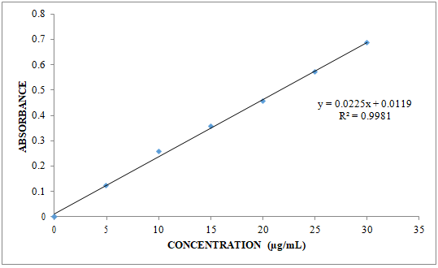

**Fig-1: Standard graph of Famciclovir in 0.1 N HCl**

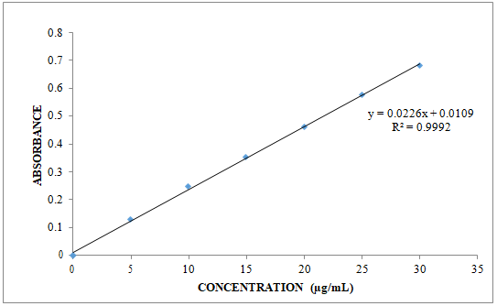

**Fig-2: Standard graph of Famciclovir in 6.8 pH buffer**

**Preformulation Parameters of Powder Blend**

**Table-8: Pre-Formulation Parameters of Core blend**

|  |  |  |  |  |  |
| --- | --- | --- | --- | --- | --- |
| **Formulation**  **code** | **Angle of**  **repose (Ө)** | **Bulk density**  **(gm/cm3** | **Tapped density**  **(gm/cm3)** | **Carr’s index**  **(%)** | **Hausner’s**  **ratio** |
| F1 | 24.72 ± 0.01 | 0.345 ± 0.018 | 0.401 ± 0.012 | 13.97 ± 0.01 | 1.16 ± 0.02 |
| F2 | 19.66 ± 0.02 | 0.332 ± 0.002 | 0.375 ± 0.015 | 11.46 ± 0.01 | 1.13 ± 0.01 |
| F3 | 20.16 ± 0.015 | 0.465 ± 0.015 | 0.532 ± 0.001 | 12.59 ± 0.01 | 1.14 ± 0.01 |
| F4 | 21.41 ± 0.01 | 0.421 ± 0.002 | 0.492 ± 0.002 | 14.43 ± 0.02 | 1.17 ± 0.02 |
| F5 | 20.60 ± 0.015 | 0.382 ± 0.001 | 0.439 ± 0.002 | 12.98 ± 0.01 | 1.15 ± 0.01 |
| F6 | 20.36 ± 0.015 | 0.523 ± 0.002 | 0.604 ± 0.017 | 13.41 ± 0.02 | 1.15 ± 0.01 |
| F7 | 19.98 ± 0.01 | 0.348 ±0.001 | 0.401 ± 0.001 | 13.22 ± 0.01 | 1.15 ± 0.01 |
| F8 | 40.13 ± 0.01 | 0.412 ±0.015 | 0.530 ±0.021 | 22.23 ± 0.01 | 1.29 ± 0.01 |

All the values represent n=3

Tablet powder blend was subjected to various pre-formulation parameters. The angle of repose values indicates that the powder blend has good flow properties. The bulk density of all the formulations was found to be in the range of 0.332 ± 0.002 to 0.523 ± 0.002 (gm/ml) showing that the powder has good flow properties. The tapped density of all the formulations was found to be in the range of 0.375 ± 0.015 to 0.604 ± 0.017 showing the powder has good flow properties. The compressibility index of all the formulations was found to be below 14.43 ± 0.02 which show that the powder has good flow properties. All the formulations has shown the Hausner’s ratio ranging between 1.13 ± 0.01 to 1.29 ± 0.01 indicating the powder has good flow properties.

**Quality Control Parameters for Tablets:**

Tablet quality control tests such as weight variation, hardness, friability, thickness and drug release studies in different media were performed on the compression tablet.

**Table-9: In Vitro Quality Control Parameters for Tablets**

|  |  |  |  |  |  |
| --- | --- | --- | --- | --- | --- |
| **Formulation Codes** | **Average Weight (mg)** | **Hardness (kg/cm2)** | **Friability (%loss)** | **Thickness (mm)** | **Drug Content (%)** |
| F1 | 500.14 | 5.2 | 0.45 | 6.21 | 96.25 |
| F2 | 498.82 | 4.1 | 0.38 | 5.49 | 98.12 |
| F3 | 499.55 | 5.0 | 0.28 | 5.05 | 100.01 |
| F4 | 496.72 | 4.7 | 0.20 | 6.56 | 98.59 |
| F5 | 499.58 | 4.2 | 0.38 | 5.84 | 98.09 |
| F6 | 497.89 | 5.6 | 0.30 | 6.11 | 95.83 |
| F7 | 500.04 | 4.5 | 0.26 | 5.87 | 99.37 |
| F8 | 500.27 | 5.1 | 0.18 | 5.39 | 98.14 |

**Weight Variation Test:**

Tablets of each batch were subjected to weight variation test, difference in weight and percent deviation was calculated for each tablet. The average weight of the tablet is approximately in range of 496.72 to 500.27 mg, so the permissible limit is ±7.5% (>500 mg). The results of the test showed that, the tablet weights were within limit.

**Hardness Test:**

Hardness of the three tablets of each batch was checked by using Pfizer hardness tester and the data’s were shown in Table 9. The results showed that the hardness of the tablets is in range of 4.1 to 5.6 kg/cm2, which was within IP limits.

**Thickness:**

Thickness of three tablets of each batch was checked by using Micrometer and data shown in Table-9. The result showed that thickness of the tablet is raging from5.05 to 6.56 mm.

**Friability:**

Tablets of each batch were evaluated for percentage friability and the data were shown in the Table 9. The average friability of all the formulations was less than 1% as per official requirement of IP indicating a good mechanical resistance of tablets.

**Drug Content:**

Drug content studies were performed for the prepared formulations. From the drug content studies it was concluded that all the formulations were showing the % drug content values within 95.83 – 100.01 %.

All the parameters such as weight variation, friability, hardness, thickness and drug content were found to be within limits.

**In Vitro Drug Release Studies**

**Table-10: Dissolution Data of Famciclovir Tablets**

|  |  |  |  |  |  |  |  |  |
| --- | --- | --- | --- | --- | --- | --- | --- | --- |
| **TIME** | **CUMULATIVE % OF DRUG RELEASE** | | | | | | | |
| **F1** | **F2** | **F3** | **F4** | **F5** | **F6** | **F7** | **F8** |
| **In dissolution media 0.1 N HCL** | | | | | | | | |
| 0 | 0 | 0 | 0 | 0 | 0 | 0 | 0 | 0 |
| 0.5 | 30.22 | 18.58 | 20.82 | 14.85 | 16.34 | 13.50 | 10.29 | 06.91 |
| 1 | 47.04 | 30.25 | 26.90 | 19.09 | 21.26 | 18.32 | 16.72 | 12.30 |
| 2 | 51.98 | 37.71 | 31.35 | 25.50 | 28.54 | 26.11 | 23.90 | 16.61 |
| **In dissolution media 6.8 Phosphate Buffer** | | | | | | | | |
| 3 | 60.35 | 45.64 | 41.05 | 32.26 | 32.80 | 30.55 | 28.89 | 22.52 |
| 4 | 69.26 | 52.83 | 46.16 | 38.34 | 39.03 | 37.81 | 36.25 | 26.81 |
| 5 | 75.90 | 60.17 | 52.09 | 46.86 | 46.97 | 43.65 | 42.10 | 35.32 |
| 6 | 91.71 | 66.98 | 59.90 | 51.71 | 52.61 | 50.07 | 47.52 | 43.60 |
| 7 | 98.23 | 79.05 | 67.72 | 58.55 | 60.76 | 56.22 | 55.99 | 50.97 |
| 8 |  | 90.14 | 73.38 | 69.14 | 67.21 | 62.89 | 62.71 | 56.82 |
| 9 |  | 97.08 | 85.89 | 77.82 | 75.14 | 72.27 | 67.63 | 63.35 |
| 10 |  |  | 98.96 | 86.91 | 81.30 | 78.14 | 75.89 | 70.82 |
| 11 |  |  |  | 91.35 | 90.18 | 86.96 | 83.71 | 73.99 |
| 12 |  |  |  | 97.08 | 99.23 | 96.82 | 90.82 | 86.34 |

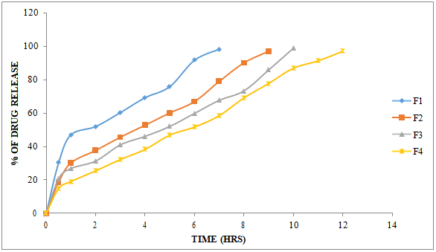

**Fig-3: Dissolution Profile of Famciclovir (F1, F2, F3, F4 Formulations)**

The results of release studies of formulations F1 to F4 are shown in Table 10 and Figure 3. The release of drug depends not only on the nature of matrix but also upon the drug polymer ratio. As the percentage of polymer increased, the kinetics of release decreased. Formulation F1 composed of drug polymer ratio of 1:1, failed to sustain release beyond 7h. This formulation underwent erosion before complete swelling could take place. Formulations with drug polymer ratios 1:2 (F2), 1:3 (F3) have extended the drug release for 10h. Further increasing the ratio to 1:4 (F4), the release was sustained for 12 h.

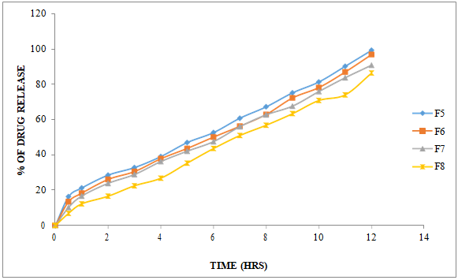

**Fig-4: Dissolution Profile of Famciclovir (F5, F6, F7, F8 Formulations)**

Hydrophobic Ethyl cellulose can be used as a matrix former for the formulation of sustained-release dosage forms. Batches containing ethyl cellulose (F5 to F8) as release retardant extended the release up to 12 hours with initial slow release. As drug polymer ratio increased, the release rate was decreased. During dissolution the erosion was observed. The results were shown in Table 10 and Figure 4.

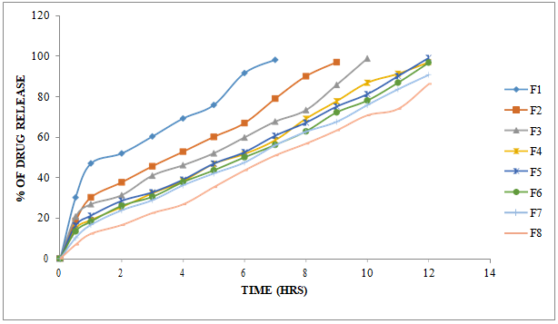

**Fig-5: Dissolution Profile of Famciclovir (F1 to F8 formulations)**

Out of total 8 batches, the drug release was extended up to 12 hours for the formulations F5. So, these formulations selected for further studies like kinetic data analysis.

**Table-11: Release Kinetics:**

|  |  |  |  |  |  |  |  |  |  |  |  |  |
| --- | --- | --- | --- | --- | --- | --- | --- | --- | --- | --- | --- | --- |
| **CUMULATIVE (%) RELEASE Q** | **TIME ( T )** | **ROOT (T)** | **LOG( %) RELEASE** | **LOG ( T )** | **LOG (%) REMAIN** | **RELEASE RATE (CUMULATIVE**  **% RELEASE /**  **t)** | **1/CUM% RELEASE** | **PEPPAS**  **log Q/100** | **% Drug Remaining** | **Q01/3** | **Qt1/3** | **Q01/3-**  **Qt1/3** |
| 0 | 0 | 0 | 0 | 0 | 2.000 | 0 | 0 | 0 | 100 | 4.642 | 4.642 | 0.000 |
| 16.34 | 0.5 | 0.707 | 1.213 | -0.301 | 1.923 | 32.680 | 0.0612 | -0.787 | 83.66 | 4.642 | 4.374 | 0.268 |
| 21.26 | 1 | 1.000 | 1.328 | 0.000 | 1.896 | 21.260 | 0.0470 | -0.672 | 78.74 | 4.642 | 4.286 | 0.355 |
| 28.54 | 2 | 1.414 | 1.455 | 0.301 | 1.854 | 14.270 | 0.0350 | -0.545 | 71.46 | 4.642 | 4.150 | 0.492 |
| 32.8 | 3 | 1.732 | 1.516 | 0.477 | 1.827 | 10.933 | 0.0305 | -0.484 | 67.2 | 4.642 | 4.066 | 0.576 |
| 39.03 | 4 | 2.000 | 1.591 | 0.602 | 1.785 | 9.758 | 0.0256 | -0.409 | 60.97 | 4.642 | 3.936 | 0.706 |
| 46.97 | 5 | 2.236 | 1.672 | 0.699 | 1.725 | 9.394 | 0.0213 | -0.328 | 53.03 | 4.642 | 3.757 | 0.885 |
| 52.61 | 6 | 2.449 | 1.721 | 0.778 | 1.676 | 8.768 | 0.0190 | -0.279 | 47.39 | 4.642 | 3.619 | 1.023 |
| 60.76 | 7 | 2.646 | 1.784 | 0.845 | 1.594 | 8.680 | 0.0165 | -0.216 | 39.24 | 4.642 | 3.398 | 1.243 |
| 67.21 | 8 | 2.828 | 1.827 | 0.903 | 1.516 | 8.401 | 0.0149 | -0.173 | 32.79 | 4.642 | 3.201 | 1.441 |
| 75.14 | 9 | 3.000 | 1.876 | 0.954 | 1.396 | 8.349 | 0.0133 | -0.124 | 24.86 | 4.642 | 2.919 | 1.723 |
| 81.3 | 10 | 3.162 | 1.910 | 1.000 | 1.272 | 8.130 | 0.0123 | -0.090 | 18.7 | 4.642 | 2.654 | 1.987 |
| 90.18 | 11 | 3.317 | 1.955 | 1.041 | 0.992 | 8.198 | 0.0111 | -0.045 | 9.82 | 4.642 | 2.141 | 2.500 |
| 99.23 | 12 | 3.317 | 1.997 | 1.079 | -0.114 | 8.269 | 0.0101 | -0.003 | 0.77 | 4.642 | 0.917 | 3.725 |

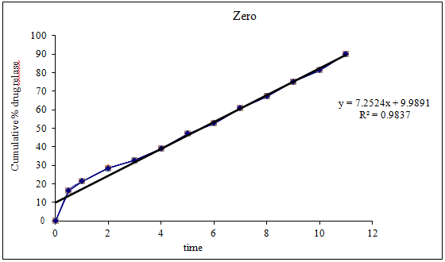

**Fig-6: Zero Order Release Kinetics Graph**

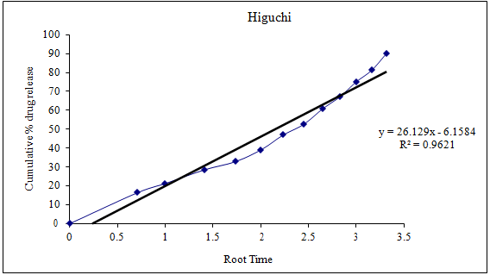

**Fig-7: Higuchi Release Kinetics Graph**

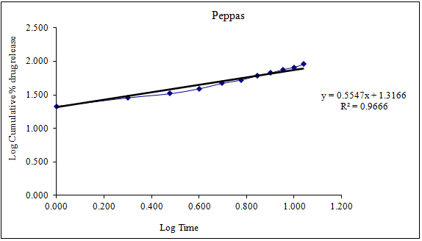

**Fig-8: Peppas Release Kinetics Graph**

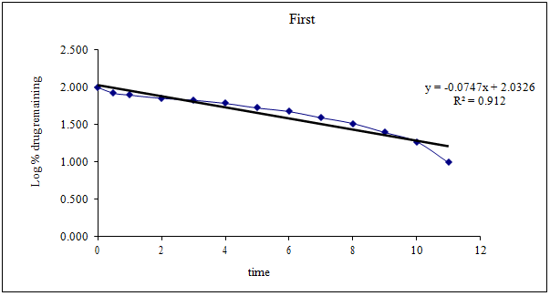

**Fig-9: First Order Release Kinetics Graph**

Optimised formulation F5 was kept for release kinetic studies. From the above graphs it was evident that the formulation F8 was followed Zero order release mechanism.

**Drug – Excipient Compatibility Studies**

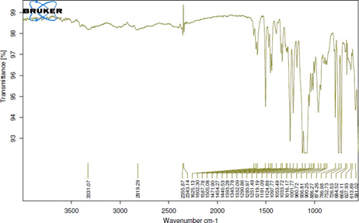

**Fig-10: FT-TR Spectrum of Famciclovir Pure Drug**

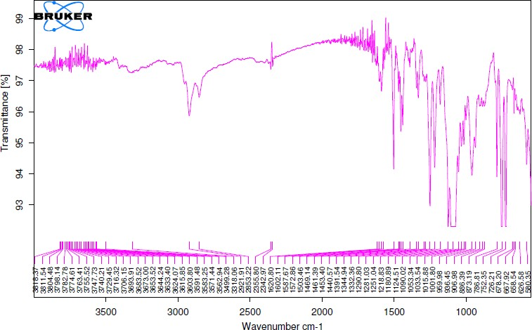

**Fig-11: FT-IR Spectrum of Optimised Formulation**

There was no disappearance of any characteristics peak in the FTIR spectrum of drug and the polymers used. This shows that there is no chemical interaction between the drug and the polymers used. The presence of peaks at the expected range confirms that the materials taken for the study are genuine and there were no possible interactions.

Famciclovir is also present in the physical mixture, which indicates that there is no interaction between drug and the polymers, which confirms the stability of the drug.

**CONCLUSION**

Famciclovir is a guanosine analogue antiviral drug used for the treatment of various herpesvirus infections, most commonly for herpes zoster (shingles). It is a prodrug form of Penciclovir with improved oral bioavailability.

As the conventional doses release the Famciclovir in just few minutes and therefore the therapeutic concentrations are maintained for a short period of time generating a need for administration of another dose

Therefore an attempt is made to maintain the therapeutic concentration for longer period of time. This is achieved by developing sustained release drug delivery system. These sustained release matrix tablets mainly prepared for release of the drug for longer period of time i.e., 12 hours and utilizing the drug to full extent avoiding unnecessary frequency of dosing.

For the formulation of sustained release matrix tablet HPMC K 15M, Ethyl cellulose and PVP was used as matrix forming agents. Other excipients used are microcrystalline cellulose (diluents), Magnesium stearate (lubricating agent). Fourier transform Infrared spectroscopy confirmed the absence of any drug/polymers/excipients interactions.

The prepared sustained release tablets were evaluated for hardness, Weight variation, thickness, friability, drug content uniformity, In-vitro dissolution studies. Formulation F5 is considered to be the optimized formulation

Matrix tablets were compressed without any problem and do not require any change in ratio of excipients in formulation. Results of the present study demonstrated that both hydrophilic and hydrophobic polymers could be successfully employed for formulating sustained-release matrix tablets of Famciclovir.

It was observed that Formulations F5 retained the drug release up to 12 hrs. All formulations were subjected for four different models viz. Zero order, First order, Higuchi matrix and Peppas model equations and all the formulations best fit in to the Zero order release mechanism by giving the values of diffusion exponent (n) in the range of 0.983 that indicate the formulation had release the drug by diffusion followed by erosion mechanism.

Hence it can be concluded that twice a daily controlled release matrix tablet of Famciclovir having satisfactory sustained release profile which may provide an increased therapeutic efficacy. The developed formulation overcome and alleviates the drawback and limitation of sustained release preparations.

**BIBILOGRAPHY**

1. Jain KK. Drug delivery systems. 1st edition. Switzerland: Humana Press; 2008. P. 1-51.Reddy KR., Mutalik S, Reddy S. AAPS Pharm. Sci. Tech.2003; 4: 19. 121- 125.
2. Chien YW. Novel drug delivery system. 2nd edition revised and expanded. New York: Informa health care; 2009. P. 1-50.
3. Jantzen GM, Robinson JR. Sustained and Controlled- Release Drug Delivery systems Modern Pharmaceutics, 4thed; 2003; 121: 501-502.
4. Salsa T, Veiga F. Drug Develop. Ind Pharm. 1997; 23: 931.
5. Gwen MJ, Joseph RR, In Banker GS and Rhodes CT, Ed. Modern Pharmaceutics, 3rdEd Marcel Dekker Inc. New York. 1996; 72: 575.
6. Jantzen GM, Robinson JR, Sustained and controlled-release drug delivery systems, in Banker GS, Rhodes CT (Eds.) Modern Pharmaceutics, 3rd Ed, Revised and Expanded, Drugs and the Pharmaceutical Sciences., Marcell Dekker, Inc. New York. 1995; 72: 575-609.
7. Lee BJ, Ryu SG, Cui JH, Drug Dev. Ind.Pharm.1999; 25: 493-501.
8. Vidyadhara S, Rao PR, Prasad JA. Indian J Pharm Sci. 2004; 66: 188-192.
9. Bogner RH. Bioavailability and bioequivalence of extended-release oral dosage forms. US Pharmacist. 1997; 22: 3–12.
10. Rogers JD, Kwan KC. Pharmacokinetic requirements for controlled-release dosage forms. In: John Urquhart, ed. Controlled-release Pharmaceuticals. Academy of Pharmaceutical Sciences. American Pharmaceutical Association. 1979: 95–119.
11. Madan PL. Sustained-release drug delivery systems, part II: Preformulation considerations. Pharm Manu fact. 1985; 2: 41–45.
12. Wani MS, Controlled Release System-A Review, 2008; 6 1: 56-62.
13. Banker GS, Anderson NR. The Theory and Practice of Industrial Pharmacy: Tablet, Lachman, (3rded) Varghese Publishing House, Bombay. 1990; 3: 293-303.
14. Manish R, Jayesh P, Siahboomi AR. Hydrophilic Matrices for Oral Extended Release: Influence of Fillers on Drug Release from HPMC Matrices. Pharma Times. 2010; 42(04): 67-73.
15. Lee VHL, Controlled Drug Delivery Fundamentals and Applications: Influence of drug properties on design, Marcel Dekker, INC, and New York. 1987; 2: 16-29.
16. Kumar KP et al. Innovations in Sustained Release Drug Delivery System and Its Market Opportunities. J Chem Pharm Res. 2010; 2 1: 349-360.
17. Brahmankar DM, Sunil B. Jaishwal. “Controlled release medication” chapter 15th in “Bio pharmaceutics and Pharmacokinetics – A Treatise, 1st Ed, 2010; 1: 347- 353.
18. Mallikarjunarao p1*, Mohan Kumar Y1, Kiran Kumar M2, Prathyusha S3, Lavanya D4. Formulation and invitro evaluation of Nevirapine extended release matrix tablets. International journal of research and development in pharmacy and life sciences. 2014; 3(4) 1054-1065.
19. Stanley S. Davis, Formulation strategies for abs windows. Drug Discovery Today, 2005; 10: 249-257.
20. Lieberman HA, Lachman L, Schwartz JB., Pharmaceutical Dosage Forms: Tablets, 2011; 3 (2): 199-287.
21. Modi SA et al. Sustained Release Drug Delivery System: A Review. Int J Pharma. Res Dev. 2011; 2 (12): 147-160.
22. Aulton ME. Pharmaceutics: The Science of Dosage Form Design. 2005; 2: 296- 298.
23. Wise DL. Handbook of Pharmaceutical Controlled Release Technology. Inc. 2005; 2: 5-24.
24. Jantzen GM, Robinson JR. Sustained and Controlled- Release Drug Delivery systems Modern Pharmaceutics, 4thed; 2011; 121: 501-502.
25. Bhargava. A et al. Oral sustained release dosage form: an opportunity to prolong the release of drug. Int J ARPB. 2013; 3: 7-14.
26. Heena Farooqui and Prashant Upadhyay. Formulation and Evaluation of Sustained-Release Tablet Having Genistein. IJPSR, 2022; Vol. 13(2): 810-820.
27. Lateef Gbenga Bakre, Emmanuel Akinyele, Oluyemisi Bamiro, Olutayo Adeleye, Olobayo Kunle. Formulation and Evaluation of Sustained Release Ibuprofen Matrix Tablets Using Starch from Maize Genotypes as Polymer. Seria Medica 2021;67(2):122-126.
28. D. Nagasamy Venkatesh, S. N. Meyyanathan, A. Mohamed Sheik Tharik, Srinivas Rao. Formulation and Evaluation of sustained release tablets of Ramipril. Research J. Pharm. and Tech. 2020; 13(8):3873-3878.
29. Pawar Simran S., Malpure Prashant S., Surana Santosh S., Bhadane Jayashri S. Formulation and Evaluation of Sustained Release Matrix Tablets of Captopril. Journal of Drug Delivery & Therapeutics. 2019; 9(4-A):260-268.
30. K. Latha, T. Chinni Kranthi and Naseeb Basha Shaik Preparation and Evaluation of Sustained Release Matrix Tablets of Tolterodine Tartrate Using Guggul Resin. Bangladesh Pharmaceutical Journal 21(1): 24-34, 2018.
31. D. M. Patil , P. A. Pawar, R. Y. Pagar, R. S. Ghule, V. A. Bairagi Formulation And Development Of Sustained Release Matrix Tablets Of Lornoxicam. Journal of Drug Delivery & Therapeutics. 2018; 8(2):102-106.
32. Sunil Kumar, B. Someswara Rao and Suresh V. Kulkarni Formulation And Evaluation Of Sustained Release Matrix Tablets of Ambroxol Hydrochloride Using Natural Polymer. IJPSR, 2014; Vol. 5(10): 4225-32.
33. Y. Ganesh Kumar, J. Sreekanth, D. Satyavati Formulation Development and Evaluation of Sustained Release Matrix Tablets of Vildagliptin - Synthetic and Natural Polymers. Asian Journal of Pharmaceutics • Oct-Dec 2015 (Suppl) • 9 (4).
34. Hitesh N. Jain, Parth P. Patel, Millin R. Gohel, Umesh M. Upadhyay Formulation And Evaluation Of Pregabalin Sustained Release Tablets. IAJPS 2016, 3 (11), 1316-1321.
35. Pooja Shetty, Ravi Kumar, Yamunappa, Prathibha Suvarna, Narayana Swamy V Design and Evaluation of Sustained Release Matrix Tablets of Etodolac Asian Journal of Pharmacy and Technology Volume No. : 6 Year: 2016.
36. Arvnabh Mishra, Mehul Charpot, Hemul V. Patel , Preparation and Evaluation of Sustained Release Tablets of Cefixime Trihydrate using Natural Excipients International Journal of Pharma Research & Review, June 2015; 4(6):1-6.
37. Dharmendra Solanki, Surendra Kumar Jain, Sujata Mahapatra Formulation and Evaluation of Sustained Release Metformin Hydrochloride Matrix Tablet Using Natural Polysaccharide Am. J. PharmTech Res. 2015; 4(6)
38. Mallikarjunarao P, Mohan Kumar Y, Kiran Kumar M, Prathyusha S, Lavanya D. Formulation and Invitro Evaluation of Nevirapine Extended Release Matrix Tablets. International Journal of Research and Development in Pharmacy and Life Sciences. 2014; 3 (4) 1054-1065.
39. Tejaswi M, Vasanth Pm, Suresh K, Ramesh T, Ramesh Malothu, Design And Evaluation Of Felodipine Extended Release Tablets Employing A New Starch Based Polymer, International Journal of Biopharmaceutics. 2013; 4(1): 27-33.
40. M. Rajesh, Mohan Kumar Pippalla, Krsc. Bharath Kumar, M. Shunmuga Sundaram, S. Palanichamy and A. Thanga Thirupathi. Formulation and Evaluation of Extended Release Tablets of Metformin Hydrochloride. International Journal of Pharmaceutical, Chemical and Biological Sciences. 2012; 2(3):318-324.