Impact of Time Management Skills on Academic and Professional Success

B.Likhitha, B.Sai Laxmi Prasanna, B.Sushmitha, B.Swarupa, B.Sai Jitesh, Dr.Gifta jerith, Dr.Thayyaba Khatoon

School of Engineering, Department of Artificial Intelligence and Machine Learning, Malla Reddy University, Hyderabad, India.

|  |  |  |
| --- | --- | --- |
| KEYWORDS:  Time Management  Productivity  Prioritization Techniques  Procrastination  Goal Setting  Stress Management |  | ABSTRACT:  This paper explains the importance of time management as a skill that impacts productivity, stress levels, and overall life satisfaction in various settings, including academic, professional, and personal domains. Through an analysis of existing literature and a survey on popular time management practices, this study identifies effective strategies such as prioritization, goal setting, and the Pomodoro Technique, which are shown to enhance task completion rates and reduce procrastination. Findings indicate that individuals who use structured time management techniques experience improved focus, reduced stress, and greater work-life balance. The study also highlights the psychological dimensions of time management, emphasizing its role in building self-discipline and fostering personal and professional development. These insights contribute to a deeper understanding of time optimization and offer practical recommendations for those aiming to enhance their time management abilities. |

**1. INTRODUCTION**

Time management is increasingly recognized as a fundamental skill essential for success in various domains, including academics, professional settings, and personal life. As demands on individuals’ time continue to grow, effectively managing time has become a key factor in achieving productivity, reducing stress, and maintaining a healthy work-life balance. Despite the widespread awareness of its importance, many people struggle to implement practical time management strategies that suit their unique lifestyles and responsibilities.

This paper explores the concept of time management, examining established techniques and their effectiveness in different contexts. From prioritization tools like the Eisenhower Matrix to focused work methods such as the Pomodoro Technique, various strategies offer potential solutions to common time-related challenges. By investigating these methods, this study seeks to understand the impact of time management on productivity, procrastination, and stress levels.

Moreover, this research considers the psychological aspects of time management, delving into how structured planning and goal setting influence behavior, motivation, and self-discipline. By examining both practical strategies and the underlying psychology, this paper aims to provide a comprehensive overview of effective time management approaches. Ultimately, the insights gained here contribute to a better understanding of time optimization and offer actionable recommendations for individuals seeking to enhance their time management skills.

By analyzing these strategies and psychological factors, this study aims to deepen our understanding of time management and its impacts. Through a combination of literature review and original data from a survey of time management practices, this paper will present actionable insights and recommendations for those seeking to improve their time management skills and enhance their productivity and well-being.

**2. LITERATURE SURVEY**

 Time management within organizational and cultural contexts critiques the dominant view of time as a purely measurable and optimizable resource. This approach argues that conventional practices often reduce time management to rigid schedules and efficiency models that overlook the complexity and relational nature of time in people’s lives. Emphasizing that time is socially constructed, these studies highlight how organizational expectations and cultural norms influence individual time use, impacting well-being and autonomy. For instance, individuals balancing work with caregiving responsibilities face distinct challenges, where "flexible" time policies may inadvertently create constant availability expectations, leading to greater work-life conflicts.

**Existing Systems and Techniques:**

Effective time management is essential for enhancing productivity and achieving a balanced lifestyle, and various systems and techniques have been developed to assist individuals and organizations in this pursuit. One prominent system is the Eisenhower Matrix, which helps prioritize tasks based on their urgency and importance. This matrix divides tasks into four quadrants: those that are urgent and important should be done first; important but not urgent tasks should be scheduled for later; urgent but not important tasks can be delegated if possible; and tasks that are neither urgent nor important should be eliminated or minimized. By using this framework, individuals can focus on what truly matters and reduce the time spent on less significant activities. Another popular technique is the Pomodoro Technique, which promotes structured work intervals to increase focus and productivity. This method involves breaking work into 25-minute focused sessions, called "Pomodoro’s,” followed by short breaks of 5 minutes.

**Challenges and Future Directions:**

Exploring the implications of remote work and flexible schedules on time management is crucial. With the rise of remote work, individuals are faced with unique challenges related to managing their time effectively in less structured environments. Researching how time management techniques can be adapted to fit remote work settings will be essential for helping individuals maintain productivity and well-being.

**Practical Applications and Implications:**

Effective time management strategies can be applied in various settings, from personal life to professional environments, enabling individuals and teams to optimize their workflows and achieve desired outcomes. Individuals can adopt a variety of time management techniques to enhance their personal productivity and well-being.

**Related works:**

The foundational theories of time management began with the work of Frederick Winslow Taylor, who introduced principles of scientific management in the early 20th century. Taylor’s emphasis on efficiency laid the groundwork for future research on optimizing time in the workplace. This theoretical background has influenced various time management methodologies.

Covey's Time Management Matrix, introduced in "The 7 Habits of Highly Effective People" (1989), further expanded the understanding of time management by categorizing tasks based on their urgency and importance. Covey's work has been widely cited in both academic and professional settings, providing a framework for prioritizing tasks effectively.

With the advent of digital tools, recent research has focused on the role of technology in enhancing time management practices. Studies such as those by Zeyi Huang (2020) have explored the effectiveness of task management applications in improving individual productivity. Their findings indicate that users of digital task management tools are better able to organize their tasks and stay focused on their goals. Furthermore, the integration of artificial intelligence into time management applications is an emerging area of study.  Bae (2022) analyzed how AI-driven applications can provide personalized recommendations for task prioritization, helping users manage their time more effectively.

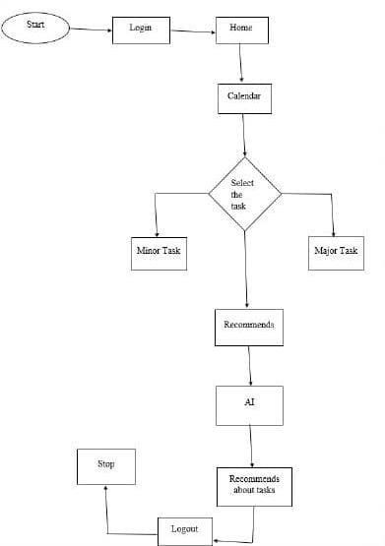The rise of digital tools has also impacted time management, as research on applications like To do List, Asana, and Trello indicates that digital tools enhance task organization, collaboration, and time tracking. Similarly, scheduling systems like Google Calendar and Microsoft Outlook have been shown to reduce cognitive load and improve scheduling efficacy. Time management is also crucial in workplace and educational settings, with studies revealing that training can improve employee productivity and reduce stress (Macan, 1994), while Britton and Tesser's research on students links effective time management to better academic performance and reduced stress.

**3. METHODOLOGY:**

1. **Research Design and Approach**

It is a mixed-methods approach, integrating both quantitative and qualitative research methodologies to evaluate the effectiveness of a time management and reminder app. The research will employ a quasi-experimental design to measure productivity metrics before and after app implementation. Concurrently, qualitative interviews will provide insights into user experiences and satisfaction with the app. This dual approach ensures a comprehensive understanding of the app's impact on users' time management behaviors.

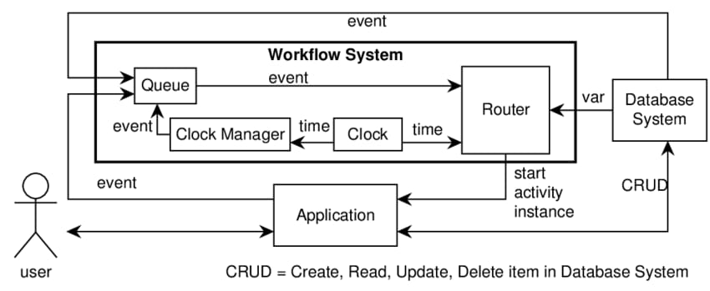

1. **Algorithms and Flow Diagrams**

This system will be designed with a user-friendly interface, structured around several key components: the User Interface (UI), Database, Task Management Module, and Notification System. A flow diagram of the app’s architecture will illustrate the interactions between these components. The UI will allow users to input tasks, set reminders, and view their schedules. The Task Management Module will categorize tasks based on priority and deadlines, while the Notification System will ensure timely reminders are sent to users.

**c) Data Collection Methods**

Quantitative data will be collected from the app's backend, tracking key metrics such as the frequency of reminders set, tasks completed, and overall user engagement. Pre- and post-implementation surveys will be administered to measure users’ perceived time management skills, productivity levels, and satisfaction with the app. In addition, qualitative data will be obtained through semi-structured interviews or focus groups, where participants will discuss their experiences, challenges, and suggestions for app improvements.

**d) Procedure**

The procedure will commence with the development and deployment of the app, incorporating features specifically designed to facilitate effective time management and reminders. Participants will be recruited through online platforms and provided with detailed instructions for using the app, along with a consent form outlining the study's purpose and their rights. Data collection will span four weeks, during which users will engage with the app and provide feedback midway to identify any immediate issues or improvements needed.

**4. IMPLEMENTATION:**

**a) Methods of Implementation**

The implementation of a time management and work-reminding app is a multifaceted process that encompasses various methodologies, technologies, and practices aimed at creating a user-centred application the implementation can be divided into several key steps:

**Project Planning and Requirement Analysis:** The first step in the implementation process involves comprehensive project planning and requirement analysis. This phase includes identifying user needs through surveys, interviews, and focus groups to understand the features and functionalities that potential users expect from the app.

**Design and Prototyping:** Once the requirements are defined, the design phase commences. This includes creating wireframes and mock-ups to visualize the app's interface and user experience. The prototypes will undergo usability testing with target users to gather feedback on navigation, layout, and functionality.

**Reminder System Implementation;** The core functionality of the app lies in its reminder system. Users can input tasks and deadlines, after which the app utilizes the trained machine learning model to send personalized reminders at optimal times.

**Testing and Quality Assurance:** The testing and quality assurance phase is crucial to ensure the app functions as intended. This includes multiple testing methodologies such as unit testing to validate individual components, integration testing to ensure that different parts of the app work together, and user acceptance testing (UAT) to gather feedback from end-users. Any issues identified during testing are addressed before the app is launched, ensuring a stable and reliable product.

**5. RESULT:**

1. **Home Page:**

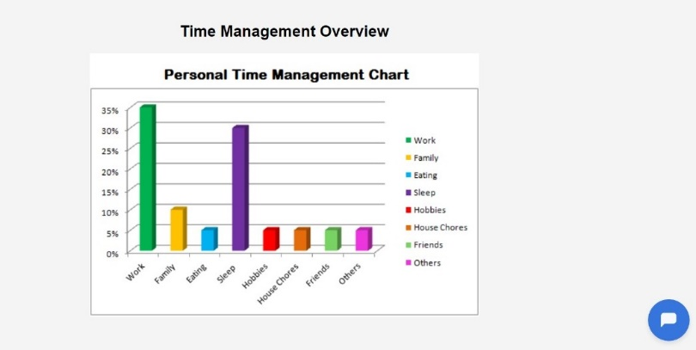

1. **Login Page:**

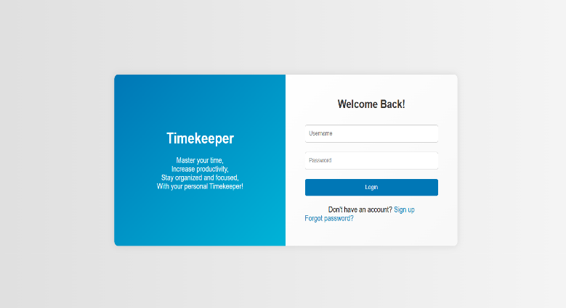

1. 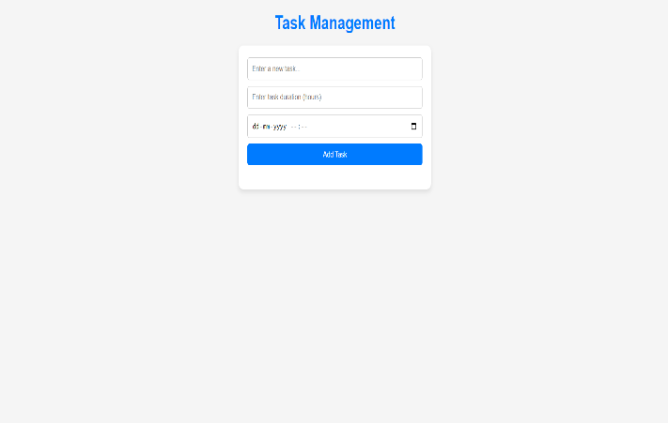**Main Page:**

**4)Test Case 1(Successful)Page:**

make a reminder," it makes a note to remind the user”:

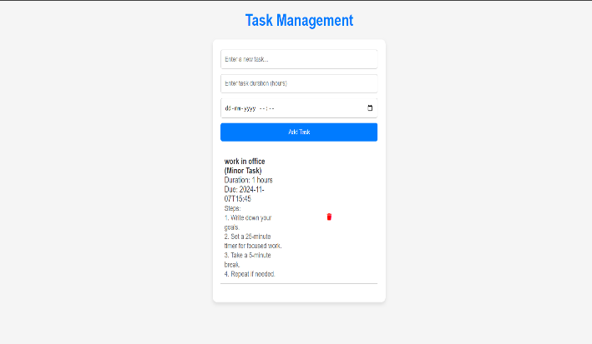

**6. CONCLUSION:**

In conclusion, the development of a time management and work-reminding app demonstrates the potential of technology to enhance productivity and help users effectively manage their time. Through a systematic implementation process that includes comprehensive project planning, user-centered design, robust development. ultimately, the successful deployment of this app contributes to improved time management practices, empowering individuals to achieve their goals more effectively.

The development of a time management and work-reminding app signifies a substantial step forward in leveraging technology to enhance individual productivity and organizational skills. Throughout the implementation process, we have emphasized user-centred design principles, ensuring that the app addresses the specific needs and preferences of its target audience. By incorporating features such as personalized reminders, task tracking, and progress monitoring, the app provides users with the tools necessary to manage their time effectively.

This methodology allows for rapid recognition of known individuals with minimal training data, making the system suitable for deployment in diverse environments. overall, the successful deployment and positive user feedback affirm the app's potential to facilitate better time management practices, ultimately empowering users to achieve their personal and professional goals.

**Future Works :**

The future of this time management and work-reminding app holds exciting possibilities for expansion and enhancement. One significant area for future work involves the integration of collaborative features that allow users to share tasks and deadlines with colleagues, family, or friends. This could foster teamwork and accountability, particularly in professional environments or group projects.

Additionally, enhancing the app's analytical capabilities could provide users with insights into their productivity patterns, helping them identify peak performance times and areas for improvement. additionally, incorporating advanced machine learning techniques, such as natural language processing, could allow for smarter task entry through voice commands, making the app even more user-friendly.

Future iterations could also explore gamification elements, encouraging users to engage with the app more consistently by rewarding them for completing tasks and achieving milestones. Moreover, conducting longitudinal studies on user engagement and productivity could provide valuable insights into the long-term effectiveness of the app.

**7. REFERENCES:**

[1] Bonatti Rogerio, Ho Cherie, Wang Wenshan, Choudhury Sanjiban, and Scherer Sebastian. Towards a robust aerial cinematography platform: Localizing and tracking moving targets in unstructured environments. In IROS, pages 229– 236, 2019.

[2] Li Rui, Pang Minjian, Zhao Cong, Zhou Guyue, and Lu Fang. Monocular long-term target following on uavs. In CVPR Workshops, pages 29–37, 2016.

[3] Changhong Fu, Adrian Carrio, Miguel A Olivares-Mendez, Ramon Suarez-Fernandez, and Pascual Campoy. Ro- bust real-time vision-based aircraft tracking from unmanned aerial vehicles. In ICRA, pages 5441–5446, 2014.

[4] Mucahit Karaduman, Ahmet C¸ ınar, and Haluk Eren. Uav ¨ traffic patrolling via road detection and tracking in anony- mous aerial video frames. Journal of Intelligent & Robotic Systems, 95(2):675–690, 2019.

[5] David S Bolme, J Ross Beveridge, Bruce A Draper, and Yui Man Lui. Visual object tracking using adaptive corre- lation filters. In CVPR, pages 2544–2550, 2010.

6] Yang Li and Jianke Zhu. A scale adaptive kernel correlation filter tracker with feature integration. In ECCV, pages 254– 265, 2014

[7] Joao F Henriques, Rui Caseiro, Pedro Martins, and Jorge ˜ Batista. High-speed tracking with kernelized correlation fiters. IEEE Trans Pattern Analysis and Machine Intelligence, 37(3):583–96, 2015.

[8] Martin Danelljan, Gustav Hager, Fahad Shahbaz Khan, and Michael Felsberg. Learning spatially regularized correlation filters for visual tracking. In ICCV, pages 4310–4318, 2015.

[9] Luca Bertinetto, Jack Valmadre, Stuart Golodetz, Ondrej Miksik, and Philip HS Torr. Staple: Complementary learners for real-time tracking. In CVPR, pages 1401–1409, 2016

[10] Matthias Mueller, Neil Smith, and Bernard Ghanem. Context-aware correlation filter tracking. In CVPR, pages 1396–1404, 2017

[11] Martin Danelljan, Gustav Hager, Fahad Shahbaz Khan, and ¨ Michael Felsberg. Discriminative scale space tracking. IEEE transactions on pattern analysis and machine intelligence, 39(8):1561–1575, 2017.

[12] Mengmeng Wang, Yong Liu, and Zeyi Huang. Large margin object tracking with circulant feature maps. In CVPR, pages 4021–4029, 2017.

[13] Ning Wang, Wengang Zhou, Qi Tian, Richang Hong, Meng Wang, and Houqiang Li. Multi-cue correlation filters for ro- bust visual tracking. In CVPR, pages 4844–4853, 2018.

[14] Feng Li, Cheng Tian, Wangmeng Zuo, Lei Zhang, and Ming- Hsuan Yang. Learning spatial-temporal regularized correla- tion filters for visual tracking. In CVPR, pages 4904–4913, 2018.