An Over View On 3d Printing Technologies-A literature review

**Dr. V.Rambabu1, T.Dhanalakshmi2, S.Dinesh3 ,S.Venkatesh4,R.Kishore5**

1 professor, Mechanical engineering, GMRIT, Rajam, Andhra Pradesh, India

2,3,4,5UG Scholar, Mechanical engineering, GMRIT, Rajam, Andhra Pradesh, India

**ABSTRACT**

Digital fabrication technology, also known as 3D printing or additive manufacturing, generates physical objects from a geometrical representation by successive addition of materials. 3D printing technology is the fast-emerging technology.3D Printing is widely used all over the world. 3D printing technology increasingly used for the mass customization, production of any types of open source designs in agriculture, healthcare, automotive industry, locomotive industry, and aviation industries. Use of 3D printing technology: In this technology, an object is printed layer by layer deposition of material directly from the computer aided design (CAD) model. Currently 3D printing is applied in food areas such as Military and Space 17 Food, Elderly Food, Sweets Food. An Accurate and precise printing is critical to a successful and 18 smooth printing. This paper provides an overview of the types of 3D printing technologies, the application of 3D printing technology and lastly, the materials used for 3D printing technology in manufacturing industry.

**Keywords:** Additive manufacuting, 3D Printing, manufacturing industy .

1. **INTRODUCTION**

3D printing has evolved rapidly since the initial concept invented in the late 1970s. The main idea is to layers of material using a digital model input from a CAD software to create a three dimensional object, a process also widely known as Additive Manufacturing. Nowadays, 3D printing lists a number of dierent applications in several industries such as medicine, manufacturing, aerospace, automotive, construction, architecture, jewelry, food and more Diversity in di¨erent technologies and materials creates infinite possibilities, covering the whole area of geometrically complex, mostly scaled models with high precision and reliability. In this paper some of the most used 3D printing technologies will be presented and compared under specific parameters that a¨ect the nal result in terms of accuracy, functionality, and usability. A wide list of Taking into consideration printing materials, advantages, disadvantages, and even di_erent applications of these technologies[1]. These issues Being a worldwide leader, Nike had major problems with the reputation of not being good enough in Vietnam, which led them to restrain tension in the 1990 s. Besides reputation ,a number of different types of production systems are introduced inside the research domain, which includes consideration of environmental conservation and social balance, as a consequence of this terrible incident. On the other hand, the advanced manufacturing-future focuses more in the name of advanced production systems on technology innovations. In order to maintain the market and in addition to saving future generations with resources, it is thus vital to integrate technology with other aspects of the essential requirements. The latest study performed by Global Manufacturing Outlook indicates that overseas investment into the manufacturing industry is mostly influenced by lower production cost and gaining access to new markets. The results clearly depict these two variables to have greater prominence in the appeal of shareholders irrespective of the firm's size. More technology to increase productThe processes of production, in recent years, were standardized and cost reduction was implemented. In a row, most recently, additive manufacturing/3D printings have been focused, which in addition to customization of the product greatly decreases costs[2]

1. Basic Principles of 3D printing

The basic principle of additive manufacturing (AM), also known as 3D printing, is to create objects layer by layer from digital models, rather than by traditional subtractive methods like machining [2]. In additive manufacturing, a 3D design is sliced into thin cross-sectional layers, which are successively built up to form the final object [5].

**Digital Design Creation:** A 3D model is created using computer-aided design (CAD) software. This model serves as the blueprint for the object. [3]

**Slicing and Layering:** The digital model is "sliced" into thin layers. Each layer is essentially a 2D cross-section of the object, which will be built sequentially from the bottom up [4].

**Layer-by-Layer Fabrication:** Using various AM technologies (e.g., Fused Deposition Modeling, Selective Laser Sintering, or Stereolithography), the printer deposits or solidifies material in each layer according to the digital design, gradually creating the full 3D object.

**Material Deposition or Solidification:** Depending on the method, material can be deposited as a melted filament, resin, powder, or metal that then solidifies to form each layer [6].

**Object Completion:** The object is built up one layer at a time until it is complete. Once the printing process is done, some post-processing may be required for finishing, such as removing supports or polishing surfaces [7]. 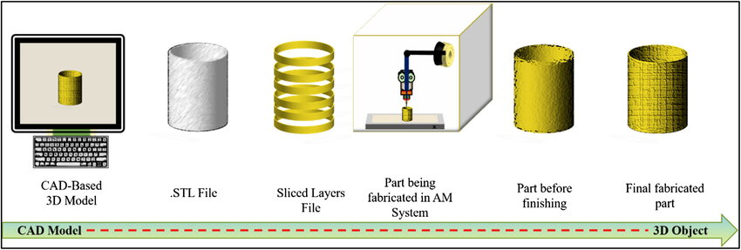

**Fig.**1-**Basic principle of 3D printing[4]**

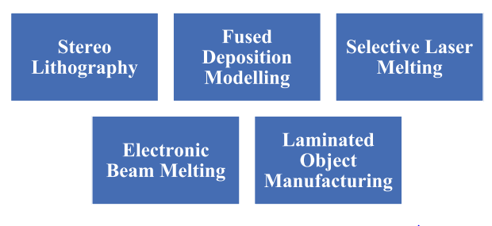

**Fig.2- Basic Principles of 3D Printing. [2]**

**2.1 Stereo lithography**

This process uses liquid and ultraviolet photo polyfer light, which subsequently solidifies and makes the modal when UV light strikes with photo polymer. As it is depicted in Fig. 3, Stereo lithography is kind of 3D printing technique used to make models, prototypes, layer by layer mode motifs utilizing photopolymerization, a technique through which light joins molecular chains and forms polymers. Then these polymers form a three-dimensional solid entity. In the 1970 s the region was researched but Charles (Chuck) W. Hull established this name as he copyrighted the proceedings in 1986. 3D Systems Inc. has been established to market his patent [2]. SLA is a 3D printing technology using a liquid photopolymer resin. SLA is a precise 3D printing technology where the model material is cured with an UV laser beam in order to arrive at the final geometry. The material needed for SLA printing – liquid resin – is stored in a tank where the working platform is gradually immersed and then locally illuminated (in the places where the respective model is to be created) by a UV laser[4]. The curing of resin by way of illumination is repeated until the part is ready, and the latter is finally washed with isopropyl alcohol in order to remove the polymer which as not hardened. After cleaning, the printout is placed in a speciality light-setter where the resin models get their final properties

**2.2 Fused Deposition Modelling**

It consists of a filament roller, from which the filament is fed to both rollers, and is then passed into a product in a semiliquid state. The component is made with this process through the extrusion of small pearls of material which solidify in layers as illustrated in Fig. 4 An extruder has a head which is fed from a thermoplastic filament or wire wound inside a spiral. The dust head heats the material to a set temperature and turns on and off the flow. The step motors generally are utilized to move the extrusion head in the Z-direction and to adapt flow to the demands. A computer-aided production (CAM) software application running on a microcontroller may remove the head in both vertical and horizontal

sensors and regulate the mechanism[2][6] Generally, the FDM printing tolerance is 0.15 mm to 0.25 mm. The greatest FDM advantages include fast adjustment of the filling of the printed 3D models. This means that it is very easy to print a prototype only for checking the adjustment and finishing. With low internal filling, or even hollow core, we save on the cost of material. With the design phase finished we may carry out final control or launch small or medium-sized production series with the final filling of the respective 3D print[5].

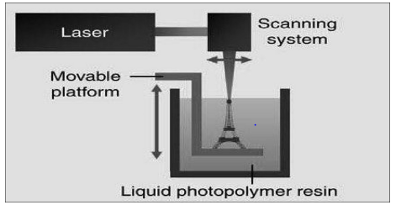 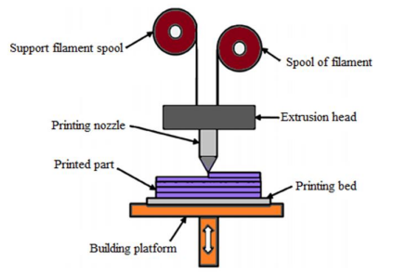

**Fig.3- Stereolithography[2] Fig.4-Fused Decompotion Modeling[5]**

2**.3 Selective Laser Melting**

The powder material used in the printer is melted instead of mixed. The interplay between the powder and the laser beam raises the temperature to a melting point in this process. It thereby impacts the bonding/fusion of the particles and their substrate solid formingThe power of the laser is controlled to bring the targeted powder region to a temperature at which the particle is melted as shown in Fig. 5. Melting may take place individually or with a substratum via the relaxation or partial melting of powder particles. In this way, the melting occurs when the grain viscosity falls with an interfacial connection between the grains without the entire melting of the temperature[4] SLS consists in merging polyamide particles with the use of a high-energy laser beam The process starts with chamber filling with powdered material. Along with the progress of printing the working surface lowers and another layer of powder is added. Sintering of the polyamide powder takes place carefully, layer by layer. The 3D SLS technology does not require any supports to be applied, because models are naturally supported by the excess of powdered material which closely surrounds the printout. The solution enables manufacturing of geometrically complex elements with high dimensional accuracy, compared to other 3D printing methods[6].

**2.4Electronic Beam Melting**

Instead of UV radiation, 3D printers employ electron beams. In the EBM process, the layer-by layer of metal powder that is shaped by a strong electron beam is built up completely dense metal components as shown in Fig. 6. The precise geometry of the 3D CAD model is melted into each layer. Great energy may be employed with great melting capacity and high productivity thanks to the EBM technique. Components are created in vacuum at high tempeatures and are better than cast and equivalent to wrapped material, leading to stress-relieving parts. The electron beam scans thepowder bed for each powder layer to keep the high temperature specific to different alloys. The electron beam then melts the outlines of the component and the bulk[2]

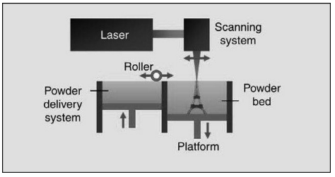 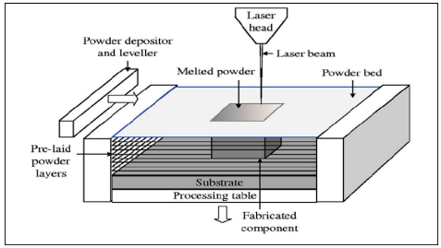

**Fig.5- Selective Laser Melting[2] Fig.6- Electronic Beam Melting[2]**

**2.5 Laminated Object Manufacturing**

The plastic, paper, or metal is then bonded together and then sliced to the required shape with laser. In it, sticky coated layers Laminates of paper, plastic or metal are gradually assembled and sliced into suitable form by laser cutters as shown in Fig. 7. Theprinted objects may be adjusted after the printing process by machining. This method' typical layer resolution is dictated bymaterial feedstock and is typically one-to-a-number of many thick sheets [2]

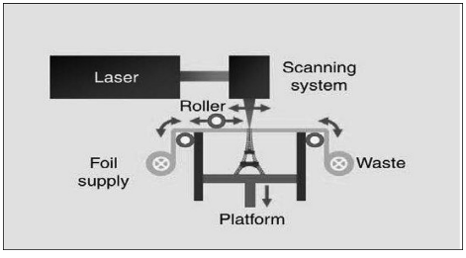

Fig.7- **Laminated Object Manufacturing[2]**

1. Bibliographic survey

**3.1 Classification of 3d printing:**

In the current situation, additive manufacturing is a maturing technology. The stereolithography process, which only employs polymer materials to form a three-dimensional model, is the first generation of additive manufacturing. With advancements in technology and materials, two distinct AM processes are now able to develop a model from varied materials as well as various metals with the same behavior of the finished product (the pieces with all properties necessary). In recent times, the most modern application of the AM technology is the production of human bio components. There are two categories of AM technique based on the material used. AM technology began from stereolithography in early years to the current production of human bio components. AM systems can be grouped in various ways, one of which is by the initial form of its material. The classification is displayed below in[9]

1. Liquid-based processes

a. Stereolithography b. Solid ground curing

2. Solid-based processes

a. Laminated object molding b. Fused deposition mold

3. Powder-based processes

a. Selective laser sintering b. Three-dimensional printer

Additive manufacturing methods started with plastic and paper materials, and when selective laser sintering took place in 1987, laser-based AM became a hit. Then, AM shifted to a metallic product, and the term rapid prototyping tooling (RPT) entered the market. In the tooling industry, patterns, molds, and

cavities are often used. The artisan or sand casting with metal or wood has created permanents and consumable patterns. These Traditional methods were very time-consuming, so the lead time of the product was increased. These designs can be made quickly using RPT technology, and thus, the lead time of the product is reduced. Metal and ceramic tools can be made by various processes such as: Selective laser sintering (SLS). For SLS, a binder was used to fabricate parts, and the laser intensity temperature can be as high as 80–90 percent of the melt temperature of the powder material. After SLS, the selective laser melting (SLM) technique was designed and marketed. Powder materials are completely melted in selective laser melting; thus, a molten pool forms and acquires the needful shape of the parts. To obtain small porosity, SLM melts the whole powder material. The SLM components can be used directly as an end functional component, die, mold, or pattern in their respective fields. Therefore, in general, metallic AM technique has been used in the tooling industries, as well as aerospace and automotive sectors, where complex components that are not possible in traditional method are needed.[6]

**4. Applications of 3d printing:**

3D printing is employed in the production of hearing instruments and some of the automotive components that demand more precision. In the car, the crane buckets. Components of the aviation now consist of 3D printers for a day since they are robust enough and light in weight. Fig. 8 shows detailing of Automobile 3D Printed parts.

The report of the Commission. They are also utilized to make artificial eyes, jaws, faces and ore. 3D printing technology is widely used in AI. They are also employed in the production of 3Dprinter handguns. And a 3D printer is constructed from separate components of a gun. With the use of 3D printers, Nike makes several sports shoes. Fig. 9 shows 3D Printed hand for orthopedic applications [12]. The technology also makes patterns for the downstream metal casting of dental crowns and for manufacturing tools for the formation of plastic to build.[2]

3D printing can be used to create patient-specific implants that nearly replicate the anatomical attributes of the damaged tissues by combining medical images from technologies such as X-ray, CT, MRI, or ultrasonic scanning. Custom implants have already been the subject of many clinical studies.

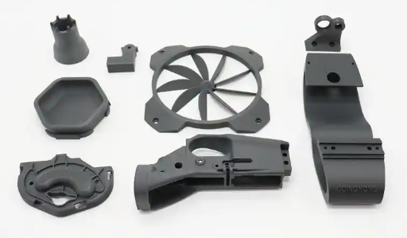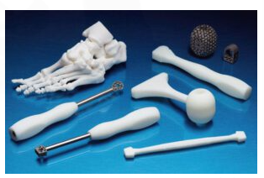

**Fig.8-3D printed automobile components[3] Fig.9-3D printed orthopedic part[8]**

The technology also makes patterns for the downstream metal casting of dental crowns and for manufacturing tools for the formation of plastic to build dental lines in the manufacturing of new items in the medical and tooth sectors. Fig. 10 shows 3D Printed Dental crown for Dental applications.

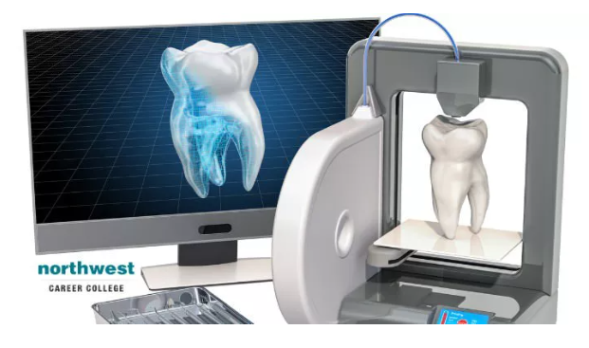

**Fig.10-** **3D printed dental part[8]**

The aerospace industrial sector is one of the origins of AM prototyping technology, but is today employed for manufacturing both end components and replacement components . The rationale for the acceptance of the 3D printing sector is that it is able to support light, rapid manufacturing and reduced supply chain costs in energy saving and fuel saving ideas, etc. 3D printing just builds portion by adding material where it thus generates less waste than the old method by the layer on the layer. Very costly materials such as titanium and other alloys are utilized in the aerospace sector that requires a lot of time and effort to recycle scarp production using traditional processing. AM reduces the rate of scarpness to 10–20% from 80 to 90% , which saves the cost time and effort by using AM as well. Maintenance, repair and rehabilitation MRO is a crucial role in the aircraft industry’s operation. In this circumstance AM is extremely advantageous not only, but the firm of MRO in some situations should also develop the usual tool for any component not accessible for purchases from the OEM. The company does not have to repair any component of the equipment at any time. Fig. 11 shows 3D Printed Aircraft parts.[2]

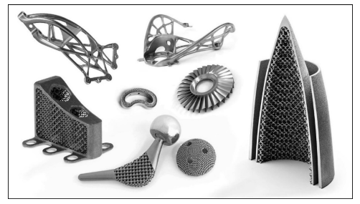

**Fig.11- 3D Printed Aircraft parts[5]**

3D printing electronics offers tremendous possibility for building different feature, look and qualities of practical 3D items. The engineers work on structural, stretchy, conforming, integrable and flexible electronics, since wearable electronics, soft robotics, machinery and human interference are of interest to individuals . Fig. 12 shows 3D Printed flexible electronics parts [7]

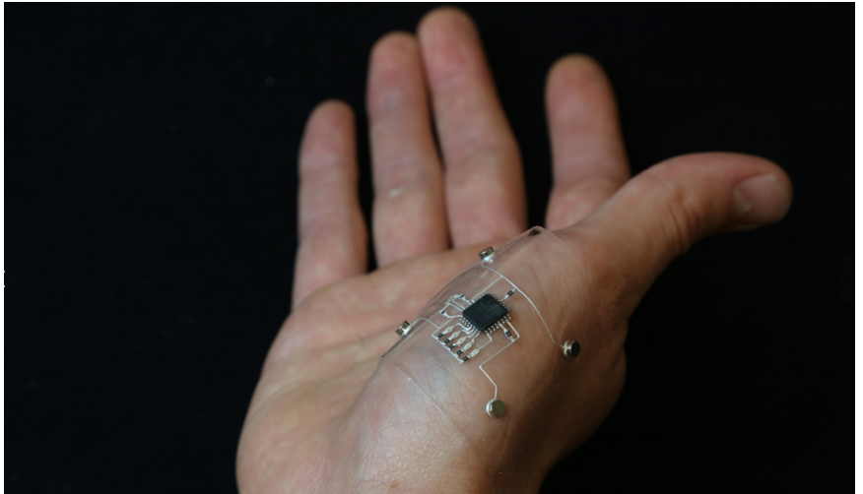

**Fig.12- 3D Printed flexible electronics parts[3]**

**4.CONCLUSION**

The first chapter explains the method of 3D printing through which it has been manufactured. It also helps us get knowledge about the method of rapid prototyping of additives. Then we discuss the various principle methods for 3D printers that include stereo lithography, Fused deposition modelling, selective laser melting and so on. Various applications involve the medical, the automotive and aerospace industries. Then 3D printers analyze the pros and cons. Advances in 3D technology revolutionize the way we generate things and generate things internationally and enhance them greatly. A computer aided design program is used to scan or design an item and slices it into little strata, which may subsequently be printed into a strong 3D product. As we all know, 3D printing works in all stages of human necessity.

**5.REFERENCES**

1. Ntousia, Margarita, and Ioannis Fudos. "3D printing technologies & applications: an overview." Proceedings of the CAD 2020 Conference, Singapore. Vol. 243. 2019.Ganesh Kumar and P.Vasanth Sena, “Novel Artificial Neural Networks and Logistic Approach for Detecting Credit Card Deceit,” International Journal of Computer Science and Network Security, Vol. 15, issue 9, Sep. 2015, pp. 222-234
2. Sun, Jie, et al. "An overview of 3D printing technologies for food fabrication." Food and bioprocess technology 8 (2015): 1605-1615
3. Jadhav, Aniket, and Vijay S. Jadhav. "A review on 3D printing: An additive manufacturing technology." Materials Today: Proceedings 62 (2022): 2094-2099.
4. Srinivasan, D., et al. "3D printing manufacturing techniques, materials, and applications: an overview." Advances in Materials Science and Engineering 2021.1 (2021): 5756563.
5. Gebler, Malte, Anton JM Schoot Uiterkamp, and Cindy Visser. "A global sustainability perspective on 3D printing technologies." Energy policy 74 (2014): 158-167.
6. Pshtiwan Shakor, Jay Sanjayan, Ali Nazari, Shami Nejadi. Modified 3D printed powder to cement-based material and mechanical properties of cement scaffold used in 3D printing, Science Direct.
7. P.F. Jacobs. Stereo Lithography and other RP&M Technologies: From Rapid Prototyping to Rapid Tooling, Society of Manufacturing Engineers (SME), Dearborn, 1996, p. 450.
8. Tamir, Tariku Sinshaw, et al. "3D printing in materials manufacturing industry: A realm of Industry 4.0." Heliyon (2023).
9. Nizam, Maruf, Rajesh Purohit, and Mohammad Taufik. "3D printing in healthcare: a review on drug printing, challenges and future perspectives." Materials Today Communications (2024): 110199.
10. Pathak, Kalyani, et al. "3D printing in biomedicine: Advancing personalized care through additive manufacturing." Exploration of Medicine 4.6 (2023): 1135-1167.
11. Jeong, Min, et al. "Materials and Applications of 3D Printing Technology in Dentistry: An Overview." Dentistry Journal 12.1 (2023): 1.
12. Song, Yongzhi, et al. "An overview of selective laser sintering 3D printing technology for biomedical and sports device applications: Processes, materials, and applications." Optics & Laser Technology 171 (2024): 110459.