**A Critical Evaluation Of Language And Ethnicity**

***Abstract:***

*This research paper investigates how language use associates with ethnic identity, specifically examining vocabulary as a reflection of cultural belonging. Language has traditionally played a crucial role in defining cultural identity, with ethnic backgrounds influencing communication styles within communities. The study acknowledges changes in language use due to globalization and increased integration of individuals from diverse backgrounds.*

*This study focuses on how language and ethnicity shape one's linguistic identity. The paper examines how one's culture, surroundings, and ethnicity influence their vocabulary. Throughout their lives, one learns to speak by observing how others communicate in their surroundings, gradually developing their own linguistic identity. A survey was conducted, and respondents were asked what contributed to shaping their vocabulary and communication skills. When asked, it was noted that ethnic culture and work life had a predominant role in the formation of their vocabulary and communication skills. Belonging to one race for instance made them direct and straight to the point while speaking, while others had no choice but embraced understanding and usage of English or a language of their work. These observations indicated that an individual's vocabulary evolved in response to shifts in environment, culture, and necessities.*

***Keywords: ethnic identity, cultural belonging, globalization, linguistic identity, vocabulary***

**Introduction:**

Language and ethnicity are two essential and intertwined concepts that have long been the focus of research, discussion, and debate. Language and ethnicity have a complicated and diverse interaction that shapes our social identities, cultural practices, and communication styles. In this study, we will critically evaluate the concepts of language and ethnicity in great depth and how it impacts the vocabulary of an individual.

Language is a formed system of communication which includes grammar and lexicon. It is the main way in which a person expresses his or her thoughts. Language is characterized by its cultural and historical differences as well as similarities, since there are great amounts of variation within cultures over time language may also change.

Ethnicity, on the other hand, refers to a person’s cultural background, which includes their heritage, traditions, and customs. It is an important aspect of a person’s identity, and it is often linked to language. Ethnicity is the term used to describe a group of people who share a common identity based on a number of characteristics, such as language, culture, ancestry, religion, history, social treatment, traditions, society, beliefs, and values. Language and ethnicity are often closely linked. A person’s ethnicity can influence the language they speak, and the language they speak can influence their ethnic identity. For example, someone who speaks Spanish may identify as Hispanic, while someone who speaks Mandarin may identify as Chinese.

While existing literature acknowledges the interplay between language and ethnicity, there is limited exploration of the specific ways in which ethnic background shapes vocabulary use. This research seeks to address this gap by investigating how ethnic background influences the vocabulary of individuals, exploring factors such as the use of ethnic-specific lexicon, and the integration of cultural expressions into everyday language.

The Objective of this study is to determine how does ones cultural and ethnic belonging impacts their way of communication and their vocabulary. Conversely this study also discusses how language is unifying force between people with similar ethnic culture.

**AIM**

This study specifically explores the interplay between linguistic belonging and ethnocultural orientation. This research aims to examine the impact of ethnic affiliation on vocabulary, such as particular terms, phrases, or grammatical forms used by certain groups. Therefore, by analysing vocabulary as a marker of ethnic identity, this study aims to uncover how language both reflects and shapes ethnic affiliation and cultural heritage. The findings are intended to provide a deeper understanding of the role of vocabulary in the construction and preservation of ethnic identity within diverse linguistic communities.

**Problem Statement**

The language one employs is not only determined by education level or social class, it is also influenced by one’s ethnic background. In this regard, one’s ethnicity can be a significant factor in one’s vocabulary as it mostly depends on the use of language within a certain ethnic group and its customs, norms, and interactions. Still, despite ample research devoted to the study of the connections between language and culture at large, the patterns of vocabulary influence that arise from ethnicity—such as particular words, expressions, or preferences—have been observed to be less thoroughly studied. This work attempts to fill this void by exploring the ways in which a person’s ethnicity can affect their individual vocabulary, including but not limited to ethnocentric vocabulary usage, and cultural integration in everyday language. The grasp of this aspect can help appreciate why and how ethnic identity is performed through language and their implications on issues including linguistic pluralism and cultural identity.

**Research Gap**

Ethnicity can play a pivotal role in shaping an individual’s lexicon, as language use is often influenced by cultural traditions, values, and social interactions unique to specific ethnic communities. However, while there is significant research on the broader relationship between language and culture, the specific ways in which ethnicity impacts vocabulary such as word choice, expressions, and linguistic preferences remain underexplored. This research seeks to address this gap by investigating how ethnic background influences the vocabulary of individuals, exploring factors such as code-switching, the use of ethnic-specific lexicon, and the integration of cultural expressions into everyday language.

**Literature Review**

While there is extensive research on the wider relationship between language and culture, the specific ways in which ethnicity influences vocabulary remain unexplored. *Joshua A. Fishman* (1999) posits that language is central to the development and preservation of ethnic identity, asserting that linguistic features such as vocabulary choices help individuals connect with their cultural heritage and distinguish themselves from other ethnic groups. Similarly, *Giles and Johnson's* (1987) Ethnolinguistic Identity Theory highlights the use of specific lexical items and expressions as tools for ethnic groups to assert and maintain their identities within larger multicultural societies. linguistic variations are significant in understanding sociolinguistic behaviour, such as code-switching, where individuals alternate between language forms depending on social contexts. Code-switching allows individuals to navigate multiple social identities and demonstrates how ethnic vocabularies can adapt while preserving cultural heritage *(Cambridge University Press)​(*[*English Department*](https://dept.english.wisc.edu/rfyoung/336/ethnicity.pdf)*)*. Analysing vocabulary in this light reveals how ethnicity impacts linguistic expression and how these influences persist despite pressures for linguistic assimilation in broader social contexts. The literature reveals that while language broadly serves as a means of expressing and reinforcing ethnic identity, vocabulary offers a unique lens for examining this relationship. some of the aspects that have been examined include code-switching, lexical borrowing, etc, all of which relate to ethnic-specific vocabulary. Nonetheless, there are some aspects that remain under discussion—for instance how and to what extent ethnicity affects vocabulary use and choice. This study, in turn, will address this research gap by bringing into focus vocabulary as a separate unit of language which is ethnically preserved and expressed across borders.

**Methodology**

A questionnaire was prepared on the topic and a survey was conducted at one of the top universities of India. A hundred students were asked to answer the questionnaire with the answers they most resonate too.

**Result Analysis**

**Vocabulary Variations with Ethnic Interactions**



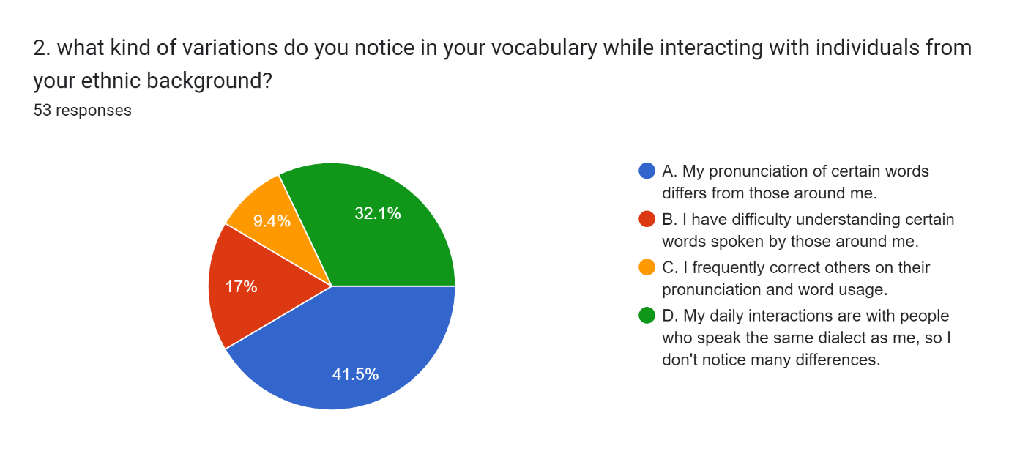



The data suggest that individuals often adjust their pronunciation, vocabulary, and overall communication style when interacting within their ethnic communities a phenomenon that aligns with theories of linguistic accommodation and code-switching. Ethnic group members often consider speaking to each other in terms of the language's ethnic-specific features in conversation, which entails an unconscious or conscious reversion to certain phonological and lexical aspects of the language, which has a particular ethnicity background. It is motivated by the need of being culturally congruent and can serve to strengthen the existing relational forms within the ethnic group.

Conversely, several respondents expressed difficulty in comprehending certain vocabulary during ethnic interactions, which may highlight a gap in heritage language proficiency, especially among second- or third-generation individuals. This finding aligns with research on language attrition, where younger generations may lose fluency or develop only partial proficiency in their ethnic language. The observed lexical gaps and pronunciation variations could be indicative of a broader trend towards "heritage language decay," where language fluency and vocabulary depth in ethnic languages diminish across generations due to limited use and lack of formal instruction.

**Factors Shaping Vocabulary Choices**



Forms response chart. Question title: 3.What factors do you believe might shape your vocabulary choices when communicating with others?
. Number of responses: 53 responses.



The results show that various factors influence vocabulary selection, with ethnic origin and cultural context being the most significant drivers. The influence of ethnic heritage on vocabulary suggests that language serves as a conduit for expressing cultural identity and transmitting cultural values. This describes the Sapir-Whorf hypothesis, which states that language influences how individuals think and experience the world, demonstrating why some vocabulary choices incorporate meaning as part of context rather than usefulness alone.

Furthermore, educational background and personal experiences were frequently mentioned as crucial elements in vocabulary growth, emphasizing the significance of formal education in vocabulary acquisition. Education exposes people to specialized vocabulary and normative language use, which might differ greatly from the vocabulary associated with ethnic languages. The combined influence of cultural context, heritage, and formal education implies that vocabulary is a dynamic, adaptive feature of language that is influenced by both intrinsic ethnic identity and extrinsic social factors.

**Impact of Cultural and Community Activities on Vocabulary Development**



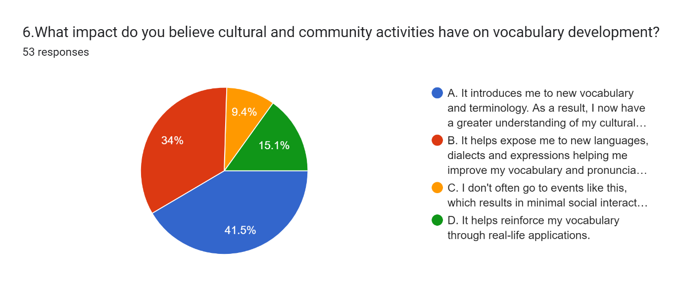



Numerous responses underlined the significance of cultural and community activities in expanding their ethnic vocabulary and reinforcing existing knowledge. Active involvement in certain cultural practices, such as social functions, including festivals and religious activities, or even simple gatherings, creates an environment within which the conventional language is used and passed on. Such practices offer the benefit of assimilating and applying certain expressions that would be peculiar to a culture, which would otherwise be out of reach in other situations, hence preserving that particular aspect of the ethnic dialect that would have been lost if there was no formal teaching of the language.

On the contrary, many respondents who claimed that they do not part take in cultural activities very much, usually reported having a narrow scope of vocabulary – thus stressing the importance of taking an active part in the community for the purposes of language preservation. These results are consistent with sociocultural approaches that highlight the significance of “heritage language enclaves,” in which community spaces are used as unstructured pedagogic settings allowing for vocabulary retention and language pass on to the younger generations.

**Influence Of Ethnicity On Communication Style**



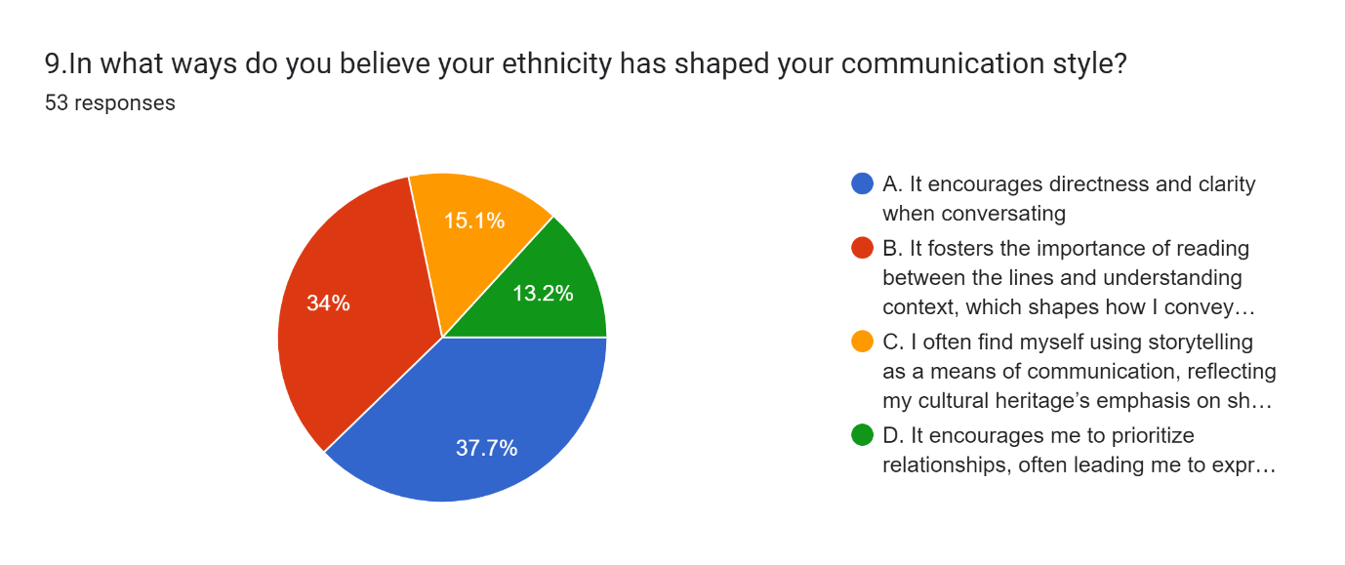



The respondents emphasized that ethnicity has had a paramount bearing on the preferred communication style, with most having encouraged directness and clarity or even storytelling. This has been particularly true for storytelling, which has often been used as a means of communication, as it has fit in with cultures that use stories to express their values, morals, and history. Such a tendency when communicating has hinted towards ethnic background distinctions not only in levels of vocabulary but also in how the speech has been organized and the speech strategies employed.

Storytelling as a communicative practice reflects cultural models of language that emphasize relational and communal aspects of discourse, particularly within ethnic groups where oral tradition plays a prominent role. These findings suggest that vocabulary alone cannot capture the full extent of language's cultural significance, as communication style itself is a culturally embedded phenomenon.



**Ethnicity's Role in Enriching Language and Vocabulary**

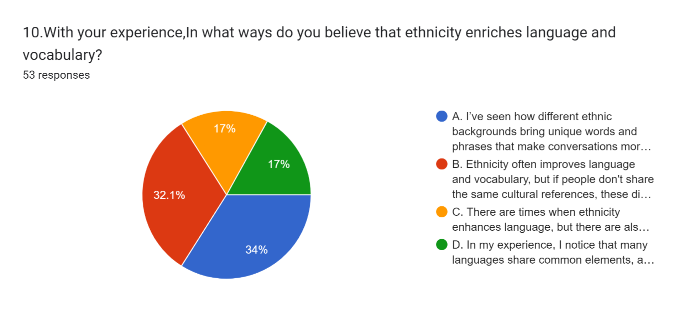



Respondents agreed that their ethnicity ethnic background enriches their vocabulary, since it provides them with culturally specific words and phrases that express their roots. This enrichment includes skills that enable them to portray certain cultures or concepts that may not have English equivalents. Consequently, the everyday use of such words encourages respect for different languages and enhances the sense of belonging to a particular ethnicity in a diverse setting.

The findings underscore the value of ethnic diversity as a linguistic resource that contributes to the richness of a multicultural society. Exposure to diverse ethnic backgrounds expands one’s linguistic repertoire, enhancing cognitive and cultural flexibility. Ethnic language and vocabulary thus play an essential role in the social fabric, promoting inclusivity and encouraging the preservation of cultural heritage.

**Adaptability of Language with Diverse Groups**



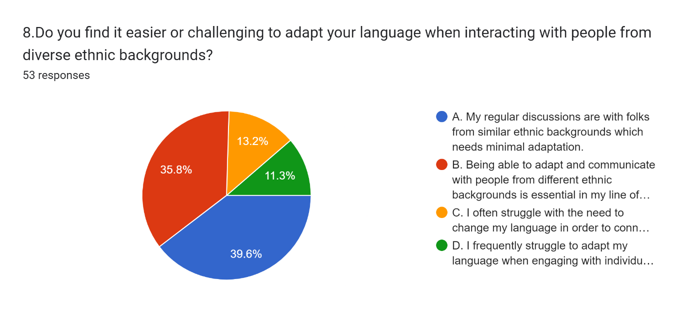



It was observed that many of the respondents were of the opinion that interacting with people with different languages demands flexibility in one’s vocabulary and communication style. This flexibility is a type of language adaptability, where one strives to modify their use of language so as to be understood and to conform to various cultural expectations. This was, however, a challenge to some of the respondents especially in cases where discrepancies in vocabulary led to confusion. Whereas some respondents saw adaptation as a skill that helps to ease communication with people from other cultures with great regard, other respondents viewed it as an innate ability that comes with practice.

These findings support communication accommodation theory, which suggests that individuals modify their speech patterns to align with their interlocutors, thereby creating a sense of solidarity. This adaptability is critical in multicultural societies, where effective communication depends on the ability to navigate diverse linguistic landscapes without compromising one’s ethnic linguistic identity.



**Effect of Native Language on Sense of Belonging**

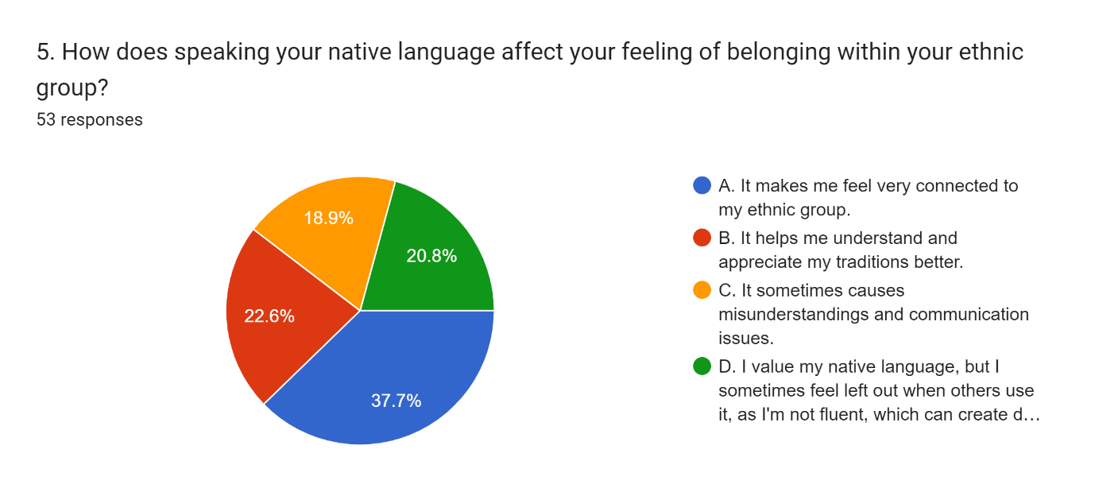



Using one's language was reported to many respondents as a way to boost their sense of connectiveness to the ethnic community, in relation to which many affirmed the aspects of cultural persistence and bonding. With that said, some claimed also that there were challenges and misunderstandings in the communication inside the ethnic group due to the presence of numerous dialects or language skills of different generations within the same ethnic group. This contradiction highlights the complex function of indigenous languages as far as bringing people together into a community is concerned; on one hand, it helps in promoting a certain cultural orientation, on the other, it presents challenges to some people as far as other more mixed communities that continue to change and incorporate new ethnicities. This simultaneous function of the indigenous language points to the fact that on one hand, one uses the language for enhanced feeling of belonging to a community, but some other factors arise due to different languages of some members especially of the younger generation.

**Situational Use of English Vocabulary**

Many respondents reported using English predominantly in educational and professional settings, underscoring its role as the language of academia, commerce, and global communication. English is often a requirement in professional environments, and its use in academic settings reflects institutional preferences and the perceived prestige associated with English in globalized economies. Moreover, many participants indicated that English is their primary language of communication in daily life, a finding which reflects the widespread adoption of English as a second language or even a first language among individuals in multilingual and multicultural settings.

However, a notable number of respondents also reported using English within the home, indicating that English has permeated private, informal spaces traditionally reserved for native languages. This could be contributed by several factors, including intergenerational language shifts, bilingual household dynamics, and the increasing influence of English-language media and digital platforms on younger generations. This shift points to a potential language convergence within families where English may gradually replace or co-exist with ethnic languages, raising questions about the long-term sustainability of ethnic language preservation in immigrant and diasporic communities.

**Unexpected Findings**

One surprising finding from the study was that the respondent's educational background, language of instruction, and languages taught to them in school all play a significant impact in developing their linguistic identity and word choice. They would always speak using language that came readily to them, regardless of ethnicity. Furthermore, there were circumstances where the responder claimed that it was required for them to be multilingual for their job or day-to-day life convenience.

**Scope Of Further Research**

The findings from this study underscore the dynamic relationship between ethnicity and language, particularly in how vocabulary is shaped and adapted through daily interactions. Future research could done upon these insights by examining more closely how everyday conversations, both within and outside one’s ethnic community, influence and develop vocabulary and language choices. Specifically, researchers could explore the role of spontaneous, informal language use in shaping an individuals' active vocabularies, as opposed to vocabulary learned in formal educational or professional settings. Investigating whether different conversational contexts such as family discussions, social gatherings, or digital interactions yield unique vocabulary patterns would provide a deeper understanding of how linguistic repertoires evolve. Furthermore, long-term investigations assessing changes in vocabulary over time may enable to additionally understand how certain linguistic environments experienced on numerous occasions cement or alter a person's language choice. With the increase of multicultural and multilingual contacts in society, it may be also important to study how given vocabularies are cross-culturally exchanged within the population, how, for example, this encourages the use of loanwords, slang terms and words from specific cultures. Such studies would not only increase knowledge of vocabulary learning in societies with several ethnic compositions but they would also add to theoretical perspectives about language and the aspects of identity management.

**Conclusion**

The results provide compelling evidence to support the assertion that ethnic based factors greatly influence ones use of language, range of vocabulary and the way one communicates and this has great relevance in the efforts put in place to safeguard one culture. There is however a great deal of use of English in both social and professional spheres, yet ethnic languages continue to play an important role in the preservation of cultural values and interpersonal connections. Ethnic background enhances the language with unique words, phrases, and ways of communicating that cement the unity of a people and their traditions. There are however challenges posed to the preservation of ethnic languages especially among the youth by the dominance of the English language. These results suggest that in addition to the safeguarding of indigenous minority languages, linguistic diversity in the context of multiculturalism should be encouraged for the development of societies where various identities can exist without conflict.

**Reference**

1. *Fishman, J. A. (1977). Language and Ethnicity in Minority Sociolinguistic Perspective. Multilingual Matters.*
2. *Edwards, J. (2009). Language and Identity: An Introduction. Cambridge University Press.*
3. *Wardhaugh, R., & Fuller, J. M. (2014). An Introduction to Sociolinguistics. Wiley-Blackwell.*
4. *Crystal, D. (2003). The Cambridge Encyclopedia of Language. Cambridge University Press.*
5. *Baker, C., & Jones, S. P. (1998). Encyclopedia of Bilingualism and Bilingual Education. Multilingual Matters.*
6. *Mesthrie, R., Swann, J., Deumert, A., & Leap, W. L. (2009). Introducing Sociolinguistics. Edinburgh University Press.*
7. *Romaine, S. (2000). Language in Society: An Introduction to Sociolinguistics. Oxford University Press.*
8. *Hymes, D. (1974). Foundations in Sociolinguistics: An Ethnographic Approach. University of Pennsylvania Press.*
9. *Trudgill, P. (2000). Sociolinguistics: An Introduction to Language and Society. Penguin Books.*
10. *Giles, H., & Coupland, N. (1991). Language: Contexts and Consequences. Open University Press.*
11. *Labov, W. (2001). Principles of Linguistic Change: Social Factors. Wiley-Blackwell.*
12. *Bucholtz, M., & Hall, K. (2005). "Identity and interaction: A sociocultural linguistic approach." Discourse Studies, 7(4–5), 585–614.*
13. *Giles, H., Taylor, D. M., & Bourhis, R. Y. (1977). "Dimensions of ethnic identity: An example from Northern Ireland." Ethnic and Racial Studies, 1(1), 15–35.*
14. *Edwards, J. (1985). Language, Society, and Identity. Basil Blackwell.*
15. *Lippi-Green, R. (2012). English with an Accent: Language, Ideology and Discrimination in the United States. Routledge.*
16. *Zhang, Q. (2005). "A Chinese yuppie in Beijing: Phonological variation and the construction of a new professional identity." Language in Society, 34(3), 431–466.*
17. *Pavlenko, A., & Blackledge, A. (2004). Negotiation of Identities in Multilingual Contexts. Multilingual Matters.*
18. *Ochs, E. (1993). "Constructing social identity: A language socialization perspective." Research on Language and Social Interaction, 26(3), 287–306.*
19. *Fought, C. (2006). Language and Ethnicity. Cambridge University Press.*
20. *Gumperz, J. J. (1982). Discourse Strategies. Cambridge University Press.*
21. *Nation, I. S. P. (2001). Learning Vocabulary in Another Language. Cambridge University Press.*
22. *Schmitt, N. (2010). Researching Vocabulary: A Vocabulary Research Manual. Palgrave Macmillan.*
23. *Coxhead, A. (2000). "A new academic word list." TESOL Quarterly, 34(2), 213–238.*
24. *Milton, J. (2009). Measuring Second Language Vocabulary Acquisition. Multilingual Matters.*
25. *Gardner, D., & Davies, M. (2007). "Pointing out frequent phrasal verbs: A corpus-based analysis." TESOL Quarterly, 41(2), 339–359.*
26. *Nation, I. S. P., & Waring, R. (1997). "Vocabulary size, text coverage, and word lists." In N. Schmitt & M. McCarthy (Eds.), Vocabulary: Description, Acquisition and Pedagogy (pp. 6–19). Cambridge University Press.*
27. *Webb, S. (2008). "The effects of context on incidental vocabulary learning." Reading in a Foreign Language, 20(2), 232–245.*
28. *Laufer, B. (1998). "The development of passive and active vocabulary in a second language." Applied Linguistics, 19(2), 255–271.*
29. *Henriksen, B. (1999). "Three dimensions of vocabulary development." Studies in Second Language Acquisition, 21(2), 303–317.*
30. *Schmitt, N., & Zimmerman, C. B. (2002). "Derivative word forms: What do learners know?" TESOL Quarterly, 36(2), 145–171.*
31. *Kachru, B. B. (1985). "Standards, codification and sociolinguistic realism: The English language in the Outer Circle." In R. Quirk & H. Widdowson (Eds.), English in the World (pp. 11–30). Cambridge University Press.*
32. *Canagarajah, S. (1999). Resisting Linguistic Imperialism in English Teaching. Oxford University Press.*
33. *Bourdieu, P. (1991). Language and Symbolic Power. Harvard University Press.*
34. *Norton, B. (2000). Identity and Language Learning: Gender, Ethnicity and Educational Change. Longman.*
35. *Kramsch, C. (1998). Language and Culture. Oxford University Press.*
36. *Blommaert, J. (2010). The Sociolinguistics of Globalization. Cambridge University Press.*
37. *Heller, M. (2007). Linguistic Minorities and Modernity: A Sociolinguistic Ethnography (2nd ed.). Continuum.*
38. *Pennycook, A. (1998). English and the Discourses of Colonialism. Routledge.*
39. *Zentella, A. C. (1997). Growing Up Bilingual: Puerto Rican Children in New York. Blackwell.*
40. *Makoni, S., & Pennycook, A. (2007). Disinventing and Reconstituting Languages. Multilingual Matters.*
41. *Wei, L. (2011). The Routledge Applied Linguistics Reader. Routledge.*
42. *Benmamoun, E., Montrul, S., & Polinsky, M. (2013). "Heritage languages and their speakers: Opportunities and challenges for linguistics." Theoretical Linguistics, 39(3–4), 129–181.*
43. *Park, J. S. Y., & Wee, L. (2012). Markets of English: Linguistic Capital and Language Policy in a Globalizing World. Routledge.*
44. *Smith, L. E., & Forman, M. L. (1997). World Englishes 2000. University of Hawaii Press.*
45. *"The Power of Multilingualism in the Workplace." Harvard Business Review,* [*https://hbr.org/*](https://hbr.org/)*.*
46. *"How Ethnicity Shapes Language and Communication." Pew Research Center,* [*https://www.pewresearch.org/*](https://www.pewresearch.org/)*.*
47. *"Language and Identity in a Multilingual World." The British Council,* [*https://www.britishcouncil.org/*](https://www.britishcouncil.org/)*.*
48. *Ethnic and Racial Studies Journal articles on language and ethnicity: https://www.tandfonline.com/toc/rers20/current*
49. *"The Role of Language in Building Ethnic Identity." Language Magazine,* [*https://www.languagemagazine.com/*](https://www.languagemagazine.com/)
50. *Journal of Sociolinguistics articles on language and ethnicity:* [*https://onlinelibrary.wiley.com/journal/14679841*](https://onlinelibrary.wiley.com/journal/14679841)