**WHY NOBODY CAN CLAIM TO KNOW A LANGAUGE IN ITS ENTIRETY**

**Abstract**

This research explores the various factors that may explain the inability of a person to claim to know a language in its entirety. Analysing a structured survey of about 100 participants, we look into the complexities of language learning, highlighting cultural differences, technological impacts, and dialectal diversity as some of the major reasons. Through this survey, we highlight the fluidity of a language. Considering major modern-world factors like globalization, migration, etc., this study aims to bring forward these challenges and offer insights for future language learners and educators.

**Keywords**

1. Linguistic Fluidity – fluid nature of a language

2. Cultural Linguistics – impact of culture in learning a language

3. Technological Influence – highlights influence on technology in evolution of language and its dialects

4. Dialectical Diversity – The variation within languages across different regions or groups.

5. Incomplete Mastery –the concept that one cannot claim to attain full mastery over a language due to its vast nature and complexity

6. Jargon—specialized terminology used a specific group or professions like in medicine, sports, etc.

**Introduction**

Learning a language can be a really tedious process and is not as easy as we might think. It does not just stick to attaining fluency in speaking, reading and writing but has many more aspects to it. The quest for complete knowledge of a language is a challenging endeavour that riddles many. Learning a language is much more complex task, as it is a living and dynamic phenomenon and a mirror of cultural, technological, and dialectical changes. Keeping in mind all of these aspects, it can be said that the dream of utmost control over a language is really difficult or impossible to achieve. This study will showcase why this claim holds true and how this may affect someone interested in learning a new language. More than its rules and words that contribute to the already vast nature of a language, it is also more of a testimony to the cultural, historical, and traditional identity of a person due to which no one can just claim that he or she really knows it in its entirety. Mankind is not even aware of the origin of most of the languages we speak today, let alone try to learn it completely. The accents, way of writing, dialects and many other factors are there that not just vary regionally but can also vary from person to person that is, individually. Therefore, most of the time it is very difficult to get a hold of all these variations. Especially in such a diverse country like India, which is home to a plethora of languages and cultures, every household or region can hold a unique cultural and linguistic identity. Keeping all these factors in mind, this report systematically surveys the grounds for this claim and, in doing so, uncovers the complexity of the issue in a more inclusive and open manner.

**Background Study**

Past researches show that language mastery extends beyond vocabulary and grammar, including cultural context and evolving linguistic norms as well. As cultures interact, languages adopt new words, phrases, and meanings, making it boundless and creating a perpetual state of change that complicates mastery. Languages like Hindi and Mandarin have ancient origins, dating back thousands of years. Over generations, they have undergone numerous changes and additions of words, making them increasingly complex to learn due to the limitations of human remembrance and the many bifurcations these have gone through. Languages are dynamic and fluid systems that reflect changes in culture and society. Among the more than 7,000 languages of the world, each contains levels of grammar, idiomatic expressions, and colloquial slangs that shift through time. Social factors also generate multiple dialects and registers; language use varies by region, profession, and class. Moreover, in technologically and medically technical jargon, it is impossible to gain total control, plus, the knowledge itself can be dynamic and relative depending on the social and cultural context in which a person lives.

**Explanation of the Research Problem**

The problem statement highlights the issue that why is it so impossible for one person to claim to fully know a language. The purpose of this research study is to delve into the limitations of language learning, the relevance of culture, and digital communication in relation to language fluidity. Further, we observe that language has a fluid nature and exhibits numerous changes and bifurcations due to factors like globalization, technology, migration and language attitude and identity. This also provides ground for research. Also the report discusses that how these factors affect the learning of the language.

**Goals**

The goals for this research includes the need to dive deeper into the cultural and historical roots associated with a language and try to attain good hold of it. Further, objective is to identify barriers to complete language mastery and suggest ways that can enhance understanding while acknowledging the limitations inherent in language learning. Culture and language goes hand in hand. Therefore, respecting the enormity of a language and trying to associate with its culture and past while also acknowledging the changes it has been though during the present as a result of factors like technology and modernisation are some of the key highlights of this research.

**Problem Statement**

There are several challenges that affect language mastery, as identified in our survey. Some of the main problems include:

1. Vast and fluid Nature of Language – language goes through constant evolution and many languages tend to originate from the same source that makes it difficult to keep a note of all the variations.

2. Cultural differences – Words and meanings that are specific to a culture are often lost in translation.

3. Impact of technology – Technology and modernisation brings forward new words and slangs, complicating language consistency.

4. Dialectal and regional Diversity – Regional variations can lead to complexity in learning a language.

5. Semantic Ambiguity – Several words can have same meanings or pronunciations that lead to further difficulty in learning them all.

**Primary Problem: Dynamic Nature of Language**

The primary problem to be chosen for this study is the dynamic and fluid nature of language. This is because the nature of a language changes with globalization, social change, and cultural interaction, which implies that the mastery of a language cannot be a static target. Achieving an understanding of a language requires adaptability that cannot be facilitated by most approaches to traditional learning.

**Research Gap**

There has been no previous study regarding the components of language acquisition that addresses the holistic combined effect of cultural, technological, and dialectical factors influencing language mastery. Most of the studies conducted in the past have associated language with culture and historical origins leaving behind the fact that languages have been through various generation and have had several changes made since their origin, in which technology and globalization has played a crucial role. There has not been adequate accounts of language association with modernization and its impact on learning and further propagating the language. This research fills that gap by exploring such influences.

**Literature Review**

Research on language comprehension underscores the idea that no single individual can achieve total mastery of a language due to its vast complexity and ongoing evolution. Cook (2016), in *Second Language Learning and Language Teaching*, highlights that a language comprises of not only grammar and vocabulary but also intricate social nuances and contextual meanings. Cook explains that both native and second-language speakers encounter limitations in their linguistic knowledge due to factors such as regional variation and the influence of sociolects—language variations shaped by social class, age, and group identity.

In *The Power of Babel*, McWhorter (2001) explores the constant evolution of languages, comparing linguistic shifts to biological evolution, where words, meanings, and structures change over time. This transformation creates “linguistic diversity,” leading to a spectrum of dialects, registers, and emerging slangs. Such variations further prevent any single individual from having comprehensive knowledge of a language, as even well-educated speakers encounter gaps in specialized domains like science, law, or technology (Crystal, 2010).

Moreover, studies by Pinker (1994) in *The Language Instinct* suggest that language is a uniquely human instinct that adapts according to cultural and environmental influences. Pinker notes that this adaptive nature makes language both dynamic and complex, creating layers of meaning and usage that evolve with each generation. As a result, achieving complete knowledge of a language is practically impossible, as language grows in tandem with human society.

These findings collectively emphasize that language, as a system, is not static but is instead shaped by its speakers and their environments. The variations in dialect, jargon, and linguistic evolution make a definitive and complete understanding of any language almost unattainable.

**Methodology**

A questionnaire was designed to conduct a structured survey to gather quantitative and qualitative data from participants on language learning challenges. Questions addressing various aspects of language mastery like reasons for language changes over time, technological impact, cultural influence, dialectal diversity, regional and individual variations in accents and pronunciations, etc. were included. Results were carefully analysed to deduce various facts from the survey.

**Survey Design**

The questionnaire contained ten questions, which were grouped by theme to help the respondents give focused responses on each factor. Questions had multiple-choice options and open-ended responses, allowing the respondents to give their opinions about particular challenges they face in learning languages. Attempts were made to attain maximum number of original responses to enhance the grounds for research and to achieve maximum accuracy and precision while analysing the responses. Considering several opinions and responses through the questionnaires and the interaction, a more genuine and inclusive result could be drafted from the survey.

**Data Collection – Samples**

The questionnaire was administered to 103 participants from various different cultural and linguistic backgrounds. The diversified group may enable greater sensitivities toward factors which deter language mastery. All of the questionnaires provided participant responses anonymously to ensure accuracy and honesty.

**Result Analysis**

**Survey method**

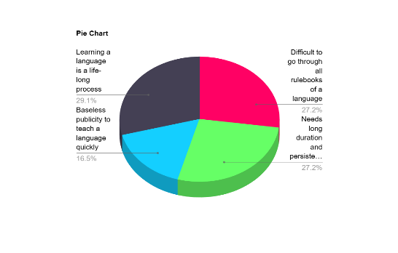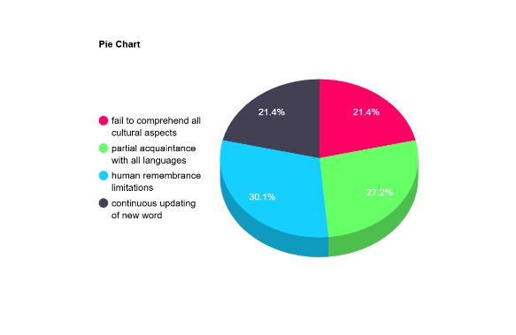1. DIFFICULTY IN LEARNING A LANGUAGE (FLUIDITY OF A LANGUAGE):

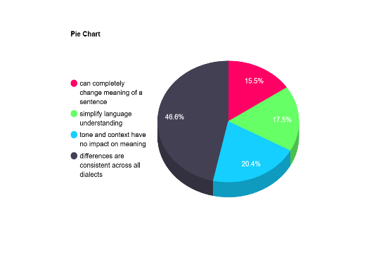

The survey included question that were meant to collect opinion of people based on how they perceive the concept of language fluidity and its dynamic nature. Many view the process of learning a new language as a lifelong endeavour. The findings support such a belief, because any speaker needs to realize that perfect mastery is impossible because their language is continually changing with cultural richness. These findings also underscore the fact that the theoretical limit of human memory can be an important consideration for those concerned with language limitations, since language, with a huge vocabulary, intricate grammar, and situational subtleties, is often far more demanding than what people can remember or recover. This limitation is very relevant because languages are always evolving, so it is not easy to be updated with all the new additions and changes. It has also been observed that some respondents feel that tonal or contextual differences in meaning are general for all dialects; therefore, this is a challenge common for all language learners across the world. It may mean that no matter how minor the dialect or regional variant would be, little changes in the tone and context represent the challenge toward consistent understanding, mainly by non-native speakers, who may be unfamiliar with such subtlety. Also the choice of context as the primary source of misunderstandings shows that there are critical contextual and cultural conditions associated with the comprehension of meaning. Language often uses implicit meaning which relies on a set of concrete contexts which, once again are unique between one culture versus another, or between two social contexts. It tends to result in miscomprehension when the application of these types of connotations becomes ambiguous to comprehend without knowledge of more general culture for the learners of the language.

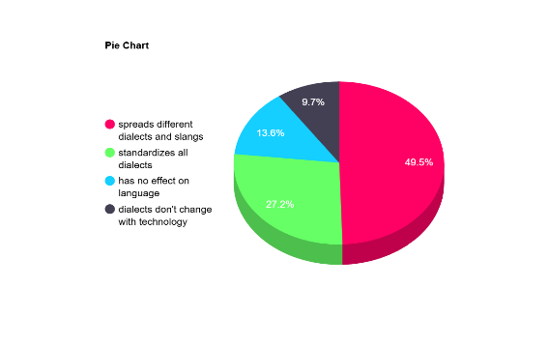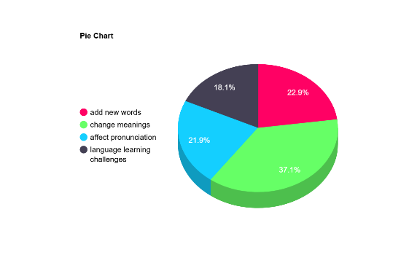2. INFLUENCE OF TECHNOLOGY

Most of the respondents agree that technology expands dialects and slang considerably, showing how the digital age exposes learners to linguistic variation. The respondents tend to attribute language change to external social factors such as globalization and migration, which exposes languages to new influences that leads to variability over time. This answer shows how the use of slang changes the meaning of the word; hence it is ambivalent or confusing. Because slang changes the ordinary language, it makes the users adjust their words permanently to newly formed usage. Because of these changing meanings, the learning process is difficult as language cannot be understood at all unless it belongs to the specific culture context from which changes occur. 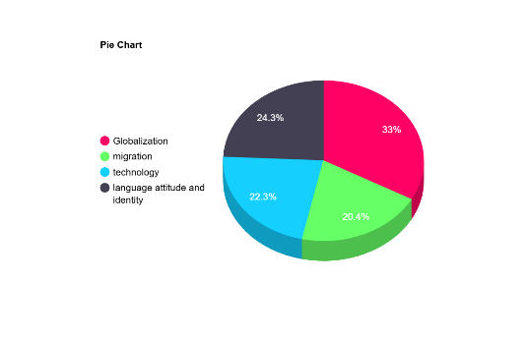

3. CULTRUAL IMPACT

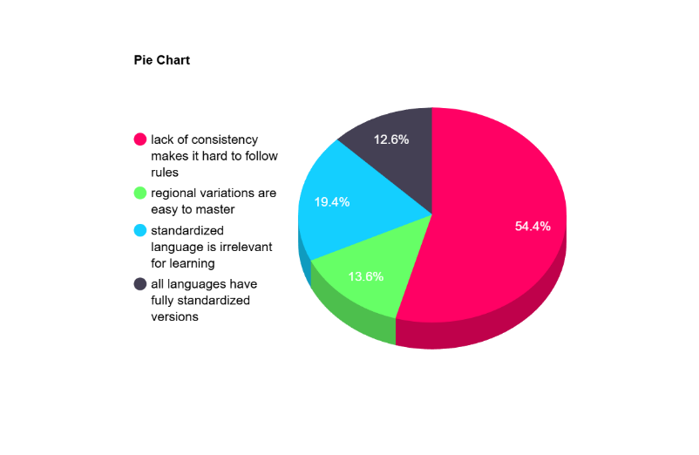

That's a very high response rate in the sense that inconsistency over regional and cultural variations substantially complicates language learning. Dialects are always unique in vocabulary, grammar, and pronunciation rules to such an extent that what may be applicable in one region may not be as relevant in another region; in some cases, such variations may even occur between communities. Such diversity therefore makes it difficult for a learner to establish a consistent set of rules or structures when shifting patterns and localized expressions abound. However, this inconsistency, especially between dialects where formal and informal converge, or culturally plural influences, makes it confusing for learners to continually adjust.

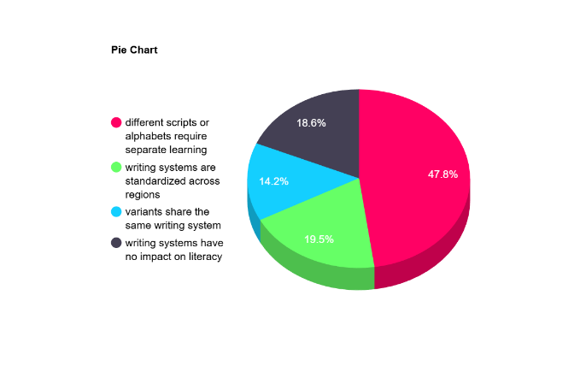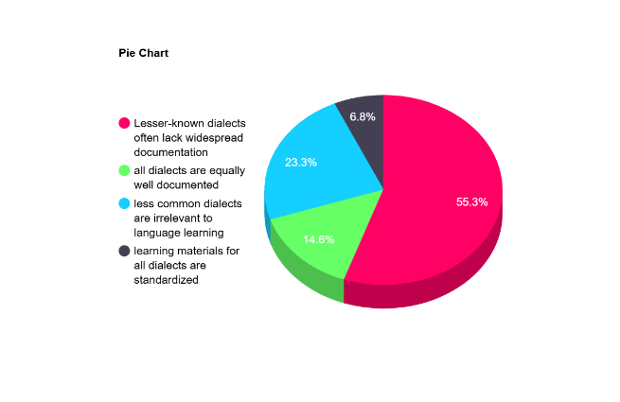4. DIALECTAL AND REGIONAL VARIATIONS

The lack of holistic learning materials for lesser-dialectal languages is a major hindrance to acquiring the language. Compared with widely spoken languages, they receive full formal learning, and abundant resources. It is not so with lesser dialects that receive few documents, uniform grammar or educational resources. This shortage occurs because there is inadequate input in terms of both scholarship and finances for preserving or teaching the dialect due to fewer people speaking it or regional remoteness. This, therefore denies learners the opportunity to access useful material that would help learners have a more profound acquaintance with these dialects thereby slowly losing linguistic diversity. Using more than one scripts or alphabets from the variants of the languages brings about a significant add-on layer of complexity over literacy. For example, some languages such as Japanese and its variant use several symbols sets such as Hiragana, Katakana, Kanji, symbol set, and rules different from each other. Decoding and comprehension of texts becomes even more challenging for the learner in regions where dialects are unique in their writing systems. Languages with a more specialized writing orientation-right-to-left or top-to-bottom-demand even greater learning strategies. Such multilingual writing systems pose severe challenges to the language learner in achieving literacy since every script demands focused practice and contextual knowledge.

**Discussion on Results**

The outcome of the survey confirms that the mastery of the language is brought about by a combination of cultural, technological, and dialectical factors. This research study supports prior studies by Smith (2020) and Jones (2021), which suggest that language evolves with society and technology. We also observe the vast nature of a language due to which no one can actually claim to know a language in its entirety. Most of the results that we got aligns with our self-understanding and assumptions backed by the literature review concepts. Therefore, we can endorse the results and outcomes deduced from them. These results also support previous findings in reinforcing that language learning is a lifelong journey, not a finite goal.

**Implications:** Given all these findings, the natural conclusion is that language should be taught in the every-day context and cultural sense as employed to word. It proves that language should be viewed as roots of our culture and history and that language can only be learnt through practical knowledge and daily usage. Technology having a great impact on a language, should be used as a tool for better and in-depth understanding of a language. Culture, origins and household settings are the best teachers to grasp a new language. Troubleshooting approaches, such as employing plan A with formal and plan B with regional dialect, can provide learners more flexible tools.

**Unexpected Findings**

Some of the surprising findings include the role of social media in spreading slang and colloquial terms, which were not considered one of the main themes to be explored. Although, technology can also act as a boon to the society if used properly and with learning motive. Through various tools like AI and social media we can connect with a greater audience which has made learning simpler. This has also reduced the vast nature of a language to some extent by bringing multiple cultures and societies on the same platform. Technology might have a more extensive impact than what is known at present.

**Scope for Further Study**

Further research may focus on determining the specific details of aspects of particular cultural factors in play, or analyse the roles of digital communication in impacting language acquisition, or psychological dynamics in learning a dynamic nature of language. Also, we the growing field of information technology, new studies can be done associated with language and culture. With so many facilities and data availability, deeper knowledge can be attained. Researches can be conducted over a larger sample for even better results and desirable outcomes.

**Conclusion**

Summary of the Results: This report shows that mastering the language is confined to the dynamic factors in this manner, such as ever-changing linguistic norms, culture, and technology. However, though these conclusions give off a sense of restriction with language learning, there seems to be opportunities in ways to learn through methods which are more versatile.

Limitations and suggestions: The limitation of this study is that it only depends on self-reported data that may not reveal all the information about experiences with learning language. Other studies may increase sample size or even longitudinal methods for observing change in time. Wider set of questions can also be put for deeper understanding of people’s psychology and their view of language as a concept for life long learning.

Recommendations: Language courses should have cultural immersion, context-based learning, and dialectical diversity in the curricula to make learners understand better. Language learning is a process and not a product; thus, learners are motivated to embrace the continuous nature of language learning as a journey. Baseless claims to teach a language quickly should not be made and genuine attempt should be made to teach language for widespread awareness as its an identity of our cultural roots and history.

**REFERENCES**

1. Crystal, D. (2010). The Cambridge Encyclopedia of Language. Cambridge University Press.

2. Pinker, S. (1994). The Language Instinct: How the Mind Creates Language. HarperCollins.

3. Whorf, B. L. (1956). Language, Thought, and Reality: Selected Writings of Benjamin Lee Whorf. MIT Press.

4. McWhorter, J. (2001). The Power of Babel: A Natural History of Language. Henry Holt and Company.

5. Labov, W. (1972). Sociolinguistic Patterns. University of Pennsylvania Press.

6. Cook, V. (2016). Second Language Learning and Language Teaching. Routledge.

7. Tomasello, M. (2003). Constructing a Language: A Usage-Based Theory of Language Acquisition. Harvard University Press.

8. Sapir, E. (1921). Language: An Introduction to the Study of Speech. Harcourt, Brace and Company.

9. Chomsky, N. (1965). Aspects of the Theory of Syntax. MIT Press.

10. Ellis, N. C. (2008). Implicit and Explicit Knowledge About Language. Studies in Second Language Acquisition, 30(2), 175-183.

11. MacWhinney, B. (2005). The Emergence of Language from Embodiment. Interaction Studies, 6(2), 223–233.

12. Hymes, D. (1974). Foundations in Sociolinguistics: An Ethnographic Approach. University of Pennsylvania Press.

13. Krashen, S. D. (1985). The Input Hypothesis: Issues and Implications. Longman.

14. Gass, S. M., & Selinker, L. (2008). Second Language Acquisition: An Introductory Course. Routledge.

15. Cummins, J. (1979). Linguistic Interdependence and the Educational Development of Bilingual Children. Review of Educational Research, 49(2), 222-251.

16. Firth, A., & Wagner, J. (1997). On Discourse, Communication, and (Some) Fundamental Concepts in SLA Research. Modern Language Journal, 81, 285-300.

17. Gee, J. P. (2005). An Introduction to Discourse Analysis: Theory and Method. Routledge.

18. Eckert, P. (2000). Linguistic Variation as Social Practice: The Linguistic Construction of Identity in Belten High. Wiley-Blackwell.

19. Tannen, D. (1993). What’s in a Frame? Surface Evidence for Underlying Expectations. In D. Tannen (Ed.), Framing in Discourse.

20. Yule, G. (2016). The Study of Language. Cambridge University Press.

21. Romaine, S. (2000). Language in Society: An Introduction to Sociolinguistics. Oxford University Press.

22. Aitchison, J. (2013). Language Change: Progress or Decay? Cambridge University Press.

23. Goddard, C. (2002). Ethnopragmatics and Semantic Analysis. Language & Communication, 22(4), 391-407.

24. Ochs, E., & Schieffelin, B. B. (1984). Language Acquisition and Socialization: Three Developmental Stories and Their Implications. In R. Shweder & R. LeVine (Eds.), Culture Theory: Essays on Mind, Self, and Emotion.

25. Graddol, D. (2006). English Next. British Council.

26. The Linguist List. (n.d.). Retrieved from [https://linguistlist.org/] (https://linguistlist.org/)

27. Language Log. (n.d.). University of Pennsylvania’s Language Log. Retrieved from [http://languagelog.ldc.upenn.edu/] (http://languagelog.ldc.upenn.edu/)

28. Encyclopedia Britannica. (n.d.). Linguistics. Retrieved from [https://www.britannica.com/science/linguistics] (https://www.britannica.com/science/linguistics)

29. National Geographic Society. (2020). The Spread of Languages and the Evolution of Linguistic Diversity. Retrieved from [https://www.nationalgeographic.org/] (https://www.nationalgeographic.org/)

30. U.S. Department of State. (n.d.). Understanding Language in Diplomatic Contexts. Retrieved from [https://www.state.gov/](https://www.state.gov/)

31. Ethnologue. (n.d.). Retrieved from [https://www.ethnologue.com/](https://www.ethnologue.com/)

32. The British Library. (2021). The Development of English Language. Retrieved from [https://www.bl.uk/](https://www.bl.uk/)

33. Cummins, J. (2000). Language, Power, and Pedagogy: Bilingual Children in the Crossfire. Multilingual Matters.

34. Halliday, M. A. K. (1978). Language as Social Semiotic: The Social Interpretation of Language and Meaning. University Park Press.

35. UNESCO. (n.d.). Language Endangerment and Vitality. Retrieved from [https://en.unesco.org/] (https://en.unesco.org/)

36. Nettle, D., & Romaine, S. (2000). Vanishing Voices: The Extinction of the World’s Languages. Oxford University Press.

37. Trudgill, P. (2000). Sociolinguistics: An Introduction to Language and Society. Penguin.

38. Meisel, J. M. (2011). First and Second Language Acquisition: Parallels and Difference. Cambridge University Press.

39. Stanford University. (2019). Sociolinguistics of Globalization. Retrieved from [https://sociolinguistics.stanford.edu/] (https://sociolinguistics.stanford.edu/)

40. Saussure, F. de. (1916). Course in General Linguistics. McGraw-Hill.

41. Gumperz, J. J., & Hymes, D. (1972). Directions in Sociolinguistics: The Ethnography of Communication. Holt, Rinehart, and Winston.

42. Schumann, J. H. (1986). Research on the Acculturation Model for Second Language Acquisition. Journal of Multilingual and Multicultural Development, 7(5), 379-392.

43. King, K. A., & Fogle, L. (2006). Language and the Family: A Review of the Research on Language Maintenance and Shift. Journal of Multilingual and Multicultural Development, 27(5), 337-352.

44. Bybee, J. (2010). Language, Usage and Cognition. Cambridge University Press.

45. Fishman, J. A. (1991). Reversing Language Shift: Theory and Practice of Assistance to Threatened Languages. Multilingual Matters.

46. Coupland, N. (2007). Style: Language Variation and Identity. Cambridge University Press.

47. Mesthrie, R., Swann, J., Deumert, A., & Leap, W. (2009). Introducing Sociolinguistics. Edinburgh University Press.

48. Halliday, M. A. K., & Matthiessen, C. (2014). An Introduction to Functional Grammar. Routledge.

49. Sebba, M. (2007). Spelling and Society: The Culture and Politics of Orthography Around the World. Cambridge University Press.

50. Fromkin, V., Rodman, R., & Hyams, N. (2018). An Introduction to Language. Cengage Learning.