**NEPHROBLASTOMA ON HORSESHOE KIDNEY: A case report and review of the literature.**

**S.ABDOU, M.TAOUCHIKHT, H.FARES, K.NOUNI, A.LACHGAR, H.ELKACEMI, T.KEBDANI, K.HASSOUNI.**

**RADIOTHERAPY DEPARTMENT.**

**NATIONAL ONCOLOGY INSTITUTE RABAT.**

**Résumé :**

Le rein en fer à cheval est une pathologie malformative de l’appareil urinaire dont le diagnostic est parfois difficile.

L'incidence de certains types de cancer semble majorée par cette anomalie (néphroblastome et carcinome).

L’objectif principal de ce travail est de rapporter l’expérience du service de radiothérapie de l’institut national d’oncologie INO dans la prise en charge d’un cas de néphroblastome sur rein en fer à cheval à travers une observation avec revue de littérature.

**Abstract:**

The horseshoe kidney is a malformative pathology of the urinary tract that can be difficult to diagnose.

The incidence of certain types of cancer seems to be increased by this anomaly (nephroblastoma and carcinoma).

The main objective of this work is to report the experience of the radiotherapy department of the INO National Institute of Oncology in the management of a case of nephroblastoma in a horseshoe kidney, through an observation and review of the literature.

 **Introduction :**

Horseshoe kidney is an asymptomatic malformation of the upper urinary tract, resulting from the fusion of the two kidneys, usually at the lower pole.

The discovery of a tumoral process on a horseshoe kidney (RFC) provides an opportunity to take stock of both the particularities of this association and the diagnostic and therapeutic difficulties.

**Observation :**

Three-year-old child with no particular history of disease, diagnosed 03 months ago with progressive abdominal enlargement and incoercible vomiting.

Radiological work-up included abdominal ultrasound showing a renal tumor, CT scan showed a right renal mass on horseshoe-shaped kidneys.

The patient underwent preoperative chemotherapy with 04 courses of Actinomycin VCR followed by partial right and left nephrectomy.

Histology was in favor of a regressive type of nephroblastoma on horse kidney, intermediate risk, necrotic remodeling estimated at 72%, absence of anaplasia or nephrogenic remnants, infiltrated peri-renal fat with tumoral excision limits, hilar lymph node 1N+/5N.

The omentum was infiltrated by the tumor, a tumor classified as SIOP 2016 stage III.

The child then underwent external radiotherapy to the abdomen in total, with a total dose of 10Gy /1.5Gy/fr in 10 fractions. Progress was marked by good digestive tolerance and good local and regional control.

**Discussion:**

**1-Horseshoe kidney:**

Horseshoe kidney is the most common form of fusion anomaly (1/400 to 1/1,000).

The incidence of CFN is estimated at 0.25% of the general population [1], with a male predominance

Renal fusion involves the lower poles in 96% of cases.

Often due to fusion of metanephrogenic elements during differentiation and ascent.

Ascension begins in the 8-9 mm embryo, and allows the kidneys to move from their sacral position to the cranial region.

During this ascent, fusion, usually of the lower poles, occurs early, limiting the usual rotation of the kidneys [2],

The horseshoe-shaped kidney is associated with several morphological anomalies:

• Dilation of the pyelocalic cavities is often moderate, with no functional repercussions. However, it may be part of a true stenosis of the pyeloureteral junction.

• Vesico-ureteral reflux in a quarter of cases, responsible for pyloric enlargement,

• Lithiasis complications (20%).

• Extrarenal malformations: neurological, chromosomal (trisomy 18, Turner syndrome), bone, cardiovascular.

• Tumor pathologies (30%), notably nephroblastoma, but also adenocarcinoma or carcinoid tumors of the kidney [3].

**2- Horseshoe kidney cancer:**

The first observation of cancer in a horseshoe kidney was described by Hildebrand in 1895 [4], and since then, reported cases have been relatively rare.

All histological types have been described, but with varying incidences:

• Carcinomas are the most common [5]. While they account for 90% of all kidney cancers (normal kidney), their percentage in cancers on RFC is lower, estimated at 54.3% by Hayashi [6]. It would appear that this anatomical malformation does not increase the incidence [6].

• Urothelial tumors account for 17.1% of horseshoe kidney cancers [6].

• Nephroblastomas (Wilms' tumors) account for 14.3% [6, 7]. The incidence of Wilms' tumors developed on RFCs, on the other hand, appears to be higher than average [8 - 9].

As a result, the discovery of a horseshoe-shaped kidney in a child would seem to call for special surveillance in view of this risk factor [8].

• Carcinoids are exceptional tumors of the kidney [10]. On the other hand, they appear to be much more frequent on RFCs [10, 11], the risk of occurrence being multiplied by 62 for Krishnan [12] and by 82 for Begin [13]. A carcinoid tumour on a RFC is most often multifocal and seems to have a better prognosis than on a normal kidney [12].

• A few cases of oncocytoma have been reported [14, 15].

**Circumstances of discovery:**

The diagnosis of a horseshoe-shaped kidney tumor is often fortuitous.

In our patient, the malformative anomaly was discovered incidentally by imaging.

In some cases, a tumor syndrome can be a warning sign [15], and in other cases, it is the occurrence of a complication which, during the exploratory workup, reveals a suspicious tumor process [6, 16].

**Paraclinical:**

In fact, it is the radiological data that enable us to explore the lesions and make a precise preoperative assessment.

Ultrasound is most often used to visualize an anomaly in the position of the kidney, and to highlight any parenchymal localization.

It does not always allow analysis of the isthmic portion. In fact, this is only possible 27 times out of 34 for Strauss, l a non-definition of the lower pole of the kidney leading to suspicion of RFC [17].

CT scans clarify the location of the kidneys, the structure of the isthmus and the dimensions of the tumor process.

Intravenous urography is often difficult to interpret because of the superimposition of excretory cavities due to non-rotation of the kidneys [18].

On the other hand, the frequent presence of hydronephrotic dilatation of the cavities, as was the case in our patient, makes interpretation tricky.

In fact, arteriography is a key examination, both in terms of diagnosis and visualization of vascular pedicles, which can be highly variable and knowledge of which is essential in determining an operative strategy [1, 3 - 5, 18].

Vascular opacification confirms any hypervascularization of the tumoral zone, and above all locates arterial pedicles and their distribution in the parenchyma.

**Therapeutically:**

Nephroblastoma is a chemosensitive tumor, and the aim of induction chemotherapy according to the European school is to reduce tumor volume, thus facilitating total excision and reducing the risk of tumor rupture intraoperatively, to avoid dissemination of cancer cells [19].

More recently, SIOP has proposed a new protocol for the diagnosis and treatment of renal tumors in children, called UMBRELLA SIOP-RTSG 2016, which succeeds that of 2001.

The molecules used are: actinomycin D, vincristine, doxorubicin, cyclophosphamide, carboplatin, ifosfamide, etoposide.

Like the 2001 SIOP protocol, the UMBRELLA-SIOP-2016 protocol continues to recommend the preoperative use of actinomycin, vincristine and doxorubicin for children over 6 months of age, depending on the stage of the disease :

• Four weeks' preoperative chemotherapy with Actinomycin and Vincristine for localized tumors.

• Six weeks' chemotherapy with Actinomycin, Vincristine and doxorubicin in metastatic tumors.

Postoperative chemotherapy is designed to reduce the incidence of metastases and locoregional recurrence. It is administered according to the anatomopathological stage and histological type of the tumor, and is brief for stage I and long for stages II, III and IV.

Our patient underwent preoperative chemotherapy with 04 courses of Actinomycin VCR, in accordance with the GFA- -Néphro-2005 protocol derived from the SIOP 9 protocol (2001).

Surgery remains a major step in the treatment of nephroblastoma, but in the case of a horseshoe-shaped kidney, the surgical procedure is often difficult due to the non-systematization of this vascularization, which varies in number and origin, as well as to the relationships of the isthmus, which can, in some cases, pass behind the great vessels or sometimes between the inferior vena cava and the aorta [20].

When the tumor is lateralized, the surgical procedure consists of heminephrectomy of the portion of the kidney bearing the tumor.

In the case of isthmus tumors, the majority of authors perform an isthmectomy with a margin of healthy parenchyma greater than 1 cm in the two remaining hemi-reins [20].

Our patient underwent partial right then left nephrectomy.

Nephroblastoma is a highly radiosensitive tumor that can be cured with relatively low doses. The main aim of radiotherapy is to achieve local and distant control of the disease, and reduce the risk of relapse by improving recurrence-free survival and overall survival.

Indicated in front of the following criteria:

• Tumor rupture, lymph node involvement, unfavorable histology, notably intermediate risk stage III (lymph node involvement, residual disease after surgery, tumor rupture) or high histological risk: stage II and III, or in the presence of positive margins (tumor margins), residual tumor, or metastatic disease.

Radiotherapy has evolved considerably in recent years, thanks to the advent of new techniques such as arc therapy, which have enabled better definition of target volumes and better protection of organs at risk [21].

Anatomical data are acquired using the dosimetric scanner, then target volumes are delineated on the basis of tumor extension. However, the conventional irradiation fields are identical in the various NWTS, SIOP and COG protocols (Figure 1, Figure 2):

• Locoregional irradiation encompassing the tumor bed.

• Abdominal irradiation including all peritoneal surfaces.

• Lung irradiation, which must cover the entire lung.

• Hepatic irradiation should be limited to unresectableresidual masses after chemotherapy or with post-surgical tumor residue

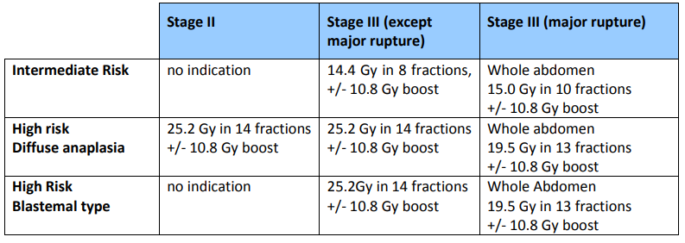

**Figure 1: Summary of abdominal radiotherapy recommendations according to the 2016 UMBRELLA protocol [21].**

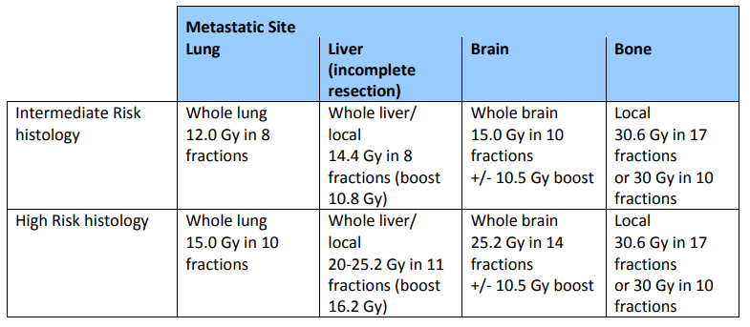

**Figure 2: Summary of radiotherapy recommendations for metastatic sites according to the 2016 UMBRELLA protocol [21].**

The total dose depends on tumor location, stage and histological group, with doses distributed according to the recommendations of the UMBRELLA- SIOP 2016 protocol.

In our case, radiotherapy was performed using the VMAT technique.

The thickness of the cuts used was 2-3 millimeters with jointed cuts.

Conceptually, radiotherapy target volumes have been defined in accordance with ICRU 50 and ICRU 62 guidelines Figure 4, Figure 5

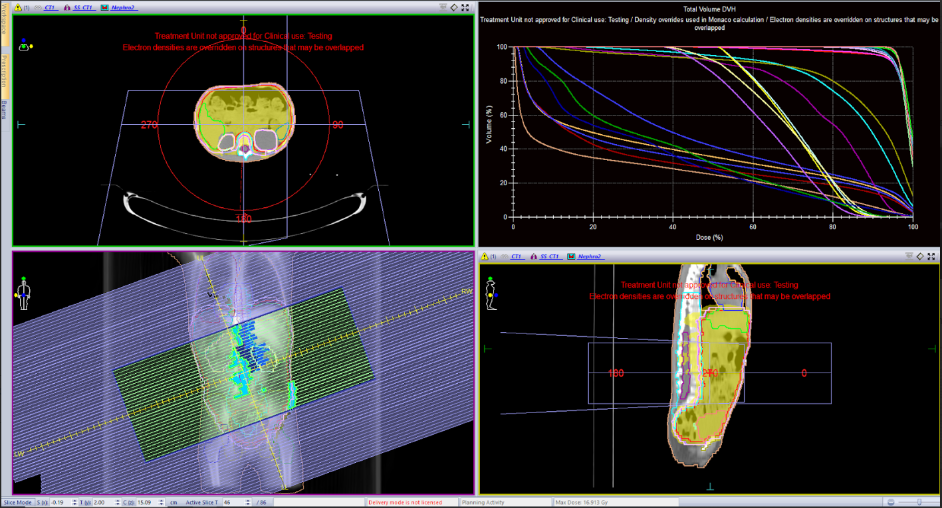

**Figure 4: Radiotherapy treatment plan used in our patient.**

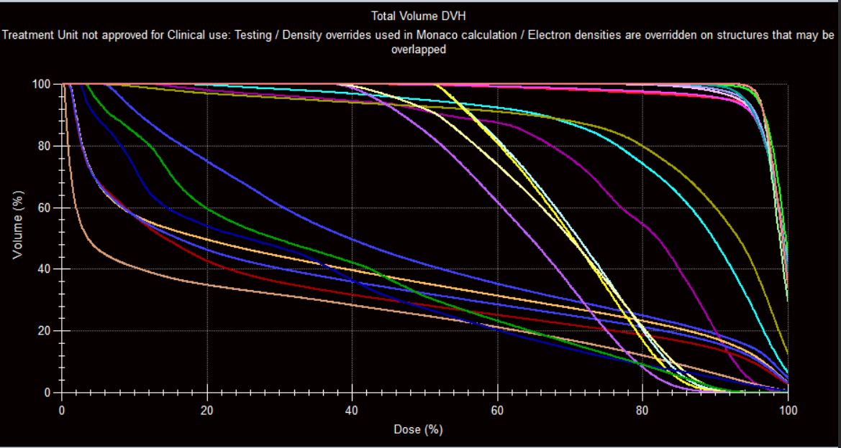

**Figure 5: A. Dosimetric constraints of the radiotherapy treatment plan used in our patient.**

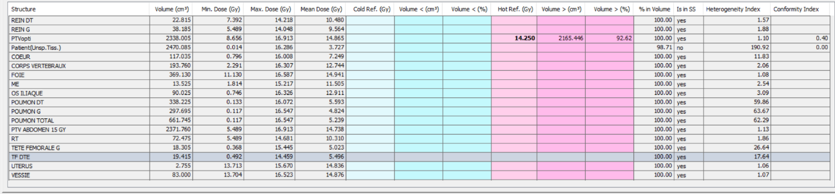

**Figure 5: B. Dosimetric constraints of the radiotherapy treatment plan used in our patient.**

The irradiated volume was the entire abdomen, without boosting the hilum lymph node given the tumor rupture, at a total dose of 10Gy /1.5Gy/fr in 10 fractions, optimizing protection by using shields over the kidneys and respecting dosimetric constraints.

Monitoring was clinical and tomographic on a daily basis, with good digestive tolerance and no adverse events.

Survival of children with nephroblastoma is currently over 85%, all stages combined. Therapeutic de-escalation enables over 65% of children to be cured without having received anthracyclines or radiotherapy, and therefore without any risk of late treatment complications. The most severe forms of the disease (initial metastases or relapses) are now, despite their rarity, better defined, and pose the problem of specific, adapted treatment.

Monitoring was clinical and tomographic on a daily basis, with good digestive tolerance and no adverse events.

**Conclusion :**

The horseshoe kidney is a rare clinico-radiological entity of renal symphysis, most often discovered on the occasion of associated pathologies or complications. Management is characterized by diagnostic and therapeutic difficulties due to the anatomical and surgical particularities of this malformation.

**References:**

1. Glenn JF. Analysis of 51 patient with horseshoe kidney. N Engl J Med 1979 ; 261 : 684.

2. Averous M, Veyrac C. Malformations congénitales du rein. Encycl Méd Chir (Éditions Techniques, Paris).

Néphrologie-Urologie, 18-125-A-10. 1995 : 17 p.

3. Benchekroun A, Lachkar A, Soumana A, Farih MH, Belahnech Z, Marzouk M, Faik M. Le rein en fer à cheval pathologique : à propos de 30 cas. Ann Urol 1998 ; 32 : 279-82.

4. Nagar RC, Sanwal BL. Squamous cell carcinoma in a horseshoe kidney. J Indian Med Assoc 1989 ; 87 : 14-6.

5. Takagi Y, Kanai S. A case of renal cell carcinoma in a horseshoe kidney. Hinyokika Kiyo 1992 ; 38 : 697-8.

6. Hayashi T, Fukuda H, Hagiwara T, Sakai K. Renal celle carcinoma in a horseshoe kidney.Hinyokika Kiyo 1991 ; 376135.

7. Trulock TS, Ricketts RR, Verras A, Kim TH, Hawkins HK,Woodard JR. Wilms tumor arising in horseshoe kidney. Urology 1985 ; 25 : 306-9.

8. Nirgiotis JG, Black CT, Sherman JO. Wilms’ tumor in horseshoe kidney: presentation due to ureteropelvic junction obstruction. J Surg Oncol 1991 ; 48 : 210-2.

9. Smith-Behn J, Même R. Malignancy in horseshoe kidney. South Med J 1988 ; 81 : 1451-2.

10 Kurl S, Rytkonen H, Farin P, Ala-Opas M, Soimakallio S. A primary carcinoid tumor of the kidney: a case report and review of the literature. Abdom Imaging 1996 ; 21 : 464-7.

11.Van Den Berg E, Gouw AS, Oosterhuis JW, Storkel S, Dijkuizen T, Mensik HJ, De Jong B. Carcinoid in a horseshoe kidney. Morpholoy, immunohistochemistry, and cytogenetics. Cancer Genet Cytogenet 1995 ; 84 : 95-8.

12. Krishnan B, Truong LD, Saleh G, Sirbasku DM, Slawin KM. Horseshoe kidney is associated with an increasd relative risk of primary renal carcinoid tumor. J Urol 1997 ; 157 : 2059-66.

13. Begin LR, Guy L, Jacobson SA, Aprikian AG. Renal carcinoid and horseshoe kidney: a frequent association of two rare entities – a case report and review of the literature. J Surg Oncol 1998 ; 68 : 113-9.

14. Klimberg I, Epstein H, Wajman Z. Oncocytoma in a horseshoe kidney. J Urol 1986 ; 135 : 1002-4.

15. Mottola A, Di Cello V, Saltutti C, Natali A, Fiorelli C, Barbagli G. Oncocytoma in a horseshoe kidney. Minerva Urol Nefrol 1992 ; 44 : 253-5.

16. Kawakami S, Yonese J, Tachibana Y, Kobayashi T, Yoshino S, Kawai T. Renal cell carcinoma in a horseshoe kidney:

report of two cases. Hinyokika Kiyo 1993 ; 39 : 357-9.

17. Strauss S, Dushnitsky T, Peer A, Manor H, Libson E, Lebensart PD. Sonographic features of horseshoe kidney:

review of 34 patients. J Ultrasound Med 2000 ; 19 : 27-31.

18. Treugut H, Schulze K, Schulze HJ, Meiisel P. Malignant tumours in horseshoe kidneys. ROFO Fortschr Geb Rongenstr

Nuklearmed 1979 ; 130 : 287-90.

19. Davidoff AM. Wilms Tumor. Advances in Pediatrics. janv 2012;59(1):247‑67.

20. Benchekroun A, Lachkar A, Soumana A, Farih MH, Belahnech Z, Marzouk M, Faik M. Le rein en fer à cheval pathologique à propos de 30 cas. Ann Urol 1998 ; 32 : 279-82.

21. Vaidya DSJ, Howell DL, Chowdhury DT, Oostveen DM, Powis MM, Okoye MB, Et Al. To be used in conjunction with the Umbrella Study Protocol. 2020;