**Splenic radiotherapy: a case report and review of the literature.**

**S.ABDOU, M.TAOUCHIKHT, H.FARES, K.NOUNI, A.LACHGAR, H.ELKACEMI, T.KEBDANI, K.HASSOUNI.**

**Radiotherapy Department, National Institute of Oncology, Rabat, Morocco.**

**KEY WORDS :** Radiotherapy, splenomegaly, myeloproliferative syndrome.

**ABSTRACT :**

Splenic radiotherapy is a palliative treatment option in the therapeutic arsenal for symptomatic splenomegaly, a frequent complication of myeloproliferative syndromes.

The main objective of this study is to report on the experience of the radiotherapy department of the (INO) National Institute of Oncology in the field of splenic radiotherapy, through an observation and review of the literature.

**Introduction :**

Myelofibrosis (MFI) and chronic myeloid leukemia (CML) are diseases characterized by the presence of splenomegaly.

Splenic irradiation has long been used in these cases, but there are still few usable data, and the optimum treatment modalities have yet to be defined.

**Case report :**

Patient aged 57, with no particular history of disease, more than 1 year from date of diagnosis, progressive increase in abdominal volume accompanied by anemia, asthenia and weight loss.

The diagnosis of primary myelofibrosis was made in the internal medicine department at RABAT on the basis of symptomatic splenomegaly associated with cytopenia resistant to myelosuppressive therapy and JAK 2 inhibitors, requiring repeated transfusions.

The patient was then referred to our department for possible splenic radiotherapy, following which he underwent 10 sessions of three-dimensional external radiotherapy at a total dose of 10 Gy in 1 Gy per fraction.

The evolution was marked by regression of the splenomegaly after the 5th session, with a slight increase in the hematological lines.

**Discussion :**

Symptomatic splenomegaly is a troublesome complication observed during hematological diseases, including primary myelofibrosis (PM), with a percentage of 27% [1].

Primary myelofibrosis (PMF) is the rarest of the myeloproliferative syndromes (MPS) [2].

Diagnosis is usually straightforward in the presence of splenomegaly (resulting from myeloid metaplasia), erythromyelism, red cell morphological abnormalities on slide and bone marrow histological myelofibrosis [2].

Epidemiological incidence is 3 to 7 new cases/million population/year. The disease mainly affects Caucasians, with an average age at diagnosis of around 60 (20% under 50). Both sexes are equally affected. Familial cases are quite exceptional. Contributing factors include prolonged exposure to benzene derivatives and radiation [2].

Median survival varies from 40 to 60 months depending on the series, but individual values vary widely. Anemia is the main prognostic factor. Therapeutic options are limited [2].

Clinical diagnosis of the disease was often made incidentally by splenomegaly and/or blood count abnormalities. Symptoms are diverse, dominated by anemia, asthenia, abdominal signs (pain, dyspepsia, etc.) and weight loss. Other signs are rarer at first: permanent or predominantly vesperal hyperthermia, sweating, bone pain.

Splenomegaly is the fundamental sign, which is constant in many series. Sometimes absent at the time of diagnosis, it always appears rapidly, usually within a year. Splenomegaly is highly variable in size, ranging from moderate (< 10 cm overhang) in 38% to 75% of cases, to very large, reaching as far as the iliac fossa. Classically, it is one of the largest hematological spleens, invading the entire abdomen and weighing over 5 kg [2].

Hepatomegaly is present in about half of all cases, often of moderate size, except after splenectomy. Small peripheral adenopathies are palpable in less than 10% of cases [2].

In our patient, the predominant clinical sign was a progressive increase in abdominal volume, revealing splenomegaly, which was moderate on clinical examination, with an 8-cm protrusion, evolving in the context of an anemic syndrome, asthenia and weight loss.

The main manifestations of symptomatic splenomegaly are a feeling of heaviness with abdominal pain in the left hypochondrium, and cytopenia due to sequestration [3].

Hemogram abnormalities encountered during the course of the disease may affect several blood lines, in particular :

* Red blood cells: normocytic, aregenerative anemia with dacryocytosis (Figure 1) and anisocytosis Leucocytes : hyperleucocytose (neutrophiles et basophiles),
* Platelets: Thrombocytosis or thrombocytopenia, sometimes with circulating micro-megakaryocytes.
* Myelimia and erythromyelimia.

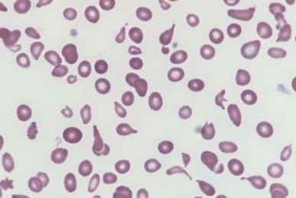

**Figure 1: Dacryocytosis or red blood cells in tears.**

Osteo-medullary biopsy: the bone is hard to penetrate and aspiration is often impossible. There are 3 aspects (Ward and Block):

* Stage I: Hyperplastic form with increased reticulin.
* Stage II: Mutilating collagen fibrosis.
* Sage III : Osteomyelosclerosis.

Cytogenetics: Karyotype analysis verifies the absence of the Philadelphia chromosome (Phi: marker of the t (9;22) chromosome translocation specific to chronic myeloid leukemia) and identifies a clonal cytogenetic abnormality, in terms of number or structure, in 30% to 50% of cases [4].

Molecular biology:

* Search for mutations in Janus kinase 2, a member of the tyrosine kinase family of enzymes involved in signal transduction for erythropoietin, thrombopoietin and granulocyte colony-stimulating factor (G-CSF), among other entities.
* Testing for thrombopoietin receptor and calreticulin mutations.

The main aim of the criteria formerly used by the Polycythemia Vera Study Group (PVSG) was to differentiate MFP from Vaquez's polyglobulia (PV) and CML [2]. Diagnosis is now based on a combination of positive and negative, essential and secondary elements, integrating clonal abnormalities (including JAK2) and retaining a predominant place for histology, including the “prefibrosis” entity.

Currently the diagnosis of PMF is based on the 2022 ICC criteria and involves a composite assessment of clinical and laboratory features, however a subclassification into overtly fibrotic and early/pre-fibrotic stages is to be noted (**table 1)** [5].

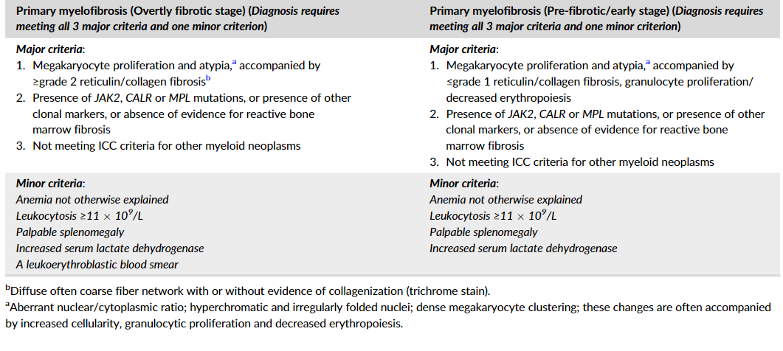

**Table 1: International consensus classification (ICC) diagnostic criteria for primary myelofibrosis, overt and pre-fibrotic [5].**

The differential diagnosis of MFP is made with closely related myeloid neoplasias, such as chronic myeloid leukemia, essential thrombocythemia, Vaquez polycythemia, myelodysplastic syndromes, chronic myelomonocytic leukemia, acute panmyelosis with myelofibrosis and acute megakaryoblastic leukemia.

Treatment is symptomatic and directed against complications, including blood transfusions or erythropoietin (EPO), or hypo-uricemic therapy (allopurinol).

Corticosteroid therapy with prednisone or prednisolone, at an initial dose of 0.5 to 1 mg/kg/day, is more rapidly effective (less than 1 month) on cytopenias (anemia, especially if there is a hemolytic component, and thrombocytopenia).

Medical treatment may include JAK inhibitors (RUXOLITINIB) targeting the JAK2 gene mutation found in 50% of patients. Based on this data, specific inhibitors of the tyrosine kinase associated with JAK1 and JAK2 receptors have been developed. A Phase 3 study has just confirmed their benefits in terms of splenomegaly reduction and quality of life. This benefit is maintained for at least 5 years.

Allogeneic transplantation of hematopoietic stem cells, from blood or bone marrow, is currently the only potentially curative treatment. It can only be applied to a minority of patients who are sufficiently young and have an HLA-identical donor, whether related or not [6].

Splenectomy may be indicated for large and/or symptomatic splenomegaly, accompanied by severe cytopenias, after failure of medical treatment. The challenge is to reduce early postoperative morbidity, which remains high, notably haemorrhage, locoregional or pulmonary infections and, above all, thromboembolic events.

Chemotherapy may be considered to reduce splenomegaly or significant hyperleukocytosis, using Hydrea or Purinethol.

Radiotherapy has limited indications [2].

However, in myelofibrosis there is myeloid activity, and patients escape drug therapy. It has been shown that myeloid cells are radiosensitive to low doses of total body irradiation [7]. Abdominal “bath” radiotherapy (8-10 Gy) may be useful in cases of ascites associated with peritoneal foci of myeloid metaplasia. Rare foci of symptomatic ectopic hematopoiesis (painful or compressive) are also accessible to radiotherapy.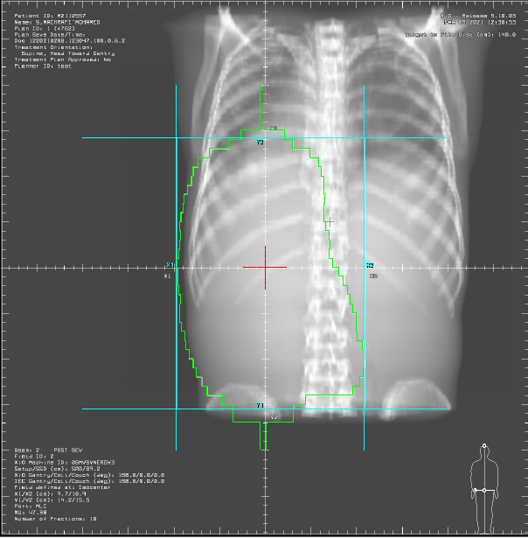

**FIGURE 2: Ballistics and irradiation fields used for our patient.**

Our patient underwent 3D radiotherapy at a total dose of 10 Gy in 1Gy/fraction in 10 fractions, with rigorous monitoring of blood lines by daily hemogram with measurement of splenic arrow, with no notable adverse effects. The evolution was marked by a slight decrease in transient splenic arrow for a duration of 06 months.

Cautious splenic irradiation (3 to 10 Gy) may be considered in cases where splenectomy is contraindicated [2].

It must be fractionated and requires rigorous hematological monitoring due to the risk of major cytopenia. L’efficacité sur le volume splénique et les symptômes est toujours transitoire.

**Conclusion :**

An uncommon disease affecting middle-aged adults, MFP was first identified over a century ago. However, its course under treatment is still fairly similar to its natural history.

Patients with MF react differently to splenic irradiation in terms of response (duration), but almost identically in terms of toxicity. The aim of irradiation is to palliate splenomegaly.

Given the slow and unpredictable evolution of this disease, and the complexity of its pathogenesis, it is nevertheless likely that the future will rely on multiple approaches, involving the combination of several molecules, including targeted treatments.

**Reference:**

[1]. O’Reilly RA. Splenomegaly in 2,505 patients at a large university medical center from 1913 to 1995. 1963 to 1995: 449 patients. West J Med 1998;169 (2):88–97.

[2]. Dupriez B., Demory J.-L., Le Bousse-Kerdiles M.-C., Giraudier S., Bilhou-Nabera C., Abgrall J.-F., Rey J. Myélofibrose primitive. EMC (Elsevier Masson SAS, Paris), Hématologie, 13-011-B-60, 2008.

[3]. Sager O, Beyzadeoglu M, Dincoglan F, et al. Adaptive splenic radiotherapy for symptomatic splenomegaly management in myeloproliferative disorders. Tumori 2015;101(1):84–90.

[4]. Demory JL, Dupriez B, Fenaux P, Lai JL, Beuscart R, Jouet JP, et al. Cytogenetic studies and their prognostic significance in agnogenic myeloid metaplasia: a report of 47 cases. Blood 1988;72:855-9.

[5]. Tefferi A. Primary myelofibrosis: 2023update on diagnosis, risk-stratification, and management. AmJ Hematol. 2023;98(5):801‐821. doi:10.1002/ajh.26857TEFFERI 821.

[6] .Van Besien K, Deeg HJ. Hematopoietic stem cell transplantation for myelofibrosis. Semin Oncol 2005;32:414-21.

[7]. Cosset JM. Socie G, Girinsky T, Dubray B, Fourquet A. Gluckman E. Radiobiological and clinical bases for total body irmdiation in the leukemias and lymphomas. SemRad One 19955: I- 16 Clift RA, Buckner CD, Thomas ED, Bensinger WI. Bowden R