VMAT in prostate cancer: Experience at the RABAT INO national oncology institute
S.ABDOU, H.FARES, M.TAOUCHIKHT, K.NOUNI, A.LACHGAR, H.EL KACEMI, T. KEBDANI, K. HASSOUNI.
Radiotherapy Department, National Institute of Oncology RABAT INO
Summary:
Study object :
To report the experience of the external radiotherapy department of the RABAT National Institute of Oncology in the conformal irradiation of prostate cancers with intensity modulation of the volumetric modulated arc therapy (VMAT).
Materials and methods:
This is a retrospective study conducted in the external radiotherapy department between January 2017 and December 2021. All patients with prostate cancer were included. Those with immediate metastatic disease at the time of diagnosis were excluded.
For 441 patients, respecting dose constraints in organs at risk of toxicity. VMAT was the technique used in all our patients.
Results and statistical analysis:
A total of 441 prostate cancer patients were treated in our department.
The median age at diagnosis was 72 years, with an average consultation time of 8 months.
Mean PSA: 59 ng/ml (range 5.03 to 403 ng/ml).
Pelvic MRI was performed in 94% of patients. Three of our patients were classified as oligo-metastatic.
The predominant histological type was ADK in 100% of cases.
Tumors were classified according to the current Amico and NCCN classifications.
Treatment consisted of a combination of external radiotherapy and hormone therapy in 97% of cases, and exclusive radiotherapy in 3% of cases.
In terms of therapeutic tolerance, 66% of patients experienced acute toxicities of all kinds, and 45% of patients experienced late toxicities.
Complete remission was achieved in 100% of patients, with a mean PSA Nadir of 0.09 ng/ml.
Overall recurrence-free survival was 94%, with a relapse rate of 6%.
Conclusion :
VMAT is an effective technique for treating prostate cancer, with a better rate of locoregional control and reduced toxicity than 3D conformal radiotherapy.

Introduction :
Prostate cancer is the leading cause of cancer in men over 60. It is the leading cause of cancer mortality in men over 70, and ranks 2nd in overall mortality after bronchopulmonary cancers. [1].
External radiotherapy is one of the curative therapeutic methods for localized prostate cancer. We report on the experience of the radiotherapy department of the RABAT National Institute of Oncology in conformal radiotherapy of VMAT-type localized prostate cancer.
Volumetric Arc Therapy with Intensity Modulation or VMAT is one of the latest innovative radiotherapy techniques with the potential to improve coverage of complex tumor volumes while better preserving organs at risk.
Patients et méthodes:
Period from January 2017 to December 2021,
441 patients with localized prostate cancer were treated with curative conformal radiotherapy arc therapy (VMAT) in the radiotherapy department of the RABAT national oncology institute.
Diagnostic and therapeutic data were collected from clinical records, the MOSAIC® verification and registration system and the MONACO® radiotherapy treatment planning software. Patients who had not started treatment or who had received palliative radiotherapy were excluded. The treatment strategy was based on international guidelines [2,3].
Stratification into risk groups according to D’Amico classification was carried out before the start of treatment [4], based on the initial serum level of prostate-specific antigen (PSA), Gleason score and TNM stage. Post-operatively, radiotherapy was chosen in the event of positive margins, pTNM stage greater than or equal to pT3a, and in the event of recurrence after prostatectomy [5,6].
Résultats :
A total of 441 patients with prostate cancer were treated in our department.
The median age at diagnosis was 72 years, with extremes of 56 and 89 years, with an average consultation time of 8 months.
Personal antecedents were as follows: 40% of our patients had commorbidities (12% diabetes, 10% heart disease, 18% hypertension).
A family history of prostate cancer was noted in 3% of our patients.
Mean PSA: 59 ng/ml (range 5.03 to 403 ng/ml).
Prostate MRI is recommended both to establish therapeutic indications (to detect any extra-capsular involvement of the seminal vesicles or lymph nodes), and to help delineate the anatomoclinical target volume, sequenceT2, offering the possibility of registration with the dosimetric CT scan, was carried out in 94% of patients.
STRUCTURE | %
Seminal vesicle  Capsule  Bladder  Rectum | 31,5  36,4  12,1  3,03

Table1 : loco-regional invasion MRI.
Three of our patients were classified as oligo-metastatic on remote extension.
The predominant histological type was ADK in 100% of cases.
Tumors were classified according to Amico and NCCN in rigor;
NCCN Classification:
NCCN | %
Low  Intermediate favorable  Unfavorable intermediate  High  Very high | 3,6  2,4  5,4  57  31
Table 2: NCCN risk levels.

Classification AMICO :

Risk | %
Intermediate  High | 16,4  83,6
Table 3: AMICO risk levels.
Hormonotherapy in combination with radiotherapy was indicated in 97% of cases of localized high-risk or intermediate-risk prostate cancer, and in locally advanced tumors (T3b and T4).
Neoadjuvant hormonotherapy was used in 73% of cases, and concomitant hormonotherapy in 27%, lasting 6 months in 27%, 2 years in 30%, and 3 years in 42% of cases. However, 3% of patients received exclusive radiotherapy.
Conformal radiotherapy technique:
Conformal radiotherapy is based on delineating target volumes as closely as possible, so as to irradiate only a minimum of surrounding organ at risks. This involves locating the target volume, usually by CT scan, and then drawing up a treatment plan adapted to the patient's anatomy and characteristics.
The creation of an appropriate restraint to ensure perfect reproducibility of patient positioning at each session, by immobilization tools using Knee and Foot Locks in a way to keep the patient in the same position every day, comfortable and in a good position for treatment.
Dosimetric CT scan realised with intravenous injection of contrast to locate the bladder and vascular axes, 3 mm slices over an acquisition zone: L3-L4, 2cm below the lesser trochanters The images are then transferred to a dosimetry console where, on each slice, the prostate volume and seminal vesicles are delimited with PTV margins of 7mm in all directions except 5mm posteriorly, as well as organs at risk: the two femoral heads, rectum and bladder, not forgetting the abdominal cavity and penile bulb.
The volume irradiated was distributed as follows: Prostate with lymph nodes in 74% of patients, the prostate lodge: 11%, and the prostate alone in 15% of patients.
The prescribed dose to the PTV was 76 Gy in 2Gy/fraction for a total of 38 fractions, using a single or double arc to cover 95% of the PTV, with a maximum dose not exceeding 107% of the prescribed dose. The prostatic loge received 66Gy in 33 fractions.
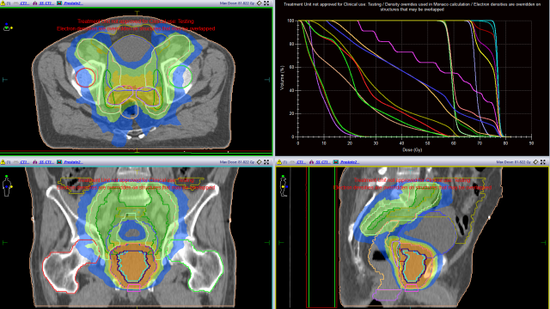
Figure 1: Target volumes and DVH iconography INO RABAT radiotherapy department.
Dosimetric analysis :
Dose-volume histograms have been designed for organs at risk and target volumes.
PTV : D2% (101%), D5% (100%), D95% (93%).
Bladder: V74Gy (8,28%), V70Gy (15,50%) et V60Gy (26,6%).
Rectum : V74Gy (2,07%), V70Gy (8,68 %) et V60Gy (22%).
Femoral heads : V50Gy (10%).
Weekly CBCT (cone beam CT) monitoring: Position verification acquisition performed on the first three days, then every other day, then comparison between CT dosimetric imaging and CBCT imaging: Double comparison registration algorithm and application of measured offsets.

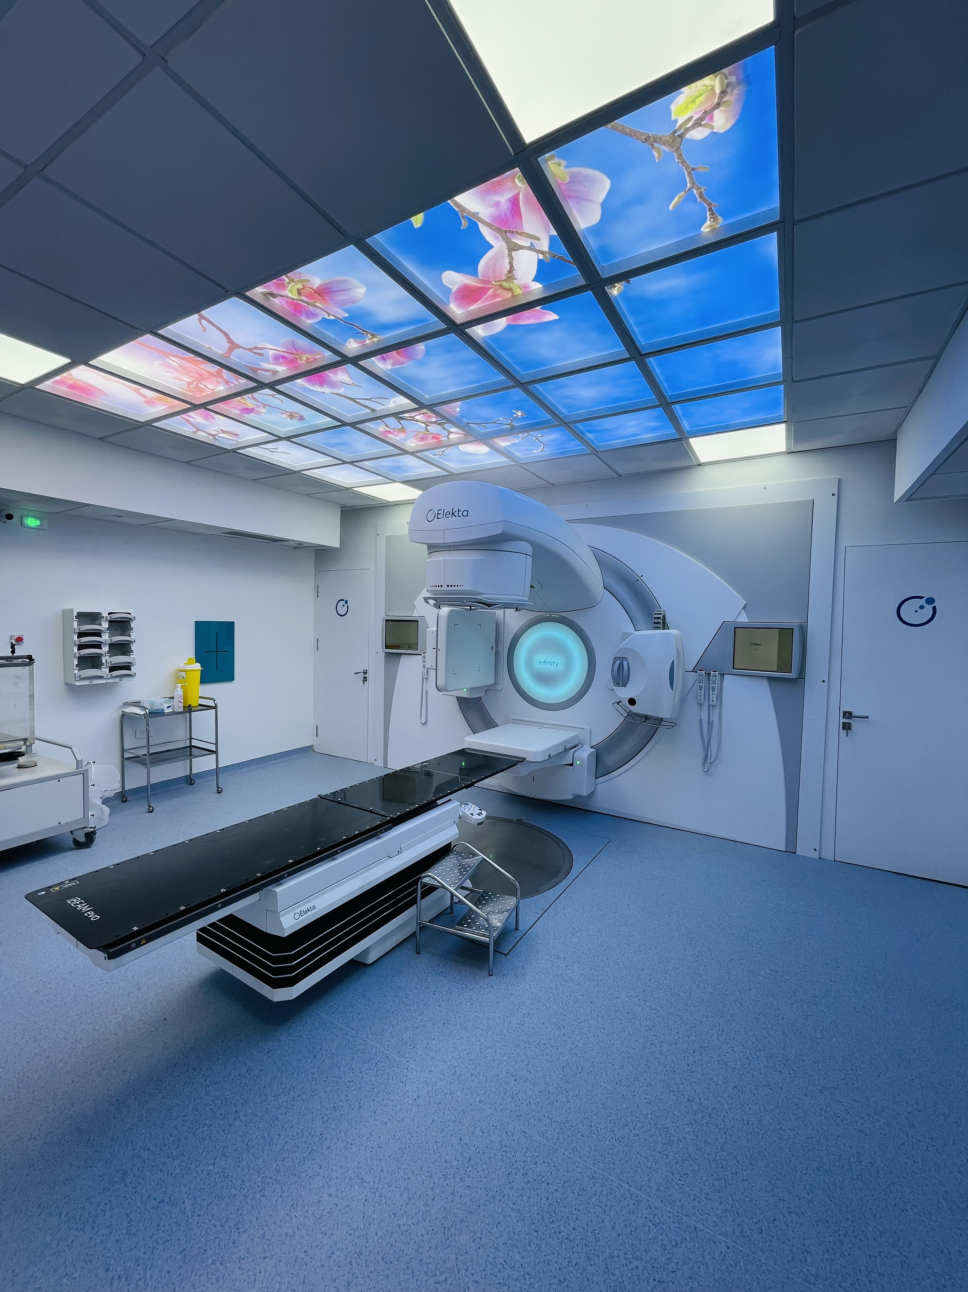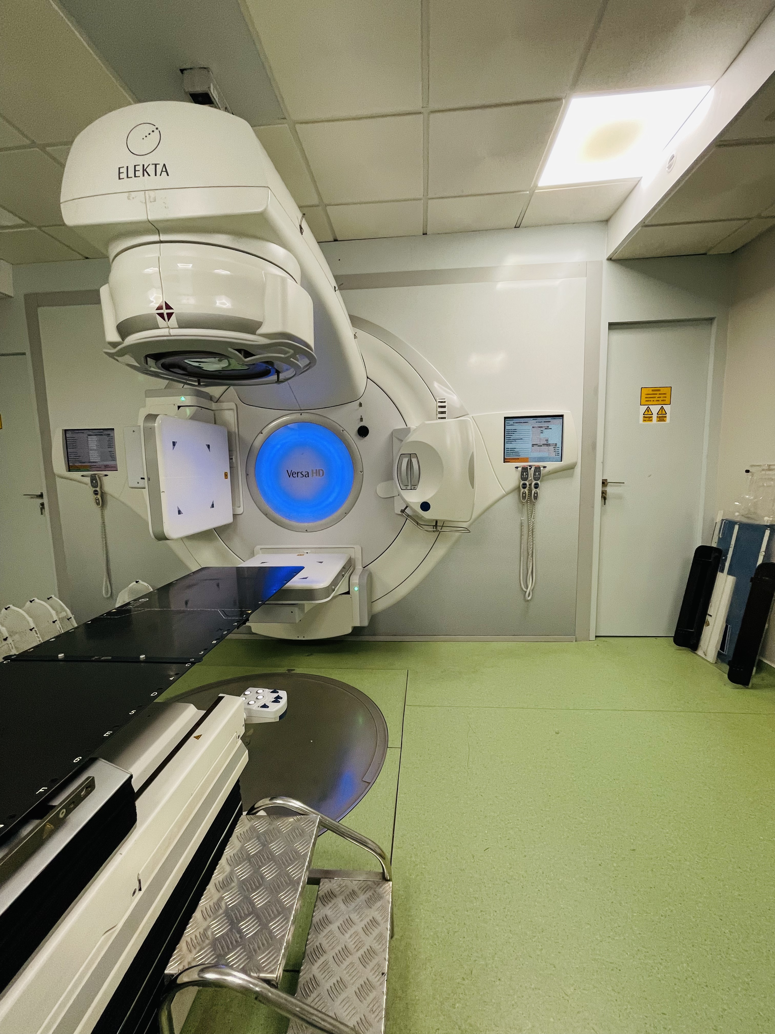

Figure 2. VMAT platform in the radiotherapy department of the INO RABAT national oncology institute.

CBCT monitoring helps reduce treatment errors by quickly detecting any positioning or alignment problems that could compromise treatment efficiency or cause damage to surrounding healthy tissue.
Regarding therapeutic tolerance: 66% of patients experienced acute toxicity according to CTCAE version 4.0:
Toxicity | %
Genito-urinary | %
Dysuria grade 1 | 20
Cystitis non infective grade 1 | 26
Digestive | %
Anal pain grade 1 | 17
Diarrheoa grade 2 | 21
Table 3 :Acute toxicities based on CTCAE version 4.0.

Late toxicities were noted in 45% of patients, notably genitourinary and digestive toxicities:
Toxicity | %
Genito-urinary | %
Urinay incontinence grade 1 | 6
Cystitis grade 1 | 19
erectile dysfunction | 9
Digestive | %
Diarrhoea grade 1 | 12
Table 4 : Late toxicities based on CTCAE version 4.0.
Discussion :
In 1953, arc therapy was described by Johns et al., then in 1965 Takahashi presented the concept with a multi-blade collimator.
In 1983 Brahme et al. and Chin et al. proposed arc therapy coupled with multi-blade collimator movements and dose rate variation.
Intensity-modulated arctherapy (IMAT), the origin of current volumetric arctherapy techniques, was first introduced by Yu et al. in 1995.
In 2008, Otto et al introduced an evolution of IMAT with the possibility of varying the dose rate in addition to the rotation speed of the gas pedal arm and the blades of the multi-blade collimator. Concerning our experience of the radiotherapy department at the RABAT National Institute of Oncology the VMAT technique for prostate cancer was started in 2018.

There is a dose-response relationship in prostate cancer irradiation. Several randomized studies have shown a benefit of high-dose irradiation (78 to 80 Gy) in terms of biochemical and clinical recurrence-free survival, compared with standard-dose irradiation (68 to 70 Gy) [8].
Studies on VMAT confirm its effectiveness in prostate cancer [8]. It enables adjustment of the dose rate and the field of view of the MLC multi-blade collimator, delivering highly compliant treatment with optimal sparing of organs at risk [8]. In our study, all dose constraints were met for all treatment plans with short treatment times.
A notable advantage reported in prostate studies is the significant reduction in irradiation time, as well as the more frequent use of image-guided radiotherapy (IGRT) and reduced risks associated with patient or tumor movement during the irradiation session.
Arc therapy with a single arc can, in optimal circumstances, be delivered in one to two minutes, compared with seven to ten minutes with IMRT with five to seven fixed beams, while the time dedicated to planning seems longer and more complex than with conventional IMRT techniques [8].
VMAT enables concave dose distribution, generating a high dose to the prostate while sparing healthy tissue [8], so target volume coverage is assessed on the basis of D2%, D98%, compliance index and homogeneity index defined in ICRU 83. However, the benefits of VMAT can only be seen clinically if the image is guided (IGRT), which reduces the uncertainties associated with intraprostatic movement [9].
The VMAT technique offers time savings reported in the literature that translate into at least two benefits: a reduction in prostatic movement during the session (intra fraction) and an economic gain enabling the number of patients treated to be increased and more verification images to be produced [9].
During irradiation, irritative effects are at the forefront, generally appearing from the end of the second week of irradiation. In the urinary tract, the most frequent signs are nocturnal pollakiuria, urgency, urinary burning and dysuria.
In the digestive tract, the partial rectal irradiation will often modify patients' diarrhea and/or constipation. Acute radiation effects can be managed both medically and paramedically, and patients are reminded of the importance of hygiene and diet.

The importance of a monitoring consultation to check tolerance of acute treatment toxicities, essentially digestive and urinary toxicity in prostate cancers [10].

Position control under the gas pedal can be achieved by controlling the position of the prostatic target volume (image guidance): directly using low-energy (kV) or high-energy (MV) cone tomography, or indirectly using intraprostatic markers.

The VMAT technique is an improvement on intensity modulation techniques, but only if the quality of its implementation is optimal both in terms of planning and delivering the treatment plan.

The quality of dose distribution and the efficiency of VMAT implementation are closely linked to the performance of dose calculation algorithms and the dose optimisation. Accelerator quality control should be based on a series of tests similar to those used in step-and-shoot techniques: blade positioning accuracy and reproducibility tests, beam uniformity tests during delivery of monitor units [9].

Conclusion :

Conformal radiotherapy improves radiation tolerance compared to conventional radiotherapy; conformal radiotherapy allows an increase in the dose delivered to the prostate without a prohibitive increase in toxicity; the increased dose improves biochemical control of the disease in patients in the intermediate group, and probably also in patients in the unfavorable group.

Reference :

[1] GLOBOCAN 2012 (IARC) Section of Cancer Surveillance. Fact sheets
Morocco.
[2]Scardino P (2003) Update: NCCN prostate cancer Clinical Practice Guidelines. J Natl Compr Canc Netw 3:S29–S33.
[3]. Heidenreich A, Aus G, Bolla M, et al (2008) EAU Guidelines on Prostate Cancer. Eur Urol 53:68–80.
[4]. D’Amico AV, Whittington R, Malkowicz SB, et al (1999) Pretreatment nomogram for prostate-specific antigen reccurence after radical prostatectomy or external beam radiation therapy for clinically localized prostate cancer. J Clin Oncol 17:168–72.
[5]. Bolla M, van Poppel H, Collette L, et al (2005) Postoperative radiotherapy after radical prostatectomy: a randomised controlled trial (EORTC trial 22911). Lancet 366:572–8.
[6]. Thompson IM, Tangen CM, Paradelo J, et al (2009) Adjuvant radiotherapy for pathological T3N0M0 prostate cancer significantly.
[7] F. Jouyaux, R. De Crevoisier, J.-P. Manens, J. Bellec, G. Cazoulat, P. Haigron, C. Chira, E. Le Prisé, C. Lafond.
[8] 7. Otto K (2008) Volumetric modulated arc therapy: IMRT in a single gantry arc. Med Phys 35: 310-317.
[9] F. Jouyauxa, R. De Crevoisier, J.-P. Manens, J. Bellec, G. Cazoulat,P. Haigron, C. Chira, E. Le Prisé, C. Lafond Cancer/Radiothérapie 14 (2010) 679–689.
[10] Gross E. Radiothérapie conformationelle du cancer de la prostate. Prog Urol. 2011;21(11):801-7.

