EXAMINE THE MECHANICAL PROPERTIES OF PLA POLYMAR TENSILE TEST SAMPLES PRODUCED THROUGH 3D PRINTING IN VARIOUS ORIENTATIONS

**1Ashish Saini, 2Nikul Kumar, 3Sheel Kumar Dixit**

1Scholar, M.Tech (Mechnical Engineering Deptt.), Bhagwant Institute of Technology, Muzaffarnagar, UP

2,3 Assistant Professor, Mechnical Engineering Deptt., Bhagwant Institute of Technology, Muzaffarnagar, UP

## ABSTRACT

*In this research, the impact of build orientation on the tensile strength of poly (lactic acid) or PLA polymers was examined. Utilizing PLA filaments of 1.70mm diameter, tensile test samples were designed with SolidWorks software in accordance with the ASTM D638 specifications for plastics. Then, the samples were 3D printed in orientations of 45 degrees, flat to the base, and upright using a FDL 3D printer. The finished specimens were subjected to stress tests using a Gunt universal testing machine, where it was found that the flat orientation samples experienced the greatest tensile stress due to more efficient load distribution across the layers. On the other hand, the vertically printed samples showed the least tensile stress, suggesting less effective load transmission. Optical microscopy was employed to observe the print layer orientations of the materials.*

**Keywords:** Fused Deposition Modeling, 3D Printing, Build Orientation, Tensile Strength, PLA, Mechanical Properties.

**Cite this Article:** Abdullah Alhuzaim, Investigating the Mechanical Properties of PLA Polymer Tensile Test Samples Produced Via 3D Printing in Various Orientations: Flat, Vertical, and 45 Degrees, International Journal of Mechanical Engineering and Technology (IJMET), 15(2), 2024, pp. 35-42.

# INTRODUCTION

3D printing is a modern technique for crafting detailed forms of materials and components. Known by several names, including fusion deposit molding, additive manufacturing, and fused filament fabrication, this process relies heavily on filament for the creation of materials. The filament is a key element in the 3D printing procedure [1-5].

Filaments used in 3D printing are made from polymer-based and other assorted materials. A plethora of filament options are utilized in 3D printers, encompassing ABS (acrylonitrile butadiene styrene), PLA (poly(lactic) acid), PVA (polyvinyl alcohol), PTFE (polyethylene tetraphthalate), HIPS (high-impact polystyrene), Nylon, as well as composite variants like Wood/PLA, Carbon/PLA, and Metal/PLA among others [1-5].

The choice of filament depends on the specific application area. For instance, metal/PLA filament is employed in the production of mechanical parts, Nylon is utilized for creating machine components, toy parts, and mechanical elements like gears and bearings, as well as consumer products. PETT is preferred for food packaging applications due to its safety for direct contact with food, making it suitable for items like cups, kitchen utensils, and soda bottles. PLA, classified as a biodegradable polymer, is used to manufacture surgical implant parts for medical purposes, including screws, pins, and rods. PLA filament is also applied in food packaging, such as candy wrappers and disposable tableware.

In contemporary 3D printing, the focus is on producing lightweight materials. For instance, the wings of unmanned aerial vehicles are fabricated using the fusion deposit molding (FDM) process. [7-8]

Furthermore, this method involves a significantly shorter fabrication time, is cost-effective, allows for easy material changes, requires minimal maintenance, operates without the need for constant supervision, and maintains a low working temperature. [9-10]

The aim of study is to examine how the print layer orientation direction influences the tensile properties of PLA polymer and to analyse the tensile stress in materials printed in different positions. The selection of PLA as the filament is driven by its biodegradability and eco-friendly nature. Additionally, PLA does not emit harmful odors during the printing process.

# EXPERIMENTAL PROCEDURE

* + Materials and Modelling

PLA filament from eryone Standard PLA made in China is employed for crafting the 3D samples. The initial step involves designing the sample in modelling software, adhering to ASTM D638 standards dimensions, and saving it in STL (Stereo Lithographic) format. Subsequently, the STL file is input into the 3D printing machine manufactured by Bambu lab A1

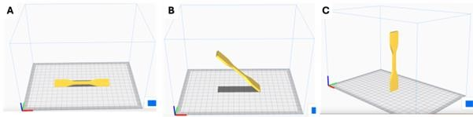

**Figure 1** illustrates different orientations of the printing layers on 3D printed materials: (a) at 90- degree positions, (b) at 45-degree positions, and (c) in vertical positions.

Tensile test samples were designed using 3D modelling software and printed with a 3D Printer Bambu lab A1. These samples were printed in three orientations: flat, vertical, and inclined at a 45-degree angle. Prior to initiating the printing process, the parameters are configured as follows: the print layer thickness is established at 0.2mm, the filament diameter:

1.75mm with +-0.03mm tolerance and the melting temperature is set to 220°C. The machine's bed temperature is adjusted to 65°C. The material's fill density is designated as 100%, and the printing speed is (outer walls): 200 mm/sec and the (inner walls): 300 mm/sec. The material is then printed in different print layer orientation directions, specifically flat positions, 45-degree, and vertical positions, the support generated only at: 45 degrees sample illustrated as figure 1 (a, b, and c).

**Table 1:** Parameters of printer settings.

|  |  |
| --- | --- |
| **Item** | **Value** |
| **Filament** | Eryone stander PLA |
| **Filament diameter** | 1.75mm with +-0.03mm tolerance |
| **Print speed (outer walls)** | 200 mm/s |
| **Print speed (inner walls)** | 300 mm/s |
| **Nozzle Temperature** | 220 degrees |
| **Bed Temperature** | 65 degrees |
| **support generated** | 45 degrees sample |

* Tensile Testing

Tensile tests were carried out using Gunt Hamburg WP310 universal testing machine in accordance with ASTM D638 standards shown in figure 3. Tests were conducted at a constant crosshead speed of 2 mm/min until failure, with data on stress and strain recorded throughout.

The specimen dimensions consist of a length of 75 mm, a width of 19 mm in the grip side area, a width of 6 mm in the gauge length side area, and a material thickness of 4 mm.

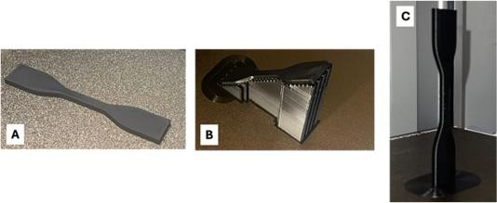

**Figure 2:** Actual rented tensile samples (A) flat (B) 45 degree (C) vertical sample

Flat sample was printed directly into the heated substrate which affect the shape of the layer alignments. 45 degree sample was built with the use of support. The vertical position sample was build upright as shown in figure 2.

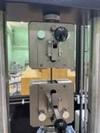

* + Optical Microscopic Analysis

**Figure 3:** Tensile test setup

The print layer orientations of the sample are examined through Motic microscope analysis. The specimens are placed on the flat surfaces of the microscope, and images of the outer surfaces and print layer orientations of the materials are captured. All images are taken at a magnification factor of 5X.

# RESULTS AND DISCUSSION

Depicts the stress-strain diagram of 3D printed materials with varying print layer orientations shown in figure 4. The results indicate that the highest stress is observed in materials printed at 45-degree positions, while the lowest stress is recorded in upright-positioned samples. The variations in stress arise from changes in print layer orientation and loading directions on the printed materials. For instance, in materials printed at a 45-degree position, one layer is printed along the axis of the materials, and another layer is printed in the transverse direction of the material axis. This alternating layer formation along the axis and transverse direction is illustrated in Figure 3a. In materials printed at a 90-degree position, with a maximum stress of 40.41MPa, the print layer is formed at +45 degrees and -45 degrees, as shown in Figure 3b. The lower stress value in this case is attributed to the applied loading being transferred at an incline on the printed layers.

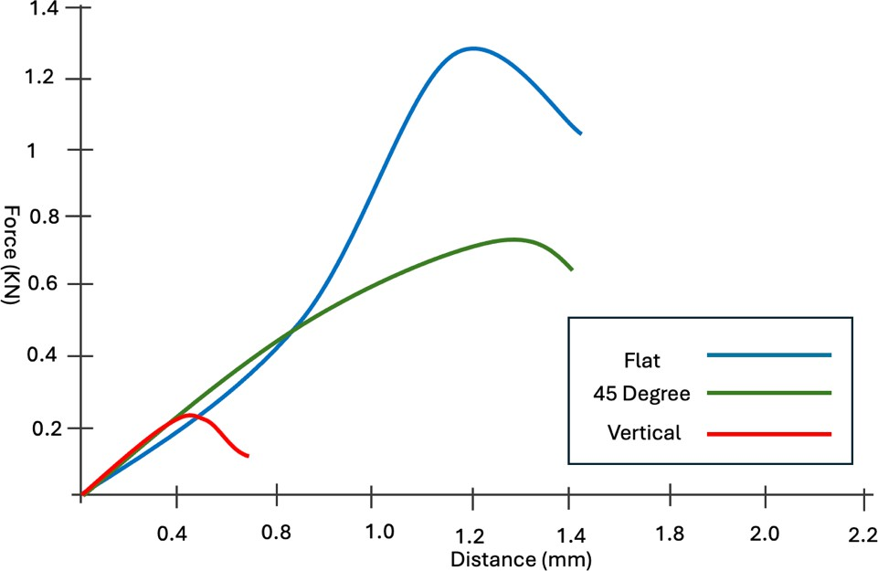

**Figure 4.** Stress-strain curve depicting different PLA materials with varied print layer orientations.

In terms of mechanical properties, it can be seen from Figure 4 and Table 2 that the flat position sample reaches maximum tensile strength (1.37 KN), while the vertical position reaches the minimum (0.28 KN). Because the tensile strength of FDM 3D-printed PLA parts becomes optimal if the parts are fully oriented along the direction of loading stress [11].

As shown in Figure 7a, the parts that can transfer the stress at the highest level are the parts oriented along the loading stress direction. And, as shown in Figure 7b and 7c, fracture mode of the vertical build position and the 45 position differs from the flat build orientation. There are two types of fracture modes which are the interlayer fracture and the intra-layer fracture and the fracture mode affects the mechanical strength of the FDM 3D-printed PLA parts. The interlayer fracture strength mainly depends on the interlayer bonding strength, and the intra- layer fracture mainly depends on the strength of the extruded material [12]. Obviously, the loading direction of the vertical build oriented part is totally perpendicular to the direction of the extruded lines, indicating that the bond between line and line is weak and that interlayer fracture occurs easily during the tensile test [11,14]

According to the tensile results listed in Table 2, samples printed in horizontal directions exhibited higher tensile strength, while samples printed in vertical (vertical) direction exhibited 90% lower tensile strength.

In terms of print angles, it was seen that the mechanical properties of the 45° position and vertical position were not much different figure 6. The print angles can be seen in figure 6 and

7. It has been observed that, the 0° angle had the maximum tensile strength, followed by the 45°, and 90° printing angles, respectively. The tensile strength for the 0°, 45°, and 90° printing angles were approximately 48 MPa, 31 MPa, and 5 MPa, respectively. The reason the 0° printing angle had the highest mechanical properties was that the orientation of the structure aligned with the direction of the loading force in a single slice of the original filament. Thus, the direction of the loading should be considered when designing and applying the FDM 3D- printed PLA parts [14].

Table 1 presents the tensile properties of PLA materials with different orientations in 3D printing. The maximum tensile strain is observed in materials printed at a 90-degree position, while the minimum tensile strain is anticipated in materials printed at a 45-degree position. This variation is attributed to the load transfer differing across the print layers of each material.

**Table 2:** Tensile Properties

|  |  |  |  |  |  |
| --- | --- | --- | --- | --- | --- |
| **No** | **Printing position** | **Stress (MPa)** | **Force (KN)** | **Strain (%)** | **Distance (mm)** |
| 1 | Flat | 48 | 1.35 | 0.28% | 1.4 |
| 2 | 45 | 31 | 0.75 | 0.18 | 1.4 |
| 3 | 90 | 4.8 | 0.25 | 65 | 0.7 |

Figures 3a-c depict the print layer orientations of materials printed in various positions, and the optical microscope images validate that the printing layers are indeed printed in different orientations on 3D printed materials. Figure 3a illustrates the printing layer along the axis and transverse direction of the materials, obtained from materials printed at 45-degree positions. When altering the positions of the materials, the 3D printing machine (Z axe x1) automatically adjusts its print layer orientations. By shifting to the 90-degree position, the print layer orientations are formed in +45° and -45° directions, as shown in Figure 3b. In upright positions, each printing layer takes on an oval shape from the bottom to the top of the materials, as depicted in Figure 3c.

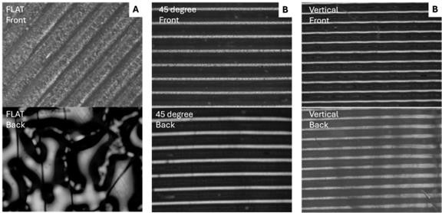

Figure 6: (a) Flat sample front and back (b) 45 degree sample front and back (c) Vertical sample front and back

Figure 5 presents the broken specimens, and how the specimens printed with different build orientation are torn. For specimen printed with 45° and vertical° position, the direction of fracture is the same as the raster direction.

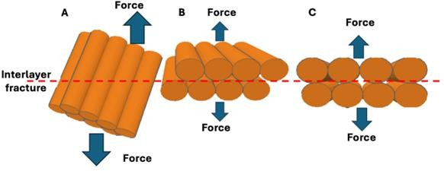

**Figure 7:** Tensile failure mechanism at (a) flat, (b) 45 degree (c) vertical orientation

It can be seen in figure 8 the broken specimens and failure mechanism and the Fracture surfaces in each specimens printed with different raster directions. This is interesting because it was expected that the perpendicular layer direction has worse properties than the parallel to the direction of the longitudinal axis.

The vertical sample which has the layers in top of each other broke is sharp edge manner, which the inerlayer raped off casing the sharp edge. the results do not appear good mechanical properties compare with the other build orientation. Moreover, the 45-degree sample shows an angular fractur this is due the layer overlaps in an angle. This helps the fracture to propagate in between and through the layers. In the other hand, the flat position sample

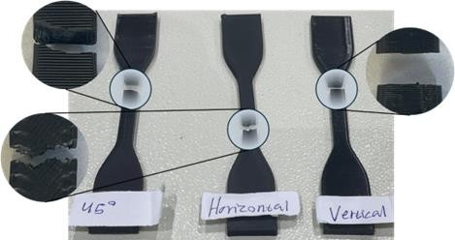

**Figure 8:** Broken PLA specimens at three different orientations

The vertical sample exhibits a brittle fracture with striated cracking, as depicted in Figure

8. In the horizontal sample, bending deformation occurs along a straight member. This causes contraction in the fibers above the neutral axis and elongation in the fibers below the neutral axis. The 45-degree sample behaves similarly to the horizontal sample but is observable from the side.

# CONCLUSION

In this paper, the mechanical properties of the FDM 3D printing technology have been examined three different build positions, The following conclusions were drawn from the aforementioned study:

* + The PLA 3D sample was successfully manufactured in accordance with ASTM D638 standards.
  + The highest tensile stress in 3D printed materials is observed in materials printed at a flat and the fibres in 45-degree position.
  + The maximum force that the sample withstand are determined to be 1.35 KN for materials printed at flat position. Conversely, the minimum force that the sample withstand is recorded as 0.28 KN for materials printed in an upright position as the applied load acts inclined to the print layer.
  + Microscope images confirm that the print layer is printed in diverse orientations on the materials.
  + Changing the printing positions results in the automatic adjustment of the print layer orientation during the 3D printing process.

# REFERENCES

1. F. Akasheh, et al., “Effect of Build Orientation on the Mechanical Properties and Fracture Behavior of ABS Produced by Fused Deposition Modeling,” *Microsc. Microanal*. 23 (Suppl 1), 2017. doi:10.1017/S1431927617004457
2. I. Gibson, D.W. Rosen, B.Stucker, “*Additive manufacturing Technologies*”, (Springer, NY) 2010.
3. A. Bellini, and S. Güçeri, “Mechanical Characterization of Parts Fabricated using Fused Deposition Modeling,” *Rapid Prototyping Journal*, vol 9(4), 2003, pp. 252-264.
4. Nadir Ayrilmis, et al., “Effect of printing layer thickness on water absorption and mechanical properties of 3D-printed wood/PLA composite materials,” *The International Journal of Advanced Manufacturing Technology*, Vol. 102, June 2019, pp. 2195–2200.
5. Patrick Hartunian and Mohsen Eshraghi, “Effect of Build Orientation on the Microstructure and Mechanical Properties of Selective Laser-Melted Ti-6Al-4V Alloy,” *J. Manuf. Mater. Process*. 2018, 2, 69; doi:10.3390/jmmp2040069,
6. S. K. Moon, Y. E. Tan, J. Hwang, and Y. J. Yoon, “Application of 3D printing technology for designing light-weight unmanned aerial vehicle wing structures,” *Int. J. Precis. Eng. Manuf.- Green Technol*., vol. 1, no. 3, 2014, pp. 223–228.
7. Ahn Sung Hoon, Montero Michael, Odell Dan, Roundy Shad, K. Wright Paul, “Anisotropic material properties of fused deposition modelling ABS,” Rapid prototyping journal, 8 (4), 248- 257, 2002.
8. K. M. Ashtankar, Dr. A. M. Kuthe, Bechu Singh Rathour, “Effect Of Build Orientation On Mechanical Properties Of Rapid Prototyping (Fused Deposition Modelling) Made Acrylonitrile Butadiene Styrene (ABS) Parts” in Proceedings of the *ASME 2013 International Mechanical Engineering Congress and Exposition,* USA 2013.
9. Rolando Quintana, Jae-Won Choi, Karina Puebla & Ryan Wicker, “Effects of build orientation on tensile strength for stereolithography-manufactured ASTM D-638 type I specimens*” Int J Adv Manuf Technol*, vol. 46, 2010, pp. 201–215. DOI10.1007/s00170-009-2066-z.