**RENEWABLE ENERGY-POWERED MOBILE CHARGER WITH DUAL INPUT SOURCES**

1**Mr. A. Kuppuswamy,** 2**Linith Hariharan S,** 3**Bhagavathi Kalishwaran R,**4**Hanuram S,**

5**Arun Kumar S**

1Assistent Professor, Department of Electrical and Electronics Engineering, P. A. College of Engineering and Technology, Pollachi, Tamilnadu, India

2,3,4,5UG Student, Department of Electrical and Electronics Engineering, P. A. College of Engineering and Technology, Pollachi, Tamilnadu, India

**ABSTRACT**

The increasing dependency on mobile devices has driven a need for sustainable and portable charging solutions. This project presents the design and implementation of a solar-powered power bank with multiple charging ports, providing an eco-friendly alternative to conventional battery chargers. The power bank harnesses solar energy through photovoltaic (PV) panels, converting sunlight into electrical energy stored in rechargeable batteries. The multiple ports allow simultaneous charging of multiple devices, enhancing the utility for users with various gadgets. The project explores key design considerations, including the selection of high-efficiency solar panels, the incorporation of a robust battery management system (BMS), and the optimization of charging circuits for different port configurations (e.g., USB, Type-C). It also addresses challenges such as energy conversion efficiency, power output stability, and adaptability to varying sunlight conditions. To improve performance, the system includes an intelligent control unit to manage power distribution and prevent overcharging, ensuring device safety. Additionally, the portability and versatility of the power bank make it suitable for outdoor activities and emergency situations where conventional power sources may not be available.

**Keywords:**Renewable Energy, Solar, Charging.

1. **INTRODUCTION**

In today's technology-driven world, mobile devices have become an integral part of daily life, enabling communication, entertainment, work, and access to information. As reliance on smart phones and other mobile devices increases, so does the demand for power to keep these devices operational throughout the day. Traditional charging methods, such as electrical outlets or standard power banks, have limitations, especially in outdoor or off-grid environments where access to power is restricted. This has led to the development of alternative, sustainable charging solutions that can provide on-the-go power in a more environmentally friendly manner. Solar energy, a renewable and abundantly available resource, presents a viable solution to the power needs of mobile devices. The concept of a solar power bank combines the portability of a traditional power bank with the sustainability of solar energy, offering a reliable means of charging devices without relying on conventional electrical infrastructure. By harnessing the sun's energy through photovoltaic (PV) panels, solar power banks provide an efficient way to charge mobile devices in remote or outdoor settings.

1. **LITERATURE SURVEY**

A. Sharma, (2017), A Comprehensive Study of Solar Power in India and World. Renewable and Sustainable Energy Reviews, 15, 1767-1776.

In 2022 project, Gupta and Varma built upon the previous work of Kumar, 2019 and Chauhan, 2017, advancing the design of solar power banks for mobile devices. One key improvement was the inclusion of smart charging algorithms, which intelligently distribute power based on the needs of the connected devices, ensuring optimal charging and extending battery life. While Kumar, 2019 worked on efficient charging through portable systems, Gupta and Varma improved upon this by adding foldable solar panels, making the device more compact and easier to transport. Another innovation was the real-time power monitoring system, which provides users with detailed information on input, output, and battery status through a digital display. This was a significant leap from Chauhan's 2017 design, which lacked any monitoring system and focused solely on basic solar-to-electrical energy conversion.

Zweibel, K. (2010), Should Solar Photovoltaics Be Deployed Sooner Because of Long Operating Life at Low, Predictable Cost Energy Policy, 38, 7519-7530**.**

There are several new features in their project, Solar-Based Charging System for Portable Devices. In addition to incorporating flexible solar panels, they implemented a fast-charging circuit that significantly improved the speed at which multiple devices could be charged. Unlike previous models, their system included a dynamic power distribution mechanism that intelligently adjusted the energy flow depending on the device's power requirements, optimizing energy usage. Moreover, they added voltage regulation technology, which safeguarded connected devices from overcharging and voltage fluctuations, addressing a key shortfall in earlier designs. This feature ensured safe charging for avariety ofmobile devices and enhanced the system's longevity and performance. Another significant addition was the ability to operate in low-light conditions, allowing the solar panels to still generate power even in areas with less sunlight, which was a notable improvement over previous designs that required direct sunlight for efficient operation. The project also focused on portability and cost-effectiveness, making the power bank lightweight and affordable, which broadened its potential application in rural and underserved regions.

1. **MODELING AND ANALYSIS**

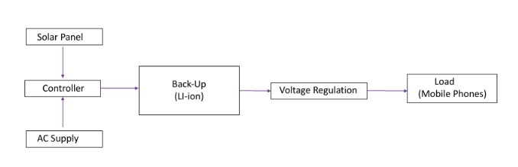

**Figure1:**Block Diagram

1. **HARDWARE DESCRIPTION**

This project operates by capturing sunlight through a solar panel, which converts it into direct current (DC) electricity. A boost converter steps up the generated voltage to the required 5V for USB charging. This output is directed to a 9000mAh lithium-ion battery, which stores excess energy for later use. A battery management system (BMS) monitors the battery's state of charge, ensuring safe charging and preventing overcharging. Once charged, the system provides power to mobile devices through multiple USB output ports. Users can easily connect their devices for charging. Additionally, a battery level indicator informs users of the current charge status. Designed to adapt to varying sunlight conditions, the system maintains consistent performance even in poor weather. Overall, this project offers an efficient and sustainable solution for mobile device charging using renewable energy. The solar-powered mobile charging project operates by first capturing sunlight through a solar panel, which converts the sunlight into direct current (DC) electricity. This generated DC voltage is often insufficient for charging mobile devices, so a boost converter steps up the voltage to the required level, typically 5V for USB charging. Once charged, the system provides power to mobile devices through multiple USB output ports. Users can easily connect their devices for charging. Additionally, a battery level indicator informs users of the current charge status. Designed to adapt to varying sunlight conditions, the system maintains consistent performance even in poor weather. Overall, this project offers an efficient and sustainable solution for mobile device charging using renewable energy. The incorporation of components like the boost converter and battery management system ensures efficient energy conversion and safe operation.

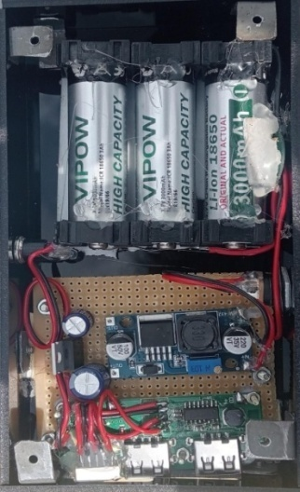

**Figure 2:**Hard ware

1. **RESULTS AND DISCUSSION**

The solar-powered mobile charging project operates by first capturing sunlight through a solar panel, which converts the sunlight into direct current (DC) electricity. This generated DC voltage is often insufficient for charging mobile devices, so a boost converter steps up the voltage to the required level, typically 5V for USB charging. The output from the boost converter is directed to a rechargeable battery, such as a 9000mAh lithium-ion battery, allowing it to store excess energy generated during sunny conditions. A battery management system (BMS) is implemented to monitor the battery's state of charge, ensuring safe charging and discharging processes. This system prevents overcharging and deep discharging, thereby enhancing the battery's lifespan. Once the battery is charged, the system can provide power to mobile devices through multiple output ports, allowing users to connect their devices via USB cables

.

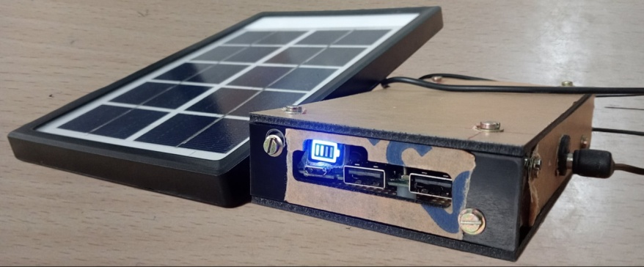

**POWER BANK CHARGING BY SOLAR PANEL**

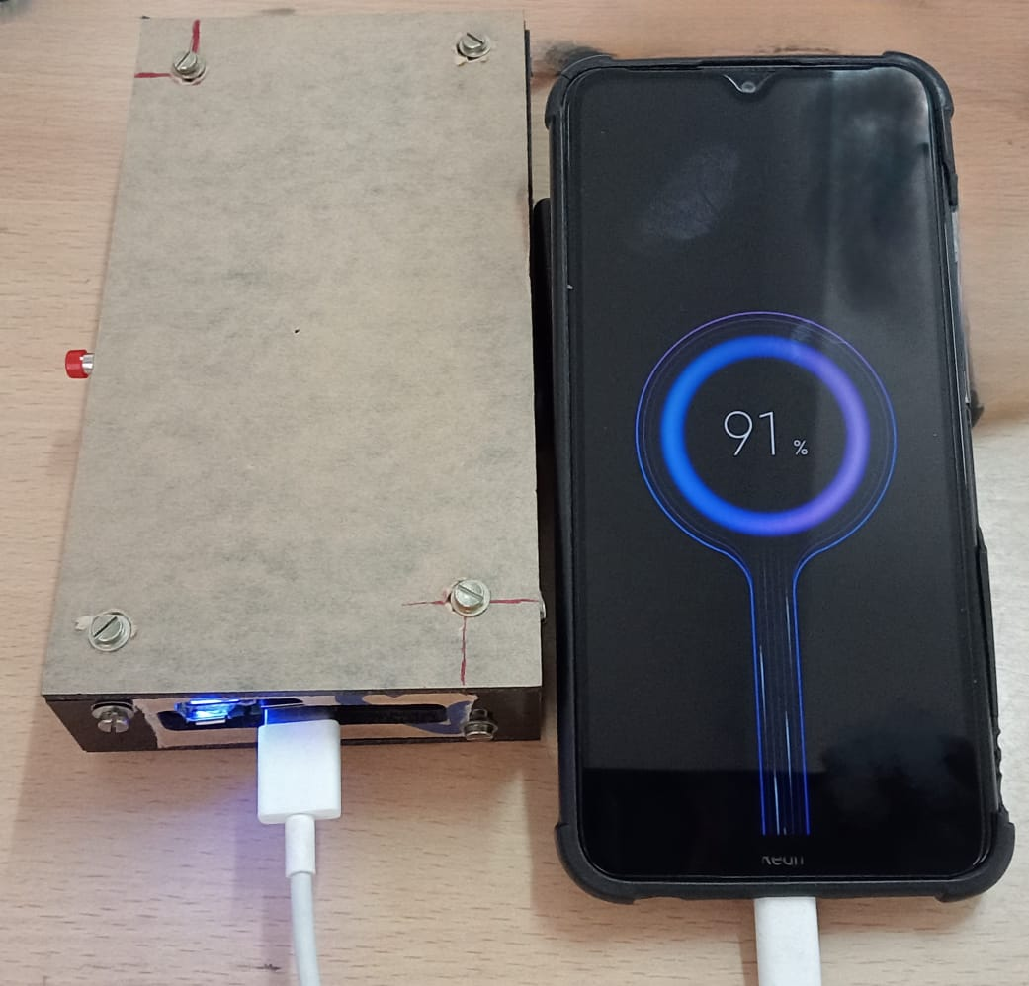

**OUTPUT OF PROJECT**

**Figure3:**Output of the HardWare

1. **CONCLUSION**

The solar-powered mobile charging system exemplifies the integration of renewable energy technology with practical applications. By harnessing solar energy, the project not only provides a sustainable means of charging mobile devices but also demonstrates the feasibility of eco-friendly solutions in everyday life. The incorporation of components like the boost converter and battery management system ensures efficient energy conversion and safe operation. As society moves toward greener technologies, this project stands as a promising step toward energy independence and environmental sustainability

1. **REFERENCES**
2. Askari Mohammad Bagher, Mirzaei Mahmoud Abadi Vahid, Mirhabibi Mohsen. (2015), “Types of Solar Cells and Application”. American Journal of Optics and Photonics. Vol. 3, No. 5.
3. Dhal, Sanbandh Bhusan, Arun Agarwal and Kambita Agarwal. (2016), “Solar powered mobile power bank system”. American Journal of Electrical and Electronic Engineering 4, no: 148-151.
4. Shruti Sharma, Kamlesh Kumar Jain, Ashutosh Sharma a review on (2015). “Solar Cells: In Research and Applications”. Materials Sciences and Applications, 6, 1145-1155.
5. Chih-HaoHou Chun-Ti Yen Tsung- Hsi Wu Chin-Sien Moo, (2014). “A Battery Power Bank of Serial Battery Power Modules with Buck-Boost Converters”.
6. Gupta, G. F. Alapatt, R. Podila, R. Singh, K.F. Poole, (2009). “Prospects of Nanostructure-Based Solar Cells for Manufacturing Future Generations of Photovoltaic Modules”. International Journal of Photo energy.
7. Lal. S and Raturi. A, (2012), “Techno-Economic Analysis of a Hybrid Mini-Grid System for Fiji Islands”. International Journal of Energy and Environmental Engineering.
8. Shufian, A., Rahman, M.M., Ahmed, K, Islam, R., Hasan, M. and Islam, T., (2019), “Design and Development of Solar Energy”. Engineering and Robotics Technology, IEEE.
9. Singh T., P. Bhardwaj, B. Singh, and A. Kumar. (2014), "Design and development of portable power charger a green energy initiative". International Journal of Electronics and Communication Technology.