# IMPROVED & OPTIMIZED MEDIA FOR BUTTON MUSHROOM

**Mr. Sumit Magar,Mr.Anil Landage, Dr.Vijaysinh Sable, Author, Guide,Principle,Voice Principle.**

# ABSTRACT

A total of 294 single spores were isolated from eleven-button mushroom strain and 132 were evaluated for their fertility of which 24 were found non-fruiting whereas eleven single spore isolates started fruiting after second flush of cropping and remaining were fertile. button mushrooms (Agaricus bisporus) were coated by dissolving four different organic coating material viz. apple peel powder), carboxymethyl cellulose, tartaric acid, and glycerol monostearate in distilled water and dipping the mushroom in coating solution for 45 to 75 experiments were conducted using response surface methodology and the coated as well as uncoated samples were stored at ambient and refrigerated conditions. Various quality parameters of button mushroom were measured. During the last decade several major breakthroughs have been achieved in mushroom biotechnology, which greatly enhanced classical mushroom breeding. Other hand efficacy of developed organic coating powder tested on button mushroom (Agaricus bisporus) shows some prominent practical application for fresh produce. From analysis and interpretation of the experimental result it was found that organic coating powder was effectively increase the shelf life of button mushroom also maintained its quality.

## INTRODUCTION

Indian agriculture will continue to be a main strength of Indian economy. With the variety of agricultural crops grown today, we have achieved food security by producing over 200 million tons of food grain. However, our struggle to achieve nutritional security is still on. Though we have significant achievements in milk, vegetables and fruit production still we have to do more. In future, the ever-increasing population, depleting agricultural land, changes in environment, water shortage and need for quality food products at competitive rates are going to be important issues. To meet these challenges and to provide food and nutritional security to our people, it is important to diversify the agricultural activities in areas like horticulture. Diversification in any farming

system imparts sustainability. Mushrooms are one such component that not only impart diversification but also help in addressing the problems of quality food, health and environment related issues. One of the major areas that can contribute towards goal of conservation of natural resources as well as increased productivity is recycling of agro-wastes including agro-industrial waste. Utilizing these wastes for growing mushrooms can enhance income and impart higher level of sustainability. Commercial production of edible mushrooms bio converts the agricultural, industrial, forestry and household wastes into nutritious food (mushrooms). Indoor cultivation of mushrooms utilizes the vertical space and is regarded as the highest protein producer per unit area and time-almost 100 times more than the conventional agriculture and animal husbandry.

This hi-tech horticulture venture has a promising scope to meet the food shortages without undue pressure on land. Mushroom farming today is being practiced in more than 100 countries and its production is increasing at an annual rate of 6-7%. In some developed countries of Europe and America, mushroom farming has attained the status of a high-tech industry with very high levels of mechanization and automation. Present world production of mushrooms is around 3.5 million tones as per FAO Stat and is over 25 million tones (estimated) as per claims of Chinese Association of Edible Fungi. The wide variation in world production data in FAO Stat and CAEF is partly due to the fact that in FAO Stat, mushroom means butt on mushroom (Agaricus spp.) along with the boletes, morels and tuber, whereas CAEF data covers all types of

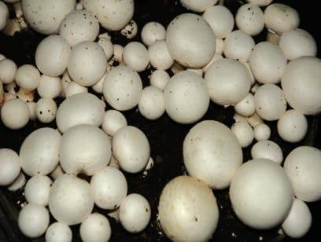

Mushroom .China alone is reported to grow more than 20 different types of mushrooms at commercial scale and mushroom cultivation has become China’s sixth largest industry.

Furthermore, the production and consumption of the Agaricus Bosporus mushroom increased in the past years and production occupied the first rank and constitute by 40% of the production by the rest of the fungi known internationally (Nasiri et al 2013). It became a desirable food instead of meat because of its high nutritional value, as it contains 20-40% of protein on a dry weight basis, and its proteins are similar to animal meat proteins in terms of quality, while it ranked the third after meat and eggs in terms of quantity as well as, it's content of mineral salts, essential amino acids and vitamins (A, D, B1, B2, and B3), which earned it high medical importance, so doctors advise to give it food for patients with heart disease, atherosclerosis, and high blood pressure as well as containing some inhibiting materials for cancer tumors growth,

Therefore, the growing need for this in Iraq as it is characterized by its high nutritional value. A bisporus had highly nutritious qualities with a rich source bisporus . A cancer, and antioxidant, reduction as antifungal activity, strain were diabetic-inflationary, anti-blood pressure and cholesterol, liver protective, antifibrotic, anti contents have a high moisture sample bisporus . A Depending on harvest and growth. It has both medicinal and nutritional Due to their excellent digestibility, protein. In addition to being a great source of protein, mushrooms are also a meat tive for alternant free, and -Erol, gluten, and minerals, and are low in calories, fat, cholesteric source of vitamin.

To improving the production and quality of mushroom by adding biochar and ash to the casing layer, two different media are needed for the cultivation of mushrooms, commercial Agaricus bisporus strain available to meet specific demands for fresh and processed products is very limited. Despite an enormous on the part of mushroom scientists, conventional breeding techniques have resulted in few novel strains. Two different media are needed for the cultivation of mushrooms to grow fruiting bodies, one of them A .bisporus(the material utilized to cover the mushroom compost to induce the transition from asexual to (Pardo reproductive growth after complete colonization This casing layer had the effect to promotes an ecological change and improving the quality of the compost also had an impact on the management of cultivation conditions, depended on the genetic capacity of the mycelium induction rather depended on physical, chemical and microbiological factors as pH, particle size and electrical conductivity.

The casing layer has an alkaline pH of 7-8 this rate has important to grow this mushroom and another hand help control the presence of competitors such as Trichoderma, which grows better at

acidic, sometime could adding some supplement to improve character casing layer, also could adding biochar and ash.

To improve and increase the shelf life of button mushroom use of coating is essential, the past few years, research has been focused on the development of new sustainable coatings, based on biodegradable polymers. The type of coating to be used is based on the biological property of the product to be coated. In postharvest processing, many researchers have used different types of edible coating material such as Natural Seal TM 1020, cellulose-based edible coating on cut apple and other fruits and vegetables crop, which have proven increase in their shelf life.

It is evident from the above that the yields of major market crops of the worldwill have to be more than doubled, simply to maintain the current consumption pattern .In case of mushrooms, for which vast markets (like India) still remain to be trapped, the production at global level may have to be more than doubled in the next 18-20 years.

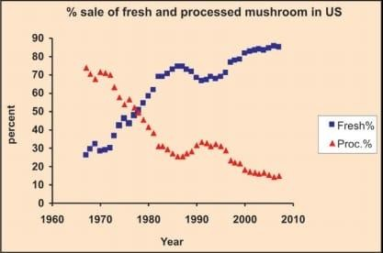

It is possible to cultivatemushrooms under varied climatic conditions. Some of the important mushrooms fortemperate, sub-tropical and tropical conditions are briefly described below:

## A.TEMPERATURE MUSHROOM

The button mushroom is most popular variety both for domestic and export market At global level it ranks first. The major production is from Hitech projects .However, Hitech projects faced several problems in successful production resulting in high cost of production. The main problems are quality of raw materials particularly, wheat/paddy straw, chicken manure and some times gypsum resulting Button mushroom6 Mushrooms: Cultivation, Marketing and Consumptionin

poor quality of compost and poor yield. Besides, high cost of imported cultures/spawn, machineries and casing material are other impediments.

In recent years evenincreasing cost of electricity has given severe blow to the mushroom industry. Several medium scale projects have started growing mushroom targeting big city markets utilizing indigenous machinery and equipment. However, during winter season hundreds of seasonal growers undertake button mushroom production particularly in Northern States targeting big cities like Delhi, Chandigarh, etc.

## ADVANTAGES

There are good opportunities in India both for domestic and export market for buttonmushroom .

* Seasonal production is possible in big way in Jammu and Kashmir, HimachalPradesh, Punjab, Haryana, Uttar Pradesh, Uttaranchal, Bihar, West Bengal, NorthEastern Region, Madhya Pradesh and other areas where temperature remainsbelow 200C during winter season. In this situation cost of production is low.
* Raw materials are easily and cheaply available for compost and casing material
* Awareness about food and medicinal values is increasing in the country thuscreating better domestic market.
* Transport facilities are available both by land and air
* There is increasing market for postharvest products like pickle and soup powder.

## LIMITATION

* High cost of energy for year round production.
* Un-organized production and sale particularly by seasonal farmers.
* Lack of facilities to produce quality compost, casing material, spawn and processed products.

## PRESERVATION TECHNIQUES :

1. Vegetative mycelium culture (Tissue culture)

Under aseptic conditions using laminar flow, young basidiocarp is cleaned withsterilized distilled water and dipped into 0.1% mercuric chloride or 2.5% sodiumhypochlorite solution for 1 min. In case of button mushroom, the basidiocarp is air driedand split open longitudinally from centre and vegetative mycelial bits are cut from thecollar region (junction of pileus and stipe). Whereas, in black ear mushroom, the ear iscut along the edge with a sterilized scissor and inner tissues are scrapped and smallbits of tissues are taken. These bits are then washed in sterilized water to remove HgCl2and placed in oven sterilized petriplates having culture media. Inoculated plates areincubated at 250 ± 20C in a BOD incubator. In general, tissue from inside the fruiting bodyof mushroom is taken from the region of active growth.Within 4-5 days the new mycelium growing over the media is observed. The purecultures are made by carefully transferring young mycelium from growing edge of thecolony from petriplate to test tubes and again incubating at 250 ± 20C for 10-14 days (350Cfor Volvariella spp.

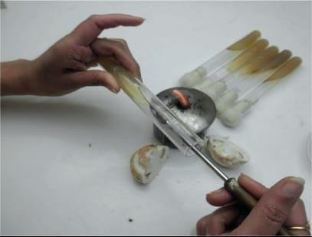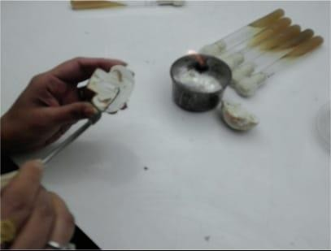

FIG 2 : Tissue culture Fig 3 : tissue culture in tube

1. MULTISPORE CULTURE:

Under aseptic conditions, spore mass is scraped from a fresh spore print orbasidiocarp and suspended in 100 ml of sterilized distilled water in flasks and shaked toobtain uniform spore

suspension. A few drops of this suspension is added to lukewarmculture medium and poured into oven sterilized petriplates. Petriplates are rotated tohomogenize the spore suspension into culture medium. The culture medium is allowedto solidify and then petriplates are incubated at 250°± 20C for 3-4 days (350C for Volvariellavolvacea). The spore germination is observed under microscope and germinating sporesare transferred carefully to culture tubes along with a piece of agar containing a culturemedium recommended for the mushroom species isolated. The culture tubes are thenincubated at 250C for 10-14 days in case of Agaricus bisporus and A.bitorquis and at320C for Volvariella volvacea for 7 to 10 days.

## RESULT AND DISCUSSION

**Optimization of process parameters to enhance the shelf life of coated button mushroom :**

Numerical optimization of the processing parameters, that is, APP concentration (% wt/vol), CMC concentration (% wt/vol), and dipping time (s) was carried out using Design-Expert 10.0.1 statistical software. All the responses, that is, weight loss (%), shrinkage ratio, Aw, color variation (ΔE*), microbial load [log (cfu/g)], % FRSA, and shelf life were considered for optimization. Optimization of the samples was done on the basis of data (except shelf life) taken on the 2nd day of storage for coated button mushroom. The goal set up for optimization of processing parameters and response variables for shelf life enhancement of coated button mushrooms.Based on abovementioned criteria, the optimization was carried out . Out of the 48 solutions obtained, the one with highest desirability (0.853) was selected. The most optimum point obtained ,. It shows that after coating of freshly harvested button mushroom, the coated button mushroom can be safely consumed for 5 days.

## CONCLUSION:

Succesfull inhibition from the microbial attack on coated button mushroom samples were found by the application of developed organic coating powder and The practice of added casing layer is an important technique for improving yield in the industrial production of A. bisporus. Waste conversion such as biochar and ash can be selected as quality supplements. These wastes were suggested to enhance properties of the physical and chemical of casing layer thus had effect for the development and growth of the fruiting bodies

Concluded that the biochar added to casing layer when applied properly has significant benefits, including an increase in yield and biological efficiency and the most important one is reduction in fruit formation cycle when combined with ash. On the other hand, the application of biochar, ash and interaction added increase protein fruit body content.

## REFERENCES:

* 1. Rajeev Ranjan Thakur,Navin Chandra Shahi ,Shukhdev Mangraj ,original Artical:Development of an organic coating powder and optimization of process parameters for shelf life enhencement of button mushroom ,
  2. Indian journal of Ecology (2020) 47 Special issue (12):225-230: Optimal Conditions for Production of the Mother Culture for Cultivated Mushrooms Agaricus bisporus(White Iraqi Strain),
  3. Appl Microbiol Biotechnol (1999) 52: 474-483,J. M. H. Stoop á H. Mooibroek: Advances in genetic analysis and biotechnologyof the cultivated button mushroom, Agaricus bisporus,
  4. Abd Allah, W. E., & Ahmed, T. (2020). Drying Kinetics of White Button Mushroom (Agaricus bisporus) Using Different Equipment of Drying Considering of Power Density. Journal of Soil Sciences and 10.21608/jssae.2020.109424Agricultural,
  5. Alqaisi, Tikrit Journal for Agricultural Sciences (2024) 24 (1): ISSN:1813-1646 (Print); 2664-0597 (Online)Tikrit Journal for Agricultural Sciences Journal Homepage: [http://www.tjas.org,](http://www.tjas.org/) improving the production and quality of white button mushroom (Agaricus bisporus) by adding biochar and ash to the casing layer,
  6. Director Directorate of Mushroom Research (ICAR) Chambaghat, Solan–173213 (HP)Ph.: 01792-230451, 230541, 230767Fax: 01792-231207E-mail: dirdmur@icar.org.in; [directordmr@gmail.com](mailto:directordmr@gmail.com) Website: nrcmushroom.org .