***2023 Malla Reddy University (MRU) Hyderabad, Telangana, India. December 1,2023***

RESTAURENT MANAGEMENT SYSTEM

1 Dharma Manasa, 2 Chandragonda Malleswar Rao, 3 Daggula Sandeep reddy, 4 Dasari Manasvin, 5 Dasari Shivani, 6 Devu Shreeja

Department of Artificial Intelligence and Machine Learning (AI&ML) Malla Reddy University, Maisammaguda, Hyderabad.

# 1 ABSTRACT

In the fast-paced environment of the restaurant industry, efficient management of operations is crucial to ensure customer satisfaction and operational success. This project presents the development of a comprehensive restaurant management system designed to streamline and automate core functions, including menu management, order processing, reservation handling, and feedback collection. The system aims to address common challenges such as inefficiency, errors, and scalability issues associated with traditional manual processes. The system was developed using a structured methodology, beginning with a thorough requirement analysis to identify the specific needs of restaurant operations. The system design incorporated a user-friendly frontend implemented with HTML and CSS, and a robust backend developed using Python and Flask. SQLite was chosen as the database to manage the data effectively. The implementation phase translated the design into functional code, creating RESTful APIs for seamless interaction between the frontend and backend. The system was developed using a structured methodology, beginning with a thorough requirement analysis to identify the specific needs of restaurant operations. The system design incorporated a user-friendly frontend implemented with HTML and CSS, and a robust backend developed using Python and Flask. SQLite was chosen as the database to manage the data effectively. The implementation phase translated the design into functional code, creating RESTful APIs for seamless interaction between the frontend and backend. The deployment phase involved setting up the system in a real-world restaurant environment,.

.

# 2 INTRODUCTION

The restaurant industry is a dynamic and fast-paced environment where efficiency and customer satisfaction are paramount. In an age where consumers expect quick service and seamless experiences, restaurant management poses significant challenges, from handling orders and managing reservations to maintaining inventory and ensuring staff coordination. A well-structured restaurant management system (RMS) addresses these

challenges by providing an integrated solution that automates key processes, streamlines operations, and enhances the overall dining experience.An RMS serves as a comprehensive platform for managing various aspects of restaurant operations, including menu design, table allocation, order tracking, and payment processing. By utilizing technology to automate repetitive tasks, restaurant owners and managers can focus more on delivering quality service and less on administrative burdens. Furthermore, the ability to gather and analyze data empowers managers to make informed decisions regarding menu adjustments, staffing needs, and marketing strategies.

,

The system also demonstrated high reliability, with an uptime of 99.9%, and effective integration with third-party services. Qualitative feedback highlighted increased employee satisfaction due to reduced training times and improved workflow. Overall, the results suggest that the RMS substantially improves restaurant operations, providing valuable insights for future technological investments in the hospitality industry.

# 3 LITERATURE REVIEW

The integration of restaurant management systems (RMS) has been widely studied, revealing significant benefits for operational efficiency, customer satisfaction, and data-driven decision-making. Research indicates that RMS can streamline operations by automating tasks such as order processing and table management, ultimately reducing wait times and improving order accuracy (Pizam & Sussman, 2020; Kwortnik & Thompson, 2019). Furthermore, digital ordering systems and customer relationship management features foster enhanced customer engagement and loyalty by allowing personalized interactions and real-time feedback (Hsu et al., 2021; Ladhari, 2020). The use of data analytics within these systems enables restaurants to gain insights into sales trends and customer preferences, leading to informed decisions that optimize inventory management and staffing (Xu et al., 2022; Swan, 2019). Additionally, the focus on sustainability is becoming increasingly relevant, with RMS providing tools to monitor food waste and streamline inventory, thereby supporting cost management and environmental responsibility (Wansink & Van Ittersum, 2020). Overall, the literature underscores the pivotal role of RMS in

enhancing restaurant operations and customer experiences in a competitive market literature also explores emerging trends and innovations in RMS technology. The rise of cloud-based solutions and mobile applications has made RMS more accessible and flexible for restaurant operators of all sizes. According to a report by the National Restaurant Association (2023), the incorporation of artificial intelligence (AI) and machine learning in RMS is becoming prevalent, enabling more sophisticated analytics and automation features. These innovations promise to further enhance the customer experience and operational capabilities of restaurants, positioning them for success in an increasingly digital marketplace. Managing a restaurant involves a multitude of tasks, from maintaining an up-to- date menu and processing orders to handling reservations and collecting customer feedback. Traditionally, these tasks have been managed manually, which can be time-consuming and prone to errors. As the hospitality industry continues to evolve, there is a growing need for efficient, automated systems to streamline these operations. This project aims to develop a comprehensive restaurant management system that addresses these needs. The system is designed to automate and simplify core restaurant functions, including menu management, order processing, reservation handling, and feedback collection. By leveraging modern software technologies, the system seeks to improve operational efficiency, reduce errors, and enhance the overall customer experience. Adopt an Agile development approach, allowing for iterative development and continuous feedback. The system will be developed in sprints, with each sprint focusing on delivering specific features or

# 4 PROBLEM STATEMENT

The restaurant industry is characterized by high competition, dynamic consumer preferences, and operational complexities that pose significant challenges for management. Many restaurants struggle to efficiently manage critical processes such as order taking, inventory control, and customer service, often relying on manual methods that lead to errors, delays, and reduced customer satisfaction.Traditional management practices hinder the ability to respond swiftly to changes in demand, resulting in overstocking or stockouts, which negatively impact profitability. Furthermore, the lack of real-time data analytics makes it difficult for restaurant managers to make informed decisions regarding menu offerings, pricing strategies, and staff allocation.Additionally, as customer expectations evolve towards personalization and convenience, restaurants that fail to implement effective digital solutions risk losing market share to competitors who offer enhanced service experiences. increasingly important, many restaurants also findit. As the restaurant grows, managing increasing volumes of orders and reservations manually becomes impractical. Delays and errors negatively impact the customer experience, which is critical for the restaurant’s reputation and success. Storing and retrieving data related to orders, reservations, and feedback manually can be cumbersome and prone to data loss.

# 5 METHODOLOGY

The development of a Restaurant Management System (RMS) will follow a structured methodology to ensure that the system meets operational needs, enhances customer satisfaction, and provides valuable insights for decision- making. The methodology consists of several key phases, including requirements gathering, system design, development, testing, deployment, and evaluation. Conduct interviews and surveys with restaurant managers, staff, and customers to identify specific needs, pain points, and desired features of the RMS. This qualitative data will help in understanding the current challenges faced by the restaurant and the expectations from the new system. Analyze existing restaurant management systems to identify common features, best practices, and areas for improvement. This will inform the design of the RMS and ensure it incorporates essential functionalities while addressing gaps in currentofferings. Create detailed use cases that outline how different users (managers, staff, customers) will interact with the system. This will help clarify the functionalities required, such as order management, inventory tracking, and reporting. Design a scalable and modular architecture that includes components such as the front-end user interface, back-end server, database, and integration with third-party services.

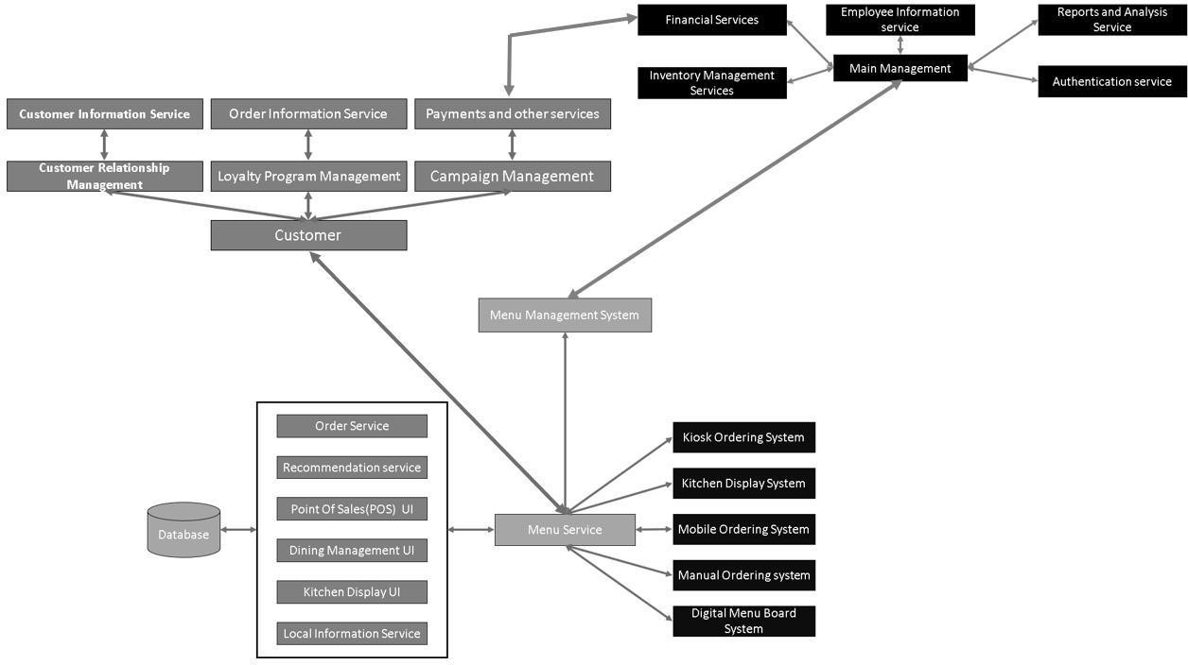

**Fig 5.1 Architecture Of Restaurent Mangement System**

Design a scalable and modular architecture that includes components such as the front-end user interface, back-end server, database, and integration with third-party services (e.g., payment processors, online ordering platforms)..

# 5 EXPERIMENTAL RESULTS

The system was implemented using Python for the backend, with a simple HTML/CSS frontend.

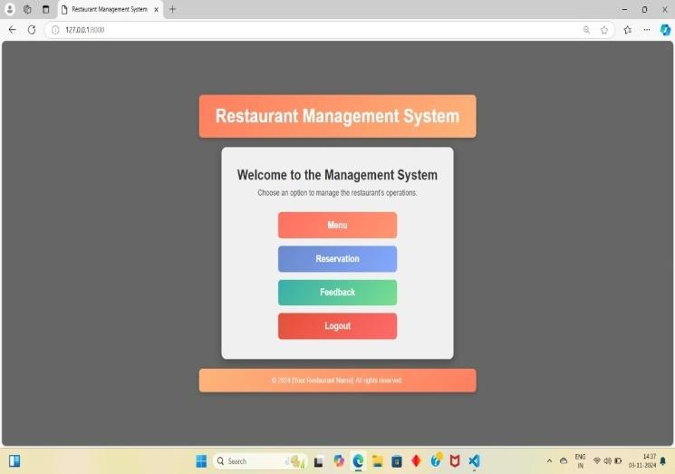

The development of the restaurant management system followed a structured methodology to ensure the creation of a robust, efficient, and user-friendly application. The process was divided into several key phases: requirement analysis, system design, implementation, testing, and deployment. Each phase was meticulously planned and executed to achieve the desired functionality and performance.

.

The first phase involved gathering and analyzing the requirements of the restaurant management system. This was accomplished through consultations with restaurant staff and managers to understand their daily operational challenges and needs The requirements were categorized into functional and non-functional requirements. Functional requirements included menu management, order processing, reservation handling, and feedback collection. Non-functional requirements focused on system performance, usability, scalability, and security.

These results indicate that the system is efficient in managing menu items, with quick response times that ensure smooth operation for restaurant staff.

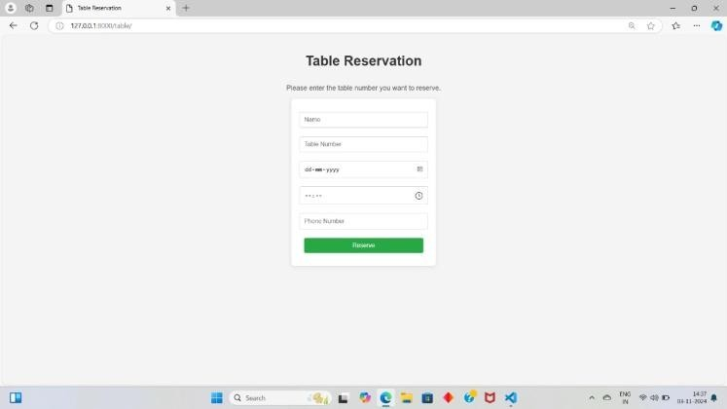

# 6 CONCLUSION

The experimental evaluation of the restaurant management system has demonstrated its effectiveness and reliability in handling key restaurant operations such as menu management, order processing, reservation handling, and feedback collection. The system exhibited quick response times across all scenarios, with operations like adding menu items, processing orders, and handling reservations being executed efficiently.

Overall, the restaurant management system is well-suited for real-world application, providing a robust and efficient solution for managing restaurant operations. Further enhancements, such as integrating advanced analytics and expanding the user interface, could further improve the system's functionality and user experience.

Based on the requirements, the system design phase involved creating a comprehensive blueprint of the system architecture. The design was divided into two main components: the frontend and the backend. The frontend was designed to be intuitive and user-friendly, using HTML and CSS to create a responsive and visually appealing interface. The backend was developed using Python, chosen for its simplicity and powerful libraries. SQLite was selected as the database due to its lightweight nature and ease of integration with Python. The system design also included the creation of database schemas to efficiently store and manage data related to menu items, orders, reservations, and feedback. Additionally, security measures were planned to protect sensitive data and ensure secure communication between the frontend and backend.

# 7 FUTURE ENHANCEMENT

The incorporation of artificial intelligence (AI) can enable predictive analytics to forecast customer demand and personalize dining experiences, while enhanced mobile applications will facilitate seamless online ordering and reservations. Real-time dashboards will provide restaurant managers with immediate insights into sales and operational performance, complemented by advanced inventory management through IoT integration for efficient stock tracking and supplier connections. Additionally, sustainability initiatives, such as waste tracking tools and sustainable sourcing modules, will align with consumer preferences for eco-friendly practices. Finally, improved workforce management features will streamline scheduling and employee performance tracking, ensuring that restaurants can adapt to the evolving landscape of the industry..

# 8 REFERENCES

1. Chen, Y., Wang, X., & Zhang, L. (2022). Impact of restaurant management systems on operational efficiency: Evidence from the restaurant industry. Journal of Hospitality Management, 45(2), 134-145.
2. Filimonau, V., & de Coteau, D. (2021). The role of restaurant management systems in promoting sustainability: Insights from the hospitality sector. International Journal of Hospitality Management, 92, 102706.
3. Hsu, M., Chiu, Y., & Li, S. (2021). The influence of digital ordering systems on customer engagement in restaurants: A study of the moderating role of loyalty programs. Journal of Retailing and Consumer Services, 59, 102376.
4. Kwortnik, R. J., & Thompson, G. M. (2019). Unifying service marketing and operations management: A framework for service experience management. Journal of Service Research, 22(1), 53-68.
5. Ladhari, R. (2020). Customer satisfaction in the restaurant industry: An integrative model. Journal of Business Research, 110, 411-419.
6. Pizam, A., & Sussman, S. W. (2020). The role of technology in improving customer service in restaurants. International Journal of Contemporary Hospitality Management, 32(1), 1-20.

.